**WA HEALTH RESEARCH PROTOCOL**

**HOTWHEELS study**

**Heating On Transport WitH prEtErm and Low birth weight neonates using Servocontrol*:***

***A pragmatic randomised controlled trial.***

**Temperature control in preterm infants, who require transport after birth, using a targeted patient temperature management system integrated into a neonatal transport platform.**

**Protocol Version 2**

Dr Varuna Chaudhary, Dr. Michael Lee, Dr Alex Wilson, Dr Saumil Desai, Dr Vamsi Batta

Dr Jacqueline Gardiner, Dr Gayatri Jape, Dr Steve Resnick,

Kylie McDonald, Jo Blacker, Dr Jonathan Davis

**C**ontents

1 Project Details 3

Project Summary 3

2 Rationale / Background 3

3 Project Aims / Objectives / Hypotheses 6

4 Project Design 6

Source and Selection of Participants 7

Participant inclusion criteria. 7

Exclusion criteria 7

Method 7

Randomisation 7

Masking 8

Consent 8

Description of the thermal care procedures 9

5 Assessment of Efficacy 11

Outcome measures 11

6 Assessment of Safety 11

6.1 Risks and Benefits 11

6.2 Data and Safety Monitoring Committee 12

6.3 Adverse Event Reporting 12

7 Data Management, Statistical Analysis 14

Data collection 14

Sample size considerations 14

Data security and confidentiality 15

Project Duration/Schedule 16

8 Quality Control and Quality Assurance 16

9 Ethics 16

Consent 16

Sufficient protection of privacy 17

10 Budget, Financing, Indemnity and Insurance 17

11 Publication 17

12 References 18

|  |  |  |  |
| --- | --- | --- | --- |
| Project Details | | | |
| **Protocol/Research Project Title:** | Temperature control in preterm and low birth weight infants who require transport after birth, using a targeted patient temperature management system integrated into a neonatal transport platform**.** | | |
| **Protocol Number (Version and Date):** | Version 2, 20 February 2024 | | |
| **Project Start Date:** | 1 April 2024 | **Project Finish Date:** | 1 April 2027 |
| **Coordinating Principal Investigator Name:** | Dr Jonathan Davis | | |
| **Coordinating Principal Investigator Contact Details:** | jonathan.davis@health.wa.gov.au | | |
| **Sponsor Name (if applicable):** | Child and Adolescent Health Service | | |

## 

## Project Summary

**Background** Preterm and low birth weight babies are at vulnerable to wide temperature variations outside of the normal range. This increases their risk of death and long-term consequences. Admission temperature in neonatal intensive care has consistently been shown to be an important prognostic marker for neonatal outcomes. During neonatal transport, environmental factors make temperature regulation more challenging.

**Objectives** A pilot randomisedcontrolled trial to compare two modalities (servocontrolled vs. current standard) of thermoregulation during the transport of preterm and low birth weight babies soon after birth.

**Project Plan.** All eligible babies <34weeks GA and/or 1500g weight who are retrieved by NETS WA will be approached for randomisation to either servocontrol or standard thermal control. The primary outcome will be temperature in the normothermic range (36.5 – 37.5oC) on arrival to the receiving neonatal unit. Secondary outcomes will look at the breakdown of babies with mild, moderate and severe hypothermia, any hyperthermia and the incidence intraventricular haemorrhage in the first 7 days of life. We aim to recruit 66 patients in 12 months to assess feasibility, safety, and efficacy and 172 patients in total over 3 years to adequately power the study.

|  |
| --- |
| Rationale / Background |

*2.1 Neonatal transport: what is it?*

Every year the newborn emergency transport service of Western Australia (NETS WA) travels to hospitals all over WA. Over 1100 babies require the services of the NETS team every year. Doctors from throughout the state can, at any time of the day or night, call the NETS service for advice, or to request the transfer of a baby who can no longer be cared for in the health care facility they are at, or need treatment that is only provided in a few centralised facilities.

The service is contacted through a free phone number: 1300 NETSWA and is immediately connected via a conference call with a neonatal specialist doctor and nurse. The history and condition of the patient are discussed, and the urgency is assessed. The NETS team is made up of a neonatal-trained doctor and nurse who travel either by specialized road ambulance or fixed-wing aircraft with a purpose-built intensive care transport equipment cot. This team and equipment are dispatched to attend to the baby wherever they are in WA. On arrival of the NETS team to the referring hospital, the baby is assessed, and treatment is continued or escalated following discussion with a neonatal consultant based in Perth. The team then returns with the baby in the intensive care cot to the neonatal intensive care unit (NICU) in Perth Children’s Hospital/ King Edward Memorial Hospital.

*2.2 Thermoregulation in Preterm and low birth weight Neonates*

Maintaining a normal temperature after birth is a major challenge for newborn survival and morbidity. Thermal control is arguably the most essential part of neonatal care (1,2,3). Hypothermia is common in infants born at hospitals, at home and may even occur in tropical environments (1).

Preterm infants <34 weeks’ gestation and <1500g weight are especially vulnerable to cold stress/ hypothermia due to their large surface area to body mass ratio, minimal subcutaneous fat stores, low tone, and limited capacity to generate heat from fat stores. In very low birth weight infants, mortality is inversely related to admission temperature (28% increase per 1o decrease(4). Moderate hypothermia is also associated with interventricular haemorrhage (5).

A large Canadian study reviewed the admission temperature of over 9,000 infants and adverse outcomes. In this study, those within an optimum temperature range of 36.5 - 37.2oC, had the lowest rates of mortality, neurological injury, retinopathy of prematurity, necrotising enterocolitis, bronchopulmonary dysplasia, and nosocomial sepsis. Since 2015 the International Liaison Committee on Resuscitation (ILCOR) Neonatal Task Force has recommended that the temperature of newly born non-asphyxiated infants be maintained between 36.5. and 37.5oC after birth through admission and stabilisation (6).

Recommended interventions to prevent thermal loss at birth in preterm infants include moderation of environmental temperature, infant warmers, polythene bags/wraps, preheated mattresses, and heated and humidified gases (2, 7, 8, 9). A considerable proportion of preterm infants are hypothermic during neonatal intensive care unit admission (4, 10, 11, 12). Neonatal transport services as such have an important role in attaining normal body temperature during transport (13). The newborn emergency transport service of Western Australia (NETS WA) is responsible for safely transporting and retrieving newborns and infants. There is a reported incidence of hypothermia in transported infants of 70%. There is negative correlation between birth weight, gestation, and admission temperature. Hyperthermia has also been reported in similar cohorts and ranged from up to 19%, on admission. Mortality is more common in infants who experience moderate hypothermia (32 - 36OC). Mortality rates improve when transport was undertaken with a specialised transport team (13).

Between 2016 and 2020 NETS WA transported 5426 infants: 3227 acute retrievals. In the total population 619/3227 (19%) had a temperature <36.5oC; 515 had mild hypothermia, and 104 moderate; none were severe; 92/3227 (2.8%) had a temperature >36.5oC on admission. In total, 22% of all infants arrived with a temperature outside the recommended range. Of the 3227 babies, 400 were <33 weeks’ gestation (12.4%). In the more vulnerable population of infants <33 weeks, 81/400 (20%) had a temperature outside of the range (36.5 - 37.5); 67/400 (16.8%) had a temperature <36.5, 56 had mild hypothermia, 11 moderate hypothermia and none were severe. Hyperthermia (>37.5) was present in 14/400 (3.5%).

NETS WA provides thermal control to preterm babies during transport using a few methods. The main way is an Airborne ® Voyager transport incubator (international biomedical, TX, USA, Figure 1 A). The temperature of the cot is set at 36oC. In addition to the transport incubator a TransWarmer ® thermal mattress (Cooper surgical, CT, USA, Figure 1B) is used to provide an additional heat source. The third element is a sterile polythene suit to minimise environmental heat loss (Neohelp Vygon, Ecouen, France, Figure 1C). A hat is also placed on the baby’s head. The temperature of the baby is checked every 15 minutes. These interventions have developed over time and in response to changes to thermal control in the static neonatal intensive care environment. This is the current standard of care for preterm babies requiring transport after birth.

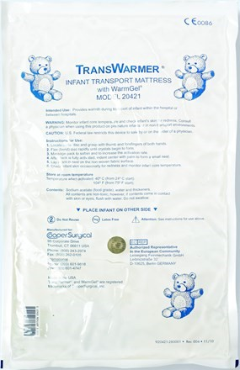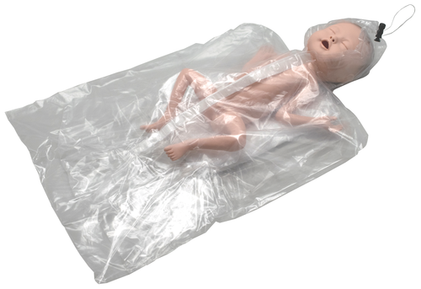  
  
  
**Figure 1. A: Airborne ® Voyager transport incubator courtesy of International Biomedical); B: Transwarmer chemical mattress; C: Neohelp Polythene Bag**

Alternate methods of providing thermoregulation to preterm infants have been reported. Servomechanisms are automated devices that use error sensing negative feedback to correct the action of a mechanism. Servocontrols allow the benefits of automation without the need for regular human intervention. Servo-controlled thermoregulation has been reported in stabilising preterm infants after delivery and during transport for definitive care (14, 15, 16). A systematic review and metanalysis of thermal servo-controlled systems in managing very low birth weight infants concluded that very limited information exists on their use during stabilisation or immediately after birth (17) . Reports on using servo-controlled devices in neonatal transport for preterm babies are relatively unstudied. One research letter from London, UK has reported in 36 babies their impact on temperature control and a favourable safety profile (14). Further study of servo-controlled devices in transporting preterm babies is urgently required.

|  |
| --- |
| Project Aims / Objectives / Hypotheses |

This randomized controlled trial aims to compare the effectiveness of a new servocontrolled patient temperature management system with the current standard of thermal control in preterm and low birth weight infants during transport, from their place of birth to a neonatal intensive care unit (NICU).

We hypothesize that the servo-controlled device achieves better temperature control during transport, decreases temperature fluctuation, improves admission temperature and reduces the incidence of intraventricular haemorrhage, compared to standard care.

To achieve these aims, we will:

* Recruit preterm (<34 weeks GA) and low birth weight infants (<1500g) who require transport to a NICU from their place of birth.
* Randomize these neonates to receive either standard thermal care or the new servocontrolled patient temperature management system.
* Record temperatures of babies in both groups on arrival, during transport and at the receiving unit.
* Statistically evaluate and compare temperature changes during transport and arrival at the receiving unit.
* To measure the incidence of intraventricular haemorrhage in both groups.
* Report adverse events in both groups.

|  |
| --- |
| Project Design |

Pilot, single-centre, non-blinded randomised controlled trial of thermal management with servo controlled patient temperature management system (Criticool Mini, Belmont Medical Technologies MA, USA) or without (standard care) during neonatal transport of preterm babies. The study will be conducted in Western Australia (WA) during the transportation of infants by the Newborn Emergency Transport Service of WA.

## Source and Selection of Participants

All patients < 34 weeks’ gestation and or <1500g referred to the Newborn Emergency Transport Service of Western Australia for transport will be eligible for screening and consent.

## Participant inclusion criteria.

1. Corrected Gestational age ≤ 34 weeks and/or
2. Current weight ≤1500 g
3. Informed parental consent.
4. Sufficient understanding of English language.

## Exclusion criteria

1. Major congenital gastrointestinal abnormality (e.g., gut wall abnormality, imperforate anus or tracheoesophageal fistula or atresia)
2. Necrotising enterocolitis
3. Parental refusal to participate

## Method

## Randomisation

Eligible babies whose parents have provided consent will be randomly assigned to either servocontrolled patient temperature management system (intervention arm) or standard thermal care (control arm) in a 1:1 ratio. Randomisation of patients will be done via REDCap. Permuted blocks (sizes 4 and 6) will be used, with the randomisation list (order) be generated by an independent statistician using https://www.sealedenvelope.com/, with the list then loaded into the study REDCap database to provide participants with a treatment allocation at the time of consent. Multiple pregnancies will be randomised as individuals (as they will travel in a cot independently). The assigned procedure will then be performed.

## Masking

Due to the variation in hardware, it is not possible for the transport team to be masked in the treatment allocation. The statistician who will perform the analysis will be masked to allocation.

## Consent

The parent(s) of babies who meet the criteria will be approached on arrival at the referring hospital by the trial trained NETS team (doctor / nurse). It will be explained their baby needs to stay warm during the transport and is at increased risk of low temperature due to its size and/or age. Parents will be asked if they consent to their baby to be a part of this study and randomised to receiving either the standard care or the servocontrolled patient temperature management system (PTMS). The parents will be given a short explanatory leaflet with a picture of the PTMS and how it works. They can choose for their child to be randomised to either participate in the study using the PTMS or choose not to participate in the study and receive standard care.

This is a high stress situation for parents with an acutely ill baby in preparation for emergency transport to a tertiary hospital. To minimize additional stress, this will be a phased, two-stage consent process:

1. **Verbal consent**

Verbal consent will be requested from the parent with parental responsibility for the child. The use of the servocontrolled patient temperature management system including a rectal probe will be explained to the parent with the aid of parent information leaflet Their verbal consent for their infant to participate in the study will be obtained.

In case of extremely stressful situations (life threatening situation of the baby, inability to stabilise at peripheral hospital prior to transfer), participation in the trial will not be offered and standard care will be provided to avoid increasing parental stress and concern.

Parents or guardians with a limited understanding of English will not be consented for participation in the study and will automatically be offered routine care.

Parents of all newborns who are transported by NETS WA are routinely counselled pre-transfer about the clinical condition and treatment of their baby and what to expect once they reach the tertiary care hospital. This process takes 10 to 15 minutes, and is dependant on the urgency of the situation. During this time, the NETS team will explain the HOTWHEELS study, show them the information leaflet containing pictures of the servocontrolled patient temperature management system and answer any questions the parents may have. The NETS team are highly experienced in these situations, will approach parents only if the situation is appropriate and will ensure no undue pressure is placed on parents to agree to their infant participating in the trial.

1. **Signed Consent**

After arrival at the NICU in PCH or the CAHS NICU in King Edward Memorial Hospital, and the baby and parents are settled, the parent who agreed for their child to be randomised to the trial will be approached by a member of the NETS team for written consent for their child to continue participation in the trial. Any questions about the study will be answered. Continued participation in the trial requires the written agreement of the parent for use of the infants ‘medical information. At this time the parent is free to withdraw their infant from the trial. It will not affect the care of the baby and their relationship with healthcare providers in any way and the family will be reassured of the same.

Should the parent withdraw consent the randomisation in REDCap will be voided.As the occurrence of this will be random across the study period, this is not anticipated to impact balanced allocation.

## Description of the thermal care procedures

1. **Standard thermal Care (Figure 1) page 5**

Babies randomised to the standard arm will be placed in a:

* The Airborne ® Voyager transport incubator (international biomedical, TX, USA) set at **36oC**
* Neohelp wrap (Vygon, Ecouen, France)
* Hat
* TransWarmer ® thermal mattress (Cooper surgical, CT, USA)
* Temp is monitored every 15 min by a skin probe readout. Cot temperature is adjusted accordingly

1. **Servo-controlled patient temperature management system (Figure 2)**

Infants randomised to the intervention arm will have their temperature managed using the servocontrolled patient temperature management system. The device requires the insertion of a rectal and skin temperature probe.

* + The temperature will be set at 37.0 oC in the targeted temperature management mode in the servocontrolled patient temperature management system
  + A diagram of a figure

    Description automatically generated with medium confidenceThe infant will be wrapped in a proprietary plastic wrap to allow the servocontrolled thermal regulation. This wrap comes in two sizes. It is a single use, one-piece, body-shaped, flexible garment that is easy to wrap and secure for the patient. A pressure relief algorithm periodically lets the water drain from the wrap, for slight repositioning of the patient, and specially designed channels within the garment distribute pressure.

**Figure 2. Servocontrolled patient temperature management system**

We have designed a preterm nested configuration with the proprietary plastic wrap to accommodate smaller infants. We have adapted the apparatus to provide optimum thermal care while considering both physiology and developmental care (18). The configuration is visualised below, Figure 3. The infant will be placed in the nested wrap once the neonatal transport is ready for transfer.

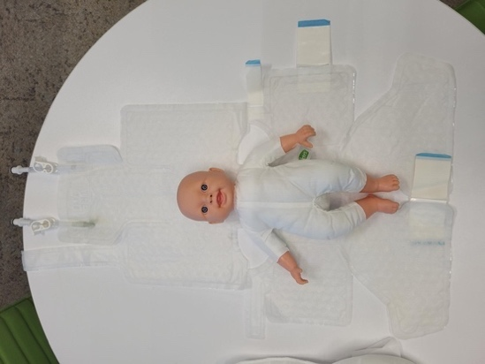

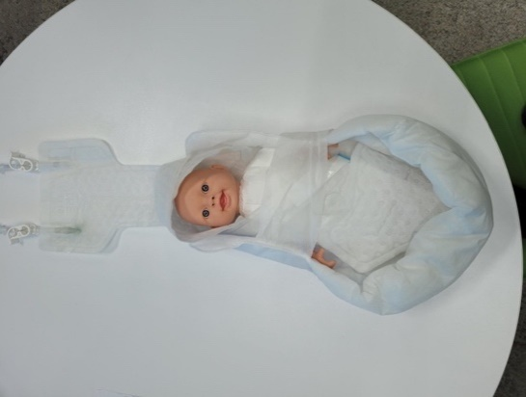**Figure 3. Adapted nesting of the plastic wrap for preterm infants.**

To provide biofeedback and for the servocontrolled device to function correctly a core temperature probe must be inserted into the patient and a surface temperate probe must be attached to the patient skin (Figure 3)

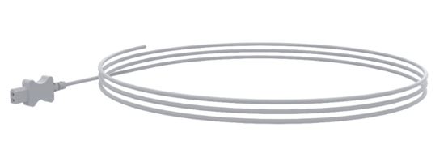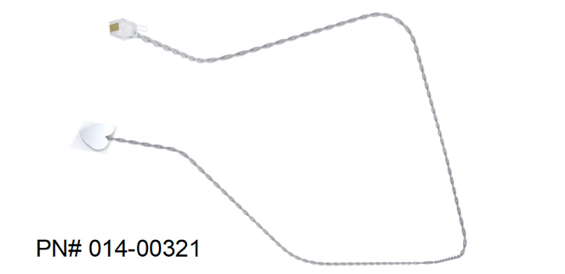

**Figure 4. Rectal and surface probes for the servocontrolled patient temperature management system**

There are concerns that rectal probes may cause mucosal damage or perforation. Rectal temperature measurement is a safe accurate method of recording temperature in preterm infants (19, 20) in NICU. In the transport environment servo-controlled thermoregulation using a rectal probe has been described. In a population of infants <28 weeks and <1kg, 36 infants with a median gestation of 25.5 (23 – 37 weeks) and birth weight 793 g (500 – 1135g), all were transported with a rectal probe ,without adverse incident. The median time spent on the device was 97 minutes (14). We consider using rectal thermometer and servo-controlled thermoregulation to be safe in preterm infants.

|  |
| --- |
| Assessment of Efficacy |

## Outcome measures

*Primary outcome*:

The primary outcome measure is the proportion of infants in the normal thermal range (36.5oC – 37.5oC)(4) on admission to NICU.

*Secondary outcomes:*

*Short term*

1. the proportion of infants with mild hypothermia (36.0 – 36.4 oC)
2. proportion of infants with temperature <36.0 oC on admission to NICU
3. proportion of infants with temperature >37.5 oC (hyperthermia)
4. temperature at one hour of admission in NICU.
5. The change in temperature from first contact with the NETS team to arrival in NICU.
6. Serious adverse events (SAE) (hypothermia <35 oC; hyperthermia >39 oC.
7. Adverse events related to the use of servocontrolled patient temperature management system including incidence of skin of rectal lining trauma.

*Long term*

1. The proportion of intraventricular haemorrhage (all grades and grade III- IV) in first 7 days of life.
2. Mortality before discharge.

|  |
| --- |
| 1. **Assessment of Safety** |

* 1. **Risks and Benefits**

The risks of using the servocontrolled patient temperature management system are those associated with the warming process. The PTMS is designed to provide more efficient, controllable and accurate temperature control with constant monitoring. There is negligible risk of injury and perforation with the use of rectal probe (Figure 4). Rectal temperature measurement is a safe accurate method of recording temperature in preterm infants in NICU (19,20). In the transport environment servo-controlled thermoregulation using a rectal probe has been described. In a population of infants <28 weeks and <1kg, 36 infants with a median gestation of 25.5 (23 – 37 weeks) and birth weight 793 g (500 – 1135g), all were transported with a rectal probe without adverse incident. The median time spent on the device was 97 minutes (14). We consider using rectal thermometer and servo-controlled thermoregulation to be safe in preterm infants. As an added safety measure we will use a small, narrow (7Fr), flexible rectal probe inserted only to a very short distance (<5 cm).

The proposed benefits of the servocontrolled patient temperature management system are increased efficiency and more accurate temperature control.

## 6.2 Data and Safety Monitoring Committee

We will establish an independent data and safety monitoring committee (DSMC) comprising a biostatistician and 3 additional clinical specialists who have no conflicts of interest with this study. A full report of serious adverse events and non-serious adverse events in the whole study population will be provided to the DSMC for discussion according to the timeframes as agreed in the DSMC Charter. The roles, responsibilities, constitution and operations of the DSMC will be described in the DSMC Charter, which will be reviewed and agreed by each member before the first subject is randomized.

All Serious Adverse Events (SAEs) will be reported to the sponsor within 24 hours of the investigators becoming aware of the event, in line with the NHMRC safety reporting guidelines, with the exception of SAEs that occur in control participants unrelated to study procedures. If the SAE is assessed by the Principal Investigator to be probably or possibly related to the intervention, review of the cases will be undertaken by the DSMC according to the timeframes outlined in the DSMC Charter.

* 1. **Adverse Event Reporting**

Any complications that relate to the thermoregulation that meet the definition of an SAE will be reported in accordance with the procedures described in this protocol.

All Adverse Events will be reported to the Sponsor in accordance with the NHMRC Safety monitoring and reporting in clinical trials involving therapeutic goods 2016 (NHMRC Safety monitoring guidance) requirements. All adverse events will be reported to the CPI and Director of NETS. Adverse Events will be reported to the chief investigator, and an investigation and report prepared for the clinical incident management system.

Serious adverse events and any other safety critical events identified by, or urgent safety measures instigated by the Principal Investigator will be initially reported to the Sponsor within 24 hours of the PI being aware of these events.

All significant safety issues or suspected unexpected severe adverse reactions occurring at a study site will be reported to the institution within 72 hours of the site PI becoming aware of the event.

**6.3.1 Definitions**

Adverse Event (AE): Any untoward medical occurrence in a patient enrolled into this study regardless of its causal relationship to study intervention. Adverse Events are classified as serious or non-serious (see below definition for a serious adverse event).

Serious Adverse Event (SAE); any SAE is defined as any AE that:

– Results in death; or

– Is immediately life threatening; or

– Requires prolongation of existing hospitalisation; or

– Results in persistent or significant disability/incapacity

Suspected Unexpected Serious Adverse Reaction (SUSAR):

– A SUSAR is any SAE that is both suspected to be related to the study treatment and is unexpected (i.e. not consistent with applicable product information, or previously known safety profile).

Significant Safety Issue (SSI) – (excluding Urgent Safety Measure)

– An SSI is defined as a safety issue that could adversely affect the safety of the participants; or materially affect the continued ethical acceptability or the conduct of the trial. SSIs may not fall within the definition of a SUSAR but require other action such as the reporting of an urgent safety measure.

Urgent Safety Measure (USM)

– USM is defined as a measure required to be taken to eliminate an immediate hazard to a participant’s health or safety (i.e. requires amendment to the protocol or change in the way the trial is conducted). This type of SSI can be investigated by either the site-investigator or sponsor-investigator and changes to protocol and study conduct can be implemented before seeking approval from HREC’s or institutions.

|  |
| --- |
| Data Management, Statistical Analysis |

**Data collection**

A dedicated research nurse will manage and coordinate the study and collect the required data obtained from the patient medical record. A study database will be established in REDCap provided by The Health Department of Western Australia. Access to the REDCap database will be provided to the project team. Two-factor identification will protect the database and be integrated into the WA Health systems. Access to the REDCap database will be provided to study approved members of the NETS Team. Data can be entered directly into the REDCap database for the duration of transport.

Neonatal temperature on arrival by the NETS team, at NICU admission and after 1 hour will be collected by NETS team and onward health care providers. Further information will be collected from source documents and patient medical records by the project team. Copies of consent forms and CRFS will be saved in dedicated password protected trial file on the secure WA Health server. We will follow a formalised data management plan, with all data entered onto an established REDCap database and reviewed monthly. The REDCap database allows for in-built range and consistency checks. Regular audits of data will be completed by research staff to ensure completeness and accuracy of data.

## Sample size considerations

Between 2016 and 2020 approximately there were 568 infants born <34 weeks’ gestation and/or ≤1500 g (average 113 infants per year). Based on unpublished observation data (2016 – 2020), assuming that 20% of the subjects in the standard care group whose temperature was outside the range (36.5 – 37.5) the study would require a sample size of 86 for each group (i.e. a total sample size of 172, assuming equal group sizes), to achieve a power of 80% for detecting a difference in proportions of -0.15 (i.e. reduction to 5% in the servo-controlled group) between the two groups at a two sided p-value of 0.05. To obtain the study target of 172 in 3 years, we would require a recruitment rate of 51% of the total target patient number per year. We believe this is obtainable.

We further intend to stratify the study participants by gestational age ≤28 and 28+1 – 33+6 and weight <1000 and 1000-1500 in order to perform a subgroup analysis to better understand their effect on thermoregulation using the two different modalities.

**Figure 1: Data analysis plan**

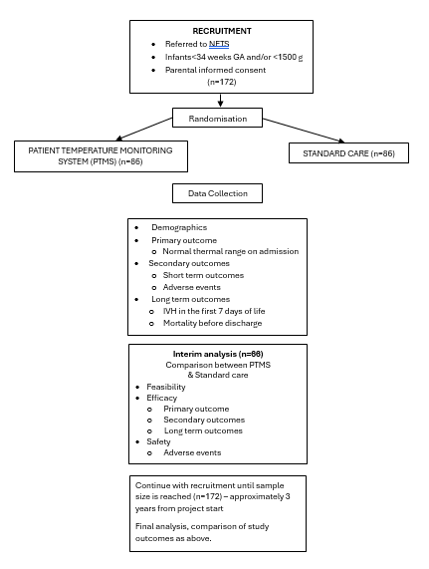

## Data security and confidentiality

Data on REDCap database will contain patient identifiers. REDCap automatically assigns a study ID number. Only de-identified data will be extracted from the REDCap database for analysis by the study team and biostatistician. Reidentification is only possible by members of the study team with authorised access to the REDCap database. Any hard copies of source documents will filed in a locked cabinet. The study team and study biostatistician will perform the data analysis and reporting.

At the end of the trial, data will be archived and stored for 25 years as detailed in the Western Australian Sector Disposal Authority, Section 12.4.4.(21) Data will be destroyed in keeping with the CAHS policy, documented and listed with disposal authority for the retention and disposal of research records. Physical copies will be shredded and disposed of in confidential waste. Digital records will be erased.

## Project Duration/Schedule

We would estimate that the project will take 3 years to complete as the numbers of babies <34 weeks and/or<1500g in WA are small. We estimate that with 65 babies in this gestation and weight category per year requiring transfer this will take approximately 3 years (with timed add for 10% loss of recruitment).

|  |
| --- |
| Quality Control and Quality Assurance |

The trial will be conducted in compliance with the protocol, good clinical practice and the application regulatory requirements. The Device has been TGA approved with all relevant safety checks completed. It has been assessed by MTMU and approved for use on NETS WA cots. The chief concern will be the tolerability and safety of rectal temperature measurement in small babies. As discussed in the background to the project, published data from the London neonatal transport service has demonstrated safety in the baby being transport with servo-controlled warming via rectal probe biofeedback. Adverse events will include complications of temperature probe use as well as temperature excursion <35oC or >38oC.

|  |
| --- |
| Ethics |

Ethical approval from the Child and Adolescent Health Service Human Research Ethics Committee (HREC), along with governance approval at the study site will be sought prior to the initiation of the study.

Trial investigators will permit trial-related monitoring, audits, and regulatory inspections, providing direct access to source data/documents. This may include, but is not limited to, review by external sponsors, Human Research Ethics Committees, and institutional governance review bodies.

**Consent**

Transporting extremely preterm born infants to a tertiary hospital for care is a very stressful situation for parents. We are seeking a 2-step consent process from parents to randomise their baby to one of two warming and temperature control procedures.

At the time of preparation for transportation, the NETS team will explain the two methods for cooling body temperature and provide sufficient information that the parent has an understanding of the methods, risks and potential benefits. Parents will be provided with clear and simple explanatory information pamphlet.

Parents will provide verbal consent to randomise their baby to either the standard care in the transport incubator or the servocontrolled patient temperature management system. The team are unwilling to impose added stress or burden on parents at the time of transportation by providing the PICF. A verbal explanation accompanied by a simple leaflet will provide a clear and succinct explanation. The verbal agreement will be recorded on REDCap database.

After arrival at the tertiary centre and after baby and parents are settled, the NETS team will approach the parent to provide written consent for their child to participate in the trial. Parents will have an opportunity to read the PICF and ask any questions.

**Sufficient protection of privacy**

* All data is stored on the WA Health REDCap system and only accessible to the study team under WA health security access protocols.
* No identified data will be used in analysis or reporting of outcomes.
* No participant will be identified in any form of reporting or analysis.

|  |
| --- |
| Budget, Financing, Indemnity and Insurance |

Funding has been secured from Perth Children’s Hospital Foundation ($198,000). This grant will cover the costs of the device and services required to conduct and report on the project. This funding is shared with our parallel research project : Efficiency of servo-controlled vs. cold pack delivered therapeutic hypothermia for newborns with hypoxic ischaemic encephalopathy (HIE) during neonatal transport: A randomised controlled trial (COOLCOTS RGS0000006472). The equipment and NETsSteam are the same. In-kind funding will be provided by CAHS Perth Children’s Hospital.

|  |
| --- |
| Publication |

The findings of the study will be published in a peer-reviewed medical journal.

|  |
| --- |
| References |

1. Trevisanuto D, Testoni D, de Almeida MFB. Maintaining normothermia: Why and how? Seminars in Fetal and Neonatal Medicine. 2018;23(5):333-9.
2. World Health Organization M, Newborn Health/Safe M. Thermal protection of the newborn : a practical guide. Geneva: World Health Organization; 1997.
3. Silverman WA, Fertig JW, Berger AP. THE INFLUENCE OF THE THERMAL ENVIRONMENT UPON THE SURVIVAL OF NEWLY BORN PREMATURE INFANTS. Pediatrics. 1958;22(5):876-86.
4. Laptook AR, Salhab W, Bhaskar B. Admission Temperature of Low Birth Weight Infants: Predictors and Associated Morbidities. PEDIATRICS. 2007;119(3):e643-e9.
5. Miller SS, Lee HC, Gould JB. Hypothermia in very low birth weight infants: distribution, risk factors and outcomes. Journal of Perinatology. 2011;31(S1):S49-S56.
6. Perlman JM, Wyllie J, Kattwinkel J, Wyckoff MH, Aziz K, Guinsburg R, et al. Part 7: Neonatal Resuscitation. Circulation. 2015;132(16_suppl_1):S204-S41.
7. McCall EM, Alderdice F, Halliday HL, Vohra S, Johnston L. Interventions to prevent hypothermia at birth in preterm and/or low birth weight infants. Cochrane Database of Systematic Reviews. 2018;2018(2).
8. Wyckoff MH, Aziz K, Escobedo MB, Kapadia VS, Kattwinkel J, Perlman JM, et al. Part 13: Neonatal Resuscitation. Circulation. 2015;132(18_suppl_2):S543-S60.
9. Wyllie J, Bruinenberg J, Roehr CC, Rüdiger M, Trevisanuto D, Urlesberger B. European Resuscitation Council Guidelines for Resuscitation 2015. Resuscitation. 2015;95:249-63.
10. Lyu Y, Shah PS, Ye XY, Warre R, Piedboeuf B, Deshpandey A, et al. Association Between Admission Temperature and Mortality and Major Morbidity in Preterm Infants Born at Fewer Than 33 Weeks’ Gestation. JAMA Pediatrics. 2015;169(4):e150277.
11. Lunze K, Bloom DE, Jamison DT, Hamer DH. The global burden of neonatal hypothermia: systematic review of a major challenge for newborn survival. BMC Medicine. 2013;11(1):24.
12. Wilson E, Maier RF, Norman M, Misselwitz B, Howell EA, Zeitlin J, et al. Admission Hypothermia in Very Preterm Infants and Neonatal Mortality and Morbidity. The Journal of Pediatrics. 2016;175:61-7.e4.
13. Cunningham K, Colm P, O’Donnell CP, McCarthy LK, editors. P468 Admission temperature of outborn newly born infants following neonatal transport: a literature review2019: BMJ Publishing Group Ltd and Royal College of Paediatrics and Child Health.
14. Sharma N, Fierens I, Mohinuddin S, Ratnavel N, Kempley ST, Sakhuja P. Servo-controlled thermoregulation in extreme preterm and Extremely low birth weight infants during neonatal transport. Archives of Disease in Childhood - Fetal and Neonatal Edition. 2020;105(1):113-4.
15. Hsu K-H, Chiang M-C, Lin S-W, Lin J-J, Wang Y-C, Lien R. Thermal Blanket to Improve Thermoregulation in Preterm Infants: A Randomized Controlled Trial. Pediatric Critical Care Medicine. 2015;16(7):637-43.
16. Cavallin F, Doglioni N, Allodi A, Battajon N, Vedovato S, Capasso L, et al. Thermal management with and without servo-controlled system in preterm infants immediately after birth: a multicentre, randomised controlled study. Archives of Disease in Childhood - Fetal and Neonatal Edition. 2021;106(6):572-7.
17. Ercolino O, Baccin E, Alfier F, Villani PE, Trevisanuto D, Cavallin F. Thermal servo-controlled systems in the management of VLBW infants at birth: A systematic review. Front Pediatr. 2022;10:893431.
18. Picheansathian W, Woragidpoonpol P, Baosoung C. Positioning of Preterm Infants for Optimal Physiological Development: a systematic review. JBI Libr Syst Rev. 2009;7(7):224-59.
19. Morley CJ, Hewson PH, Thornton AJ, Cole TJ. Axillary and rectal temperature measurements in infants. Archives of Disease in Childhood. 1992;67(1):122-5.
20. McCarthy LK, O'Donnell CPF. Comparison of rectal and axillary temperature measurements in preterm newborns. Arch Dis Child Fetal Neonatal Ed. 2021;106(5):509-13.
21. Western Australia University Sector Disposal Authority, 15 August 2022 https://www.wa.gov.au/system/files/2022-08/WAUSDA%202022-005.pdf