Participant Information Sheet & Consent Form
Intervention Study – Parent/Guardian consenting on behalf of participant

Title: Temperature control in preterm and low birth weight infants who require transport after birth using a targeted patient temperature management system integrated into a neonatal transport platform.
Short Title: | HOTWHEELS study
Protocol Number: | RGS0000006433 v2
Coordinating Principal Investigator | Dr Jonathan Davis
Principal Investigator | Dr Varuna Chaudhary
Associate Investigator(s) | Dr Michael Lee
Location | NETS WA, Perth Children’s Hospital

We spoke to you about your baby participating in this research study and being transported to Perth Children’s Hospital using the standard care for keeping your baby warm during transport or specialised patient temperature management system.
This Participant Information Sheet/Consent Form provides more detail about the research study.
Please read this information carefully. Please ask questions about anything that you don’t understand or want to know more about.
Participation in this research is voluntary. We know you agreed for your baby to take part, but you are free to change your mind. Your baby will receive the best possible care whether or not they take part.
If you decide you would like your child to continue the research study, we ask you to please sign the consent form. By signing it you are telling us that you:
- Understand what you have read
- Consent for your child taking part in the research study
- Consent to the use of your child’s personal and health information as described.
You will be given a copy of this Participant Information and Consent Form to keep.

What is the purpose of this research?
Newborn babies cannot regulate their body temperature. We know that keeping a premature baby’s temperature within normal range,. 36.5 - 37.5ºC is a critical part of care. Every baby’s temperature is closely monitored all the time (during transport and during hospital care).
We use various equipment to keep a baby’s temperature within normal range. Currently we use heat packs which lie under the baby’s quilt, a specially made plastic cover called Neohelp to wrap around the baby and adjust the temperature of the incubator to keep the baby warm.

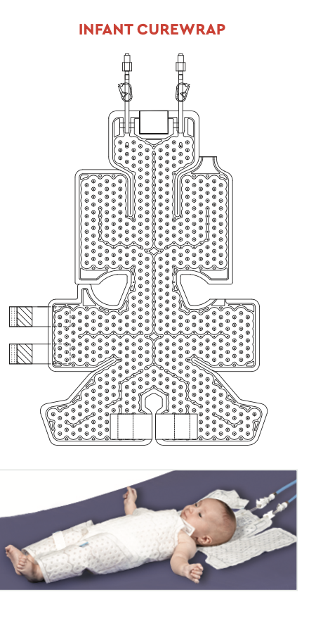
During transportation the NETS team use heat packs, rewarming equipment and temperature probes to warm, monitor and regulate a baby’s body temperature. The baby’s temperature is monitored by probes attached to skin, and the temperature of the incubator is adjusted accordingly.
We have a new sophisticated baby temperature controlling device. This uses a special wrap around the baby’s body with a specialised patient temperature management system (PTMS) to keep their temperature within a set range. The baby’s temperature is monitored by an internal rectall probe and the temperature of the PTMS monitored and adjusted by a computer system call the Criticool.
The PTMS device is approved for use in Australia, and is already used in many Neonatal Units.
We want to use this device for babies’ temperature control during transport to hospital.

What does participation in this research involve?
Your baby was transported by Newborn Emergency Transport Service (NETS) to Perth Children’s Hospital.
You verbally agreed for your baby to be part of the study and your baby was randomized (allocated by chance) to be treated with either:
- Standard method of warming, using heat packs, plastic wrap, hat and mittens. Temperature is monitored using skin temperature probes and under the armpit checks and then the incubator temperature can be adjusted accordingly.
or
- Patient temperature monitoring system (PTMS) device and body wrap The baby’s temperature is monitored using a small probe in their rectum (bottom) throughout the transport.
We would ask your permission to use information from your baby’s medical records to compare outcomes between the two groups of babies. We will compare the baby's temperature control during transport and on arrival at the hospital. We will also compare progress in hospital after transportation, and their health outcomes for the first month in hospital.

What are the possible risks and benefits?
We know that the patient temperature monitoring system is safe, and it is currently used to treat babies across Australia and in other countries.
As with any warming equipment (including the heat packs used in standard care), there is a small risk of skin irritation, breakdown or discomfort with the patient temperature monitoring system.
All babies are continuously monitored and a Neohelp sheet (layer between the baby and the heating device) avoids direct contact of the device to the babies’ skin.
Babies in the PTMS group have their temperature monitored with a rectal probe as opposed to skin temperature or underarm temperature probe monitoring. To prevent any damage to the rectum, the rectal probe is soft, very small and narrow and inserted to a short distance (less than 5cm).
The benefits are that the PTMS device is a highly sophisticated machine and may improve the thermoregulation of vulnerable babies during transportation. Knowing this will improve outcomes for all babies requiring temperature regulation on their journey to specialized hospitals.

Could this research study be stopped unexpectedly?
It is possible that this research study could be stopped unexpectedly if the device is shown to be not effective.

What will happen to information about my child?
By signing the consent form you consent to the study doctor and relevant research staff collecting and using personal information about your baby for the research study.
Any information obtained in connection with this research study that can identify your baby will remain confidential. All information on your child is confidential and safely stored on the WA Health hospital computer systems. Only study investigators will have access to the study information. At the end of the study, the information will be securely stored on WA Health computer servers until the youngest child in the study is 25 years old, and then destroyed. Any hard copy study materials (eg. consent forms) are safely stored and at the end of the study, archived until the youngest child in the study is 25 years of age, then destroyed.

What happens with the results of the research?
It is anticipated that the results of this research study will be published and/or presented in a variety of forums. In any publication and/or presentation, information will be provided in such a way that your child cannot be identified their confidentiality is protected at all times.

Who is organising and funding the research?
This research is carried out by a team of clinician-researchers, led by Dr Jonathan Davis, Consultant Neonatologist at the CAHS Neonatal unit, Newborn Emergency Transport services. The Newborn Emergency Transport Western Australia have received the PTMS courtesy of Perth Children’s Hospital Foundation.

Who has reviewed the research study?
All research in Australia that involves humans is reviewed by an independent group of people called a Human Research Ethics Committee (HREC). This research study has been approved by the Child and Adolescent Health Service Human Research Ethics Committee. This study will be carried out according to the National Statement on Ethical Conduct in Human Research (2023).

Who can I talk to if I need more information?
If you would like further information concerning the study, you can contact the following people:
Clinical Contact Person
Name | Jonathan Davis
Position | Neonatologist; Medical Director NETS WA
Telephone | (08) 6456 2222
Email | Jonathan.davis@health.wa.gov.au

If you have any complaints about any aspect of the study or the way it is being conducted, then you may contact:
Executive Director Medical Services
Telephone: 6456 2222

Consent Form
Title: Temperature control in preterm and low birth weight infants who require transport after birth using a targeted patient temperature management system integrated into a neonatal transport platform.
Short Title: | HOTWHEELS study
Protocol Number: | RGS0000006433 v2.0
Coordinating Principal Investigator | Dr Jonathan Davis
Principal Investigator | Dr Varuna Chaudhary
Associate Investigator(s) | Dr Michael Lee
Location | NETS WA, Perth Children’s Hospital

Declaration by Parent/Guardian
I have read the Participant Information Sheet and I understand the contents.
I understand the purposes, procedures and risks of the research described in the study.
I give permission for my child’s doctors, other health professionals, hospitals or laboratories outside this hospital to release information to Perth Children’s Hospital concerning my child’s disease and treatment for the purposes of this study. I understand that such information will remain confidential.
I have had an opportunity to ask questions and I am satisfied with the answers I have received.
I freely agree to my child participating in this research study as described and understand that I am free to withdraw them at any time during the research study without affecting their future health care.
I understand that I will be given a signed copy of this document to keep.

Baby’s name: ………………………………………………………………………………………

Parent’s name ……………………………………………………………………………………..

Parent’s signature………………………………………… Date ……………………………..

Declaration by researcher: I have supplied an Information Sheet and Consent Form to the participant who has signed above, and believe that they understand the purpose, extent and possible risks of their involvement in this study.

………………………………….. ………………………………………. …………………
Research team member’s name Research team member’s signature Date
Note: All parties signing the Consent Form must date their own signature.

Withdrawal Form
Title: Temperature control in preterm and low birth weight infants who require transport after birth using a targeted patient temperature management system integrated into a neonatal transport platform.
Short Title: | HOTWHEELS study
Protocol Number: | RGS0000006433 v2.0
Coordinating Principal Investigator | Dr Jonathan Davis
Principal Investigator | Dr Varuna Chaudhary
Associate Investigator(s) | Dr Michael Lee
Location | NETS WA, Perth Children’s Hospital

Declaration by Parent/Guardian

I wish to withdraw my child from participation in the above research study and understand that such withdrawal will not affect their routine treatment, relationships with those treating them or the relationship with Perth Children’s Hospital.
Baby’s name: ………………………………………………………………………………………

Parent’s name ……………………………………………………………………………………..

Parent’s signature………………………………………… Date ……………………………..

Declaration by Study Doctor/Senior Researcher
I have given a verbal explanation of the implications of withdrawal from the research study, and I believe that the parent/guardian has understood that explanation.
……………………………………………….. …………………………. …………………
Name of Study Doctor/Senior Researcher Signature Date

Note: A senior member of the research team must provide the explanation of, and information concerning, withdrawal from the research study.
All parties signing the Consent Form must date their own signature.

