HOTWHEELS study
Your baby will be transported by the Newborn Emergency Transport Service (NETS) to King Edward Memorial Hospital/Perth Children’s Hospital. They will cared for by the NETS team in a mobile incubator.
One important part of your baby’s care is to ensure their temperature is kept within normal range i.e. not too cold and not too warm. We have equipment we use as the current care standard to maintain your baby’s temperature including specialist plastic wraps, pre-warmed mobile incubators and heat packs. Maintaining your baby’s temperature can still be a challenge despite all this, especially the more premature/smaller your baby is.
The NETS team have new equipment that regulates a baby’s body temperature. This is a soft blanket and a special device which responds to the baby’s changing temperature. The baby’s temperature is constantly monitored by a small soft rectal probe. The thermometer has a very small risk of unwanted events. The risks include damage to the surface the skin or lining of the rectum. However, the team are well trained and experienced its use and will be taking additional precautions.
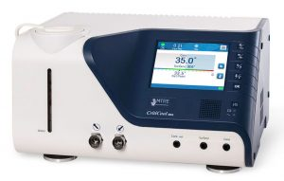

The patient temperature management system is already being used in neonatal intensive care units in Australia, but is not yet used during transport of babies. We want to compare the use of the temperature system to the standard equipment mentioned above.
We need your consent to randomly allocate your baby to be kept warm with either the temperature management system or standard equipment to maintain their core body temperature. We will compare the two devices and see which works best. Your baby will still be nursed in a pre-warmed incubator in both cases.
If you don’t want to do this, that’s no problem, your baby will be cared for with the standard equipment and receive the best possible care. If you are happy for your baby to be in this project, our team will talk to you later in the hospital about the study and answer any questions you may have.

