PROTOCOL

EFFECT Trial: Evaluating Fermentable Fibre as a Long COVID Therapy

Version: 1.0
24/02/2024

HREC/105455/Alfred-2024

Authors:
Dr Paul Gill
Dr Jane Varney
Dr Arwel Jones
A/Prof Jane Muir
Prof Menno van Zelm
Prof Anne Holland

Contents
Summary 4
1. Background 5
2. Rationale 8
3. Aim and Objectives 9
3.1 Aim 9
3.2 Objectives 9
4. Methods 10
4.1 Study design 10
4.2 Setting 10
4.3 Participant eligibility criteria 10
4.3.1 Inclusion: 10
4.3.2 Exclusion: 10
4.4 Outcomes 10
4.4.1 Primary: 10
4.4.2 Secondary: 10
5.5 Recruitment 14
5.6 Assessment and Follow-up 14
5.7 Intervention 15
5.8 Procedures 15
5.8.1 Consent 15
5.8.2 Randomisation 15
5.8.3 Demographics & Medical History 15
5.8.4 Long COVID Symptom questionnaires 16
5.8.5 Dietary information 16
5.8.6 Gastrointestinal symptom questionnaire 16
5.8.7 Biological sample collection, processing and analysis 16
5.9 Sample Size 17
5.10 Data analysis 17
5.11 Participant payment 18
5.12 Withdrawal 18
5.13 COVID-19 Contingencies 18
5.14 Risk & Safety 18
5.14.1 Risk management 18
5.14.2 Safety Reporting 19
5.15 Data management 20
5.15.1 Security and privacy 20
5.15.2 Data monitoring and management 21
5.16 Ethical and regulatory considerations 21
5.17 Indemnity 22
6. Dissemination 22
7. References 23

Summary
Title: | Investigating the immunomodulatory and clinical effects of fermentable fibre intervention to reduce symptoms of Long COVID
Short Title: | EFFECT: Evaluating Fermentable Fibre as a Long COVID Therapy
Design: | Blinded dietary intervention with a parallel design
Setting | Collaborative study (Alfred Health and Monash University)
Aim 1 (primary) | To assess if dietary supplementation of fermentable fibers inulin and resistant starch improves Long COVID symptoms compared to a rice-flour placebo
Aim 2 | To characterize changes to the gut microbiota and immune system that are associated with symptom severit
Eligibility Criteria: | Inclusion:  Adults (18 years or over)  Diagnosis of Long COVID, defined as symptoms persisting for more than 3 months after being infected with SARS-CoV-2  Experiencing symptoms of Brain fog and fatigue  Exclusion:  Currently taking immunosuppressive medication  Have taken antibiotics in the past 2 months  Existing history of functional gut symptoms indicative of poor tolerance to fermentable fibres  Currently adhere to a vegan or vegetarian diet  Pregnant or planning pregnancy  Unable to speak or read English
Sample Size | 40 participants (20 per arm)
Endpoints | Primary: Changes in Long COVID symptoms of fatigue from baseline  Secondary:  Assessment of tolerability to fermentable fibre  Assessment of compliance to study diets during intervention  Assessment of recruitment  To compare changes to gut microbiota profile at the end of each intervention period (day 18)  Changes to faecal and plasma metabolites at the end of each intervention period (day 18)  Changes to inflammatory cytokine concentrations in plasma after each intervention period (day 18).  Examination of immunophenotype after each intervention period (day 18).  Compare changes to SARS-CoV-2 specific immune responses after each intervention period (Day 18).  Examine if immune phenotype or gut microbiota profile may be associated with changes to disease symptoms after intervention.
Data analysis | Data from the primary outcome (Symptoms of Fatigue) will be compared between the placebo and intervention groups using appropriate statistical tests (parametric or non-parametric tests depending on normal distribution).
Keywords
Long COVID; Immunity; Diet; Gut microbiota

1. Background
Long COVID has emerged as a global health issue with long-term social and economic impacts. It is estimated that 5-10% of people infected with SARS-CoV-2 experience Long COVID symptoms across multiple organ systems, including cognitive impairment, fatigue, immune dysfunction and gut dysbiosis(1). The wide spectrum of symptoms that patients experience has also made it challenging to find reliable biomarkers of disease. However, it has been observed that Long COVID patients particularly carry fewer butyrate-producing species Roseburia inulinivorans and Faecalibacterium prausnitzii in their gut microbiota(2). This dysbiosis may link to Long COVID symptoms via microbial metabolites that have immunomodulatory activity such as butyrate, a type of SCFA (Figure 1).

SCFA may modulate subsets of immune cells that have been identified as dysfunctional in Long COVID. These may be innate immune cells such as neutrophils and macrophages, as well as adaptive cells such as B and T lymphocytes(3). Together, these may modulate underlying immune dysregulation that contributes to Long COVID symptoms. Indeed, pre-clinical models show that fermentable fibers such as inulin, increase microbial metabolites, such as butyrate, that directly act on immune cells to ameliorate symptoms of SARS-CoV-2 infection(4). However, there are often difficulties in replicating findings from animal dietary studies into human trials, particularly due to difference in physiology and fiber dosage (5).

Our team has been able to overcome these challenges, using dietary supplementation with fermentable fibers (resistant starch and inulin) to increase short-chain fatty acids (SCFA), including butyrate, to modulate the immune system of healthy people (Figure 2)(6). With the current lack of therapeutic options for Long COVID, there is a clear need to explore the use of non-pharmacological agents such as fermentable dietary fiber to treat symptoms associated with Long COVID, such as gut dysbiosis, immune dysfunction and fatigue.

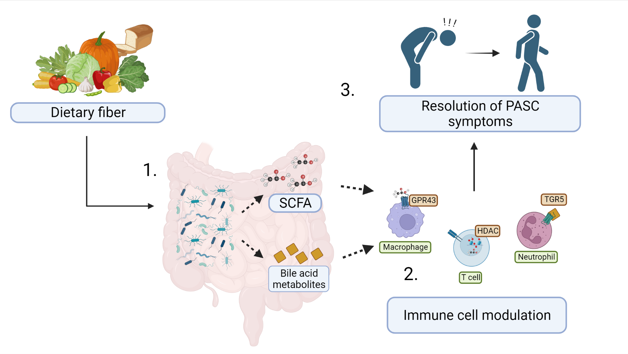
Figure 1. Proposed action of gut microbiota derived metabolites in Long COIVD (PASC). 1) Fermentable dietary fibers are metabolized by the gut microbiota in the colon producing short-chain fatty acids (SCFA). Fermentable fiber also modulates microbial metabolism of bile acids in the colon, increasing secondary bile acid metabolites. 2) Microbial metabolites have anti-inflammatory effects on local immune cells in the gut and also enter the systemic circulation to modulate systemic immune function. 3) Together, this reduces the inflammatory response that may underly Long COVID symptoms such as fatigue and brain fog .
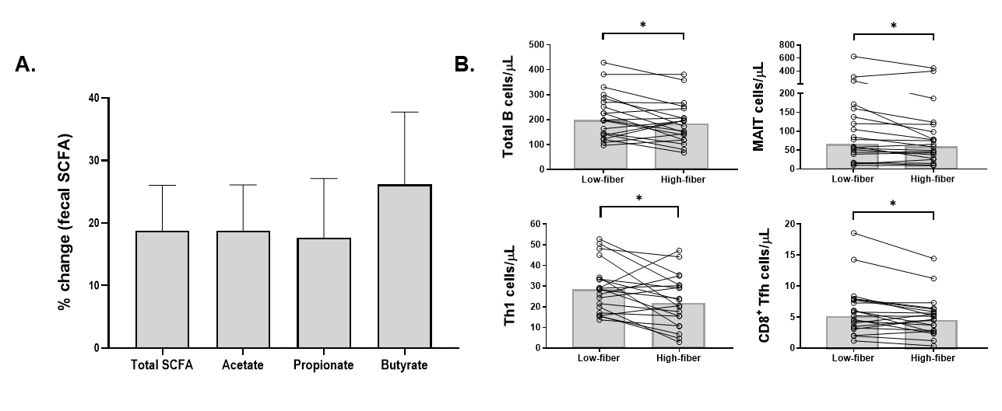
Figure 2. Consumption of fermentable fibers increases SCFA and reduces circulating peripheral blood lymphocyte subsets in healthy people. A) Changes to fecal SCFA levels after high-fiber diet relative to low-fiber diet. Data shown as mean±SEM. B) Paired changes to peripheral blood concentrations of total B cells, Mucosal-associated invariant T (MAIT) cells, T-helper (Th)1 cells and CD8⁺ T-follicular helper (Tfh) cells after low-fiber and high-fiber intervention. Bar represents median. Data from (6)

2. Rationale
Post-acute sequelae of SARS-CoV-2 infection (PASC) or Long COVID is a chronic condition that causes an array of symptoms, affecting multiple body systems. Although Long COVID may affect up to 10% of those who are infection with SARS-CoV-2, there is still poor understanding of disease pathology. Cohort studies of Long COVID patients have observed dysbiosis of the gut microbiota in these patients when compared to healthy subjects. Long COVID patients have reduced abundance of short-chain fatty acid (SCFA) producing bacteria, particularly butyrate producing species that are important for maintenance of gut homeostasis. However, it remains unclear if the reduction in butyrate-producing species may contribute to underlying disease in Long COVID.

Increasing butyrate and SCFA concentrations has been observed to have anti-inflammatory effects in other immune-mediated models of disease, and have been proposed as a potential therapeutic to treat Long COVID(7). It remains unknown if increasing SCFA delivery has any therapeutic benefit in Long COVID. Our study team has extensive experience with supplementing fermentable fiber into the diet to increase SCFA concentrations in people (6, 8, 9). Therefore, we aim to investigate if fermentable fiber supplementation has therapeutic benefit in Long COVID patients. This will be via a dietary intervention study, to assess if fermentable fiber supplementation improves symptoms of Long COVID.

3. Aim and Objectives

3.1 Aim
The overall aim of this study is to investigate the effects of a fermentable fiber dietary intervention in Long COVID patients.

3.2 Objectives
This overall aim will be split into 2 objectives. Firstly, to assess if dietary supplementation of fermentable fibers inulin and resistant starch improves Long COVID symptoms compared to a rice-flour placebo. This objective will be the primary endpoint of the study. Secondly, to characterize changes to the gut microbiota and immune system that are associated with symptom severity. The second objective will investigate mechanisms by which fermentable fiber may modulate Long COVID symptoms. This may be via modulation of the gut microbiota and/or the immune system.

4. Methods

Study design
A double-blinded dietary intervention study with a parallel design (Figure 3A)

Setting
This is a collaborative research study between Alfred Health and Monash University. The study and research procedures will be coordinated by Monash University. Patients will be recruited from Alfred Health.

Participant eligibility criteria

4.3.1 Inclusion:
- Adults (18 years and over)
- Diagnosis of Long COVID, defined as symptoms persisting for more than 3 months after being infected with SARS-CoV-2(10)
- Experiencing symptoms of Brain fog and fatigue

4.3.2 Exclusion:
- Currently taking immunosuppressive medications
- Have taken antibiotics in the past 2 months
- Existing history of functional gut symptoms indicative of poor tolerance to fermentable fibres
- Currently adhere to a vegan or vegetarian diet
- Pregnant or planning pregnancy
- Unable to speak or read English

Outcomes

4.4.1 Primary:
- Comparison of Long COVID symptoms of fatigue from baseline between placebo and fermentable fibre intervention.

4.4.2 Secondary:
- Assessment of tolerability to fermentable fibre
- Assessment of compliance to study diets during intervention
- Assessment of recruitment
- To compare changes to gut microbiota profile at the end of each intervention period (day 18)
- Changes to faecal and plasma metabolites at the end of each intervention period (day 18)
- Changes to inflammatory cytokine concentrations in plasma after each intervention period (day 18).
- Examination of immunophenotype (Overall blood counts of leukocytes, lymphocyte subsets, granulocytes and monocytes) after each intervention period (day 18).
- Compare changes to SARS-CoV-2 specific immune responses (antibodies, B and T cell responses) after each intervention period (Day 18).
- Examine if immune phenotype or gut microbiota profile may be associated with changes to disease symptoms after intervention.

.

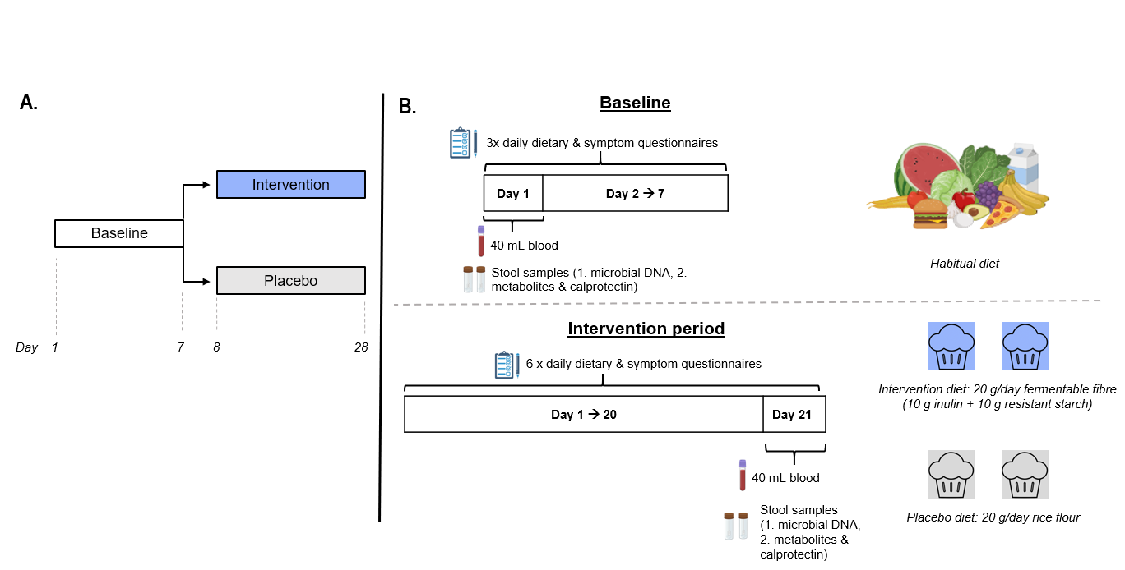
Figure 3. EFFECT Trial design. A) Overall design of double-blind dietary intervention study. B) Outline of sampling timeline and intervention diets during baseline and intervention periods.

5.5 Recruitment
Potentially eligible participants will be recruited primarily through the Long COVID clinic at the Alfred hospital. Screening for eligible participants will take place within existing database and clinic lists of Alfred Health. Eligible participants will first be contacted by telephone by a member of staff at the Alfred Health Long COVID clinic who has access to this information as part of usual care. If the person is interested in receiving more information, they will be sent the study flier and PICF (via email or post) subject to whether they only want contact details of the research team or the full study information. The interested participant’s contact phone number or email may also be passed on to the Principal Investigator if consent is given by the interested participant to the clinical team. Alternatively, interested participants will be asked to contact the research team using the details on the study flier or PICF provided to them by an Alfred health staff member.

Importantly, the first contact with potential participants will be staff members of Alfred Health staff who have access to the potential participants' information as part of standard care. The research team will maintain a ‘declaration of interest’ log for eligible participants who have expressed an interest in the study. The PICF will inform the potential participants that the research team will keep their name and contact details on file until study can proceed. Once the necessary participants have consented and completed baseline assessment, this ‘declaration of interest’ log will be destroyed.

5.6 Assessment and Follow-up
The duration of participation will be approximately 26 days, consisting of a 7-day baseline assessment period, followed by a 18-day intervention period (Figure 3B). Face-to-face visits for study procedures will occur at baseline on Day 1 and on at the end of the intervention period. This will be Day 18 of intervention and Day 26 of the overall study.

5.7 Intervention
During the 3-week fibre intervention, participants will consume their habitual diet, supplemented with 20 g fermentable fiber/day (10 g inulin, 10 g resistant starch) added to 2 intervention food items. The placebo arm will mirror the intervention arm, except that intervention food items will be supplemented with low-fiber rice flour. The intervention food items will be prepared by our research chef and dietitian, at a metabolic kitchen at the Department of Nutrition and Dietetics at Monash University. The intervention items are frozen and then supplied to the participants to reheat and consume at home. These will be a range of baked goods such as muffins, pancakes and muesli bars. This approach has been used previously by our study team(8, 11, 12). Participants will be instructed to maintain their normal dietary pattern during the intervention period. The participants will be blinded to the nature of the intervention.

5.8 Procedures

5.8.1 Consent
Initial information about the project (Flier or PICF) will be provided to potential participants by a member of the Alfred Health Long COVID clinic, however they will not be involved in gaining informed consent. Any questions by potential participants will be answered by the Principal investigator. The Principal investigator will obtain written informed consent for all participants via the PICF. Only persons who provide written, informed consent will undertake the study procedures outlined in this protocol. This will occur at Monash University, Central Clinical School, Level 4, Alfred Centre. Participants will be asked to complete the written consent form at the baseline visit (Day 1). Should there be any subsequent amendment to the protocol, which might affect participant’s involvement in the trial, continuing consent will be obtained using an amended PICF, which will be signed by the participant.

5.8.2 Randomisation
Using an online randomisation tool (randomisation.com) participants will be randomised (1:1) to either the Placebo diet or Fermentable fibre diet. A researcher independent to the research team will generate the randomisation sequence.

5.8.3 Demographics & Medical History
At baseline (Day 1), participants will visit the Principal Investigator at the recruiting centre (Alfred Health) for collection of demographics (age, ethnicity, gender), and medical history including other comorbid chronic diseases (e.g. cardiovascular diseases, diabetes, osteoporosis), medication use, COVID-19 vaccination and infection history and smoking history.

5.8.4 Long COVID Symptom questionnaires
At the baseline visit, participants will be asked to complete an abridged version of the Long COVID symptom burden questionnaire(13) containing the following sections:
- Fatigue
- Memory, thinking and communication
- Impact on daily life
In addition, participants will also complete a Fatigue Severity Scale (FSS) questionnaire. This will be a total of 6 pages of questions and should take approximately 15-20 minutes.

5.8.5 Dietary information
During the baseline period, participants will be asked to complete a food diary on 3 separate days (2 weekdays and 1 day of the weekend) to assess overall macronutrient, energy, and fibre intake. This will be via a mobile application (Easy Diet Diary).

During the intervention period, participants will also complete the same food diary on 3 individual days to assess if background diet was maintained during the intervention.

5.8.6 Gastrointestinal symptom questionnaire
During the baseline period, participants will be asked to complete a daily gastrointestinal questionnaire. This will be a 1-page questionnaire measuring gastrointestinal symptoms XX using a visual-analogue scale. Participants will also complete this questionnaire throughout the intervention period. However, to ease the burden on the participants they will only be requested to complete this on 6 days spread throughout the intervention period.

5.8.7 Biological sample collection, processing and analysis
Blood:
Blood samples will be collected at baseline (Day 1) and at the end of each intervention period (Day 26), as outlined in Figure 3B. Blood samples will be obtained from an antecubital vein by the Principal Investigator at Central Clinical School of Monash University (Level 4, Alfred Centre) via venepuncture into five tubes of 10 ml K₃EDTA coated vacutainers. Blood samples will be processed at the van Zelm laboratory of the Department of Immunology at Monash University.

Total leukocyte counts will be determined with the Cell Dyn analyser (Abbott core laboratory, Abbott Park, IL), and absolute numbers of leukocyte subsets will be determined by flow cytometry as we have previously described(6). Briefly, 50μl of whole blood from each sample will be added to 20μl of an antibody cocktail for the measurement of cell-surface CD3, CD4, CD8, CD16, CD19, CD45 and CD56 via a LSRII analyser or LSRFortessa X-20 (BD Biosciences). From the remaining sample, peripheral blood mononuclear cells (PBMC) will be isolated by Ficoll-Paque density centrifugation and cryopreserved in liquid nitrogen for later analysis of Immune-phenotype and SARS-CoV-2 specific T and B cell responses at the van Zelm lab(14). Plasma from each sample will be stored at -80°C (Department of Immunology, Monash University) to be analysed later for measurements of SARS-CoV-2 specific immunoglobulins via enzyme-linked immunosorbent assay (ELISA) and measurements of inflammatory cytokines. Plasma may also be used to measure metabolites (e.g. Short-chain fatty acids) at the Department of Gastroenterology Lab, Monash University.

Stool:
Stool samples will be collected by participants during the baseline period and at the end of the intervention period. At the baseline visit Participants will be provided with 4 Omnigene.Gut collection tubes (DNA Genotek) to collect faecal material. They will be instructed and provided with information to guide them through the sample collection process. Participants will collect a stool sample into 2 tubes during the baseline period, and then another sample into the other 2 tubes at the end of the intervention period. Omnigene.Gut tubes will stabilise faecal material for up to 60 days at room temperature. This will allow participants to store the faecal samples and then return them for the second study visit at the end of the intervention period. Participants will also be provided with additional containers and zip-lock bags to assist with collection and transport of stool samples.

After stool samples have been returned to the research team, they will be immediately stored in -80°C for later use at the Department of Gastroenterology Monash University. One set of tubes (baseline and post-intervention) will be used for faecal metabolite analysis at the Department of Gastroenterology. This will primarily be analysis of Short-chain fatty acids, Branched-chain fatty acids and faecal ammonia as previously described(6). The other set of Omnigene gut tubes will be used for isolation of microbial DNA at the Department of Gastroenterology, Monash University. This will then be sent for metagenomic sequencing too profile gut microbiota species and functional pathways.

5.9 Sample Size
We will aim to recruit a total of 40 participants to this study, with 20 participants randomized into each arm (fermentable fibre, placebo). As this study is a pilot, we have not performed a power calculation. However, we have previously shown that a similar intervention of this duration and size is sufficient to modulate immune cells and gastrointestinal symptoms (6, 8, 9).

5.10 Data analysis
Data from the primary outcome (Symptoms of Fatigue) will be compared between groups to assess differences between placebo and intervention. This will be made using appropriate statistical tests (parametric or non-parametric tests depending on normal distribution) via SPSS (v26.00; SPSS Inc., Chicago, IL, USA).

Secondly, linear mixed modelling will be performed to correlate changes in immune parameters and gut microbiota with changes to Long COVID symptoms. Furthermore, high dimensionality network analysis will also be conducted to determine immune and gut microbiota signatures associated with symptom severity.

5.11 Participant payment
Participants will not be paid to participate in the trial. Participants may be provided with vouchers to cover the cost of parking at the Alfred Hospital visitor car park as part of attending study visits.

5.12 Withdrawal
In the event that a participant withdraws from a study, no further personal information will be collected from the participant at the time of withdrawal. However, personal information already collected will be retained to ensure the results of the project can be measured properly. Participants will be informed that data collected up to the time of withdrawal will form part of the study results. If this this not desired by the participant, the data will be withdrawn from the project. have until study publication to withdraw their data. Participants who take part in the interview will have until the close of recruitment for withdrawal from the study.

5.13 COVID-19 Contingencies
In the event where a study participant is experiencing symptoms inidicative of a new COVID-19 infection (and/or have a confirmed RAT/PCR test result), they will be asked to re-schedule study appointments on site at Monash University/Alfred Health until symptoms resolved. If participants develop symptoms during the baseline period, participants will be advised to delay the intervention diet until symptoms resolve. If a new COVID-19 infection develops during the intervention period, participants will asked to pause the intervention diet until these resolve. Additional foods may be provided to participants in this event if necessary to ensure they may complete at least 2 weeks of continuous intervention diet prior to the second study appointment. In the event that the study researcher has a confirmed COVID-19 infection, they will attempt to postpone any study appointments if possible or another member of the research team will take over if necessary.

5.14 Risk & Safety

5.14.1 Risk management
Consumption of fermentable fiber may cause minor gastrointestinal symptoms in some people. We have chosen the same fermentable fiber combination and amount that has been tolerated in healthy people in a previous study conducted by our team. This dose will be slowly increased from 10-20 g/day in the first 3 days of the intervention to prevent sudden onset of symptoms. Intervention item recipes will be tested prior to bulk cooking to ensure palatability. If a participant dislikes an intervention item, the study coordinator will substitute this item for another equivalent item.

To minimize the burden placed on participants, daily symptom questionnaires will be brief and consist of 1 page of 6 visual-analogue scales to assess GI and overall symptoms. The SBQ-LC will only be completed once at baseline and at the end of the intervention. Furthermore, participants will be invited to use a convenient phone application (Easy Diet Diary) to record dietary intake during baseline and only during the intervention.

Blood sampling carries a minor risk of discomfort and bruising but good practice minimises risk. Venepuncture will be performed by a qualified member of the team who has experience in collecting blood samples from the study population.

5.14.2 Safety Reporting
The Principal investigator will maintain an adverse event log for this study. Adverse events will be defined as any unfavourable, unintended diagnosis, symptom, sign (including an abnormal laboratory finding), syndrome, or disease that occurs during the trial, having been absent at baseline, or if present at baseline, appears to worsen. A serious adverse event will be defined as any adverse event that leads to
- Death;
- serious deterioration in health that either resulted in life threatening illness or injury, permanent impairment of a body structure or a body function, or hospitalisation or prolongation of existing hospitalisation;
- medical or surgical intervention to prevent life threatening illness.

All adverse events and serious adverse events will be reported on the adverse event log. Each adverse event will be further classified by its severity and relatedness to trial procedure or intervention. The severity of an adverse event is not the same as its seriousness. Severity refers to the intensity of a specific event, whereas seriousness is the extent by which an event poses a threat to a participant’s life or functioning. Assessment of severity will be in accordance with the following:
- An event that is easily tolerated by the patient, causing minimal discomfort and not interfering with everyday activities.
- Moderate: An event that is sufficiently discomforting to interfere with normal everyday activities.
- Severe: An event that prevents normal everyday activities.
- Life Threatening: An event that has life threatening consequences; urgent intervention indicated.
- Fatal: An event that results in death.

An adverse event may or may not be causally related to the trial interventions or procedures. A causal relationship means that the intervention or procedure caused (or is reasonably likely to have caused) the adverse event. For all adverse events, it is the responsibility of the clinician who examines and evaluates the participant to determine the relatedness of the event to the trial intervention or procedure. During causality assessment, clinical judgement shall be used and the presence of confounding factors, such as concomitant medication/treatment, the natural history of the underlying disease, other concurrent illness or risk factors shall also be considered.
Assessment of the relatedness of the adverse event will be in accordance with the following:
- Not related: There is no evidence to suggest there is a causal relationship. Such exclusion may occur when the event: is not a known adverse effect of the intervention or procedure; has no temporal relationship with the intervention or procedure; involves a body-site or an organ not expected to be affected by the intervention or procedure
- Unlikely: There is little evidence to suggest there is a causal relationship. There is another reasonable explanation for the event.
- Possible: There is some evidence to suggest a causal relationship (e.g. the event occurred within a reasonable time after starting the intervention or receiving a procedure). However, the influence of other factors may have contributed to the event (e.g. the patient’s clinical condition, other concomitant events). Cases where relatedness cannot be assessed or no information has been obtained should also be classified as possible.
- Probable: the relationship with the use of the intervention or procedure seems relevant and/or the event cannot reasonably be explained by another cause.
- Definitely: There is clear evidence to suggest a causal relationship, and other possible contributing factors can be ruled out.

The trial coordinator (and/or coordinating principal investigator) will ensure the Research Ethics Committee (REC) is informed of any serious adverse events where necessary (e.g. those deemed related to trial intervention or procedure).

5.15 Data management

5.15.1 Security and privacy
There will be no electronic transfer of data from Alfred Health to Monash University servers. All first contact with potential participants will be completed by Alfred Health who have access to this information as part of routine care. Long COVID symptom data or confirmation of any other medical history will be recorded directly on a hard copy of the Baseline Assessment Form by a member of Alfred staff who has access to this information as part of usual care. This form (labelled with participant ID) will then be handed to the chief investigator. All completed hard copy data collection forms will be stored in a locked filing cabinet within a locked office at the Central Clinical School of Monash University (Level 4 Alfred Centre). Completed PICFs will be stored in a locked filing cabinet within a locked office at the Central Clinical School of Monash University (Level 4 Alfred Centre). Only the Chief Investigator will have access to all of this information. Information will be stored indefinitely, in accordance with REC requirements for interventional studies. If, at some stage in the future, the ethics committee deems storage is no longer required data will be deleted and paper copies will be destroyed using a secure document destruction service. Data on the original hard copy data collection forms (kept under participant ID) will be entered on to spreadsheets on Monash University computers with encryption and password protection. Electronic data will be stored on these Monash University computers and no identifying information will be stored in these files. Participant anonymity will be maintained on original hard copy data collection forms or electronic data by assigning each participant a unique code. Codes linking individuals to data will be kept separately in a locked filing cabinet at the Central Clinical School of Monash University (Level 4 Alfred Centre).

5.15.2 Data monitoring and management
The sponsor of the study is Monash University. The study has received external funding from Springer Nature as part of a Global Gut health grant, however the funder has no role in the design, conduct and analysis of the study.

The data custodian will be the Chief Investigator (Jane Varney) on behalf of Monash University. The Chief Investigator has overall responsibility for the study and shall oversee all study management.
The research team shall meet on a monthly basis (or when appropriate) to ensure all practical details of the study are progressing well. As there are no perceived safety concerns or high risk in participating in the proposed study there are no pre-defined study criteria for stopping the research prematurely. We do not expect the study to need to stop prematurely. Participants will be informed that participation is voluntary and they are free to withdraw at any time.

The Chief Investigator shall carry out monitoring of study data as an ongoing activity. Monitoring of study data at Monash University shall include source data verification; data storage procedures; local quality control checks and procedures and backup of study database. Entries on project databases will be verified by inspection against the source data.

5.16 Ethical and regulatory considerations
The study shall not commence until the study protocol and all participant facing documentation have been reviewed and approved from Alfred Hospital Ethics Committee.
Where an amendment is required to study documentation that required Ethics approval, changes will not be implemented until Alfred Hospital Ethics Committee approval is received. Once local approval is obtained, the amendment will be implemented.
Annual Progress Reports will be submitted to the Alfred Hospital Ethics Committee within 30 days of the anniversary date on which the favourable opinion was given – until the end of the study.

5.17 Indemnity
Monash University as research Sponsor indemnifies its staff, research participants and research protocols with clinical trials insurance.

6. Dissemination
Plans are made to disseminate the findings in peer-reviewed journals and conferences. In line with the current guidelines of The International Committee of Medical Journal Editors, each member of the research team will be required to meet each of the following four criteria to be identified as an author;
Substantial contributions to the conception or design of the work; or the acquisition, analysis, or interpretation of data for the work; AND
Drafting the work or revising it critically for important intellectual content; AND
Final approval of the version to be published; AND
Agreement to be accountable for all aspects of the work in ensuring that questions related to the accuracy or integrity of any part of the work are appropriately investigated and resolved.
Contributors who do not meet all of the above criteria for authorship (despite being given the opportunity to) will not be listed as authors, but they will be acknowledged in any publication. Examples of activities that alone (without other contributions) will not qualify a contributor for authorship are acquisition of funding; general supervision of a research group or general administrative support; and writing assistance, technical editing, language editing, and proofreading.
We will produce patient facing material that communicates findings to public audiences. Key findings will be presented in the form of brief written Plain English summaries to be circulated to participants involved in the project (if requested) or patient support groups across Australia. Participants will also be invited to a consultation with a dietitian on the research team who may share dietary information to inform participants about their dietary habits. This will be both general information about healthy eating, as well as information about sources of fermentable fiber that can be incorporated into the diet. We will also prepare summaries of findings on websites and social media (e.g. X/Twitter) via investigator or affiliated organisation profiles.

7. References
1. Davis HE, McCorkell L, Vogel JM, Topol EJ. Long COVID: major findings, mechanisms and recommendations. Nat Rev Microbiol. 2023;21(3):133-46.
2. Liu Q, Mak JWY, Su Q, Yeoh YK, Lui GC, Ng SSS, et al. Gut microbiota dynamics in a prospective cohort of patients with post-acute COVID-19 syndrome. Gut. 2022;71(3):544-52.
3. Altmann DM, Whettlock EM, Liu S, Arachchillage DJ, Boyton RJ. The immunology of long COVID. Nat Rev Immunol. 2023;23(10):618-34.
4. Fukuda S, Song I, Yang J, Saito M, Hartanto T, Nakayama Y, et al. Prebiotic inulin ameliorates SARS-CoV-2 infection by modulating the gut microbiome and increasing DCA formation in a Syrian hamster model. Research Square; 2023.
5. Gill PA, van Zelm MC, Muir JG, Gibson PR. Review article: short chain fatty acids as potential therapeutic agents in human gastrointestinal and inflammatory disorders. Alimentary Pharmacology & Therapeutics. 2018;48(1):15-34.
6. Gill PA, Muir JG, Gibson PR, van Zelm MC. A Randomized Dietary Intervention to Increase Colonic and Peripheral Blood Short-Chain Fatty Acids Modulates the Blood B- and T-cell Compartments in Healthy Humans. Am J Clin Nutr. 2022;116(5):1354-67.
7. Li J, Ghosh TS, McCann R, Mallon P, Hill C, Draper L, et al. Robust cross-cohort gut microbiome associations with COVID-19 severity. Gut Microbes. 2023;15(1):2242615.
8. So D, Yao CK, Ardalan ZS, Thwaites PA, Kalantar-Zadeh K, Gibson PR, et al. Supplementing Dietary Fibers With a Low FODMAP Diet in Irritable Bowel Syndrome: A Randomized Controlled Crossover Trial. Clin Gastroenterol Hepatol. 2021.
9. Halmos EP, Power VA, Shepherd SJ, Gibson PR, Muir JG. A diet low in FODMAPs reduces symptoms of irritable bowel syndrome. Gastroenterology. 2014;146(1):67-75 e5.
10. Welfare AIoHa. Long COVID in Australia- a review of the literature Canberra: Australian Government; 2022.
11. Gill PA, Inniss S, Kumagai T, Rahman FZ, Smith AM. The Role of Diet and Gut Microbiota in Regulating Gastrointestinal and Inflammatory Disease. Front Immunol. 2022;13:866059.
12. Jama HA, Rhys-Jones D, Nakai M, Yao CK, Climie RE, Sata Y, et al. Prebiotic intervention with HAMSAB in untreated essential hypertensive patients assessed in a phase II randomized trial. Nature Cardiovascular Research. 2023;2(1):35-43.
13. Hughes SE, Haroon S, Subramanian A, McMullan C, Aiyegbusi OL, Turner GM, et al. Development and validation of the symptom burden questionnaire for long covid (SBQ-LC): Rasch analysis. BMJ. 2022;377:e070230.
14. Hartley GE, Edwards ESJ, Varese N, Boo I, Aui PM, Bornheimer SJ, et al. The second COVID-19 mRNA vaccine dose enhances the capacity of Spike-specific memory B cells to bind Omicron BA.2. Allergy. 2023;78(3):855-8.

