Participant Information and Consent Form
Short Name of Project | Cardiac Risk in Cirrhotic Cardiomyopathy (CRICC)
Full Name of Project | Cirrhotic Cardiomyopathy and Improving Cardiovascular Risk Prediction in Patients Undergoing Liver Transplantation
Principal Investigator  Co-Investigator | Professor Omar Farouque  Dr Benjamin Cailes
Project Sponsor | N/A
Site Name | Cardiology Department, Austin Health  Victorian Liver Transplant Unit, Austin Health

What am I being invited to do?

We, the project team, invite you to take part in a project that aims to identify potential risk factors for cardiac dysfunction in liver transplant patients that may help to predict and prevent cardiac complications following liver transplantation. You have been invited to take part because you are on the waitlist for a liver transplant.
Around 200 people will take part in this project. They will be from the Victorian Liver Transplant Unit at Austin Health.
Please read this information and feel free to ask any questions. You can take some time to make up your mind and decide if this project is right for you. You can also talk to someone you trust, like a family member, friend, or your local doctor.

What is the purpose of this project?

In this project, we will look at two new non-invasive assessments of your cardiac risk which may help to predict the risk of cardiac events following liver transplantation surgery. This information would be very valuable as it would allow us to better identify high risk patients in the future who may require further cardiac workup in order to minimise the risk of cardiac events occurring during or after your surgery. We are also interested to see whether any abnormalities on the initial testing improve following the transplantation of a new, functional liver.

Do I have to take part and can I change my mind?

Taking part is up to you
You get to decide whether you take part in this project. You can say no if you want to.
Your decision won’t affect your relationship with your doctor or the hospital. If you don’t take part, your doctor will discuss other options with you.
You can change your mind at any time
If you do take part, you can stop at any time. If you want to stop, please tell someone in the project team. You do not have to tell us the reason.
Once you stop taking part, we will not collect any more information about you. We will keep the information we have already collected to make sure the results of the project can be measured properly.
The project might stop for other reasons
We might need to stop the project while you are taking part. If this happens, we will explain the reasons to you.
We may also ask you to stop taking part in the project if it is no longer in your best interest. If this happens, we will discuss this with you.

What do I have to do if I take part?

If you chose to participate, you will be asked to perform a 20-minute test during which pupil dilating eye drops will be administered and we will take measurements of the blood vessels in the back of your eye using a special camera called a Dynamic Vessel Analyzer. This process is generally safe and painless, however you may experience some blurred vision for 30-60 minutes afterwards. We will also take a blood sample of 40ml during your dobutamine stress echocardiogram and will collect information from your medical record including your previous medical history, the reason for undergoing liver transplantation, the results of your pre-operative screening and the results of your liver transplantation procedure. The blood sample will be stored and analysed to assess for markers of inflammation or vessel dysfunction that could help us identify patients with cardiac dysfunction.
We will ask you to come for a repeat assessment 3 months following your surgery. We will make all reasonable attempts to schedule this appointment on the same date as your other appointments at Austin Health. All patients will undergo repeat eye assessment and, depending on the results of your initial testing, approximately one in three patients will be asked to undergo a repeat dobutamine stress test and blood sample donation. The patients that will be asked to repeat this test will be the ones who had subtle signs of cardiac dysfunction on their initial test. Please note that these would be additional tests that are not standard of care and are purely for research purposes.
Reimbursement for inconvenience and expenses
We will not reimburse you for your out-of-pocket expenses while you are taking part in this project.

What are the possible benefits of taking part?

There are no direct benefits of your participation in this study. The project is aiming to demonstrate the effectiveness of these two tests to use in the future to help improve the cardiac risk assessment of patients awaiting a liver transplant. The long-term goal is to use this information to allow a personalised risk assessment of patients and enable us to reduce the risk of future patients having cardiac events.

What are the risks and discomforts of taking part?

There are minimal risks involved as the blood sample is taken from a cannula (tube) already inserted into a blood vessel for your stress test procedure. There are no side effects to this process. The cannulation itself may be associated with a small amount of pain, bruising or bleeding. Similarly, there are minimal risks involved with testing the vessels at the back of the eye as this is done using a camera and a flashing light. However, this process does require dilating eye drops and patients may find that their vision is mildly impaired for up to an hour following the test.

If I take part, what will happen to my information and samples?

Collecting your information
We will collect information for the project from your medical record and directly from you.
Keeping your information safe
To keep your information safe, we will:
follow all relevant privacy requirements.
keep it securely stored in a password-protected database and access will only be available at the discretion of the principal investigator – Professor Omar Farouque.
take steps to prevent anyone from accessing information that identifies you unless they need to, for example, to check it in an audit.
give it a code and keep it separate from anything that could easily identify you, like your name or contact information.

You can ask us to tell you what information we have collected about you as part of this project. If your information is not correct, you can also ask us to change it.

Keeping your samples safe
We will keep your blood sample safe by:
keeping them stored in the secure freezers of the Victorian Liver Transplant Unit. This sample will have a number but no personal details on it. The sample is for research use only.

We will keep any leftover samples that have not been used up in the project indefinitely until no further testing is required. After this, we will destroy them.

Who is running and paying for this project?

This project is being run by Professor Omar Farouque.
This project has no external funding.

Who has approved this project?

The Austin Health Human Research Ethics Committee has approved this project. This committee makes sure that this project meets Australian ethical standards for research that involves people.

Where can I find more information?

Thank you for taking the time to read this information about our project. You can contact a member of the project team at any time to ask questions.
If you have any complaints about how this project is being run, please contact:
Name | Dr Benjamin Cailes
Position | Senior Researcher
Telephone | 9496 5000
Email | ben.cailes@austin.org.au

Name | Office for Research, Austin Health
Telephone | 9496 4090
Email | research@austin.org.au

Signature Page
Short Name of Project | Cardiac Risk in Cirrhotic Cardiomyopathy (CRICC)
Full Name of Project | Cirrhotic Cardiomyopathy and Improving Cardiovascular Risk Prediction in Patients Undergoing Liver Transplantation
Principal Investigator  Co-Investigator | Professor Omar Farouque  Dr Benjamin Cailes
Project sponsor | N/A
Site Name | Cardiology Department, Austin Health  Victorian Liver Transplant Unit, Austin Health

Consent to take part in this project
By signing this consent form, I acknowledge that:
I freely agree to take part in this project
I understand that I can stop taking part in the project at any time
I have read, or have had read to me, the information provided about this project and understand what is involved
I have had the opportunity to consider the information, ask questions and am satisfied with the answers I received
I give permission for my medical records to be accessed for the purposes of this project

Person taking part in the project
Signature: ______________________________________________ Date: ______________
Name: _________________________________________________

Person conducting the informed consent discussion
I have explained the research project, its procedures and risks to the participant and I believe they have understood that explanation.
Signature: ______________________________________________ Date: ______________
Name: __________________________________

Witness
Signature: ______________________________________________ Date: ______________
Name: __________________________________

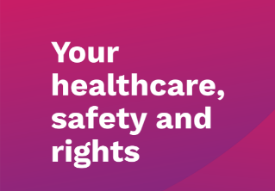 |  | 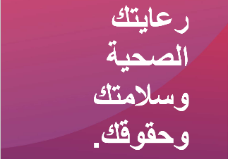 | 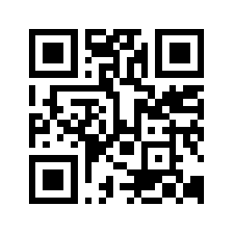
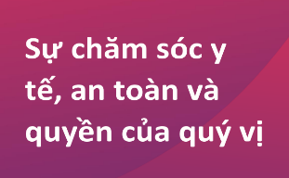
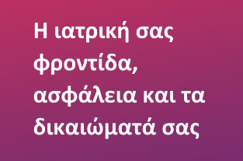
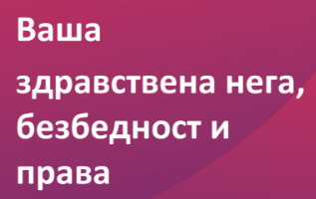 | 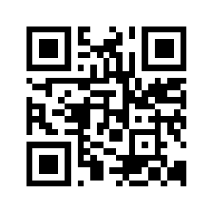 | 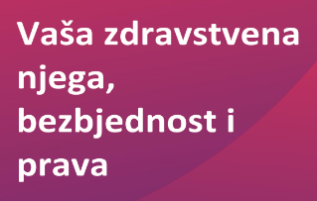
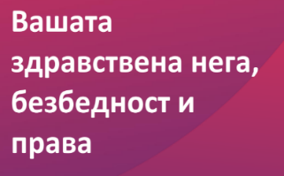 |  | 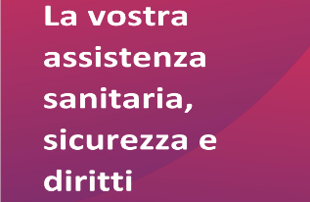

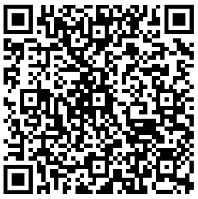
Tell us what you think!
Help us improve our services and the care we provide. What did we do well? How can we improve?
Please scan the QR code on the right to provide your feedback.

