**Research protocol:**

***Changing the focus:* Facilitating engagement in physical activity for people with dementia in a local community - A feasibility study**

**Funding: National Centre for Healthy Ageing: Living Lab research grant round 3**

Table of Contents

Research team 4

Project manager 4

Research assistant 4

Background 5

Short summary 5

Background and rationale 5

Aims of the study 6

Project objectives 6

Methods 7

Design 7

Participants 7

Inclusion criteria 7

Recruitment 8

Intervention 9

Primary outcomes 11

Secondary outcomes 14

Economic evaluation 15

Data analysis 16

Primary outcomes 16

Secondary outcomes 16

Data management 17

Ethics and ethical issues 17

Feasibility study 17

Consent and withdrawal process 17

Confidentiality 18

Possible benefits and risks to participants 18

Service on offer if adversely affected 19

Payment 19

Interviews 19

Consent and withdrawal process 19

Confidentiality 20

Possible benefits and risks to participants 20

Service on offer if adversely affected 20

Payment 20

Plans for return of results to participants 20

Scientific/clinical community 20

Key stakeholder groups 21

General community including participants who request a summary of outcomes 21

Plans for dissemination and publication of project outcomes 21

Timeline 22

References 25

# Research team

CIA-Professor Keith Hill (Director of the Rehabilitation Ageing and Independent Living (RAIL) Research Centre, Monash University) email: keith.hill@monash.edu

CIB-Associate Professor Michele Callisaya (Senior Researcher, Peninsula Clinical School, Central Clinical School, and Senior Clinical Research Fellow (Allied Health), Peninsula Health) email: [michele.callisaya@monash.edu](mailto:michele.callisaya@monash.edu)

CIC-Dr Claudia Meyer (Senior Research Fellow, Bolton Clarke Research Institute) email: [cmeyer@boltonclarke.com.au](mailto:cmeyer@boltonclarke.com.au)

CID- Dr Morag Taylor (Research Fellow, Neuroscience Research Australia / University of New South Wales) email: [m.taylor@neura.edu.au](mailto:m.taylor@neura.edu.au)

CIE- Dr Katherine Lawler (Senior lecturer, La Trobe University) email: Kate.Lawler@latrobe.edu.au

CIF- Professor Pazit Levinger (Principal Researcher, National Ageing Research Institute) email: [P.Levinger@nari.edu.au](mailto:P.Levinger@nari.edu.au)

CIG-Associate Professor Susan Hunter (Faculty Scholar, University of Western Ontario, Canada) email:smuir4@uwo.ca

CIH-Associate Professor Dawn Mackey (Simon Fraser University) email: [dmackey@sfu.ca](mailto:dmackey@sfu.ca)

CII-Associate Professor Elissa Burton (Co-Lead Dementia and Ageing Domain, Curtin School of Allied Health and enAble Institute, Faculty of Health Sciences, Curtin University) email: [E.Burton@curtin.edu.au](mailto:E.Burton@curtin.edu.au)

CIJ-Professor Terry Haines (Head of School, School of Primary and Allied Health Care, Monash University) email: [terry.haines@monash.edu](mailto:terry.haines@monash.edu)

CIK-Associate Professor Natasha Brusco (Rehabilitation Stream Lead, Rehabilitation Ageing and Independent Living (RAIL) Research Centre, Monash University) email: [Natasha.Brusco@monash.edu](mailto:Natasha.Brusco@monash.edu)

CIL-Dr Angel Lee (Research Fellow, Rehabilitation Ageing and Independent Living (RAIL) Research Centre, Monash University) email: [angel.lee@monash.edu](mailto:angel.lee@monash.edu)

CIM-Dr Christina Ekegren (Senior Research Fellow, Rehabilitation Ageing and Independent Living (RAIL) Research Centre, Monash University) email: [christina.ekegren@monash.edu](mailto:christina.ekegren@monash.edu)

CIN-Dr Amelia Crabtree (Geriatrician) email: [amelia.crabtree@monashhealth.org](mailto:amelia.crabtree@monashhealth.org)

## Project manager

Dr Angel Lee (Research Fellow, Rehabilitation Ageing and Independent Living (RAIL) Research Centre, Monash University) email: [angel.lee@monash.edu](mailto:angel.lee@monash.edu)

## Research assistant

TBC

# Background

## Short summary

People with dementia have low activity levels. Physical activity reduction post dementia diagnosis is associated with accelerated cognitive decline, increased risk of falls, poor mobility, physical dysfunction, social isolation, depression and reduced quality of life. There is strong evidence that various forms of physical activity can be implemented safely, and achieve good outcomes for people with dementia. A new model of community care, *“Changing the focus”,* will be co-developed with stakeholders and consumers, and field-tested to evaluate physical activity engagement for people with mild dementia. Preferred ways for physical activity participation will be determined by shared decision-making with the person with dementia and their carer, to improve physical activity levels, function, independence, safety (falls), and quality of life.

## Background and rationale

This research addresses two significant health problems of older Australians:

(a) *Dementia*. The incidence and prevalence of dementia in Australia is projected to grow from 459,000 in 2020, to 1,076,000 by 2058.1 While the major direct impacts of dementia are cognitive impairment and progressive cognitive decline, onset and progression of dementia are also associated with other health problems that have significant negative personal and carer impact, and add resource and economic cost to health and care systems. Impacts to the individual include reduced independence, physical function, balance, mobility, and community participation, poor mental health, and increased falls.2

(b)*Low levels of physical activity.* Older people generally have low physical activity levels, with only 25% of Australians aged >65 years meeting physical activity guidelines.3 People with dementia have even lower activity levels.4 Further, physical activity reduction post dementia diagnosis is associated with accelerated cognitive decline.5 For older people, higher physical activity levels reduce the risk of chronic disease and falls, and improve balance, mobility, function, psychological health, wellbeing and quality of life. Systematic review evidence supports that various forms of physical activity can be implemented safely, and achieve similar outcomes for people with dementia,6 and improve or delay decline in cognition and structural brain changes (e.g. increased hippocampal volume), and reduce neuro-psychiatric symptoms associated with dementia (Fig 1).6, 7 Other benefits include improved activities of daily living and reduced social isolation. These programs, including those with balance training, have been safely implemented in people with dementia, often with carer support or in a supervised setting.8

No systematic approach exists for identifying physical activity needs, or promoting physical activity in people with dementia, despite growing evidence of physical activity benefits along the dementia pathway(Figure 1).

This research addresses this major unmet need for an early, systematic approach to identify physical activity needs for people with mild dementia, and embed referral pathways/training opportunities for exercise leaders to support improved physical activity options.Without this preventive approach, the high and growing impact of reduced mobility, increased dependence and rates of cognitive decline and falls associated with dementia will continue to escalate. Effective management is required to improve outcomes for the person with dementia and their carer before later stages of dementia, when problems become greater and less amenable to intervention.



To address these gaps, we will pilot and evaluate a new model of care to facilitate physical activity engagement for people with mild dementia. The new model will include information / education resources for health professionals and people with dementia and their carers, referral pathways, physical activity needs assessment, and supported implementation of targeted, individualised physical activity to address physical impairments and physical activity deficits. It will be underpinned by shared decision-making with the person with dementia and their carer, to improve and maintain function, independence, safety (falls), and quality of life.

# Aims of the study

1) To pilot and evaluate “*Changing the Focus”* physical activity program to achieve uptake and sustained physical activity participation, and improve physical, cognitive, mental health and wellbeing outcomes for people with mild dementia;

2) To identify factors influencing implementation and effectiveness; and

3) To understand the utilisation and cost of support (formal and informal care) and health care, as well as opportunity costs, for both the person living with dementia and their carer, from a societal perspective; in addition to the cost of implementation of the approach.

We will also develop resources to support training of physical activity providers and collate information resources for physical activity programs in the Frankston/Mornington Peninsula region for people with dementia and their carers.

## Project objectives

This project will use an innovative approach aiming to improve multiple health and wellbeing outcomesthrough early assessment of physical activity levels, needs and preferences for people with mild dementia, and implementation of our ‘*Changing the Focus’* program*.*The program will provide opportunities at/around the time of diagnosis to change the negative focus onprogressive decline(e.g. anxiety about increasing disability, concern about diagnosis and decline in health/wellbeing) to a positive one highlighting the potential for physical activity to facilitate maintenance or improvements across multiple health domains.

# Methods

The components of the methods utilised in piloting and evaluating the “*Changing the Focus*” physical activity program is shown in Figure 2.



### Design

A feasibility pre-post, single group study

### Participants

(1) People with a medical diagnosis of dementia (any type) and with mild severity [MMSE (with education adjustments)9 ≥18], or people without a medical diagnosis of dementia and with a MMSE score of 18-23 inclusive, at recruitment, (2) their informal carer, and (3) referrers and exercise leaders providing physical activity options for the participants with dementia.

### Inclusion criteria

*For people with dementia or cognitive impairment.* Adults (age ≥60 years); living in the community; medical diagnosis of dementia–mild severity (see above); not housebound due to physical impairments (e.g. severe stroke); not meeting World Health Organisation physical activity guidelines for older people (<150 minutes moderate/vigorous physical activity/week); and have capacity to consent if an informal carer /responsible person is not available; willingness to assist in data collection and participate in a semi-structured interview to obtain their perspectives of the program (details below in *Implementation outcomes* section).

Presence of an informal carer is preferred but not essential. Where available, they will be an important support for the person with dementia during the intervention. Recruitment will include people from culturally and linguistically diverse backgrounds who have sufficient English proficiency to understand the study, assessment / intervention instructions, or have a readily available interpreter (family member/friend able to assist).

*For informal carer.* Adults (age ≥18 years); willingness to assist in data collection and participate in a semi-structured interview to obtain their perspectives of the program (details below in *Implementation outcomes* section); capable to assist the person with dementia to adhere to the chosen physical activity program and/or home exercises if required.

*For referrers and exercise leaders providing physical activity options for participants with dementia.*  Health professionals (e.g. general practitioners, Cognitive Dementia and Memory Service staff, community therapists) who refer people with dementia to the “*Changing the Focus”* program, and exercise practitioners who implement physical activity programs with participants will be involved in semi-structured interviews to obtain their perspectives of the program (details below in *Implementation outcomes* section).

### Recruitment

*People with mild dementia (n=60)* will be recruited from the Frankston/Mornington Peninsula region of Victoria, using multiple promotional avenues including primary care clinics, allied health private practices, Memory Cafes, local government, promotion through Carers Victoria and Dementia Australia, and the Frankston and the Mornington Peninsula Shire local council newsletters. In addition, they will be recruited from Peninsula Health’s CDAMS clinic and their new Carers Clinic (due to commence in Sept 2023) and their outpatient/community rehabilitation programs. A separate ethics application will be submitted to Peninsula Health HREC for approval, for recruitment of participants through this source.

An email and/or telephone contact will be made to the above avenues introducing them to the study and a flyer for inviting people with dementia or cognitive impairment will be provided to them so that they can send it to potential participants for their consideration to participate in the study. Direct recruitment for people with dementia or cognitive impairment and their carers will also be used e.g. through advertising on the website of organisations, newsletters, social media. Referrers e.g. GPs or allied health professionals from CDAMS/outpatient/community rehabilitation programs/private practice clinics participating in the study can refer their patients/clients to the program directly by contacting the researcher.

*Carers of people with mild dementia (up to n=0-60)* will be recruited through two potential avenues: (1) in some cases the carer may have seen the promotional materials for the program and initiated the contact with the program for the person with dementia who they provide care for. In such cases, the carer will then be asked if they are interested and able to participate in the carer component of the study; or (2) in other cases where the person with dementia has been referred to the “Changing the Focus” program, in the initial contact or home visit (to obtain participation consent for the person with dementia), the study therapist will ascertain if there is an informal carer, and if so, will ask if they would be interested in participating in the carer component of the project. However, carers’ participation is preferred where available, it is not required for the study.

*Referrers* (anticipate n=15-20, purposive selection of referrers to reach data saturation) who work with people with dementia/cognitive impairment will be recruited from primary care clinics, allied health private practices, CDAMS, outpatient/community rehabilitation programs in the Frankston/Mornington Peninsula region of Victoria and Peninsula Health, who have referred one or more clients to the “Changing the Focus” program. Referrers who refer one or more participants to the “Changing the Focus” program will be contacted by a member of the project team approximately one month after the referral is received. An email and/or telephone contact will be made to the referrers inviting them to participate in the interview (qualitative component) of the study.

*Exercise providers* (anticipate n=15-20, purposive selection of exercise providers to reach data saturation) Exercise providers who conduct physical activity programs attended by one or more of the people with mild dementia participating in the “Changing the Focus” program following the project assessments and decision making process. They will be approached by phone or email. The contact will be from a member of the project team approximately 6 months after the person with dementia commenced the physical activity program, inviting them to participate in the interview (qualitative component) of the study.

### Intervention

***Preparation:*** In preparation for the intervention, the project team will develop a training program for exercise practitioners in the Frankston / Mornington Peninsula area who are interested in improving their understanding of strategies to support working with people with mild dementia in programs they provide. Training will include in-person opportunities at the start of the intervention period, and online resources (may include in-person training recordings) will be made available for exercise practitioners who engage with the program. Another round of in-person training opportunities can be arranged in mid-2024 depending on the demand of new exercise practitioners who join the program. An updated physical activity program directory in the local areas (being updated by Peninsula Health, which should be available by the time of commencement of the intervention) will be promoted through the training program, and be made available to the research staff supporting the decision making about suitable physical activity options in the local area for each participant with dementia, as well as to referrers and providers who request a copy.

***First home visit (~2.5 hours)***. Following recruitment and screening for eligibility criteria, an initial home visit will be organised by the study therapist (a Physiotherapist or Exercise Physiologist) at the home of the person with dementia and their carer. This first home visit will include (1) a consenting process (see details in the section of Ethics and ethical issues-consent and withdrawal) for the person with dementia +/- carers if applicable, (2) assessment of baseline physical performance outcomes (see secondary outcomes below); (3) identification of domains of physical performance (based on assessment outcomes) outside of age adjusted normal limits as potential intervention priorities, (4) discussion of physical activities that are likely to address impairments, (5) discussion about physical activities they enjoy, or have previously undertaken, and (6) discussion of physical activity options available locally.

A shared-decision support tool, as depicted in Figure 3, will be developed by the research team to aid the decision making discussion used by the study therapist and the person with dementia and their carer in this home visit (similar to an approach previously used by CI’s Hill and Meyer for a falls prevention program for people with dementia).10 This discussion will also incorporate the setting of physical activity goals (Figure 3).

Whatever physical activity options are selected, each individual’s program will aim to: (1) address identified physical impairments; (2) incorporate multimodal (balance, strength and fitness) physical activities personalised to the person, across the week; and (3) progress dosage of physical activity intervention by 10-20% / month from the baseline physical activity level, starting from month 1 (e.g. if doing 30 min/week, initial target=36 min/week) and aiming to progress at each month to reach a minimum 12-month target of ≥150 min/week. Progression principles for increasing dosage will be provided to participants/carers and discussed during motivational support calls during the 12 months intervention period.

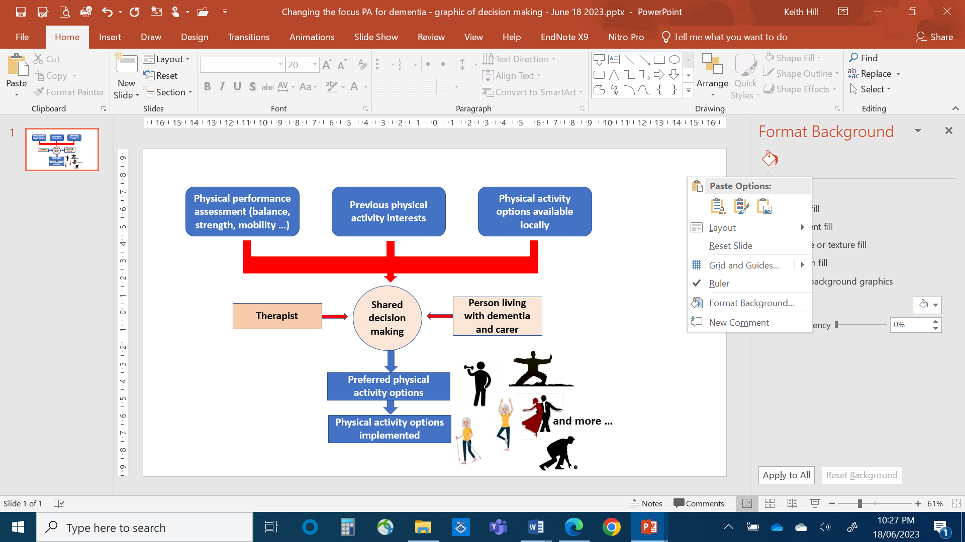

Figure 3: Shared decision making to identify preferred physical activity option/s to undertake.

To assist with the discussion of physical activity options available locally, the Peninsula Health physical activity program directory will be utilised, as well as other programs the research team identify. Examples of local physical activity programs that may be discussed include group exercise (e.g. community health centre), Council on The Ageing strength training programs, gym programs, and walking programs. Individually tailored home exercise programs (provided by the study therapist) will also be offered as another option (it is anticipated this option may be selected by approximately 40%), augmented by telehealth options.

***Second home visit (~45 mins).*** The study therapist will perform a second home visit for the person with dementia and/or their carer at week 3 of the decision-making session (when the physical activity plan has commenced) to provide motivational support.

***Third home visit (~1 hour)***. The study therapist will perform a third home visit for the person with dementia and/or their carer at six months to repeat physical performance outcomes (see secondary outcomes below), and discuss participation level, participation barriers and facilitators, and maintenance of physical activity longer term.

***Fourth home visit (~1 hour)***. The study therapist will perform a fourth (and final) home visit for the person with dementia and/or their carer at 12 months to repeat physical performance outcomes (see secondary outcomes below), and discuss participation level, participation barriers and facilitators, and maintenance of physical activity longer term.

***Motivational support (~20 minutes for each phone/video call).*** After the first home visit, motivational support will be provided by the study therapist through a series of telephone contacts. Seven phone calls (or video-conference) will occur in the months 0-6 of each individual’s intervention (suggested phone schedule at week 2, 6, 9, 12, 16, 20 and 24). Guided by the COM-B framework for behaviour change,11 the aim is to increase capability (defined as the individual's psychological and physical capacity to engage in the physical activity program by having the necessary knowledge and skills), provide motivation (defined as processes that energize and direct behaviour including goals and decision-making) and capitalise on the opportunity (defined as all the factors that lie outside the individual that make physical activity participation possible) to reinforce exercise behaviour (figure 4)

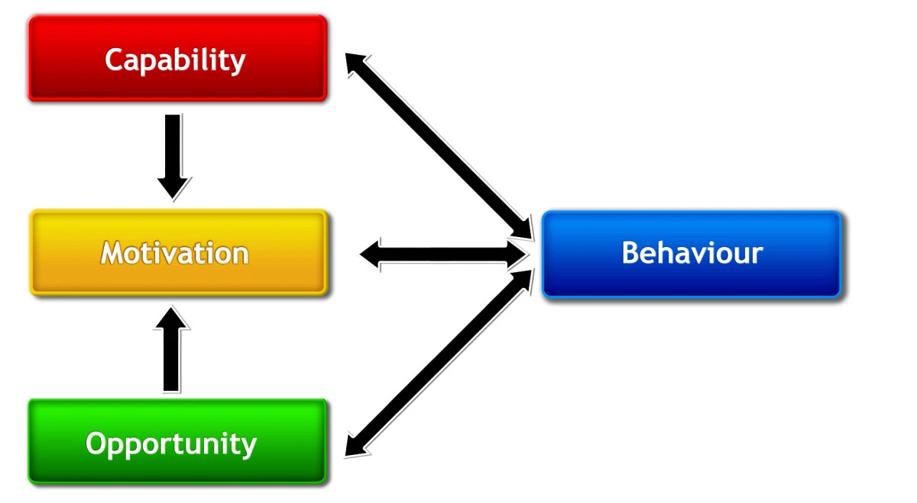Figure 4. The COM-B framework for behavioural change

Each call will focus on discussing the program, challenges, barriers, facilitators, revisiting the goal and troubleshooting for solutions. Two further support calls will occur in months 6-12 (suggested phone schedule at week 32 and 40). If indicated, (e.g. health status change) additional home visits may be scheduled. Exit interviews (for people with dementia +/- carers who withdraw from the program between 0-6 months) will occur if participation ceases, exploring barriers/challenges leading to cessation.

The study therapist will provide referrers who refer their patients/clients to the “Changing the Focus” program with updates of what their patients/clients are doing for physical activities/exercises and how they have been progressing at around one month after the program commences. The study therapist will also follow-up with physical activity/exercise providers who provide exercise programs to participants of the “Changing the Focus” program at around one month after program commencement to see if the providers would need any support to cater their programs for people with mild dementia/cognitive impairment.

### Primary outcomes

Implementation outcomes assessing:

1) ***Participation*** by a) the number of people with dementia continuing with the program at 12 months (using >70% continuing with their selected program(s) at 12 months as a benchmark for success, similar to that reported in an exercise pilot study of people with dementia, n=96);12 and b) the total time of physical activity participation undertaken each week (using the Active Australia survey13).

2) ***Intervention acceptability*** to a) people with mild dementia and their carer, assessed through a question at 6 and 12 month assessments (i.e. Is the “*Changing the Focus*” program acceptable (i.e. suitable for you and adequate to meet your needs-“Yes”, “No”, “Unsure” using a target criterion of >75% as a benchmark of acceptability from assessment question), and b) referrers, exercise providers, people with mild dementia and their carer, assessed through a semi-structured interview (see qualitative sub-study, under *Implementation outcomes* heading, below).

#### Implementation outcomes

Implementation evaluation will follow the RE-AIM Framework, which focuses on domains of reach, effectiveness, adoption, implementation and maintenance.

***Reach.*** The project will be promoted through multiple avenues for recruitment, so reach will be limited to documentation by the research team about avenues targeted for recruitment, number of responses received through each avenue of recruitment, and proportion of those indicating interest who met study inclusion criteria and commenced participation in the study.

***Effectiveness.*** Outcomes associated with effectiveness (i.e. secondary outcomes) are described below.

***Adoption.*** Outcomes associated with adoption (i.e. participation and intervention acceptability) are described above.

***Maintenance.*** Outcomes associated with maintenance (i.e. sustained physical activity participation, retention) are described above.

***Implementation*.** Outcomes associated with implementation and aspects of intervention acceptability will be evaluated through semi-structured interviews with purposive samples of three stakeholder groups (10-20 participants / group, to point of data saturation in each group):

a) Referrers to the physical activity program (e.g. general practitioners, other medical specialists, hospital staff, allied health practitioners, others). Details of referrers will be recorded by research staff, and they will be contacted within one to two months of the referral, to ask if they are willing to be involved in a brief, semi-structured interview. Purposive sampling (Figure 5) will aim for a diverse mix of referrers and exercise providers (e.g. general practitioners, physiotherapists, exercise physiologists). The interview will explore how the referrer heard about the program, the type of benefits they consider the person with dementia may obtain from increasing their physical activity, factors they consider are important in determining if a person with dementia might be suitable for participation in this type of program, how they may be able to support uptake and sustained participation in the program by the person with dementia and future sustainability of the “*Changing the Focus*” program.

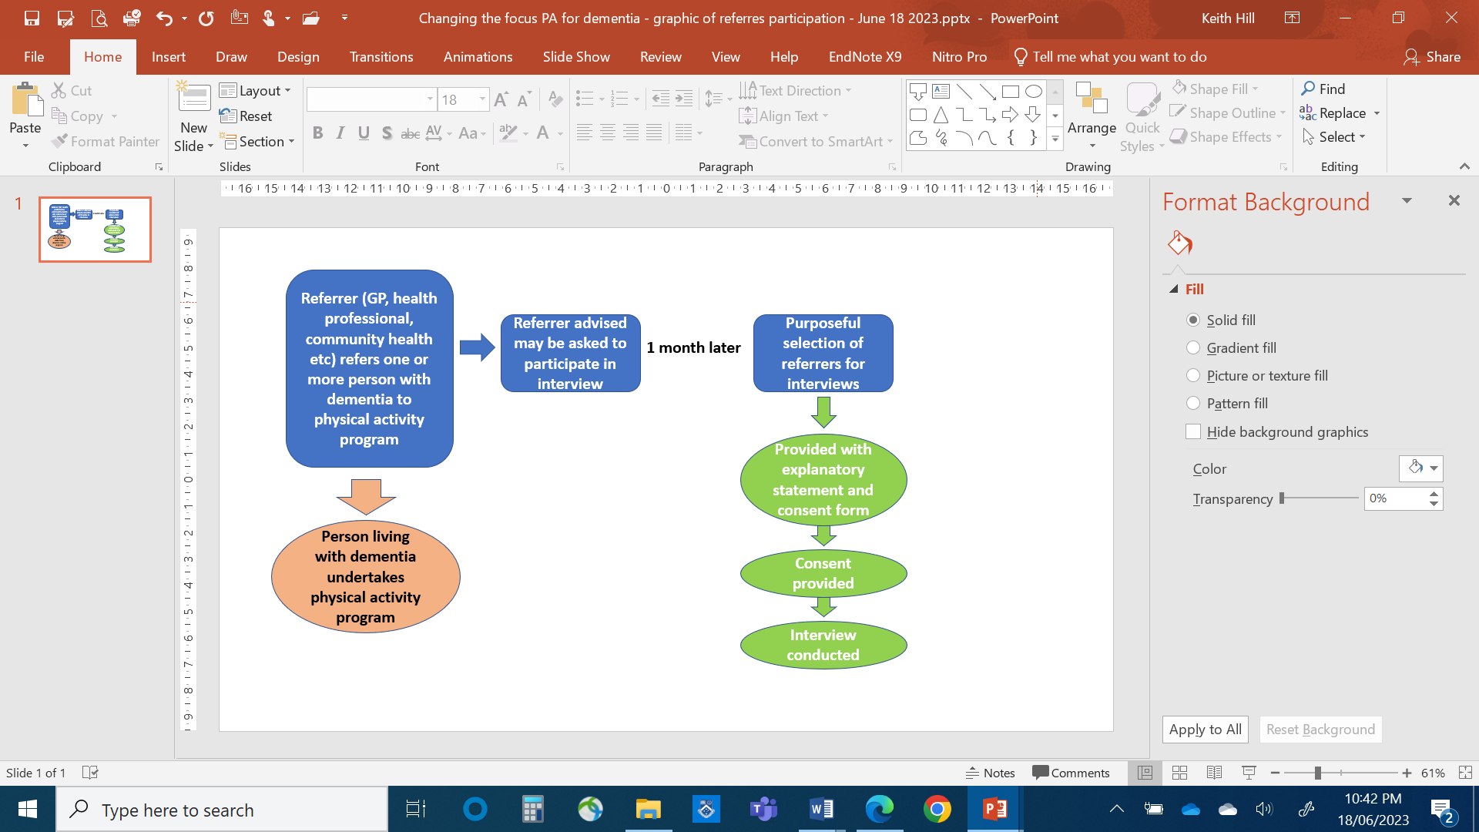

Figure 5. Process for recruiting (purposeful selection) of referrers for interviews.

b) Exercise leaders who become involved in the program after the home assessment/shared decision making about physical activities to be undertaken by the person with dementia (e.g. gym instructors, physiotherapist, exercise physiologists, walking group leaders), will be asked if they are willing to participate in an interview at the end of the 6 month physical activity program. Purposive sampling (Figure 5) will aim for a diverse mix of exercise leaders across different types of physical activity programs (e.g. group exercise programs, gymnasium programs, walking program), those who receive training and those who did not (training is recommended for them but not compulsory to participate in this study). The interview will explore:

* Exercise providers’ satisfaction with the in-person training and/or online training resources if they are trained (training resources to be developed by the research team)
* Improvements that can be made to the training resources and any other training that they felt is required
* Their confidence with working with people with dementia, if adjustments were required to accommodate the person with dementia into the program
* Perspectives about what worked well, what may have been able to be done differently to achieve better outcomes
* Changes noted associated with physical activity participation for the person with dementia
* Whether the exercise provider would be seeking opportunities to attract more people with dementia to this type of physical activity program and the future sustainability of the “*Changing the focus*” program

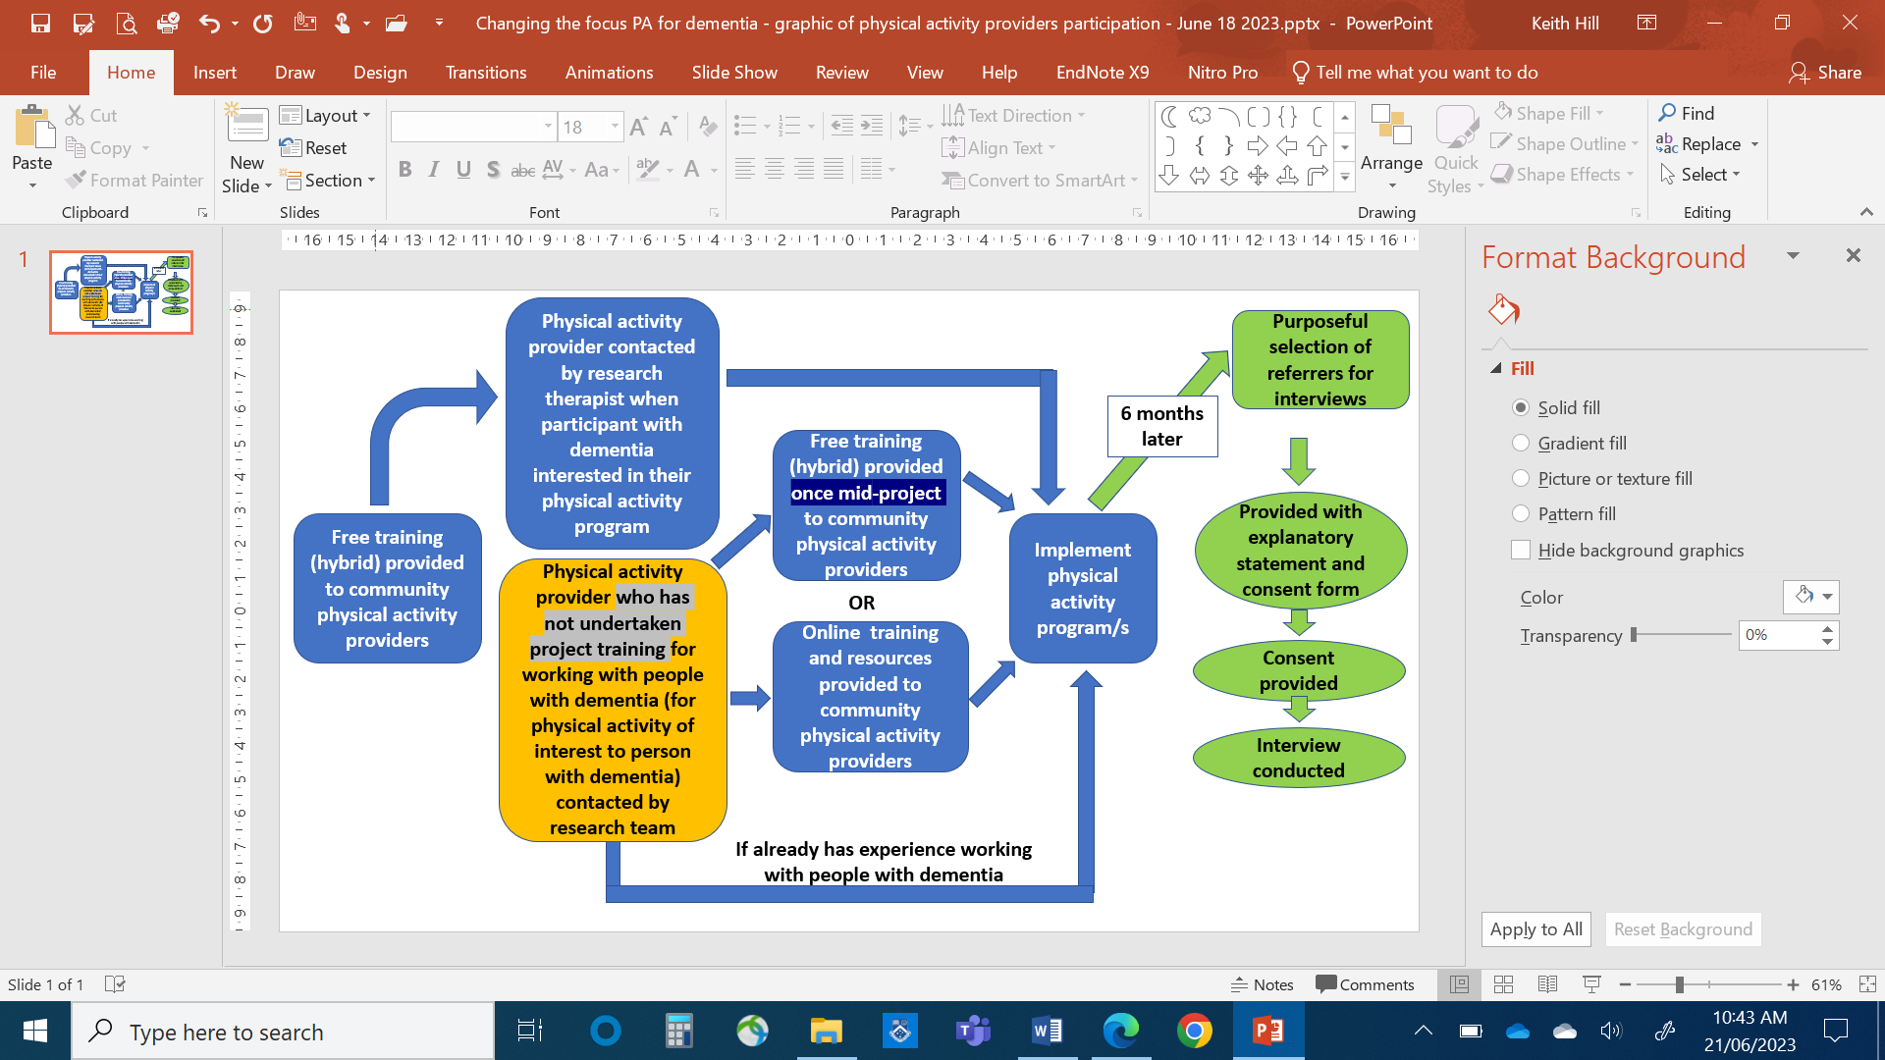

Figure 5. Process for recruiting (purposeful selection) of physical activity providers for interviews.

c) People with mild dementia and/or their carer who participated in the programwill be invited to participate in a semi-structured interview **at the end of their six months intervention physical activity program**. Purposive sampling for interview participants will aim to include a mix of types of program/s undertaken, and different participation levels. The interview will explore their perspectives on shared decision-making processes, support for participation, perceived benefits of participation, and barriers/facilitators to participation and the future sustainability of the “*Changing the focus*” program. Interviews will be offered to be conducted for the dyad (person with dementia and their carer) together, but may be undertaken separately if this is requested by the person with dementia or the carer.

### Secondary outcomes

Preliminary effectiveness outcomes at baseline, month 6 and 12 measuring:

1) ***Life space*** using the Life SpaceAssessment-Cognitive Impairment questionnaire;14

2) ***Dynamic balance*** using Step test;15

3) ***Endurance***using 2 minute walk test;16

4) ***Leg strength*** using30 second sit-to-stand test;17

5) ***Mobility*** usingTimed Up and Go test;18

6) ***Cognition*** using the Mini Mental State Examination9;

7) ***Social connectedness*** using Lubben Social Network Scale-6;19

8) ***Physical activity enjoyment*** using the Physical EnjoymentScale PACES-8;20

9) ***Activity of Daily living*** using the KATZ Activities of Daily Living Index;21

10) ***Quality of Life*** using the health-related QoL scale EQ5D5L22 (for both person with dementia and their carer).

11) The ***impact of caring*** using the Zarit Carer Burden Scale.23

12)Occurrence of **any *adverse events*** including falls and injuries. a) Number of falls in each month, b) circumstances and activity during falls, and c) injury as a result of the fall, recorded by the person with mild dementia or carer using a daily falls diary. A fall will be defined as “inadvertently coming to rest on the ground, floor or other lower level, excluding intentional change in position to rest in furniture, wall or other objects”.24 The falls diary will be collected by the study therapist at each phone call and home visit.

13) ***Additional*** ***Physical activity data*** using a daily physical activity diary. The physical activities undertaken and time spent in each “new” physical activity (activities that are new to the participants as a result of participating in the “Changing the Focus” program, including a change in an existing activity e.g. increased time, intensity or frequency) will be recorded weekly by the person with mild dementia and/or their carer. The total time spent in “new” physical activities each week will be added. The physical activity diary will be collected by the study therapist at each phone call and home visit.

Where necessary, carers will assist in questionnaire completion/data collection. Assessments will evaluate change in physical, cognitive and mental health outcomes, quality of life (QoL) and falls, and inform the joint decision-making discussion for the intervention (between the study therapist, person with dementia, and their carer). Changes in participation level, participation barriers and facilitators will be discussed/addressed at each home visit and telephone contact.

Historical longitudinal data from control participants from existing RCT data sets from projects by our team with participants with dementia (control sample n=15625 and n=2026) will be used to gain an insight on the “usual care” trajectory on similar outcomes to our study participants over the 12 month follow-up (comparison data available for >half of outcome measures).

### Economic evaluation

The **explorative economic evaluation** will be reported according to the Consolidated Health Economic Evaluation Reporting Standards 2022 (CHEERS 2022) statement27, will take a societal perspective, and will report the cost of program implementation, as well as the cost-effectiveness and cost-utility of the program using a pre-post design.

1. The cost of program implementation analysis will include costs attributed to implementing and running the physical activity and dementia pathway, training of physical activity personnel, and participant costs for program access. Implementation costs will be collected via survey from the Program Manager on a monthly basis and will include the 6-months prior to program commencement, as well as the 12 months of the program. This analysis will inform future program uptake and scaling in other regions.
2. Cost data will be collected for the person living with dementia and this includes support from informal and formal carers, health care utilisation, pharmaceuticals, and opportunity costs. Costs will be collected at baseline, 6-months and 12-months. On each of these three occasions, the person living with dementia (with support from their carer) will be asked to recall support and health care utilisation over the preceding 6-months.
3. Effect data includes falls (only for the person living with dementia) and quality of life (both the person living with dementia and their carer). As baseline, the person living with dementia will be asked to recall falls, and falls injuries, over the preceding 6-months. Then, for the following 12 months, the person will complete a falls diary that will prospectively capture the number of falls, and injuries from falls. At baseline, 6-months and 12-months, both the person living with dementia and their carer will be asked to complete the EQ-5D-5L 22, 28, 29 quality of life tool. At each of the three timepoints, the raw scores will be converted into a utility index, and the change in utility index from one time point to the next will be used to calculate the quality adjusted life years (QALY) gained or lost 22, 28, 29.
4. Cost and effect data will be combined for the cost-effectiveness analysis (costs and falls data only for the person living with dementia) and for the cost-utility analysis (costs and quality of life data for both the person living with dementia and their carer).

## Data analysis

### Primary outcomes

**Primary outcomes** will be determined through descriptive statistics:

a) participation rate (number of people with mild dementia continuing with physical activity program at 6 months and at 12 months out of the number of people with mild dementia commencing the physical activity program at baseline)

b) intervention acceptability to people with mild dementia and their carer using a target criterion >75% acceptability (assessment question at 6 and 12 months)

For intervention acceptability relating to the interviews:

c) themes generated from data analysis from the interviews of referrers, exercise providers, people with dementia and carers regarding implementation, aspects of program acceptability, barriers/facilitators to participation and future program sustainability. Interview data will be recorded and transcribed verbatim, with two researchers independently reviewing/coding data to generate themes and sub-themes using thematic analysis.30

For total physical activity time per week in the last week, a general linear mixed model will be used.

### Secondary outcomes

**Potential benefits** will be compared at each time point of home visits i.e. at baseline, month 6 and 12 using a general linear mixed model.

**Adverse events including falls and injuries** will be summarised using descriptive statistics and narratives.

**Economic outcomes**

The costing of items in the economic evaluation will be based on actual costs where available, and where these are not available, costs, excluding carer time, will be based on market rates, with carer time based on the current Australian minimum wage. All costs will be presented as AUD 2024/25, with costs collected prior to 2024/25 to be inflated by the consumer price index (<https://www.rba.gov.au/calculator/>).

1. The cost of program implementation analysis will report each cost type, including the number of units utilised, the cost per unit, and the total cost. Results will be presented as an overall cost, as well as a cost per participant to inform the cost-effectiveness and cost-utility analyses.
2. Cost data will be collected for the person living with dementia and this will be analysed for each time point using an independent t-test with the mean (SD) reported, as well as the mean difference (95%CI) between time points.
3. Effect data includes falls (only for the person living with dementia) and quality of life (both the person living with dementia and their carer). EQ-5D-5L raw scores will be converted into a utility index, and the change in utility index from one time point to the next will be used to calculate the quality adjusted life years (QALY) gained or lost 22, 28, 29. Effect data will be analysed for each time point using an independent t-test with the mean (SD) reported, as well as the mean difference (95%CI) between time points.
4. Cost and effect data will be combined for the cost-effectiveness analysis (costs and falls data only for the person living with dementia) and for the cost-utility analysis (costs and quality of life data for both the person living with dementia and their carer). The incremental cost effectiveness ratio (ICER) will be calculated using the bootstrap method (5,000 replications) with the results presented on a cost-effectiveness plane and as a probability of cost-effectiveness across a range of willingness to pay thresholds (AUD $0 to $50,000)31.

# Data management

The personal information that will be collected in the study assessments will include age, gender, medical history, previous physical activity participation, and falls in preceding 12 months. All assessment data (primary and secondary outcomes) collected at baseline, 6 and 12 months will be entered into a data file stored in S drive (a secured drive) in Monash University’s server. Qualitative data from interviews will be stored in computer data files (S drive) as audio/video recordings and transcripts. Any information obtained in connection with this study will be made anonymous after data analysis is completed.

Any hard copies (after project completion and publication) will be destroyed. Access to data files will be restricted to Chief Investigators who have log-on and a secure password to the data files. The data file will be archived and stored in Monash University password protected system for a period of 7 years after project completion. After seven years, the data file will be destroyed. The storage and the destruction of hard copies data file and hard copy data will adhere to Monash University regulations.

All access to the data will be restricted to the research team and upon approval by the CIA. Access to data after the project is completed will be restricted to the research team and with a relevant ethics approval.

The final report, and any resulting conference, journal publications or presentation will only contain results from participant responses that are aggregated or individual responses de-identified.

# Ethics and ethical issues

Ethics approval from the Human Research Ethics Committee of Monash University will be sought. A separate ethics application will be submitted through Peninsula Health, to accommodate recruitment for some participants that may occur through Peninsula Health specialist geriatric services, such as the Cognitive Dementia and Memory Service (CDAMS).

### Feasibility study

Participants will be provided with a plain language information sheet, and written consent form. They will be informed that they can contact CI Hill or project manager to clarify any issues before they sign the consent form.

### Consent and withdrawal process

Participation in this study is voluntary. Following email and/or telephone contacts with potential participants, copies of the plain language statement and consent form will be forwarded by email or mail to people expressing interest in the project. At the first home visit, a study therapist will go through the Explanatory Statement and consent form with the person with dementia and/or carer, answer questions or concerns they might have, and explain about the consent process.

The study therapist will determine if the person with dementia is able to consent using a cognitive capacity checklist (this process has been used previously by the research team in a number of projects). If they are able to give consent, they will sign the consent form and the researcher will witness their signature. If the person is not capable to give consent, the informal carer (or their medical treatment decision maker if they have one) will give consent on their behalf by signing a different consent form and the signature witnessed by the researcher. All consent forms will be signed in two copies (one copy for them to keep and one copy for the research team).

Ongoing consent by the person with dementia/cognitive impairment (for the possibility of cognitive decline during the 12-month period) will be obtained by the study therapist (using the cognitive capacity checklist as needed). There will be an opportunity for the person with dementia/cognitive impairment and/or their carer to re-negotiate consent during the study. The participants can discuss this directly with the study therapist.

Referrers to the physical activity program may be approached one month after making a referral for a person with dementia to the program (depending upon purposive sampling) to undertake an interview with project staff. Similarly, physical activity providers may be approached 6 months after commencing a physical activity program with participants (depending upon purposive sampling) to undertake an interview. In both cases, if the referrer or physical activity provider is interested in participating in the interview, or finding more out about this component of the study, they will be sent the Explanatory Statement, and Consent Form to sign if willing to participate.

The participants can withdraw from the study at any time. They will need to let the researcher know as soon as possible. Any information that was collected from the person with dementia or their carer before the withdrawal will still be included in the project. They will not be able to withdraw the information that was already collected. Whether they participate in the study, continue to participate or withdraw from the study will not affect the relationship between them and their referrers/exercise providers and researchers. There will be no follow-up by the research team after their withdrawal.

### Confidentiality

Any information obtained in connection with the study that may identify the person with dementia and/or their carer will be de-identified at the completion of the study. Any journal publications or conference papers will only contain results from responses that are aggregated or individual response de-identified.

### Possible benefits and risks to participants

People with dementia may experience benefits from regular exercise including improved physical activity level, physical function and quality of life.

Carers may experience benefits from their care recipient participating in regular exercise including improved independence of activities of daily living of the person with dementia/cognitive impairment.

Referrers may benefit from attending the training program and/or accessing the online resources associated with this study to enhance their care for people with dementia. They may also benefit from having our study therapist discussing and identifying suitable physical activity program(s) with their patients/clients (and their carers if applicable) to meet their physical activity goal, as well as following up with their patients/clients regularly for 12 months to provide continual support to ensure their ongoing physical activity participation. They will receive updates for your referrals.

Exercise providers may benefit from attending the training program and/or accessing the online resources associated with this study to enhance their care for people with dementia. They may also benefit from having our study therapist following up with their clients (who participate in the study) for 12 months to provide continual support to ensure ongoing exercise participation.

There is a risk of falls in people with dementia during the physical activity program because of their often increased baseline risk for falls, although research evidence indicates that participation in health professional prescribed exercise programs can be safe and feasible for people with dementia. Falls risk will be minimised through supervision of exercises by the physical activity provider and/or the carer during the program as well as training and written resources provided by the research team to support physical activity providers and carers to ensure safety of exercise delivery and implementation. People with dementia, carers and physical activity providers will be supported by the research team with regular contacts.

We do not anticipate any risk of exercise providers or carers falling or injuring themselves when delivering/supervising the exercise program. If the exercise provider or carer does fall or injure themselves, they will report the incident to the researcher, their organisation and complete the work injury procedure of their organisation. They will review how the exercise supervision was being provided and suggest strategies to reduce future risks of falling or injury associated with delivery/supervision of exercise. They may consult their GP if medical help is needed or seek employee health services within their organisation if they are available. If the carer does fall or injure themselves, they will inform the researcher of the incident. The researcher will review how the exercise or exercise supervision was being provided and suggest strategies to reduce future risks of falling or injury associated with supervision of exercise. They may consult their GP if medical help is needed.

### Service on offer if adversely affected

While we will make every effort to prevent a fall, it may happen. If the person with dementia falls during the physical activity program, the exercise provider will check the person for injury and apply first aid if required. The exercise provider will follow their organisation’s policy and notify the person with dementia’s family. If the injury is serious, the provider will call for an ambulance and stay with the person until help arrives. The provider will report the incident to the research team. The research team will work together with the service provider, the person with dementia, their carer (and their medical practitioner if applicable) to decide whether ongoing participation of the person with dementia in this study is appropriate.

In the case of a fall during home exercise (for those participants where this is provided), the carer will seek medical help for the person with dementia through his/her medical practitioner or call for an ambulance if needed. The carer will be instructed not to continue with the home exercises until the CIA or study therapist has reviewed the home exercise recommendations and the person’s status in terms of continuing. There may be a need to modify (reduce the level / intensity / duration of) the physical activity program, in the short term, following a fall or other adverse event, which the study therapist will advise on if required.

If the person with dementia or carer requires counselling, they can call the National Dementia Helpline on [1800 100 500](tel:1800100500). The researcher will be able to help with this process or they can visit their GP for more advice.

### Payment

There is no payment for taking part in the physical activity program. Depending on the chosen physical activity program(s), the person with mild dementia / cognitive impairment and their carer may need to pay a low cost in order to attend the program(s) and meet the associated transportation cost for the 12-months’ time.

### Interviews

### Consent and withdrawal process

Interview participants (people with mild dementia and their carer) will follow the same consenting process as described in the feasibility study (page 17). The consent form will consist of options to provide written consent to the feasibility study and the interview or feasibility study individually, from which they can chose their involvement in one or both study components. The consent process will be completed at the first home visit with the study therapist.

Interview participants (referrers, and physical activity service providers) will be provided with an Explanatory Statement, and written consent form. They can contact CI Hill or the project manager to clarify any issues before they sign the consent form. The consent form will be returned to CI Hill or the project manager before the interview begins. Consent forms will include that the person agrees to participate in the interview, have the interviews audio recorded, allow the researchers to contact them at the end of project to validate data interpretation if necessary and permit the use of data collected in future research.

Participants can withdraw from the interview at any stage by notifying the research team. There will be no implications for withdrawal or follow-up made.

### Confidentiality

Any information obtained in connection with the evaluation that may identify the referrer, service provider or the person with mild dementia and/or their carer will be de-identified at the completion of the study. Any journal publications or conference papers will only contain results from responses that are aggregated or individual response de-identified.

### Possible benefits and risks to participants

There will be no direct benefit to the participants from participation in the interviews. However, their participation will contribute to the refinement of the “*Changing the focus*” to optimise the acceptability, safety, feasibility and benefits of physical activity programs for older people with mild dementia. This has the potential to be beneficial in improving health outcomes for older people with mild dementia.

There is a slight chance that participants may feel uncomfortable answering some questions in the interview. They can ask to pause the interview until they are ready or terminate the interview at any time during the interview.

### Service on offer if adversely affected

If participants become distressed because of the assessments or interview, the research team will be able to direct them for counselling services or other appropriate support. Alternatively, they may consult their GP for counselling services or other appropriate support.

If the person with dementia or carer requires counselling, they can call the National Dementia Helpline on [1800 100 500](tel:1800100500). The researcher will be able to help with this process or they can visit their GP for more advice.

### Payment

People with mild dementia/cognitive impairment, carers, referrers and exercise providers will be paid a $50 e-gift card to thank you for their time in attending the interview. The person with dementia and their carer may choose to be interviewed separately or together, or only one of them may choose to participate. Whether the person with dementia and the carer are interviewed together or separately, each will receive a $50 e-gift card.

# Plans for return of results to participants

## Scientific/clinical community

This will be made available by research publications and conference presentations.

## Key stakeholder groups

This will be made available via summary presentations and a brief summary report to participating referrers and physical activity providers.

## General community including participants who request a summary of outcomes

A plain language summary (de-identified) will be provided on the Rehabilitation, Ageing and Independent Living (RAIL) Research Centre website and forwarded to all participants at the end of the project.

# Plans for dissemination and publication of project outcomes

Dissemination and publication of project outcomes will occur using the above channels.

# Timeline

Timeline of “*Changing the Focus*” project (implementation and evaluation plus an economic evaluation) 2023-2025

|  |  |  |  |  |  |  |  |  |  |  |  |  |  |  |  |  |
| --- | --- | --- | --- | --- | --- | --- | --- | --- | --- | --- | --- | --- | --- | --- | --- | --- |
| 2023 | | | | | | | | | May | Jun | Jul | Aug | Sep | Oct | Nov | Dec |
| Protocol preparation and writing of associated documents | | | | | | | | | x | x |  |  |  |  |  |  |
| Submission to MUHREC | | | | | | | | |  |  | x |  |  |  |  |  |
| Submission to Peninsula Health ethics | | | | | | | | |  |  |  | x | x |  |  |  |
| Development of training resources for physical activity referrers and providers | | | | | | | | |  |  | x | x |  |  |  |  |
| Trial registration | | | | | | | | |  |  |  | x | x |  |  |  |
| Promotion of the study to physical activity referrers and providers for the community of practice of “*Changing the Focus*” | | | | | | | | |  |  |  |  |  | x | x | x |
| RA to keep CoP of referrers and providers growing | | | | | | | | |  |  |  |  |  | x | x | x |
| Collate/update information resources for people with dementia and carers for local physical activity programs | | | | | | | | |  |  |  |  |  | x |  |  |
| Development of assessment protocols for study therapists | | | | | | | | |  |  |  |  | x | x |  |  |
| Hiring of study therapists and RA | | | | | | | | |  |  | x | x | x |  |  |  |
| Training of study therapists | | | | | | | | |  |  |  |  |  | x |  |  |
| Promotion of the study to people with dementia +/- carers | | | | | | | | |  |  |  |  |  | x | x | x |
| 12-month Intervention (n=60 people with mild dementia +/-carers) | | | | | | | | |  |  |  |  |  |  | x | x |

|  |  |  |  |  |  |  |  |  |  |  |  |  |
| --- | --- | --- | --- | --- | --- | --- | --- | --- | --- | --- | --- | --- |
| 2024 | Jan | Feb | Mar | Apr | May | Jun | Jul | Aug | Sep | Oct | Nov | Dec |
| Roll out of training and resources to referrers and providers as the CoP continues to grow |  |  | x | x | x | x | x | x | x | x | x | x |
| RA to keep CoP of referrers and providers growing | x | x | x | x | x | x | x | x | x | x | x | x |
| Recruitment (people with mild dementia +/- carers) |  |  | x | x | x | x | x | x | x | x | x | x |
| Intervention |  |  | x | x | x | x | x | x | x | x | x | x |
| Evaluation (exit interviews for people with mild dementia and/or their carers between 0-6 months) |  |  | x | x | x | x | x | x | x | x | x | x |
| Evaluation (6-month interviews for exercise providers, people with mild dementia and/or their carers who are continuing with the program) |  |  |  |  |  |  |  |  | x | x | x | x |
| Evaluation (1-2 month interview for exercise referrers) |  |  |  |  | x | x | x | x | x | x | x | x |

|  |  |  |  |  |  |  |  |  |  |  |  |  |
| --- | --- | --- | --- | --- | --- | --- | --- | --- | --- | --- | --- | --- |
| 2025 | Jan | Feb | Mar | Apr | May | Jun | Jul | Aug | Sep | Oct | Nov | Dec |
| Intervention | x | x | x | x | x | x | x | x | x | x | x | x |
| Roll out of training and resources to referrers and providers as the CoP continues to grow | x | x | x |  |  |  |  |  |  |  |  |  |
| RA to keep CoP of referrers and providers growing | x | x | x |  |  |  |  |  |  |  |  |  |
| Evaluation (exit interviews for people with mild dementia and/or their carers between 0-6 months) | x | x | x | x | x | x |  |  |  |  |  |  |
| Evaluation (6-month interviews for exercise providers, people with mild dementia and/or their carers who are continuing with the program) | x | x | x | x | x | x |  |  |  |  |  |  |
| Evaluation (1-2 month interview for exercise referrers) | x |  |  |  |  |  |  |  |  |  |  |  |
| Economic evaluation | x | x | x | x | x |  |  |  |  |  |  |  |
| Data analysis, writing of reports/manuscript and dissemination of results |  |  | x | x | x | x | x | x | x | x | x | x |

# References

1. Dementia Australia *Dementia Prevalence Data 2018-2058, commissioned research undertaken by NATSEM, University of Canberra;* [*https://www.dementia.org.au/information/statistics/prevalence-data*](https://www.dementia.org.au/information/statistics/prevalence-data), 2018.

2. Gutzmann, H.; Qazi, A. Depression associated with dementia, *Zeitschrift fur Gerontologie und Geriatrie*. **2015, *48,*** 305-311.

3. Australian Institute of Health and Welfare *Physical activity across the life stages. Cat. no. PHE 225. Canberra: AIHW.*, 2018.

4. Lu, Z.; Harris, T. B.; Shiroma, E. J.; Leung, J.; Kwok, T. Patterns of Physical Activity and Sedentary Behavior for Older Adults with Alzheimer's Disease, Mild Cognitive Impairment, and Cognitively Normal in Hong Kong, *Journal of Alzheimer's disease : JAD*. **2018, *66,*** 1453-1462.

5. Soni, M.; Orrell, M.; Bandelow, S., et al. Physical activity pre- and post-dementia: English Longitudinal Study of Ageing, *Aging & mental health*. **2019, *23,*** 15-21.

6. Chan, W. C.; Yeung, J. W.; Wong, C. S., et al. Efficacy of physical exercise in preventing falls in older adults with cognitive impairment: a systematic review and meta-analysis, *Journal of the American Medical Directors Association*. **2015, *16,*** 149-154.

7. Wang, X.; Wang, H.; Ye, Z., et al. The neurocognitive and BDNF changes of multicomponent exercise for community-dwelling older adults with mild cognitive impairment or dementia: a systematic review and meta-analysis, *Aging*. **2020, *12,*** 4907-4917.

8. Lam, F. M. H.; Huang, M.-Z.; Liao, L.-R.; Chung, R. C. K.; Kwok, T. C. Y.; Pang, M. Y. C. Physical exercise improves strength, balance, mobility, and endurance in people with cognitive impairment and dementia: a systematic review, *Journal of physiotherapy*. **2018, *64,*** 4-15.

9. Folstein, M. F.; Folstein, S. E.; McHugh, P. R. “Mini-mental state”: A practical method for grading the cognitive state of patients for the clinician, *Journal of Psychiatric Research*. **1975, *12,*** 189-198.

10. Meyer, C.; Hill, S.; Hill, K. D.; Dow, B. Inclusive Decision Making for Falls Prevention: A Discussion Tool for Use With People With Dementia and Their Caregivers, *J Aging Phys Act*. **2019, *27,*** 711-718.

11. Michie, S.; van Stralen, M. M.; West, R. The behaviour change wheel: A new method for characterising and designing behaviour change interventions, *Implementation Science*. **2011, *6***.

12. Yu, F.; Vock, D. M.; Zhang, L., et al. Cognitive Effects of Aerobic Exercise in Alzheimer's Disease: A Pilot Randomized Controlled Trial, *Journal of Alzheimer's disease : JAD*. **2021, *80,*** 233-244.

13. AIHW The Active Australia Survey: A guide and manual for implementation, analysis and reporting. (Welfare, A. I. o. H. a. (ed.)). Canberra: Australian Government, 2003.

14. Ullrich, P.; Werner, C.; Bongartz, M.; Kiss, R.; Bauer, J.; Hauer, K. Validation of a Modified Life-Space Assessment in Multimorbid Older Persons With Cognitive Impairment, *Gerontologist*. **2019, *59,*** e66-e75.

15. Hill, K. D.; Bernhardt, J.; McGann, A. M.; Maltese, D.; Berkovits, D. A New Test of Dynamic Standing Balance for Stroke Patients: Reliability, Validity and Comparison with Healthy Elderly, *Physiotherapy Canada*. **1996, *48,*** 257-262.

16. Brooks, D.; Davis, A. M.; Naglie, G. The feasibility of six-minute and two-minute walk tests in in-patient geriatric rehabilitation, *Canadian journal on aging = La revue canadienne du vieillissement*. **2007, *26,*** 159-162.

17. Parfitt, G.; Post, D.; Penington, A.; Davison, K.; Corlis, M. Challenges associated with physical assessments for people living with dementia: Modifying standard assessment protocols, *SAGE open medicine*. **2020, *8,*** 2050312120910359.

18. Podsiadlo, D.; Richardson, S. The timed "Up & Go": a test of basic functional mobility for frail elderly persons, *J Am Geriatr Soc*. **1991, *39,*** 142-148.

19. Lubben, J.; Blozik, E.; Gillmann, G., et al. Performance of an Abbreviated Version of the Lubben Social Network Scale Among Three European Community-Dwelling Older Adult Populations, *The Gerontologist*. **2006, *46,*** 503-513.

20. Mullen, S. P.; Olson, E. A.; Phillips, S. M., et al. Measuring enjoyment of physical activity in older adults: invariance of the physical activity enjoyment scale (paces) across groups and time, *International Journal of Behavioral Nutrition and Physical Activity*. **2011, *8,*** 103.

21. Wallace, M.; Shelkey, M. Reliability and Validity of Katz ADL Index, *AJN The American Journal of Nursing*. **2008, *108***.

22. Herdman, M.; Gudex, C.; Lloyd, A., et al. Development and preliminary testing of the new five-level version of EQ-5D (EQ-5D-5L), *Quality of Life Research*. **2011, *20,*** 1727-1736.

23. Zarit, S. H.; Reever, K. E.; Bach-Peterson, J. Relatives of the impaired elderly: Correlates of feelings of burden, *The Gerontologist*. **1980, *20,*** 649-655.

24. Organization, W. H. WHO global report on falls prevention in older age. See <https://apps.who.int/iris/handle/10665/43811> for further details. Accessed 8th June 2020.

25. Taylor, M. E.; Wesson, J.; Sherrington, C., et al. Tailored Exercise and Home Hazard Reduction Program for Fall Prevention in Older People With Cognitive Impairment: The i-FOCIS Randomized Controlled Trial, *The journals of gerontology Series A, Biological sciences and medical sciences*. **2021, *76,*** 655-665.

26. Suttanon, P.; Hill, K.; Said, C., et al. Feasibility, safety and preliminary evidence of the effectiveness of a home-based exercise programme for older people with Alzheimer’s disease: a pilot randomized controlled trial, *Clinical Rehabilitation*. **2012, *27,*** 427-738.

27. Husereau, D.; Drummond, M.; Augustovski, F., et al. Consolidated Health Economic Evaluation Reporting Standards 2022 (CHEERS 2022) statement: updated reporting guidance for health economic evaluations, *International journal of technology assessment in health care*. **2022, *38,*** e13.

28. EuroQOL EQ-5D. **2020*,*** <https://euroqol.org/>.

29. Norman, R.; Mulhern, B.; Lancsar, E., et al. The Use of a Discrete Choice Experiment Including Both Duration and Dead for the Development of an EQ-5D-5L Value Set for Australia, *PharmacoEconomics*. **2023, *41,*** 427-438.

30. Braun, V.; Clarke, V. Using thematic analysis in psychology, *Qualitative Research in Psychology*. **2006, *3,*** 77-101.

31. Nixon, R. M.; Wonderling, D.; Grieve, R. D. Non‐parametric methods for cost‐effectiveness analysis: the central limit theorem and the bootstrap compared, *Health economics*. **2010, *19,*** 316-333.