Dear Parents and Carers,
You and your child are invited to take part in this research study. Researchers at the Black Dog Institute have developed a digital exposure-focused intervention (the Courage Quest intervention) for children aged 8-12 years with anxiety disorders. In this study, we are conducting a clinical trial to evaluate whether the digital exposure-focused intervention can reduce anxiety disorders and symptoms.

What is the Black Dog Institute?
Founded in 2002, the Black Dog Institute is a global leader in mental health research and the only medical research institute in Australia dedicated to improving mental wellbeing across the lifespan. As leaders in digital-based healthcare tools, we’re a driving force in making help seeking and intervention accessible to all.
Why do we need this study?
In Australia, 1 in 14 children experience anxiety that interferes with their daily lives, yet only 19% receive appropriate care and support. To address an under-resourced system with increasingly long waitlists, we’re developing a digital program called Courage Quest to help children with anxiety. Through the Courage Quest program, parents or caregivers and children will learn evidence-based tools used in Cognitive-Behavioural Therapy (CBT), including graded exposure techniques. We need your help with testing this digital program that aims to provide accessible and evidence-based support to Australian children.
What does the study involve?
If you choose to take part, both you and your child will be allocated to one of two 10-week digital programs: 1) the “Courage Quest” intervention, or 2) the “Raising Healthy Minds” intervention. Each of these interventions require a minimum of 20 minutes per week for ten weeks. If you are allocated to the Raising Healthy Minds intervention, you will use this for ten weeks, then you will receive ten weeks access to the Courage Quest App, and an additional three therapist support phone calls.
In addition to these programs, you will be invited to:
- Complete screening questionnaires (approximately 10 minutes), consent forms, and an online clinical questionnaire (approximately 1 hour)
- Complete questionnaires on three occasions (approximately 10-20 minutes each)
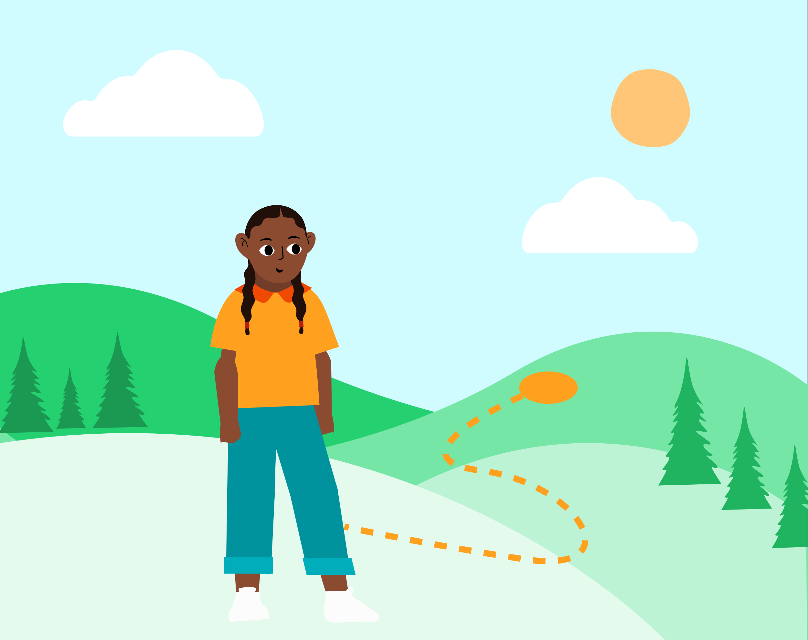
- Engage in three phone calls with a therapist to provide support during the program
How do I sign up?
To find out if this study is the right fit for you and your child, please click on this link to get started. If the study is the right fit for you, you will be directed to provide parent and child consent.
Please refer to the attached Information Sheet for Parents for detailed information about the study. If you have any questions or concerns at all, please contact us at couragequest@blackdog.org.au.
Yours sincerely,
Professor Jennie Hudson
Director of Research and Professor of Clinical Psychology

Information Sheet for Parents

- In this study, we are aiming to answer the following research question:
Does the Courage Quest intervention reduce high levels of anxiety symptoms and result in greater remission of anxiety disorders for children aged 8 to 12 years compared to children participating in an active control intervention?

- Who is conducting this research?
This research is being conducted by Jennie Hudson (Chief Investigator), Deanna Francis (Post-doctoral Researcher), Chloe Lim (Post-doctoral Researcher), Abigail Allsop (Project Manager), Emma McDermott (Research Assistant), Gemma Sicouri (Senior Research Associate), Annabel Songco (Post-doctoral Researcher), Melissa Aji (Clinical Psychology Registrar), and Wendy Chen (Clinical Psychology Registrar) at the Black Dog Institute.
This research is funded by Perpetual Impact Philanthropy Program on behalf of the Bendix Family Charitable Endowment. These funders will be provided with regular updates about the study progress but will not inform the design or implementation of the study goals.

- Who can participate?
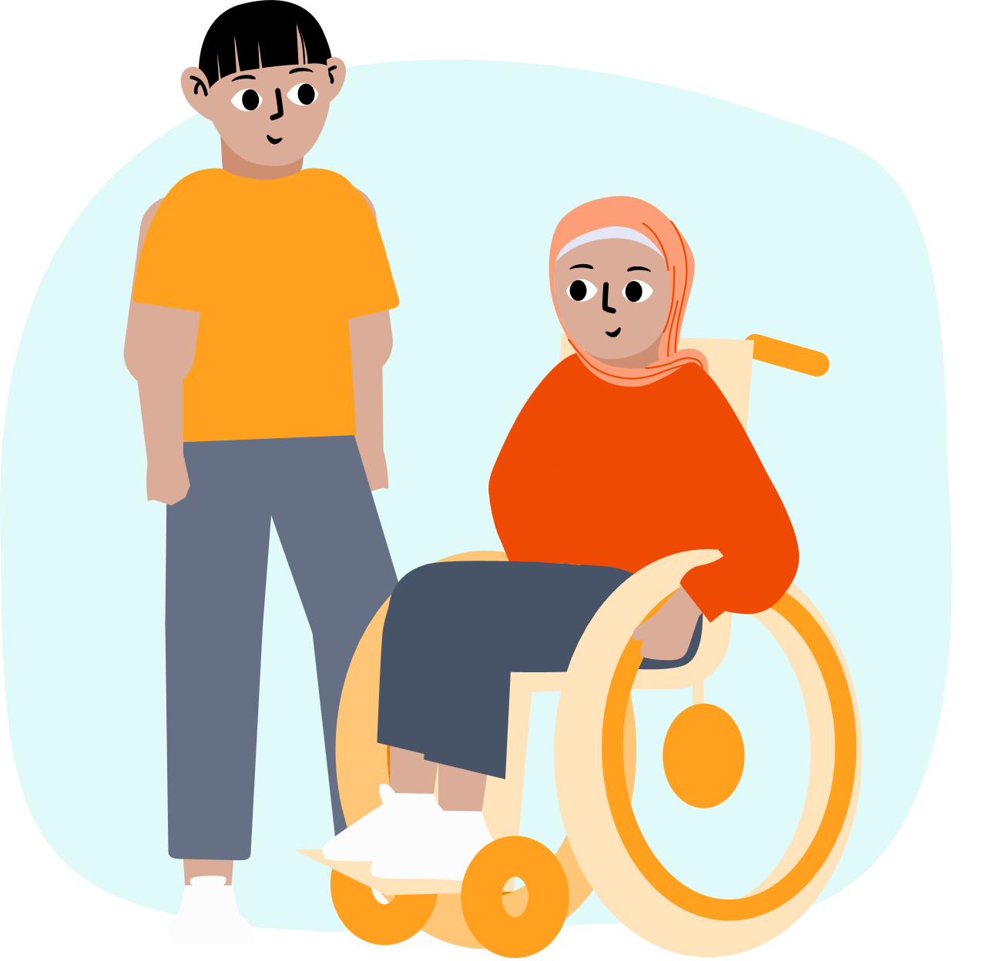
Before you decide to participate in this research study, we need to ensure that it is okay for you and your child to take part. The research study is aiming to recruit children (and their parent/carer) who:
- Are aged 8 to 12 years
- Have anxiety (the child does not need a previous diagnosis; we will ask questions to see if your child meets this criteria)
- Have the capacity to complete questions (with help if needed)
We want to ensure that both programs we offer are the right fit for you and your child. We are unable to recruit children who:
- Struggle with feeling sad a lot of the time, are very impulsive or have significant difficulty obeying rules and/or concentrating at school. If your responses indicate that your child might experience one of these, we think the program is not the best fit at this time and we will provide alternative referral suggestions
- Have a diagnosed intellectual disability
- Are currently receiving psychological CBT-based therapy for anxiety (this includes through a psychologist or an online program but does not include school counsellor support)
- Are currently prescribed medication for anxiety
- Are currently experiencing life-threatening suicidal ideation and/or had serious suicidal ideation in the last month
- Have participated in the pilot case study part of this project
- Do I have to take part in this research study?
Participation in any research study is voluntary. If you do not want to take part, you do not have to. Our study offers two low-intensity digital interventions. If you want to receive a more intensive intervention involving face to face weekly treatment for your child and do not want to participate in this study, you can do so by seeing a psychologist who can deliver Cognitive Behavioural Therapy (CBT). To access alternative treatment options, we recommend you visit your child’s GP or paediatrician for a mental health care plan.
If you decide to take part and then change your mind, you can withdraw from the study following the instructions in section 9 of this information.

- What does it involve? Are there any risks?
If you decide you want to take part in the research study, you will be asked to:

- Complete screening questions to determine if this study is the right fit for you and your child (more information below)
- Read the information carefully (ask questions if necessary)
- Complete the online consent form
- Complete an online clinical questionnaire to find out about your child’s mental health (more information below)
- After randomisation, download the intervention app using the instructions we provide you (more information on randomisation and the intervention below)
- Complete the demographic and assessment questionnaires (more information below)

Screening Questions: Before you provide your consent and contact details, we will ask you some questions to see if this study is the right fit for you and your child. These questions will ask you about you and your child (e.g., age, experience with psychological therapy and medication, etc.) as well as information about your child’s anxiety and whether or not your child has thoughts of suicide. These questions will take approximately 10 minutes.

Online Clinical Questionnaire: If the study is the right fit for you and your child, a researcher will contact you by phone to schedule the online clinical questionnaire. The online clinical questionnaire will be 1-hour long, and you can complete it in your own time, taking breaks whenever you need to. This clinical questionnaire will provide information to us about your child’s mental health and determine if the study continues to be the right fit for you and your child. Whether the study is the right fit or not, we will give you a 5-minute phone call and you will receive a feedback report from this clinical questionnaire providing you information about your child’s mental health upon completion.

If the study is the right fit for you, we will ask you to complete the online clinical questionnaire again after the immediate post-intervention assessment and delayed follow-up assessment, where a researcher will contact you by phone to schedule in the online clinical questionnaire.

Randomisation: If you decide to take part, you and your child will be randomly allocated (like the flip of a coin) to receive either 1) the digital exposure-focused intervention (Courage Quest) alone, or 2) an existing intervention called Raising Healthy Minds plus the digital exposure-focused intervention (Courage Quest). Please see below for more information about these two interventions.

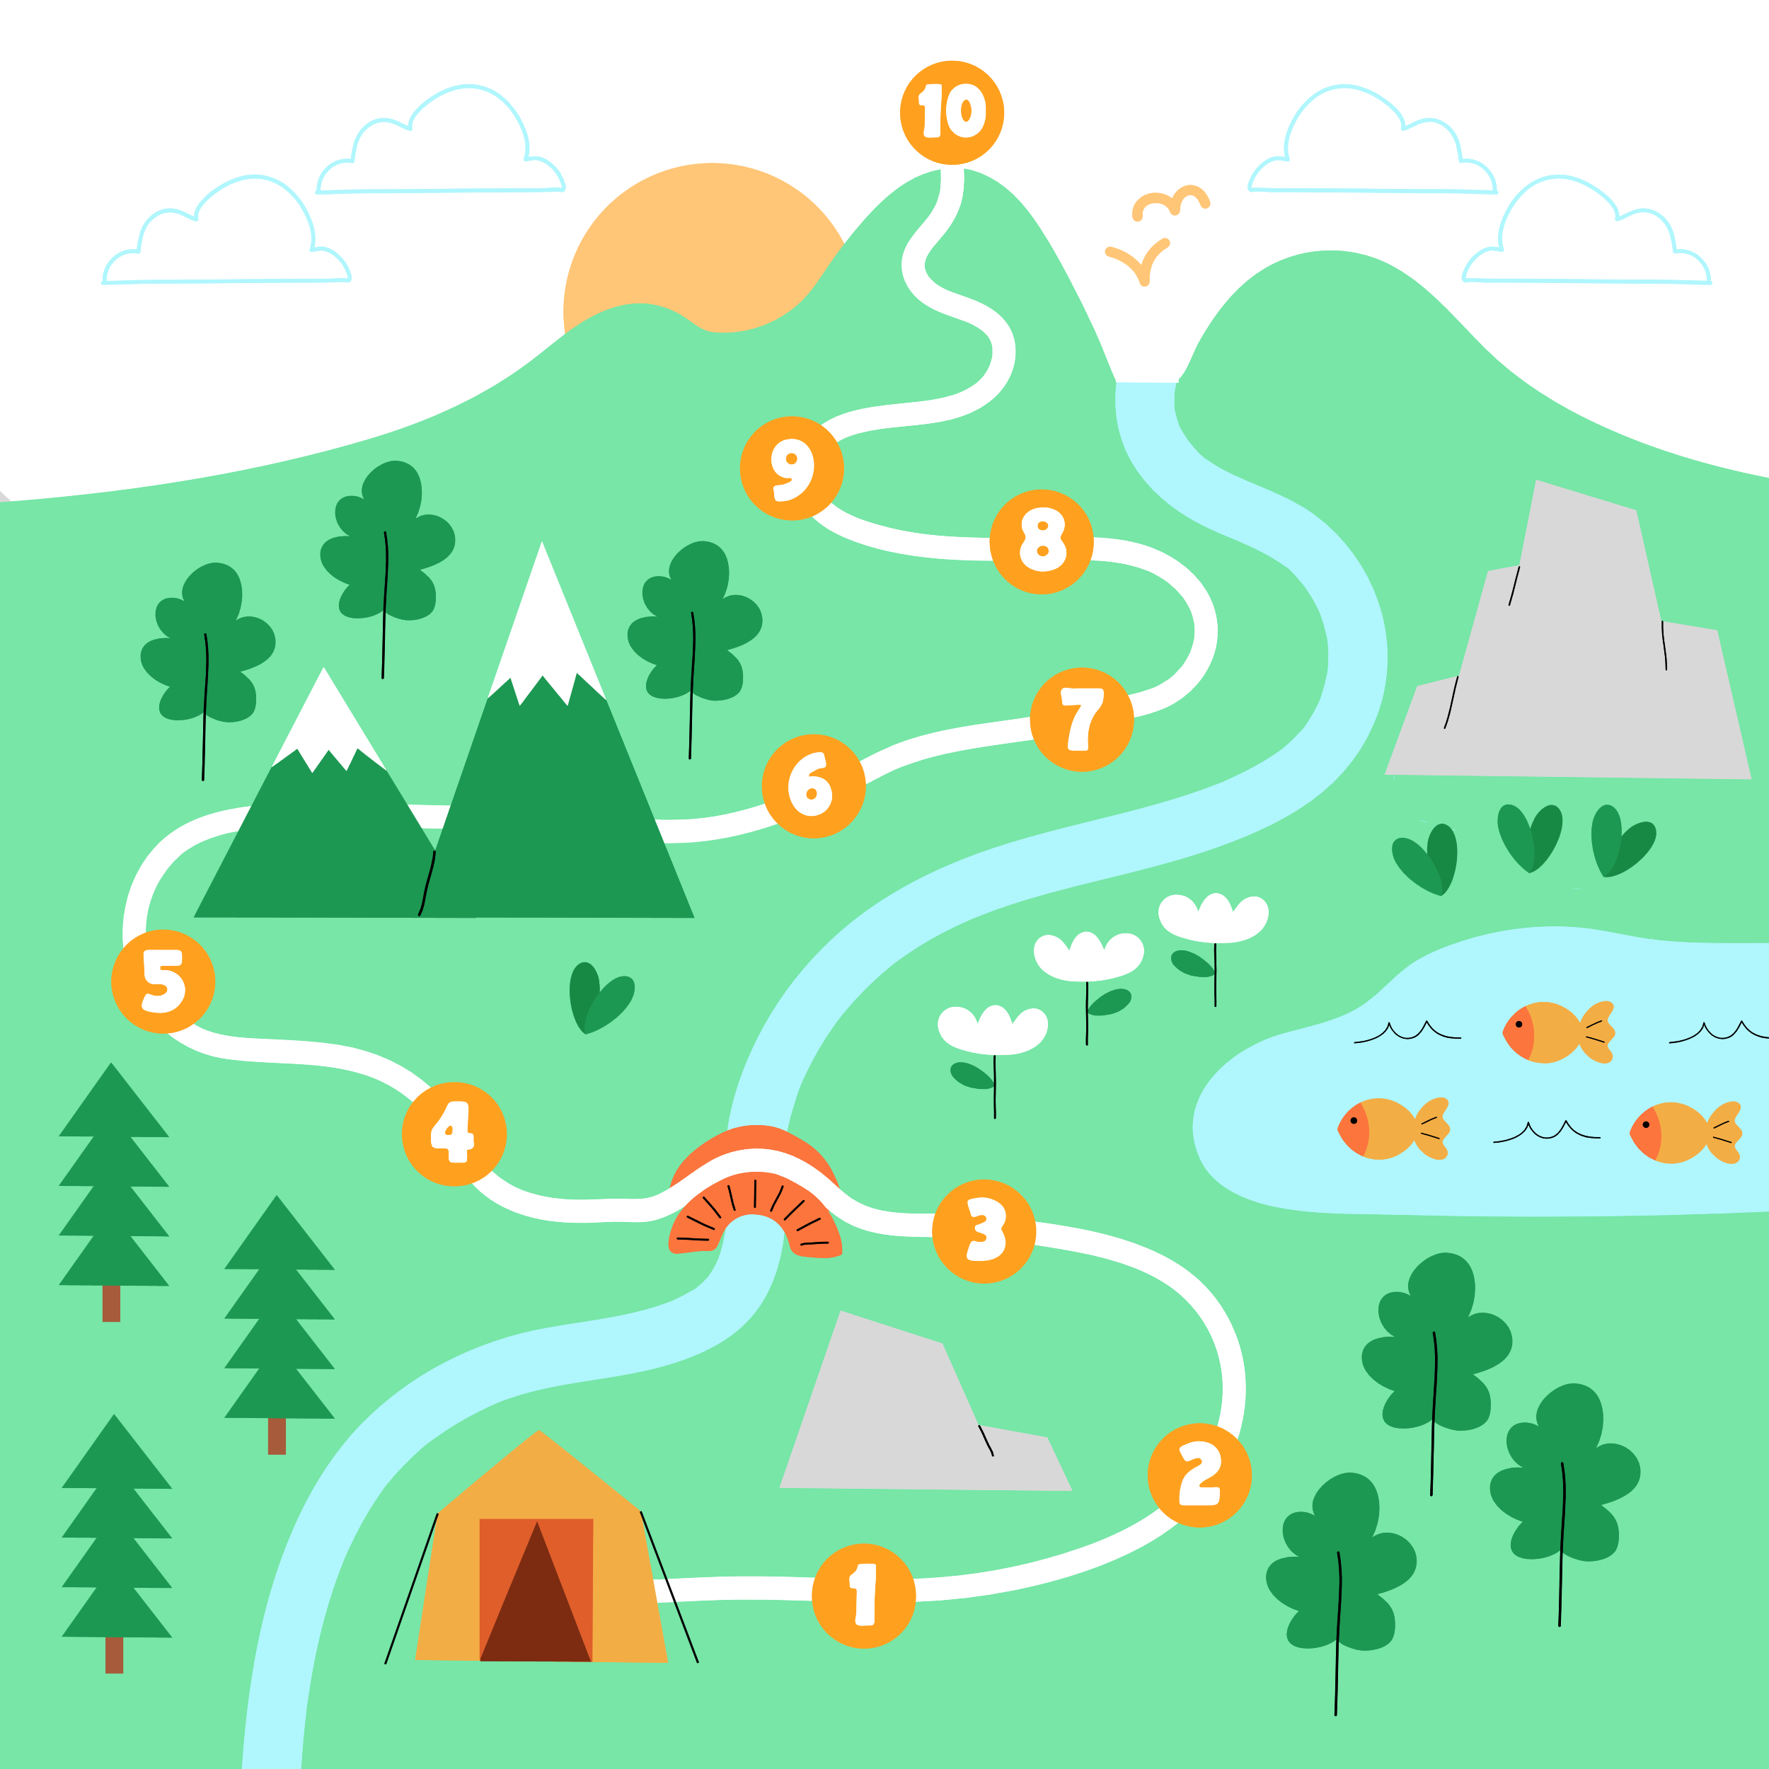
Courage Quest Program: The Courage Quest intervention includes 10 weekly modules to teach you and your child skills in graded exposure. These activities involve watching videos, practicing skills in the real world, and answering questions. You can complete the Courage Quest intervention on a device at home (e.g., a mobile, iPad, etc.). The intervention requires the following commitment:
    - Parent and child complete 10 x weekly modules at home (can be split across multiple days); these take a minimum 20 minutes per week, but we recommend that the more time you engage with the program, the more benefits you will likely see.
    - Parent completes 3 x 20-minute support sessions with a therapist over the phone or telehealth.
    - Schedule and complete regular home practice activities (approximately 5-10 minutes daily practice).

Raising Healthy Minds Intervention: The Raising Healthy Minds intervention is a mobile app created by the Raising Children Network (Australia) and funded by the Australian Federal Department of Health. We have permission from the Director of the Raising Children Network to include this app in our study. The app provides information and resources to parents about children’s mental health. You can complete the intervention on a device at home (e.g., a mobile, iPad, etc.). The intervention requires the following commitment:
    - Parent and child complete 10 x weekly modules at home (can be split across multiple days); these take approximately 20 minutes per week, but we recommend using the intervention for approximately an hour per week for the best results.
    - Parent completes 3 x 20-minute check-in sessions with a therapist over the phone or telehealth.

After using the Raising Healthy Minds intervention for 10 weeks, you will then receive 10 weeks access to the Courage Quest intervention, and an additional 3 x therapist support phone calls.

Assessments: If you and your child participate in this study, you and your child will be invited to complete online questionnaires at three time points: 1) Baseline, 2) Immediate post-intervention, and 3) Delayed follow-up (see below).

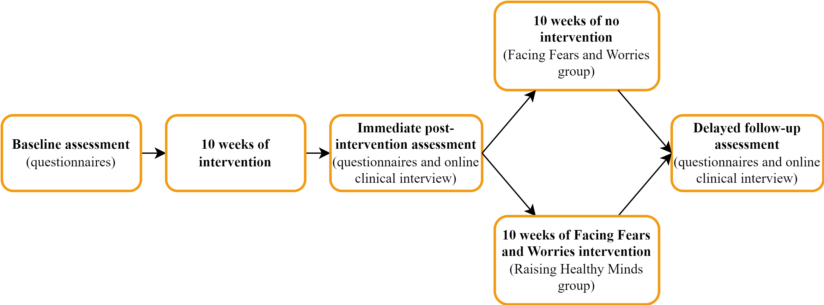

- The baseline assessment will ask some demographic questions (e.g., gender identity, ethnicity, demographics) and questions about your child’s mental health. This should take approximately 10-15 minutes to complete.
- The post-intervention assessment will include questionnaires that ask about your child’s mental health, as well as your experience with the intervention (either Courage Quest or Raising Healthy Minds), and should take approximately 15-20 minutes to complete. Following these questionnaires, you will be invited to complete the online clinical questionnaire (details above).
- The delayed follow-up assessment questionnaires will include questions that ask about your child’s mental health and should take approximately 10-15 minutes to complete. Following these questionnaires, you will be invited to complete the online clinical questionnaire again (details above).

Additional Costs: There are no costs associated with participating in this research project.

Psychological Distress: It is possible, and often expected, that children may become anxious when completing anxiety interventions. However, if you or your child become upset or distressed as a result of participating in the research project, we recommend following up with the below services:

- If you are in immediate danger, call 000
- NSW Health Mental Health Line (1800 011 511)
- Beyond Blue – 1300 22 4636
- Lifeline Australia – 13 11 14
- The Kids Helpline (1800 55 1800)
- Suicide Call Back Service – 1300 659 467
- 13YARN (crisis support for Aboriginal & Torres Strait Islander people) – 13 92 76

- What are the possible benefits to participation?
If you choose to complete the online clinical questionnaire, you will receive a feedback report with information about your child’s mental health (even if this study is not the right fit for your child) within 1 week of completing the online clinical questionnaire.

If you choose to participate in the study, you will receive evidence-based strategies to support your child’s anxiety. However, we cannot guarantee your child will show improvements in their mental health following their participation in this study. Nonetheless, you will receive resources to support your child’s anxiety.

In terms of reimbursement, you will receive $30 for completing the first assessment, $50 for the second, and $70 for completing both the 10-week program (either the Courage Quest intervention or the Raising Healthy Minds intervention) and the third assessment, totalling to $150 for the entire study. These will be paid as a gift card within 30 days of completing each assessment. The gift card can be redeemed across major retailers in Australia both online and in store (e.g., Apple, Woolworths, Coles, Rebel). If there is evidence that you have taken the surveys more than once, your response is fraudulent, or your response was not completed correctly, you may not receive reimbursement. We reserve the right to withhold reimbursement when fraud is suspected.

- What will happen to information about me and my child?
By signing the consent form, you consent to the research team collecting and using information about you and your child for the research study, including data from the screening questions. Your identifiable data will not be shared with anyone outside of the research team unless there is a risk of serious harm to you, your child, or others, or if there is a risk of a serious crime.
The research team will store the data collected for this research project for a minimum of 15 years after the completion of the research or until the participants reach 25 years of age, as per the retention period for clinical trials involving children. Questionnaire data and participant data collected will be stored online via Qualtrics. Participant data collected through Qualtrics will be encrypted and stored within UNSW. This research will be stored electronically on a UNSW password protected OneDrive only accessible to the approved research investigators. Your data will be stored in a re-identifiable format where you and your child’s identities will be linked to a unique Participant ID. Only the research team will be able to link your Participant ID to your identifiable information.
If other researchers want access to your data for future research studies, they will need to obtain ethics approval before doing so. In these cases, your data will be de-identified so that you and your child’s identities will be unknown to these other researchers. The data will also be transferred to these other researchers through a secure UNSW OneDrive folder.
Data from the Courage Quest app will be stored using the Amazon Relational Database Service (RDS) and Amazon DynamoDB. This information is stored in Amazon’s secured Amazon Web Services (AWS) servers in Australia. Amazon is the world’s leading cloud IT infrastructure provider providing high-performing, robust and secure infrastructure maintaining several compliance certifications, including ISO 27001, SOC1, SOC2, SOC3, PCI DSS, IRAP, ISO 9001, CSA, ICO 27017 and ISO 27018.
The information you provide is personal information for the purposes of the Privacy and Personal Information Protection Act 1998 (NSW). You have the right of access to personal information held about you by the University, the right to request correction and amendment of it, and the right to make a complaint about a breach of the Information Protection Principles as contained in the PPIP Act. Further information on how the University protects personal information is available in the UNSW Privacy Management Plan.

- How and when will I find out about the results of the research study?
The research team intend to publish results of the research in peer reviewed journals. We will also write a brief summary of the main research outcomes on the BDI website at the end of this trial. All Information will be published in a way that will not identify you or your child. If you would like to receive a copy of the results you can let the research team know by inserting your email or mailing address in the consent form. We will only use these details to send you the results of the research.

- What if I want to withdraw from the research study?
If you do consent for you and your child to participate, you may withdraw at any time by completing the withdrawal of consent form which will be made available to you via email. Alternatively, you can ring the research team (see contact details below) or email couragequest@blackdog.org.au and tell them you and your child no longer want to participate. If you decide to leave the research study, the researchers will destroy any information that has already been collected and no additional information will be collected. Your decision not to participate or to withdraw you or your child from the study, will not affect you or your child’s relationship with UNSW Sydney or the Black Dog Institute.

- What should I do if I have further questions about my involvement in the research study?

The person you may need to contact will depend on the nature of your query. If you require further information regarding this study or if you have any problems which may be related to your involvement in the study, you can contact couragequest@blackdog.org.au or you can contact the following member/s of the research team individually:

Name | Emma McDermott
Position | Research Assistant
Telephone | (02) 9065 9092
Email | emma.mcdermott@blackdog.org.au
Name | Chloe Lim
Position | Postdoctoral Researcher
Telephone | (02) 9065 9061
Email | chloe.lim@blackdog.org.au
Name | Abigail Allsop
Position | Project Manager
Telephone | (02) 9065 9163
Email | a.allsop@blackdog.org.au
Name | Melissa Aji
Position | Clinical Psychology Registrar
Telephone | 02 9065 9173
Email | m.aji@blackdog.org
Name | Wendy Chen
Position | Clinical Psychology Registrar
Telephone | 9065 8146
Email | wenting.chen@unsw.edu.au

Chief Investigator:

Name | Jennie Hudson
Position | Chief Investigator
Telephone | (02) 9065 9251
Email | jennie.hudson@blackdog.org.au

- What if I have a complaint or any concerns about the research study?
If you have a complaint regarding any aspect of the study or the way it is being conducted, please contact the UNSW Human Ethics Coordinator:
Position | Human Research Ethics Coordinator
Telephone | + 61 2 9385 6222
Email | humanethics@unsw.edu.au
HC Reference Number | HC230097

Driving a mentally healthier world
Taking part in this study is an incredible opportunity to be part of a research project that has the potential to decrease anxiety disorders and symptoms in Australian children. Thank you for taking the time to read through this information sheet. We hope you consider your child’s participation in the Courage Quest Study.

If you would like to participate in the Courage Quest Study:
Click here

Online Consent Form – Parent providing own consent

Thank you for your interest in this research. If you are a parent/carer of a child and would like to participate in this study, please carefully read the information below, complete your details at the bottom of this page, and select “I agree and give consent for both myself and my child”.

Please note that your child will still have to complete a consent form for themselves.

If you do not want to participate in this study, please select “I do not give consent”

By selecting the "I agree" button below:
- I understand I am being asked to provide consent to participate in this research study;
- I understand I will be contacted by the research team to complete questionnaires;
- I understand that if there is evidence that I have taken the surveys more than once, my response is fraudulent, or my response was not completed correctly, I may not receive reimbursement. The researchers reserve the right to withhold reimbursement when fraud is suspected.
- I have read the Participant Information Sheet, or it has been provided to me in a language that I understand;
- I understand the purposes, study tasks and risks of the research described in the study;
- I provide my consent for the identified information collected about me and my child from the screening questions (already answered) to be used for the purpose of this research study.
- I provide my consent for the de-identified information collected about me and my child to be made available to other researchers. I understand that the data will be de-identified, that other researchers who want to access my de-identified data will need to obtain ethics approval first, and that my data will be transferred to these other researchers through a secure UNSW OneDrive folder, as described at section 7 of the Participant Information Statement (insert link here).
- I provide my consent for information to be collected about me and my child. I understand this information will be used for the purpose of this research study only.
- I understand that my data will not be shared with anyone outside of the research team unless there is a risk of serious harm to me, my child, or others, or if there is a risk of a serious crime.
- I have had an opportunity to ask questions and I am satisfied with the answers I have received;
- I understand that I can download a copy of this consent form from [INSERT weblink]
- I understand that the results of the research will be made available on the Black Dog Institute Website.
- I freely agree to participate in this research study as described and understand that my child and I am free to withdraw at any time during the study and withdrawal will not affect me or my child’s relationship with any of the named organisations and/or research team members;

Access to study results:
- I would like to receive a copy of the study results via email, using the contact details provided below;

Optional Consent for reuse of data and future research:
- I provide my consent for my name and contact details to be retained in a register so I can be contacted about other research projects in the future.

Full name of parent/carer
Full name of child
Parent/Carer’s email address
Parent/Carer’s mobile number

I agree and give consent for both myself and my child
I do not give consent

Online Form for Withdrawal of Participation

I wish to WITHDRAW consent for both myself and my child to participate in the “Courage Quest” research study.

I understand that such withdrawal WILL NOT affect my relationship with The University of New South Wales or the Black Dog Institute.

- I am withdrawing my consent and I would like any identifiable information collected about me which I have provided for the purpose of this research study withdrawn.
- I am withdrawing my consent to participate in further components of this research and provide my permission for the research team to retain and/or use information collected about me which I have provided for the purpose of this research.
- I am withdrawing my consent and I understand that any information already published and/or not linked to my identity cannot be withdrawn from the research.

Please enter your details below. These details are not for us to contact you, but to ensure we properly withdraw you from the study:

Full name of parent/carer
Full name of child
Parent/carer’s email address
Parent/carer’s mobile number

Submit withdrawal of consent for both myself and my child:
Submit withdrawal
Cancel (i.e., do not withdraw me or my child)

