Participant Information and Consent Form

“COURAGE QUEST” - A DIGITAL EXPOSURE-FOCUSED INTERVENTION FOR CHILDREN WITH ANXIETY: A PILOT CASE STUDY

This sheet has information about a research project to help children face their fears and worries. You can choose to be part of this research if you would like to.
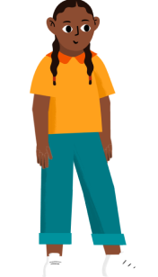

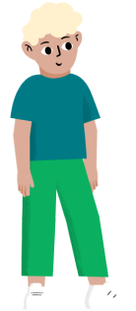

Research means finding out what people think about things and using the information to help other people.

You can ask someone you trust to help you understand this sheet.

Who is doing the research? What is it about?

My name is Jennie Hudson. I am a researcher at the Black Dog Institute. I am working with Deanna Francis, Chloe Lim, Emma McDermott, Abigail Allsop, Gemma Sicouri, Annabel Songco, Melissa Aji, and Wendy Chen.

Lots of kids (and adults!) feel worried or anxious. Anxiety can stop us from doing things we’d like to do – like seeing friends or trying something new.

We’ve made a digital program, called Courage Quest, to see if it can help kids feel less worried and more confident!
What do I have to do?

Part 1
We’ll ask you to fill in some questions on a device (e.g., computer, mobile, or tablet)

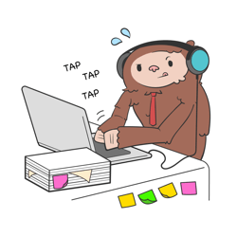

We will ask you about:
- Your thoughts and feelings

There are no right or wrong answers!

You can say no if you don’t want to answer a question, and you can stop at any time.

You can do the questions whenever you want to. They will take about 5-10 minutes.

What do I have to do?

Part 2

We’ll ask you to use the Courage Quest app with your parent/carer. You will:

- Watch videos and answer questions on a computer, mobile, or tablet
- Do activities in real life.
- Practise your new skills!

You and your parent can choose when to do the activities.

What do I have to do?

Part 3
We’ll ask you to fill in the same questions from Part 1 again. You can answer these questions on a computer, mobile, or tablet.

We will ask you about:
- Your thoughts and feelings

There are no right or wrong answers!

You can say no if you don’t want to answer a question, and you can stop at any time.

You can do the questions whenever you want to. They will take about 5-10 minutes.

What do I have to do?

Part 4

We’ll give you and your parent/carer a call and ask you about:

- What you thought about the app
- What you thought about the activities
- What you thought about your new skills

You and your parent can choose when to do this call. It will take about 10-15 minutes for you.

Do I have to do it?

No!

You can say no at any time – it’s up to you. No one will be angry if you say no.

Even if you say yes, you can change your mind later.

If you don't want to be part of the study anymore, tell your parent to complete the Online Withdrawal Form which they have in the emails we send them.

What will happen to my information?

We will keep your information at the University. We have to keep it for 15 years or until you turn 25 years old! Only the research team will see your answers.

We will keep your information private.
We will not tell anybody your name.
No one will know it was you who took part.

Who can I talk to about the research?

If you have any questions, you can ask your parent to email the researchers:
Email: couragequest@blackdog.org.au

Or you can ask your parent to talk to:
Name: Chloe Lim
Phone: (02) 9065 9061
Email: chloe.lim@blackdog.org.au

If you want to complain about this research, you can ask your parent to talk with the Human Research Ethics Coordinator. It is their job to listen to you and find out what happened.
Phone: (02) 9385 6222
Email: humanethics@unsw.edu.au
Tell them this number: HC230097

If you feel upset after taking part, you can talk to some who supports you, or call:
- NSW Health Mental Health Line (1800 011 511)
- Beyond Blue (1300 22 4636)
- Lifeline Australia (13 11 14)
- The Kids Helpline (1800 55 1800)
- 13YARN crisis support for Aboriginal & Torres Strait Islander people (13 92 76)

I want to take part.

“COURAGE QUEST” - A DIGITAL EXPOSURE-FOCUSED INTERVENTION FOR CHILDREN WITH ANXIETY: A PILOT CASE STUDY

I am signing this form because I want to be part of the study.

- I understand that it is my choice to be part of the study.
- I have read the Participant Information Sheet and I understand it.
- I understand that my information will be collected for this research project only.
- I understand that I can ask questions at any time and the research team will help me.
- I am saying yes to participating in this research project and I understand that I can change my mind later and say no. If I say no, I understand that no one will be angry with me.

My name: _____________________

Please select one:
I want to be part of the study
I do not want to be part of the study

