Research Participant Information Statement Master

Title | Hot Legs in Heart Failure: Examining Changes in Core Temperature and Lower Limb Blood Flow.
Version Number/Date | Version 1, 7/02/2023
Ethics Number | 2022/910
Principal Investigator | Prof Norm Morris
Co-Investigators | Dr Aaron Bach, Dr Surendran Sabapathy, Dr Llion Roberts, Ms Menaka Louis, Dr Pramod Sharma, Prof Rohan Jayasinghe
Location | Griffith University, Gold Coast

- What is the study about?
You are invited to participate in a research project, “Hot legs in heart failure: Examining changes in core temperature and lower limb blood flow”. The purpose of this study is to examine the effects of lower-limb heating on how we regulate heat and how it affects the way oxygen and blood are delivered to our muscles. The results of the study will enable clinicians to determine the effectiveness of this intervention and its potential utility as an adjunct therapeutic strategy to improve cardiovascular function in heart failure patients.
You were selected as a possible participant because you meet the eligibility criteria for inclusion in this research study. Participation in the study will require you to attend Griffith University for 5 visits on separate days (approximately 5 hours in total). These will entail an initial baseline assessment (approximately 30 mins), followed by another 4 visits (approximately 60 mins) of lower limb immersion and various measurements as outlined in this document. For research visits 2-5, you will be randomly assigned to various assessments, with these subsequent to either thermoneutral (water temperature 30°C) or hot (water temperature 40°C) lower limb immersion with water up to your ankle or knee height.

- What does the study involve?
If you agree to participate in the study you will be asked to visit Griffith University on five separate occasions (approximately 5 hours in total). During the first visit, you will be familiarised with the procedures in the study. The subsequent research visits 2-5 and assessments will be undertaken in a random order and will comprise of 45 minutes of placing your lower in a circulating water bath limbs (the depth being either just below the knee or just above your ankle) maintained at either 30°C or 40°C. During the lower limb immersion, we will continuously monitor your heart rate, oxygen saturation and blood pressure. We will also measure your skin temperature and skin blood flow with probes placed on your skin, as well as the size and flow of the blood vessels in your legs using an ultrasound machine. Following the lower limb immersion, you will undertake measurements of the oxidative capacity of the muscles in your lower limb. This is done using a device that measures how much oxygen is in your lower limb muscle (the gastrocnemius).
It is desirable that your local doctor is advised of and approves your decision to participate in this research study prior to you commencing it.
The measurements and tests that you will undertake are outlined below:
- Your core temperature measured using a physical ingestible pill (device) which monitors your core temperature (see Figure 1). On the morning of the study you will take the pill (approximately 2-3 hours prior to the study commencing). Prior to being given the ingestible pill will be given a wrist band you should put on as soon as you have taken the pill. You need to wear this for 36 hours so that anyone is aware you have ingested a non-MRI (magnetic resonance imaging) compatible pill – this is standard practice. The pill is safe and it will be expelled naturally (in the stool) within 8-36 hours of ingestion.
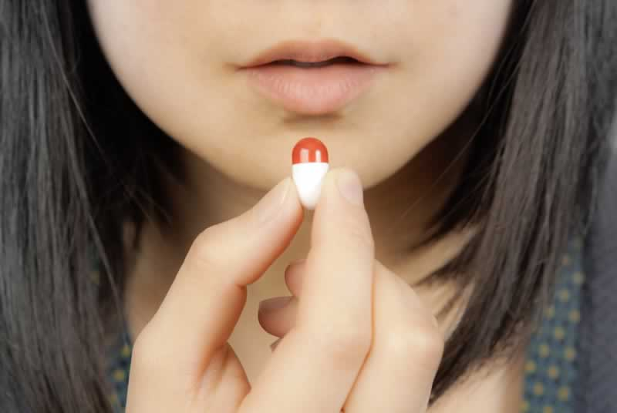
Figure 1. Image of ingestible core temperature pill.
- Skin temperature and blood flow measurement will involve putting a small temperature/blood flow probe on your thigh and forearm. During the time that your lower legs are in the water we will repeat the measures of skin temperature and blood flow every five minutes.
- The oxidative capacity of the lower limb will be measured using small device placed on the skin which emits an infra-red beam. The device behaves exactly the same as a pulse oximeter that measures your blood oxygen saturation when you go and see the doctor. To measure the oxidative capacity of your lower we will also put a blood pressure cuff position around your upper thigh and measurements taken using surface probes placed over a muscle at the front of your thigh.

- What are the possible benefits?
We cannot guarantee that you will receive benefits from this research. However, results from this study will provide information on whether lower-limb heating may be a viable treatment option for improving disease related changes in exercise tolerance in individuals with heart failure. These results may improve or inform clinical guidelines relating to the management of heart failure patients.

- What are the possible risks?
The ingestible core temperature pill will be used to monitor body temperature during prior to, during, immediately post water immersion. The device is safe to use and minimal risk when used as intended. To ensure this we will be screening participants for any reasons they shouldn’t take ingest the pill, including individuals:
- with a surgically implanted electro-medical device (e.g. pacemaker);
- with a body mass less than 40kg;
- with a history of gastrointestinal surgery;
- with a history of gastrointestinal disorders (e.g., Chron's, diverticula, motility issues);
- with a scheduled MRI scan within 48h following the expected pill ingestion;
- with a suspicion they may be pregnant or are confirmed to be pregnant.
Furthermore, should you need an unscheduled MRI scan (i.e., as a result of an acute medical event) and are not responsive to inform the medical personnel, you will be given a wristband for you to wear in the 36 hours after ingestion that says you have consumed a temporary electronic medical device that they should be aware of.
With the lower limb heating protocol, individuals may experience skin softening or breakdown, increased swelling, overheating, and excessive dilation or constriction of your blood vessels. However, we will minimise the risk of these potential issues by thoroughly screening you for any skin conditions and closely monitoring you during the lower limb water immersion for any potential physical symptoms or discomfort. Note to manage any risk of fungal infection in the water, our protocol with the water bath will be:
- The water tank is filled with fresh water for each visit.
- Chemical disinfectant and sanitiser added to the water each use, Sanit-eezy which is a registered pool sanitiser (non-chlorine-based) that controls bacteria in pools.
- The water tank will be sprayed with anti-viral cleaner i.e., viraclean/vircon after each time it is emptied, then rinsed with clean water.
- Every four weeks the system filled with hot water (without a participant) and ran for 30 minutes with disinfectant in water to generally clean.
- In the unlikely event of a fungal infection, we will have you will stop the water immersion immediately and you will be referred to your general practitioner to manage the infection. You will not be able to recommence the study until the fungal infection is resolved.

- How much time will the study take?
The study will involve the following:
- Visit 1 (familiarisation) – approx. 1½ hour
- Visit 2-5 approx. 1½ hour

- Will I incur any costs by participating in the study?
There will be no associated costs when for your research appointments as part of this study. In addition, we will offset the car parking costs at the hospital when you attend these research appointments.

- Can I tell other people about the study?
You are free to discuss this study with your family and others that you wish to, including your treating clinicians. However, in order to minimise bias of the study results, we request that you do not disclose the lower limb immersion protocol that you have been allocated to with the researcher undertaking your outcome measurements.

- Will I receive the results of the study?
Participants can request a report and an explanation of the study results from the research team. This will be provided following completion of the study.

- Confidentiality and disclosure of information
The conduct of this research involves the collection, access, storage and/or use of your identified personal information. The information collected is confidential and will not be disclosed to third parties without your consent, except to meet government, legal or other regulatory authority requirements. A de-identified copy of this data may be used for other research purposes, including publishing openly (e.g., in an open access repository). However, your anonymity will at all times be safeguarded. For further information consult the University's Privacy Plan at http://www.griffith.edu.au/about-griffith/plans-publications/griffith-university-privacy-plan
Any information that is obtained in connection with this study that may identify you will remain confidential and will be disclosed only with your permission, except as required by law. In any publication, information will be provided in such a way that you cannot be identified. This information may also be presented at some time in the future at clinical meetings, although you will not be identified in this process. Research data will be retained in a password protected electronic file at Griffith University for a period of five years from the date of the final publication before being destroyed.

- Can I withdraw from the study?
Your decision whether or not to participate is completely voluntary. If you decide to participate, you are free to withdraw your consent and discontinue participation at any stage. You can withdraw your consent by advising the researcher, Professor Norm Morris, either verbally, via email, or by completing and returning the ‘Participant Withdrawal of Consent Form’ that is supplied herein. The study will in no way change your relationship with the staff, whether you choose to participate or not.

- How can I obtain further information?
When you have read this information, should you wish to participate in the study, require further information or have any concerns regarding this study please contact Professor Norm Morris listed below:
Professor Norm Morris
Email: n.morris@griffith.edu.au
Phone: (07) 5678 0162

- What can I do if I have a complaint or a concern?
Any concerns or complaints about the conduct of this study should be directed to:
If you have any complaints about the ethical conduct of the research you can contact the Manager, Research Ethics, Griffith University on (07) 3735 4375 or research-ethics@griffith.edu.au
Any complaint will be investigated promptly and you will be informed of the outcome.

- Who has reviewed the research project?
All research in Australia involving humans is reviewed by an independent group of people called a Human Research Ethics Committee (HREC). The ethical aspects of this research project have been approved by the

Griffith University Research EthicsResearch Ethics & Integrity
Nathan campus, Griffith University
Email: research-ethics@griffith.edu.au
170 Kessels Road QLD 4111, Australia
Phone: (07) 3735 4375

This information sheet is for you to keep.
Research Participant Consent Form

Title | Hot Legs in Heart Failure: Examining Changes in Core Temperature and Lower Limb Blood Flow.
Version Number/Date | Version 1, 7/02/2023
Ethics Number | 2022/910
Principal Investigator | Prof Norm Morris
Co-Investigators | Dr Aaron Bach, Dr Surendran Sabapathy, Dr Llion Roberts, Ms Menaka Louis, Dr Pramod Sharma, Prof Rohan Jayasinghe
Location | Griffith University

Participant Consent

I agree to participate in this research. I have read the Research Participant Information Statement and had any question I have about the research answered for me by the researcher.

______________________________________________________________________
Name of Research Participant (First name and Surname)(Print)

_____________________________________________ _________________________
Research Participant Signature Date

________________________________________________________________________
Name of Researcher (Print)

_____________________________________________ _________________________
Researcher’s Signature Date
Research Participant
Withdrawal of Consent Form

Title | Hot Legs in Heart Failure: Examining Changes in Core Temperature and Lower Limb Blood Flow.
Version Number/Date | Version 1, 7/02/2023
Ethics Number | 2022/910
Principal Investigator | Prof Norm Morris
Co-Investigators | Dr Aaron Bach, Dr Surendran Sabapathy, Dr Llion Roberts, Ms Menaka Louis, Dr Pramod Sharma, Prof Rohan Jayasinghe
Location | Griffith University

You can withdraw your participation consent by advising the researcher verbally, via email to n.morris@griffith.edu.au or by returning this completed form to Professor Norm Morris, The School of Health Sciences, Griffith University.

I hereby WITHDRAW my consent to participate in the research proposal described above and understand that such withdrawal WILL NOT jeopardise any treatment or my relationship with Griffith University researchers.

Research Participant Name (Print)

_______________________________________ ______________________________
Research Participant Signature Date

