Table of Contents: Project Protocol
1. Title 2
2. Project team roles & responsibilities 2
3. Background information 3
3.1. Project outline 3
3.2. Introduction/background information 3
3.3. Rationale/justification 4
4. Study objectives 5
4.1. Hypotheses 5
4.2. Research questions/ aims 6
5. Study design 6
5.1. Study methodology 6
5.2. Research setting 7
6. Study population 7
6.1. Participants (Who and How many) 7
6.2. Inclusion and exclusion criteria 8
7. Sample size determination and power 8
8. Procedure 9
8.1. Screening of participants 9
8.2. Consent approach 9
8.3. Participant withdrawal 10
8.4. Recruitment 10
8.5. Intervention 11
8.6. Participant follow-up 14
9. Study outcome 14
10. Data collection 14
10.1. Schedule of measurement 14
10.2. Data collection (what and how) 17
11. Missing data 19
12. Data analysis 19
13. Outcome measures addressing the research question 22
14. Safety and adverse events 23
15. Data management and record keeping 24
15.1. Confidentially and privacy 24
15.2. Data security 24
15.3. Record retention 24
15.4. Secondary use 24
16. Resources 24
17. Results, outcomes and future plans 25
References 26
Appendices 29

Title
The effectiveness of an evidence-based health education program for parents of children undergoing congenital heart disease (CHD) surgery in Vietnam (version 1)

Project team roles & responsibilities
- Tran Thi Mai Huong
Affiliations and positions
The principal researcher
PhD candidate, School of Nursing
Queensland University of Technology
Responsibilities: The principal researcher identified the research problem, reviewed the literature and wrote the research proposal. If she gains an approval from the Human Research Ethics Committee, she will implement the intervention, collect data, analyse data, write up the thesis and write articles for publication. She is responsible for data management. She is also supervised to do all these tasks by her supervisors in the PhD course.
- Associate Professor Joanne Ramsbotham
Affiliations and positions
The principal supervisor
Senior Lecturer, School of Nursing
Queensland University of Technology
Responsibilities: Associate Professor Joanne Ramsbotham is the Principal Supervisor of the principal researcher in this study. Associate Professor Ramsbotham has responsibilities to review all research activities, provide comments and feedback on the principal researcher's work and have oversight of the research integrity and accuracy of data analysis.
- Associate Professor Debbie Long
Affiliations and positions
The associate supervisor
School of Nursing
Queensland University of Technology
Visiting Fellow | Queensland Children’s Hospital
Research Lead | PICU Long Term Outcomes Centre for Children’s Health Research
Chair | Paediatric Intensive Care Optimising Long-term Outcomes (PICOLO)
Responsibilities: Associate Professor Debbie Long has responsibility to supervise the principal researcher by providing comments and feedback on any research activities, such as the research proposal, data collection and thesis write-up and ensuring research integrity by having oversight of data collection and data analysis.

Background information

Project outline
This study aims to improve parents’ congenital heart disease (CHD) knowledge and their children’s health outcomes and is implemented in two phases. Phase 1 aims to develop an evidence-based health education program for parents of children undergoing CHD surgery and conduct a pilot study to assess the feasibility of the program and study protocol, in preparation for a larger study. Phase 2 aims to test the effectiveness of the evidence-based health education program on parental CHD knowledge and children’s health outcomes.

Introduction/background information
Congenital heart disease refers to abnormalities in the structure or function of the heart that present at birth. The disease accounts for the most common birth defects (Van Der Linde et al., 2011) and is one of the leading causes of death in the first year of life (Bjornard et al., 2013). The incidence rate is high in developing countries, such as Africa and Asia, while it is low in most developed countries, such as in Europe and North America (Wu et al., 2020). Congenital heart disease is often diagnosed in infancy or even before birth through foetal ultrasound. Thanks to advances in surgical techniques, more children with CHD receive repair and are now expected to survive into adulthood (Raissadati et al., 2015). However, survival of infants born with CHD is dependent on how accessible healthcare facilities are for treatment and what health education on CHD disease specific management strategies parents receive (Saxena, 2019). For example, affected children in developed countries often receive timely diagnosis, surgical intervention and parent health education which result in better short-term and long-term health outcomes for such vulnerable population (Bernstein, 2004). In contrast, most children with CHD in developing countries present with late-stage complications due to late diagnosis, ongoing re-admission and substantial disease symptoms often related to poor parent knowledge of disease management to prevent complications, for example heart failure and pulmonary hypertension (Saxena, 2019).
In developing countries, parents of children with congenital heart disease may have inadequate levels of CHD knowledge (Cheuk et al., 2004; Ndile & Kohi, 2011) which may prevent them from implementing appropriate disease specific management behaviours that minimise morbidity or morbidity for their affected child’s condition. Due to the shortage of trained healthcare staff and low levels of health education provision in these countries, a high care burden has been placed on these parents without specialist support over a long time period leading to further increased risks of morbidity and mortality for affected children (Hwang et al., 2017; Jivanji et al., 2019; Rashid et al., 2016; Saxena, 2018; Wu et al., 2020). Additionally, children with CHD may also receive heart surgery at a later age in developing countries compared to those in developed countries, and as such are also vulnerable as late surgical intervention is linked to higher rates of complications and ongoing disease symptoms (Jivanji et al., 2019; Saxena, 2019). In short, the combination of lack of parent health education leading to low parent CHD knowledge, together with late surgical intervention may cause high rates of surgery-related complications and hemodynamic dysfunction leading to poor long term health outcomes for children with CHD.
Vietnam is facing the same problems as other developing countries in the provision of treatment and care for children with CHD. Affected children in the country might also receive CHD surgery at a later age (Phuc, 2015), and they are taken care of by parents with extremely low levels of disease specific knowledge (Nguyen et al., 2019; Tran, 2018). Moreover, low attention to health education for parents of affected children and resulting low knowledge has been identifed (Nguyen et al., 2019; Tran, 2018). As a result, Vietnamese children with CHD may experience high morbidity and mortality. Providing health education for parents of children undergoing CHD surgery may improve their CHD knowledge and then moderate the development of disease specific health literacy skills which may contribute to better health outcomes for their children.

Rationale/justification
Vietnamese parents of children with CHD have low disease specific knowledge, which in turn may negatively affect their children’s health outcomes (Nguyen et al., 2019; Tran, 2018). Prior research interventions that raise people’ disease specific knowledge have been identified as correlating with better adult and child long-term health outcomes in chronic disease contexts (Butz et al., 2005; Carrillo Zuniga et al., 2012; Lohan et al., 2015; Mancuso, 2008; Manganello, 2008; Sørensen et al., 2012). Given the implications from these studies (Butz et al., 2005; Carrillo Zuniga et al., 2012; Lohan et al., 2015; Mancuso, 2008; Manganello, 2008; Sørensen et al., 2012), it is likely that implementing the evidence-based health education program in this study will improve parental CHD knowledge and disease specific management behaviours. Therefore, this research will be significant because of two drivers.
First, this research study aims to fill identified gaps regarding low parental CHD knowledge and disease specific management behaviours by providing parents of children undergoing CHD surgery in Vietnam with the first formal evidence-based health education program option. If successful and embedded as standard care, the program could then benefit approximately 1000 children after CHD surgery in the Heart Center annually when their parents would receive appropriate disease specific management health education.
Second, the study aims to contribute to better understanding of the relationships between parental CHD knowledge, parent health literacy and their children’s health outcomes in a CHD population in Vietnam. Clear understanding about this association would enable healthcare staff, especially nurses, to identify vulnerable groups and apply appropriate strategies to promote parents’ comprehension of given health knowledge. As a result, parents, regardless their backgrounds, would be equally provided with good quality of care, which in turn may increase their affected children’s long-term outcomes.

Study objectives

Hypotheses
Phase 1:
- The evidence-based health education program is feasible to deliver and acceptable for parents of children undergoing CHD surgery.
- The research protocol implementation is feasible.
Phase 2:
- Parents of children undergoing CHD surgery who participate in the evidence-based health education program will have better CHD knowledge about post-operative care than those who receive standard care at two weeks and six weeks after discharge.
- Children undergoing CHD surgery, whose parents participate in the evidence-based health education program, will have better health outcomes than those whose parents receive standard care at two weeks and six weeks after discharge.
- Parental health literacy predicts levels of parental CHD knowledge between groups over time.
- Parental health literacy predicts children’s health outcomes between groups over time.

Research questions/ aims
The research questions are:
Phase 1:
- Is the evidence-based health education program feasible to deliver and acceptable for parents of children undergoing CHD surgery?
- Is the research protocol implementation feasible?
Phase 2:
- Do parents of children undergoing CHD surgery who participate in the evidence-based health education program will have better CHD knowledge about post-operative care than those who receive standard care at two weeks and six weeks after discharge?
- Do children undergoing CHD surgery whose parents participate in the evidence-based health education program will have better health outcomes than those whose parents receive standard care at two weeks and six weeks after discharge?
- How does parental health literacy predict levels of parental CHD knowledge between groups over time?
- How does parental health literacy predict children’s health outcomes between groups over time?

Study design

Study methodology
The study includes two phases, in which Phase 1 is to test for the feasibility of the study protocol for Phase 2. Phase 1 pilot study will be a two-group quasi-experimental design, which was selected as substantial risks to the study integrity were identified, making a randomised controlled trial impractical. Specifically, parents accompany their child during a long hospital stay post heart surgery and the open ward infrastructure of the research setting is likely to facilitate parents sharing experiences and ideas, contributing to a high risk of control group contamination if a randomised control trial was used. Consequently, the random assignment of parents to both control and intervention group in the research setting at the same time for extended periods is impractical. Moreover, a two-group quasi-experimental study design can be employed to examine cause-and-effect relationships between independent and dependent variables when randomisation is not possible (McIntosh-Scott, 2014). Therefore, the two-group quasi-experimental design is justified for the Phase 1 pilot study.
The study protocol in Phase 1 pilot study will inform conduct of a larger trial in Phase 2. Following this, Phase 2 will be a two-group quasi-experimental study to examine the effectiveness of the evidence-based health education program on parental CHD knowledge and their children’s health outcomes. Justifications of Phase 2 study design are the same as previously discussed in Phase 1.

Research setting
The two phases of the study will be conducted in the Heart Center, Vietnam National Children’s Hospital, Hanoi, Vietnam. The Centre is the referral health facility that provides paediatric treatment and interventions for children with CHD in Vietnam, servicing an approximate population of 40 million people from the North to the Centre of Vietnam (National Children's Hospital, 2021). Centre services include open heart surgery, catheterisation, cardiac examination and diagnosis, medical treatment and diagnostic investigations. Before the COVID-19 pandemic, approximately 1,000 open-heart surgeries and 500 closed-heart surgeries were performed annually. The annual mortality rate for heart surgery is below 3%, with a low rate of surgery-related complications (National Children's Hospital, 2021).

Study population

Participants (Who and How many)
Participants of the study will be the same in two phases. They are parents and their children undergoing CHD surgery in the Heart Center, Vietnam National Children’s Hospital.
Phase 1 pilot study will consecutively recruit 10 dyads of parents and their children in each of the intervention and control groups.
Phase 2 will recruit a total of 148 dyads of parents and their children into the control and intervention group. The sample size calculation will be presented in section 7 in this Project Protocol.

Inclusion and exclusion criteria
Participants in the two phases will be selected using the same eligibility criteria as follows.
Inclusion criteria:
- Parents who are primary caregivers, have Vietnamese language literacy, and agree to participate in the study.
- The child’s age ranges from 0 to 5 years (up to 5 years and 11 months) undergoing CHD surgery, which is categorised by the Risk Adjusted classification for Congenital Heart Surgery (RACHS-1) from 1 to 6.
Exclusion criteria: Children who have complex chromosomal arrangements, other major comorbidities, or birth complications.

Sample size determination and power
Phase 1
As literature suggested, no calculation of sample size will be made in Phase 1 pilot study (In, 2017; Thabane et al., 2010). A convenience sample of 20 parents and their children for the two groups will be recruited to test the feasibility of the program and of the study protocol.
Phase 2
The sample size will be calculated using GPower 3.1. Based on a similar study by Staveski et al. (2016), demonstrating an effect size of .5, and considering 80% power and a type 1 error rate (alpha) of .05 (two-tailed), a sample size of 128 participants may be required. With an assumption of a 15% attrition rate, the estimated sample size will be 148 for the two groups. The final sample size will be calculated with reference to the pilot study’s results in Phase 1.

Procedure

Screening of participants
The same screening process will be implemented for both phases of the study and is undertaken on the day of the child’s admission for surgery by the principal researcher. First, following eligibility criteria, parents will be asked if they are primary caregivers and if they are able to read and write in Vietnamese language. Immediately following this, their child’s medical record will be reviewed to assess if they meet the inclusion criteria (age, surgical procedure). Next, further screening of child’s records using the exclusion criteria will be implemented to determine if any complex chromosomal arrangements, major comorbidities, and birth complications are present. Finally, if eligibility criteria are met, dyads of parents and their children will be selected for the consent process. The information in the study eligibility and exclusion criteria is a part of data that needs to be collected for the routine admission process in the Heart Center. All healthcare staff in the Heart Center have access to it.

Consent approach
Parents of children undergoing CHD surgery in this study are able to consent to participate. The consent process will start on the day of the child’s admission for CHD surgery after the study participants are screened using eligibility and exclusion criteria. First, the principal researcher will approach parents and initiate a verbal discussion regarding the study aim and purpose. Parents will receive explanation about potential benefits of the study which are to provide improvements in how clinicians and nurses can support parents to understand and manage their child’s condition after surgery. As a result, affected children may have better health outcomes. Simultaneously, parents will be provided with the following forms for their reference, (1) the Participant Information Form, (2) the Consent Form (Parent/Guardian) and (3) the Withdrawal of Consent Form. Next, parents will be given up to 12 hours on the admission day to consult their family members, friends and general practitioners prior to making a decision regarding participation. Finally, the principal researcher will come back to meet parents in their child’s ward when the scheduled time lapses. If parents agree to participate in the study, they will be asked to sign the Consent Form and return it to the principal researcher.
After completing the consent process, parents will be also asked two more questions. First, they will be asked about their best convenient time and preferred phone numbers that the research team can use to contact them for study data collection. Second, parents will be asked if they want to know further information after the study completion. If they agree, their email addresses will be voluntarily provided.

Participant withdrawal
Participant withdrawal processes and consequences of this decision will be explained to participants at the consent process by the principal researcher. First, parents will be provided with information that their withdrawal from the study at any time will not change their child’s care in any way or have any negative impact. Second, parents will be asked for options in the management of their collected data if they do decide to withdraw from the study. The two options will be written in the Withdrawal of Consent for QUT Research Project, which includes (1) a request to destroy the collected data and (2) an agreement for the further use. Finally, parents will be asked to voluntarily sign the Withdrawal of Consent for QUT Research Project and tick the appropriate box regarding their collected data use if they decide to withdrawal.

Recruitment
Phase 1 recruitment
Once consent is provided, participants will be recruited by time period to prevent intervention contamination. Control group participants will be recruited first, which will be followed by a two-week wash-out period and then the recruitment of the intervention group will be undertaken. Figure 1 depicts data collection weeks in the study timeline. In Week 1, dyads of parents and their children undergoing CHD surgery will be approached by the chief investigator on their child’s admission for surgery. After undergoing the screening and consent process, dyads of parents and their children will be allocated in the control group. The recruitment will continue until 10 dyads of parents and their children are recruited, which is forecast to be completed within one week. After a two-week wash-out period, intervention group participants (those receiving the evidence-based health education program) will be recruited in week 4. The process is repeated as in the recruitment of the intervention group.

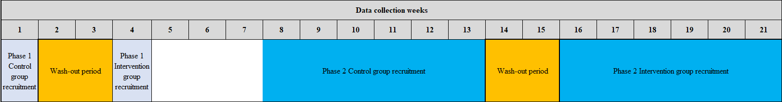
Figure 1. Data collection weeks in the study timeline
Phase 2 recruitment
Dyads of parents and their children in the control group will be recruited first from week 8 to week 13 and followed by a two-week wash-out period (Week 14 and 15). This wash-out period will ensure the last control group of parents and child dyads are discharged from the hospital prior to the first intervention group dyads being admitted to the ward. Dyads of parents and their children in the intervention group will be recruited from week 16 to week 21. The recruitment process will continue until there are 74 parents in each group. The estimated time period for recruitment is from 12 to 14 weeks for both groups.

Intervention
Participants in the two phases will receive the same intervention based on their group allocation.
Control group
Control group parents will only receive 15-minute standard care health education provided by on-duty doctors and nurses in the Heart Center at their children’s discharge (verbal explanations with no parent hard copy resources). The content of standard care is inconsistent between on-duty healthcare staff and are largely about medication administration and the schedule of outpatient appointments. No follow-up education is provided after discharge.
Intervention group
Intervention group parents will receive standard care plus five training sessions in the evidence-based health education program by the principal researcher over a period of 10 weeks. Table 1 provides an outline of the intervention in this study. The health education will start in Week 1 on the day of the child’s admission for heart surgery and continue in Week 2 and Week 3 during hospitalisation. The program will extend to the post-discharge phase with two follow-up training sessions in Week 5 (or Week 6) and Week 9 (or Week 10). The follow-up training sessions will be organised to match with the child’s outpatient appointments for standard care after surgery, to do health education in person. If parents are unable to attend their child’s outpatient appointments, they will receive similar health education via phone calls. Throughout the program, parents will be provided with relevant health information at each training session with support of parent hard copy resources, which will be given to parents for their reference at home. Examples of important topics in the program are signs of deterioration, medication adherence and nutritional needs. The teach-back method will be applied in one-on-one interactions to promote parents’ comprehension of given health knowledge. Total time required for all five training sessions is about 3.3-3.8 hours.

Table 1. The outline of five training sessions in the evidence-based health education program.
Time | Session name | Who targeted | What | Learning approach | Duration (Minutes) | Notes
Week 1 | Face-to-face group training | A group of 4–5 parents. | - General CHD knowledge.  - The child’s surgical procedure. | Teacher-led active learning | 100 | - On the child’s day of admission.  - In the meeting hall.
Week 2 | First one-on-one bedside training | At least one parent. | - Signs of deterioration.  - Medication adherence.  - Nutritional needs. | Teach-back method | 30–45 | At the bedside.
Week 3 | Second one-on-one bedside training | At least one parent. | - Wound care.  - Prevention of infective endocarditis.  - Immunisation.  - Dental care.  - Outpatient schedules.  - Physical activities | Teach-back method | 30–45 | At the bedside.
Week 5 or  Week 6 | First one-on-one follow-up training | At least one parent. | - Address parents’ currents care problems.  - Signs of deterioration.  - Medication adherence.  - Nutritional needs. | Teach-back method | 20  (Either in person or phone call) | - 2 weeks after discharge at the outpatient appointment.  - 2-week duration to increase chance to meet in person.
Week 9 or  Week 10 | Second one-on-one follow-up training | At least one parent. | - Address parents’ currents care problems.  - Signs of deterioration.  - Medication adherence.  - Nutritional needs. | Teach-back method | 20  (Either in person or phone call) | - 6 weeks after discharge at the outpatient appointment.  - 2-week duration to increase chance to meet in person.
Total time spent |  |  |  |  | 200-240 (3.3-3.8 hours)

Participant follow-up
Only intervention group parents in both phases will receive two one-on-one follow-up training sessions at their child’s outpatient appointments two weeks and six weeks after discharge, which will last approximately 20 minutes per visit. Each follow-up training session will focus on addressing parents’ care for their child after surgery that they are faced with. Furthermore, the session will continue to consolidate parents’ ability in correctly drawing up their children’s medications, providing appropriate nutritional needs and timely recognition of deterioration. Alternatively, if parents are unable to attend their child’s outpatient appointments, a 20-minute phone call will be made to provide them with follow-up education (see Table 1). The process is the same as in-person follow-up education at the child’s outpatient appointments. Meanwhile, no follow-up training is provided for control group parents; however, they will receive a 20-minute in-person interaction or phone call for the study instrument completion.

Study outcome
In Phase 1, the primary outcomes are parent acceptability of the evidence-based health education program, and the feasibility of the study protocol, including participant (parents and children) eligibility rate, parent consent rate, parent participation rate, missing data rate, lost-to-follow-up rate and sufficiency of a two-week wash-out period to prevent control /intervention group contamination. In addition, secondary outcomes of Phase 1 consist of parental CHD knowledge, parental health literacy and children’s health outcomes (e.g., clinical data, such as oxygen saturation, left ventricular eject fraction (LVEF), heart rate, weight, and social changes).
In Phase 2, the primary outcome is parental CHD knowledge while the secondary outcome is children’s health outcomes. Parental health literacy will be collected in Phase 2 to examine its relationship with levels of CHD knowledge and children’s health outcomes, which is elucidated in the Health Literacy Skills conceptual framework (Squiers et al., 2012).

Data collection

Schedule of measurement
The duration and timepoints for measurement are the same for both study phases. Measurements will occur at four time points. They include (1) at baseline on the day of the child’s admission for CHD surgery, (2) at hospital discharge, (3) at outpatient appointment two weeks after discharge (consistent with Week 5 or Week 6 in the first follow-up training session) and (4) at outpatient appointment six weeks after discharge (consistent with Week 9 or Week 10 in the second follow-up training session). Measurements at the three latter time points (except at baseline) for the intervention group parents will be performed after completing training sessions. At the post-discharge phase, parents who attend their child’s outpatient appointment will be asked to complete the study instruments. If they are unable to attend it, they will receive a phone call for the study measurement. Table 1 illustrates the schedule of measurement for two phases of the study.

Table 2. The schedule of measurement for two phases of the study
Measurements | Time points |  |  |  | Time spent for each time point (minutes)
 | At baseline | At discharge | 2 weeks after discharge (Either in person or via phone call) | 6 weeks after discharge  (Either in person or via phone call)
Feasibility for Phase 1 intervention group only
Parent acceptability of the program |  | X |  | X | 2
Parents’ outcomes for two phases and both groups
Parental CHD knowledge | X | X | X | X | 10
Parental health literacy | X |  |  |  | 2
Children’s outcomes for two phases and both groups
Children’s health outcomes | X | X | X | X | 15  5: ask and note parents’ responses  10: review the child’s medical record
Demographics for two phases and both groups
Parents’ demographics | X |  |  |  | 3
Children’s demographics | X |  |  |  | 5

At baseline in both phases, all participants will be asked to complete the instruments to assess parental CHD knowledge, parental health literacy, children’s health outcomes, parents’ and children’s demographics (see Table 2). Duration for each instrument completion is provided in Table 2. Parents in the two groups will be additionally asked to complete the Vietnamese parent LKQCHD and the Child Health Outcome Form at three more time points, including at discharge, at outpatient appointment two weeks and six weeks after discharge. Only intervention group parents in the Phase 1 pilot study will be additionally asked to complete the Parental Perception on the Feasibility Instrument at discharge and at outpatient appointment six weeks after discharge, which will take approximately 2 minutes each to complete.
According to the schedule of the study measurement and time spent for each instrument (see Table 2), it will take approximately 70 minutes to complete all study instruments for the phase 1 control group parents, while the intervention group will spend 74 minutes due to additional time to complete the Parental Perception on the Feasibility Instrument. In Phase 2, both intervention and control group participants will spend approximately 70 minutes to complete all study instruments. The reason is that parents in the two groups in Phase 2 complete the same instruments as control group parents in Phase 1.

Data collection (what and how)
Phase 1 data collection
Phase 1 pilot study data collection will include four main types of information, including (1) feasibility, (2) parents’ outcomes, (3) children’s health outcomes and (4) demographics of parents and children. The principal researcher will collect data for Phase 1. The data collection in Phase 1 will be described as the following domains, including types of information and gathering methods. Appendix 1 provides a detailed description of each outcome in the study.
First, data on feasibility includes parent acceptability of the evidence-based health education program and the feasibility of the study protocol. Parent acceptability of the evidence-based health education program will be measured by asking parents to self-rate the Parental Perception on the Feasibility Instrument, which includes 14 items using a 5-point Likert scale from 1 to 5 (1=strongly disagree, 2=disagree, 3=neutral, 4=agree and 5= strongly agree) and an open-ended question for additional comments. Mean total scores ≥ 3.0 will indicate acceptability. The feasibility of the study protocol will be captured by the principal researcher, which includes eligibility rate, parent consent rate, parent participation rate, missing data, lost-to-follow-up rate, and sufficiency of a two-week wash-out period.
Second, parents’ outcomes will include their CHD knowledge and health literacy. Parental CHD knowledge will be collected using the Vietnamese parent Leuven Knowledge Questionnaire for Congenital Heart Disease (the Vietnamese parent LKQCHD) (Tran, 2018). This is a 23-item instrument, which encompasses four domains, including (1) the disease and its treatment, (2) the prevention of complications, (3) physical activity, and (4) heredity (Tran, 2018). Items include multiple choice questions, multiple answer questions and one open-ended question. The total score for an individual parent will range from 0 to 23. Data will be collected by the principal researcher who will read questions to parents and record their responses. Parental health literacy will be measured using the Vietnamese short-form health literacy instrument, which includes 12 dimensions of health literacy with 12 questions (Duong et al., 2019). Parents will be asked to rate their perception about their levels of difficulty with each dimension of health literacy using a 4-point Likert scale (1= very difficult; 2=difficult; 3=easy and 4=very easy). The health literacy scores range from 0 to 50.
Third, children’s health outcomes that will be collected using the 15-item Child Health Outcome Form for clinical data (e.g., oxygen saturation and left ventricular ejection fraction) and social major changes (e.g., changes in primary care and parents’ divorce). All children’s clinical data is obtained by reviewing the child’s medical records as part of standard care. No additional clinical data will be collected as part of the study. Meanwhile, major social changes will be collected by asking parents and noting their responses.
Fourth, parents’ demographics will be obtained using the Parent Demographic Form. The information includes parents’ age, gender, ethnicity, educational backgrounds, occupation, income and some data about alternative caregivers if applicable, such as their relationship to the child and care hours per week. Data will be gathered by asking parents and noting their responses. Children’s demographics will be collected using the Child Demographic Form. Information includes children’s birth date, age at surgery, gender, birth order, prematurity, diagnosis, surgical procedures and number of previous heart surgeries. Children’s demographics will be collected by asking their parents and noting answers.
Phase 2 data collection
Phase 2 will collect the following data, including parents’ outcomes (e.g., parental CHD knowledge and parental health literacy), children’s health outcomes, parents’ and children’s demographics. Detailed descriptions of data types and collection methods are the same as in Phase 1, which were previously discussed in this section. The difference in the data collection of Phase 2 is that the principal researcher will only do study measurements at baseline while the research assistants (two senior nurses) will perform the rest of the outcome measures in this study.

Missing data
Risks of missing data in the study is possible when parents do not take their child to outpatient appointments after surgery. Hence, parents will not be able to complete the study instruments. To manage missing data, some strategies will be applied. First, phone numbers of both parents will be collected at baseline and updated when having communication with them during each training session. Parents will be asked regarding their best available time and preferred mobile phone numbers to contact them during the recruitment process. Second, it will be explained to parents that outpatient appointments are as part of standard care after surgery to promote their child’s health. Parents’ presence will maximise the success of their child’s treatment therapy because doctors can provide them with necessary health information. Hence, the research team will take these opportunities to meet parents and their child in person for follow-up training and instrument completion. Third, if parents are not able to attend their child’s outpatient appointments, a maximum of 5 phone calls will be made for follow-up training and instrument completion. Otherwise, loss to follow-up will be reported. Finally, the missing data rate in Phase 1 and a 15% attrition rate will be used to calculate Phase 2 sample size to limit potential impacts of loss to follow-up that occurs.

Data analysis
Phase 1 data analysis
Parents and children’s demographics will be reported by mean (standard deviation) for normal distribution or median (interquartile range) for skewed distribution for continuous variables. Counts and percentage will be employed to describe categorical variables of parents and children’s demographics, including parents and children’s genders, parents’ educational backgrounds, and children’s RACHS-1 categories.
Parent acceptability of the evidence-based health education program will be calculated by mean and standard deviation (SD) for normal distribution and median and interquartile range (IQR) for skewed distribution. Parents’ contributions in the open-ended question regarding their recommendations to improve the effectiveness of the program will be synthesised in themes (e.g., elements, delivery modes, and time) and necessary adjustments will be discussed with the supervision team prior to Phase 2. In addition, mean/median scores of parent acceptability of the program will be also reported into subgroups of parents’ age and educational backgrounds to identify different perspectives in each group and then determine appropriate strategies to meet information needs if there is a difference.
The duration of each training session will be measured in minutes for each type of training session, such as face-to-face group training sessions, one-on-one bedside training sessions and one-on-one follow-up training sessions. Based on these statistics, mean training time will be calculated for each type of training sessions implemented during the pilot study. The calculation of the duration of each training session will inform time sufficiency for Phase 2.
The eligibility rate will be calculated by dividing numbers of eligible dyads of parents and their children by total participants that are screened and then multiplied by 100.
The parent consent rate will be calculated using a sum of parents who agree to join the program divided by total eligible parents and then multiplied by 100.
The parent participation rate in the evidence-based health education program will be calculated by counting active parents who participate in each training session, divided by number of intervention group parents and multiplied by 100. Reasons for not attending the training sessions will be summarised to justify appropriate strategies to engage parents in Phase 2.
Missing data rate is the percentage of missing data value in the observation of interest in each time point of measurement. For example, the child’s echocardiography results do not contain values of left ventricular ejection fraction. Details in types of missing data will be reported to inform the data collection in Phase 2.
Lost-to-follow-up rate will be computed by dividing numbers of parents who do not complete the study instruments by total intervention group parents and then multiplied by 100.
Sufficiency in the wash-out period will be reported by the number of control group parents still in ward when intervention group parents arrive in to consider the sufficient time for Phase 2.
Parental CHD knowledge scores, parental health literacy scores, and children’s health outcomes will be reported by mean (SD) for normal distribution or median (IQR) for skewed distribution. Independent samples t-tests or Mann-Whitney U tests will be employed to compare intergroup mean or median differences of continuous data at each time point. The one-way analysis of variance (ANOVA) will be utilised to compare means of two or more independent groups. The paired t-test will be also used to examine intragroup mean differences in these outcomes between time points. Mean or median changes with 95% confident intervals (CI) will be reported.
Phase 2 data analysis
The analytic plan for the research study will include two steps, descriptive analysis and inferential analysis. The Statistical Package for Social Science version 23 (SPSS 23) will be employed for data analysis for this study. All responses from parents and their children will be coded, input, and checked for coding errors, outliers, and data consistency errors following quality control procedures. Following this, descriptive statistics will be conducted to describe trends and patterns of the data set. Mean and standard deviations (SD) will be used to report normally distributed continuous data, while median and interquartile range (IQR) will be employed to summarise skewed continuous data. For example, parents’ age, their child’s oxygen saturation, and LVEF are continuous variables of this research study, which will be reported by mean (SD) or median (IQR). Categorical variables, such as parents’ educational backgrounds and occupation, will be described by counts and percentage.
Inferential tests will be then utilised to evaluate intergroup and intragroup differences in demographics and outcome measures of the study at four time points; at baseline, at discharge, at outpatient appointments two weeks after discharge, and at outpatient appointment six weeks after discharge. Chi square or Fisher Exact tests will be used to explore baseline differences about categorical variables, such as parents’ educational backgrounds and children’s RACHS-1 categories between the two groups.
Regarding intergroup comparisons, independent samples t-tests or Mann-Whitney U tests will be employed to compare mean or median differences of continuous data at each time point. For example, mean or median differences in parental CHD knowledge between the two groups at each time points will be identified using independent samples t-tests or Mann-Whitney U tests. A one-way analysis of variance (ANOVA) will be used to compare means from more than two independent groups.
Regarding intragroup comparisons, paired t-test will also be used to examine mean differences for continuous data. For example, parental CHD knowledge, children’s oxygen saturation and LVEF will be compared between time points.
Group-wise linear regression will be employed to examine the impact of parental health literacy on parental CHD knowledge and children’s health outcomes in the two groups over time. A p-value for this study will be less than or equal to 0.05.

Outcome measures addressing the research question
Outcome measures address research questions in Phase 1 and Phase 2. Appendix 1 summarises necessary outcomes of the study regarding instruments, description and criteria.
In Phase 1, parent acceptability of the evidence-based health education program and the feasibility of the study protocol are outcome measures (see Appendix 1). First, the feasibility of the program will be evaluated based on mean scores of parent acceptability using the Parental Perception on the Feasibility Instrument. If mean scores are equal to or greater than 3.0 points, the program will be considered as feasible. Second, the feasibility of the study protocol will be assessed by calculating the following outcomes. They include eligibility rate, parent consent rate, parent participation rate, missing data rate, lost-to-follow-up rate and sufficiency of a two-week wash-out period to prevent control /intervention group contamination. Criteria for the feasibility of the study protocol is as follows.
A eligibility rate ≥ 80% will be acceptable based on the research experiences at the Vietnam National Heart Centre research site (Nguyen et al., 2019; Tran, 2018). Similarly, a parent consent rate ≥ 80% will be considered acceptable,
A parent participation rate ≥ 80% and above will indicate the appropriateness and acceptability of the evidence-based health education program (Abshire et al., 2017).
A missing data rate ≤ 10% will be considered as acceptable.
Lost-to-follow-up rate ≤ 15% will be considered acceptable, which is consistent with a previous study on this topic (Ni et al., 2016).
It is anticipated that sufficiency of a two-week wash-out period will be appropriate if all dyads of control group parents will discharge when intervention group ones arrive in ward.
In Phase 2, intergroup comparisons of parental CHD knowledge and children’s health outcomes before and after the program implementation will indicate differences between participants in the intervention and control group. Thus, the findings will facilitate the conclusion about the effectiveness of the evidence-based health education program. Furthermore, parents’ and their children’s baseline demographics will be compared between the two groups to detect possible heterogeneity which enables the principal researcher to have an accurate interpretation of the study results. Finally, parental health literacy will be used to examine its relationship with levels of CHD knowledge and children’s health outcomes, which was elucidated in the Health Literacy Skills conceptual framework (Squiers et al., 2012). It is forecasted that parental health literacy is a predictor of their levels of CHD knowledge and their children’s health outcomes. A summary of these outcome measures will be provided in Appendix 1.

Safety and adverse events
The study intervention is highly likely to be safe for parents and their children. First of all, all participants regardless of study group will receive standard care, meaning that access to, and provision of routine treatment and care will be provided to all parents and children during hospital and outpatient appointments. Intervention group parents will receive additional health education on CHD. Health information included in the program will be evidence-based and standardised by the principal researcher and her supervisors, who are experts in paediatric nursing care. Furthermore, parent education has been shown to be effective in the improvement of disease specific knowledge and children’s health outcomes in other chronic disease contexts (Butz et al., 2005; Carrillo Zuniga et al., 2012; Lohan et al., 2015). Thus, standardised CHD health education in this study will provide parents with knowledge of recommended CHD specific management behaviours that may positively affect their children’s health after surgery. Finally, the study will only collect children’s clinical data as part of routine inpatient care provision documentation and outpatient appointments. No additional invasive procedures or measures will be performed as part of the study data collection. Hence, no harm or risks related to the study intervention are predicted to impact children and the study procedure is forecasted as safe for all participants.

Data management and record keeping

Confidentially and privacy
Participants’ personal information will be re-coded to protect their confidentiality and privacy. Data entry and storage processes will be implemented with high attention to participants’ confidentiality and privacy. First, data recorded on paper instruments will be inputted into Research Electronic Data Capture (REDCap), which will automatically allocate each dyad of parents and their children a study ID. Only the principal researcher and her supervisors have a username and password to access the study data in the REDCap. Second, data sets will be exported from the REDCap into SPSS for data analysis. Finally, the principal researcher is responsible to store the l information in paper sheets and field notes for further re-identical needs during data analysis. The data security will be presented in the next section.

Data security
During data collection, paper instruments and field notes that contain participants’ personal information will be securely stored in a locked filing cabinet in the principal researcher’s private office. Only the principal researcher has a private key to access to the stored data in her office. Electronic data and data sets in REDcap and SPSS will be saved in QUT One-drive, which requires the principal researcher’s account and password to access. Simultaneously, a back-up copy of this electronic data will be stored in the principal researcher’s laptop in her home, which requires a password to access.

Record retention
The study data will be stored for 15 years since the date of publication. After that, the paper instruments containing data will be destroyed.

Secondary use
The study data can be shared with other researchers. The principal will consider each case regarding types of data and purposes of data use to give permissions to access. A data sharing agreement will be signed prior to sharing. The principal researcher will be responsible to monitor if the shared data are used as per the agreement.

Resources
The study needs resources for the field work in Vietnam to make the project possible. The resources will include financial support and on-site support. First, the financial support is needed to pay for the field work in Vietnam, which will include return airplane tickets for the principal researcher, payment for research assistants and printing services for learning materials. QUT will offer this funding for the study because the principal researcher is the University scholarship awardee. A detailed budget has been attached to the Confirmation document. Second, the study may need to use the local meeting halls and available learning materials that facilitate health education, for example artificial heart models. The Vietnam National Children’s Hospital will provide the principal researcher with free use of these facilities as she is a senior nurse there. Prior to data collection, the principal researcher will apply for ethics clearance with the committee from Vietnam National Children’s Hospital for further consideration in providing support. Finally, additional fees that emerges from the study intervention implementation such as telephone bills for follow-ups will be self-funded by the researcher.

Results, outcomes and future plans
After the completion of the study, the principal researcher plans to disseminate the research outcomes to parents regardless of their allocated group either in person or via email. First, parents who request to know the study outcomes will be informed of the effectiveness of the evidence-based health education program on CHD knowledge and children’s health outcomes. Second, control group parents will receive the parent hard copy resources for their at-home references. These resources will be sent to parents’ email address or handed on by the research assistants.
Following requirements of a PhD thesis, the study aims to have three publications. The first one would be a scoping review regarding health education for parents of children with chronic disease, which may start in the middle of this year (2023). The second article might be about results of the pilot study while the third one will be about the main study. Both these articles will start secondary to the final seminar, which would be in September 2024.

References
Abshire, M., Dinglas, V. D., Cajita, M. I. A., Eakin, M. N., Needham, D. M., & Himmelfarb, C. D. (2017). Participant retention practices in longitudinal clinical research studies with high retention rates. BMC Medical Research Methodology, 17, Article 30. https://doi.org/10.1186/s12874-017-0310-z
Bernstein, D. (2004). Congenital heart disease in: Behrman RE, Kliegman RM, Jenson HB (ends). Nelson's Textbook of Pediatrics. In: Philadelphia. WB Saunders CO.
Bjornard, K., Riehle‐Colarusso, T., Gilboa, S. M., & Correa, A. (2013). Patterns in the prevalence of congenital heart defects, metropolitan Atlanta, 1978 to 2005. Birth Defects Research Part A: Clinical and Molecular Teratology, 97(2), 87-94. https://doi.org/10.1002/bdra.23111
Butz, A., Pham, L., Lewis, L., Lewis, C., Hill, K., Walker, J., & Winkelstein, M. (2005). Rural children with asthma: impact of a parent and child asthma education program. Journal of Asthma, 42(10), 813-821. https://doi.org/10.1080/02770900500369850
Carrillo Zuniga, G., Kirk, S., Mier, N., Garza, N. I., Lucio, R. L., & Zuniga, M. A. (2012). The impact of asthma health education for parents of children attending head start centers. Journal of Community Health, 37, 1296-1300. https://doi.org/10.1007/s10900-012-9571-y
Cheuk, D., Wong, S., Choi, Y., Chau, A., & Cheung, Y. (2004). Parents’ understanding of their child’s congenital heart disease. Heart, 90(4), 435-439.
Duong, T. V., Aringazina, A., Kayupova, G., Nurjanah, f., Pham, T. V., Pham, K. M., Truong, T. Q., Nguyen, K. T., Oo, W. M., & Su, T. T. (2019). Development and validation of a new short-form health literacy instrument (HLS-SF12) for the general public in six Asian countries. Health Literacy Research and Practice, 3(2), e91-e102. https://doi.org/10.3928/24748307-20190225-01
Hwang, I. C., Sisavanh, M., Billamay, S., Phangmanixay, S., Oudavong, B., Kang, J., Kwon, B. S., Kim, G. B., Bae, E. J., Noh, C. I., & Choi, J. Y. (2017). Congenital heart disease at Laos Children's Hospital: Two year experience. Pediatrics International, 59(3), 271-279. https://doi.org/10.1111/ped.13156
In, J. (2017). Introduction of a pilot study. Korean Journal of Anesthesiology, 70(6), 601-605. Jivanji, S. G., Lubega, S., Reel, B., & Qureshi, S. A. (2019). Congenital heart disease in East Africa. Frontiers in Pediatrics, 7, Article 250. https://doi.org/10.3389/fped.2019.00250
Lohan, A., Morawska, A., & Mitchell, A. (2015). A systematic review of parenting interventions for parents of children with type 1 diabetes. Child: Care, Health and Development, 41(6), 803-817. https://doi.org/10.1111/cch.12278
Mancuso, J. M. (2008). Health literacy: a concept/dimensional analysis. Nursing & Health Sciences, 10(3), 248-255. https://doi.org/10.1111/j.1442-2018.2008.00394.x
Manganello, J. A. (2008). Health literacy and adolescents: a framework and agenda for future research. Health Education Research, 23(5), 840-847. https://doi.org/10.1093/her/cym069
McIntosh-Scott, A. (2014). Key concepts in nursing and healthcare research. SAGE.
National Children's Hospital. (2021). Heart Center. Retrieved October 31, 2021 from https://benhviennhitrunguong.gov.vn/trung-tam-tim-mach.html
Ndile, M., & Kohi, T. (2011). The knowledge of parents of children with congenital heart disease in Dar es Salaam, Tanzania. Africa Journal of Nursing and Midwifery, 13(2), 57-66.
Nguyen, T. T., Dang, T. H. V., & Tran, T. M. H. (2019). The knowledge of congenital heart disease of parents who had children with congenital heart disease at the National Hospital of Pediatrics in 2019. Vietnam National Nursing Journal (27), 100-107.
Ni, Z., Chao, Y., & Xue, X. (2016). An empowerment health education program for children undergoing surgery for congenital heart diseases. Journal of Child Health Care, 20(3), 354-364. https://doi.org/10.1177/1367493515587057
Phuc, V. M. (2015). Challenges in the management of congenital heart disease in Vietnam: A single center experience. Annals of Pediatric Cardiology, 8(1), 44-46. doi: 10.4103/0974-2069.149517
Raissadati, A., Nieminen, H., Jokinen, E., & Sairanen, H. (2015). Progress in late results among pediatric cardiac surgery patients: a population-based 6-decade study with 98% follow-up. Circulation, 131(4), 347-353. https://doi.org/10.1161/CIRCULATIONAHA.114.011190
Rashid, U., Qureshi, A. U., Hyder, S. N., & Sadiq, M. (2016). Pattern of congenital heart disease in a developing country tertiary care center: Factors associated with delayed diagnosis. Annals of Pediatric Cardiology, 9(3), 210-215. http://doi.org/10.4103/0974-2069.189125
Saxena, A. (2018). Congenital Heart Disease in India: A Status Report. Indian Pediatrics, 55(12), 1075-1082. https://doi.org/10.1007/s13312-018-1445-7
Saxena, A. (2019). Status of pediatric cardiac care in developing countries. Children, 6(2), Article 34. https://doi.org/10.3390/children6020034
Sørensen, K., Van den Broucke, S., Fullam, J., Doyle, G., Pelikan, J., Slonska, Z., & Brand, H. (2012). Health literacy and public health: a systematic review and integration of definitions and models. BMC Public Health, 12(1), Article 80. https://www.doi.org/10.1186/1471-2458-12-80
Squiers, L., Peinado, S., Berkman, N., Boudewyns, V., & McCormack, L. (2012). The health literacy skills framework. Journal of Health Communication, 17(3), 30-54. https://doi.org/10.1080/10810730.2012.713442
Staveski, S. L., Parveen, V. P., Madathil, S. B., Kools, S., & Franck, L. S. (2016). Parent education discharge instruction program for care of children at home after cardiac surgery in Southern India [Article]. Cardiology in the Young, 26(6), 1213-1220. https://doi.org/10.1017/S1047951115002462
Thabane, L., Ma, J., Chu, R., Cheng, J., Ismaila, A., Rios, L. P., Robson, R., Thabane, M., Giangregorio, L., & Goldsmith, C. H. (2010). A tutorial on pilot studies: the what, why and how. BMC Medical Research Methodology, 10, Article 1. https://doi.org/10.1186/1471-2288-10-1
Tran, T. M. H. (2018, August 29-30). Vietnamese parental knowledge of congenital heart defects (CHD): Translation and content valid test of the Leuven Knowledge questionnaire for congenital heart disease. 17th World Congress on Clinical Nursing & Practice, Zurich, Switzerland.
Van Der Linde, D., Konings, E. E., Slager, M. A., Witsenburg, M., Helbing, W. A., Takkenberg, J. J., & Roos-Hesselink, J. W. (2011). Birth prevalence of congenital heart disease worldwide: a systematic review and meta-analysis. Journal of the American College of Cardiology, 58(21), 2241-2247. https://doi.org/10.1016/j.jacc.2011.08.025
Wu, W., He, J., & Shao, X. (2020). Incidence and mortality trend of congenital heart disease at the global, regional, and national level, 1990–2017. Medicine, 99(23), e20593. http: //doi.org/10.1097/MD0000000000020593.

Appendices
Appendix 1. A description of the study outcomes
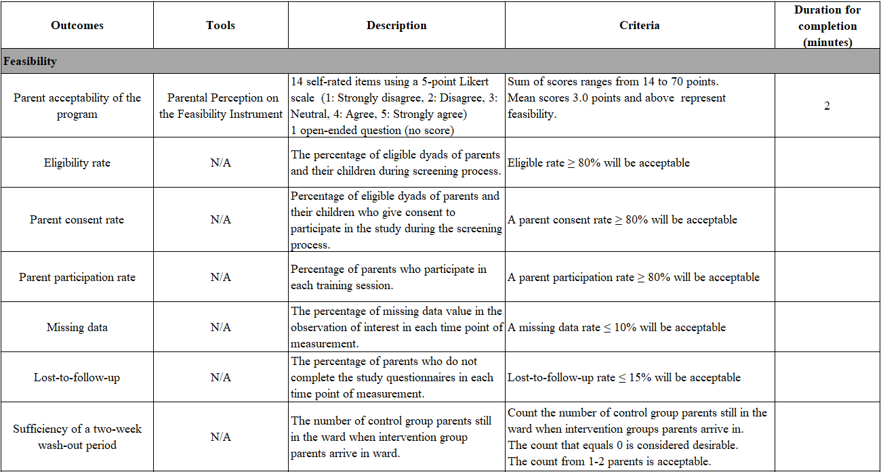
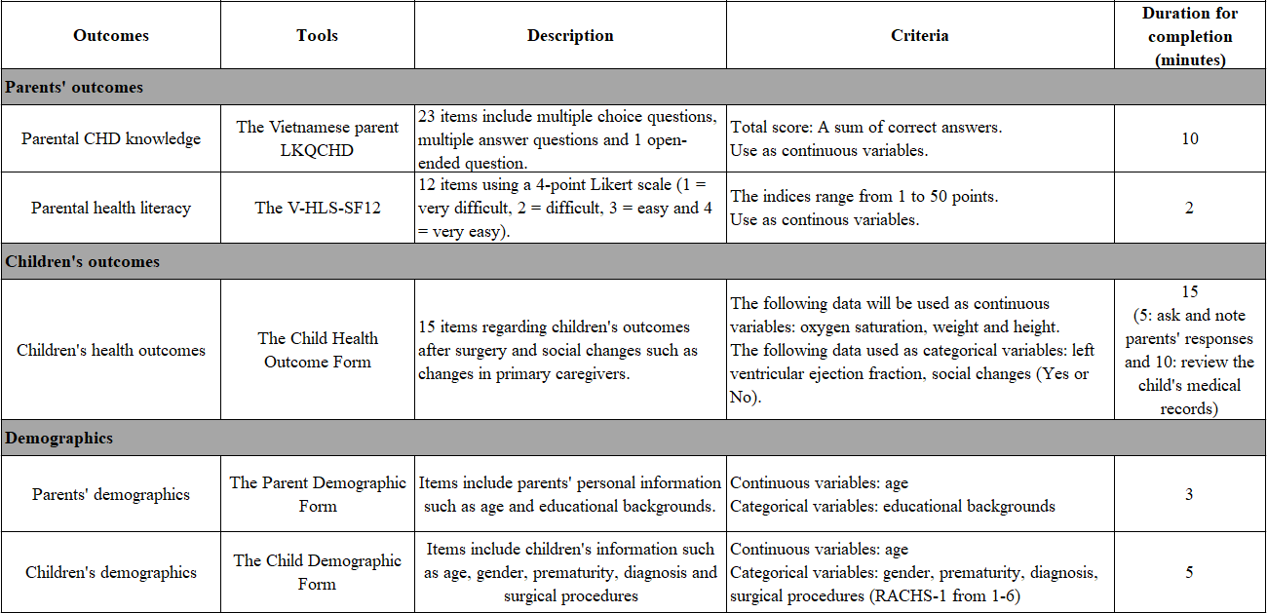

Appendix 2. The Parental Perception on the Feasibility Instrument
The Parental Perception on the Feasibility Instrument

Instructions:
We would like your perspectives and feedback on experiences in the evidence-based health education program for parents of children undergoing CHD surgery, particularly on parent hard copy resources and the whole evidence-based health education program.
Please rate your agreement or disagreement with the following statements by ticking the relevant answer (If you disagree, please provide comment to help improve parent assistance in the future).
Questions | Strongly disagree |  | Disagree |  | Neutral |  |  | Agree | Strongly agree
Scale 1. Parent hard copy resources (Please tick the most appropriate option in the box below)
- I was able to understand the nature of my child’s heart abnormality and effects on health when using the parent hard copy resources.
- My development of understanding of my child’s health issue was supported by the parent hard copy resources.
- I gained knowledge of what extra care my child will need in the future to cope with their heart abnormality from the parent hard copy resources.
- The information in the parent hard copy resources was relevant to my parenting needs at this time.
- The parent hard copy resources were complex and did not help me understand my child’s condition
- The parent hard copy resources were provided at a time when I wanted information on my child’s condition.
- The parent hard copy resources helped me consolidate my knowledge from face-to-face group interactions and one-on-one interactions.
Add any comments about the parent hard copy resources here.

Questions |  | Strongly disagree |  | Disagree |  | Neutral | Agree |  |  | Strongly agree
Scale 2. The evidence-based health education program (Please tick the most appropriate option in the box below)

- I was able to understand the nature of my child’s heart abnormality and effects on health after joining the evidence-based health education program.
- My development of understanding of my child’s health issue and what I had to do was supported by the evidence-based health education program.
- The evidence-based health education interactions were not helpful to my understanding of my child’s condition and parenting at home.
- I now have knowledge of what extra care my child will need in the future to cope with their heart abnormality, after joining the evidence-based health education program.
- The information in the evidence-based health education program was relevant to my needs.
- The evidence-based health education program was provided at a time when I wanted information on my child’s condition.
- The evidence-based health education program used effective communication strategies to confirm my understanding (e.g., face-to-face group interactions, one-on-one interactions and teach-back).
Add any comments about the evidence-based health education program.

Scale 3. Open-ended question (Please write down your ideas)
- Could you please provide some suggestions to make the program better?
………………………………………………………………………………………………………………………………………………………………………………………………………………………………………………………………………………………………………………………………………………………………………………………………………………………………………………………………………………

Thank you!

Công cụ đo lường nhận thức của cha mẹ về chương trình Giáo dục sức khỏe
Hướng dẫn:
Chúng tôi mong muốn nhận được sự chia sẻ về cảm nhận và góp ý của quý cha mẹ về chương trình Giáo dục sức khỏe dựa trên bằng chứng (GDSKDTBC) dành cho cha mẹ có con phẫu thuật tim bẩm sinh, cụ thể về tài liệu dành cho cha mẹ và toàn bộ chương trình.
Quý cha mẹ vui lòng thể hiện sự đồng ý hoặc không đồng ý của mình với các câu hỏi dưới đây bằng cách đánh dấu “V” vào câu trả lời phù hợp (Nếu quý cha mẹ không đồng ý ở câu hỏi nào, vui lòng cho chúng tôi biết thêm ý kiến vào ô trống phía dưới giúp chúng tôi cải thiện chất lượng chương trình).
Câu hỏi | Rất không đồng ý | Không đồng ý | Bình thường | Đồng ý | Rất đồng ý
Phần 1: Tài liệu dành cho cha mẹ (Vui lòng đánh dấu “V” vào ô phù hợp)
- Tôi có khả năng hiểu bệnh của con và ảnh hưởng của bệnh lên sức khỏe khi sử dụng tài liệu dành cho cha mẹ.
- Tài liệu dành cho cha mẹ hỗ trợ tôi hiểu biết các vấn đề sức khỏe của con.
- Tôi tiếp thu kiến thức trong chăm sóc con trong tương lai để giúp con thích nghi với bệnh tình của con từ tài liệu dành cho cha mẹ.
- Thông tin trong tài liệu dành cho cha mẹ phù hợp với nhu cầu chăm sóc con của tôi.
- Tài liệu dành cho cha mẹ rất khó hiểu và không giúp tôi hiểu được bệnh tình của con tôi.
- Tài liệu dành cho cha mẹ cung cấp cho tôi thông tin tôi cần cho tình trạng bệnh của con tôi.
- Tài liệu dành cho cha mẹ củng cố kiến thức mà tôi đã được hướng dẫn từ tương tác nhóm trực tiếp và tương tác một đối một.
Các nhận xét khác.

Câu hỏi | Rất không đồng ý | Không đồng ý | Bình thường | Đồng ý | Rất đồng ý
Phần 2: Chương trình GDSKDTBC (Vui lòng đánh dấu “V” vào ô phù hợp)
- Tôi có khả năng hiểu bệnh của con và ảnh hưởng của bệnh lên sức khỏe sau khi tham gia chương trình GDSKDTBC.
- Chương trình GDSKDTBC hỗ trợ tôi hiểu biết các vấn đề sức khỏe của con.
- Chương trình GDSKDTBC không hữu ích trong việc nâng cao hiểu biết của tôi về bệnh tình của con tôi và cách chăm sóc con tại nhà.
- Tôi tiếp thu kiến thức trong chăm sóc con trong tương lai để giúp con thích nghi với bệnh tình của con sau khi tham gia chương trình GDSKDTBC.
- Chương trình GDSKDTBC phù hợp với nhu cầu về chăm sóc con của tôi.
- Chương trình GDSKDTBC cung cấp cho tôi thông tin tôi cần cho tình trạng bệnh của con.
- Chương trình GDSKDTBC sử dụng phương tiện giao tiếp hiệu quả giúp tôi hiểu đúng các kiến thức (ví dụ tương tác nhóm trực tiếp, tương tác một đối một, “dạy lại”).
Các nhận xét khác.

Phần 3. Câu hỏi mở (Vui lòng viết ra ý kiến cá nhân của quý cha mẹ)

- Quý cha mẹ vui lòng cho chúng tôi thêm các gợi ý để giúp chương trình tốt hơn?
………………………………………………………………………………………………………………………………………………………………………………………………………………………………………………………………………………………………………………………………………………………………………………………………………………………………………………………………………………

Xin cảm ơn!

Appendix 3. The Vietnamese parent LKQCHD
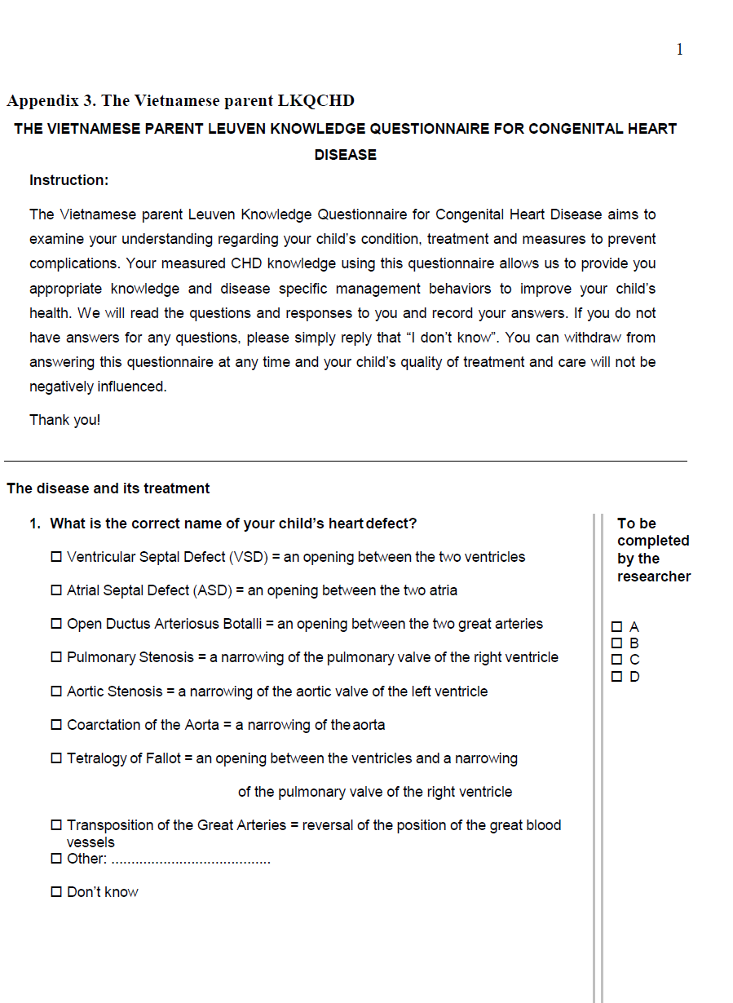
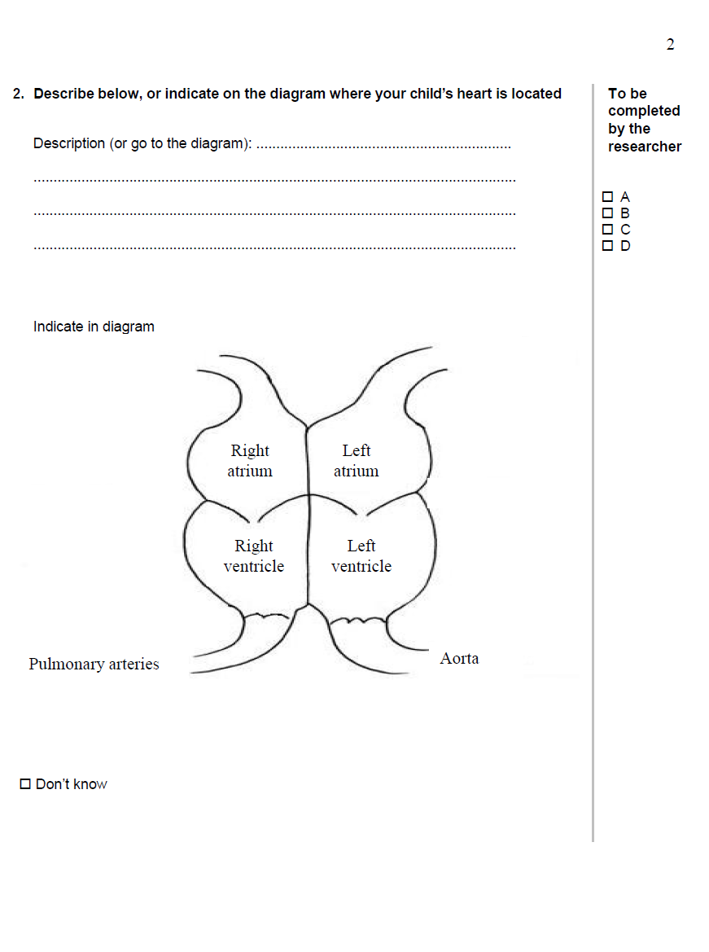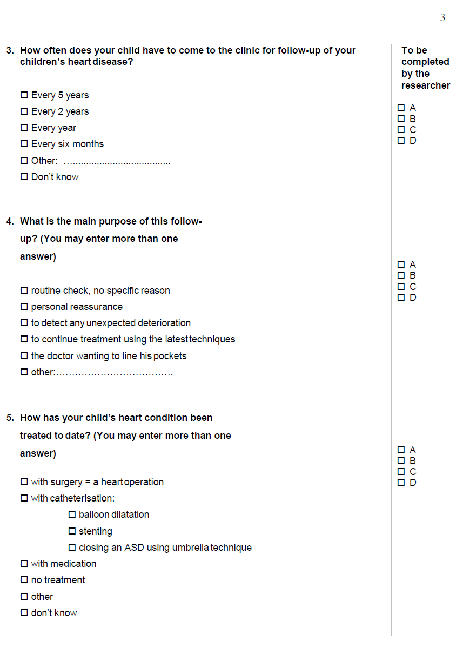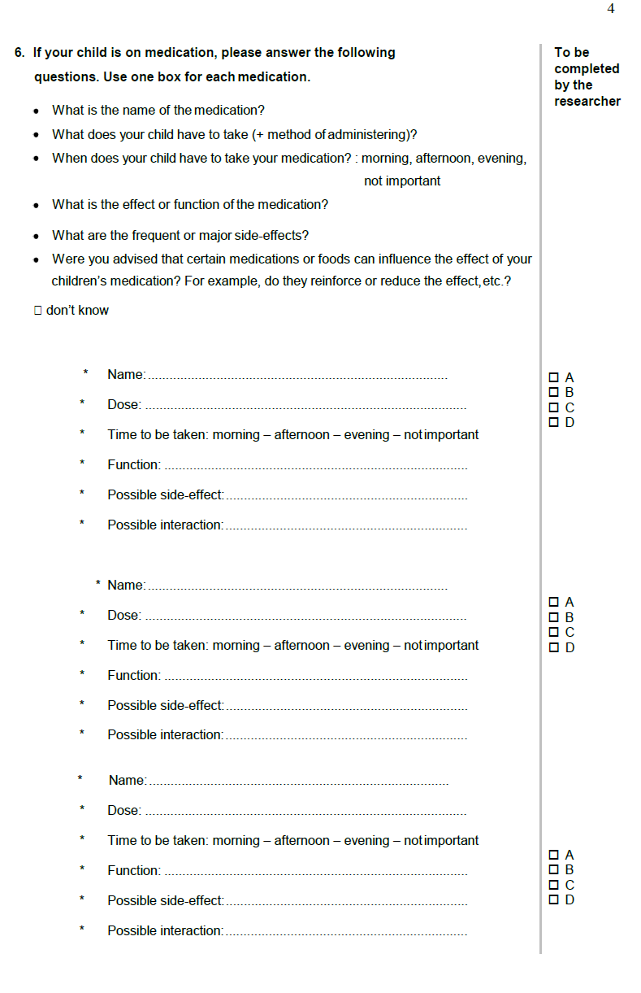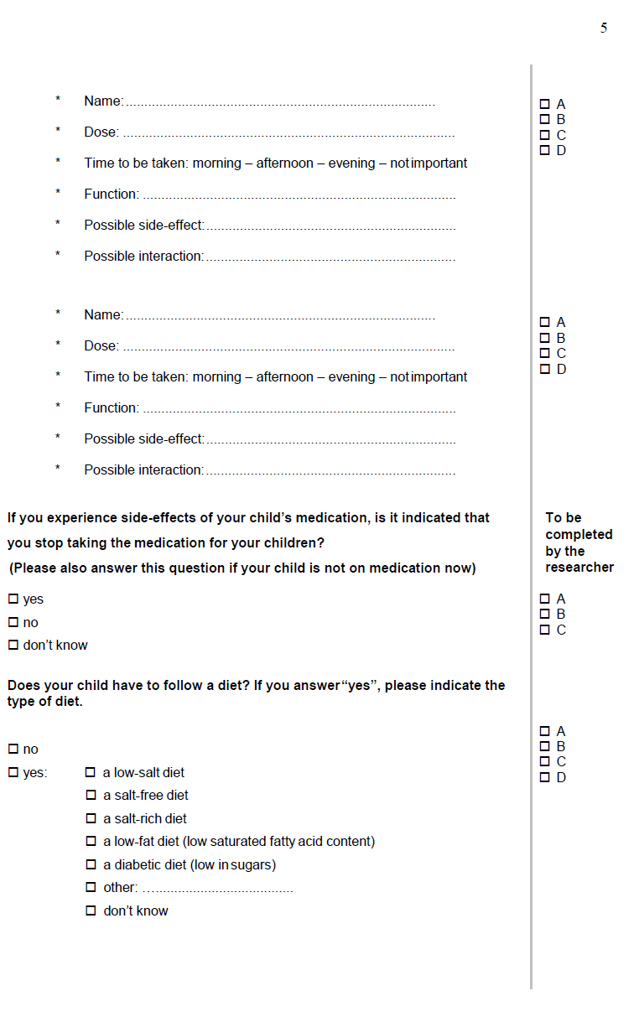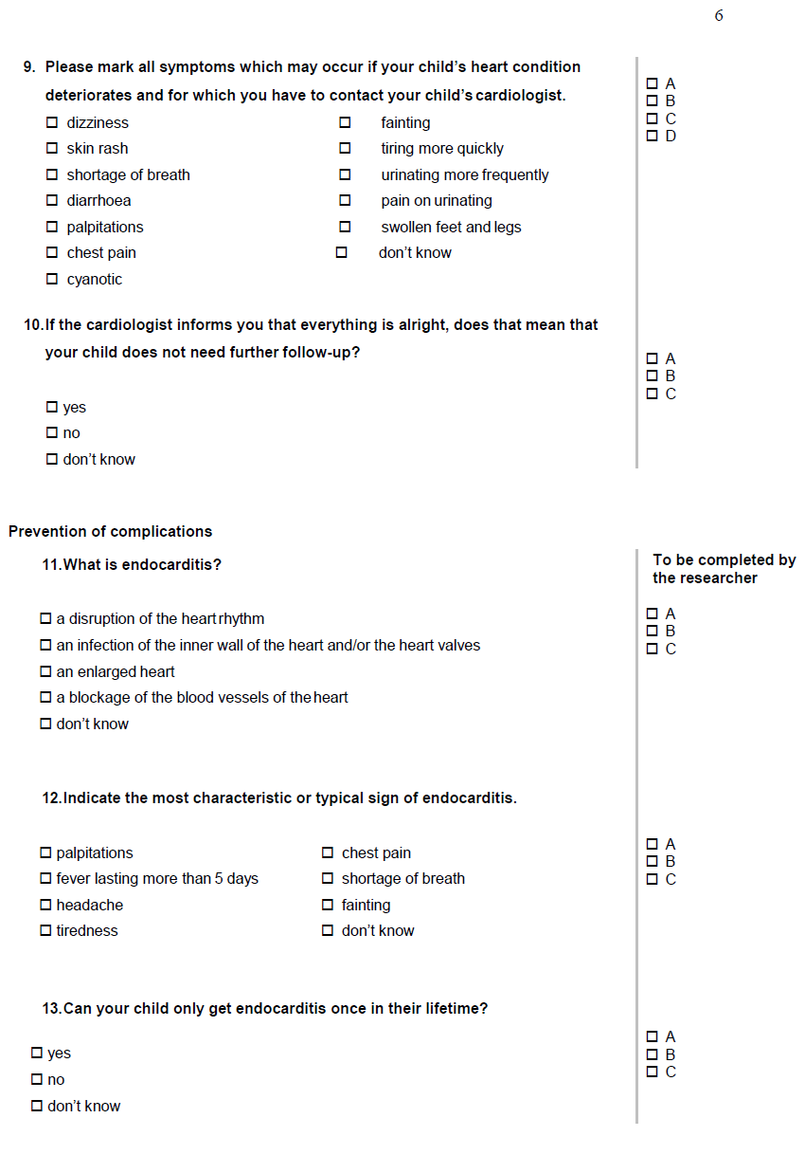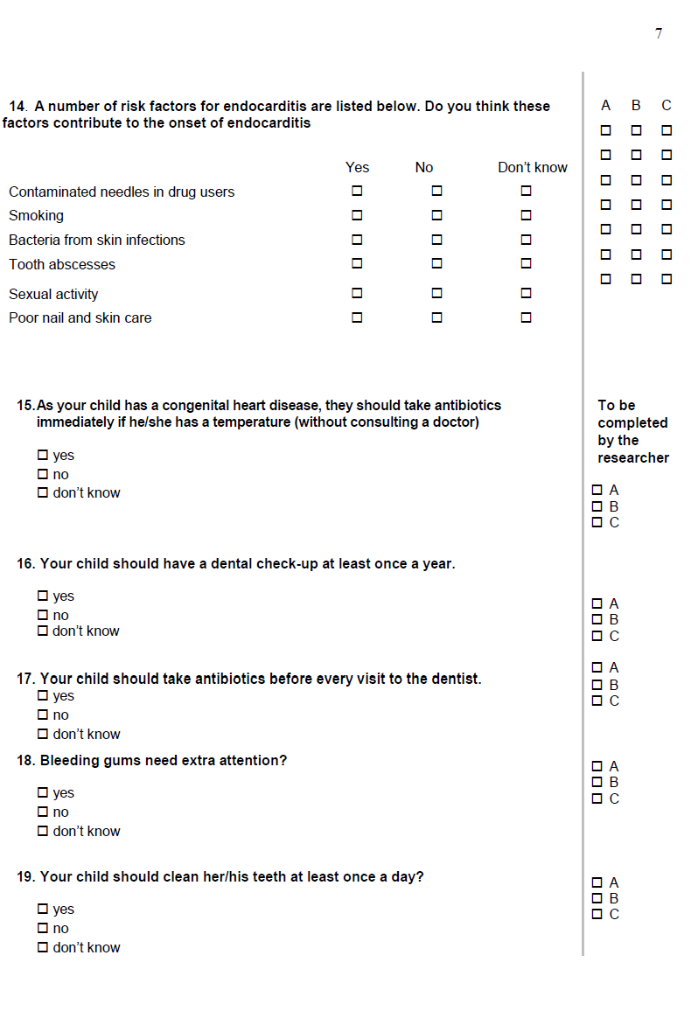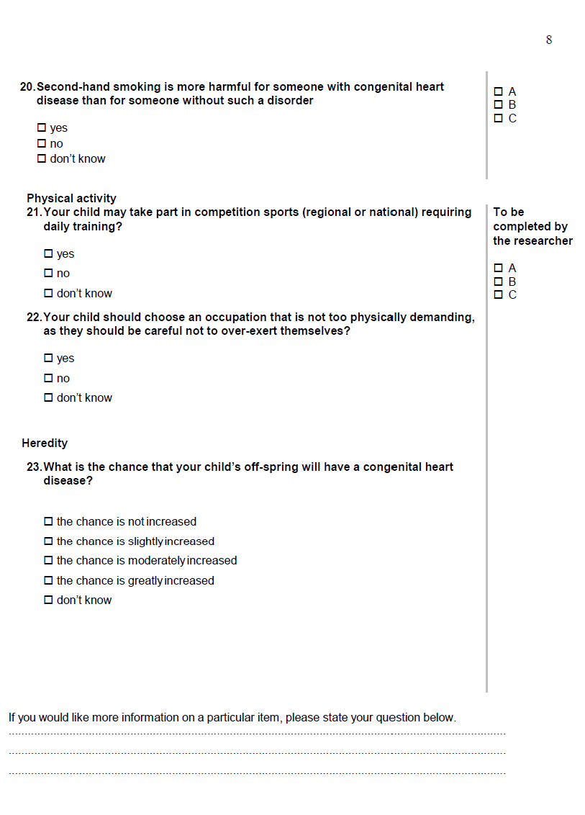
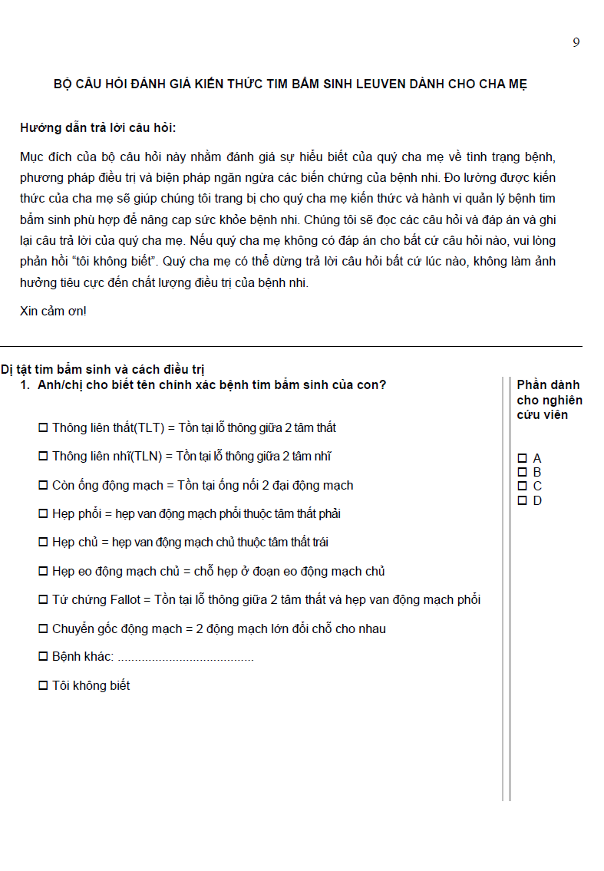
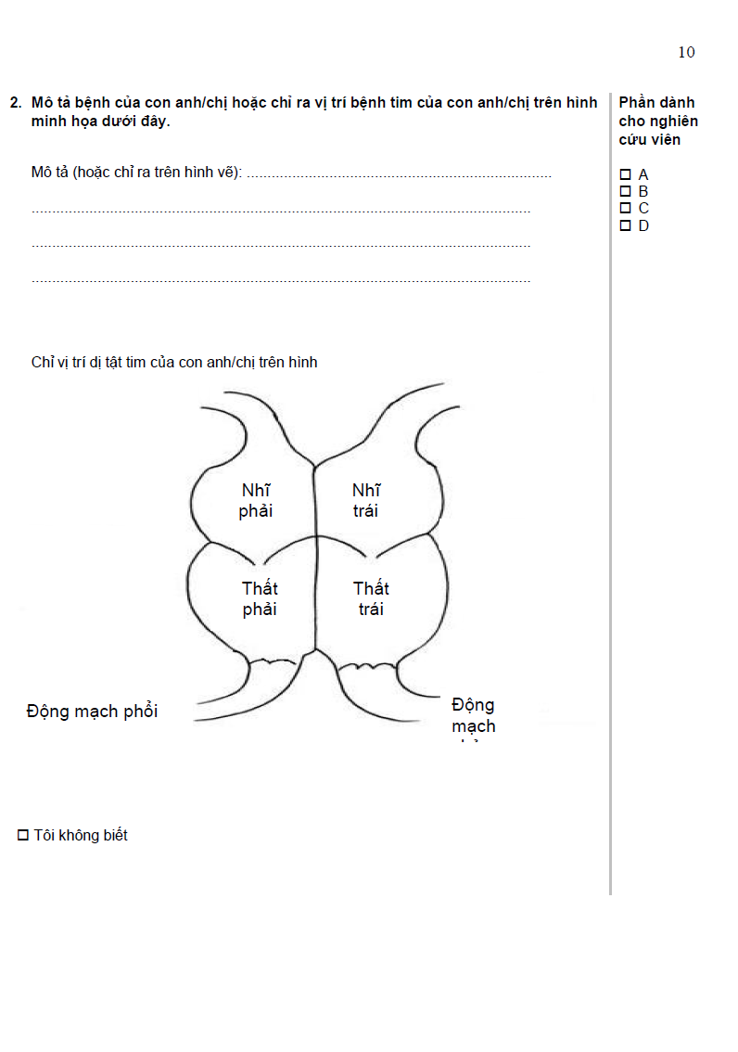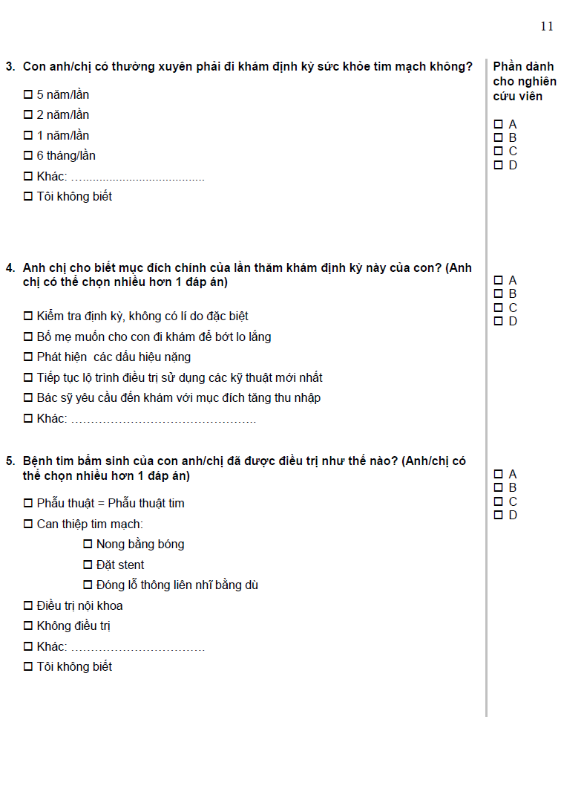

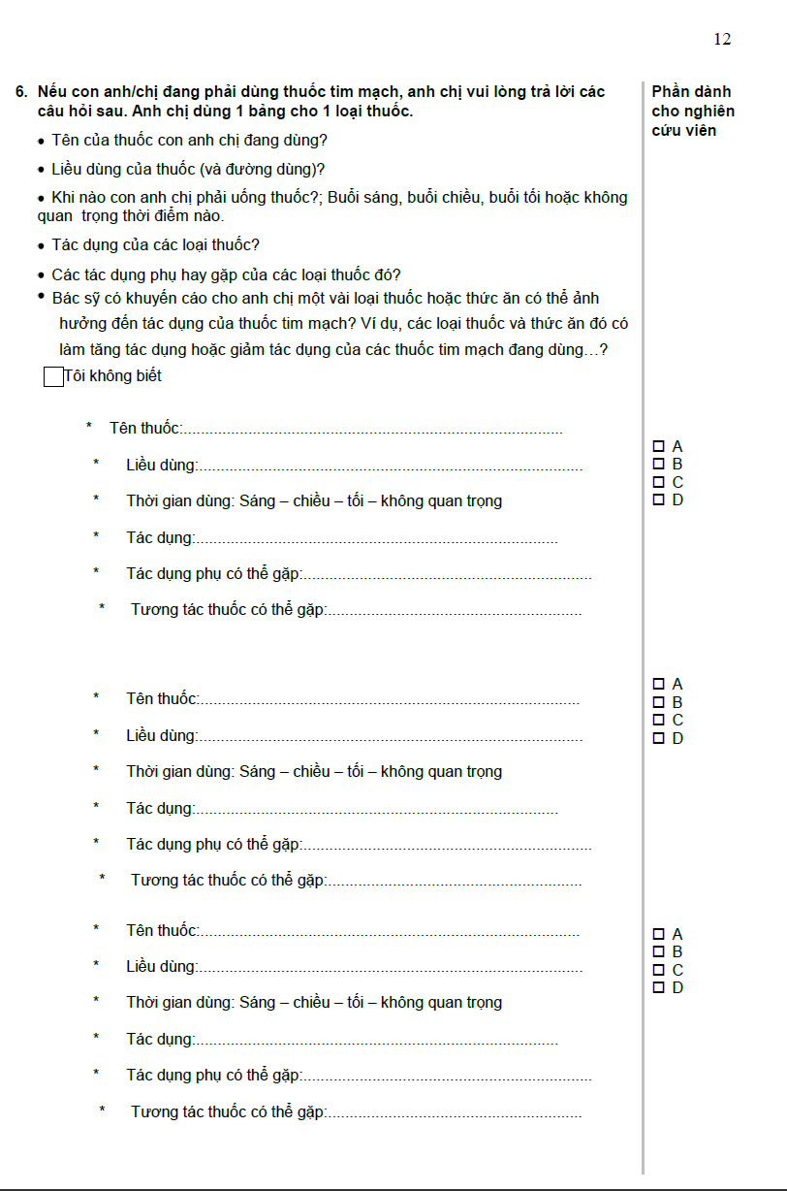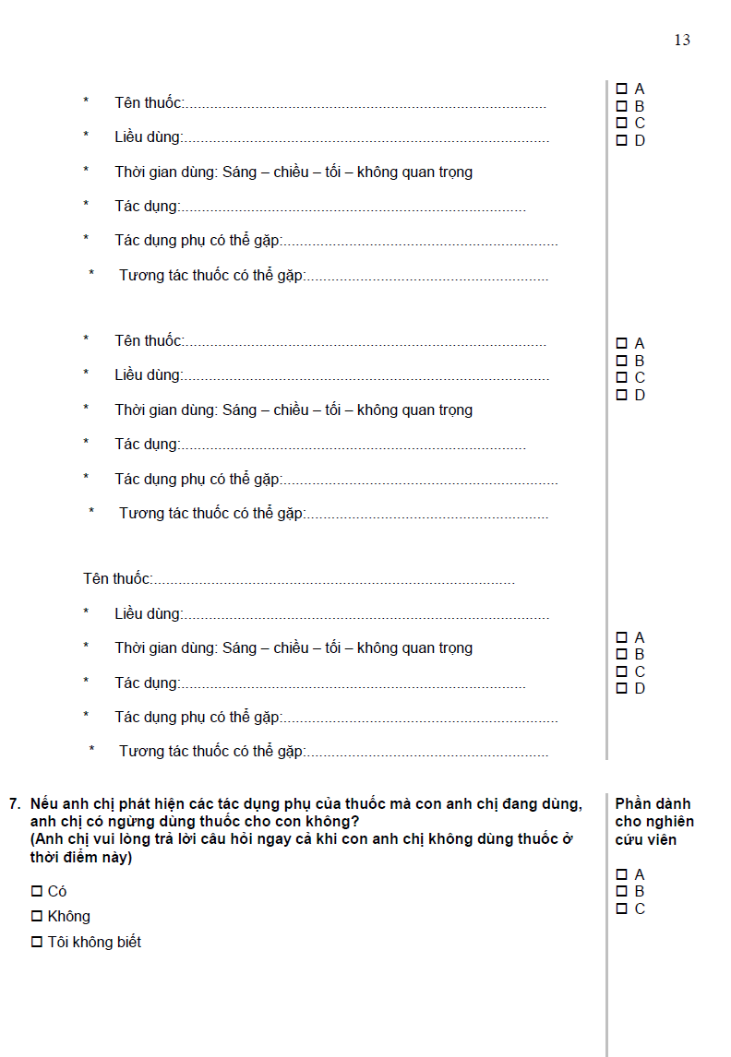
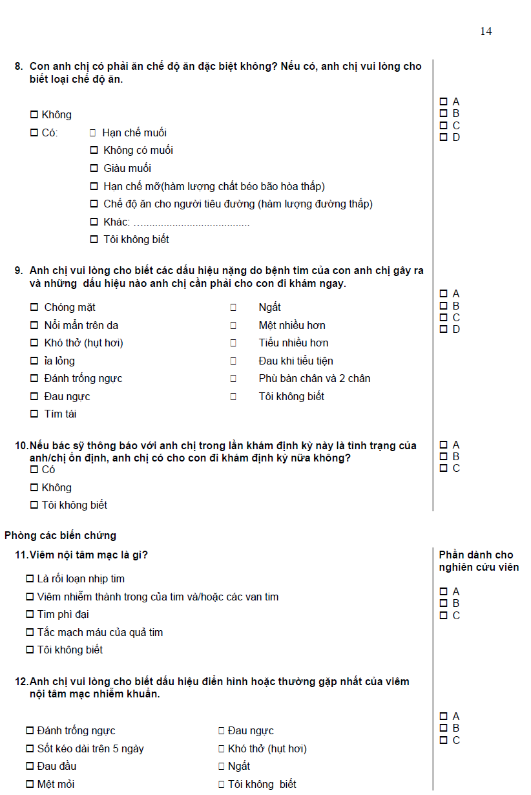
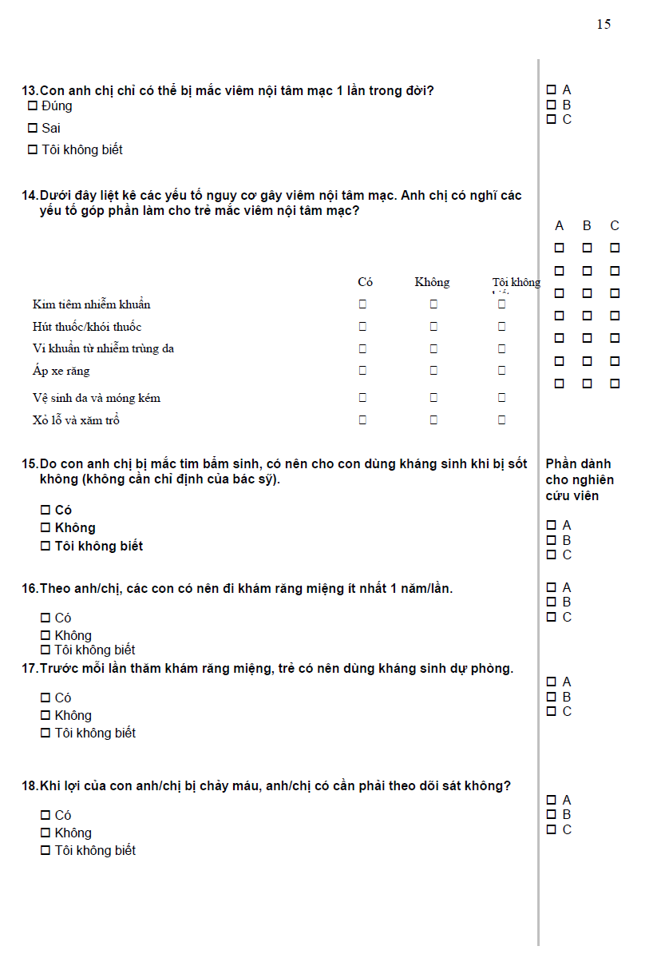
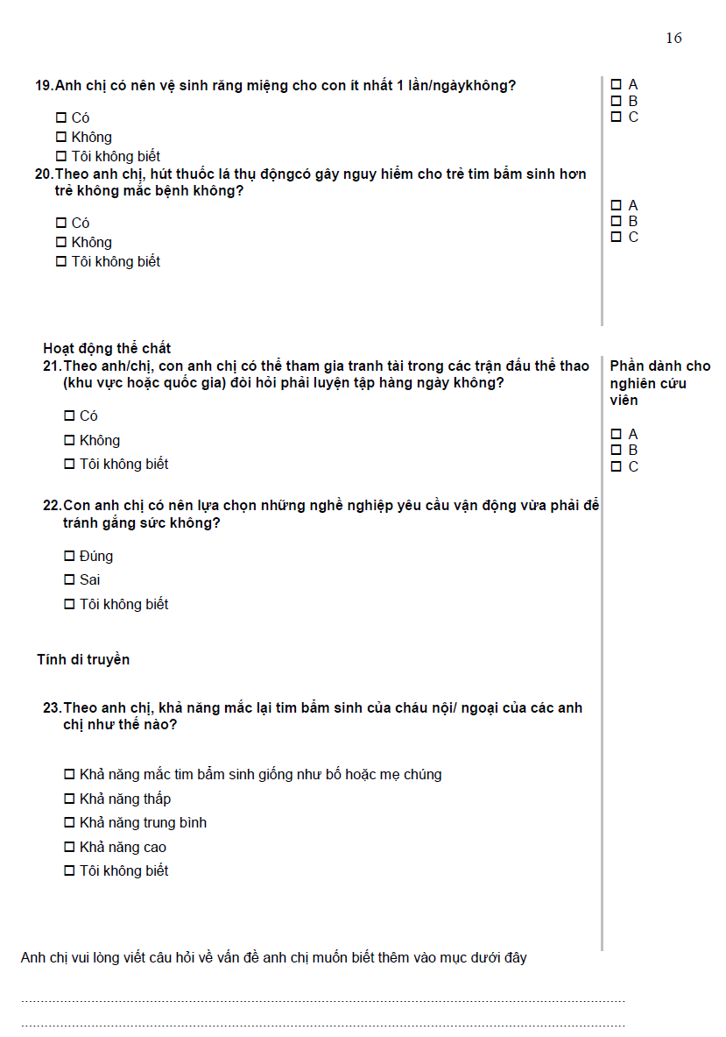

Appendix 4. The Vietnamese short-form health literacy instrument (V-HLS-SF12)
THE VIETNAMESE SHORT-FORM HEALTH LITERACY INSTRUMENT (V-HLS-SF12)
We would like to your perspectives on health literacy. On a scale from very easy to very difficult, how easy would you say it is to:
Questions |  | Very difficult | Difficult | Easy | Very easy
 | …find information on treatments of illnesses that concern you?
 | …understand the leaflets that come with your medicine?
 | …judge the advantages and disadvantages of different treatment options?
 | …call an ambulance in an emergency?
 | …find information on how to manage mental health problems like stress or depression?
 | …understand why you need health screenings (such as breast exam, blood sugar test, blood pressure)?
 | …judge which vaccinations you may need?
 | …decide how you can protect yourself from illness based on advice from family and friends?
 | …find out about activities (such as meditation, exercise, walking, Pilates etc. ) that are good for your mental well-being?
 | …understand information in the media (such as Internet, newspaper, magazines) on how to get healthier?
 | …judge which everyday behaviour (such as drinking and eating habits, exercise etc.) is related to your health?
 | … join a sports club or exercise class if you want to?

Thank you!
BỘ CÂU HỎI VỀ NĂNG LỰC VỀ SỨC KHỎE
Chúng tôi muốn tìm hiểu nhận thức của quý cha mẹ về năng lực sức khỏe. Với thang đo dưới đây từ mức độ “rất dễ” đến “rất khó”, cha mẹ nhận thấy mức độ dễ dàng khi thực hiện những việc sau đây của bản thân mình như thế nào?
Câu hỏi |  | Rất  khó | Khó | Dễ | Rất dễ
 | …tìm thông tin về việc chữa bệnh mà cha mẹ quan tâm?
 | …hiểu được các nội dung trong tờ hướng dẫn sử dụng thuốc?
 | …đánh giá được những ưu nhược điểm của các phương pháp điều trị khác nhau?
 | …gọi xe cứu thương trong trường hợp cấp cứu?
 | …tìm kiếm thông tin về làm thế nào để quản lý các vấn đề về sức khỏe tâm thần như căng thẳng hoặc trầm cảm?
 | …hiểu được tại sao ông/ bà cần kiểm tra sức khỏe (như khám vú, xét nghiệm đường máu, huyết áp)?
 | …cân nhắc và biết được loại vắc xin nào mà ông/ bà cần?
 | …quyết định cách tự bảo vệ sức khỏe để tránh bệnh tật dựa vào lời khuyên của gia đình và cha mẹ bè?
 | …tìm các hoạt động có lợi cho sức khỏe tâm thần (như thiền, tập thể dục, đi bộ, tập dưỡng sinh…)?
 | …hiểu các thông tin trên các phương tiện truyền thông (như Internet, báo, tạp chí..) về làm thế nào để nâng cao sức khỏe?
 | … đánh giá hành vi hàng ngày nào của cha mẹ (như các thói quen ăn uống, tập thể dục …) có liên quan đến sức khoẻ?
 | … tham gia các câu lạc bộ thể thao hoặc các lớp thể dục nếu cha mẹ muốn?

Xin cảm ơn!

Appendix 5. The Child Health Outcome Form
CHILD HEALTH OUTCOME FORM
- Child’s full name:………………………………………………………………………………
- Local ID:………………………………………………………………………………………..
- Data collection timepoint: (check one and add date)
- Admission (date):………………………………………………………………………………………….
- Discharge (date):………………………………………………………………………………………….
- Follow-up 1 (date):………………………………………………………………………………………
- Follow-up 2 (date):……………………………………………………………………………………….
- Oxygen saturation (number %):………………………………………………………………..
- Heart rate (beats per minute):…………………………………………………………………..
- Left ventricular ejection fraction (number %):…………………………………………………
- Weight – (bare? in kilograms; 1 decimal place):……………………………………………….
- Height (in centimetres; 1 decimal place):………………………………………………………
- Feeding type (Tick the appropriate box)
Breastfed
Bottle-fed
Tube fed
Other, please specify (e.g.: Mixed of breastfed and bottle-fed):
- Feeding amount/frequency
- Estimate of amount of milk per meal if not breastfed (e.g.: some breastfed and some bottle-fed) (in millilitres):……………………………………………………………………………….
- Frequency of meals per day if not breastfed (times per day):..........................................
- Breathing difficulties while feeding (Y/N):…………………………………………….
- Readmission (Y/N):……………………………………………………………………..
- Date:……………………………………………………………………………………………………..
- Reasons (e.g.: heart failure, respiratory failure, deterioration, overloaded, viral illness):………………………………………………………………………………………………….
- Major change in medical condition not anticipated (Y/N) (if Yes, move to Questions 13.1; 13.2 and 13.3, if No, move to Question 14):
- When did the major change happen (during hospital stay or after discharge)?
…………………………………………………………………………………………………………………………………………………………………………………………………………………………………………………………………………………………………………………………………………………..
- What is the new identified diagnosis or change in condition?
…………………………………………………………………………………………………………………………………………………………………………………………………………………………………………………………………………………………………………………………………………………..
- What changes in treatment did the child receive? (e.g.: require additional surgery, cath-lab or medication changes)
……………………………………………………………………………………………………………………………………………………………………………………………………………………………………………………………………………………………………………………………………………………
- Are there any social changes impacting on caring of the child? (Specify Yes or No; If Yes, move to Question 15; if No, the question ends):
- Please specify social changes and when they occurred (e.g., change in primary carer; parents get divorced; grandparents take care of the child; other major influences)?
…………………………………………………………………………………………………………………………………………………………………………………………………………………………………………………………………………………………………………………………………………………..
…………………………………………………………………………………………………………………………………………………………………………………………………………………………………………………………………………………………………………………………………………………..

MẪU TÌNH TRẠNG SỨC KHỎE CỦA BỆNH NHI
- Họ tên bệnh nhi:………………………………………………………………………………..
- Mã y tế:…………………………………………………………………………………………
- Thời điểm thu thập: (Chọn 1 và điền ngày)
- Nhập viện (ngày):………………………………………………………………………………………..
- Ra viện (ngày):…………………………………………………………………………………………….
- Khám lại lần 1 (ngày):…………………………………………………………………………………...
- Khám lại lần 2 (ngày):……………………………………………………………………………………
- Độ bão hòa oxy (số %):…………………………………………………………………………
- Nhịp tim (nhịp trên phút):……………………………………………………………………….
- Phân suất tống máu thất trái (số %):…………………………………………………………….
- Cân nặng – (Không mặc quần áo? Đơn vị kilogram; tính đến 1 số thập phân)
- Chiều cao (Đơn vị centimetres; tính đến 1 số thập phân):………………………………………
- Hình thức ăn của bệnh nhi (Đánh dấu vào ô phù hợp)
Bú mẹ
Bú bình
Ăn qua sonde
Khác, ghi rõ (Ví dụ: hỗn hợp):
- Lượng thức ăn/số bữa
- Định lượng sữa/bữa của bệnh nhi nếu bệnh nhi không bú mẹ (Ví dụ: lượng sữa mẹ và lượng sữa công thức) (đơn vị mililitre):………………………………………………………………………..
- Số bữa ăn trong ngày nếu bệnh nhi không bú mẹ (số bữa/ngày):................................................
- Bệnh nhi khó thở khi ăn (C / K):………………………………………………………………..
- Nhập viện lại (C/K)
- Ngày:……………………………………………………………………………………………………
- Lí do (Ví dụ: suy tim, suy hô hấp, xuất hiện dấu hiệu nặng, quá tải dịch, nhiễm virus): ……………………………………………………………………………………………………………
- Xuất hiện sự cố sức khỏe không mong muốn (C/K) (if Có, trả lời câu hỏi 13.1; 13.2 and 13.3, if không, chuyển đến câu 14):
- Khi nào bệnh nhi xuất hiện biến cố sức khỏe (Trong bệnh viện hay sau khi xuất viện)?
…………………………………………………………………………………………………………………………………………………………………………………………………………………………………………………………………………………………………………………………………………………..
- Biến cố sức khỏe/thay đổi tình trạng của bệnh nhi mới được phát hiện là gì?
…………………………………………………………………………………………………………………………………………………………………………………………………………………………………………………………………………………………………………………………………………………..
- Các thay đổi phác đồ điều trị của bệnh nhi? (Ví dụ: Mổ lại, thông tim chẩn đoán hoặc thay đổi thuốc)
…………………………………………………………………………………………………………………………………………………………………………………………………………………………………………………………………………………………………………………………………………………..
- Có xảy ra các thay đổi xã hội ảnh hưởng đến chăm sóc bệnh nhi không? (Ghi rõ Có hoặc Không; Nếu “Có” thì trả lời câu hỏi 15; nếu “Không” thì bộ câu hỏi kết thúc):
- Ghi rõ các thay đổi và thời điểm xảy ra (ví dụ: thay đổi người chăm sóc, cha mẹ li dị, ông bà chăm sóc bệnh nhi, các thay đổi lớn khác)?
…………………………………………………………………………………………………………………………………………………………………………
…………………………………………………………………………………………………………………………………………………………………………
……………………………………………………………………………………………………………………………………………………………………………………………………………………………………………………………………………………………………………………………………………………………………………………………………………………………………………………………………………………………………………………………..
Appendix 6. The Parent Demographic Form
PARENT DEMOGRAPHIC FORM
Primary caregiver of the child (mother, father, grandmother):
- Mother’s demographics
- Full name:
- Date of birth (yyyy):
- Gender (female/other):
- Residential address (commune/district/city):
- Phone number:
- Ethnicity (Kinh; Hmong, Tay):
- Educational level (write grade levels if parent did not finish 12-year schooling):
Primary school
Secondary school
High school
Vocational
Higher education
- Occupation:
- Father’s demographics
- Full name:
- Date of birth (yyyy):
- Gender (male/other):
- Residential address (commune/district/city):
- Phone number:
- Ethnicity (Kinh; Hmong, Tay):
- Educational level (write grade levels if parent did not finish 12-year schooling):
Primary school
Secondary school
High school
Higher education
- Occupation:
- For both parents
- Parents live together (Y/N; if Yes, tick “married” in “marital status”; if No, tick in the “separate; divorced or widowed” in “marital status”):
- Marital status
Married
Separated; divorced or widowed

- Number of children (If primary caregivers are parents of the child):
- Socioeconomic status (monthly income):

No income, dependants of the child’s grandparents
Below 5,000,000 VND
5,000,000 – 10,000,000 VND
Over 10,000,000 VND

- For alternative caregivers
- Does your child have an alternative caregiver? (Yes/No)
- Relationship with the child:
- Approximately how many hours per week does this person provide care to the child?
- Educational level:
MẪU THÔNG TIN HÀNH CHÍNH CỦA CHA MẸ
Người chăm sóc chính của bệnh nhi(mẹ, bố, bà…):
- Thông tin hành chính của mẹ
- Họ tên mẹ:
- Năm sinh (năm):
- Giới tính (Nữ/khác):
- Địa chỉ thường trú (xã-phường/huyện-quận/tỉnh-thành phố):
- Số điện thoại:
- Dân tộc (Kinh; Hmong, Tay…):
- Trình độ văn hóa (Ghi rõ lớp nếu mẹ không hoàn thành 12 năm học):
Tiểu học
Trung học cơ sở
Trung học phổ thông
Trường nghề
Đại học
- Nghề nghiệp:
- Thông tin hành chính của cha
- Họ tên cha:
- Năm sinh (năm):
- Giới tính (Nam/khác):
- Địa chỉ thường trú (xã-phường/huyện-quận/tỉnh-thành phố):
- Số điện thoại:
- Dân tộc (Kinh; Hmong, Tay…):
- Trình độ văn hóa (Ghi rõ lớp nếu cha không hoàn thành 12 năm học):
Tiểu học
Trung học cơ sở
Trung học phổ thông
Trường nghề
Đại học
- Nghề nghiệp:
- Thông tin chung của cha mẹ
- Cha mẹ sống cùng nhau (C/K; Nếu có đánh dấu “đã kết hôn” vào mục “tình trạng hôn nhân”; nếu không, đánh dấu vào ô “li thân” vào mục “tình trạng hôn nhân”):
- Tình trạng hôn nhân
Đã kết hôn
Li thân; li dị hoặc góa bụa

- Số con chung (Nếu cha mẹ là người chăm sóc chính của bệnh nhi):
- Điều kiện kinh tế xã hội (Thu nhập hàng tháng):

Không có thu nhập, sống dựa vào ông bà của bệnh nhi
Dưới 5,000,000 VND
5,000,000 – 10,000,000 VND
Trên 10,000,000 VND

- Thông tin hành chính của người chăm sóc phối hợp
- Bệnh nhi có người chăm sóc phối hợp không? (Có/Không):
- Quan hệ với bệnh nhi:
- Người chăm sóc phối hợp chăm sóc trẻ bao nhiêu giờ/tuần?
- Trình độ văn hóa:
Appendix 7. The Child Demographic Form
CHILD DEMOGRAPHIC FORM

- Child’s full name:……………………………………………………………………………..
- Local ID:……………………………………………………………………………………….
- Date of surgery (dd/mm/yyyy):………………………………………………………………..
- Date of Birth (dd/mm/yyyy):……………………………………………………………………
- Age at surgery (weeks/months):………………………………………………………………..
- Gender (male/female):……………………………….................................................................
- Birth order (1st child, 2nd child…):……………………………………………………………….
- Prematurity (gestational age; <37 weeks) (Y/N):……………………………………………….
- Pre-operative procedures/Intervention (tick the appropriate box):
Balloon atrioseptostomy; Extensive resuscitation; Inotrope therapy, Long transfer period; Ventilation; Not applicable
- Surgery information
- Diagnosis (on children’s medical records):……………………………………………………
- Procedure (on children’s medical records):……………………………………………………..
- RACHS-1 categories (from 1 to 6): ……………………………………………………………
- Numbers of previous heart surgeries (number):…………………………………………………
- Classification of surgery (tick the appropriate box):
Elective
Emergency
Urgent

MẪU THÔNG TIN HÀNH CHÍNH CỦA BỆNH NHI

- Họ tên bệnh nhi:………………………………………………………………………………..
- Mã y tế:………………………………………………………………………………………….
- Ngày phẫu thuật (dd/mm/yyyy):………………………………………………………………...
- Ngày sinh (dd/mm/yyyy):……………………………………………………………………….
- Tuổi lúc phẫu thuật (theo tuần/theo tháng):…………………………………………………….
- Giới tính (nam/nữ):………………………………………………………………………………
- Con thứ mấy (thứ nhất, thứ hai...):……………………………………………………………….
- Đẻ non (tuổi thai; <37 tuần) (C/K):……………………………………………………………..
- Quy trình/Can thiệp trước phẫu thuật (đánh dấu vào ô phù hợp):
Phá vách liên nhĩ bằng bóng; Hồi sức tích cực; Liệu pháp vận mạch, Thời gian vận chuyển dài; Thở máy; Không áp dụng
- Thông tin phẫu thuật
- Chẩn đoán (Hồ sơ bệnh án):……………………………………………………………………
- Phương pháp phẫu thuật (Hồ sơ bệnh án):……………………………………………………..
- RACHS-1 mức độ nguy cơ của phẫu thuật (Từ 1 to 6):………………………………………..
- Số lần phẫu thuật tim trước đó (số lần): ……………………………………………………….
- Phân loại phẫu thuật (Đánh dấu vào ô phù hợp):
Mổ theo lịch
Mổ cấp cứu
Mổ cấp cứu có trì hoãn

Appendix 8. Research Budget

RESEARCH BUDGET

Expense | Unit | Quantity | Cost in VND | Cost in AUD | References
Return ticket | Ticket | 1 | 25.027.500 | 1,500 | Singapore Airline
Wage for research assistants | Patient | 148 | 29.600.000 | 1,774 | Vietnamese wage norm for research assistants  http://www.salaryexplorer.com/salary-survey.php?loc=236&loctype=1&job=142&jobtype=3
Cost for printing the parent hard copy resources | Copy | 75 | 11.250.000 | 674 | Costs provided by the Vietnam Medical Publishing House
Cost for printing instruments | Page | 1,043 | 1.668.500 | 100 | AUD 0.10/page  For extra printing fees during data collection.
Total |  |  | 67.546.000 | 4,048

