Appendix 4

Participant Information Sheet

Date Information Sheet Produced: 22/11/2022

Project Title
Investigating the effect of nGVS on somatosensory perception in healthy adults.

Kia Ora I am Preet Kamal Kaur, a PhD student from AUT in Auckland who is interested in the brain, how it functions, and how we can maximise its abilities. Thank you for showing an interest in this project. This information sheet will help you decide if you would like to take part in this study. It explains what we are doing in the study, what your participation would involve, what the benefits and risks to you might be and what happens after the study ends. Please take time to consider this information, and, if you wish, talk with relatives, whānau, friends, or healthcare workers before deciding whether to participate. If you decide to participate, we thank you. If you decide not to take part, there will be no disadvantage to you, and we thank you for considering our request.

What is the purpose of this research?
We want to understand how the sensory information from the foot and information from the inner ear (vestibular system) work together to help us keep balanced on our feet. In this study we are adding an extra stimulation to the inner ear to see if this affects balance. The stimulation we are adding is called noisy galvanic vestibular stimulation (nGVS).
Galvanic vestibular stimulation (GVS) has been used for over 100 years to investigate balance and is a safe method. In our study we are using a particular form of GVS called nGVS, in which a weak stimulus that is not usually felt or heard is used.
The aim of this study is to determine whether nGVS changes the sensory perception of tactile stimulus in healthy older adults i.e., how well a person feels sensory inputs in the foot.
The results of this study will provide a greater understanding of the effects of nGVS on balance in future, the study may help in developing a new treatment using nGVS for people with poor balance. The findings of this research may be used for academic publications and presentations in various research journals or conferences.

How was I identified and why am I being invited to participate in this research?
You will have seen advertisement and have contacted one of the researchers involved in this study. We are looking for healthy volunteers to participate. You may be eligible for his study if you meet the following criteria:

Older Adults aged 65 years and over
Have no medical conditions such as epilepsy, diabetes, cardiac arrythmias, inner ear problem or active BPPV which might affect participation
Are right-handed
No speech dysfunction
No pacemakers or metal implants in head, neck and right foot
No skin allergies to adhesive plasters
Can stand for an hour without any difficulty or assistance (which is broken in three sessions of standing of 20 minutes each with a 2-minute break in between)
Are willing to take part in research for two sessions
Are willing to give consent to touch your head and neck
Can come to AUT (Akoranga campus) twice

Because we are using brain stimulation there are a few reasons why you might be excluded from this study. If you have or have had any of the following, this study is not suitable for you:

Have falls more than twice in the last 6 months
Any neurological impairment
Have a pacemaker, or other metal implants in your head or neck or right foot
Any speech dysfunction
Any allergic skin reaction to sticking plasters as a similar substance is used in the foot electrodes

We will be recruiting 27 people to participate in the study on first come first basis.

How do I agree to participate in this research?
If you have decided to take part in the study, we encourage you to contact the primary researcher (Preet Kamal Kaur) on her contact details given below, and if you have any questions, please feel free to ask. She will send the information sheets (PIS) describing in detail the study procedures and risks or benefits to you, by either email or post. She will contact you after ten days to know your decision. In the meantime, you are free to discuss the opportunity with your family (whanau) or friends. If you agree, we will call you to ask you some health specific questions to determine if you are eligible. If eligible we will arrange a time for you to come to AUT, Akoranga as per your convenience, for giving consent and to perform the study experiment. There will be two sessions in total, of an hour each approximately.
Your participation in this research is voluntary (it is your choice) and whether you choose to participate will neither advantage nor disadvantage you. You can withdraw from the study at any time. If you choose to withdraw from the study, then you will be offered the choice between having any data related to you removed or allowing it to use. However, once the findings have been produced, removal of your data may not be possible.

What will happen in this research?
This study involves a commitment of two sessions of an hour each approximately. There is also a need to touch your head and neck for this study. If you decide to take part you will be invited to come to Auckland University of Technology on Akoranga Dr, Northcote. This study will be conducted by Preet Kamal Kaur.
However, you are not required to provide or have a medical check up for this research. We will ask you to complete a simple health screening form to check you have no medical condition that would prevent you from participating in this research.

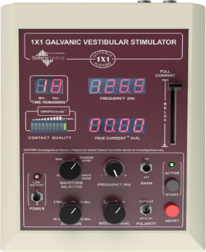 | 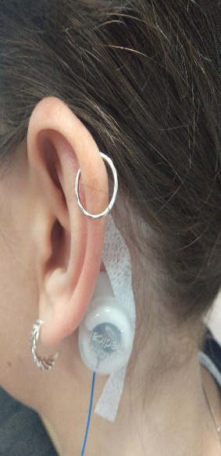 | 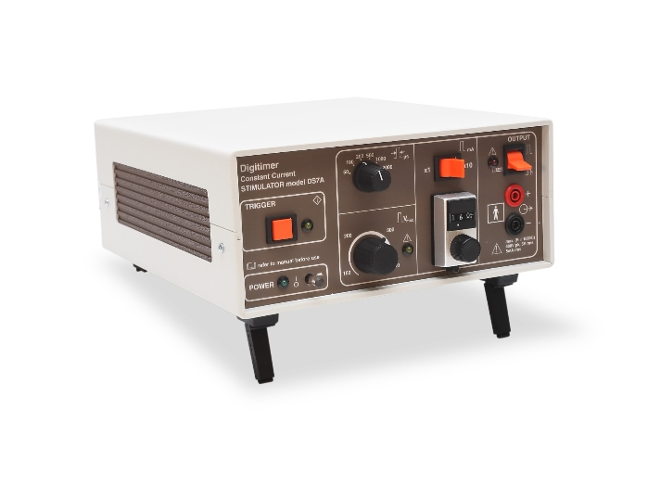
A | B | C | D

At the start of the session, we will confirm that you do not have any medical condition that might influence you taking part in the study.
Following this, you will be given a questionnaire to determine your handedness (left or right). You will be asked to tick the column that indicates which hand you use to do activities such as brushing your teeth, writing, drawing, opening box. Afterwards, you are asked to follow small 3 steps command, to see your cognitive ability such as “Say hello, tap the mouthpiece of the phone 3 times, then say I’m back”.
After this, the researcher will show you the nGVS machine (Figure A) and electrical stimulator machine Digitimer, Model DS7AH (Figure C). Then the research assistant will set up both machines and ask your permission to touch your head and neck for placing electrodes (Figure B) and on your right foot (Figure D). Then he/she will place electrodes i.e., behind the ears for nGVS stimulation and on your right foot.
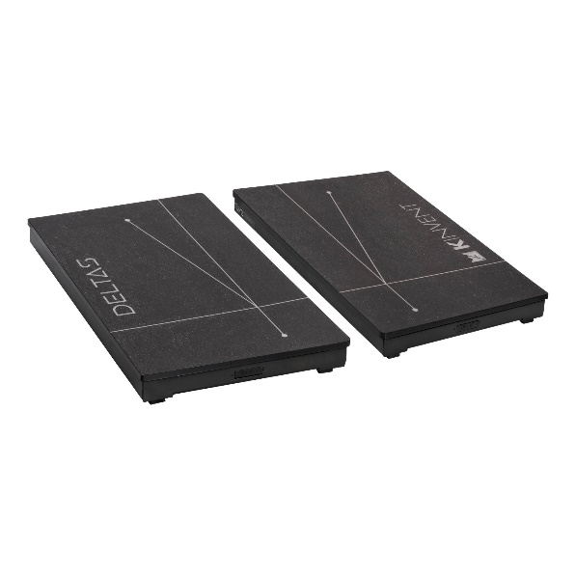
E
Then you will be asked to stand comfortably with your eyes closed on the portable force plates to measure your balance (Figure E).
First the nGVS machine will be turned on and you will receive nGVS stimulation for 20 minutes. The nGVS stimulation is very weak and sometimes you will not even feel it. When you are receiving nGVS stimulation you will receive small electrical stimulation to your right foot and will be asked if you can feel it. This electrical stimulus is not painful. These electrical stimuli will be repeated two more times.
At the same time the researcher will switch on the force plates twice which will automatically take your balance data without any hassle through inbuild software.

What are the discomforts and risks?
Occasionally people can develop redness under the nGVS electrodes or electrical stimulator electrodes or may get a mild reaction to adhesive tape if the skin is sensitive which can be improved by applying aloe vera gel. This usually disappears quickly, and your researcher will monitor this and help with this.
Added for older adults: Part B
There is no extra burden to you in measuring the balance outcomes on force plate as it is automatically measured by force plates.

What are the benefits?
There are no direct benefits to you. However, your contribution will help us to results of this study will provide a greater understanding of the effects of nGVS on balance. In future, the study may help in developing a new treatment using nGVS for people with poor balance. As a participant you will have the experience of participating in a modern research laboratory project.

What compensation is available for injury or negligence?
In the unlikely event of a physical injury because of your participation in this study, rehabilitation, and compensation for injury by accident may be available from the Accident Compensation
Corporation, providing the incident details satisfy the requirements of the law and the Corporation's regulations.

How will my privacy be protected?
Your personal information and assessment results will be labelled with a participant code which will be just given to you and will be kept with other participants’ data so we can investigate how effective the treatment has been.
All the identifiable health information will be kept private and confidential. Your non-identifiable data will be kept in locked password protected files in a locked room which will be destroyed after 10 years.
All data that is published outside of the research team will be anonymised and your name will be kept confidential. Results may be published in academic journals and used in conference presentations. Every attempt will be made to preserve your anonymity and your name will not be listed in any published material, nor will any information that could identify you.

What are the costs of participating in this research?
There may be some cost incurred coming to the session. We will provide you with a $20 countdown voucher for each time you have to travel to AUT, to help with that cost. The total time commitment for this study is 2 hours only (two sessions of 1 hour each approximately).

Will I receive feedback on the results of this research?
A summary of the results will be available to you at the end of the study if you would like to see them. You can also give consent if you wish your individual results or wish for your data to be used in future research studies.

What do I do if I have concerns about this research?
Any concerns regarding the nature of this project should be notified in the first instance to the Principal Investigator, Professor Denise Taylor, denise.taylor@aut.ac.nz, 09 921 9999 ext. 9680
Concerns regarding the conduct of the research should be notified to the Executive manager of AUTEC at +64 9 921 9999 extn: 6038

Whom do I contact for further information about this research?
Please keep this Information Sheet and a copy of the Consent Form for your future reference. You are also able to contact the research team as follows:
Researcher Contact Details:
Preet Kamal Kaur: preet.kamal.kaur@aut.ac.nz

Project Supervisor Contact Details:
Professor Denise Taylor: denise.taylor@aut.ac.nz

Dr Sharon Olsen: sharon.olsen@aut.ac.nz

