Patient Survey

Name __________________________________________
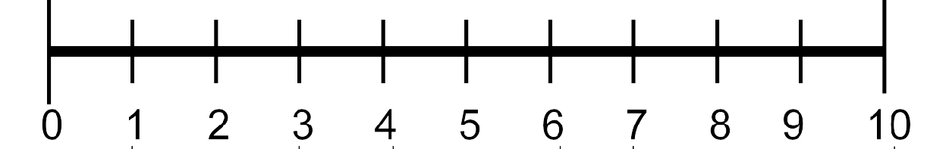
Pain: how would you rate your pain on a scale of 0 (no pain) to 10 (worst pain)?
Please circle the appropriate response.

Patient Satisfaction: ‘how would you describe the results of your procedure’
- Excellent
- Very good
- Good
- Fair
- Poor

Return to Work
Are you currently employed?
Y N
Have you returned to work?
Y N
How long after the procedure did you return to work?
________________________

QuickDASH
Please rate your ability to do the following activities in the last week by circling the number below the appropriate response.
NO
MILD
MODERATE
SEVERE
UNABLE

 | DIFFICULTY | DIFFICULTY | DIFFICULTY | DIFFICULTY
1. Open a tight or new jar. | 1 | 2 | 3 | 4 | 5
2. Do heavy household chores (e.g., wash walls, floors). | 1 | 2 | 3 | 4 | 5
3. Carry a shopping bag or briefcase. | 1 | 2 | 3 | 4 | 5
4. Wash your back. | 1 | 2 | 3 | 4 | 5
5. Use a knife to cut food. | 1 | 2 | 3 | 4 | 5
6. Recreational activities in which you take some force or impact through your arm, shoulder or hand | 1 | 2 | 3 | 4 | 5
(e.g., golf, hammering, tennis, etc.).

NOT AT ALL SLIGHTLY MODERATELY
QUITE A BIT
EXTREMELY

7. During the past week, to what extent has your arm, shoulder or hand problem interfered with your normal social activities with family, friends, neighbours or groups?

1 2 3 4 5

 | NOT LIMITED AT ALL | SLIGHTLY LIMITED | MODERATELY LIMITED | VERY LIMITED | UNABLE
8. During the past week, were you limited in your work or other regular daily activities as a result of your arm, shoulder or hand problem? | 1 | 2 | 3 | 4 | 5
Please rate the severity of the following symptoms in the last week. (circle number)
NONE
MILD
MODERATE
SEVERE EXTREME
9. Arm, shoulder or hand pain. 1 2 3 4 5

11. During the past week, how much difficulty have you had sleeping because of the pain in your arm, shoulder or hand? (circle number)
10. Tingling (pins and needles) in your arm, shoulder or hand.
1
2
3
4
5
NO
MILD
DIFFICULTY DIFFICULTY
SO MUCH MODERATE SEVERE DIFFICULTY DIFFICULTY DIFFICULTY THAT I
CAN’T SLEEP

1 2 3 4 5

For Hand Therapist to Complete

Grip strength

Wrist range of motion

Flexion ________________________________________

Extension ______________________________________

Supination _____________________________________

Pronation ______________________________________

