The Surgery Compared with Radiofrequency Ablation for Partial Wrist Denervation (SRAPiD) Trial

Investigators

Principal Investigator
Dr Abhinav Aggarwal
Position: Consultant Hand Surgeon
Institution: Sydney Hospital

Associate Investigators
Dr Peter Scougall
Position: Consultant Hand Surgeon
Institution: St Luke’s Hospital

Dr Damian Ryan
Position: Consultant Hand Surgeon
Institution: Macquarie University Hospital

Dr Richard Lawson
Position: Consultant Hand Surgeon
Institution: North Shore Private Hospital

Dr Sebastian Fung
Position: Consultant Radiologist
Institution: St Vincent’s Private Hospital

Dr Rosemary Prosser
Position: Hand Therapist
Institution: Sydney Hand Therapy

Ms Susan Dunn
Position: Hand Therapist
Institution: North Shore Hand Therapy

Ms Natalia Alfaro
Position: Hand Therapist
Institution: Macquarie Hand Therapy

Mr Ashwin Aggarwal
Position: Medical Student
Institution: South Western Sydney Clinical School UNSW

Confidential

This document is confidential. No part of it may be transmitted, reproduced, published, or used without the prior written authorisation of Dr Abhinav Aggarwal.

Statement Of Compliance

This clinical trial will be conducted in compliance with all stipulations in this protocol, the conditions of the ethics committee approval, and the NHMRC National Statement on ethical Conduct in Human Research (2018).

Summary

In this randomised control trial we look to compare two techniques of partial wrist
denervation (surgery, radiofrequency ablation) for improvement of pain in end-stage wrist
arthritis. Our hypothesis is that the intervention (radiofrequency ablation) is non inferior to
the control (surgery). The primary outcome is to compare pain scores for the two groups
using a visual analogue scale. The secondary outcomes include an assessment of function,
motion, strength, satisfaction and return to work. We believe this study to have importance in guiding future management decisions for this complex clinical scenario.

Introduction

The patient with painful, end stage wrist arthritis with high functional demands presents as a challenge to the hand surgeon. Traditionally, partial or total wrist arthrodesis has been considered in this population as a salvage procedure. This procedure has shown to be highly successful in the treatment of chronic wrist pain but at the expense of wrist motion (1). This can be quite limiting in patients who desire wrist motion for activities of daily living. A majority of these patients would elect to rather have a procedure that could make their wrist move (2) and there is a high perception of disability from reduced wrist motion (3) after arthrodesis. The complication rate from total wrist arthrodesis is not insignificant with issues relating to non-union or hardware prominence (4). For these reasons, a more conservative approach for management of chronic wrist pain may be preferable.

The use of partial wrist denervation for painful, end-stage wrist arthritis has been well described in the literature (5-12). It involves neurectomies of terminal sensory fibres of peripheral nerves that innervate the wrist capsule and or ligaments – commonly the anterior (AIN) and posterior (PIN) interosseous nerves. The procedure is minimally invasive and involves a single 3-4cm dorsal longitudinal incision through which both PIN and AIN neurectomy is performed. The procedure allows for a management of chronic wrist pain with a preservation of baseline motion. It results in high return to work rates (up to 94%) and patient satisfaction (up to 92%) (13), as well as improved pain (3.25 points) and grip strength (5.58 kg) (14). Additionally, an unsuccessful neurectomy also does not preclude or complicate subsequent salvage procedures which should not be seen as a complication. There is a relatively high survival rate (76%) at an average 18 months follow up (15).

Recently, a technique of percutaneous radiofrequency ablation for partial wrist denervation has been described (16). The procedure avoids the risks of surgery and can be done on an outpatient basis. The limited outcome results are similar to surgery for function, motion, strength and satisfaction (16). However, it is still an emerging technique without a strong evidence base or direct comparison to surgery.

In our study, we aim to conduct the first prospective, multicentre randomised clinical trial comparing surgery with radiofrequency ablation for partial wrist denervation in patients with painful, end stage wrist arthritis. The primary outcome is to compare pain scores for the two groups using a visual analogue scale. We propose a null hypothesis that there will be no significant differences between the groups. The secondary outcomes include an assessment of function, motion, strength, satisfaction and return to work. We believe this study to have importance in guiding future management for this complex clinical scenario.

Study Goals

i. To assess outcomes of surgery compared with radiofrequency ablation for partial wrist denervation in patients with painful, end stage wrist arthritis.

ii. To assess demographic characteristics of patients with painful, end stage wrist arthritis.

iii. To assess the response to local anaesthetic prior to surgery or radiofrequency ablation for partial wrist denervation in patients with painful, end stage wrist arthritis.

iv. To assess the complication profile for surgery or radiofrequency ablation for partial wrist denervation.

v. To assess the need for additional surgery after partial wrist denervation.

vi. To assess return to work timeframes after surgery or radiofrequency ablation for partial wrist denervation.

vii. To assess the health economic implications for surgery or radiofrequency ablation for partial wrist denervation.

Hypothesis: The outcomes will be similar for surgery or radiofrequency ablation for partial wrist denervation (null hypothesis).

Study Design

Type of Study: Prospective, Multicentre, Open Label, Randomised Clinical Trial

Centres: St Luke’s Hospital, Macquarie University Hospital, North Shore Private Hospital, St Vincent’s Private Hospital

Research Population: patients with painful end stage wrist arthritis that have failed non operative management and salvage procedures are being considered

Inclusion Criteria

≥ 18 yrs old
Proficiency in English
Capacity to comprehend the survey
Capacity to attend follow up

Exclusion Criteria

Wrist instability
Concomitant procedures (e.g. carpal tunnel release)
Patients with medical conditions that preclude anaesthesia or surgery
People with a cognitive impairment, an intellectual disability or a mental illness

Expected Duration: 3-4 yrs

Methodology

Patients with painful, end stage wrist arthritis that have failed non operative management and are being considered for salvage procedures will be screened by the hand surgeons (PS, DR, RL) for eligibility. The study investigators will determine the diagnosis of end stage wrist arthritis for each trial candidate according to their medical history, presentation, physical examination and radiographic confirmation of arthritis within the previous 6 months in the
affected (index) wrist to be treated. Once screened for eligibility, each patient will receive an image guided diagnostic local anaesthetic nerve block as a predictor of response to partial wrist denervation. This will be an ultrasound guided blockade of the PIN and AIN using an injection of a local anaesthetic (Marcaine [bupivacaine] 0.5%) by a consultant radiologist (JK, JL). A patient is deemed a positive responder if he/she experiences a 50% decrease in pain score on the numeric rating scale relative to baseline within 24hrs after the local anaesthetic blockade. Those with a good response to diagnostic nerve block will be considered as benefitting from a partial wrist denervation procedure and invited to participate in the study. Each patient consultation will follow a standard format of initially explaining the study, providing an information sheet and obtaining written informed consent if the patient chooses to participate. The following demographic data will be collected for each patient.

a. Age
b. Sex
c. Handedness
d. Occupation
e. Insurance Status
f. Diagnosis

Simple randomisation to surgery group or radiofrequency ablation group will occur according to computer-generated random numbers. The randomisation will be carried out by an independent person, who is unaware of the study protocol and not otherwise in control of the study. This independent person will place the allocation list in sequentially numbered, opaque, tamper-proof envelopes handled only by the independent person and the principal researcher. The researchers are blinded to the allocation sequence. As a patient is enrolled in the study, the associate researchers (hand surgeon, interventional radiologist) will contact the principal researcher, who will open the relevant envelope and reveal the randomised allocation to the associate researcher. Because of the interventions being compared (surgery versus radiofrequency ablation) it will not be possible to blind participants, surgeons or hand therapists to outcomes. Though this increases the risk of performance and detection bias, care will be taken to ensure that the treatment outside the intervention is identical between groups.

Surgery

Three surgeons (PS, DR, RL) will perform the surgery for partial wrist denervation with neurectomy of the terminal branches of anterior (AIN) and posterior (PIN) interosseous nerves using a single dorsal incision.

Patients will receive either a regional anesthetic or local anesthesia with parenteral sedation. A pneumatic tourniquet will be applied to the upper arm. A 3-5cm longitudinal incision will be made dorsally over the interval between the distal radius and ulna. The deep antebrachial fascia will be excised longitudinally, exposing the musculotendinous junction of the extensor digitorum communis. The extensor digitorum communis tendons are retracted, exposing the PIN, lying on the dorsal surface of the interosseous membrane. 2cm of the PIN is resected with bipolar cautery. A 2-3cm longitudinal incision is then made in the distal aspect of the interosseous membrane, exposing the AIN, lying between the interosseous membrane and the deep surface of the pronator quadratus muscle. 2cm of the AIN is resected with bipolar cautery. The tourniquet is released and haemostasis is performed. A layered wound closure is completed and a soft, sterile dressing applied.

Postoperatively, follow up will occur at 1-2 weeks for a wound check. The patient will commence guided range of motion exercises with hand therapy after the initial follow up appointment (RP, SD, NA). The therapy will progress with weekly sessions (30-60mins) for 4 weeks. The therapy will be administered by certified hand therapists from either a physiotherapy or occupational therapy background. The protocol for hand therapy includes

Post Op Week 1
- removal post op dressings
- wound care and oedema control as required
- start early desensitization over dressings
- start early active range of motion exercises
- proprioceptive exercises – gentle and mid-range
- focus on education regarding importance normal movement patterns and integration of hand function during light ADLs

Post Op Week 2
- remove wound steri strips and commence scar massage
- ongoing oedema control as required (+/- intermittent use of tubigrip)
- increase desensitization program
- progress active range of motion exercises, add progressive end of range stretch and upgrade proprioceptive exercises
- ongoing focus functional use and normal movement patterns

Post Op Week 3
- discard any use of tubigrip or supports
- progress end of range stretches and proprioception exercises aiming for full range of motion
- commence light strengthening and further increase focus heavier functional use
- return to work or sports

Post Op Week 4
- upgrade strengthening program
- final review with expectation of full functional recovery
- discharge from hand therapy

Strategies to monitor patient adherence to therapy protocol include 1/ use of patient therapy diary for instructions for home program which requires patient to ‘tick the box’ when done prescribed program daily and 2/ at beginning of each session therapist to ask for demonstration of previous sessions home program.

Radiofrequency Ablation

One radiologist (SF) will perform the radiofrequency ablation for partial wrist denervation with neurectomy of the terminal branches of anterior (AIN) and posterior (PIN) interosseous nerves using a single dorsal approach.

The procedure is done on an outpatient basis without sedation. Ultrasound guidance is used to visualise the dorsal forearm compartment using a transverse anatomic projection along the short axis of the extensor tendons. The PIN is described as a thin, hypoechoic, and noncompressible ovoid structure (1-3mm) located along the radial margin of the
fourth extensor compartment between the extensor digitorum communis and extensor pollicis longus (16). Once the nerve has been identified, 2mL of 1% lidocaine is injected around the nerve for confirmation prior to ablation. A radiofrequency ablation probe is then advanced at a 45deg angle in a proximal to distal direction tangential to the major axis of the PIN. A 480Hz direct current is applied, generating an ablation effect of 80°C/J, maintained for 60 seconds. The AIN is then visualised between the interosseous membrane and deep surface of pronator quadratus. A similar sequence of confirmation is performed with 2mL of 1% lidocaine from the dorsal forearm through the interosseous membrane. The radiofrequency probe is then placed adjacent to the AIN. Another 480Hz direct current is applied, generating an ablation effect of 80°C/J, maintained for 60 seconds.

The patient will commence guided range of motion exercises with hand therapy after the initial follow up appointment (RP, SD, NA). Hand therapy will be conducted in the same manner as for participants in the surgery arm.

Outcome Measures

The following outcome measures will be collected prior to intervention at baseline and then at 3, 6 and 12 months.

g. Pain Score
severity using an 11-point numeric rating scale (NRS) ranging from 0 (no pain) to 10 (worst pain)
h. Quick Disabilities of the Arm, Shoulder and Hand (QuickDASH) Score
i. Patient Satisfaction
j. Return to Work
k. Grip Strength
l. Range of Motion
Flexion
Extension
Supination
Pronation

These outcome measures (g-j) will be collected by surveys completed prior to intervention at baseline and then at 3, 6 and 12 month follow up intervals. A single nominated hand therapist will assess grip strength and range of motion (k, l) for each patient through the defined time intervals. Grip strength (k) will be measured using a Jamar dynamometer (Lafayette Instrument Company, Lafayette, IN). 12 months was chosen as the duration of follow up as that is the expected duration of pain improvement after partial wrist denervation. All patients will be evaluated for complications, need for additional surgery or cross over between groups until the final follow up at 12 months. These outcome measures were chosen from similar studies looking at outcomes of partial wrist denervation (17) that would allow us to longitudinally compare the two intervention groups.

The protocol is summarised as follows.
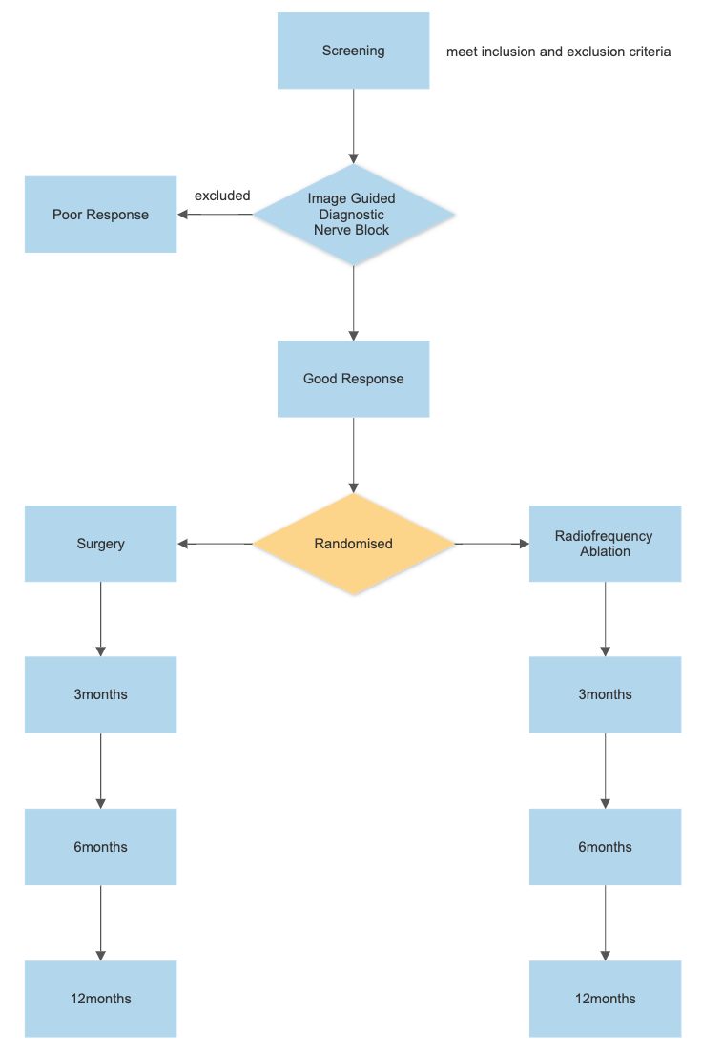

Statistical Analysis and Data Management

Using SPSS Statistical Software and Microsoft Excel, descriptive statistics will be produced to
analyse data obtained from the study. In this process, scores will be assigned to each
question and univariate analysis will be used to examine mean values and confidence
intervals for each response.

This study is a non-inferiority clinical trial, where we aim to show the intervention
(radiofrequency ablation) to be non-inferior to the control (surgery). The mean clinical
important difference (MCID) has been approximated as 2 for the primary outcome (pain
score using VAS) based on previous literature (13, 15). A power analysis was conducted
using an alpha value of 5% and beta value of 80%. A standard deviation was assumed to be
2.3 (17). A sample size of 34 patients (17 patients in each group) would be required to
adequately power this trial. We aim to recruit 42 patients (21 in each group) to allow for 20% loss to follow up.

All data will be handled securely and in accordance with patient privacy. Each computer
containing data will be password protected and paper records will be stored in a locked
cabinet within the hand surgery department. After the data collection is completed, all
identifiers will be removed.

Timepoints

Prior to Intervention (0 months)

3, 6 and 12 months

Ethical Considerations

Both treatment arms (surgery, radiofrequency ablation) are current standards of care in management of patients with painful, end stage wrist arthritis where salvage procedures are being considered. Potential harms from either procedure are rare but include persistent pain, infection, neuroma or complex regional pain syndrome. The risk profile is considered similar for both procedures.

Patients will be assured that their participation in this research project is voluntary and that their normal clinical care will not be influenced by their participation (or lack of participation) in the research project, and that they can withdraw from the project at any time. Any information that is obtained in connection with this study and that can be identified with the participant will remain confidential and will be disclosed only with permission of the participant or except as required by law. In any publication, information will be provided in such a way that participants cannot be identified. Participation in this research is not expected to influence future relationships with staff or the health service. Participants will not receive any benefits for their participation. Potential harms from the study are restricted to the time and inconvenience of completing the questionnaire.

Expected Outcomes

It is expected that this study will help inform our management of patients with end stage wrist arthritis resulting in pain and disability. The study will be published in a peer reviewed journal.

Acknowledgements

We acknowledge the time and support of our radiologists, Dr John Korber and Dr James Linklater.

References

(1) Field J, Herbert TJ, Prosser R: Total wrist fusion: A functional assessment. J Hand Surg Br 1996;21(4):429-433.8856527

(2) Adey L, Ring D, Jupiter JB. Health status after total wrist arthrodesis for posttraumatic arthritis. J Hand Surg Am. 2005 Sep;30(5):932-6.

(3) Adams BD, Grosland NM, Murphy DM, McCullough M: Impact of impaired wrist motion on hand and upper-extremity performance. J Hand Surg Am 2003;28(6):898-903.14642503

(4) Berber O, Garagnani L, Gidwani S. Systematic Review of Total Wrist Arthroplasty and Arthrodesis in Wrist Arthritis. J Wrist Surg. 2018 Nov;7(5):424-440.

(5) Dellon AL, Mackinnon SE, Daneshvar A. Terminal branch of anterior interosseous nerve as source of wrist pain. J Hand Surg Br. 1984;9(3):316e322.

(6) Dellon AL. Partial dorsal wrist denervation: resection of the distal posterior interosseous nerve. J Hand Surg Am. 1985;10(4): 527e533.

(7) Ferreres A. Wrist denervation: surgical considerations. J Hand Surg Br. 1995;20(6):769e772.

(8) Weinstein LP, Berger RA. Analgesic benefit, functional outcome, and patient satisfaction after partial wrist denervation. J Hand Surg Am. 2002;27(5):833e839.

(9) Hofmeister EP, Moran SL, Shin AY. Anterior and posterior interosseous neurectomy for the treatment of chronic dynamic instability of the wrist. Hand (NY). 2006;1(2):63e70.

(10) Van de Pol GJ, Koudstaal MJ, Schuurman AH, Bleys RL. Innervation of the wrist joint and surgical perspectives of denervation. J Hand Surg Am. 2006;31(1):28e34.

(11) Riches PL, Elherik FK, Breusch SJ. Functional and patient-reported outcome of partial wrist denervation versus the Mannerfelt wrist arthrodesis in the rheumatoid wrist. Arch Orthop Trauma Surg. 2014;134(7):1037e1044.

(12) Swärd EM, Franko MA, Wilcke MK. The effects of partial wrist denervation in wrist osteoarthritis: patient-reported outcomes and objective function. Journal of Hand Surgery (European Volume). 2022;47(8):798-804.

(13) Chin KWTK, Engelsman AF, van Gulik TM, Strackee SD. Selective denervation of the wrist for chronic pain: a systematic literature review. J Hand Surg Eur Vol. 2020 Mar;45(3):265-272.

(14) Tieman TE, Duraku LS, van der Oest MJ, Hundepool CA, Selles RW, Zuidam JM. Denervation of the Joints of the Hand and Wrist: Surgical Techniques and a Systematic Review with Meta-Analysis. Plastic and Reconstructive Surgery. 2021;148(6):959e-972e.

(15) Kadhum M, Riley N, Furniss D. Is partial wrist denervation beneficial in chronic wrist pain? A systematic review. J Plast Reconstr Aesthet Surg. 2020 Oct;73(10):1790-1800.

(16) Smeraglia F, Berritto D, Basso MA, Mosillo G, Grassi R, Mariconda M. Percutaneous Radiofrequency Ablation of the Posterior and Anterior Interosseous Nerves for Chronic Wrist Pain: A Novel Technique. Tech Hand Up Extrem Surg. 2020 Jun 26;25(2):89-93.

(17) Milone MT, Klifto CS, Catalano LW. Partial Wrist Denervation: The Evidence Behind a Small Fix for Big Problems. J Hand Surg Am. 2018 Mar;43(3):272-277.

(18) Myles PS, Myles DB, Galagher W, Boyd D, Chew C, MacDonald N, Dennis A. Measuring
acute postoperative pain using the visual analog scale: the minimal clinically important
difference and patient acceptable symptom state. Br J Anaesth. 2017 Mar 1;118(3):424-429.

