Study Protocol

Investigating the effect of multidisciplinary prehabilitation on deconditioning, hospital acquired complications and length of stay in patients offered Haematopoietic allogenic stem cell transplant: A feasibility trial.

Sponsor
RAH Haematology Clinical Trials & Cancer Haematology

Table of Contents
Study Protocol 1
Investigators 4
Executive Summary 8
Title 8
Background 8
Aims 9
Study Procedures 9
Specific eligibility criteria 10
Inclusion Criteria 10
Exclusion Criteria 10
Sample Size 10
Recruitment Strategy 10
Written Informed Consent 11
Multi-disciplinary Prehabilitation program 11
Dietetics intervention “Optimising Nutrition” 12
Exercise Program “Time to get Moving” 12
Social Work “Legal and Financial Support” 12
Occupational Therapy intervention “Preparing for Transplant” 13
Psychology “Enhancing coping skills” 14
Method 14
Feasibility 14
Pre-liminary Efficacy 15
Hospital-related outcomes 15
Ethical Considerations 15
Potential benefits 15
Potential risks 16
Indemnity and Compensation for injury 17
Protocol deviations 17
Data Management 18
Data Collection 18
Database 18
Publication 19
Data Analysis 19
Management of Adverse Advents 19
Safety Reporting Requirements 20
Confidentiality 20
Project Activity Timeline 21
Study Flow 22
References 23
Appendices 24
Appendix 1 24
Appendix 2 34
Appendix 3 38
Appendix 4 45
Appendix 5 48
Appendix 6 49
Appendix 7 52
Appendix 8 55
Appendix 9 56
Appendix 10 57

Investigators
Sponsor
RAH Haematology Clinical Trials & Cancer Haematology
Central Adelaide Local Health Network Research Finance Team: Research Office
Level 3 Roma Mitchel Building
136 North Terrace, Adelaide SA 5000

Project Endorser
A/Prof Peter Bardy
Consultant Haematologist
Royal Adelaide Hospital
Port Rd, Adelaide SA 5000

Investigators
Karlee Naumann
Exercise Physiologist, Principal Investigator
BClinExPhys, MRes
Youth Cancer Services
Royal Adelaide Hospital
Port Rd, Adelaide SA 5000
Email: karlee.naumann@sa.gov.au
Phone: 040716 8145
Responsibilities: Protocol development, ethics application, recruitment, baseline data collection/assessments, deliver intervention, post-intervention data collection/assessments, data cleaning and analysis, writing/manuscript publication

Mr Morgan Atkinson
Program Manager
BAppSc. (HM), BHlthSc (HM)
Youth Cancer Services SA/NT
Royal Adelaide Hospital
Port Rd, Adelaide SA 5000
Email: morgan.atkinson@sa.gov.au
Phone: 0419527081
Role: Investigator
Responsibilities: Protocol development, ethics application, data cleaning and analysis, writing/manuscript publication

Tianna Ceravolo
Senior Occupational Therapist CALHN
BHlthSc, Master of OTRoyal Adelaide Hospital
Port Rd, Adelaide SA 5000
Email: tianna.ceravolo@sa.gov.au
Phone: 0448666755
Role: Investigator
Responsibilities: Protocol development, ethics application, baseline data collection/ assessments, deliver intervention, post-intervention data collection/ assessments, data cleaning and analysis, writing/publication of manuscript

Swapna Deepak
Social Worker CALHN
BArts, Master of SW
Royal Adelaide Hospital
Port Rd, Adelaide SA 5000
Email: swapna.deepak@sa.gov.au
Phone: 0428 420 890
Role: Investigator
Responsibilities: Protocol development, ethics application, baseline data collection/ assessments, deliver intervention, post-intervention data collection/ assessments

Vanessa Kay
Social Worker CALHN
Royal Adelaide Hospital
Port Rd, Adelaide SA 5000
Email: vanessa.kay@sa.gov.au
Phone: 0481 462 293
Role: Investigator
Responsibilities: Protocol development, ethics application , deliver intervention, writing/publishing manuscript

Peter Konstantopoulos
Senior Dietitian CALHN
BSci (Biomedical), BNutrition and Dietetics, Hons HlthSci (Biochemistry/Molecular Biology)
Royal Adelaide Hospital
Port Rd, Adelaide SA 5000
Email: peter.konstantopoulos@sa.gov.au
Phone: 0412545260
Role: Investigator
Responsibilities: Protocol development, ethics application, baseline data collection/ assessments, deliver intervention, post-intervention data collection/ assessments, writing/publishing manuscript

Prof Carol Maher
Professor of Population Health
PhD (Physiotherapist)
University of South Australia
Corner of North Terrace and, Frome Rd
Adelaide SA 5001
Email: carol.maher@unisa.edu.au
Phone: +61 8 830 22315
Role: Investigator
Responsibilities: Protocol development, ethics application, consultation/support during research, data cleaning and analysis, writing/publication of manuscript

Dr Ben Singh
Research Fellow
PhD (Exercise Physiologist)
University of South Australia
Corner of North Terrace and, Frome Rd
Adelaide SA 5001
Email: ben.singh@unisa.edu.au
Phone: +61 8 830 22446
Role: Investigator
Responsibilities: Protocol development, ethics application, consultation/support during research, data cleaning and analysis, writing/publication of manuscript

Annabel Tolfts
Senior Physiotherapist CALHN
Royal Adelaide Hospital
Port Rd, Adelaide SA 5000
Email: Annabel.tolfts@sa.gov.au
Phone: 7074 0000
Role: Investigator
Responsibilities: Protocol development, ethics application, baseline data collection/ assessments, deliver intervention, post-intervention data collection/ assessments

Alison Virieux
Bone Marrow Transplant Coordinator
BA Nursing, Grad Cert (Social Science)
Royal Adelaide Hospital
Port Rd, Adelaide SA 5000
Email: Alison.Virieux@sa.gov.au
Phone: Ext 43173
Role: Investigator
Responsibilities: Protocol development, ethics application , Recruitment, post-intervention data collection/ assessments, data cleaning and analysis, writing/publishing manuscript

Michelle Wall
MDS/AML Nurse Consultant RAH
Dip HE, BA (Hons), MSc, PG CertRoyal Adelaide Hospital
Port Rd, Adelaide SA 5000
Email: michelle.wall@sa.edu.au
Phone: 0400532188
Role: Investigator
Responsibilities: Protocol development, ethics application, recruitment, post-intervention data collection/ assessments, data cleaning and analysis, writing/publication

Dr Sarah Wilksch
Senior Clinical Psychologist
PhD (Clinical Psychology), BA Psychology (Honours)
CALHN Cancer Services Psychology
Royal Adelaide Hospital
Port Rd, Adelaide SA 5000
Email: sarah.wilksch@sa.gov.au
Phone: 0481 919 354
Role: Investigator
Responsibilities: Protocol development, ethics application, baseline data collection/ assessments, deliver intervention, post-intervention data collection/ assessments, writing/publication

Executive Summary
This study aims to develop and test a multidisciplinary prehabilitation (prehab) program for patients with acute myeloid leukaemia and myelodysplastic syndromes who are being offered an allogeneic haematopoietic cell transplantation (allo-HSCT) at the Royal Adelaide Hospital (RAH).
Who is it for?
You may be eligible for this study if you are aged 18 years or older, you have been diagnosed with acute myeloid leukemia (AML) or myelodysplastic syndrome (MDS), you are being treated at the RAH and you have been offered a stem cell transplant (allo-HSCT) procedure as a treatment.
Study details
All participants who choose to enrol in this study will be given access to the specially designed prehab program. The program will commence immediately after completion of chemotherapy and prior to the scheduled stem cell transplantation procedure. The program will involve multiple areas, including diet and nutrition guidance, a supervised twice-weekly exercise program, advice from a social worker, an educational and occupational therapy needs assessment session, and a session with a psychologist. These sessions will be delivered over an 8-week period and participants will continue to receive their treatment as usual from allied health staff both before, during and after consenting to partake in this project. Participants may be referred to social work, physiotherapy, occupational therapy, exercise physiology, cancer psychology or other available allied health services at any point following their cancer diagnosis depending on their needs.
It is hoped this research will demonstrate that the prehabilitation program is feasible and has a positive effect on participants physical and mental wellbeing. If the program is feasible, this study will provide key findings to inform a future large scale randomised controlled trial, and provide information required to underpin ongoing prehab for allo-HSCT patients. This innovative model of multi-disciplinary prehab has strong potential to be adapted for other patient populations across the cancer program at the RAH.

Title
Investigating the effect of multidisciplinary prehabilitation on deconditioning, hospital acquired complications and length of stay in patients offered Haematopoietic allogenic stem cell transplant: A feasibility trial.

Background
Patients undergoing haematopoietic allogenic stem cell transplant (allo-HSCT) experience sharp functional decline throughout their acute hospital admission, leading to prolonged hospital admission (current average length of hospital admission at Royal Adelaide Hospital (RAH) = 46 days) and hospital acquired complications¹. New efforts are needed to curtail the length of stay and improve patient outcomes. Emerging evidence in leading cancer treatment centres suggests that optimising patients’ nutritionally, physically, psychologically, and functionally prior to their admission for an allo-HSCT may achieve this².

Prehabilitation (prehab) is a multi-disciplinary (MD) service model which ensures patients are prepared physically and psychologically for medical procedures that are associated with high rates of morbidity or mortality³. Such a model of care is emerging as best-evidence practice. However, currently, there is no multidisciplinary prehab service within the cancer centre at the RAH.

The purpose of this preliminary study is to develop and pilot a MD prehab program for patients being offered an allo-HSCT at the RAH, with an emphasis on proving its safety and feasibility. Patients undergoing treatment with the aim of receiving allo-HSCT are an ideal population for this feasibility study, given that allo-HSCT is associated with high rates of morbidity and mortality, hospital acquired complications and prolonged hospital admissions¹. We anticipate a prehab program in this group will be feasible, help prevent a deterioration in patient outcomes both during and after their hospital stay and reduce the length of stay for patients in the acute care setting. If the program is feasible, this study will provide key findings to inform a future large scale randomised controlled trial (RCT), and provide information required to underpin ongoing prehab for allo-HSCT patients. Furthermore, this innovative model of multi-disciplinary prehab has strong potential to be adapted for other patient populations across the cancer program at the RAH.

This is a feasibility study, designed to evaluate a MD program in adults undergoing allo-HSCT. The trial will be conducted and reported according to CONSORT (feasibility studies extension)⁴ and TIDieR statements⁵.

Aims
- To determine the feasibility and safety of a MD prehab program in adults offered allo-HSCT. Feasibility will be assessed in terms of program uptake, retention, adherence, and acceptability to patients/families/allied health practitioners. Safety will be assessed in terms of adverse events.
- To evaluate whether a MD prehab program is associated with improvements in functional capacity and psychosocial outcomes.
- To evaluate the number of hospital-acquired complications reported in participants completing the MD prehab program.
- To evaluate whether a MD prehab program is associated with reduced length of stay.

Study Procedures
Recruitment: Patients who meet the eligibility criteria will be identified via the RAH bone marrow transplant multi-disciplinary team (MDT) meeting and the MDS/AML MDT. Recruitment will commence (pending ethics approval) in February 2023 and the study is expected to conclude at the end of July 2024.

Specific eligibility criteria

Inclusion Criteria
- Participants must be aged ≥18 years of age.
- Diagnosed with Acute myeloid leukemia (AML)/Myelodysplastic Syndrome (MDS) and offered allo-HSCT at the RAH.
- Medically stable (as determined by absolute contraindications to exercise as per national and international exercise guidelines⁶⁻⁷) and have written clearance from their consultant haematologist.

Exclusion Criteria
- Cognitive impairment severe enough to limit participation in the prehab program (as determined by a medical practitioner).
- Any absolute contraindications to exercise (as per written medical clearance), for example unstable angina or uncontrolled heart failure. Patients with permanent pacemaker will be excluded from bio-electrical impedance spectroscopy.

Sample Size
The aim is to recruit 20 patients into this study. As the primary endpoint of this study is to assess the feasibility and safety; therefore, a sample size calculation was not performed. The target sample of 20 will be sufficient to address the research aims regarding feasibility and safety and will provide evidence on the preliminary efficacy of the MD prehab intervention. Data obtained from this feasibility study will be used to inform clinical practice, as well as power calculations and sample size for a subsequent, adequately powered RCT.

Recruitment Strategy
Potential participants of the study will be identified by the AML/MDS MDT, transplant MDT, and the MDS/AML Nurse Consultant (or Haematologist or other members of the treating team) and screened for eligibility. The research team will need to consider the following criteria when screening participants for eligibility:
• histology, i.e., high risk vs low risk disease (high risk likely to proceed to transplant low risk potentially a treatment protocol)
• relapsed disease (we will likely include relapsed disease in the study due to similarities in treatment)
• patients treated with Venetoclax/Azacitidine will be included in study..
Any member of the research team can initiate discussions of the trial with potential participants. However, any formal consent will be obtained by the principal investigators. If a patient is identified and consents to the study, written medical clearance from their treating Haematologist will be required prior to study enrolment. Recruitment will occur over a 12 month period.

Written Informed Consent
The investigators must explain to each participant the nature of the study, its purpose, procedures, expected duration and the potential risks and benefits involved along with any discomfort it may entail. Potential participants will be given an opportunity to ask questions about the study prior to providing consent. The participants will be encouraged to discuss their involvement in the research with their family members and medical team. The use of an interpreter service will be considered for those whose primary language is other than English. If specific cultural issues arise, all that is reasonable and possible will be done to allow the participants to be involved.

The investigators are responsible for obtaining written informed consent before entering the participant into the study and before performing any study-related procedure. Written consent should be documented by the participant, with a personally dated signature and the personally dated signature of the informing investigator. The investigators will supply all enrolled participants with a copy of the signed Participant Information and Consent Form. Signed consent forms must remain in each participant’s study file and must be available for verification. Participants will be provided with 48hr+ to consider consent to the study.

Participants will be made aware that they can refuse to participate in the trial or withdraw from the trial at any stage without prejudice to further care and treatment at the RAH. In the case that a participant withdraws from the study, all data collected prior to their date of withdrawal will be kept and no future data will be collected. If a participant chooses to revoke their consent, then no further data will be collected.

Multi-disciplinary Prehabilitation program
The multidisciplinary prehab program comprises of functional, nutritional, and psychosocial assessment and support from the cancer allied health team. The 8-week intervention will commence immediately following the completion of induction chemotherapy and for those patients offered allogenic haematopoietic stem cell transplant (allo-HSCT), once remission has been achieved and the timing of the transplant has been identified. Implementing the exercise intervention post-induction therapy will provide a standardised variable across various treatment regimens for Acute Myeloid Leukemia (AML)/Myelodysplastic Syndrome (MDS) and represents a period where patients experience a significant decline in function. Chemotherapy cycles are 28 days (with the potential to extend beyond 28 days to allow for count recovery or infection). Therefore, an 8-week program will allow those patients proceeding to transplant following the 2nd cycle of consolidation therapy to participate.

Dietetics intervention “Optimising Nutrition”
One 45-60min initial assessment will be conducted face to face at the beginning of the intervention to determine each patient’s nutritional status. There are no further sessions planned unless clinically indicated. This assessment will include pre-transplant education to discuss strategies to maintain or improve nutrition status prior to allo-HSCT (this includes education on food safety guidelines and eating a high energy, high protein diet to minimise weight loss). Participants assessed to be at risk of malnutrition or malnourished using the Patient-Generated Subjective Global Assessment (PGSGA)⁸, or deemed high nutritional risk, will be followed up via phone or telehealth two weeks after completing the baseline assessment to monitor compliance with the dietary education completed. On admission, naso-enteric feeding will commence as per usual dietetic care to maintain nutritional intake in the acute phase post-HSCT. At the completion of the study the number of dietetics sessions attended will be tallied and divided by the number of sessions prescribed to calculate adherence.

Exercise Program “Time to get Moving”
Participants will complete two supervised sessions per week for 8 weeks (total of 16 supervised exercise sessions). Exercise sessions will be conducted either in the Royal Adelaide Hospital gymnasium, on the ward or via telehealth and will be supervised by an Accredited Exercise Physiologist/Physiotherapist with experience in prescribing exercise to individuals with cancer. The exercise prescription will be based on current national and international recommendations for individuals with cancer (from Exercise and Sports Science Australia & American College of Sports Medicine): each participant will be asked to complete 6-8 resistance exercises and 20-40 mins of aerobic exercise during each session. Each session will be 60 minutes. Resistance exercise will involve performing a combination of free weight/dumbbells, body weight, resistance band and machine exercise for 2-3 sets of 8-12 repetitions per exercise. Aerobic exercise will involve walking or jogging on the treadmill or cycling on the cycle ergometer. Exercise intensity will be 12-14 RPE (13 = “Somewhat hard”) on the Borg Rating of Perceived Exertion Scale (RPE)⁹. If a participant cannot achieve this exercise goal (e.g., due to low fitness levels or presence of treatment-related side effects), then the exercise will be modified on an individual basis by the Exercise Physiologist/Physiotherapist. To ensure safety, at the beginning of each session, participants will complete a comprehensive safety questionnaire (Please refer to Appendix 2 in the Study Protocol document). Safety will be monitored using the common terminology for adverse events (Version 5.0. Common Terminology Criteria for Adverse Events (CTCAE)). Any issues scored as grade 3 or above will be discussed with the treating team. Oxygen saturation, heart rate (pulse oximetry) and blood pressure will be assessed immediately prior to, during and immediately following all exercise sessions. Exercise prescription will be recorded electronically. Clinician field notes with be evaluated at the end of the intervention for feasibility/safety information and provide information on exercise prescription adherence.

Social Work “Legal and Financial Support”
The social work service currently provides patients with therapeutic-based assessment and intervention including, initial psychosocial assessments, analysing and implementing solution focused practice, and working collaboratively with patients and family members to support their stem cell journey. Additionally, 2-4 weeks into the intervention, social work will deliver a single 45-60min face-to-face education session to provide pre-transplant participants with information on legal documents, and finances. The presentation will include information on completing a Will, Enduring Power of Attorney and Advanced Care Directive (documents and information available at https://www.sa.gov.au/topics/family-and-community/planning-ahead/power-of-attorney-and-advance-directives and https://advancecaredirectives.sa.gov.au/), and accessing Centrelink, Superannuation, financial counselling, and carer support (documents will be specifically designed by the social work team with information referencing https://www.unitingcommunities.org/service/financial-and-energy-services/financial-support-services, https://www.servicesaustralia.gov.au/centrelink?context=1, and https://www.carerssa.com.au/). Following the presentation, a pack will be provided with the legal documents discussed and relevant contact numbers. Social work will then arrange a 30min face-to-face, follow-up appointment at week 6-8 of the intervention with the patient to discuss questions and concerns, directly related to the pack information (and if required, to facilitate the completion of legal documents). At the completion of the study the number of social work sessions attended will be tallied and divided by the number of sessions prescribed to calculate adherence.

Occupational Therapy intervention “Preparing for Transplant”
Occupational therapy (OT) input will include an education, assessment and intervention component (60min session delivered face to face or via phone/telehealth). The OT assessment component will be an adapted version of the standardized acute OT initial assessment. The OT initial assessment will gather information about social history, home set up, premorbid and current physical and cognitive functional status, supports and more. This assessment will support identifying any environmental/personal /occupational barriers, risks and functional changes to inform or identify any equipment or service needs. The intervention component will include equipment provision, referrals to other allied health disciplines (i.e., social work, psych), referrals to other required services and communication with the inpatient OT team for follow up of high-risk patients. The educational component will be focused on energy conservation/cancer related fatigue education, this will be delivered in the form of a discussion with the therapist with 2 parts. Part 1 of the discussion will include standardized questions regarding the patient’s current perception and reporting of their current level of fatigue, with the intent to gather specific information regarding fatigue levels throughout a 24-hour period of the day in relation to activities of daily living (ADLs). From this information the OT will complete part 2 which will be to provide tailored energy conservation education which will be guided with the use of the ‘Cancer related fatigue education booklet’ which will be given to the patient at the end of the session to take home. The OT education, assessment and intervention will aim to be completed in weeks 1-3 in a singular session. At the completion of the study the number of OT sessions attended will be tallied and divided by the number of sessions prescribed to calculate adherence.

Psychology “Enhancing coping skills”
A single 60-90min face-to-face psychology education session will be provided to participants during weeks 6-8 of the program. The psychology session will be focussed on providing psychoeducation and strategies to enhance their coping in the lead up to and during their planned stem cell transplant. Topics covered will include (1) psychoeducation about the emotional impact of a stem cell transplant, (2) strategies for mood management and anxiety, (3) practical strategies for coping with a stem cell transplant admission (including what to bring into hospital, the importance of social support and physical activity). Patients will also be provided with a copy of a booklet created by the RAH Cancer Psychology Team titled “Skills for coping with a Stem Cell Transplant”, it is 5 pages, and the estimated reading time is 10mins. At the completion of the study the number of psychology sessions attended will be tallied and divided by the number of sessions prescribed to calculate adherence.
Patients will receive treatment as usual from allied health staff both before, during and after consenting to partake in this project. They will be referred to social work, physiotherapy, occupational therapy, exercise physiology, cancer psychology or other available allied health services at any point following their cancer diagnosis depending on their needs. Participants in the prehab program may therefore already be known to the individual disciplines and may continue to receive ongoing input from allied health staff beyond their completion of the program.

Method

Feasibility
Program feasibility will be evaluated by assessing 1) program uptake, 2) retention, 3) adherence, 4) acceptability and 5) safety.
- Program uptake will be determined as the percentage of participants approached versus the number of patients enrolled into the prehab program.
- Retention will be determined as the percentage of enrolled participants who complete the 8-week study.
- Adherence will be determined as the number of sessions attended versus the number of sessions prescribed.
- Acceptability of the prehab program to patients/families/health staff will be assessed using a purpose-built questionnaire administered at the end of the 8-week prehab phase (Appendix 3).
- Safety will be assessed as the number, grade and causality of adverse events (this will be graded via the Common Terminology Criteria for Adverse Events (CTCAE) and will be monitored and recorded throughout the prehab program (Appendix 2). Clinician field notes will also be reviewed to gather information on safety throughout the research.

Pre-liminary Efficacy
Patient outcomes (Physical and psychosocial outcomes) will be measured at baseline and immediately following the 8-week program. Hospital-related outcomes will be gathered post-transplant. The following outcomes will be assessed:
Physical outcomes: (Appendix 4)
- Leg strength: 30-second chair stand
- Upper-body strength: Grip strength
- Aerobic fitness: 2-minute step test
- Falls risk: 8-Foot Up-and-Go
- Anthropometry: Body Mass/Bioelectrical Impedance (Appendix 4)
- Nutritional status: Patient-Generated Subjective Global Assessment (PGSGA) (Appendix 5)
- Activities of Daily Living: AKPS, RUG-ADL and ECOG (Appendix 6)
Psychosocial outcomes:
- The European Organisation for Research and Treatment of Cancer Care Quality of Life Questionnaire (EORTC QLQ C30, Appendix 7)
- The Hospital Anxiety and Depression Scale (HADS, Appendix 8)
- The Cancer Behavior Inventory (Brief Form, Appendix 9)
- National Comprehensive Cancer Network Distress Thermometer (Appendix 10)

Since the study is underpowered for inferential statistics, the outcomes will be presented using descriptive statistics (i.e., means, standard deviation, percentages), and effect sizes (Cohen’s d) to determine preliminary efficacy.

Hospital-related outcomes
- Hospital-acquired complications
- Length of stay
Falls, pressure injuries and length of stay will be assessed post-discharge from transplant. Hospital-related outcomes will be gathered via a case note review and from extrapolating data from Safety and Quality to capture length of stay and count of hospital acquired complications experienced by each patient.

Ethical Considerations
All eligible patients will be invited to participate in the study.

Potential benefits
Studies of multidisciplinary allied health support prior to and during cancer treatment have demonstrated excellent uptake and have been shown to be safe and effective at improving psychosocial wellbeing, hospital related outcomes and functional capacity². Therefore, we hope that this study will facilitate improvements in health-related quality of life, length of stay and hospital acquired complications such as pressure sores and falls. Further, we hope to see improvements in functional measures such as walking endurance, muscular strength, activities of daily living and nutritional status, however we cannot guarantee that participants will directly benefit from participating in this study. It is hoped that the information gained from this study may help improve allied health services provided to future cancer patients at the Royal Adelaide Hospital.

Potential risks
Patient-reported outcome measures: There is a possibility that questionnaires administered during the study could stimulate psychological distress. If psychological distress occurs the study doctor will be able to arrange for counselling or other appropriate support. Any counselling or support will be provided by qualified staff who are not members of the research project team. This counselling will be provided free of charge.
Exercise and Exercise testing: All participants will be screened for absolute and relative contraindications to exercise and will require written medical clearance from their treating Haematologist prior to enrolment. As with any type of strenuous physical activity there is a very slight risk of a serious adverse event (e.g., chest pain or other heart problems, or musculoskeletal injury or death) during the exercise/exercise tests that will be performed, but this risk is no different than if such exercise were performed at home or a local gym. Exercise/exercise testing will be supervised, participant’s vital signs will be monitored closely, and exercise/exercise tests will be stopped immediately if there are any adverse symptoms. Participants without heart disease should not experience chest pain, dizziness, or irregular heart rhythm during exercise/exercise tests. If, at any time during exercise, the participant experiences adverse symptoms or does not wish to continue, the exercise will be ceased. A study doctor will be available during the exercise/exercise tests to monitor and will be available should there be any complications. Emergency equipment will always be available in case of a serious event. It is likely that participants will experience minor adverse events (e.g., delayed onset muscle soreness or episodes of minor joint/muscle pain) related to the exercise/exercise testing. This is a normal response to exercise, and it is generally temporary and is not harmful. All adverse events will be documented according to the Common Terminology Criteria for Adverse Events (CTCAE) Version 5.0., and monitored for severity and causality. Level one (mild) adverse events are highly likely (expected to occur in approximately 20 out of every 100 exercise/exercise testing sessions), with intervention not indicated, level two (moderate) adverse events are possible and require minimal or non-invasive intervention (expected to occur in approximately 1 out of every 100 exercise/exercise testing sessions), level 3 (severe) adverse events are highly unlikely and require medically significant intervention, level 4 (life threatening) adverse events are highly unlikely and require urgent intervention and level 5 (death) adverse events are rare (1 death per 1.51 million exercise sessions)¹⁰⁻¹². Any adverse events scored as grade 3 or above will be immediately reported to the CALHN Research office and formally reviewed by the research and treating teams.
Infection Risk: Given that patients undergoing cancer treatment are frequently immunocompromised, standard infection control measures will be implemented. All shared equipment will be cleaned with a disinfectant wipe in between participants. Participants will not attend the appointments at the same time as participants with known infections. The incidence of infection in participants will be recorded according to the Common Terminology Criteria for Adverse Events (CTCAE) Version 5.0., and monitored by the research team.
Psychology: If psychological risk is detected during the ‘enhancing coping skills’ intervention, participants will be referred to the psychology department for assessment and ongoing care as required at no cost to the participant.
Occupational Therapy: If mobility or home modification concerns are identified during the ‘Preparing for transplant’ intervention, participants will be referred to the occupational therapy department for assessment and ongoing care as required at no cost to the participant.
Dietetics: If high malnutrition risk is identified, participants will be referred to the dietetics department for assessment and ongoing care as required at no cost to the participant.
All information will be de-identified, so the chance of identification resulting from dissemination of the study findings is low.

Indemnity and Compensation for injury
If participants suffer any injuries or complications as a result of this research project, they will be directed to contact the study team as soon as possible and will be assisted with arranging appropriate medical treatment. If the participant is eligible for Medicare, they will receive any medical treatment required to treat the injury or complication, free of charge, as a public patient in any Australian public hospital. The study is indemnified by SA Health.

There are no reportable conflicts of interest relating to this research study. There are no known restrictions on publication or dissemination of research findings.

Protocol deviations
This study has been designed, based on knowledge of the literature, and will be conducted according to globally accepted standards of the Note for Guidance on Good Clinical Practice (CPMP/ICH/135/95) annotated with TGA comments¹³, in agreement with the Declaration of Helsinki¹⁴, the National Statement on Ethical Conduct in Research Involving Humans¹⁵ and in keeping with local regulations and institutional guidelines. Any significant changes to the conduct, objectives, design, or eligibility criteria of the study protocol will require a formal protocol amendment. Any protocol amendment will be reviewed by the project investigators with decisions and outcomes formally recorded. The protocol amendment will then be submitted to the relevant ethics committees for approval. If necessary, participants already active in the study will be re-consented.
A serious breach is a breach of Good Clinical Practice or the protocol that is likely to affect to a significant degree the safety or rights of a trial participant, or the reliability and robustness of the data generated in the clinical trial. The principal investigator will use continuous vigilance to identify and report any suspected breaches to the sponsor within 72 hours of becoming aware of the event and report any serious breaches confirmed by the sponsor as occurring at the site to their institution (research governance office) within 72 hours of being notified of the serious breach.

Participants will be fully informed using a written Participant Information and Consent Form (PICF) approved by the institutional Human Research Ethics Committee. The patient has the right to expect an appropriate explanation of treatment options available and possible complications; to expect the clinician who carries out the treatment to be suitably trained and qualified; to expect appropriate aftercare. If any complications of the disease or its treatment occur, appropriate treatment will be provided. Should there be any questions or concerns raised by the participants they will be encouraged to contact the principal or associate investigators for further discussion. If the investigator has any concerns about a participant, counselling and support services will be made available through the RAH. Participants can withdraw from the study at any time, without impact on their care at the RAH. All information collected will be kept private and confidential.
On the completion of the final assessment results will be disseminated with participants verbally.

Data Management
All data (consent forms, outcome measures, and questionnaires) will be collected and recorded electronically and then securely stored in the CALHN REDCap database. Only the investigators named on the application will have direct access to the research data and results.

The participant will be assigned a study ID so that their name is not stored directly with their data. A password protected spreadsheet will be used to allow data to be re-identified if required and made only available to investigators named on the application. Any hardcopies of the data will be de-identified at the earliest possible time, transferred and securely stored in a password protected, de-identified REDCap database. Original hardcopies will then be destroyed via secure processes. Following the completion of the study, data will be archived and kept for the recommended 15-year period, in accordance with state legislation, prior to being appropriately disposed.

Data Collection
A spreadsheet of all potential participants who meet the eligibility criteria will be kept.

Database
A CALHN REDCap database will be used to store collected data. Only de-identified data will be entered in the database for analysis. Data and consent forms will be stored separately on the database.

Publication
All authors will be involved in the drafting or writing of the manuscript and will make a substantial contribution to the concept or design of the manuscript, or the acquisition, analysis, or interpretation of data for the manuscript. Included authors agree to be accountable for all aspects of the work. The results from this study will be disseminated via conference presentations and aiming for publication in a relevant quartile 1 journal. Participants will be provided with a summary of the study findings at the conclusion of the study.

Data Analysis
As the primary endpoints of this pilot study are safety and feasibility of the intervention, most of the statistics will be descriptive in nature. As the study does not involve inferential statistical analysis, there is no need for power calculations.

Safety data will be compiled and analysed in terms of frequency of adverse events. As already stated, the trial may be terminated early if grade three to five adverse events are encountered.
Acceptability will be based on data collected during the training sessions (i.e. pain, adherence, rate of uptake). These data will be complied and analysed using descriptive statistics (mean pain score, SD, range).

Preliminary efficacy will be determined on the basis of change between pre- and post-intervention in 30-second chair stand, Grip strength, 2-minute step test, 8-Foot Up-and-Go, Body Mass/Bioelectrical Impedance, PGSGA, EORTC QLQ C30, HADS, The Cancer Behaviour Inventory and the National Comprehensive Cancer Network Distress Thermometer. Mean change, and 95% confidence intervals will be reported. P values will not be reported, as per CONSORT pilot study recommendations.

Hospital-related outcomes (complications and length of stay) will be reported by descriptive analysis.

Management of Adverse Advents
The study will be discussed at a monthly meeting with the project investigators so that any issues or concerns arising from the project may be discussed. The investigators will monitor the implementation of the study and will immediately address any concerns of participants involved. If any participant has any concerns, they will be able to contact either the researchers or the ethics committee (contact details to be provided on the patient information and consent form). If any patient becomes distressed or indicates severe distress the researchers will inform the patient’s treating clinicians.
The research team will review the accumulating data and grade one adverse events on a two monthly basis. The research team will be notified of any grade three to five adverse event within 24 hours. The research team can recommend either holding recruitment pending further investigation or premature closure of the study if they have significant concerns relating to adverse events. Grading of adverse events will be according to the Common Terminology Criteria for Adverse Events version 5.

Safety Reporting Requirements
A significant safety issue (SSI) is a safety issue that could adversely affect the safety of participants or materially impact on the continued ethical acceptability or conduct of the trial. An Urgent Safety Measure (USM) is a measure required to be taken in order to eliminate an immediate hazard to a participant’s health or safety. A serious adverse event (SAE) is any untoward medical or psychological occurrence that results in death, is life threatening, requires inpatient hospitalisation or prolongation of existing hospitalization, or results in persistent of significant disability or incapacity. A Suspected Unexpected Serious Adverse Reaction (SUSAR) is an adverse reaction that is both serious and unexpected. The principal investigator will report all SAEs and all USMs instigated by the site within 24 hours of becoming aware of the events to CALHN Research Services. The principal investigator will report as specified in the protocol all safety critical events and any additional requested information relating to reported deaths to CALHN Research Services. The principal investigator will use continuous vigilance to identify and report all SSIs within 72 hours of identification of the event to all approving HRECs and the relevant Research Governance Officers. The principal investigator will report all SUSAR within 72 hours of identification of the event to the relevant Research Governance Officers.

Confidentiality
Data will only be collected with the signed permission of the participant. All questionnaires and case record forms will be identified with a unique participant identity number (re-identifiable data) and will not include information that would allow direct identification of the participant. Personal information (including consent forms) will be stored separately and securely from the study data.

Project Activity Timeline

- Month 1-4:
  - Ethics approval
  - Discuss project with various clinical networks to create awareness of the project to optimise recruitment
  - Set short- and long-term goals for recruitment
  - Ongoing meetings with statistician and Data Safety and Monitoring Committee
- Month 4 to 19:
  - Aim to enrol 20 participants on the study during the 12-month period
  - Recruitment to start as soon as possible
  - Engage participants in 8-week prehab program
- Month 19 to 24:
  - Complete the last of the 8-week prehab programs
  - Complete interim data analysis
  - Write report and present publication
- Month 24+:
  - Gather hospital-related outcomes following completion of all SCT
  - Seek appropriate grants for further funding if the pilot study is found to be feasible, acceptable, and demonstrates encouraging results

Study Flow
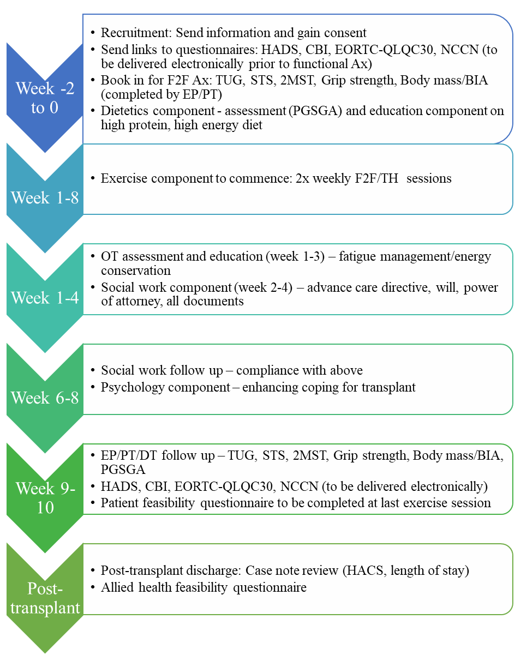
2MST: 2-minute step test; Ax: Assessment; BIA; Bioimpedance assessment; CBI: Cancer Behaviour Inventory; EORTC-QLQC30: Core quality of life questionnaire; F2F: Face-to-face; HADS: Hospital Anxiety and Depression scale; HACS: Hospital acquired complications; OT: Occupational therapy; PGSGA: Patient-Generated Subjective Global Assessment; STS: Sit-to-stand test; TH: Telehealth; TUG: Timed up and go test.

References
- Tabbara, I. A., Zimmerman, K., Morgan, C., & Nahleh, Z. (2002). Allogeneic hematopoietic stem cell transplantation: complications and results. Archives of internal medicine, 162(14), 1558-1566.
- Crowe, J., Francis, J. J., Edbrooke, L., Loeliger, J., Joyce, T., Prickett, C., ... & Denehy, L. (2022). Impact of an allied health prehabilitation service for haematologic patients receiving high-dose chemotherapy in a large cancer centre. Supportive Care in Cancer, 30(2), 1841-1852.
- Scheede‐Bergdahl, C., Minnella, E. M., & Carli, F. (2019). Multi‐modal prehabilitation: addressing the why, when, what, how, who and where next?. Anaesthesia, 74, 20-26.
- Eldridge, S. M., Chan, C. L., Campbell, M. J., Bond, C. M., Hopewell, S., Thabane, L., & Lancaster, G. A. (2016). CONSORT 2010 statement: extension to randomised pilot and feasibility trials. bmj, 355.
- Hoffmann, T. C., Glasziou, P. P., Boutron, I., Milne, R., Perera, R., Moher, D., ... & Michie, S. (2014). Better reporting of interventions: template for intervention description and replication (TIDieR) checklist and guide. Bmj, 348.
- Schmitz, K. H., et al., American College of Sports Medicine Round Table on Exercise Guidelines for Cancer Patients. Medicine and Science in Sports and Exercise, 2010, 42(7), p. 1409-1426.
- Hayes, S. C., Newton, R. U., Spence, R. R., & Galvão, D. A. (2019). The Exercise and Sports Science Australia position statement: exercise medicine in cancer management. Journal of science and medicine in sport, 22(11), 1175-1199.
- Jager-Wittenaar, H., & Ottery, F. D. (2017). Assessing nutritional status in cancer: role of the Patient-Generated Subjective Global Assessment. Current opinion in clinical nutrition and metabolic care, 20(5), 322-329.
- Borg, G. (1998). Borg's perceived exertion and pain scales. Human Kinetics.
- Whang, WM, Manson, JA.E. Hu, F.B., Chae, C.U., Rexrode, K.M., Willett, W.C., Stampfer, M.J., Albert, C.M. JAMA, March 22/29, 2006—Vol 295, No. 12
- Kuriachan, V.P., Sumner, G.L., & Mitchell, L.B. Sudden Cardiac Death. Current Problems in Cardiology, 2015-04-01, Volume 40, Issue 4, Pages 133-200
- Atkinson, M., Tully, A., Maher, C., Innes-Wong, C., Russo, R., Osborn, M. Safety, feasibility and efficacy of robotics-based rehabilitation in deconditioned paediatric, adolescent and young adult cancer patients. Cancers 2022 (Currently in review process for publication)
- Therapeutic Goods Administration. (2000). Note for guidance on good clinical practice (CPMP/ICH/135/95): annotated with TGA comments.
- Williams, J. R. (2008). The Declaration of Helsinki and public health. Bulletin of the World Health Organization, 86, 650-652.
- World Medical Association. Declaration of Helsinki. World Medical Association; 2004 [updated 2004 17/05/08; cited 2005 01/05/01].
- Jones, C. J., Rikli, R. E., & Beam, W. C. (1999). A 30-s chair-stand test as a measure of lower body strength in community-residing older adults. Research quarterly for exercise and sport, 70(2), 113-119.
- Roberts, H. C., Denison, H. J., Martin, H. J., Patel, H. P., Syddall, H., Cooper, C., & Sayer, A. A. (2011). A review of the measurement of grip strength in clinical and epidemiological studies: towards a standardised approach. Age and ageing, 40(4), 423-429.
- Dugas, E. W. (1996). The development and validation of a field test to estimate aerobic endurance in older adults. California State University, Fullerton.
- Beam, W.C. & Adams, G.M., Exercise Physiology laboratory manual 6th Ed; 2011. McGrawHill.

Appendices

Appendix 1

CASE REPORT FORM

Investigating the effect of multidisciplinary prehabilitation on deconditioning, hospital acquired complications and length of stay in patients offered Haematopoietic allogenic stem cell transplant: A feasibility trial.

Patient Study ID #: PREHAB  

CONFIDENTIAL

ELIGIBILITY CHECKLIST Patient Study ID #:  PREHSCT 
Date of Visit: d d / m m / y y y y
A) Inclusion Criteria

YES NO
- Aged over 18 years of age  
- Diagnosed with AML/MDS  
- Undergoing an allo-HSCT at the RAH  
- Medically stable with medical clearance  
(determined by a medical practitioner)
All boxes must be answered YES to include the patient into the study

B) Exclusion Criteria

YES NO
- Cognitive impairment (determined by a medical practitioner)  
- Patients who undergo surgery only  
- <6 months life expectancy  
- Absolute contraindications to exercise  
  - Unstable Angina
  - uncontrolled heart failure
  - acute systemic infection accompanied by fever
- Insufficient English to participate in the program  
or to complete the questionnaires
All boxes must be answered NO to include the patient into the study

RECRUITMENT INFORMATION
Cancer Diagnosis
Co-morbidities Hypertension  Coronary Heart Disease 
Arrhythmia  Diabetes Mellitus 
Asthma  COPD 
Obesity BMI>30  Stroke/TIA 
Other
Other
Other
Currently Performing Exercise  YES  NO
If yes, further details

Smoking status  Smoking  Quit Smoking  Never smoked
Weight . kg Height .m BMI .kg/m2
Medication (please circle)
ACE inhibitor Angiotensin Receptor Antagonist
Beta-blocker Calcium channel blocker
Statin Diuretic
Oral hypoglyaemic Insulin
Antiplatelets Warfarin
Other

PAPERWORK CHECKLIST

- Eligible for the HSCT MD study

- Written informed consent provided

- Patient information sheet and copy of consent to patient

- Patient information sheet and copy of consent in medical notes

Evaluation completed by Date Signature
d d / m m / y y y y

Principal Investigator Date Signature
d d / m m / y y y y
Entered into database by Date Signature
d d / m m / y y y y

CHECKLIST – BASELINE ASSESSMENT DATA
Date: d d / m m / y y y y
 | DATE COMPLETED | DATA ENTERED INTO DATABASE
Demographic information
EORTC QLQ-C30
HADS
The Cancer Behavior Inventory (Brief Form).

NCCN
Patient-Generated Subjective Global Assessment (PGSGA)

30s Chair sit-to-stand
Grip strength
2-minute step test
8ft up and go
Bioelectrical Impedance
Off study

Completed By: Date Signature
d d / m m / y y y y

CHECKLIST – POST 8 WEEK ASSESSMENT DATA
Date: d d / m m / y y y y
 | DATE COMPLETED | DATA ENTERED INTO DATABASE
Demographic information
EORTC QLQ-C30
HADS
The Cancer Behavior Inventory (Brief Form).
NCCN
Patient-Generated Subjective Global Assessment (PGSGA)
30s Chair sit-to-stand
Grip strength
2-minute step test
8ft up and go
Bioelectrical Impedance
Feasibility Questionnaire
Off study

Completed By: Date Signature
d d / m m / y y y y

CHECKLIST – 3-6 MONTH ASSESSMENT DATA
Date: d d / m m / y y y y
 | DATE COMPLETED | DATA ENTERED INTO DATABASE
Hospital-related outcomes (3-6m post)
Off study

Completed By: Date Signature
d d / m m / y y y y

OFF STUDY FORM
Date Off Study: d d / m m / y y y y
REASON OFF STUDY

YES NO
Withdraw consent  
Relapsed Disease  
Deceased Date Of Death: d d / m m / y y y y
Other Specify

Completed By: Date Signature
d d / m m / y y y y

Functional Fitness Measures
Study Week (Please Circle): Baseline Week 8
Evaluation

Height . cm
Body Mass . kg
Body Mass Index . kg/m³
Bioelectric Impedance . body fat %
2min Step Test  steps
Comments:

Grip strength T1 Right Arm  kg Left Arm  kg
T2 Right Arm  kg Left Arm  kg
Comments:

30s Sit to Stand  reps
Comments:

8ft up and go Trial 1   s Trial 2  s
Best  s
Comments:

Completed By: Date Signature
d d / m m / y y y y

Exercise Assessment
Study Week (Please Circle): Baseline 8 week
Evaluation

Adherence to the exercise plan from participants point of view

 Good  Moderate  Poor

Adherence to the exercise program from the Exercise Physiologist point of view

 Good  Moderate  Poor
Number of supervised exercise sessions completed

Intervention

Resistance Exercise  YES  NO

Aerobic Exercise  YES  NO

Completed Exercise at prescribed level  YES  NO

Resistance Ex: Dose Frequency

Aerobic Ex: Duration Frequency

Target HR:

Completed By: Date Signature
d d / m m / y y y y

Appendix 2

Safety Checklist for RAH MD HSCT study

This list must be reviewed and documented prior to every exercise session
If adverse events or medical concerns identified, please contact the red team registrar.

Participant Name: _____________________________ Date of Birth: __________________

Since your last exercise session have you experienced:

- Fever or infection YES NO

- Anaemia (low haemoglobin or red blood cells) YES NO

- Light headedness or faints YES NO

- Bleeding or bruising for no reason YES NO

- Chest pain YES NO

- Shortness of breath or other lung problems (eg asthma) YES NO

- Any new pain YES NO

- Broken bones YES NO

- Leg or ankle swelling YES NO

- Seizures YES NO

- Skin sores, ulcers or rashes YES NO

Since your last exercise session have you had any:

- Hospital admissions YES NO

- Emergency Department visits YES NO

- New medical problems YES NO

- Changes to medications (ie new medicines or dose changes) YES NO

- Operations YES NO

- Blood transfusions (red cells, platelets, other) YES NO

Are you pregnant? YES NO

If the answer is “yes” to any of these questions, record the details on the next page

Has the Medical Officer agreed this person can proceed today? YES NO

Completed by:

Name: ________________________ Date: ________________________

Signature: ________________________ Designation: ________________________

Safety Checklist for RAH MD HSCT Trial

Details of any safety concerns noted PRIOR to session:
(Please attach relevant investigations. If additional details/comments are needed, please attach)

Nature of the Safety Concern: ________________________________________________________

Brief description: ___________________________________________________________________

__________________________________________________________________________________

Severity (mild, moderate, or severe as per CTCAE v5): ______________________________________

Was any intervention required?: YES NO Details: _____________________________

Was hospitalisation required?: YES NO Details: _____________________________

Did it limit instrumental ADLS? YES NO Details: _____________________________

Did it limit self-care ADLs? YES NO Details: _____________________________

Was it life-threatening? YES NO Details: _____________________________

CTCAE v5 Grade (circle): 1 2 3 4 5

Relationship to Exercise (circle): CERTAIN PROBABLE POSSIBLE UNLIKELY

Follow-up of any safety concerns noted DURING the PREVIOUS session:

Were there any safety concerns during the previous session? YES NO

Nature of the Safety Concern: ________________________________________________________

Description: ________________________________________________________________________

__________________________________________________________________________________

Severity (mild, moderate, or severe as per CTCAE v5): ______________________________________

Was any intervention required?: YES NO Details: _____________________________

Was hospitalisation required?: YES NO Details: _____________________________

Did it limit instrumental ADLS? YES NO Details: _____________________________

Did it limit self-care ADLs? YES NO Details: _____________________________

Was it life-threatening? YES NO Details: _____________________________

CTCAE v5 Grade (circle): 1 2 3 4 5

Causality (circle): CERTAIN PROBABLE POSSIBLE UNLIKELY

Work-sheet

Participant Name: _____________________________ Date of Birth: _______________________

Today’s Date: _______________________________ Session number: ______________________

Did the patient attend the previous prescribed session? YES NO

If “NO”, reason(s) for non-attendance: _________________________________________________

Was there a delay between the previous session and today’s? YES NO

If “YES”, reason(s) for delay: ___________________________________________________________

Start time:

Did today’s session need to be interrupted or stopped early? YES NO

If “YES”, please circle: INTERRUPTION STOPPED EARLY

Reason: ___________________________________________________________________________

Details of any safety concerns noted during today’s session:

Were there any safety concerns during today’s session? YES NO

Nature of the Safety Concern: ________________________________________________________

Description: ________________________________________________________________________

__________________________________________________________________________________

__________________________________________________________________________________

Severity (mild, moderate, or severe as per CTCAE v5): ______________________________________

Was any intervention required?: YES NO Details: _____________________________

Was hospitalisation required?: YES NO Details: _____________________________

Interim CTCAE v5 Grade (circle): 1 2 3 4 5
Interim Causality (circle): CERTAIN PROBABLE POSSIBLE UNLIKELY

Date of next session: ______________________

Investigator Name: ______________________ Signature: ______________________
Notes: ___________________________________________________________________________

__________________________________________________________________________________

__________________________________________________________________________________

__________________________________________________________________________________

__________________________________________________________________________________

__________________________________________________________________________________

__________________________________________________________________________________

__________________________________________________________________________________

__________________________________________________________________________________

__________________________________________________________________________________

__________________________________________________________________________________

__________________________________________________________________________________

__________________________________________________________________________________

__________________________________________________________________________________

__________________________________________________________________________________

__________________________________________________________________________________

__________________________________________________________________________________

__________________________________________________________________________________

__________________________________________________________________________________

__________________________________________________________________________________

__________________________________________________________________________________

__________________________________________________________________________________

Appendix 3
Feasibility Questionnaires: Participant version
Rating: Exercise Program “Let’s get moving” |  | Strongly Disagree | Disagree | Neutral | Agree | Strongly Agree
I liked coming to sessions |  | 1 | 2 | 3 | 4 | 5
I feel I have improved during sessions |  | 1 | 2 | 3 | 4 | 5
I would continue sessions if they were available |  | 1 | 2 | 3 | 4 | 5
The frequency of sessions was appropriate |  | 1 | 2 | 3 | 4 | 5
The duration of sessions was appropriate |  | 1 | 2 | 3 | 4 | 5
Overall Rating Mark “X”
1
5
10

Comments (Best/worst part?):

Rating: Social Work “Legal and Financial Support” | Strongly Disagree | Disagree | Neutral | Agree | Strongly Agree
Discussing Wills, Enduring Power of Attorney, and Advanced Care Directives is important prior to transplant. | 1 | 2 | 3 | 4 | 5
The social work education session was informative. | 1 | 2 | 3 | 4 | 5
I understand and can now confidently explain what a Will, Enduring Power of Attorney, and Advanced Care Directive is. | 1 | 2 | 3 | 4 | 5
The strategies discussed during the session helped me to complete my legal documents. | 1 | 2 | 3 | 4 | 5
I know where to access financial support should I need it. | 1 | 2 | 3 | 4 | 5
The location of the social work session was appropriate. | 1 | 2 | 3 | 4 | 5
The duration of the social work session was appropriate | 1 | 2 | 3 | 4 | 5
Overall Rating Mark “X”
1
5
10

Comments (Best/worst part?):

Rating: Dietitian “Optimising Nutrition” | Strongly Disagree | Disagree | Neutral | Agree | Strongly Agree
Discussing the high energy, high protein and low immunity diet was important prior to transplant. | 1 | 2 | 3 | 4 | 5
The location of the discussion regarding Dietetics was appropriate | 1 | 2 | 3 | 4 | 5
The duration of the discussion regarding Dietetics was appropriate | 1 | 2 | 3 | 4 | 5
More dietetics sessions would have been helpful | 1 | 2 | 3 | 4 | 5
Overall Rating Mark “X”
1
5
10

Comments (Best/worst part?):

Rating: OT “Preparing for Transplant” | Strongly Disagree | Disagree | Neutral | Agree | Strongly Agree
The Occupational Therapy service supported my readiness for transplant. | 1 | 2 | 3 | 4 | 5
The location of the discussion regarding equipment, home set up, services and education was appropriate | 1 | 2 | 3 | 4 | 5
The duration of the discussion regarding equipment, home set up, services and education was appropriate | 1 | 2 | 3 | 4 | 5
Was the energy conservation education/support beneficial? | 1 | 2 | 3 | 4 | 5
More Occupational Therapy sessions would have been helpful | 1 | 2 | 3 | 4 | 5
Overall Rating Mark “X”
1
5
10

Comments (Best/worst part?):

Rating: Psychology “Enhancing coping” | Strongly Disagree | Disagree | Neutral | Agree | Strongly Agree
Discussing strategies for enhancing my coping was important prior to transplant. | 1 | 2 | 3 | 4 | 5
The psychology education session was informative. | 1 | 2 | 3 | 4 | 5
The psychology education session was helpful in teaching me strategies to cope with a transplant. | 1 | 2 | 3 | 4 | 5
The strategies discussed during the session helped me to feel better prepared to cope with my transplant. | 1 | 2 | 3 | 4 | 5
The location of the psychology session was appropriate. | 1 | 2 | 3 | 4 | 5
The duration of the psychology session was appropriate. | 1 | 2 | 3 | 4 | 5
More psychology sessions would have been helpful | 1 | 2 | 3 | 4 | 5
Overall Rating Mark “X”
1
5
10

Comments (Best/worst part?):

Feasibility Questionnaire: Allied Health version
Please provide Allied Health Discipline here:
 | Strongly Disagree | Disagree | Neutral | Agree | Strongly Agree
The intervention you delivered met your approval | 1 | 2 | 3 | 4 | 5
The environment of the intervention you delivered was appropriate | 1 | 2 | 3 | 4 | 5
The delivery of the intervention was as expected | 1 | 2 | 3 | 4 | 5
I had the appropriate equipment | 1 | 2 | 3 | 4 | 5
The intervention was implementable | 1 | 2 | 3 | 4 | 5
The intervention was feasible | 1 | 2 | 3 | 4 | 5
The intervention was safe | 1 | 2 | 3 | 4 | 5
The overall invention was associated with improvements in functional capacity | 1 | 2 | 3 | 4 | 5
The overall invention was associated with improvements in psychosocial outcomes | 1 | 2 | 3 | 4 | 5
The overall invention was associated with improved hospital-related outcomes | 1 | 2 | 3 | 4 | 5
Overall Rating Mark “X”
1
5
10

What worked/What didn’t work when you delivered the intervention?:

Any other comments:

Appendix 4
Functional Assessment Procedure
30-Second Chair Stand
Purpose: To test leg strength and endurance
Equipment: A chair with a straight back without arm rests (seat 17” high), and a stopwatch.

Procedure:
- Instruct the patient:
  - Sit in the middle of the chair.
  - Place your hands on the opposite shoulder crossed, at the wrists.
  - Keep your feet flat on the floor.
  - Keep your back straight, and keep your arms against your chest.
  - On “Go,” rise to a full standing position, then sit back down again.
  - Repeat this for 30 seconds.
- On the word “Go,” begin timing.
If the patient must use their arms to stand, stop the test. Record “0” for the number and score.
- Count the number of times the patient comes to a full standing position in 30 seconds.
If the patient is over halfway to a standing position when 30 seconds have elapsed, count it as a stand.
- Record the number of times the patient stands in 30 seconds.¹⁶

Grip Strength
Purpose: To measure the maximum isometric strength of the hand and forearm muscles.
Equipment: handgrip dynamometer
Pre-test: Explain the test procedures to the subject. Prepare forms and record basic information such as age, height, body weight, gender, hand dominance. Calibrate dynamometer, adjust to suit the subject (the base should rest on the first metacarpal (heel of palm), while the handle should rest on middle of the four fingers).
Procedure:
- The subject holds the dynamometer in the first hand to be tested, with the arm at right angles and the elbow by the side of the body.
- When ready the subject squeezes the dynamometer with maximum isometric effort, which is maintained for about 5 seconds. No other body movement is allowed. The subject should be strongly encouraged to give a maximum effort.
- Repeat the test for the other hand
- Repeat the test again for both sides (record the best result).¹⁷

2-Minute Step Test
Purpose: Alternate aerobic endurance test, for use when space limitations or weather prohibits taking the 6-minute walk test. The number of full steps completed in 2 minutes, raising each knee to a point midway between the patella (kneecap) and iliac crest (top hip bone). Score is number of times right knee reaches the required height.
Equipment: Anthropometric tape measure

Procedure:
- The subject stands up straight next to the wall while a mark is placed on the wall at the level corresponding to midway between the patella (knee cap) and illiac crest (top of the hip bone).
- The subject then marches in place for two minutes, lifting the knees to the height of the mark on the wall.
- Resting is allowed, and holding onto the wall or a stable chair is allowed.
- Stop after two minutes of stepping.
Risk zone:
Less than 65 steps for men and women.¹⁸

8-Foot Up-and-Go
Purpose: To assess agility/dynamic balance, which is important in tasks that require quick manoeuvring, such as getting off a bus in time or getting up to attend to something in the kitchen, to go to the bathroom or to answer the phone. Number of seconds required to get up from a seated position, walk 8 feet (2.44m), turn, and return to seated position.
Equipment: Chair, stop watch and marker cone

Procedure:
- Place the chair next to a wall (for safety) and the marker 8 feet in front of the chair. Clear the path between the chair and the marker.
- The subject starts fully seated, hands resting on the knees and feet flat on the ground.
- On the command, "Go," timing is started and the subject stands and walks (no running) as quickly as possible (and safely) to and around the cone, returning to the chair to sit down.
- Timing stops as they sit down.
- Perform two trials.
Risk zone: More than 9 seconds.¹⁹

Bio-electrical Impedance
Bio-electrical impedance analysis will be conducted on patients in the supine position using tetrapolar bio-impedance spectroscopy (BIS) (ImpediMed, Queensland, Australia). This measurement enables an estimate of whole-body composition (lean muscle mass, intracellular fluid, extracellular fluid, total body water, and fat free mass) based on the resistance (impedance) of body tissues to a small electrical current. BIS is a bedside assessment tool that has been widely reported in the literature in a range of populations. It takes less than 15 minutes to conduct at the bedside and is non-invasive. Body weight and Body Mass Index will also be collected at these time-points.
Patients with a permanent pacemaker will be excluded from the bio-impedance measures, but will be able to participate in the other elements of the study

Appendix 5
Patient-Generated Subjective Global Assessment (PGSGA)
The Scored Patient-Generated Subjective Global Assessment (PG-SGA©) sets the standard of and is the preeminent interdisciplinary patient assessment in oncology and other chronic catabolic conditions. It includes four patient-generated historical components (Weight History, Food Intake, Symptoms and Activities and Function), the professional part (Diagnosis, Age, Metabolic stress, and Physical Exam), the Global Assessment (A = well nourished, B = moderately malnourished or suspected malnutrition, C = severely malnourished), the total numerical score, and nutritional triage recommendations. Subsequently, the results allow for triaging of specific nutrition interventions, as well as facilitating quantitative outcomes data collection⁸.

Appendix 6
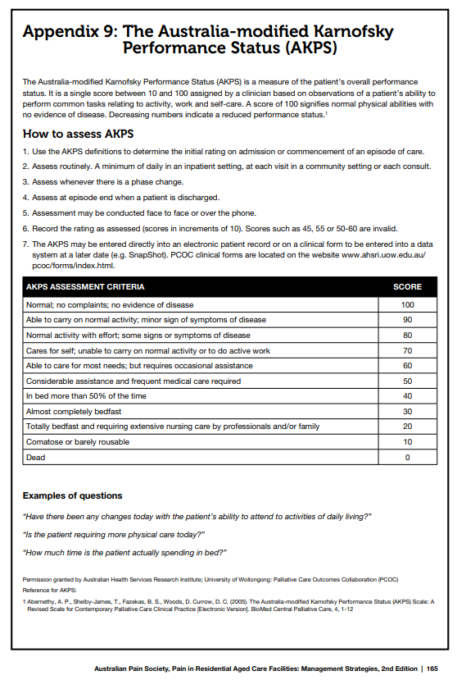
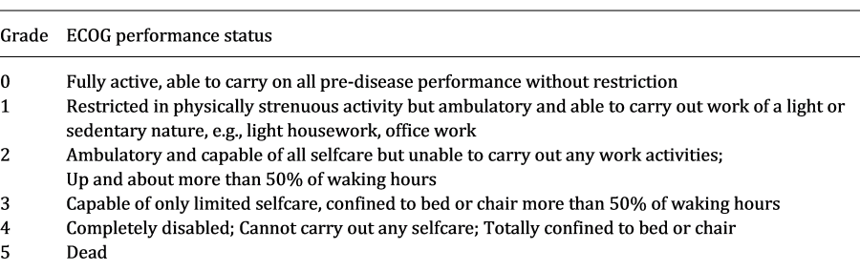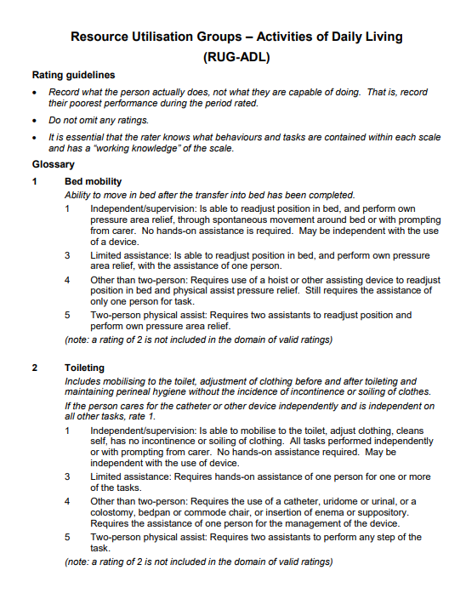
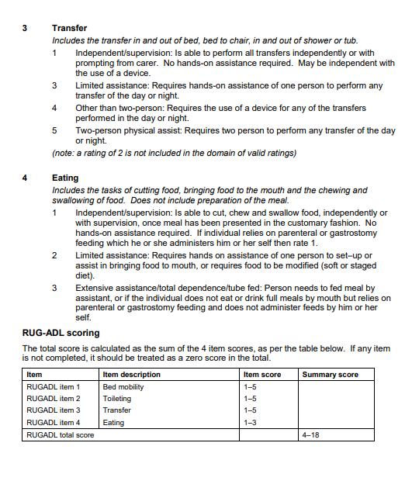

Appendix 7
The European Organization for Research and Treatment Quality of Life Questionnaire (EORTC QLQ C30) is a questionnaire designed to measure cancer patients' physical, psychological and social functions. The questionnaire is composed of 5 multi-item scales (physical, role, social, emotional and cognitive functioning) and 9 single items (pain, fatigue, financial impact, appetite loss, nausea/vomiting, diarrhea, constipation, sleep disturbance and quality of life).

EORTC QLQ-C30 (Version 3)
We are interested in some things about you and your health. Please answer all of the questions yourself by circling the number that best applies to you. There are no "right" or "wrong" answers. The information that you provide will remain strictly confidential.
 |  | Not at all | A little | Quite a bit | Very much
1 | Do you have any trouble doing strenuous activities, like carrying a heavy shopping bag or a suitcase? | 1 | 2 | 3 | 4
2 | Do you have any trouble taking a long walk? | 1 | 2 | 3 | 4
3 | Do you have any trouble taking a short walk outside of the house? | 1 | 2 | 3 | 4
4 | Do you need to stay in bed or a chair during the day? | 1 | 2 | 3 | 4
5 | Do you need help with eating, dressing, washing yourself or using the toilet? | 1 | 2 | 3 | 4

 | During the past week: | Not at all | A little | Quite a bit | Very much
6 | Were you limited in doing either your work or other daily activities? | 1 | 2 | 3 | 4
7 | Were you limited in pursuing your hobbies or other leisure time activities? | 1 | 2 | 3 | 4
8 | Were you short of breath? | 1 | 2 | 3 | 4
9 | Have you had pain? | 1 | 2 | 3 | 4
10 | Did you need to rest? | 1 | 2 | 3 | 4
11 | Have you had trouble sleeping? | 1 | 2 | 3 | 4
12 | Have you felt weak? | 1 | 2 | 3 | 4
13 | Have you lacked appetite? | 1 | 2 | 3 | 4
14 | Have you felt nauseated? | 1 | 2 | 3 | 4
15 | Have you vomited? | 1 | 2 | 3 | 4

 | During the past week: | Not at all | A little | Quite a bit | Very much
16 | Have you been constipated? | 1 | 2 | 3 | 4
17 | Have you had diarrhea? | 1 | 2 | 3 | 4
18 | Were you tired? | 1 | 2 | 3 | 4
19 | Did pain interfere with your daily activities? | 1 | 2 | 3 | 4
20 | Have you had difficulty in concentrating on things, like reading a newspaper or watching television? | 1 | 2 | 3 | 4
21 | Did you feel tense? | 1 | 2 | 3 | 4
22 | Did you worry? | 1 | 2 | 3 | 4
23 | Did you feel irritable? | 1 | 2 | 3 | 4
24 | Did you feel depressed? | 1 | 2 | 3 | 4
25 | Have you had difficultly remembering things? | 1 | 2 | 3 | 4
26 | Has your physical condition or medical treatment interfered with your family life? | 1 | 2 | 3 | 4
27 | Has your physical condition or medical treatment interfered with your social activities? | 1 | 2 | 3 | 4
28 | Has your physical condition or medical treatment caused you financial difficulties? | 1 | 2 | 3 | 4
29. For the following questions please circle the number between 1 and 7 that best applies to you
How would you rate your overall health during the past week?
1 2 3 4 5 6 7
Very poor Excellent
30. How would you rate your overall quality of life during the past week?
1 2 3 4 5 6 7
Very poor Excellent

Appendix 8
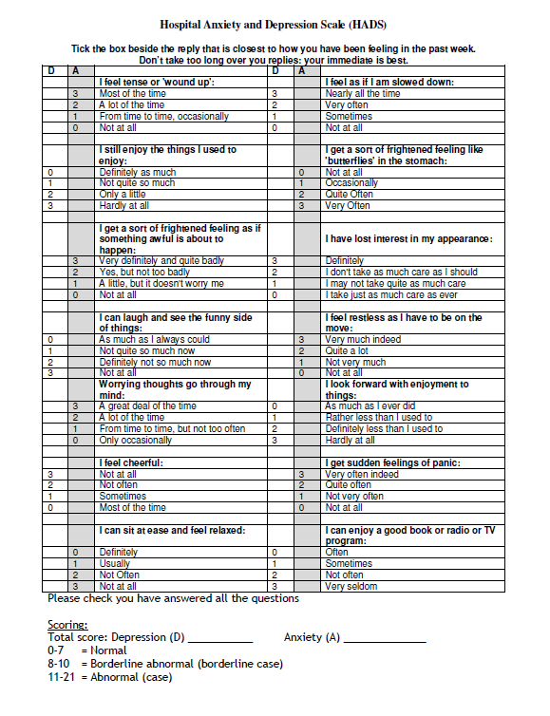

Appendix 9
Cancer Behavior Inventory (Brief Form)
This survey contains many things that a person might do during and after cancer treatment. We are interested in how confident you are that you can do those things. Be sure your ratings are about your confidence even if you have not done it in the past. So, your ratings are about your confidence that you can do these things now or in the near future.
Please read each item. Then rate that item on how confident you are that you can do that behavior. Circle a number on the scale. If you circle a “9” you are totally confident that you can do that behavior. If you circle a “1” you are not at all confident that you can do that behavior. Numbers in the middle mean that you are somewhat confident that you can do that behavior. Be sure your ratings reflect your confidence even if you have not done it in the past.
Please rate all items. If you are not sure about an item please rate it as best you can.
All items are rated on the following scale:
NOT AT ALL MODERATELY TOTALLY
CONFIDENT CONFIDENT CONFIDENT
1 2 3 4 5 6 7 8 9
- Maintaining independence
- Maintaining a positive attitude
- Maintaining a sense of humor
- Expressing negative feelings about cancer
- Maintaining activities (work, home, hobbies, social)
- Remaining relaxed throughout treatments and not allowing scary thoughts to upset me
- Actively participating in treatment decisions
- Asking physicians questions
- Seeking consolation (support)
- Sharing feelings of concern
- Managing nausea and vomiting
- Coping with physical changes
SCORING
The CBI-B is intended to be a single score measure of coping self-efficacy.
Sum the scores for the 12 items. Higher scores indicate greater coping efficacy.

Appendix 10
