Randomized head-to-head trial of PPI vs topical corticosteroids (TC’s) post food bolus impaction and/or for untreated patients with Eosinophilic esophagitis (EoE)

STUDY INVESTIGATOR(S)

Principal Investigator

Dr Hamish Philpott

Ph. +61 421227551

Email: hamish.philpott@outlook.com
Employer: NALHN,
Roles: Supervision, development and inception of research, data collection, data analysis

Co-Investigators:

Dr Derrick Tee
Ph: +61 8 8222 5141
Email: oliver.schubert@adelaide.edu.au
Roles: data collection, data analysis

A/Prof Mayur Garg
Department of Gastroenterology
185 Cooper St, Epping Vic 3076
Ph. 03 8405 8000
Email: Mayur.Garg@nh.org.au
Roles: data collection, data analysis

A/Prof Rebecca Burgell
Department of Gastroenterology-The Alfred Hospital
55 Commercial Road, Melbourne Vic 3004
Ph. 03 9076 2000
Email: Rebecca.burgell@monash.edu
Roles: data collection, data analysis

A/Prof Michael Swan
Department of Gastroenterology
Monash Medical Centre
823, Centre Road, Bentleigh East Victoria 3165
Ph. 03 9928 8111
Email: Michael.swan@monashhealth.org
Roles: data collection, data analysis

A/Prof Andrew Buckle
Department of Gastroenterology
Launceston General Hospital
274-280 Charles Street, Launceston TAS 7250
Ph. 03 6777 6777
Email: Andrew.buckle@ths.tas.gov.au
Roles: data collection, data analysis

Dr Sanjay Nandurkar
Department of Gastroenterology
Eastern Health
5 Arnold Street, Box Hill Victoria 3128
Ph. 03 9895 3281
Email: Sanjay.nandurkar@monash.edu
Roles: data collection, data analysis

Professor Nick Talley
John Hunter Hospital Newcastle
Email: Nicholas.talley@newcastle.edu.au
Roles: data collection, data analysis

Dr Charles Cock
Department of Gastroenterology
Flinders Medical Centre
Flinders Drive, Bedford Park
South Australia 5042
Ph. 08 8 204 5511
Email: Charles.cock@sa.gov.au
Roles: data collection, data analysis

Prof Nam Nguyen
Department of Gastroenterology
Royal Adelaide Hospital
Port Road, Adelaide South Australia 5000
Ph. 08 7074 0000
Email: Quocnam.nguyen@sa.gov.au
Roles: data collection, data analysis

Dr Natalie Aboustate

Ph. +61 8 313 1433

Email: natalie.aboustate@adelaide.edu.au
Roles: study coordinator, database set up, data analysis

SPONSOR: Northern Adelaide Local Health Network

1. INTRODUCTION

Eosinophilic oesophagitis (EoE) is now the leading cause of food bolus impaction (FBO) in Western Countries, and emergency retrieval of food bolus at endoscopy is a commonly performed procedure. Untreated patients with EoE and FBO represent a high-risk group that will represent with FBO. A new topical corticosteroid called Jorveza became available in May of 2022 and potentially offers superior control of EoE and thus prevention of FBO, although this is yet to be formally studied.

2. BACKGROUND

Eosinophilic oesophagitis (EoE) is a chronic inflammatory condition causing narrowing of the oesophagus manifesting clinically as dysphagia and food bolus impaction (FBO). EoE has increased markedly in frequency to a population prevalence of greater than 10 per 1000 patient years. Moreover, EoE is the predominant cause of FBO in adult patients, requiring hospital admission, endoscopic retrieval and can cause oesophageal perforation. Preventing morbidity and expense associated with FBO is a major treatment goal, where previous FBO remains that best predictor of future FBO. Notably, 75% of adults with EoE present initially and receive a diagnosis at the time of an FBO. Furthermore, a FBO event indicates the development of fibrostenosis, which will worsen over time, but with adequate treatment normalization of oesophageal anatomy, luminal caliber and oesophageal motility is possible.
EoE is diagnosed at upper gastrointestinal endoscopy (EGD), where tissue specimens (biopsies) are taken to demonstrate >15 eosinophils per HPF. Similarly, treatment success can only be judged by endoscopy and biopsy, where <5 eosinophils per HPF denotes complete response. Two first line medications, namely proton pump inhibitors (PPI’s) and topical corticosteroids (TC’s) are feasible options. PPI’s are prescribed most often due to widespread availability, and previously it was thought that PPI responsive EoE was a separate condition that required diagnosis via a trial of PPI. It is now known that patients that respond to PPI may equally respond to TC’s. Previously, a commercial preparation of TC’s was unavailable, however the recent PBS listing of Jorveza (orodispersible budesonide) in May 2022 presents a rational alternative.
TC’s may be the optimal treatment for patients presenting with EoE and FBO, but this requires scientific validation via a head-to-head randomized study. That TC’s may be preferable includes the high rate of histological response (70%, compared to 20-50% for dietary therapy and PPI’s) and the rapid onset of treatment effect possibly due to broad anti-inflammatory action (pleotropic effects) compared to simply decreasing gastric acid reflux and/or Eotaxin 3 (a chemokine) production, in the case of PPI’s. Finally, TC’s may induce more complete remodeling to deeper oesophageal layers (lamina propria and muscle). Even in the context of a full histological remission, some clinicians attempt to ‘hasten’ positive oesophageal remodeling by performing oesophageal dilatation to 16-18mm circumference (with the intention more rapidly normalize oesophageal function and completely relieve dysphagia).
Improvement in the treatment of EoE offers significant advantages both to the individual and society. Untreated or undertreated EoE (with ongoing inflammation demonstratable at endoscopy) is associated with impairment in quality of life, increase risk of psychiatric illness and recurrent presentation with dysphagia and FBO, whereas good treatment mitigates these problems. Minimizing the morbidity associated with undertreated EoE will decrease the health care costs to society at large, including the major upfront cost of emergency admission for FBO.
To date, no randomized study of Jorveza vs PPI has been performed, which represents a knowledge gap. Furthermore, the high-risk group of patients (presenting with FBO) are particularly likely to benefit from Jorveza, yet remain unstudied. The study design will provide clinically useful data and has the potential to improve management in future. Furthermore, the acquisition of clinical, histological, endoscopic, physiological (manometry) and anatomical (EUS) data will add significantly to the scientific understanding of the mechanism of disease resolution according to treatment modality.

In the context of a current knowledge gap that would otherwise guide the clinician to choosing the optimal medical treatment of patients with EoE who present with FBO and/or are on nil treatment, we propose a randomized controlled trial of PPI vs Jorveza, with a formalized treatment protocol and the ascertainment of symptom scores (questionnaire), endoscopic appearance, histological findings (biopsy), physiological (manometry) and cross sectional (endoscopic ultrasound) data, the results having potential to improve management in future.

3. STUDY AIMS

The primary aim of this study is to determine if PPI or Jorveza are superior in inducing complete histological remission (<5 eosnionophils/HPF) at first (8-10 weeks) and subsequent (18-20 weeks) endoscopy.

Secondary aims include comparing completeness of symptomatic improvement (EoE - ), normalization of endoscopic appearance (EREFS score), oesophageal peristalsis (at oesophageal manometry) and oesophageal wall thickness (at endoscopic ultrasound).

4. OUTCOMES

Primary endpoints to describe study aims are:
- Histology at oesophageal biopsy of upper and lower oesophagus (<5 eosinophils/HPF)

The study’s secondary endpoints consist of:

- Symptomatic Improvement (EoE –sAI-PRO) and EoE hypervigilance score
- Endoscopic appearance (EREF’s)
- Oesophageal peristalsis (oesophageal manometry)
- Oesophageal wall thickness (endoscopic ultrasound)
- Medication related adverse effects (allergic reaction, symptoms attributable to mediation use, oesophageal candidiasis)

5. HYPOTHESES

Primary Hypothesis

Ho – Jorveza is not superior to PPI in inducing complete histological remission (<5 eosinophils/HPF) in patients with EoE.

Ha – Jorveza is superior to PPI in inducing complete histological remission (<5 eosinophils/HPF) in patients with EoE.

Secondary Hypotheses

The superiority of Jorveza over PPI will be tested in reference to symptoms, endoscopic appearance, oesophageal peristalsis and oesophageal thickness (see secondary end-points)

6. STUDY DESIGN

This multi-center opened label randomized trial will be conducted in Australia. Adult patients who are diagnosed with EoE based on oesophageal biopsy with a finding of >15 eosinophils per high power field (15/HPF) at endoscopy, who have presented either with FBO or dysphagia, and who are on nil current treatment will be invited to participate and will be randomized to receive PPI or Jorveza. Alternatively, patients on current PPI or diet therapy (who have not yet trialed Jorveza) will be invited to cease their current medication for at least 8 weeks and then undergo endoscopy, biopsy and will be randomized to either treatment.

7. STUDY SETTING/LOCATION

The study will recruit participants from 11 sites: Adelaide (Royal Adelaide Hospital, Lyell McEwin Hospital, The Queen Elizabeth Hospital, Flinders Medical Centre) Melbourne (The Northern Hospital, Monash Medical Centre, The Alfred Hospital, Box Hill Hospital), Sydney (St George Hospital, St Vincent’s Hospital), Tasmania (Launceston Hospital).

8. STUDY POPULATION

Patients aged 18 years of age and older, who have been diagnosed with EoE, will be screened for recruitment into the study according to eligibility criteria listed in Section 9.

9. ELIGIBILITY CRITERIA

9a. Inclusion criteria

Only patients who meet the below criteria will be included in the study:
  - Aged 18 years and over.
  - Present with food bolus obstruction (FBO) or dysphagia
  - Ability to provide informed consent to participate in this study
  - Diagnosed with EoE according to endoscopy and biopsy showing >15 eosinophils per high power field in any one oesophageal location (peak count).
  - On nil current treatment, or willing to cease treatment with PPI or diet for 8 weeks prior to repeat endoscopy. Never used Jorveza

9b. Exclusion criteria

Exclusion criteria will comprise any of the following conditions or factors:
- Coexistent medical conditions that could cause oesophageal eosinophilia (e.g. primary hypereosinophilic syndrome, organ transplant recipient, connective tissue disorder, Crohn’s disease)
- Medications that could cause oesophageal eosinophilia (e.g. antiepileptic, clozapine)
- Medications that could suppress the immune system and decrease eosinophil count (e.g,systemic corticosteroids, immunosuppressant such as methotrexate or azathioprine, biological agents such as anti – TNF)
- Usual residence is a forensic facility
- Intellectual disability
- Pregnancy

10. STUDY OUTCOMES
10a. Primary Outcome

Peak eosinophil count at endoscopy and biopsy (at 8-10 weeks and 18-20 weeks) where <5 eosinophils/HPF indicates complete remission

10b. Secondary Outcome(s)

- Improvement in EREFS score (range 0-9)
- Improvement in symptoms (EEsAI – PRO, EoE hypervigilance score)
- Improvement in quality of life (EoE hypervigilance score)
- Oesophageal wall thickness at EUS
- Oesophageal peristalsis at manometry

11. STUDY PROCEDURES

11a. Recruitment of participants

Consecutive subjects will be recruited according to their presenting symptoms as follows:

- Subjects presenting to hospital with FBO who require endoscopy and are diagnosed with EoE
- Subjects presenting for elective endoscopy who are diagnosed with EoE.
- Subjects presenting to outpatients who have a diagnosis of EoE and who are not on treatment currently or those receiving treatments who have not received Jorveza and would like to be involved in the study after ceasing treatment (8 weeks)

Subjects will be invited to participate in the study prior to leaving hospital, the endoscopy room or the outpatient’s area, and written information (patient information and consent form - PICF) will be provided for the subject to read and consider. Doctors other than the PI’s who are involved in providing the routine care of these subjects (registrars and residents) will invite the subjects to participate, will provide the PICF, and will contact the subject by phone 1 week later to ask if they have made a decision, and to organize either routine treatment or be enrolled in the study.

Recruitment for this study will run over 24 months (April 2023 - April 2025)

11b. Study procedure

Potential subjects that receive the PICF will have 1 week to consider the information before being contacted by an investigator at the site. Subjects that wish to proceed will be offered an outpatient’s appointment in 2 weeks where they can meet the investigator, the completed PICF can be received, and any questions answered. The PI will then randomize the subject using computer generated block randomization software, and a prescription of either Jorveza (1mg Po BD, Falk Pharma) or PPI (pantoprazole 40mg Po BD, generic according to local supply) will be provided. A date for the endoscopy to assess disease response in 8-10 weeks will be booked. For patients that are already on an alternative treatment for EoE, but who wish to participate in the study, a period of washout (off treatment) for at least 8 weeks, prior to repeat endoscopy to establish disease activity, and then (if active, as defined as >15 eosinophils per HPF), the subject can be randomized as above.

On the day of the endoscopy, symptom scores and quality of life scores (EEsAI – PRO, and EoE hypervigilance score) will be completed prior to the procedure. At endoscopy visual analogue score (EREFS) will be completed. Biopsies of the lower and middle oesophagus (starting 5cm below the lower oesophageal sphincter and another 5cm more proximal) will be performed. 4 pieces of oesophageal tissue will be acquired in each location and will be placed in formalin for standard histopathology. The pathology specimen will be processed and then reported by the laboratory in the routine fashion (haematoxylin and eosin staining).

Endoscopic ultrasound can be performed at the time of the endoscopy using a ‘through the scope’ miniprobe (appendix 4). Overall oesophageal wall thickness 5cm proximal to gastroesophageal junction, and a further 5cm more proximal (two sites) will be recorded, along with estimates of the thickness of the layers of the oesophageal wall (mucosa, muscularis and adventitia) will be recorded.

Oesophageal high resolution manometry shall be performed within 2 weeks of the endoscopy. 10 liquid and 5 viscous swallows will be recorded, according to standardized protocol (Chicago 4 – see appendix 5)

The patient will continue the Jorveza or PPI (respectively) until they are contacted for a phone appointment or outpatients’ appointment 1-2 weeks post endoscopy, where the results of the endoscopy will be discussed. Patients that have a partial or complete response (<15 eosinophils per HPF) will continue their current treatment, whilst those that have failed to respond (>15 eosinophils per HPF) will crossover to the alternative agent (Jorveza to PPI or vice versa – see Study procedure flowchart appendix 1). Patients will then complete 8-10 weeks of treatment prior to their second endoscopy.

On the day of the endoscopy, symptom scores and quality of life scores (EEsAI – PRO, and EoE hypervigilance score) will be completed prior to the procedure. At endoscopy visual analogue score (EREFS) will be completed. Biopsies of the lower and middle oesophagus (starting 5cm below the lower oesophageal sphincter and another 5cm more proximal) will be performed. 4 pieces of oesophageal tissue will be acquired in each location and will be placed in formalin for standard histopathology. The pathology specimen will be processed and then reported by the laboratory in the routine fashion (haematoxylin and eosin staining).

The patient will continue the Jorveza or PPI (respectively) until they are contacted for a phone appointment or outpatients’ appointment 1-2 weeks post endoscopy, where the results of the endoscopy will be discussed. Patients that have a partial or complete response (<15 eosinophils per HPF) will continue their current treatment, whilst those that have failed to respond (>15 eosinophils per HPF) will be offered alternative treatment (diet, dilatation or clinical trial). The trial will conclude at this visit (appendix 1)

Participants will be asked to estimate their compliance with the treatment at the time of each of their clinical visits using a Likert Score (visual rank 1-10 – see appendix 2). In this real world intention to treat study, subjects that describe poor compliance will still continue the study.

In the patient information and consent form (PICF) it clearly states that individuals may withdraw from the study at any time, they are provided with the contact details of the principal investigator at their site, along with the central study coordinator. Ongoing routine clinical care by the treating clinicians is not influenced by the involvement in the study or otherwise.

11d. Measurement tools

Data will be collected using standardized, secure online data collection templates, using RedCaps platform (appendix 3). Routine demographic data (gender, age, postcode), comorbid atopic conditions, past medical conditions, past surgical conditions, medication, alcohol, cigarette and drug use will be recorded at the first visit. EoE specific information (date of diagnosis, presenting symptom, e.g. food bolus or dysphagia, past treatment including medication or dilatation) will also be recorded at the first visit. Symptoms will be recorded according to the EoE-AIPRO and EoE hypervigilance score (appendix 4 - which are instruments that have been trialed and proven to be valid, robust and statistically reliable measures) before the endoscopy at 8-10 weeks, and before the 2nd endoscopy at 16-18 weeks. Endoscopic data will be recorded using the EREF’s score (appendix 5) which is a frequently used and valid measure. Histology reports data (specifically the eosinophil count per HPF, according to routine histological reporting measures used internationally) will be entered into Redcaps. Endoscopic ultrasound (miniprobe – appendix 6 ) results will be recorded as thickness of oesophageal mucosa, oesophageal muscle and oesophageal adventitia 5cm proximal to the lower oesophageal sphincter and 5cm more proximal to this point (routine measurements of thickness are performed at endoscopic ultrasound). Reports of the oesophageal manometry (Chicago 4 – standard international reporting protocol) will be uploaded in a de- identified and stored as an electronic file – appendix 7. Only study code will be used and no personal information will be uploaded.

11e. Safety considerations/Patient safety

Side effects: Both PPI (Pantoprazole) and TCs (Jorveza) are approved medication for EoE treatment therefore there are no anticipated risks beyond standard treatment for the condition.

However, like all other medicines, Pantoprazole and Jorverza also have their side effects, which are expected and described by the manufacturer. The study team will monitor all side effects closely and provide necessary and promptly consultation when needed.

Adverse events/severe advert events (AEs/SAEs)
We will carry out active surveillance for adverse events (AEs). Adverse events will be graded according to the Australia National Health and Medical Research Council (NHMRC) Adverse Events definitions: https://www.nhmrc.gov.au/sites/default/files/images/NHMRC-guidance-safety-monitoring-and-reporting.pdf

The relationship of each adverse event to the trial intervention must be determined by a medically qualified individual according to the following definitions:

Related: The adverse event follows a temporal sequence from trial intervention administration, follows a known pattern of response for which no other explanation is present.

Possibly related: The adverse event has a temporal relationship to the trial intervention administration, does not follow a known pattern of response but cannot be attributed to another cause.

Not related: The adverse event is probably produced by the participant’s clinical state or by other modes of therapy administered to the participant.

The Principal Investigator will:

- Capture and assess all AEs that occur at the site as required and in accordance with the protocol.
- Report to the sponsor within 24 hours of becoming aware of the event:
• all SAEs, except those that are identified in the protocol as not needing immediate reporting
• all urgent safety measure instigated by the site
- Report to the sponsor:
• all safety critical events
• any additional requested information relating to reported deaths
- Report to the local institution within 72 hours of becoming aware of the event:

• all significant safety issues
• SUSARs arising from the local site.

Other AEs should be recorded, summarized and reported in the annual report form and the final report form.

11 f. Data monitoring

Data from each site will be double entered and stored on RedCap platform. This database will be checked at NALHN for missing or unusual values (range checks) and checked for consistency within participants over time. If any such problems are identified, the site will be contacted and asked to verify or correct the data. Study coordinator will also send reminders for any overdue and/or missing data with the regular inconsistency reports of errors.

On-site Monitoring
A site initiation visit and training will be conducted for each study site. The initiation training will include training in the administration of study drug, as well as the trial procedures. On site monitoring will also be regularly conducted by the site monitors. The frequency, type and intensity of routine monitoring and the requirements for triggered monitoring will be detailed in the Monitoring Plan which will also detail the procedures for review and sign-off. The monitoring will adhere to the principles of ICH GCP and the Monitoring Plan.

The monitors will require access to all participant medical records including, but not limited to, laboratory test results and prescriptions. The investigator (or delegated deputy) should work with the monitor to ensure that any problems detected are resolved.

12. STATISTICAL CONSIDERATIONS AND DATA ANALYSIS

12a. Sample size and statistical power

Allowing for a difference in estimated treatment effect of 30%, 36 patients in each arm (72 in total) are required, for a power of 0.8, p <.05.

12b. Statistical methods

In this intention to treat analysis, Data will be analyzed using SPSS V21.0 for windows. Continuous data will be considered using the student t – test, whilst categorical variables will be analyzed with the Mann – Whitney or Kruskall – Wallis as appropriate. Statistical significance will be recorded at p<.05 (two tailed).

13. ETHICAL CONSIDERATIONS

The study will be conducted in full conformance with principles of the “Declaration of Helsinki”, Good Clinical Practice (GCP) and within the laws and regulations in Australia.

13 a. Benefits of study
There is no guarantee or promise that participants will receive any benefits from this research, however positive results from this study can help to determine the optimal treatment for patients with EoE and therefore has the potential to significantly improve disease control and thus quality of life for the patient as well as decrease health care costs for the community.

13 b. Risk of Study

Both PPIs and TCs are approved treatment for EoE. There are no anticipated risks beyond standard treatment for the condition.

13 c. Risk Mitigation
This study is undertaken at NALHN participation in this study should not affect any other rights participants may have to compensation under common law. Participants with concerns because of this research project, will be advised in participant information sheet to contact the study team as soon as possible and assisted with concerns, complaints and arranging appropriate referrals to services.

As an eligible Medicare holder participants will receive care at Lyell McEwin Hospital, as a public patient in any Australian public hospital. There are no costs associated with participating in this research project, nor will they receive any payment for participation. Medications for this study will be prescribed by attending study doctors. Information about the medication will also be included.

13 d. Conflict of interest
Risk m mitigation for potential researcher conflicts of interests will be minimized through the medical doctor (not part of the research team) providing care will seek to inform and gain consent.

13 e. Informed consent

Informed consent will be taken by the attending doctors, all of whom will receive specific training in the study and Good Clinical Practice and will be authorized to take consent by the trial principal investigator. These doctors will also assess whether or not the patient has mental capacity to provide informed consent. It will be made completely and unambiguously clear that the patient (or their representative) is free to refuse to participate in all or any aspect of the trial, at any time and for any reason, without incurring any penalty or affecting their treatment.

The informed consent form will be presented to the participants detailing no less than: the exact nature of the study; the implications and constraints of the protocol; the known side effects, risks involved and alternatives to taking part. Those who refuse consent will be treated as per the best available standard of care and will not have any study related procedures performed.

The patient must personally sign and date two of the latest approved version of the informed consent form. The study staff will also sign and date the two copies. The patient will receive one copy.
If the patient is illiterate, a witness who is not a member of the study staff will be present during the informed consent discussion. The informed consent form will be read to the patient in the presence of the witness. If the patient agrees to participate, the form will be signed and dated by the witness.

13 f. Data management
Individual sites will have access to the Redcap platform to enter results (but not view the results of other sites). Those entering data (PI’s at each site) are trained gastroenterologists with an interest and expertise an EoE and oesophageal disease. Monitoring and oversight of the data collection across all sites will be provided by a trial nurse appointed and supervised by CI. Only de-identified data is entered to the database, with only study code and patient’s initials being used.

14. OUTCOMES AND SIGNIFICANCE

Determining the optimal treatment for patients with EoE has the potential to significantly improve disease control and thus quality of life for the patient, but also decrease health care costs for the community. Hospitalization due to food bolus impaction is frequently caused by EoE and can be mitigated by successful treatment.

It may be of value to reiterate the potential benefits of answering the research question and conducting the project. This section restates the justification for the study in terms of the anticipated results. It may be important to specify the implications of the potential results and how the results of this study may inform future research or policy makers.

15. REFERENCES

World Medical Association Declaration of Helsinki (1964)
Note for guidance on good clinical practice (June 2018)
National Statement on Ethical Conduct in Human Research (2007) – Updated 2018

16. APPENDICES

16.1. APPENDIX 1: Study procedure flowchart

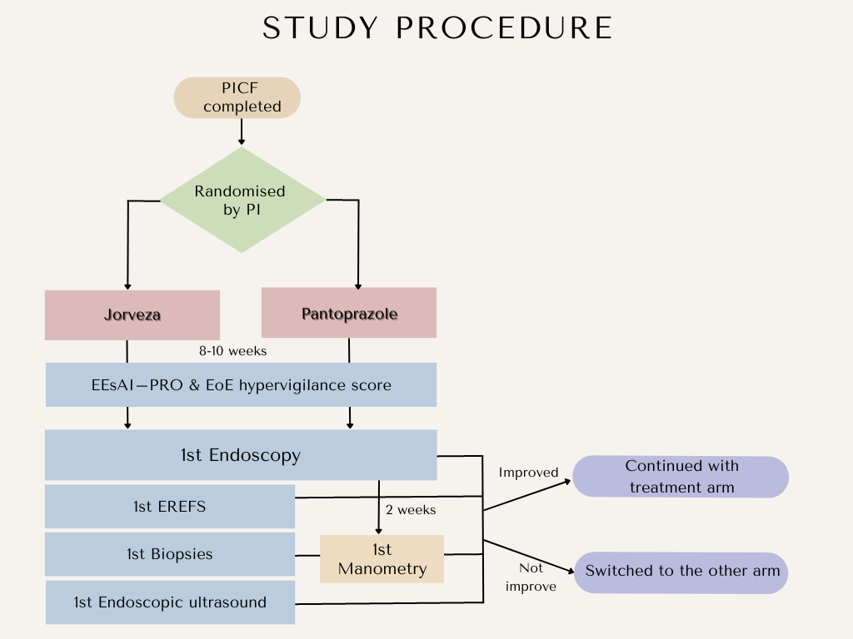

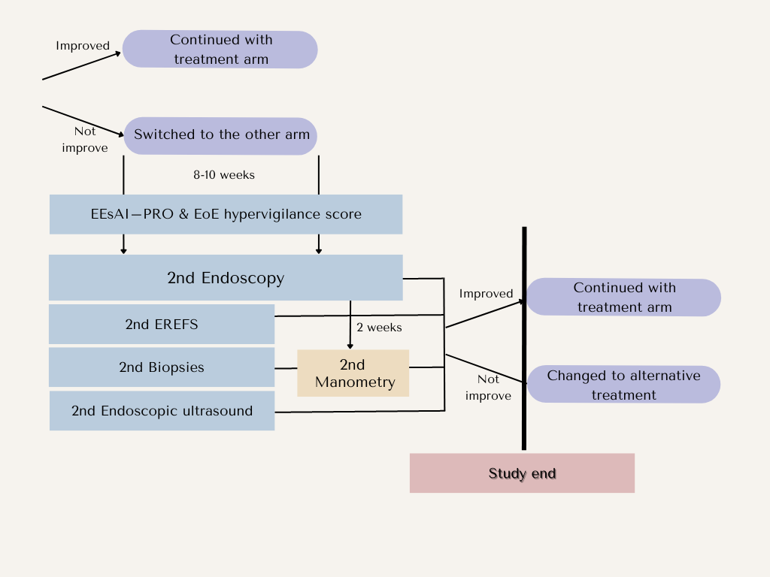

16.2. APPENDIX 2: Likert Score

1 = mild
10= severe

Instructions: draw on the line to indicate if, in the last 1 week your symptoms have been very minor (1) up to very severe (10)

16.3. APPEXDIX 3: Redcap platform
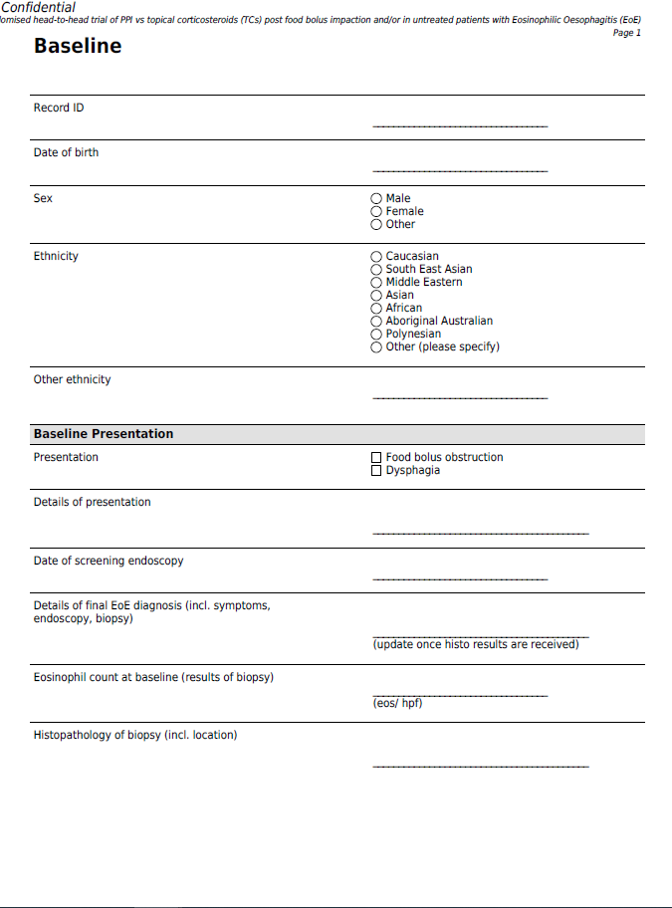

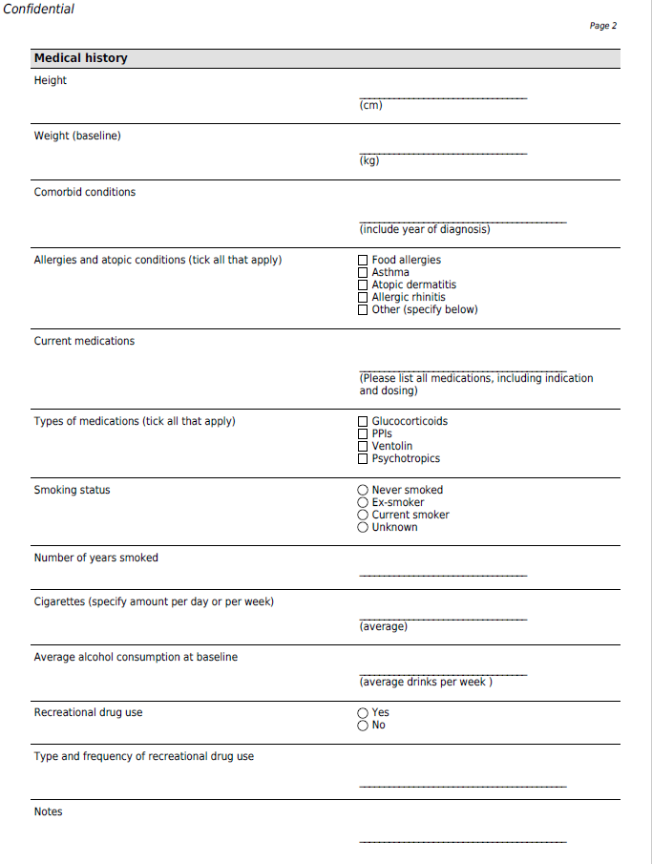

16.4. APPENDIX 4: EoE hypervigilance score

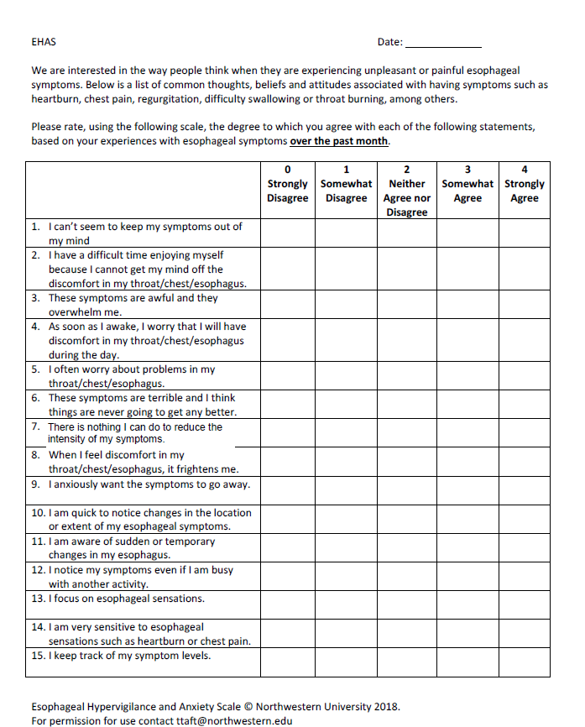

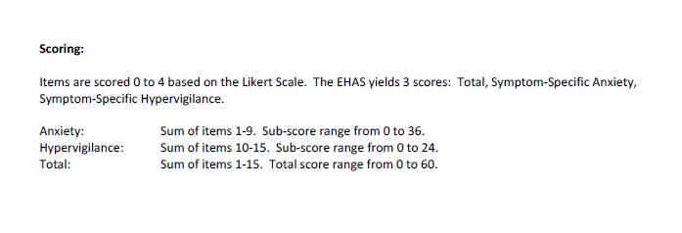

16.5. APPENDIX 5: the EREF’s score

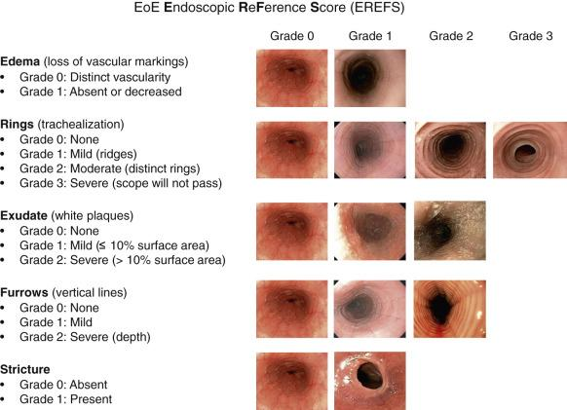

16.6. APPENDIX 6: Endoscopic ultrasound (miniprobe)

16.7. APPENDIX 7: Reports of the esophageal manometry (Chicago classification version 4.0)

