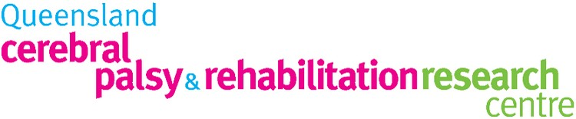
,

Helping teens with Acquired Brain Injury and Cerebral Palsy to improve social skills and the ability to make and maintain friendships

What is this study about?
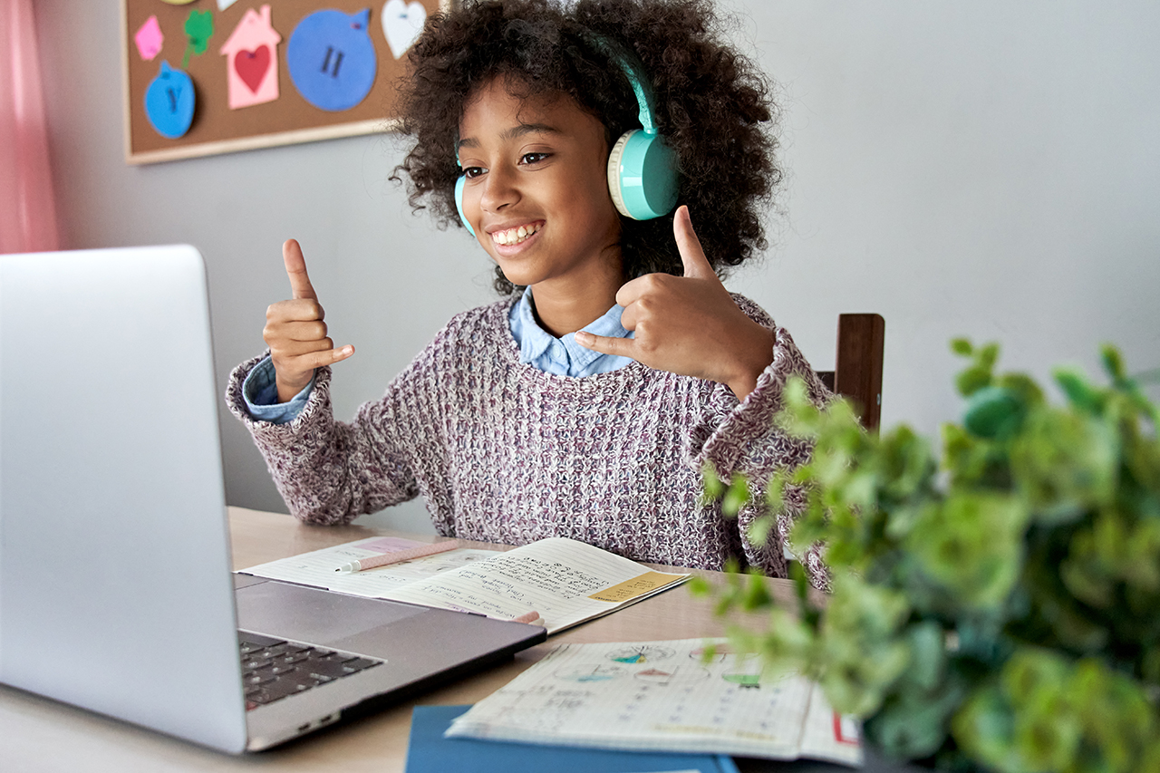

This study is for kids and teenagers (11 – 17 years at high school) who would like to learn new skills to help them make and keep friends.

We have developed a 14-week online program called PEERS® for Telehealth. This program is based on the social skills training program called PEERS®: Program for the Education and Enrichment of Relational Skills. PEERS® for Telehealth aims to help kids and teenagers learn and practice skills like talking with adults and other kids, how to deal with bullying, teasing and how to be a good friend.

We will also explore kids’/teens’ and their caregivers’ experience of the program.
Who can participate?
Teenagers who:
Have a diagnosis of CP or ABI (at least 6 months post ABI)
Are between 11-17 years of age and attend mainstream high school
Have difficulty with social skills and making and maintaining friendships
Who is not eligible to participate?
Teenagers who:
have severe visual or auditory impairment have uncontrolled epilepsy
are non-verbal
For children with acquired brain injuries (ABI) or cerebral palsy (CP), making friends and maintaining social networks can be a major challenge. We have previously demonstrated that the PEERS® program helps adolescents with brain injuries to improve social knowledge and participation.

Will PEERS® for Telehealth help teenagers children make and keep friends?

That is our research question.

What is involved?

1. A screening interview and assessment to confirm eligibility and interest in the study.
2. Completing questionnaires at the beginning of the study, at the completion of the PEERS® program, mand 9 months later.
3. Therapist led online weekly 90 minute sessions in a group of up to 8 teens and an online parent group is run at the same time in a different room.

Benefits:
If you would like to find out more or know someone who might be interested, please scan the QR code or contact us:

The program may enhance your teenager’s social skills and help develop their skills to make and keep friends. As a result, this may improve their long-term psychological wellbeing and quality of life.

You will be assisting us to gather information that may influence the way social skills training for youth with CP or ABI is delivered and provide better outcomes for their future.
Associate Professor Leanne Sakzewski University of Queensland l.sakzewski1@uq.edu.au
T: 07 3069 7345

Ms Rose Gilmore University of Queensland Rose.Gilmore@uq.edu.au

Ms Nicola Hilton
Children’s Health Queensland
Nicola.hilton@health.qld.gov.au

