Participant Information Sheet
Actions of SGLT-2 inhibitors in Individuals with Stage 4 Chronic Kidney Disease (CKD)
Lead investigator: | Professor Rob Walker | Ethics committee ref: 2022 FULL 12970
Dunedin School of Medicine
University of Otago.
Nephrology Department
Te Whatu Ora – Health New Zealand Southern.

Study Contact Details: | Dr Luke Wilson or Prof Walker  via Dunedin Public Hospital switchboard 03 474 0999 |  | Email: rob.walker@otago.ac.nz

This is the first clinical trial investigating the effects of Empagliflozin on the clearance of sodium in people with non-diabetic stage 4 Chronic Kidney Disease.
You may not get any direct health benefit from the study; but there may be a small risk of side-effects from the treatment.

You are invited to take part in a pilot study on Sodium Glucose Co-Transport 2 inhibitors (SGLT2-I) effect on sodium (salt) and glucose (sugar) clearance (passing urine) in those with Stage 4 Chronic Kidney Disease (CKD). Whether or not you take part is your choice. If you don’t want to take part, you don’t have to give a reason, and it won’t affect the care you receive. If you do want to take part now, but change your mind later, you can pull out of the study at any time.

This Participant Information Sheet will help you decide if you’d like to take part. It sets out why we are doing the study, what your participation would involve, what the benefits and risks to you might be, and what would happen after the study ends. We will go through this information with you and answer any questions you may have. You do not have to decide today whether or not you will participate in this study. Before you decide you may want to talk about the study with other people, such as family, whānau, friends, or healthcare providers. Feel free to do this.

If you agree to take part in this study, you will be asked to sign the Consent Form on the last page of this document. You will be given a copy of both the Participant Information Sheet and the Consent Form to keep.

This document is 14 pages long, including the Consent Form. Please make sure you have read and understood all the pages.

Voluntary Participation and Withdrawal From This Study

You are free to decide not to participate in this study or to withdraw at any time without adversely affecting your relationship with the investigator(s). Your decision regarding whether or not to participate in this study will not result in any loss of benefits to which you are otherwise entitled.

What is the purpose of the study?
Empagliflozin (a SGLT2-I) reduces the amount of salt and glucose that is reabsorbed by your kidneys so this extra glucose, salt, and fluid is passed out in your urine (pee). This lowers your blood pressure and provides known cardiovascular benefits. Initial studies demonstrated marked benefit in people with diabetes and kidney disease. More recent studies have demonstrated the effectiveness of SGLT2-I in slowing the progression of mild to moderate non-diabetic kidney disease as well the known cardiovascular benefits. Importantly they do not lower blood glucose below the normal range. However, there is very little data on the actions of the SGLT2-I on kidney function in individuals with more pronounced kidney disease (stage 4 chronic kidney disease) with respect to how this medication works (the handling of sodium and glucose). While the benefits of SGLT2-I are promising, the best way to prescribe these drugs may not have been optimized as there is not good information on how this medication is handled by the kidneys in those with stage 4 chronic kidney disease. Therefore, this pilot study aims to recruit 6 individuals to measure just how well empagliflozin is cleared by the kidneys, to determine the correct dose to use, as well as developing a better understanding of the effects of empagliflozin on glucose and sodium clearance in the urine in those with Stage 4 chronic kidney disease (CKD) without Diabetes Mellitus.

what will my participation in the study involve?

This pilot study involves 11 visits to our clinical research rooms over 22 days of various time commitments (from 1 to a maximum of 9 hours). During each visit you will come to the clinical research facilities Department of Medicine 9th floor Dunedin Public Hospital. We will ask you to carry out 3 timed urine collections over a 24hour period prior to visit 1, then again on visits 6 and 10. You will take 10 mg empagliflozin daily of for the first 7 days, with an increase to 25 mg of empagliflozin for the next 7 days followed by a 7 day period of not taking the empagliflozin (known as a washout period). We have added figure 1 below to help you understand the timing of the visits and what happens at each visit.
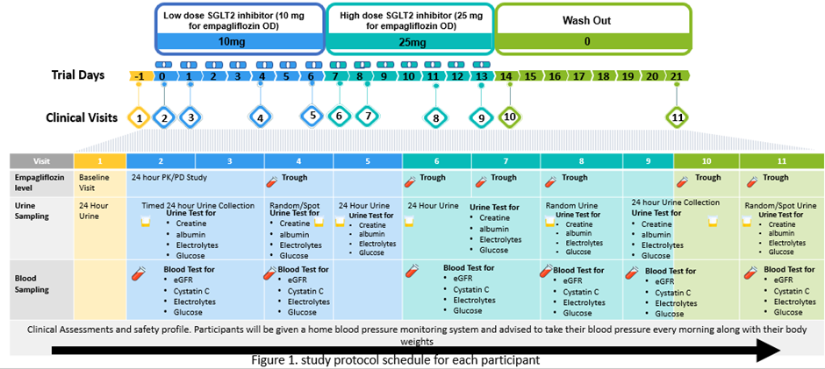

Prior to the first visit we will contact you to obtain informed consent and to organize a suitable time to deliver the necessary equipment and provide instructions for the 24-hour urine collection. We will also ask you to withhold your usual tablets until we have collected the baseline blood sample. Please bring your tablets with you to the first visit.

On the first and longest visit, having already provided informed consent and undergone a baseline 24-hour urine collection to measure your urinary excretion of sodium and glucose prior to this visit we will carry out a baseline assessment including.
- Demographic and anthropometric data will be collected including weight, height, age, sex, and self-declared ethnicity.
- Cause of stage 4 chronic kidney disease.
- Other current medications, including over the counter and herbal medicines. The prescribed dose and duration for each drug will be recorded.
- Associated health conditions.
- Smoking and alcohol history.
- Baseline blood samples (~10 mL) for serum creatinine, cystatin C, serum urate, electrolytes (Na⁺, K⁺, HCO₃²⁻, PO₄³⁻), ketones and glucose.
- If you are agreeable and consent to this we will take an additional small (5 mL) baseline blood sample and samples at visits 4, 7 and 9 to be stored within the -80°C freezers on the 9th floor. These sample will be used to investigate the effects and response to empagliflozin on metabolism (metabolomics) in the setting of chronic kidney disease pending future ethics approval.
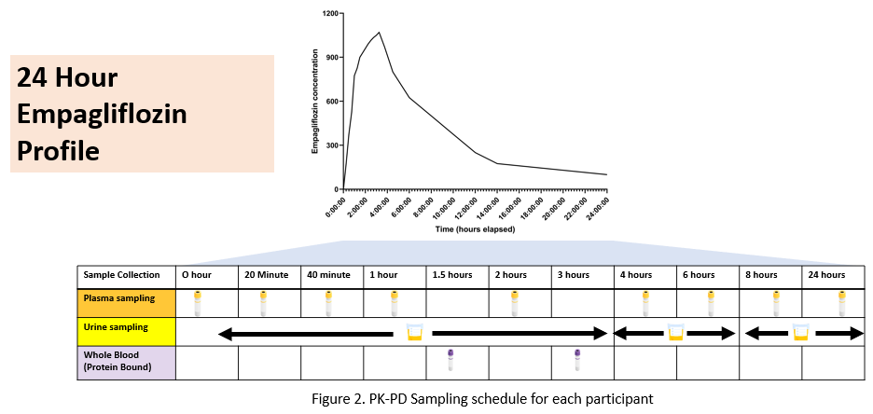
Following the baseline blood sampling we will provide you with the first dose of empagliflozin (10 mg). We will then investigate the properties and actions of empagliflozin over the next 24 hours. This is known as a pharmacokinetic and pharmacodynamics study to work out how the body removes empagliflozin. Figure 2 below is to help you understand the types (blood or urine) and times we will be collecting samples. We will provide morning and afternoon tea, and lunch and beverages during the day.

Blood samples will occur following the initial dose of empagliflozin at 20 minutes, 40 minutes, 1 hour, 2 hour, 4 hour, 6 hour, 8 hour and 24 hour time-points to measure empagliflozin concentrations, plus laboratory data including serum creatinine, cystatin C, serum urate, plasma electrolytes, and glucose.
Two additional whole blood samples (8 mL each) at 1.5 and 3-hour time-points to assess empagliflozin level that is bound to the protein within your blood (this is separate to the other measures).
Timed urine collections for 0 – 4 hours, 4 – 8hours, and 8 – 24 hours will be collected to determine the urinary empagliflozin, creatinine, albumin, electrolytes, urea, osmolarity and glucose levels.

For all measures the exact sampling times are noted.

For the visits 4, 6, 7, 8, 10 and 11 we will collect the blood samples to measure the trough levels of empagliflozin (lowest levels before the next dose) along with safety blood samples for kidney function, glucose and ketones as well as a spot urine collection. For these visits we will ask you from refraining from taking your tablets and empagliflozin until these samples are taken. We will ask you to repeat the time 24-hour urine collection for visits 5 and 10.

We will also measure your body weight and blood pressure at each clinical visit and will provide the equipment for you to carry this out daily at home.

What will happen to my blood and urine samples?

The samples (blood and urine), are labelled with your assigned unique de-identified code, and the date and time it was collected.

We will send blood and urine samples to the Southern Community Laboratories for immediate analysis of kidney function. We will provide them with your unique study identifier, biological sex (male or female) and with your date of birth as this is part of their formal quality assurance processes.

The remaining blood and urine samples for measurement of empagliflozin will be processed stored until the end of the study. These samples will then be shipped to Christchurch for analysis.

If you agree to the optional blood sampling for future studies investigating the metabolomics in response to empagliflozin these will be stored with your unique identifier and the date and time of collection within the -80°C freezer on the 9th floor of Dunedin Hospital for a maximum of 5 years. This is a potential investigation that will require additional funding.

With respect to blood samples, we acknowledge that these samples are Taonga and appropriate Tikanga will be observed. A karakia will be offered for disposal of blood samples left over from processing and/or analysis for all participants regardless of ethnicity for any sample handled directly by the research team. We will also give you the option to have the remainder of the blood samples returned to you if you wish. The disposal will be carried out using the processes and procedures as guided by the University of Otago, Southern Community Laboratories, Canterbury Health Laboratories, and the Te Whatu Ora - Southern for biological products.

You will be able to request that any of your remaining blood samples are returned to you during and following the study if you wish. We are unable to return any blood samples from once they have been transferred to Southern Community Laboratories or Canterbury Health Laboratories.

Who can take part in the study?

Any individual with stable stage 4 non-diabetic chronic kidney disease (eGFR 20 - 30 mL/min/1.73 m²) not previously on a SGLT2-I, over the age of 18 years can participate in this study. You will continue your usual tablets including diuretics and this will remain stable throughout the study unless a change is medically indicated. You will not be eligible for the study if you have stage 4 chronic kidney disease due to diabetes, or if you have been acutely unwell or clinical unstable for any reason within the last 3 months.

You will have been approached by one of your Nephrologists (kidney doctors) to see if you are interested in participating and they will have given you this information sheet.
We will then contact you after a week to see if you are willing to take part.

What are the possible benefits and risks of this study?
There are no guaranteed direct benefits to you in taking part in this study. By participating in this study, you are contributing the understanding for the action and safety of empagliflozin in those with stage 4 chronic kidney disease. If the findings demonstrate that empagliflozin is safely handled by individuals with stage 4 chronic kidney disease, it should make empagliflozin more widely available as part of usual treatment for individuals with CKD stage 4.

We do not foresee any large or unexpected risks from participating in this study. Importantly this medication does not reduce your blood glucose levels below normal levels. When you first start this medication, there may be an increase in the amount of urine you pass. Provided you continue to drink fluids according to thirst, this should not cause a problem. If you do feel dizzy or lighted headed, then please withhold the next dose of the tablet and call the research team via the hospital operator. As we will be seeing you on a very regular basis, the risk of side effects due to the empagliflozin is small. You are welcome to contact the study investigators if you have any questions or concerns. This includes reducing the dose or even stopping the empagliflozin.
To minimise risk, please avoid or limit alcohol to no more than 2 standard drinks of alcohol a day. If you are unwell with any vomiting or diarrhoea please stop the medication and let the research team know.
We think it is important to also let your GP know you will be on this medication for 2 weeks just in case you need to see them for another reason, so they are aware before making any possible changes to your management.

What are the alternatives to taking part?

If you choose not to participate in this study, or chose to withdraw from the study, this will have absolutely no impact on your on-going care by the Nephrology department

Who pays for the study?
There will be no cost to you to participate in this study. The study is being paid for with funds from the Dunedin School of Medicine Department of Medicine.

To recognize the actual or reasonable costs involved with participating in this project, all participants will be reimbursed with a supermarket voucher or petrol voucher (value of $40) for each experimental visit you complete. We will organize transport to and from Dunedin Public Hospital as necessary and for visit 1 provide you with meals and beverages throughout the day. You are free to withdraw from the study at any time, and if you choose to discontinue the study (please see full details below under ‘What are my rights?’) you will be reimbursed proportionately.

What will happen to my information?
During this study the study doctors/researchers, will record information about you and your study participation. This includes the results of any study assessments from your hospital records where available. As this is important data for our analyses, you cannot take part in this study if you do not consent to the collection of this information.
Identifiable Information
Identifiable information is any data that could identify you (e.g. your name, date of birth, or address). The following groups may have access to your identifiable information

- Specific members of the research team (to complete study assessments or in cases where a significantly abnormal test result was returned requiring clinical follow up by your appropriate healthcare provider.)
- The ACC and/or the University of Otago and their representatives, if you make a compensation claim for study-related injury. Identifiable information is required in order to assess your claim.
- The sponsor, ethics committees, or government agencies from New Zealand or overseas, if the study or site is audited. Audits are done to make sure that participants are protected, the study is run properly, and the data collected is correct.
We can notify your general practitioner of your enrolment in this study. In addition, an alert will be placed in your electronic health record within the Te Whatu Ora - Southern system stating that you have enrolled in the study.

De-identified (Coded) Information
To make sure your personal information is kept confidential, information that identifies you will not be included in any report generated during the study. Instead, you will be identified by a code. The researcher will keep a list linking your code with your name, so that you can be identified by your coded data if needed.
Access to your coded information will include, but is not limited to the following groups
- The Investigator and suitably trained and experienced study staff, to conduct the study and to perform data analysis.
- Other Researchers and delegates of the investigative team for re-analysis and peer review of study data.
- The Health and Disability Ethics Committee, to comply with legal and regulatory duties.
- Health, regulatory, or government authorities, to comply with legal and regulatory duties.
The results of the study may be published or presented, but not in a form that would reasonably be expected to identify you. As this is a clinical trial, de-identified data, will be made available on public servers after the end of the trial to allow other researchers to re-analyse the trial to check the findings, and to do other analyses of the data. Your de-identified data may be added to other datasets for the future study of treatments of Chronic Kidney Disease. Participants will be informed of the potential risks and cultural issues associated with sending data overseas and there may be no New Zealand representation on overseas governance committees.
Anonymised Information
The research team may remove the code from your de-identified information – this is called ‘anonymisation’. This makes it very difficult (but not impossible) to identify the information that belongs to you. We also ask to contribute your anonymised information to a database which will be available to the public for research, education and teaching purposes – this is an optional part of the study. This anonymised information includes clinical information, such as; age, sex and gender, height, weight, blood pressure, smoking, alcohol, ethnicity and medical conditions (for example cause of chronic kidney disease). Anonymised information means all personal details, such as your name or anything that might directly identify you, will be removed. If you agree, this anonymised data will be placed on publicly accessible websites in the future. Our aim is that other researchers and teachers will be able to use this information to improve human health.

Future Research Using Your Information.
De-identified and anonymised data will be used by the Investigator for future medical or scientific research as specified below:
To investigate the metabolomics (changes in products generated by your metabolism due to the medication). This is a potential investigation that will require additional funding.
Security and Storage of Your Information.
Your identifiable information will be stored in a secure database hosted on the secure University of Otago servers during the study. Any paper documents generated will be kept in lockable rooms within the Dunedin Public Hospital premises. Your data will be stored securely for at least 10 years after completion of the study, then destroyed. All storage will comply with local and/or international data security guidelines. Destruction of any data (paper or digital) will be performed in a secure manner following University of Otago disposal policies to protect your privacy and confidentiality.
Risks.
Although efforts will be made to protect your privacy, absolute confidentiality of your information cannot be guaranteed. Even with coded and anonymised information, there is no guarantee that you cannot be identified. The risk of people accessing and misusing your information (e.g. making it harder for you to get or keep a job or health insurance) is currently very small, but may increase in the future as people find new ways of tracing information.
Rights to Access Your Information.
You have the right to request access to your information held by the research team. You also have the right to request that any information you disagree with, is corrected. We will tell you of any findings that we have that may impact on your health. If you have any questions about the collection and use of information about you, you should ask a member of the research team.
Rights to Withdraw Your Information.
You may withdraw your consent for the collection and use of your information at any time, by informing the research team.
If you withdraw your consent, your study participation will end, and the study team will stop collecting information from you.
If you agree, information collected up until your withdrawal from the study will continue to be used and included in the study. You may ask for it to be deleted when you withdraw, unless you withdraw after the study analyses have been undertaken.
You will not be able to withdraw your de-identified data if we have shared it with other researchers after the completion of the study. If your code is removed from your information, making it anonymised, you will not be able to access, correct or withdraw your information, even if you change your mind about it being used (as we will not be able to identify your data specifically).

What if something goes wrong?
If you were injured in this study due to the intervention, you would be eligible to apply for compensation from ACC just as you would be if you were injured in an accident at work or at home. This does not mean that your claim will automatically be accepted. You will have to lodge a claim with ACC, which may take some time to assess. If your claim is accepted, you will receive funding to assist in your recovery.

In the unlikely event that ACC determines that their cover did not apply to your injury, then the University of Otago’s clinical trial insurance would apply. This cover would provide you with compensation equivalent to that you would otherwise have been entitled to under the Accident Compensation Act 2001. By signing the Consent Form for this study, should ACC decline cover, you are explicitly agreeing that compensation for any injury will be as per the terms of University’s then current clinical trials insurance cover, the full terms and conditions of which are freely available on request.

If you have private health or life insurance, you may wish to check with your insurer that taking part in this study won’t affect your cover.

What happens after the study?
Data will be coded, stored and protected for a minimum of 10 years after the completion of the study.

We expect that the results of this study will be published in peer reviewed medical journals. There may be some time between the conclusion of data collection and publication of results. You will not be personally identified in any presentations or publications from the study. If you wish, we can provide you with a written summary of the findings of our study.

Who is funding the study?
Department of Medicine, Dunedin School of Medicine, University of Otago.

Who Has Approved the study?

This study has been approved by an independent group of people called a Health and Disability Ethics Committee (HDEC), who check that studies meet established ethical standards. The Central Health and Disability Ethics Committee has approved this study.

Who do I contact for more information or if I have concerns?
If you have any questions, concerns or complaints about the study at any stage, you can contact:

Lead investigator: Professor Rob Walker
Study contact: Dr Luke Wilson
Study email: rob.walker@otago.ac.nz

If you want to talk to someone who isn’t involved with the study, you can contact an independent health and disability advocate on
Phone: 0800 555 050
Fax: 0800 2 SUPPORT (0800 2787 7678)
Email: advocacy@advocacy.org.nz
To ensure ongoing cultural safety, Te Whatu Ora - Southern encourage those who identify as Māori, and who are participating in health research or clinical trials, to seek cultural support and advice from their own Kaumatua or Kuia in the first instance, or please contact:
Te Ara Hauora - Māori Health Unit  Dunedin Hospital  Phone: (03) 474 0999 ext. 58649 | Hinge Tahi Māori Health Cultural Support  Southland Hospital  Phone: (03) 218 1949 ext. 48509

You can also contact the health and disability ethics committee (HDEC) that approved this study by phoning: 0800 4 ETHICS or by email: hdecs@moh.govt.nz

Consent Form

Sodium Glucose Co-Transporter 2 inhibitors (SGLTI-2) effect on Glucose and Sodium clearance in those with Stage 4 Chronic Kidney Disease (CKD)

I consent to the following:

I have been given sufficient time to consider whether or not to participate in this study.
I have had the opportunity to use a legal representative, whanau/ family support or a friend to help me ask questions and understand the study.
I am satisfied with the answers I have been given regarding the study and I have a copy of this consent form and information sheet.
I understand that taking part in this study is voluntary (my choice) and that I may withdraw from the study at any time without this affecting my medical care.
I consent to the research staff collecting and processing my information, including information about my health.
I consent to de-identified information from this study being placed on public databases for re-analysis and secondary analysis of the trial, and to study other questions in health and disease.
I agree to an approved auditor appointed by the New Zealand Health and Disability Ethics Committees, or any relevant regulatory authority or their approved representative reviewing my relevant medical records for the sole purpose of checking the accuracy of the information recorded for the study.
I understand that my participation in this study is confidential and that no material, which could identify me personally, will be used in any reports on this study.
I have read the ‘What if Something Goes Wrong’ section in the Participant Information Sheet. I agree that in the unlikely event that ACC declines cover for any injury to me arising from this study, the compensation available will be as per the terms of University’s then current clinical trials insurance cover.
I know who to contact if I have any questions about the study in general.
I understand my responsibilities as a study participant.
I consent to my GP or current provider being informed about my participation in the study and of any significant abnormal results obtained during the study.
I consent to the research staff collecting, storing, and using my information, including information about my health, electronic health records, now and in the future, and understand it will only be used for further investigation into health and disease.
Yes I confirm the statements listed above

Optional Points:
You can still take part in the study if you answer “No” to the following:
I agree to have an optional blood sample taken and stored for future analysis investigating the metabolism effects of empagliflozin. | Yes | No
If I decide to withdraw from the study, I agree that the information collected about me up to the point when I withdraw may continue to be processed. | Yes | No
I agree to my anonymised data (with all personal details removed) being included on publicly accessible websites to facilitate research, teaching and education | Yes | No
I wish to receive a summary of the results from the study. | Yes | No
I wish to be contacted about future research. | Yes | No

Declaration by participant:
I hereby consent to take part in this study.

Participant’s name:
Signature: | Date:

Declaration by member of research team:

I have given a verbal explanation of the research project to the participant, and have answered the participant’s questions about it.

I believe that the participant understands the study and has given informed consent to participate.

Researcher’s name:
Signature: | Date:

