In vivo analysis of undisturbed peri-implant biofilm formation, composition, and growth in periodontally healthy and stable periodontitis patients

Protocol Number | X22-0083
Coordinating Principal Investigator | Judd Sher
Protocol Authors (Co-investigators) | Axel Spahr  Jessica O’Neill
Protocol Version Number | 2
Date | 27/02/22
Sponsor (if applicable) | University of Sydney, School of Dentistry
Proprietary Notice (if applicable) | N/A

Ethics Statement:

The study will be conducted in accordance with the National Statement on Ethical Conduct in Human Research (2007) (Link to National Statement) , the CPMP/ICH Note for Guidance on Good Clinical Practice (Link to CPMP/ICH ) and consistent with the principles that have their origin in the Declaration of Helsinki. Compliance with these standards provides assurance that the rights, safety and well-being of trial participants are respected.

Disclaimer:
This study is continuation of the pilot study conducted by Dr. Denny Luo as part of his research for the DClinDent (Periodontics) program at the University of Sydney. As such, several components of the design and methodology are duplicated for this study.

Table of Contents
1. BACKGROUND AND INTRODUCTION 6
1.1. DISEASE/PROPOSED INTERVENTION BACKGROUND 6
1.2. RATIONALE FOR PERFORMING THE STUDY 7
2. HYPOTHESIS 7
3. STUDY OBJECTIVES / AIMS 8
3.1. PRIMARY OBJECTIVES 8
3.2. SECONDARY OBJECTIVES 8
4. STUDY DESIGN 8
4.1. DESIGN / STUDY TYPE 8
4.2. EXPECTED PARTICIPANT NUMBERS 8
4.3. TIME PERIOD OF THE STUDY 8
4.4. ENDPOINTS 9
4.5. CENTRES 9
5. STUDY PARTICIPANTS 9
5.1. INCLUSION CRITERIA 10
5.2. EXCLUSION CRITERIA 10
6. STUDY PROCEDURES 11
6.1. STUDY FLOW CHART [if applicable] 11
6.2. INVESTIGATION PLAN 12
6.3. STUDY PROCEDURE RISKS 15
6.4. PARTICIPANT RECRUITMENT AND SCREENING 15
6.5. PARTICIPANT ENROLMENT 17
6.6. INFORMATION AND CONSENT 17
6.9 PATIENT WITHDRAWAL 17
7. OUTCOMES 18
7.1. DEFINITION OF OUTCOMES 18
8. Statistical Considerations 18
8.1. SAMPLE SIZE OR POWER ALCULATION 18
8.2. ANALYSIS PLAN 18
The data will be expressed as mean ± standard deviation and images obtained of the biofilm structure will be described. 18
9. DATA COLLECTION 18
9.1. FORMS AND PROCEDURE FOR COLLECTING DATA 18
10. PUBLICATION & INTELLECTUAL PROPERTY 19
11. ETHICS 19
11.1. INVESTIGATOR AUTHORISATION PROCEDURE 19
The conduct of this study will commence once the initial approval process has been completed through Ethics and Governance authorisation for each site. Updated documents will only be implemented once they have been reviewed and approved by an Ethics Committee and if applicable Governance Officer for each site. 19
12. CONFIDENTIALITY, STORAGE & ARCHIVING OF STUDY 19
13. DATA SAFETY MONITORING BOARD 19
14. COMPENSATION 20
15. REFERENCES 20

Protocol Title | In vivo analysis of undisturbed peri-implant biofilm formation, composition, and growth in periodontally healthy and stable periodontitis patients
Protocol version | 1
Objectives | The primary objective is to analyse the formation, composition, and growth of an undisturbed sulcular biofilm grown in a novel implant-supported biofilm chamber (ISBC).  The secondary objective is to compare the formation, composition, and growth of an undisturbed sulcular biofilm grown in a novel ISBC in (i) periodontally healthy and (ii) stable periodontitis patients.
Study design | The study design is an exploratory non-randomised clinical trial. Two groups will receive the ISBC: (i) periodontally healthy (2) stable periodontitis patients.
Planned sample size | The expected number of participants is 8 (4 in each group).
Selection criteria | INCLUSION CRITERIA:  - Adult patients (≥21 yoa) that are suitable for treatment with single-tooth dental implants, or have received a dental implant that requires a restoration, in the posterior region (non-aesthetic sites)  - Periodontally healthy with no history of periodontitis or Stable Stage 2/3 Grade A/B periodontitis according to the 2017 world workshop on the classification of periodontal and peri-implant diseases and conditions (Chapple et al., 2018; Tonetti, Greenwell, & Kornman, 2018)  - Good oral hygiene assessed by full-mouth bleeding and plaque score  - Participants not willing not provide informed consent and willing to participate and comply with the study requirements  EXCLUSION CRITERIA:  - Patients with an absolute contraindication to dental implant treatment including recent myocardial infarction and cerebrovascular accident, valvular prosthesis surgery, immunosuppression, bleeding issues, active treatment of malignancy, drug abuse, psychiatric illness, and intravenous bisphosphonate use  - Participants with failing/compromised implants or peri-implantitis  - Implant sites located in aesthetic zones, and sites that require tissue augmentation / grafting  - Pregnant/lactating patients  - Patients who have received antibiotics within the past 3 months  - Edentulous patients
Study Procedure | Patients meeting the inclusion criteria who have consented to participate in the study will receive an ISBC, fabricated using CAD/CAM (Figure 1 and 2). The ISBC will be designed to house two chambers with channels opening into the sulcular (interproximal) region. Zirconia discs will be milled and placed in the chambers. Biofilm will be allowed to grow on the discs for 1-hour, 24-hours, 2-days, 4-days, 7-days, and 14-days before being removed for microbiological analysis. Confocal microscopy will be used to study the viability and three-dimensional structure of the biofilm at the various time points. The composition of the biofilm will also be determined using next-generation sequencing.  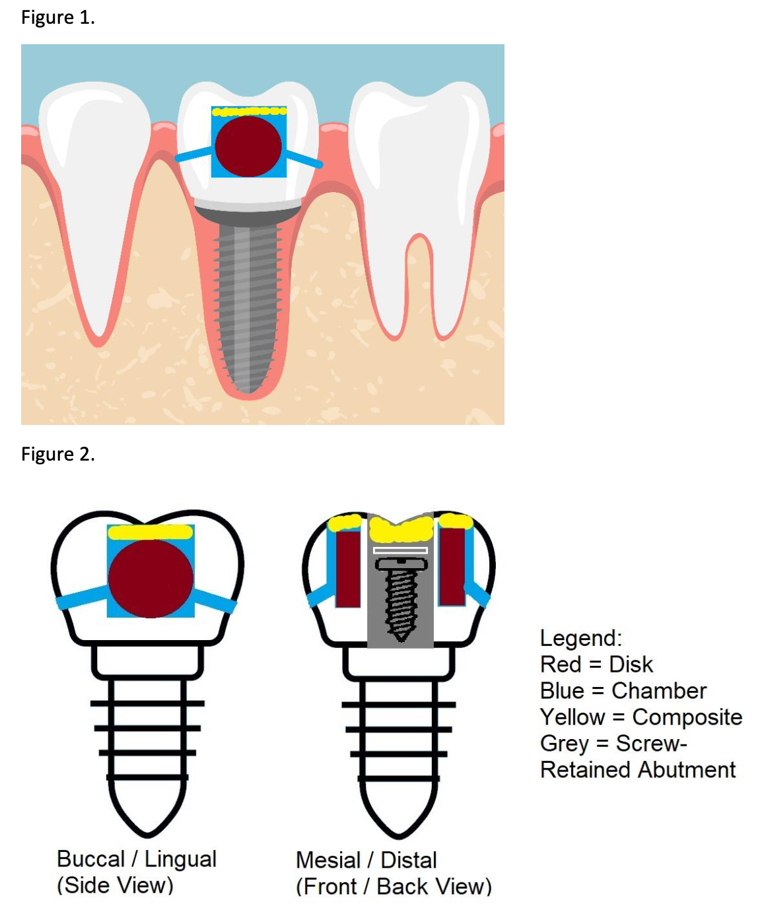
Statistical considerations | Sample size calculation: This study is a descriptive clinical trial and, as such, a sample size or power calculation is not required.  Analysis plan: Data will be expressed as mean ± standard deviation and images obtained of the biofilm structure will be described.
Time Period of Data Collection | October 2022 – June 2023
Duration of the Study | 18-24 months
Funding (if applicable) | None
Sponsor (if applicable) | University of Sydney, School of Dentistry

[if applicable:] Protocol Version Control box
Protocol  Version Number | Date | Summary of Changes
1 | 27/02/22 | -

1. BACKGROUND AND INTRODUCTION

1.1. DISEASE/PROPOSED INTERVENTION BACKGROUND
Dental plaque represents a true biofilm consisting of an extraordinarily complex three-dimensionally structured microbial community embedded within a self-produced polymeric extracellular matrix that tenaciously adheres to intraoral hard surfaces (Lindhe et al., 2015). The term ‘sulcular biofilm’ refers to dental plaque that is located below the gum line of healthy natural teeth or dental implants. If allowed to accumulate, these biofilms trigger a reversible inflammation in the periodontal and peri-implant soft tissues known as ‘gingivitis’ and ‘peri-implant mucositis’, respectively (Heitz-Mayfield & Salvi, 2018; Loe, Theilade, & Jensen, 1965). In susceptible patients, gingivitis and peri-implant mucositis can progress to involve the irreversible, progressive loss of bone around natural teeth and dental implants, ultimately leading to tooth and implant loss. Around natural teeth, this destructive inflammatory condition is referred to as ‘periodontitis’, whereas around dental implants, it is termed ‘peri-implantitis’ (Papapanou et al., 2018; Schwarz, Derks, Monje, & Wang, 2018).
Given the role of sulcular biofilms in the aetiopathogenesis of periodontal and peri-implant diseases, it is imperative that we study their structure to gain an understanding of the interactions and functional activity of individual microbes helping to drive the changes from health to disease. In the past, the structure of these biofilms has been analysed using both in vitro and in vivo models. However, whilst in vitro models have significantly added to our understanding of the biology of these biofilms, they are unable to generate a biofilm remotely comparable to those found in vivo (Roberts, Kragh, Bjarnsholt, & Diggle, 2015). This highlights the need for in vivo models where sulcular biofilms are grown in situ and then analysed ex vivo.
In most in situ studies on sulcular biofilms, samples were obtained by mechanical removal curettes or paper points (Prada-López, Quintas, Vilaboa, Suárez-Quintanilla, & Tomás, 2016). These sampling methods inevitably disturb the delicate three-dimensional structure of these biofilms, which directly influences their behaviour. Therefore, a methodology in which the sulcular biofilm is not altered during its formation, collection, processing, or analysis would be preferable. Such an undisturbed biofilm has been referred to in the literature as a Plaque-Like Biofilm (PL-Biofilm) (García-Caballero et al., 2013; Quintas, Prada-López, Prados-Frutos, & Tomás, 2015; Tomás et al., 2013).

1.2. RATIONALE FOR PERFORMING THE STUDY

Unfortunately, due to their protected location, sulcular biofilms are not easily analysed without the loss of structural integrity. Access to study PL-Biofilms located below the gum line of natural teeth and dental implants has mainly been achieved by tooth extraction (Listgarten, 1976) and explantation (Covani, Marconcini, Crespi, & Barone, 2006). However, since extraction of teeth and removal of implants is often not possible for ethical reasons, alternative methods for obtaining these biofilms are desirable. Over two decades ago, Wecke et al. (2000) developed one such method where small plastic carriers wrapped with gold foil or expanded polytetrafluoroethylene membranes were inserted to the base of a periodontal pocket, attached to the tooth surface for defined periods of time, and then processed similarly to extracted teeth (Wecke et al., 2000). Over time, this method has been modified and applied in several other studies (Drescher et al., 2010; Moter & Göbel, 2000; Schlafer et al., 2010). It should be noted that despite its proof of concept, the carriers tend to be particularly unstable and when retrieved, it is likely that the biofilm will be disturbed to some degree by contact with the gingival tissues. Another method that has been used to study sulcular PL-Biofilms around dental implants is by retrieving implant abutments (Heuer et al., 2007). However, as with the method described by Wecke et al. (2000), this sampling method is also inherently flawed as the biofilm will likely still be disturbed to some degree upon retrieval.
Clearly, novel models to grow undisturbed sulcular biofilms in vivo are desperately needed. Development of a new model to study these biofilms may help to unlock insights into sulcular biofilm formation, resistance to antibiotics, extracellular polymeric matrix composition and function, reciprocal host-cell-to-biofilm interactions, and perhaps the role of single microorganisms in the aetiopathogenesis of periodontal and peri-implant diseases. Furthermore, future studies in this area may also result in the innovation of improved diagnostic tools and preventive approaches to periodontal and peri-implant disease management than currently available, as well as open avenues for community manipulation.

2. HYPOTHESIS

The ISBC will allow us to study the formation, composition, and growth of a sulcular PL-biofilm.

3. STUDY OBJECTIVES / AIMS
This study aims to answer the following research question: “Will the ISBC allow us to study the formation, composition, and growth of a sulcular PL-biofilm?”
The variables of the sulcular PL-biofilm that will be descriptively analysed include: (i) viability (ii) microbiological profile.

3.1. PRIMARY OBJECTIVES

The primary objective is to analyse the formation, composition, and growth of a sulcular PL-biofilm.

3.2. SECONDARY OBJECTIVES

The secondary objective is to compare formation, composition, and growth of a sulcular PL-biofilm in (i) periodontally healthy and (ii) stable periodontitis patients.

4. STUDY DESIGN

4.1. DESIGN / STUDY TYPE

The study design is an exploratory non-randomised clinical trial. Two groups will receive the ISBC: (i) non-periodontitis patients (ii) stable periodontitis patients.

4.2. EXPECTED PARTICIPANT NUMBERS

The expected number of participants is 8 (4 in each group).

4.3. TIME PERIOD OF THE STUDY
The duration of the study is approximately 18 to 24-months. The table below outlines the expected time periods for the various tasks involved with this study:
Task | Start Date | End Date
Ethics Submission | Early March 2022 | End March 2022
Ethics Review and Approval | Early April 2022 | End May 2022
Advertising | June 2022 | December 2022
Recruitment | June 2022 | December 2022
Insertion of ISBC | October 2022 | June 2023
Collection of data | October 2022 | June 2023
Analysis of Data | December 2022 | August 2023
Preparations of Reports | Early May 2023 | End May 2023
Publication Draft | June 2023 | September 2023
Submission of Publications and Final Reports | Early October 2023 | End October 2023

4.4. ENDPOINTS

PRIMARY ENDPOINTS
To report the viability of the sulcular biofilm samples collected from the ISBC at the various time-points (1-hour, 24-hours, 2-days, 4-days, 7-days, and 14-days) and describe its undisturbed three-dimensional architecture.
SECONDARY ENDPOINTS
The secondary endpoint is to report the species of bacteria present in the sulcular biofilm samples collected from the ISBC at the various time-points.

4.5. CENTRES
Site Name/s | Sydney Dental Hospital / Sydney Dental School
Site Contact/Investigator | Judd Sher
Study Procedures | Study procedures to be conducted at Sydney Dental Hospital / Sydney Dental School include recruitment, dental implant treatment, provision of an ISBC and final crown/restoration, sample collection and storage, data analysis, and writing of the final report and publication.

5. STUDY PARTICIPANTS

5.1. INCLUSION CRITERIA

- Adult patients (≥21 yoa) that are suitable for treatment with single-tooth dental implants, or have received a dental implant that requires a restoration, in the posterior region (non-aesthetic sites)
- Periodontally healthy with no history of periodontitis or
- Stable Stage 2/3 Grade A/B periodontitis according to the 2017 world workshop on the classification of periodontal and peri-implant diseases and conditions (Chapple et al., 2018; Tonetti et al., 2018)
- Good oral hygiene assessed by full-mouth bleeding and plaque score
- Participants not willing not provide informed consent and willing to participate and comply with the study requirements

5.2. EXCLUSION CRITERIA

- Patients with an absolute contraindication to dental implant treatment including recent myocardial infarction and cerebrovascular accident, valvular prosthesis surgery, immunosuppression, bleeding issues, active treatment of malignancy, drug abuse, psychiatric illness, and intravenous bisphosphonate use
- Participants with failing/compromised implants or peri-implantitis
- Implant sites located in aesthetic zones, and sites that require tissue augmentation / grafting

- Pregnant/lactating patients
- Patients who have received antibiotics within the past 3 months
- Edentulous patients

5.3 Key Elements of Recruitment
- Who will be recruited?
Patients that have been referred to Sydney Dental Hospital – Department of Periodontics for dental implant treatment will be assessed for eligibility.
- How will participants be identified and recruited?
Eligible participants will be identified and screened by two registered specialist periodontists (Axel Spahr and Jessica O’Neill). Patients will be advised about dental implant treatment at this screening visit.
- Will the potential participants be screened?
Information regarding this research project will be presented to eligible participants at the screening visit. Interested potential participants will be invited to attend a consultation with the primary researcher (Judd Sher) where full-details and information about the study will be disclosed, as well as answering of any questions posed by the participants.
- What is the impact of any relationship between researchers and potential participants on recruitment?
All patients eligible will receive comprehensive implant treatment regardless of their participation in this study. This will be reinforced at all visits.
- How will the recruitment strategy facilitate obtaining the consent of participants?
Verbal and written consent will be obtained at the consultation visit with the primary researcher if patients are interested in participating in the study. It will be reinforced that participation is voluntary and all patients will receive comprehensive implant treatment regardless of their participation.

- How will the recruitment strategy ensure that participants can make an informed decision about participation?
A period of at least a week will be provided between the initial screening visit and consultation visit to potential participants. This aims to allow time to reflect and formulate any questions regarding the study.
- Are there any risks associated with the recruitment strategy for potential participants or for the viability of the project?
Potential participants will be advised that a temporary restoration on the implant prior to fabrication of a final restoration is part of the standard course of care for implant treatment. An ISBC serves as a temporary restoration, as well as a device to grow and collect biofilm.
5.4 STUDY LIMITATIONS
A limitation of the study is that the artificial environment of the ISBC is not identical to the sulcular environment below the gumline of dental implants. Nonetheless, the ISBC aims to grow a representative sulcular PL-biofilm without the need for invasive procedures such as explantation. Furthermore, the discs used for biofilm growth in the ISBC will be made from zirconia and not tooth structure. Numerous published studies have described that the micro-irregularities and surface roughness of substrates is what determines initial biofilm adhesion and subsequent biofilm growth (Al-Ahmad et al., 2010; Auschill et al., 2002; Hannig, 1999; Hannig, Kriener, Hoth-Hannig, Becker-Willinger, & Schmidt, 2007; Re, Pellegrini, Francinetti, Augusti, & Rasperini, 2011; Schwarz et al., 2007). For standardisation purposes, only one surface with consistent roughness will be used.

6. STUDY PROCEDURES

6.1. STUDY FLOW CHART [if applicable]

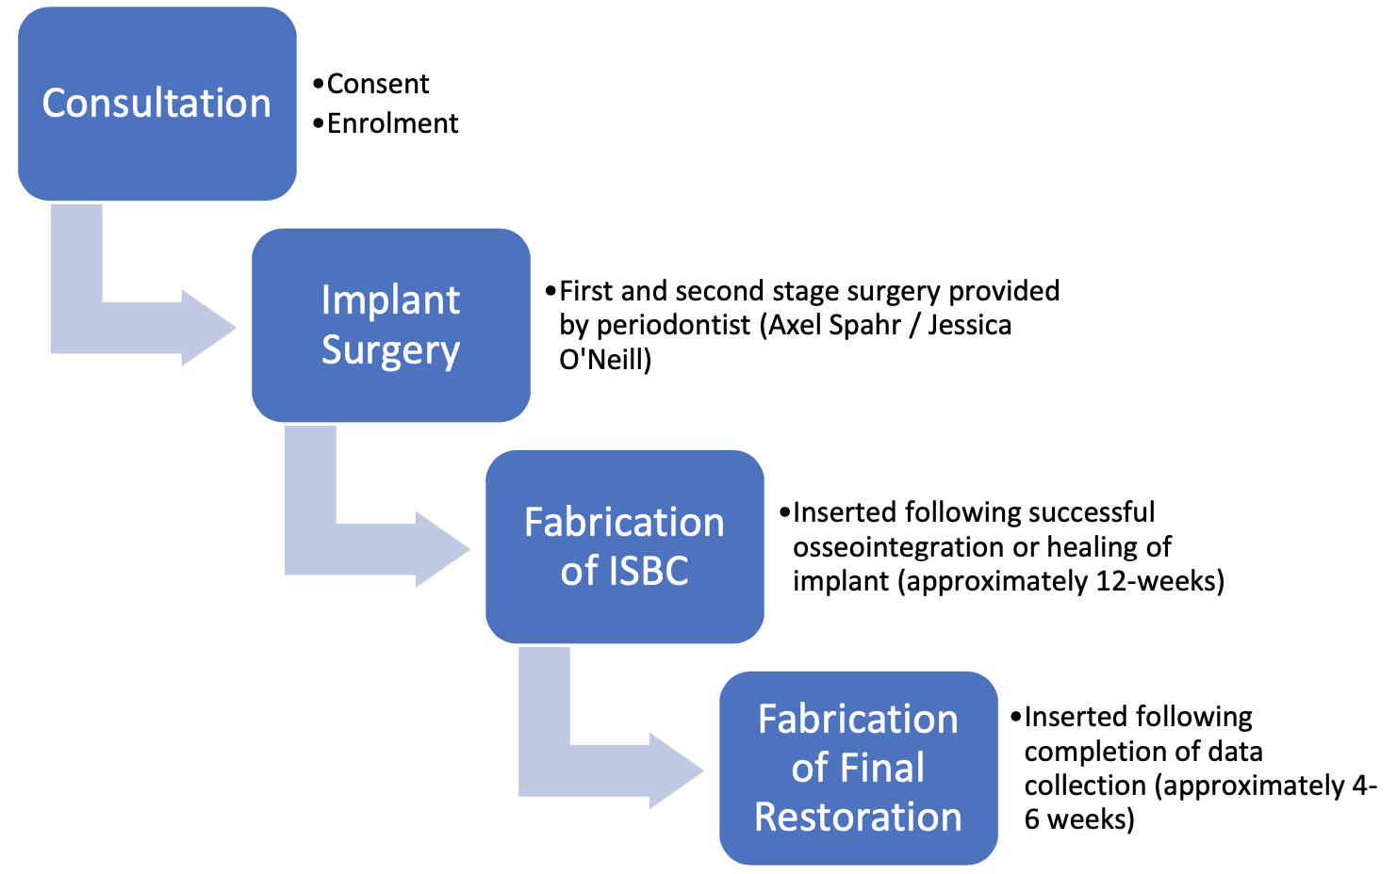

6.2. INVESTIGATION PLAN

Methodology
The Implant-Supported Biofilm Device
Bone-level implants will be placed by a registered periodontist (Axel Spahr and Jessica O’Neill) or periodontics registrar (Judd Sher) and allowed to osseointegrate for 12-weeks. An impression will be taken for study casts once soft-tissue healing following second-stage surgery is completed, where an ISBC and custom abutment will be fabricated. The ISBC will be fabricated using CAD-CAM and will be designed in a way where discs can be inserted into a chamber which is easily coverable with composite resin.
The ISBC will be 3D-printed with a Formlabs Form 2/3B 3D-printer using a biocompatible light-cured dental resin (Dental LT Clear Resin, Formlabs) that is TGA- approved for dental applications such as occlusal splints, permanent and temporary restorations, and orthodontic appliances. Technical and safety data can be found on the manufacturer’s website: https://dental.formlabs.com/
The chamber will also consist of a channel that is directed and opens into the sulcular (interproximal) region, with to aim to allow gingival crevicular fluid (GCF), saliva and substrate to flow into the chamber. A zirconia disc with a standardised roughness will be milled and mounted in the ISBC. Figure 1 illustrates the ISBC in the mouth. Figure 2 illustrates different sections of the ISBC. All ISBCs and discs will be disinfected in a 3% sodium hypochlorite solution for 10-minutes, rinsed in distilled water, and autoclaved before use. A final implant-supported prosthesis or restoration will be fabricated and inserted following completion of data collection.

Microbiological Analysis
The patient will receive a full mouth clean (mechanical removal of plaque and calculus) with ultrasonic and airflow prior to start of each time point. Oral hygiene instructions (OHI) will also be given to the patient: toothbrushing technique and interdental care. Two discs will be inserted into the ISBC at each time point. Biofilm will be allowed to grow, and the ceramic disk will be removed atraumatically for microbiological analysis and replaced with a new disc at 1-hour, 24-hours, 2-days, 4-days, 7-days, and 14-days. A total of 12 discs will be fabricated per participant (2 disks will be inserted into the ISBC for each timepoint). At each time point following disc removal, one disk will be used to analyse biofilm viability with confocal laser scanning microscopy (CLSM) while the other will be used to analyse bacterial composition with next generation sequencing.
Biofilm viability on disk retrieved from the ISBC
The ceramic discs will be carefully removed at each time point from the ISBC without disturbing the biofilm. The samples will be gently washed with phosphate buffer saline (PBS) and immediately stored in growth medium and analysed with CLSM (LIVE/DEAD BacLight).
Bacterial composition in biofilm
Biofilm grown on the discs will be scraped off using a sterile instrument (curette) and transferred into an Eppendorf tube containing PBS. This process will be repeated for each time point with the tubes containing the biofilm will be stored and kept frozen at -80 degrees Celsius until next generation sequencing analysis are carried out.
Table 1-2 lists all the potential study visits and the procedures that will be conducted at each visit.

Table 1 – Phase 1: screening and consultation, implant surgery (visit 1), and impressions for fabrication of ISBC and final crown/restoration (visit 2)
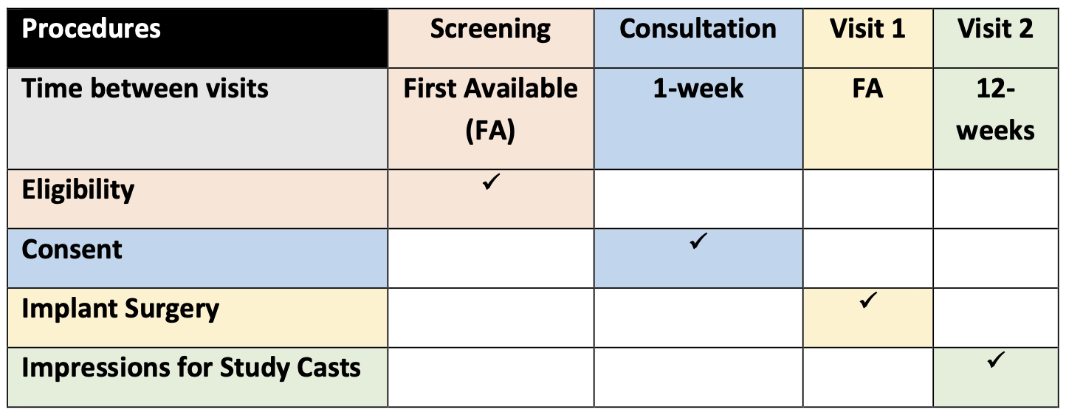
Table 2 – Phase 2: data collection phase that involves the provision of the ISBC (visit 3), the insertion and retrieval of disks at each time point (visits 3-9), and the provision of final crown/restoration (visit 9)
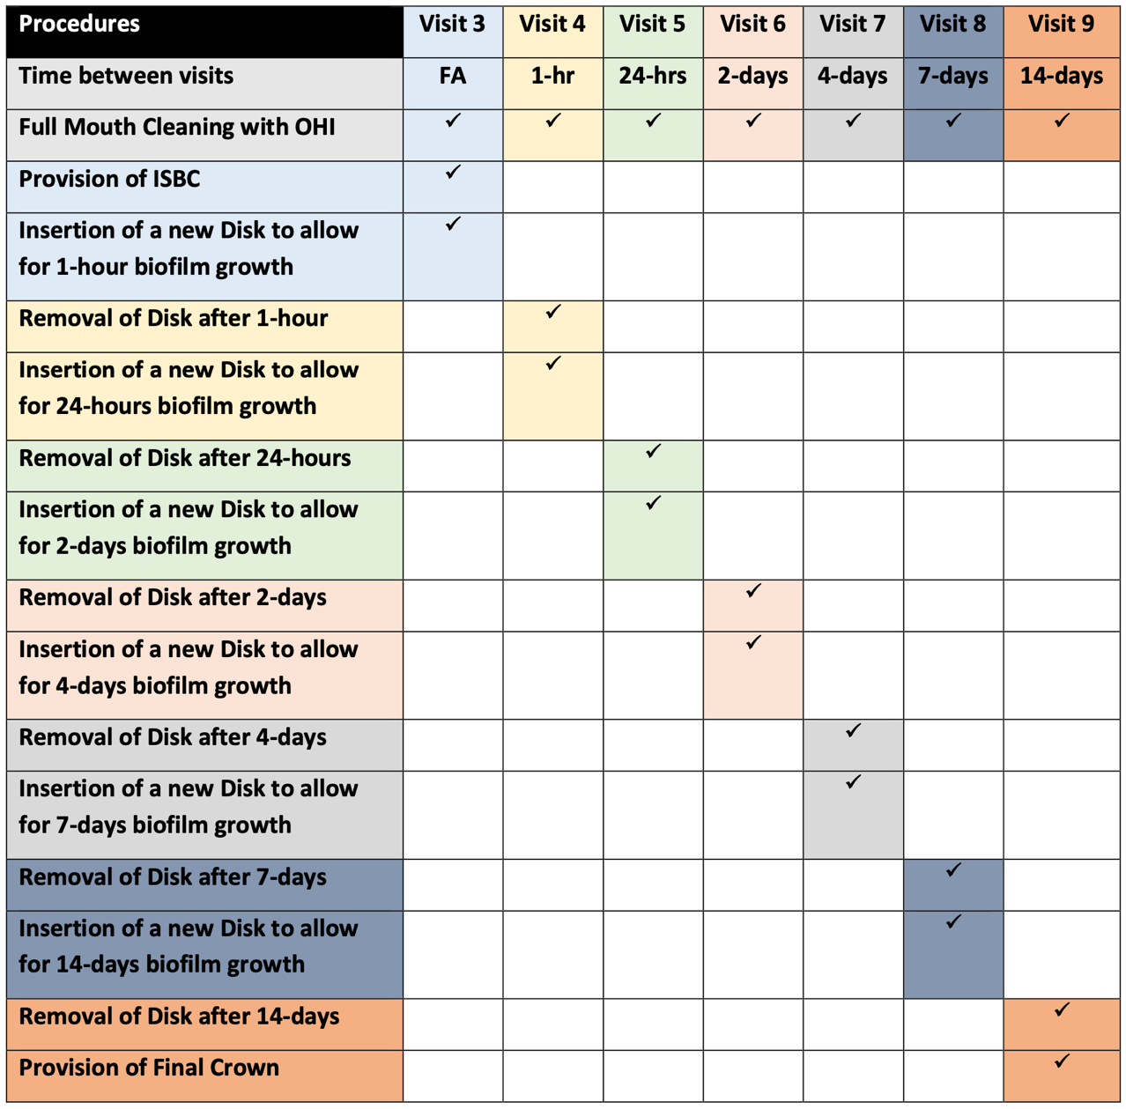

6.3. STUDY PROCEDURE RISKS
The provision of an interim or temporary restoration prior to fabrication and insertion of a final implant-supported crown or restoration is part of normal practice in implant treatment. The ISBC serves as a temporary restoration, as well as a device to grow and collect biofilm. The risk associated with using the ISBC is that the channels that open into the oral cavity can become a food or plaque trap that can result in irritations to the gingiva in the long term. However, the study period and time of the ISBC in the mouth is short (approximately 4-6 weeks). Furthermore, the ISBC will be removed if any clinical signs of irritation of inflammation are present.

6.4. PARTICIPANT RECRUITMENT AND SCREENING
Potential participants will be identified and screened by the treating specialist periodontists (Axel Spahr and Jessica O’Neill) through routine assessment of hospital patients that have been referred for implant treatment. These patients will be screened for suitability for implant treatment, as well as eligibility for this research study. Patients that fulfil the inclusion criteria will be invited to participate in the research. A personal (face-to-face) invitation with a periodontics registrar (Judd Sher) will then be offered to interested patients where full-details and information about the study will be disclosed, as well as answering of any questions posed by the participants.
Will participants be screened? | YES
If yes, what data will be collected? (NB, if participant is not eligible, will data collected be destroyed or kept?) This should be mentioned in PIS/CF) | All data regarding the patient’s medical and dental history will be documented and kept in the patient records that is stored at Sydney Dental Hospital. The patient’s suitability for implant treatment, as well as their eligibility for the research study will also be documented with reasons. Furthermore, data regarding the design of ISBC and collected from microbiological analysis will be stored on REDCap.
Who will make initial contact with participants? | Axel Spahr or Jessica O’Neill
Who will perform the consent process? How will this be carried out? | Judd Sher will perform the consent process. Personal (face-to-face) invitation from a researcher who is a member of the patient’s clinical team following a routine implant assessment. Full detail and information regarding the study will be provided.
Will participants be consented verbally/explicitly/using eConsent?  SLHD Research Forms Link | Verbally and written consent will be obtained and kept in the patient records.
Will participants be given a specific time period to consider participating? | YES
Review of existing databases or databanks (please identify the database/databank and the custodian) | REDCap will be used to store data collected and will only be accessed by Judd Sher.
Review of clinic files (please include who will be reviewing these files, for example a research coordinator). | Judd Sher, Axel Spahr and Jessica O’Neill will review the clinic files.
Advertisements (please include where the advertisement will be placed for example, in a newspaper, poster in a clinic or hospital foyer, radio announcements, website etc.) | None
Information Letter to Medical practitioners | YES
Explain how potential participants will be screened for the study | Potential participants will be identified and screened by the treating specialist periodontists (Axel Spahr and Jessica O’Neill) through routine assessment of hospital patients that have been referred for implant treatment. These patients will be screened for suitability for implant treatment, as well as eligibility for this research study. Patients that fulfil the inclusion criteria will be invited to participate in the research. A personal (face-to-face) invitation with Judd Sher will then be offered to interested patients where full details and information about the study will be disclosed, as well as answering of any questions posed by the participants. Participants will then be recruited once consent is obtained.

6.5. PARTICIPANT ENROLMENT
Potential participants will be enrolled into the study after the informed consent process has been completed and the participant has been assessed to meet all the inclusion criteria and none of the exclusion criteria. Study participants will receive a study enrolment number, and this will be documented in the participant’s record and on all study documents.

6.6. INFORMATION AND CONSENT
Brief verbal information, the NSW Health Participant Information sheet, and Consent form will be given to interested patients at the ‘Screening Visit’ with Axel Spahr and Jessica O’Neill. A period of at least one-week will be allowed for the patient to understand information provided. Following this, the patient will be invited to the ‘Consultation Visit’ with Judd Sher for reiteration of the study information and answering of any questions regarding the study. The NSW Health consent form will only be signed and sighted at the end of this ‘Consultation Visit’.
6.7 WAIVER OF CONSENT
Waiver of consent is not necessary as consent will be directly obtained.
6.8 END OF STUDY TREATMENT/WITHDRAWAL PROCEDURE
The end of study treatment or withdrawal procedure involves removing and discarding the ISBC. A final implant-supported restoration will then be inserted into the patient’s mouth.

6.9 PATIENT WITHDRAWAL
Participants may withdraw from the study for the following reasons: participant has chosen to withdraw from the study, protocol violation, or participant has experienced an adverse event. The reason(s) for withdrawal will be documented in the hospital patient record. All collected microbiological data will be deleted and removed from REDCap, and all samples will be destroyed. Participants that withdraw will be replaced by another interested participant coming from the routine implant assessment consultation.

7. OUTCOMES

7.1. DEFINITION OF OUTCOMES

The primary outcome for the viability of the biofilm grown on the disc in the ISBC will be presented as a mean percentage. Furthermore, a description of the undisturbed three-dimensional architecture of the biofilm grown on the disc will be presented.
The secondary outcome for the microbiological profile of the biofilms collected will be presented as a description of the composition as well as the mean percentage of each species that are present in the biofilm.

8. Statistical Considerations

8.1. SAMPLE SIZE OR POWER ALCULATION

This study is a descriptive clinical trial and, as such, a sample size or power calculation is not necessary.

8.2. ANALYSIS PLAN

The data will be expressed as mean ± standard deviation and images obtained of the biofilm structure will be described.

9. DATA COLLECTION

9.1. FORMS AND PROCEDURE FOR COLLECTING DATA
The data that will be collected at the ‘Consultation’ visit include:
- Basic patient demographics: age and gender
- Clinical parameters: location of implant and location of tooth to collect plaque sample
- Implant details: brand, type, and dimensions

10. PUBLICATION & INTELLECTUAL PROPERTY
This research study is presented as a project that is part of the research component of Doctor of Clinical Dentistry (Periodontics) program at the University of Sydney. The final manuscript may be published in peer-reviewed research journals and a basic overview of the research study may be presented at relevant research conferences.

11. ETHICS

11.1. INVESTIGATOR AUTHORISATION PROCEDURE

The conduct of this study will commence once the initial approval process has been completed through Ethics and Governance authorisation for each site. Updated documents will only be implemented once they have been reviewed and approved by an Ethics Committee and if applicable Governance Officer for each site.

12. CONFIDENTIALITY, STORAGE & ARCHIVING OF STUDY

Data collection is the responsibility of the research staff of Sydney Dental Hospital and University of Sydney under the supervision of the Axel Spahr. The Principal Investigator is responsible for ensuring the accuracy, completeness, legibility, and timeliness of the data reported. REDCap will be used to capture and store research data. The Maser Code Sheet Project template within REDCap will be used to store any identifiable patient data. The microbiological results will be presented as an aggregate and therefore is not identifiable. Storage of the zirconia discs and biofilm samples will be in a locked facility within Sydney Dental Hospital. The discs and ISBC are not identifiable after removal from the mouth and will be destroyed following completion of study.

13. DATA SAFETY MONITORING BOARD
A Data Safety Monitoring Board (DSMB) will oversee this study at regular intervals to review accumulating trial data and monitor the progress of this study. The DSMB will meet after the first 3 participants and then once a month until completion of the study.
The members of the DSMB are:
- Dr. Suman Madukuri: Lecturer Periodontics, University of Sydney

- Dr. Fabian Obregon: Lecturer Periodontics, University of Sydney
- Dr. Tihana Divnic-Resnik: Lecturer Periodontics, University of Sydney
The roles of the DSMB include:
- Identify, through regular monitoring, serious emerging safety concerns as rapidly as possible, to minimise the time that participants may be placed at excess risk of harm.
- Maintain confidentiality of unblinded interim results and provide an objective and unbiased assessment of those results.
- Contribute to the successful completion of the study by periodically reviewing accumulating data, to inform study conduct decisions.
If the investigators are noticing participants are experiencing gingival infection from the ISBC, this will be reviewed and appropriate action taken.

14. COMPENSATION
If a participant suffers any injuries or complications as a result of the research project, they will be advised to contact the study team and will be assisted with arranging appropriate medical treatment. If participants are eligible for Medicare, they can receive any medical treatment required to treat the injury or complication, free of charge, as a public patient in any Australian public hospital.
In addition, patients may have a right to take legal action to obtain compensation for any injuries or complications resulting from the study. Compensation may be available if their injury or complication is sufficiently serious and is caused by unsafe drugs or equipment, or by the negligence of one of the parties involved in the study (for example, the researcher, the hospital, or the treating doctor). Patients do not give up any legal rights to compensation by participating in this study

15. REFERENCES

Al-Ahmad, A., Wiedmann-Al-Ahmad, M., Faust, J., Bächle, M., Follo, M., Wolkewitz, M., . . . Kohal, R. (2010). Biofilm formation and composition on different implant materials in vivo. J Biomed Mater Res B Appl Biomater, 95(1), 101-109. doi:10.1002/jbm.b.31688
Auschill, T. M., Arweiler, N. B., Brecx, M., Reich, E., Sculean, A., & Netuschil, L. (2002). The effect of dental restorative materials on dental biofilm. Eur J Oral Sci, 110(1), 48-53. doi:10.1046/j.0909-8836.2001.101160.x
Chapple, I. L. C., Mealey, B. L., Van Dyke, T. E., Bartold, P. M., Dommisch, H., Eickholz, P., . . . Yoshie, H. (2018). Periodontal health and gingival diseases and conditions on an intact and a reduced periodontium: Consensus report of workgroup 1 of the 2017 World Workshop on the Classification of Periodontal and Peri-Implant Diseases and Conditions. J Periodontol, 89 Suppl 1, S74-s84. doi:10.1002/jper.17-0719
Covani, U., Marconcini, S., Crespi, R., & Barone, A. (2006). Bacterial plaque colonization around dental implant surfaces. Implant Dent, 15(3), 298-304. doi:10.1097/01.id.0000226823.58425.19
Drescher, J., Schlafer, S., Schaudinn, C., Riep, B., Neumann, K., Friedmann, A., . . . Moter, A. (2010). Molecular epidemiology and spatial distribution of Selenomonas spp. in subgingival biofilms. Eur J Oral Sci, 118(5), 466-474. doi:10.1111/j.1600-0722.2010.00765.x
García-Caballero, L., Quintas, V., Prada-López, I., Seoane, J., Donos, N., & Tomás, I. (2013). Chlorhexidine substantivity on salivary flora and plaque-like biofilm: an in situ model. PLoS One, 8(12), e83522. doi:10.1371/journal.pone.0083522
Hannig, M. (1999). Transmission electron microscopy of early plaque formation on dental materials in vivo. Eur J Oral Sci, 107(1), 55-64. doi:10.1046/j.0909-8836.1999.eos107109.x
Hannig, M., Kriener, L., Hoth-Hannig, W., Becker-Willinger, C., & Schmidt, H. (2007). Influence of nanocomposite surface coating on biofilm formation in situ. J Nanosci Nanotechnol, 7(12), 4642-4648.
Heitz-Mayfield, L. J. A., & Salvi, G. E. (2018). Peri-implant mucositis. J Periodontol, 89 Suppl 1, S257-s266. doi:10.1002/jper.16-0488
Heuer, W., Elter, C., Demling, A., Neumann, A., Suerbaum, S., Hannig, M., . . . Stiesch-Scholz, M. (2007). Analysis of early biofilm formation on oral implants in man. J Oral Rehabil, 34(5), 377-382. doi:10.1111/j.1365-2842.2007.01725.x
Lindhe, J., Lang, N. P., Berglundh, T., Giannobile, W. V., Sanz, M., & Araujo, M. (2015). Clinical Periodontology and Implant Dentistry (Sixth edition. ed.). Chichester, England: Wiley Blackwell.
Listgarten, M. A. (1976). Structure of the microbial flora associated with periodontal health and disease in man. A light and electron microscopic study. J Periodontol, 47(1), 1-18. doi:10.1902/jop.1976.47.1.1
Loe, H., Theilade, E., & Jensen, S. B. (1965). EXPERIMENTAL GINGIVITIS IN MAN. J Periodontol, 36, 177-187. doi:10.1902/jop.1965.36.3.177
Moter, A., & Göbel, U. B. (2000). Fluorescence in situ hybridization (FISH) for direct visualization of microorganisms. J Microbiol Methods, 41(2), 85-112. doi:10.1016/s0167-7012(00)00152-4
Papapanou, P. N., Sanz, M., Buduneli, N., Dietrich, T., Feres, M., Fine, D. H., . . . Tonetti, M. S. (2018). Periodontitis: Consensus report of workgroup 2 of the 2017 World Workshop on the Classification of Periodontal and Peri-Implant Diseases and Conditions. J Periodontol, 89 Suppl 1, S173-s182. doi:10.1002/jper.17-0721
Prada-López, I., Quintas, V., Vilaboa, C., Suárez-Quintanilla, D., & Tomás, I. (2016). Devices for In situ Development of Non-disturbed Oral Biofilm. A Systematic Review. Front Microbiol, 7, 1055. doi:10.3389/fmicb.2016.01055
Quintas, V., Prada-López, I., Prados-Frutos, J. C., & Tomás, I. (2015). In situ antimicrobial activity on oral biofilm: essential oils vs. 0.2 % chlorhexidine. Clin Oral Investig, 19(1), 97-107. doi:10.1007/s00784-014-1224-3
Re, D., Pellegrini, G., Francinetti, P., Augusti, D., & Rasperini, G. (2011). In vivo early plaque formation on zirconia and feldspathic ceramic. Minerva Stomatol, 60(7-8), 339-348.
Roberts, A. E., Kragh, K. N., Bjarnsholt, T., & Diggle, S. P. (2015). The Limitations of In Vitro Experimentation in Understanding Biofilms and Chronic Infection. J Mol Biol, 427(23), 3646-3661. doi:10.1016/j.jmb.2015.09.002
Schlafer, S., Riep, B., Griffen, A. L., Petrich, A., Hübner, J., Berning, M., . . . Moter, A. (2010). Filifactor alocis--involvement in periodontal biofilms. BMC Microbiol, 10, 66. doi:10.1186/1471-2180-10-66
Schwarz, F., Derks, J., Monje, A., & Wang, H. L. (2018). Peri-implantitis. J Clin Periodontol, 45 Suppl 20, S246-s266. doi:10.1111/jcpe.12954
Schwarz, F., Sculean, A., Wieland, M., Horn, N., Nuesry, E., Bube, C., & Becker, J. (2007). Effects of hydrophilicity and microtopography of titanium implant surfaces on initial supragingival plaque biofilm formation. A pilot study. Mund Kiefer Gesichtschir, 11(6), 333-338. doi:10.1007/s10006-007-0079-z
Tomás, I., García-Caballero, L., López-Alvar, E., Suárez-Cunqueiro, M., Diz, P., & Seoane, J. (2013). In situ chlorhexidine substantivity on saliva and plaque-like biofilm: influence of circadian rhythm. J Periodontol, 84(11), 1662-1672. doi:10.1902/jop.2013.120475
Tonetti, M. S., Greenwell, H., & Kornman, K. S. (2018). Staging and grading of periodontitis: Framework and proposal of a new classification and case definition. J Periodontol, 89 Suppl 1, S159-s172. doi:10.1002/jper.18-0006
Wecke, J., Kersten, T., Madela, K., Moter, A., Göbel, U. B., Friedmann, A., & Bernimoulin, J. (2000). A novel technique for monitoring the development of bacterial biofilms in human periodontal pockets. FEMS Microbiol Lett, 191(1), 95-101. doi:10.1111/j.1574-6968.2000.tb09324.x

