Participant Information Sheet
Interventional Study - Adult providing own consent

Gastroparesis symptoms and its treatment using low-viscosity soluble dietary fibres
Consuming test fibres for gastroparesis symptom relief
Dr Jerry Zhou, Dr Vincent Ho, Mr Harsha Suresh

Macarthur Clinical School, Western Sydney University

You are invited to take part in a research study investigating the treatment of gastroparesis using low-viscosity dietary fibres

The purpose of the study:
To determine whether the consumption of low-viscosity dietary fibres alleviates the symptoms of idiopathic gastroparesis and which among those fibres is the most effective. This study involves the ingestion of a glucose drink and three commercially available test fibres. The test is non-invasive and flexible scheduling arrangements can be made for each test. The study is being conducted by Dr Jerry Zhou (Clinical Researcher), Dr Vincent Ho (Gastroenterologist) and Mr Harsha Suresh (PhD student) at the School of Medicine, Western Sydney University.
How can you be involved?
During the 3 hour clinical trial, your blood glucose and mouth-to-caecum transit time will be measured using a skin probe and breathalyser at 30min intervals. You will also be required to fill out a simple symptom severity form at the same time in accordance with the Gastroparesis Cardinal Symptom Index (GCSI). These tests are not invasive and can be administered quite easily.
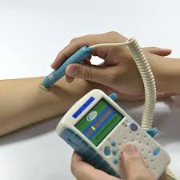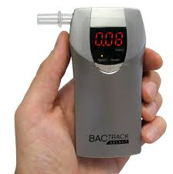
Examples of the blood probe and breathalyser measurements
The blood glucose is measured using a tiny probe on the tip of the finger. The breathalyser measurements are taken by blowing into a breath collection bag, which is then hooked up the breathalyser meter. Both the glucose probe and breathalyser is disposed after each test as biological waste.
For this study, there will be four tests spread out over consecutive weeks. A test can be re-scheduled if it is missed during that week due to reasons such as sickness, time conflict or emergencies. The following picture illustrates the plan for the clinical trial. The trial will be randomized, you will not know which test fibre you are consuming while the investigator will be aware and the monitored data will be collected for analysis.
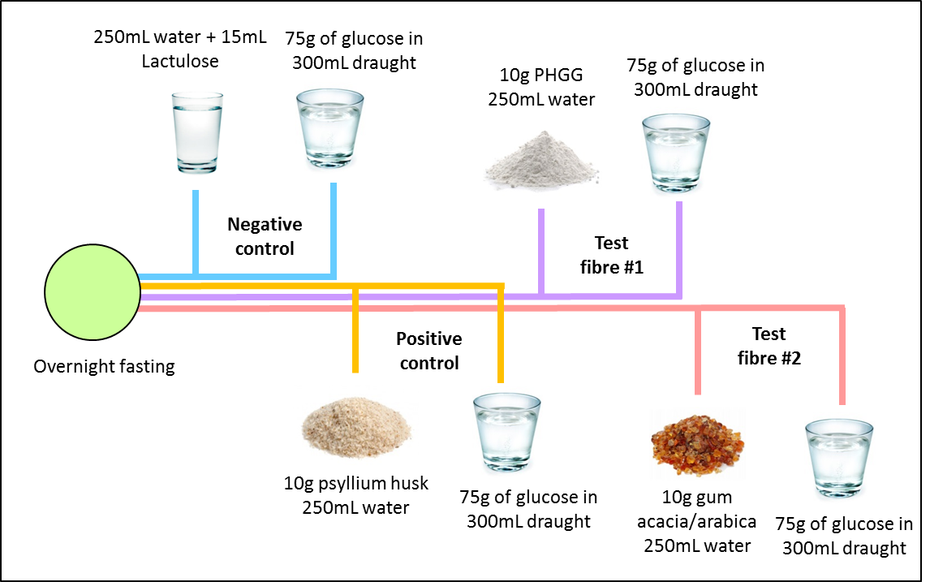
Rubric for the clinical trial
No prescriptions or medicines are required during the test. The procedure will take around 3 hours to complete and you allowed to do use electronic devices such as phones laptops etc. during the intervals to pass the time. The Participant Consent form needs to be signed before the procedure.
Are there any risks?
Serious complications are extremely rare during these tests and Dr. Ho will be available nearby during any complications or emergencies.
Complications may include:
Bloating & Nausea – Bloating can occur during the test and may be severe. In such cases, the attending physician will be contacted. Nausea can happen during the test and if there is a serious reaction, the test will be stopped and the attending physician informed.
Hyperglycaemia – This is major risk factor for type 1 and type 2 diabetes patients who are consuming a sugar test meal, though it is a rare occurrence. You may be recommended to an endocrinologist by Dr. Ho for insulin therapy.
Hyperosmolar hyperglycaemic nonketotic syndrome (HHNS) – Is extremely rare and happens when your blood glucose levels suddenly spike. You will be taken to an emergency facility at nearby Campbelltown Hospital if this occurs during a test.
You can reduce your risk of complications by carefully following your doctor’s instructions for preparing for a prolonged blood glucose test, such as fasting and eschewing certain medications.
What are the benefits?
The information gathered during this study will be used to determine whether low-viscosity dietary fibre really do improve symptoms for gastroparesis sufferers as they have been speculated to. This study will also determine which among these selected fibres are the most effective at reducing these symptoms. The mouth-to-caecum transit time will also be measured in order to analyse how quickly these fibres pass from the mouth to the gut during digestion.
The data gathered and analysed in this trial could be used to bring further symptom relief to gastroparesis patients by studying the effects of long-term fibre ingestion or by using novel low-viscosity test fibres in future clinical studies.
Other information required for the study:
The researchers would like to access your medical records to obtain general information relevant to this study (age, gender, BMI, upper GI history, medication history: antibiotics and gastric pumps to relieve gastroparesis).
All aspects of the study, including results, will be strictly confidential and only the investigators in this form will be able to access the information about the participants. A report of the study may be submitted for research publication and the participants will not be identifiable in the report.
While we intend that this research furthers medical knowledge and may improve the treatment and management of symptoms in gastroparesis patients. No incentive/payment or reimbursement is provided to participants.
Participation is entirely voluntary, if you do sign the form and wish to withdraw any time later, your samples will be destroyed and excluded from the study. Whatever your decision, please be assured that it will not affect your medical treatment or your relationship with medical staff.
When you have read this information, a member of the research team will discuss it with your further and answer any questions you may have. If you would like to know more at any stage, please feel free to contact:
Dr Jerry Zhou on 02 4620 3865
Dr Vincent Ho on 02 4634 4001
Mr Harsha Suresh on 02 4620 3662

This information sheet is for you to keep.

This study has been approved by the Ethics Review Committee of the Western Sydney University. Any person with concerns or complaints about the conduct of a research study should contact the Ethics and Research Governance Office,
Mail: Locked Bag 7279,
LIVERPOOL BC, NSW, 1871
Phone: 02 8738 8304,
Fax: 02 8738 8310
Email: research.support@sswahs.nsw.gov.au

Sincerely,

Dr Jerry Zhou

