An Online Educational Course for people with Multiple Sclerosis: a qualitative analysis
Email invitation

Dear …

We are researchers from the Neuroepidemiology Unit at the University of Melbourne. Having just completed the Multiple Sclerosis (MS) Online Course, developed by our research unit, we wish to invite you to participate in our research seeking to explore the expectations and experiences of people who have undertaken the course. We hope to understand more about what your goals and hopes were and how well the course addressed these. This would mean an interview over the phone at a time that is convenient for you. We would very much appreciate your participation.

Attached to this email is a Participant Information / Plain Language Statement with further information for you and a consent form which we do not expect you to sign, as we will ask for verbal consent during the interview if you participate. The interviewers are Dr Sandra Neate, Dr Jeanette Reece and Dr Pia Jelinek from our Unit. One of us will call you to ask if you would be willing to participate and, if so, organise a time to conduct the interview that suits you. We very much look forward to your participation.

If you do not wish to participate you may either contact me by email or wait till we call. If you have any further questions please contact me at
Sandra.neate@unimelb.edu.au
With many thanks,
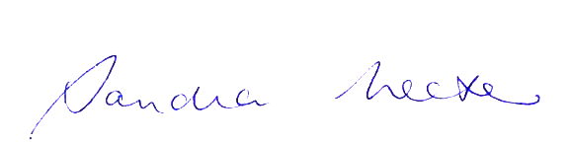

Dr Sandra Neate
Head, Neuroepidemiology Unit
Melbourne School of Population and Global Health
The University of Melbourne

