SCREEN A
Self – created records by eAPP for early antenatal hospital access

PROTOCOL

WHITU and SWSLHD

INVESTIGATORS
Coordinating principal investigator:
Angela Makris, Renal and Obstetric Physician, SWSLHD and WHITU

Co Investigators:
Alison Canty, Research Midwife, SWSLHD and WHITU

Gaksoo Lee, Research Midwife, SWSLHD and WHITU

Wendy Pickup, Research Midwife, SWSLHD and WHITU

Renuka Shanmugalingam, Obstetric physician, SWSLHD and WHITU

John Smoleniec, Obstetrician, SWSLHD and WHITU

TABLE OF CONTENTS
SCREEN A 1
1. SUMMARY 3
2. BACKGROUND AND RATIONALE 4
3. STUDY AIMS/OBJECTIVES 5
4. PARTICIPATING SITES 5
5. STUDY DESIGN 5
5.1 Study Type 5
5.2 Expected Study Duration 5
5.3 Data Source and Population 6
5.4 Recruitment and Screening 6
5.5 Inclusion Criteria 6
5.6 Exclusion Criteria 7
5.7 Consent Process 7
5.8 Study Procedures 7
7. ETHICAL CONSIDERATIONS 8
7.1 Study Procedure Benefits 8
7.2 Study Procedure Risks 9
7.3 Confidentiality and Privacy 9
7.4 Data Storage and Record Retention 9
8. Early Termination (IF APPLICABLE) 9
12. CONFLICT OF INTEREST 9
13. FUNDING 9
14. RESEARCH OUTCOMES 10
15. REFERENCES 10
16. APPENDIX A- SCREEN Questions 10
17. APPENDIX B- Patient Output 26
18. APPENDIX C – Privacy and Terms of the SCREEN APP 32
19. APPENDIX D – Introduction to the SCREEN App 39
20. APPENDIX E – Patient and Midwife Experience Surveys 40

1. SUMMARY

Study Title | SCREEN A
Aims/Objectives | Primary: Assess the correlation in identifying high risk women with the SCREEN app compared to the current practice (and the current gold standard) of midwifery booking-in assessment.  Secondary: Assess the inter-technique correlation of booking information derived from the  app compared to the information derived form a regular booking visit; Assess patient reported experiences of app usage for booking in information; Assess if there is a difference in correlation between different facilities; Assess if the translated questionnaire has similar accuracy to the English based questionnaire; Assess the differences in the proportion of women who are assessed as high risk by the app compared to the clinical assessment; Assess user acceptability by primary health; Length of time to complete the survey
Study design | Observational Cohort
Planned sample size | 280 women
Inclusion criteria | Pregnant women undertaking booking-in visit
Study procedures | Survey validation
Analysis considerations | Sample size calculation  Analysis plan
Study duration | 6-12 months

2. BACKGROUND AND RATIONALE
SWSLHD currently has an above average booking at the hospital. Currently the average booking data is 17w when the NSW health average is 13w. In many instances this does not allow adequate time for preventative interventions to be considered.

When women know they are pregnant, they will book in to their local hospital and start their antenatal care journey. There are significant imbalances in the times and rates of booking in to a hospital between different socioeconomic and geographic and cultural groups (Table 1)(1). Unfortunately over time there has not been a substantiative improvement in the first trimester booking-in rates or the gestation when women are booking in to the hospital in the first trimester (Table 2).

Table 1. First trimester booking-in rates across NSW in various categories
 | AIHW 2017 AUST
Public Patients | 67.6%
Private Patients | 85.2%

Table 2. Changes in SWSLHD Booking in over time
Year | Booking-in Rate SWSLHD
2017 | 75.1
2016 | 71.4
2015 | 64.3
2014 | 49.7
2013 | 54.6
2012 | 56.3

Although there is a significant increase in the rate of booking in over time, one quarter of women are still only being seen in the hospital until after the first trimester.
Moreover, there is significant variation across the district (Table 3).

Table 3. First Trimester booking-in different facilities across the SWSLHD
Facility within SWSLHD | Proportion of Women Booked in First Trimester
Liverpool | 84.1%
Bankstown | 56.5%
Fairfield | 64.2%
Campbelltown | 73.5%

By facilitating early booking-in, these missed opportunities would be taken advantage of to improve patient outcomes. Furthermore, many women do not feel safe enough /able to relay personal details such as intimate partner violence or abuse. In a safe setting of their choosing this may be better captured via an electronic device based app.

A group of stakeholder clinicians has generated questions and developed, with the assistance of a commercial group, an electronic application to allow women to answer questions that will allow their pregnancy risk to be assessed prior to actually booking-in to the hospital.

We plan to conduct an observational cohort study (SCREEN A) to evaluate the accuracy of our questionnaire compared to standard practice. We will also assess the acceptability of the app for women completing the questionnaires.

3. STUDY AIMS/OBJECTIVES

Aims: 1. To assess the validity of the app based questionnaire compared to the current gold standard of information ascertainment (midwifery booking-in visit).
2. Assess the validity of the questionnaires in women who are non-English speaking (Vietnamese and Arabic)
3. To assess referrals made as a result of the booking visit compared to high risk assessment based on the app.

Hypothesis: That the app will perform as well as current practice in identifying significant facts in a patient history and will present an acceptable option for women to provide initial screening information.

Primary Objective:
Assess the comparison in identifying high risk women with the SCREEN app compared to the current practice (and the current gold standard) of midwifery booking-in assessment.

Secondary Objective:
- Assess the inter-technique comparison of booking information derived from the app compared to the information derived form a regular booking visit
- Assess patient reported experiences of app usage for booking in information.
- Assess if there is a difference between different facilities in identifying high risk women, as well as the information derived from the app compared to the booking-in visit.
- Assess if the translated questionnaire has similar accuracy to the English based questionnaire
- Assess the differences in the proportion of women who are assessed as high risk by the app compared to the clinical assessment
- Assess user acceptability by primary health
- Length of time to complete the survey

4. PARTICIPATING SITES

The SCREEN app will be applied widely across the district. Thus participating sites will be:
- Liverpool Hospital Antenatal Clinic
- Campbelltown Hospital Antenatal Clinics’
- Bankstown Antenatal Clinic
- Fairfield Antenatal Clinics

5. STUDY DESIGN

5.1 Study Type

Observational Cohort Study

5.2 Expected Study Duration

4 months for recruitment and 3 months for data analysis and write up.

The study will commence once approval is provided by the HREC. In each of these facilities there are over 2000 deliveries (almost 4000 at each LDH and CTN). Thus approximately 10 women are booked in at each hospital per day. Thus it will take approximately 10 weeks allowing for staffing, women who are excluded and public holidays to recruit the required women across the various centres. Due to geographic issues- there will be differences in the proportions of women who will be recruited for the different CALD groups at different centres.

5.3 Data Source and Population

Data to be collected is in four general areas:
- Patient related data at booking, this includes all the data fields from the app (patient supplied) as well as the same data fields from the medical record (from booking-in visit) especially the fields recorded in the antenatal history progress note. Pregnancy outcome data from EMR.
- The number and type of referrals made after the assessment eg renal clinic, diabetes, haematology, social worker, PIMMS
- Satisfaction and experience surveys of the patients.
- Midwifery data regarding the times taken to complete the survey for the patients as well as time spent ascertaining and entering patient related information by the midwife

The data will be collected from a database created within the app, the EMR and from the surveys completed by the patients on the same tablet but contained within Redcap. All data will be collated in Redcap.

The population that will be recruited will be women at their booking- in visit. Recruitment will be from all the centres involved. The exclusion criteria are:
1. Unable to provide consent eg cognitive impairment
2. Unable to read in either English, Arabic or Vietnamese

The sample size (based on power calculations based on differences in correlations of answers and Kappa co-efficient) needed for this part of the study are based on the following assumptions: 80% power and allowing for 20% drop out, the frequency of the variables of interest include preeclampsia 10%, gestational diabetes risk assessment 20%, smoking rate 10%, recurrent miscarriage rate of 5%, asthma rate of 10%, epilepsy rate of 5% and an obesity rate of 30% we will need 280 women to undertake the study(2).

5.4 Recruitment and Screening

- Screening via EMR where women who are booking in for an initial visit are easily identified.

5.5 Inclusion Criteria

Inclusion criteria:
- Pregnant women attending booking-in visit at any of the antenatal clinics at SWSLHD
- Aged 16years or older

5.6 Exclusion Criteria

Exclusion Criteria:
- Unable to give consent as opt-in
- Illiterate
- Patients who are not literate in English, Vietnamese or Arabic.

5.7 Consent Process

Women will be informed about the study on the opening page of the questionnaire. They will be offered an opt-out for the study and proceeding to the questionnaire will be deemed as providing consent to participate in the study and having their data collected. Women will also be provided with a PIS in the relevant language for their future reference. They can either chose to email it to themselves or be given a paper version whilst in the clinic.

5.8 Study Procedures
The study will be an observational cohort study. The app (and its contents) have been designed by a group of clinicians (Stakeholders) by consensus and built by a specialised IT company (MOQDigital). The app has been approved by the IMTD and the privacy officer- both the content and the means of notification for patients in the future. IMTD have also been very closely involved in the app production and have loaded the app on to the SWSLHD server for future use. The app has been approved and deployed by eHealth with the appropriate certifications.

Women attending all the antenatal districts across the district, whilst in the hospital waiting for their booking visit, will be asked to participate in the study. Women will be randomised to completing the app questions as either ‘pre’ or ‘post’ their midwifery visit. This will be done prior to their enrolment via a pre-generated randomly allocated list by “sealed Envelopes”- a randomisation website. Recruitment staff will provide a patient information sheet to participants with an opt-out explanation for those that do not want to participate. These information sheets will be translated into two other languages. Non-english speaking women will be provided the patient information sheet in the appropriate language (will be translated once final PIS and protocol is approved by HREC and translation will be undertaken by SWSLHD interpreter services). The app will be completed in the appropriate language. At the end of the survey the women will be asked to complete a short satisfaction survey about their experiences.

The questionnaire takes approximately 9 mins to complete and the patient satisfaction questions about 3 mins. Given women are frequently waiting more than 30 mins, this will not impede their capacity to attend their antenatal visit. Where, the time anticipated till the appointment is less than is required for the questionnaire, women will not be approached. This is relatively easy to assess, as women’s files are marked numerically on arrival and it is obvious how many patients are to be assessed and where each woman is in the queue.

After women have had their booking visit (face –to-face with a midwife), data will be collated from the documented electronic medical record. Every attempt will be made to ensure the midwife undertaking the assessment is blinded to the fact that the woman had completed the questionnaire. To try to minimise the effect of recall bias due to repetition of the assessment, some women will undertake the app before and some will undertake the app after the routine booking visit. At the end of their visit, midwives will be asked to estimate what length of the interview was used to extract information for the booking visit and what proportion of time was spent counselling women and providing health related, personalised information regarding their pregnancies.

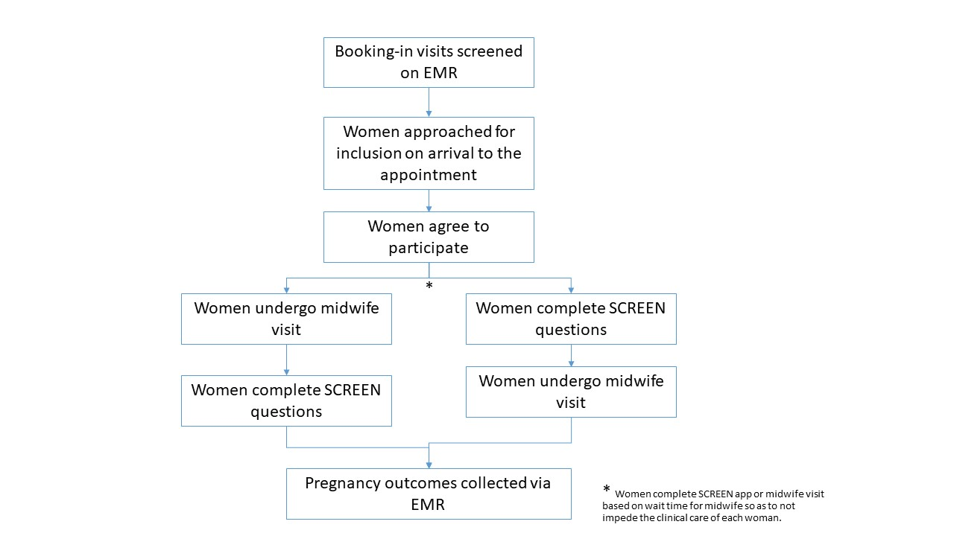
Figure 1- Patient recruitment and study path

6. DATA ANALYSIS

Data will be collected by the app as women complete the questionnaires. This data is predominantly categorical or ordinal data. The Redcap database will also collect electronically in a secure database. The databases will be combined and facilitate analysis. Continuous data will be assessed as parametric or not and appropriately statistical methods use to display the information. Where comparing between the App and the clinical results paired tests will be undertaken as appropriate. The primary outcome will be analysed by calculating the Cohen’s (kappa) coefficients to assess the comparison between the app and clinical assessment. This will also be the case for many of the secondary outcomes.

7. ETHICAL CONSIDERATIONS

Participants will be recruited for women who have an appointment made for a booking- in visit at any of the antenatal clinics participating in the study. The recruitment will be undertaken by experienced midwives who are well known in the service and have significant research experience. As such, there is no dual relationship as the research midwife will NEVER be undertaking a booking-in visit with the woman. Women will complete the questionnaire in the waiting room whilst waiting for their visits or after their visit based on practical logistics. There is no coercion. Women who do not speak English will have interpreter booked who will introduce the midwife, but the patient will read the information sheet in their primary language and either chose to opt in or opt out in their primary language. They will be free to ask questions using the interpreter who has already been block booked. This will not significantly increase the utilisation of the interpreter service, as questions and help to fill out the questionnaire will be discouraged to allow for a real world assessment of the women filling in the questionnaire at their own homes.

7.1 Study Procedure Benefits

- This research will assess the validity of anew online booking in process for women at the SWSLHD

7.2 Study Procedure Risks

- The research protocol will likely extract the same information as that by the midwife during the booking-in visit. The booking in visit can cause some distress, for example when discussing mental health and domestic violence situations. The research will not increase the background rate of distress. Identify any risk for distress (even if minimal) and outline mitigation strategy
- The design is such to avoid any dual relationships between patients and midwifery staff

7.3 Confidentiality and Privacy

- The data will all be collected and stored on the SWSLHD network. All data will be stored in Redcap in a de-identified manner- using a patient code on the SWSLHD servers. The app answers that are identifiable will be transferred to Redcap under the allocated patient codes and not names. The clinical data will be stored in a secure environment within the SWSLHD that the IMTD have confirmed is appropriately secure for patient identifiable information. The patient identifiable information will only be available to the investigators and only till the data is inserted in to RedCap

- A single Excel sheet linking the patient codes to the name and MRN will be stored by the primary investigator and the research midwives on a separate server on the SWSLHD network.

7.4 Data Storage and Record Retention

- Data will be stored in Redcap which is password protected and only study investigators will have access to this data. All users who access Redcap are identifiable by their login. Data will be stored for 7 years after the completion of the project. After that the file will be erased.
- There will not be any hardcopy consent forms.

Early Termination (IF APPLICABLE)
The study may be terminated only in the event of significant lock down where no women come to the hospital for assessment (although this would be very unlikely given the complex nature of pregnancy). This will be reported to the HREC should it occur.

12. CONFLICT OF INTEREST

- The investigators do not have any conflict of interest in undertaking this study. No financial or personal gain is achieved by undertaking this study

13. FUNDING

- WHITU will be funding the undertaking of the project

14. RESEARCH OUTCOMES

- The accuracy with which the app collates information will be a significant outcome, especially in women for whom English is not their main language. We expect to find a significant difference in various fields in these women due to the fact that patient related obstacles (embarrassment, face-to face limitation of reporting, fear of judgment) may affect the current means of obtaining some sensitive information. We expect the app to be as good as midwifery assessment in the ascertainment of demographics and risk profiling in the areas targeted by the app.

- Lastly we hope that by inserting relevant websites that are offered in an individualised manner to women, that we may see an improvement in health literacy and potentially change in their behaviours eg increased uptake of smoking cessation. Although we will not be assessing this directly, we will be assessing whether women take up the option of the extra information that is targeted to them in an individualised and relevant manner.

- Results of the study will be publicized on the Womens Health website with the adoption of the online Web App. It will also be shared via social media through the WHITU Facebook page.

- The study will be registered on the Australian Clinical Trial Registry (https://www.australianclinicaltrials.gov.au/) after its approved. The results will be presented locally to all the stakeholders. The results will then be published in a peer-reviewed journal. All data will be presented as grouped data, no single patient data will ever be presented and no data will a allow re-identification of any patient.

- Data lock 1 will occur for the booking in data after the last woman is recruited. The final data lock will occur after the outcomes of the pregnancy data is collected from EMR. This data will be stored in RedCap and deleted once the storage time has expired. We are planning for a paperless study.

15. REFERENCES

1. Australian Institute of Health and Welfare (AIHW) 2019. National Core Maternity Indicators 2017: summary report. . Cat no PER 104 Canberra Australian Institute of Health and Welfare 2019.
2. Bujang MA, Omar ED, Baharum NA. A Review on Sample Size Determination for Cronbach's Alpha Test: A Simple Guide for Researchers. Malays J Med Sci. 2018;25(6):85-99.

- APPENDIX A- SCREEN Questions

These are the questions agreed upon by a large multidisciplinary group of clinicians. These questions do not necessarily make sense in order. Within the app there is built in logic and thus depending on the womens response, there will be a different series of questions produced.

Once the app was created, the questions and the logic have been tested by over 50 clinicians and feedback incorporated in to the design. Questions were refined and optimised ready for patient exposure.

SCREEN App Questions
Q1. In which language do you prefer to complete the survey?
Answer Choices
English
Arabic
Vietnamese
Q2. Which of the roles below best represents your reason for using this app?
Answer Choices
Pregnant women booking-in
Health care provider risk assessment
Q3. What is your address?
Answer Choices
Name:
Company:
Street number:
Street:
City/Town:
State/Province:
Post Code:
Country:
Email Address:
Phone Number:
Who is your GP?
Answer Choices
Name:
Name of Practice:
Street Address:
Address 2:
City/Town:
State/Province:
Postal Code:
Country:
Email Address:

Tell us some basic details about you
Q4. Please enter your date of birth (DD/MM/YYYY)
Q5. Which one of the following groups do you identify as?
Aboriginal
Torres Strait Islander
Aboriginal and Torres Strait Islander
Asian
Indian Subcontinent
Pacific Islander
Maori
Middle Eastern
Non- White African
Caucasian
None of the above
Q6. Will your baby identify as Aboriginal or Torres Strait Islander?
Aboriginal
Torres Strait Islander
Aboriginal and Torres Strait Islander
Neither
Q7. What was your weight before pregnancy in kilograms (eg 68kg) ?
Q8. What is your current weight in kilograms (eg 68kg) ?
Q9. What is your height in centimetres (eg. 165cm)
Tell us some basic details about your pregnancy
Q10. What was the date of the first day of your last period?
pull down date or unsure
Q11. Do you have a regular menstrual cycle (28-35 days)?
Answer Choices
Yes
No
Q12. Have you had an ultrasound for this pregnancy?
Answer Choices
Yes
No
Q13. What was the estimated date of delivery from the ultrasound?
Answer Choices
Date / Time
Q14. Are you pregnant with more than one baby?
Answer Choices
Yes
No
Unsure
Tell us about getting pregnant
Q15. How long were you trying to get pregnant this time?
Answer Choices (pick one)
We weren't trying
0-6 months
7-12 months
12-18 months
19-24 months
more than 24 months
Unsure
Q16. Did you see a fertility specialist for help to fall pregnant?
Answer Choices
Yes
No
Q17. Is this pregnancy a result of IVF therapy ?
Answer Choices
Yes
No
Q18. Were donor eggs or sperm required for this pregnancy?
Answer Choices
Yes
No
Q19. Have you experienced 3 or more miscarriages?
Answer Choices
Yes
No
Q20. Have you undergone any tests to find a reason why you have experienced miscarriages?
Answer Choices
Yes
No
Q21. Did the tests reveal any reasons why you had the miscarriages?
Answer Choices
Yes (if they answer yes- a comments box can appear where they can add details- can just call it "Any comments?" Comments not obligatory
No
Q22. Is this your first pregnancy?
Answer Choices
Yes
No
Tell us about your previous pregnancies
Q23. When did you deliver your last baby?
Answer Choices
Date
Q24. How did you deliver the baby?
Answer Choices
Vaginal birth
Cesarean section
Q25. How many babies have you had in total?
Answer Choices
1
2
3
4
5
6
7
8
9
10
11 or more
Q26. How have you delivered your babies?
Please tell us how many you delivered vaginally or by cesarean (see green comment- pull down numbers)
Q27. Is the father of this pregnancy, the same father as your most recent pregnancy?
Answer Choices
Yes
No
Unsure
Q28. Have you delivered a previous baby between 35-37 weeks?
Answer Choices
Yes
No
Q29. Have you delivered a previous baby at 34 weeks or earlier?
Answer Choices
Yes
No
Q30. Have you ever lost a pregnancy after 12 weeks of pregnancy (3 months) ?
Answer Choices
Yes
No
Q31. Have any of your previous pregnancies been complicated by going in to labour prematurely (less than 37 weeks)?
Answer Choices
Yes
No
Q32. Have you ever needed a cervical stitch to be placed in a previous pregnancy?
Answer Choices
Yes
No
Q33. Have you experienced high blood pressure in a previous pregnancy?
Answer Choices
Yes
No
Q34. At what stage of your pregnancy were you first told you had high blood pressure?
Answer Choices
Right at the beginning of the pregnancy (less than 12 weeks)
Between 12-20 weeks
Between 21-30 weeks
Between 31-36 weeks
After 37 weeks
After the delivery of the baby
Unsure
Q35. Have you experienced preeclampsia in a previous pregnancy?
Answer Choices
Yes
No
Q36. Have you had diabetes in a previous pregnancy ?
Answer Choices
Yes
No
Q37. Have you had a large baby in a previous pregnancy (baby weighing more than 4.5kg at birth)?
Answer Choices
Yes
No
Q38. Have you had a kidney or urinary tract infection in this pregnancy or a previous pregnancy?
Answer Choices
Yes
No
Tell us about your health before this pregnancy
Q39. Before you were pregnant did you have Type 1 or Type 2 diabetes?
Yes
No
Q40. Have you ever been told you had a high blood sugar?
Answer Choices
Yes
No
Q41. Before you were pregnant, did you have high blood pressure?
Answer Choices
Yes
No
Q42. Were you prescribed medications to control the blood pressure?
Answer Choices
Yes
No
Q43. Are you taking those medications currently?
Answer Choices
Yes ( if they answer yes than a comments box can appear with the label "Which medications are you taking" this should be non obligatory ie if they don’t answer that’s ok
No
Q44. Do you have a kidney disease?
Answer Choices
Yes (if they answer yes then a comments box can appear "Please tell us which one if you know" - but again this is optional
No
Q45. Have you ever had a kidney disease before?
Answer Choices
Yes (if they answer yes then a comments box can appear that is optional with a label "Please tell us the name if you know and when you had it")
No
Q46. Do you experience more than 3 urinary tract infections a year?
Answer Choices
Yes
No
Q47. Do you a pituitary or adrenal disease? Eg. Tumors
Answer Choices
Yes
No
Q48. Do you have epilepsy?
Answer Choices
Yes
No
Q49. When did you have your most recent seizure?
Answer Choices
In the last 6 months
6-12 months ago
12-24months ago
More than 2 years ago
Q50. Have you ever had a seizure before ?
Answer Choices
Yes
No
Q51. Have you been diagnosed with an autoimmune disease?
Answer Choices
Yes
No
Q52. Which disorder have you been diagnosed with ?
Answer Choices
Systemic Lupus Erythematosis (SLE)
Rheumatoid Arthritis
Scleroderms
Sjogren's Disease
Chron's Disease
Ulcerative Colitis
Other (please specify)
Q53. Do you feel the disease is currently under good control?
Answer Choices
Yes
No
Unsure
Q54. Do you or have you had any problems with your heart?
Answer Choices
Yes
No
Q55. Do you have polycystic ovarian syndrome (PCOS)?
Answer Choices
Yes
No
Q56. Have you ever been told you have a high calcium on blood tests?
Answer Choices
Yes
No
Q57. Do you have an overactive thyroid or Graves’ disease?
Answer Choices
Yes
No
Q58. Did you or do you have an underactive thyroid ?
Answer Choices
Yes
No
Q59. Do you have asthma?
Answer Choices
Yes
No
Q60. Have you been admitted to intensive care for your asthma?
Answer Choices
Yes
No
Q61. Have you been admitted to hospital for your asthma in the last 5years?
Answer Choices
Yes
No
Q62. Have you ever had a blood clot in the leg, also called a deep vein thrombosis (DVT)?
Answer Choices
Yes
No
Q63. Have you ever had a blood clot in the lung, also called a pulmonary embolism (PE)?
Answer Choices
Yes
No
Q64. Have you ever been told you have an abnormal Pap smear result?
Answer Choices
Yes
No
Q65. What type of treatment did you receive for the abnormal pap smear?
Answer Choices
None- I was told have human papilloma virus (HPV) only
Laser or cryotherapy to cervix
Biopsy of cervix
Surgery to cervix
Q66. Have you had any surgery before?
Answer Choices
Yes
No
Q67. Which type of surgery have you had before?
Answer Choices
Cesarean section
Cervix surgery
D & C (also known as dilatationa and curretage)
Gastric band or other weight loss surgery
Appendix removed
Heart surgery
Kidney surgery
Brain surgery
The surgery I had is not listed (please tell us below which surgery you had) (box will appear)
Q68. Do you have any other medical conditions that may affect you or your pregnancy?
Answer Choices
Yes (if they pick this then a box will appear "Please tell us about the other medical issues not already covered"
No
Tell us about your family and your family's medical history
Q69. Do you have a first degree relative with diabetes (mum, dad or sibling)?
Answer Choices
Yes
No
Unsure
Q70. Has your sister developed diabetes in any of her pregnancies?
Answer Choices
Yes
No
Unsure
I don’t have any sisters
Q71. Has you mum or sister had a pregnancy complicated with preeclampsia?
Answer Choices
Yes
No
Unsure
Q72. Are you and the baby’s father related by blood, such as cousins?
Answer Choices
Yes
No
Q73. Do you, or anyone in your or the father’s family, have an inherited or genetic condition, such as cystic fibrosis?
Answer Choices
Yes
No
Unsure
Q74. Was anyone in your family or the baby’s father’s family born with a birth defect such as cleft lip/palate?
Answer Choices
Yes
No
Unsure
Q75. Did you, or anyone in your or the father’s family, have an intellectual disability or learning problem that needed special support at school?
Answer Choices
Yes
No
Unsure
Q76. Do you, the baby's father or anyone in your families have thalassaemia?
Answer Choices
Yes
No
Unsure
Q77. Do you, the baby's father or anyone in your families have sickle cell disease?
Answer Choices
Yes
No
Unsure
Q78. Do you, the baby's father, or anyone in your families, need to have regular blood transfusions for anaemia?
Answer Choices
Yes
No
Unsure
Q79. Do you have a diagnosed bleeding disorder, such as von Willebrand’s disease or a haemophilia?
Answer Choices
Yes
No
Unsure
Tell us "Are you ok?"
Q80. Have you had any difficult pregnancies or birth experiences that you would like to discuss with a social worker?
Answer Choices
Yes
No
Q81. Do you have any current family stressors and relationship concerns that you would like to discuss with a social worker?
Answer Choices
Yes
No
Q82. Are there any stressors impacting your emotional wellbeing currently that you would like to discuss with a social worker?
Answer Choices
Yes
No
Q83. Do you have any adverse childhood experiences that you would like to talk to a social worker?
Answer Choices
Yes
No
Q84. Do you have any other concerns that you would like to discuss with a social worker?
Answer Choices
Yes
No
Q85. Have you been diagnosed with a mental health disorder in the past (eg depression or anxiety)?
Answer Choices
Yes
No
Q86. Do you currently have a mental health disorder (eg depression or anxiety)?
Answer Choices
Yes
No
Q87. Have you ever needed medications for the treatment of your mental health disorder?
Answer Choices
Yes
No
Tell us about the things you may be taking during your pregnancy or before?
Q88. Do you smoke?
Yes
No
I stopped when I found out I was pregnant
I am trying to stop now that I know I am pregnant
Q89. How many cigarettes do you smoke per day?
0-5 a day
6-10 a day
10-20 a day
more than 20 a day
Q90. Do you drink alcohol?
Answer Choices
Yes
No
I stopped when I found out I was pregnant
I am trying to stop now that I am pregnant
Q91. How many standard drinks do you drink a day
Answer Choices
Less than 1 a month
About 1-2 a week
1-2 a day
more than 3 drinks a day
Q92. Do you take any recreational drugs
Answer Choices
Yes
No
Q93. Are you currently taking any steroid medications such as prednisone?
Answer Choices
Yes
No
Q94. Do you take any other prescription medications?
Answer Choices
Yes (if they tick yes then please make a box appear with the following label "Please list the medications you are currently taking including vitamins, herbal medications as well as prescription medications."
No
Q95. Are you allergic to any medications?
Answer Choices
Yes
No
Please list the names of medications that you are allergic to and what happened when you last took it. (this will only appear in a comments box if they answer yes)

- APPENDIX B- Patient Output

Below is the schema upon which the patient specific outputs are based. The information will be pooled in to each section based on the womens answers.

After the schema, I have inserted some mock up PDFs that women will be presented. This includes the risk assessment, the information they agreed to have sent to the about quitting smoking if necessary as well as a copy of their answers.

Given the app is not yet functional, we have a non-clinical research email (SWSLHD-PregnancyResearch@health.nsw.gov.au) set up to receive the outputs and confirm that they are arriving, as would be the case once the app is functional.

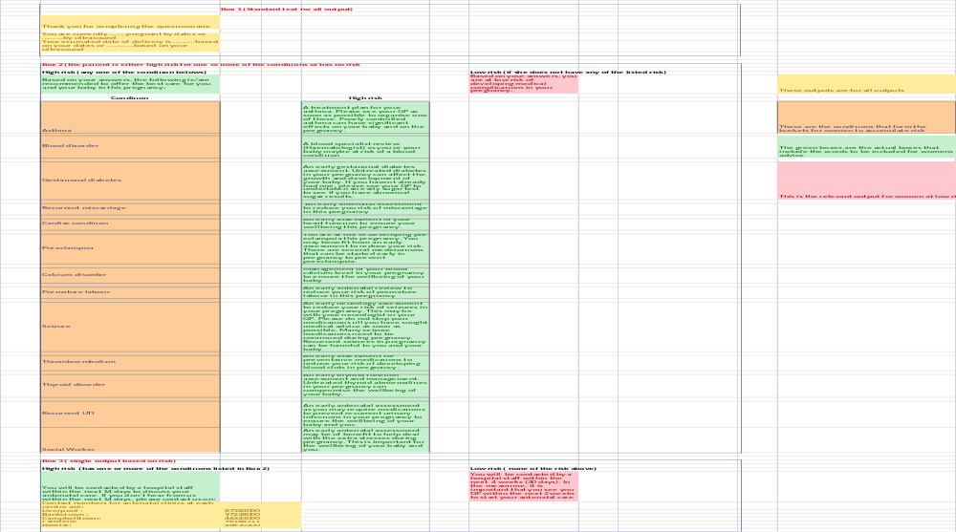

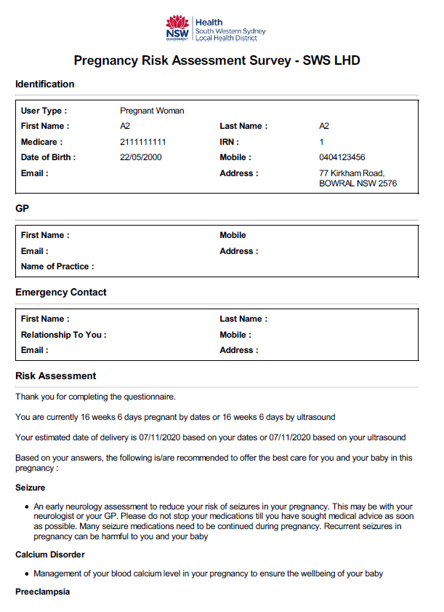
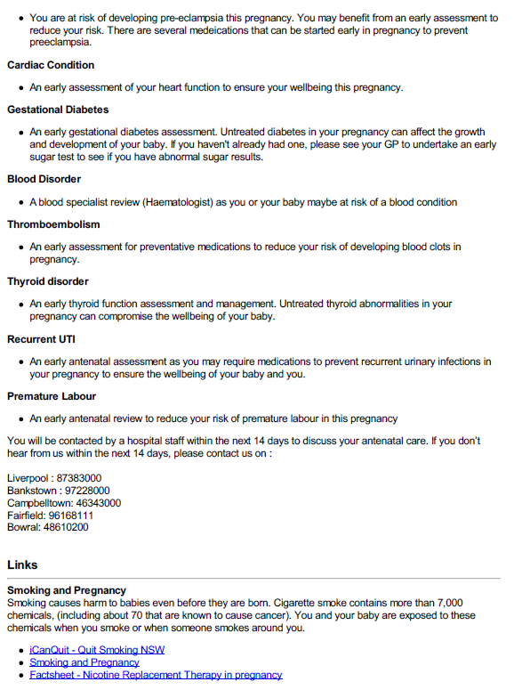
- APPENDIX C – Privacy and Terms of the SCREEN APP
These have been adopted from the NSW Health Privacy policy and terms of use of e- health.

Privacy
To ensure appropriate privacy coverage for the patient and appropriate understanding of the way patient’s health data is to be handled when the app is in its liv format, we will adhere to the privacy information set out by NSW Health. The following is inserted at the beginning of the app by way of information for the patient.

The patient is offered the hyperlink to the patient leaflet and the information is also embedded in the app. The link is:

https://www.health.nsw.gov.au/patients/privacy/Pages/privacy-leaflet-for-patients.aspx

The text below are the actual contents of the leaflet.

Collection of your health information
In order to provide you with appropriate treatment, we may collect a range of health information about you. In general terms, this may include information about your health, your pathology and diagnostic test results, x-ray and other imaging, and information about your medication.

We collect health information directly from you wherever possible. If this is not possible, or in an emergency, we may refer to your previous health records, other health care providers and your My Health Record.

Use or disclosure of your health information
Your health information may be used by the NSW public health service, or disclosed outside the
health service, to enable appropriate care and treatment to be provided to you.
For example, your information may be used or disclosed as follows:
- to other health services, hospitals or medical specialists involved in your health care.
- to your nominated GP, including information provided with your discharge referral documents.
- to the Ambulance Service of NSW.
- to My Health Record.
- to contact you at home regarding follow-up appointments.
- to your carer to assist with your care.
- to contact you for feedback on the services you have received.
- to pastoral care workers, including hospital chaplains, providing spiritual and pastoral care.
- to students and other staff for training purposes.
- to other health services and authorised third parties to help prevent a serious and imminent
- threat to someone’s life, health or welfare, such as in an emergency.
- for purposes relating to organ or tissue donation. This may include next of kin contact
- details.
- for operational and management activities, including funding, planning, safety and quality
- improvement.
- to investigate a complaint or incident.
- to manage a legal action or claim brought by the patient against the health service.
If you do not wish for us to collect, use or disclose certain information about you, you will need to tell us and we will discuss with you any consequences this may have for your health care.

The law also allows or requires for your health information to be disclosed to other third parties, for example:
- to State and Commonwealth government agencies for statutory reporting purposes, such as to report infectious diseases, cancer and other notifiable diseases; to report births and deaths, and to provide Medicare details.
- to researchers for public interest research projects as approved by a Human Research Ethics Committee.
- to other health services or law enforcement agencies, such as the police, if you provide us with information relating to a serious crime, including serious assault, domestic violence or child abuse.
- to other agencies where the information relates to the safety, welfare or wellbeing of a child or young person.
- to comply with a subpoena or search warrant if your health information is required as evidence in court.

Security of your health information
We follow strict government standards regarding the secure storage of your health information in all formats. We regularly enhance and audit our systems in order to protect your information from unauthorised access, loss or other misuse.

Your information may be stored in a variety of ways within the NSW public health service. Most commonly, your health information will be a combination of a paper record and an electronic medical record.

Access to your information
You are entitled to request access to your health information held by health services in NSW. Normally you will be asked to apply for access in writing and provide identification.

You may be charged a fee if you request copies of your health record. Requests for access to information will be responded to as soon as possible, or in most cases no later than 28 days.

Access to your information may be declined in special circumstances, such as where giving access would put you or another person at risk of mental or physical harm.

If you believe the information we hold about you is incorrect or an error has been made, please let us know and we will correct it or add a notation to your health record.

Requests for access to your health record should be addressed either to the Medical Records Department or to the manager of the health service facility you attended.

Contact us
If you have questions or a complaint about the privacy of your health information, please contact the Privacy Contact Officer​ for your health service.

Translating and Interpreting service
If you require assistance with contacting the above services or require translation, please call the Translating and Interpreting Service (TIS) on 13 14 50.
For a privacy information leaflet in other languages, visit the Multicultural Health Communication Service.
​

Terms of Use

These are displayed at the beginning of the app for patients to adhere to. Should the patient disagree- they are asked to return to see their GP.

TERMS, CONDITIONS AND DISCLAIMER POLICY

PLEASE READ THESE TERMS, CONDITIONS AND DISCLAIMER POLICY CAREFULLY BEFORE USING THE SCREEN APP AS THEY CONTAIN IMPORTANTINFORMATION REGARDING YOUR RIGHTS.
UPON ACCEPTANCE OF THESE TERMS OF USE AND THE PRIVACY POLICY THE USER SIGNIFIES THEY HAVE READ, UNDERSTOOD AND AGREE TO BE BOUND BY THE TERMS AND PRIVAVCY POLICY.

Disclaimer
This app is provided as a means to facilitate the early identification of women with pregnancies who may benefit form earlier review. It is to be used by women to provide medical information in a timely manner to ensure the appropriate assessment of their pregnancies. Women should not disregard professional advice, or delay in seeking it because of any information in the SCREEN APP.

Medical professionals accessing the SCREEN APP for risk stratification similarly should not solely rely on advice from the SCREEN APP. The information provided is educational in nature and not meant to be a substitute for professional advice and is not be used for medical diagnosis and or medical treatment.

Access
By accessing and using the SCREEN APP, users agree to the following terms and conditions of this Policy. Users must only access and use the site for lawful purposes, and in a manner that does not infringe any contractual licence agreement with regard to conduct, behaviour, safety, and security.
Access to SCREEN APP is available to all individuals who have residence in the South Western Sydney Local Health District and medical practitioners in Australia. This includes medical practitioners who have a working affiliation with NSW Public Health organisations, such as General Practice Divisions.
Users must not enter information they know or suspect to be incorrect. It is the responsibility of the individual entering the data and or the person to whom this data applies, to ensure there is no misrepresentation of any personal, medical or social information. We will not be responsible for the accuracy of the information you enter eg. Selecting an incorrect response.
Usage is monitored closely and any unauthorised usage that is identified will be blocked. By registering for the SCREEN APP, you also agree to receive a monthly WHITU Newsletter via email. If you wish to unsubscribe to the newsletter, please follow the instructions in the newsletter email.
We do not promise that you will have continuous and uninterrupted access to the App or that the App will be free of any harmful code, virus or other malware. We do not accept responsibility for any interference or damage to your device.
Copyright
To reproduce any information available through the usage of the SCREEN APP you must have written permission by the original author and publisher (WHITU SWSLHD). Content that may be copyrighted includes: designs, images, text, code, graphs, maps, and audio.
Acknowledgement of the source is not sufficient permission.
Copyright is a type of legal protection for people who produce things like writing, images, music and films. It is a legal right to prevent others from doing certain things (such as copying and making available online) without permission. Copyright protects the form or way an idea or information is expressed, not the idea or information itself. In Australia, copyright law is contained in the Copyright Act 1968 and its subsequent amendments. Definitions from the Australian Copyright Council.
For further details relating to CIAP content Terms of Use, please refer to Terms of Use.
For further information on copyright refer to the Australian Copyright Council.
Information and resource hosting
SCREEN APP content is selected on the basis of relevance to NSW Public Health clinicians and aims to provide high quality, evidence based screening of women early in their pregnancy to facilitate early intervention and implementation of best-practice.
All links from SCREEN APP are provided for information and do not imply that SCREEN APP accepts responsibility for the sites linked to, or the information provided.
SCREEN APP receives no support through advertising or sponsorship and does not support advertising on the site or linking to sites for the purpose of advertising.
SCREEN APP is not responsible for the provision of local clinical guidelines or the hosting of these guidelines, although links to sites containing local clinical guidelines may be available in the SCREEN APP.
Links to external (non-NSW Health) sites are sometimes included in web pages for the convenience of site users, but WHITU, SWSLHD and NSW Health does not have any responsibility for the privacy practices of third party sites linked to NSW Health sites. We don’t provide any of your Personal Information to these Other Websites, nor does any such information automatically pass to them with the linkage. Other Websites are not subject to this Website Usage Policy or our Privacy Policy so, before you utilise their website or disclose any Personal Information to them, we recommend that you read the terms of use, privacy policy and any other relevant policy for that Other Website.
Privacy
Is information collected about your site visit?
The statement pertaining to visitor logs is only necessary on the MOH homepage, and the homepages of any LHD site that logs visitors. Visitor logs are used on this NSW Health internet site for statistical purposes only. No attempt will be made to identify or collect personal information about users.
What does NSW Health do with personal information provided in feedback?
Email addresses provided to this site will only be used to respond to enquiries and will not be added to mailing lists, or disclosed to any other party without the user's consent, unless required to do so by law. Personal information will be kept in safe custody, sufficient to prevent unauthorised access, and will properly handled to ensure its safety, integrity, and confidentiality. Circumstances in which NSW Health may be required to disclose this information to a law enforcement agency include:
- Unauthorised tampering or interference with files published on a NSW Health site
- Unauthorised attempts to access files that are not published on the NSW Health site
- Attempts to intercept messages of other users of NSW Health sites
- Communications that are defamatory, abusive, vilify individuals or give rise to a suspicion that an offence is being committed
- Attempts to otherwise compromise the security of the web server
- Breach the laws of the State of NSW or the Commonwealth of Australia.
Site Usage
We may use a third party independent service to measure and analyse usage across the SCREEN APP. Use of such a service may involve coding being placed on pages on the Website to enable information on Website usage to be collected such as:
• the number of unique visitors to the Website;
• the average length of time these unique visitors spend on the Website when they visit; and
• the entry and exit points to and from the Website for these unique visitors.
The APP may allocate a unique identifier and this enables the tracking of the number of unique visitors to the APP. This unique identifier used would not identify a user personally, and we will not marry any data collected with any Personal Information collected on the APP. An independent service would collect and collate aggregate information and not Personal Information, which is then provided to us to assist with our analysis of APP usage. Data generated by an independent provider may also be accessible by third parties (for example, for the purpose of comparing usage patterns with similar websites).

Web Site Disclaimer and Copyright Statement
This site contains information, data, documents, pages, and images prepared by NSW Ministry of Health ("the Information") for and on behalf of the Crown in right of the State of New South Wales ("the State of New South Wales"). The Information is protected by Crown copyright.
The Information contained in this site includes information derived from various third parties, which is neither endorsed nor supported by the State of New South Wales and does not necessarily reflect any policies, procedures, standards, or guidelines of the State of New South Wales.
Whilst the Information contained in this site has been presented with all due care, the State of New South Wales does not warrant or represent that the Information is free from errors or omission.
The SCREEN APP is made available on the understanding that the developers of the app have no liability (including liability by reason of negligence) to the users for any loss, damage, cost, or expense incurred or arising by reason of any person using or relying on the information and whether caused by reason of any error, negligent act, omission or misrepresentation in the Information or otherwise. Usage of the APP does not act as a substitute for the advice of a health professional.
Furthermore, whilst the Information is considered to be true and correct at the date of publication, changes in circumstances after the time of publication may impact on the accuracy of the Information. The Information may change without notice and the SCREEN APP developers and NSW Health is not in any way liable for the accuracy of any information printed and stored or in any way interpreted and used by a user.
The SCREEN APP takes no responsibility for the accuracy, currency, reliability and correctness of any information included in the Information provided by third parties nor for the accuracy, currency, reliability and correctness of links or references to information sources (including Internet Sites) outside of the New South Wales Health Department. Links to other Internet Sites are not under the control of the State of New South Wales and are provided for information only. Although care has been taken in providing these links as suitable reference resources, due to the changing nature of the Internet content, it is the responsibility of the users to make their own investigations, decisions, enquiries about the information retrieved from other Internet Sites. Provision of these links does not imply any endorsement, non-endorsement, support or commercial gain by the State of New South Wales.
© - Copyright – WHITU, SWSLHD, New South Wales Health Department
All rights reserved. No part of this publication may be reproduced in any material form or transmitted to any other person without the prior written permission of WHITU at SWSLHD, except as permitted under the Copyright Act 1968 (as amended). In particular, the user of the Information agrees:
- To retrieve documents for information only
- To save or print a single copy for personal use only and not to reproduce any major extract or the entire document except as permitted under Copyright Act 1968 (as amended) without the prior written permission of the State of New South Wales
- To acknowledge the source of any selected passage, table diagram or other extract reproduced
- Not to make any charge for providing the Information to another person or organisation without the prior written consent of the State of New South Wales and payment of an agreed copyright fee
- Not to modify the Information without the express prior written permission of the State of New South Wales
- To include this copyright notice and disclaimer in any copy made
- This Disclaimer is subject to Crown Copyright and may not be reproduced in any form without the express permission of the State of New South Wales. This Disclaimer is designated to this Web Site as created for the Crown in right of New South Wales by the New South Wales Crown Solicitor.
Effective Date
This SCREEN APP Terms, Conditions and Disclaimer Policy applies from the date of publication, stated at the end of this document. We may update or change the SCREEN APP Policy at any time without notice to you, so we encourage you to review this statement from time to time. Notification of any changes will be advised by posting an updated version of this Policy to the Website and the changes will apply from the date of publication of the revised Policy.

- APPENDIX D – Introduction to the SCREEN App
The following is the introduction to the app that will greet patients once they have logged in.

Thank you for using the SCREEN APP. This app will ask you questions that relate to your pregnancy as well as your and your partner’s health. These questions have been developed to help identify women who during their pregnancy might need to be seen earlier than usual. By doing this we hope to make sure you and your baby have the best possible outcomes.

This questionnaire DOES NOT REPLACE your first antenatal or GP review.

Please take the summary of this questionnaire (provided at the end) to your doctor, as advised, for further assessment and management.

If you think you will have trouble answering the questions, please go through the questionnaire with someone who can help you, for example your GP, family member or friend above the age of 18. If you choose not to proceed with the questionnaire please see your GP as soon as possible.

After the survey about your pregnancy, we will ask you 4 simple questions about your experience with the survey.

- APPENDIX E – Patient and Midwife Experience Surveys

Patient Satisfaction
We would like to find out what you thought about completing the pregnancy survey. Please take the time to fill out these 4 quick questions. Your feedback will help us to make it better.

- The questionnaire was too long
Strongly agree | Agree | Neutral | Disagree | Strongly Disagree

Comments:…………………………

- The questions asked were well organized and made sense
Strongly agree | Agree | Neutral | Disagree | Strongly Disagree

Comments:…………………………..

- I liked the pop-up information pages and email summary

Strongly agree | Agree | Neutral | Disagree | Strongly Disagree

Comments:……………………………………………

- I found the survey easy to use
Strongly agree | Agree | Neutral | Disagree | Strongly Disagree

Comments:……………………………………………

Midwife- Patient Interaction
- How much time was spent for the booking-in visit?

Category | Time (mins)
With the patient in direct contact
- Prior to consult
- After consult on patient related matters

- What proportion of the time was spent:

Category | Percentage (should total 100%)
- Collecting information from patient
- Providing information
- Entering data into EMR/other
- Organizing referrals and other appointments (during consult)

- Did the patient have an interpreter present during the interview (circle relevant)?
a) YES NO
b) PHONE IN-PERSON

