Copyright information:

Re-use permitted under CC BY NC 4.0 Creative Commons — Attribution-NonCommercial 4.0 International — CC BY-NC 4.0. It permits others to copy, redistribute, remix, transform and build upon this work for any purpose, provided the original work is properly cited, a link to the licence is given, and indication of whether changes were made.

Title:
The effect on comprehension of different visual presentations to communicate prognosis: a four parallel-arm online randomised controlled trial in healthy adults.
Trial registration
These two trials are not registered yet, we plan to register them at Australian New Zealand clinical trials registry (ANZCTR) prior to commencing recruitment.
Protocol version:
August 2021-version 02
Funding:
No specific funding was received for these two randomised controlled trials; however, the first author is supported on a Ph.D. scholarship which is funded by the Centre for Research Excellence in Minimizing Antibiotic Resistance in the Community (CRE-MARC), funded by the National Health and Medical Research Council (NHMRC), Australia (reference number: 1153299). CDM and TH are chief investigators of CREMARC, and MB is employed as a postdoctoral research fellow on this grant.
Roles and responsibilities
These two trials will be conducted at the Institute for Evidence-Based Healthcare (IEBH), Bond University, QLD, Australia. Eman Abukmail, Tammy Hoffmann, Chris Del Mar, Mina Bakhit, and Mark Jones are involved in this trial. These trials are part of (EA) Ph.D. program. These trials are designed with consultation and discussion between all team members. EA is responsible for drafting the protocol, creating the interventions and the surveys, and managing data. Data will be analysed according to a predesigned plan with consultation from Associate Prof. of statistics (Mark Johns). The final report/s will be drafted by EA and reviewed by all authors for approval of the final version before submission to a peer-reviewed journal.

- Introduction
  - Background
Patient involvement in the process of decision-making about their health conditions requires that they receive and understand sufficient information to be able to make an informed decision(Charles, Gafni et al. 1997). For some decisions, part of the information needed relates to the prognosis of a health condition. Prognosis information involves communicating quantitative data in terms of the likelihood of occurrence of an outcome, recurrence, improvement, or cure overtime. Information about a condition’s natural history (that is, what is the natural course of the condition without treatment), is also encompassed under the umbrella of prognostic information. Understanding prognostic information can help people to have realistic expectations of their condition’s course and make well-informed decisions about next steps (Feldman-Stewart, Brundage et al. 2007).
Communicating quantitative information can be challenging for both clinicians and patients(Paladino, Lakin et al. 2019). We conducted a systematic review (accepted for publication in BMC Medical Informatics and Decision Making) to explore the visual methods that have been used to communicate prognostic information and if any was superior at facilitating comprehension. The review found no significant superiority of any of the methods that have been used in studies to date. Most of the existing studies focused on presenting information about prognosis as it relates to decisions about undertaking screening for diseases (mostly cancer). Very few studies have explored the best ways of presenting prognosis information for treatment decisions, so that patients can decide whether to proceed with treatment, and if so, which treatment option. This study aims to investigate whether graphs assist with the comprehension of prognostic information, and if the type of graph matters. Within this study, we will conduct two trials (trial a and trial b) – trial a: in which the scenario involves an acute condition (where a decision is needed within a few days) and trial b: that involves a chronic condition where a decision about how to manage it can occur over a longer timeframe.
  - Objectives
The overall objective of this study (trial a and trial b) is to compare the effect of different visual presentations on improving patients’ comprehension of quantitative prognostic information.
  - Research questions
RQ1: Does a bar graph presenting prognostic information improves patients’ comprehension by 1 unit or more on a 6-unit score compared to presenting the same information as text only. (Superiority)
RQ2: Does a pictograph presenting prognostic information improves patients’ comprehension by 1 unit or more on a 6-unit score compared to presenting the same information as text only. (Superiority)
RQ3: Does a line graph presenting prognostic information improves patients’ comprehension by 1 unit or more on a 6-unit score compared to presenting the same information as text only. (Superiority)
RQ4: Do the three graphs (bar graph, pictograph, line graph) have a similar effect on comprehension of prognostic information? (Equivalence)

- Methods
  - Study design
We will conduct two online randomised trials using the same design, interventions, and procedure. The two trials will only differ in the health condition presented, and hence the wording and numbers presented will be modified accordingly. Trial A, will involve the scenario of middle ear infection (acute otitis media) and trial B, will involve a scenario of tennis elbow (lateral epicondylitis).
The two trials will be conducted simultaneously but each with a fresh sample of participants (participants who participate in one trial, cannot participate in the other trial). Each trial is a 4 parallel-arm online controlled superiority randomised trial.
  - Randomisation
In each trial, participants will be randomised according to a computer-generated sequence. Dynata will use block randomisation to allocate participants to 1 of four groups: Text-only, Bar graph, Pictograph, and Line graph. For the flow of the trial and points of data collection please see (Figure 1) below.
Participants will be randomised to one of four groups using the online provider (Dynata). Participants will be aware of the presence of 4 possible allocations/ groups at the start of the survey but will not be aware of neither to which group they will be allocated to nor what the other groups will be receiving. The surveys will be sent using a router, not manually. Participants will be aware to outcome measurement (the survey questions); however, they are blinded to the answers of the survey. The researchers of these trials will have no role in the randomisation process.
To prevent crossover, participants who will participate in the online piloting will not be able to participate in the trial regardless of which condition they will be involved in. Additionally, a participant who will be randomised to one trial cannot participate in the other trial. That means we will have fresh sample for middle ear infection piloting, middle ear infection trial, tennis elbow piloting, tennis elbow trial.
  - Participant timeline
Participants will be recruited commencing August 2021 until the completion of the target sample size is reached.
  - Sample size
A pilot study of 47 participants showed the standard deviation for the primary outcome (comprehension) was at most 1.66 units. Assuming 90% power, 0.016% level of significance (adjusted to account for 3 primary comparisons), difference between groups of 1 unit, and up to 20% missing data, 97 participants are required in each group (a total of 388 participants in each trial).
  - Study setting and sampling/ recruitment
Participants will be recruited by an online provider (Dynata) to participate in one of the 4-arm randomised controlled trials. To recruit participants, Dynata uses an algorithm-based sampling tool to automatically calculate how much sample is needed to complete a study within a set time frame. Participants will be compensated with 5.90 AUD by the recruiting provider for about 15-20 min of participation in the study.

  - Eligibility criteria
Participants will be eligible if they live in Australia, are 18 years old or over, and can read and understand English. Participants do not have to have the condition presented in the scenario. Participants will be excluded if they cannot read or understand English.
Participants in both trials are panellists who gave their consent to the online provider (Dynata) to receive emails and participate in surveys. In both trials, Participants will give their consent before the start of the survey of this study. We will provide the potential participants of both trials with an information sheet to explain the aims of the trial and why we are conducting this trial. Any participant who wishes to withdraw from the trial will be free to do so with no consequences.
  - Interventions
We have four interventions conveying the same information about natural history and prognosis of a medical condition. (See appendix)
Brief name | - Text only: the information will be presented in a text only format  - Bar graph: the information will be presented in a bar graph format  - Pictograph: the information will be presented in a pictograph format  - Line graph: the information will be presented in a line graph format
Why | Comprehension of the medical information might be affected by how this information visually presented to patients. This might have a further effect on their decisions regarding their health management plans. Normally, when patients are presented with information to facilitate informed decision-making, this would include both benefits and harms information. However, as the focus of this study was to investigate how to present information about the course of an illness over time, we do not include harms information in these formats.
What | They will not receive any information regarding the interventions or any educational material. However, the intervention itself is a type of medical information about the prognosis of a medical condition. The procedure of the interventions can be seen in (Figure 1).
Who provided | The interventional surveys will be emailed by an online provider (Dynata) electronically.
How | The survey links will be emailed to the potential participants individually or they can access the survey link from their Dynata dashboard, who (in case they decide to click the link and proceed to fill the survey) will fill the survey from anywhere they would like to (e.g., home, work, café). They will have no direct contact to the person who sent the survey.
Where | The online survey can be filled in any place feasible to the participants. All they need is to have a device that is connected to the internet (i.e., computer, laptop, mobile phone)
When and  how much | This survey will be delivered once, there will be no follow up of participants. Data will be collected at one timepoint. the expected average time to finish the survey 15-20 min.
Tailoring | The interventions will not be individualised (e.g., personal risk of having a certain outcome along the course of the disease based on certain prognostic factors).  Participants of the same trial will receive the same information; however, each trial (trial A and trial B) will communicate different information.  Trial A (acute condition: acute middle ear infection) will convey information about the number of children with and without pain at three time points if they received antibiotics or not (i.e., wait for it to spontaneously resolve). We chose acute middle ear infection (acute otitis media) because it is one of the most common childhood infections (Rovers and Zielhuis 2004), with about 50% to 85% of all children have experienced at least one AOM episode (Venekamp, Sanders et al. 2015). Most people will have experience with it themselves or had someone they know who experienced it. The prognosis data comes from a high-quality systematic review(Venekamp, Sanders et al. 2015)  Trial B (tennis elbow: lateral epicondylitis) will convey information about the number of people with tennis elbow who had complete recovery at two time points. if they decided either to watch and wait, have physiotherapy, or have a corticosteroid injection. We chose tennis elbow (the data comes from on a high-quality randomised controlled trial(Bisset, Beller et al. 2006) ) as it is a chronic condition with a variable course, that has multiple treatment options (including the option of waiting for the condition to spontaneously improve).
Modification | This trial is a one session trial and there will be no follow up sessions. Therefore, no modifications being expected. (Not relevant)
How well | Not relevant

Graphical details of bar graphs and pictographs (e.g., symmetric distribution in pictograph, adding a scale, shape of the icon) were chosen based on best practice principles identified in the literature. (Lipkus and Hollands 1999, Fortin, Hirota et al. 2001, Armstrong, Schwartz et al. 2002, Ancker, Senathirajah et al. 2006, Feldman-Stewart, Brundage et al. 2007, Zikmund-Fisher, Fagerlin et al. 2007, Zikmund-Fisher, Fagerlin et al. 2008, Carling, Kristoffersen et al. 2009, Zikmund-Fisher, Fagerlin et al. 2010, Brown, Culver et al. 2011, Trevena, Zikmund-Fisher et al. 2013, Zikmund-Fisher, Witteman et al. 2014, Zipkin, Umscheid et al. 2014, Hamstra, Johnson et al. 2015, Petrova, Garcia-Retamero et al. 2015, Kasper, van de Roemer et al. 2017, McDowell, Gigerenzer et al. 2019, Brick, McDowell et al. 2020) (see appendix for the interventions of each condition).
  - Outcomes
Our primary outcome is the comprehension of the information presented. Our secondary outcomes are decision intentions (intention to take a treatment), satisfaction with the presented format (before viewing all formats), and format preference (after viewing all formats).
Participants of each trial will be randomised at the start to 1 of 4 groups: in each group participants will respond to a structured questionnaire starting by demographic questions (5 questions), baseline treatment decision intention (1 question), previous experience with the condition (1 question). Medical Maximizer-Minimizer scale(Scherer, Caverly et al. 2016) (1 question of 10 items), subjective numeracy scale (Fagerlin, Zikmund-Fisher et al. 2007, Zikmund-Fisher, Smith et al. 2007) (2 questions each has 4 items). This part will be the same for all the participants of one trial. Then each group will be presented by a specific intervention (e.g., text, bar graph, pictograph, or line graph) and then answer 6 comprehension questions. The comprehension questions are the same for all the participants of one trial. Then participants will respond to 2 questions about their treatment decision intention. Participants’ satisfaction with the presentation (i.e., the intervention they received) will be measured using 2 ranking questions (Hamstra, Johnson et al. 2015). At this stage, all the 4 presentations (text, bar graph, pictograph, line graph) will be revealed to the participants and graph preference will be measured using 3 questions. After that, participants will respond to a graphic previous experience ranking question. At the end, health literacy level of the participants will be measured using the NVS health literacy scale(Weiss, Mays et al. 2005). For the flow of the trials, please see (Figure 1).
The survey questions were developed either guided or adapted from previous related studies and modified according to the condition we have; comprehension questions(Armstrong, Schwartz et al. 2002, Zikmund-Fisher, Fagerlin et al. 2010, Galesic and Garcia-Retamero 2011, Woloshin and Schwartz 2011, Brick, McDowell et al. 2020), decision intention and previous experience with the condition(McDowell, Gigerenzer et al. 2019, Brick, McDowell et al. 2020), and satisfaction with the presentation and graph preference(Hamstra, Johnson et al. 2015).

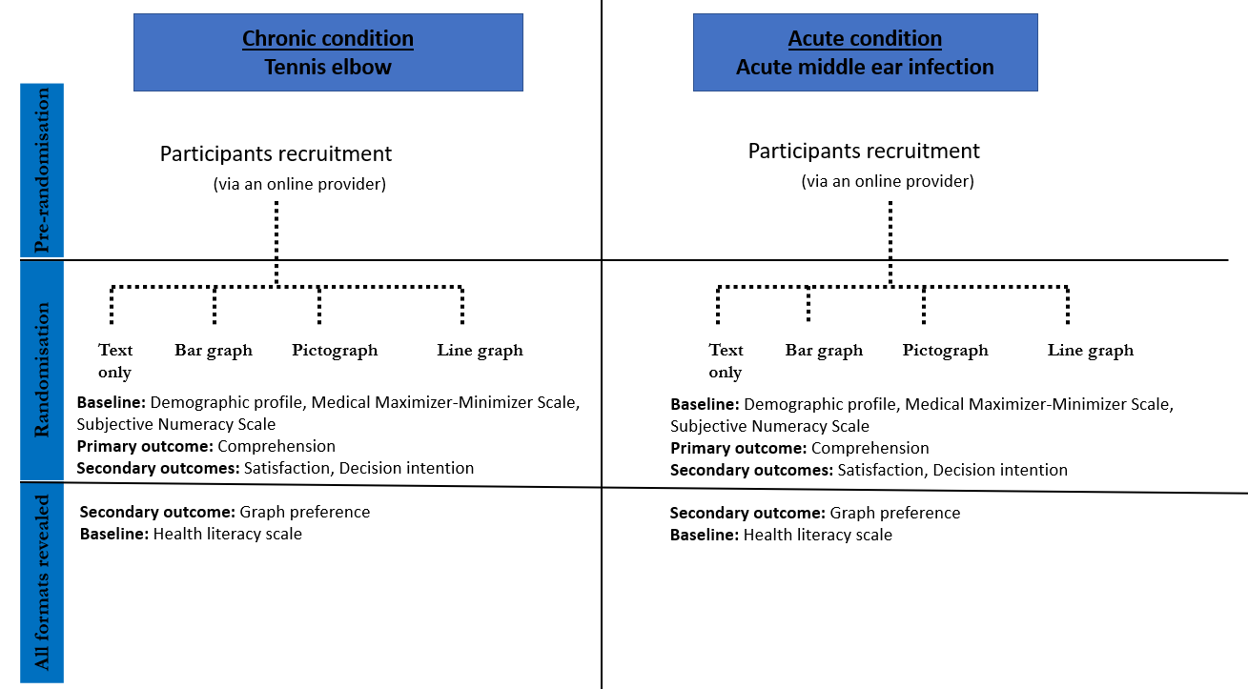
Figure 1: Flow diagram demonstrating the steps of the trial and outcome measurement.
**
  - Statistical methods
The primary analysis will test if comprehension is different between each graph format in comparison to text only (3 comparisons). 2 sample t-test will be used for each comparison and mean difference with 95% confidence interval and p-value will be reported. An adjusted analysis for each of the 3 comparisons will also be performed to account for any potential important baseline imbalances using linear regression with adjustment for age group, level of education, and health literacy level.
To assess the equivalence of the 3 graph formats, 95% confidence intervals for the mean difference between groups will be estimated for each of the 3 pairwise comparisons using 2 sample t-test. Equivalence will be concluded if the 95% confidence intervals lie between -1.0 and 1.0.
Linear regression models will be constructed to estimate the association between comprehension as the dependant variable and the independent variables (health literacy, numeracy, educational level). The measure of association reported will be the R² value.
- Results
For the comprehension questions, will be measured using 6 questions, we will score comprehension in 3 ways: the mean score of correct answers (out of 6 points score) across all questions per format, the proportion of participants answering each question correctly in each format, and the proportion of participants who answered all the questions correctly in each format.
Answers to comprehension questions will be scored as correct if they are exactly matching the numbers presented in the formats. Any other answers will be scored as incorrect. Non-responses to questions will be scored as incorrect.
The intervention will be displayed with the comprehension questions on the same page. Participants will be able to see the information while answering the questions by scrolling up and down. Participants will not be able to go to the previous page once they submitted their answers.
- Data management
Participants’ responses will be collected electronically by Dynata. The researchers will securely store a copy of the de-identified data with unique IDs linked to each participant’s responses. In our publications, only de-identified responses will be presented as the mean of the group to maintain the anonymity of participants. In line with the National Health and Medical Research Council (NHMRC) recommendations, and Bond university policy, all data will be kept for 5 years.
- Harms
There are no harms associated with this trial.
- Auditing
Not applicable
- Research ethics approval
This study received approval by Bond University Human Research Ethics Committee. Any important amendments to the protocol or the procedure of conducting the trial will be communicated to the relevant party.
- Protocol amendment
An updated protocol will be provided if any changes are made and will be submitted to the ethics committee whenever applicable.
- Consent or assent
Participants in this trial are panellists who gave their consent to the online provider (Dynata) to receive emails and participate in this type of studies. In this study, we will provide the potential participants with an information sheet to explain the aims of the trial and why we are conducting this trial. Any participant who wishes to withdraw from the trial will be free to do so with no consequences.
- Confidentiality
All personal information will be de-identified.
- Declaration of interests
All authors declare no conflict of interest.
- Access to data
Deidentified data will be accessed by authors, archived in Bond university repository as well as on OSF repository. The de-identified data can also be shared with researchers in other institutions or universities.
- Ancillary and post-trial care
Not applicable.
- Dissemination policy
We are aiming to publish this study in a peer-reviewed journal.

References

Appendix
1 Interventions for the acute condition
  - Text only
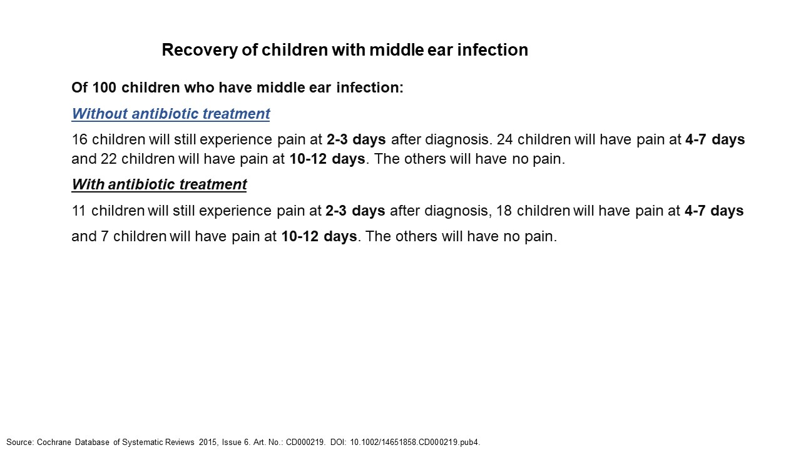

  - Bar graph
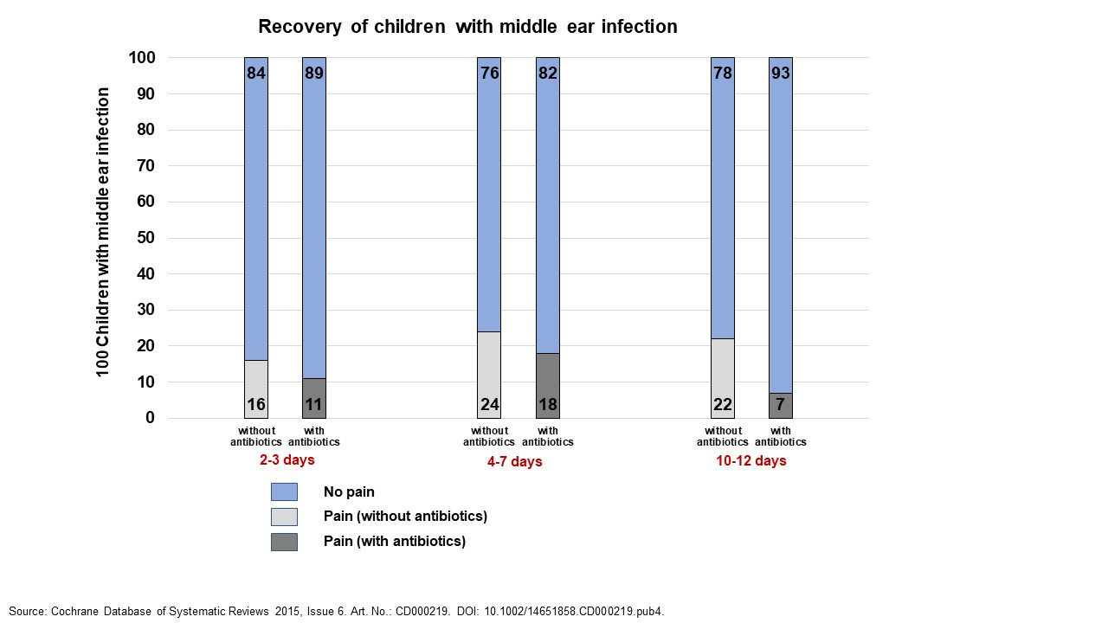

  - Pictograph
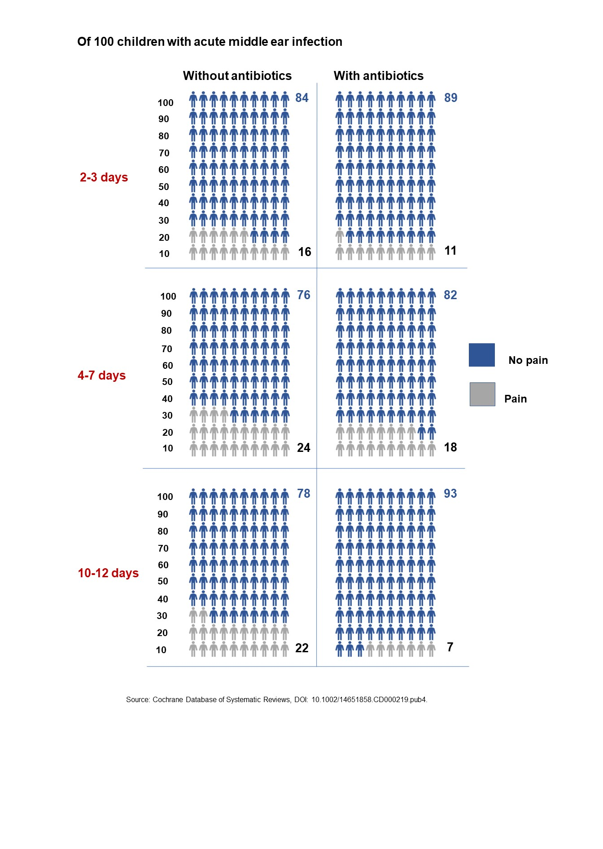

  - Line graph
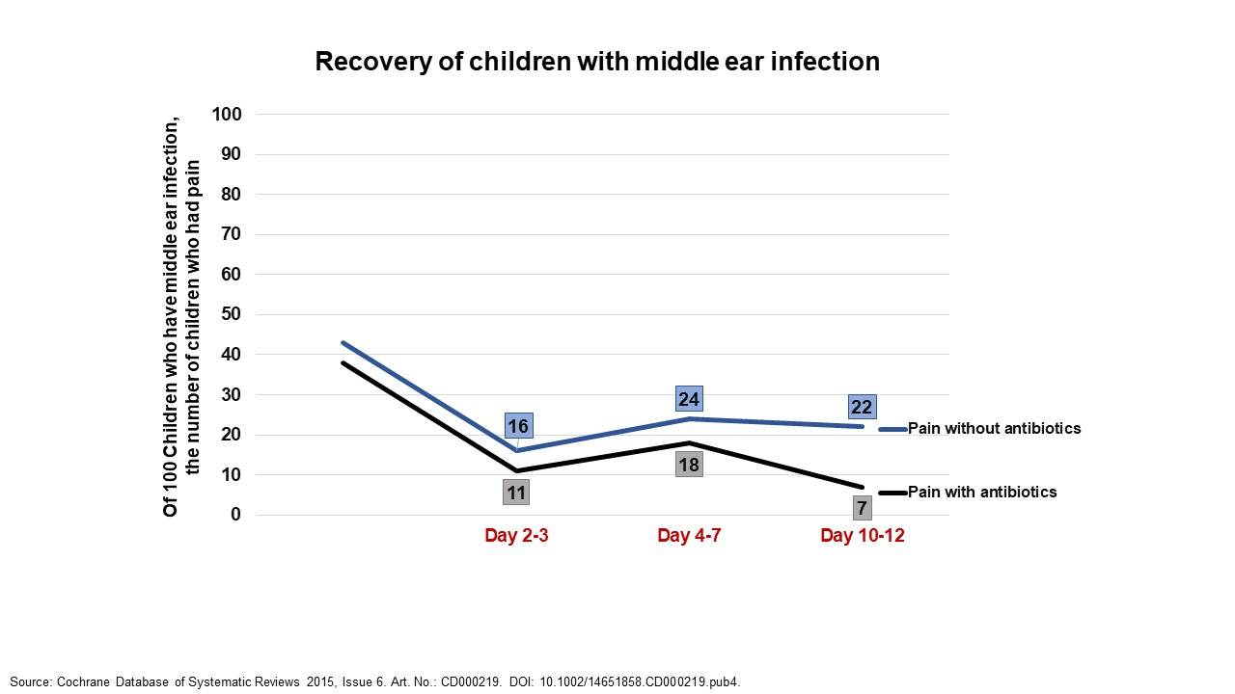

2 Interventions for the chronic condition
2.1. Text only
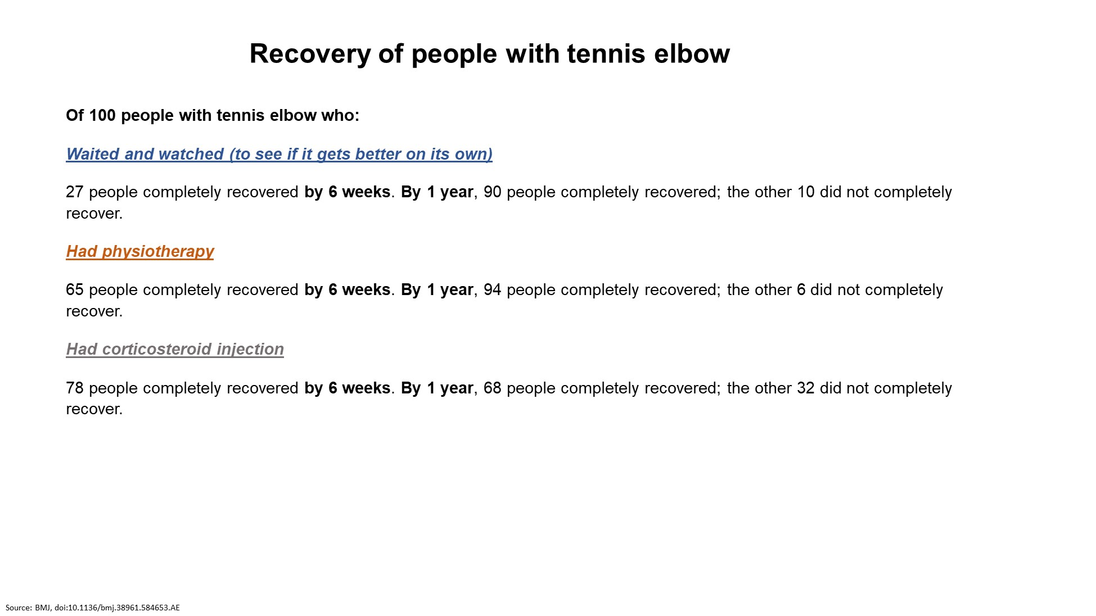
2.2. Bar graph
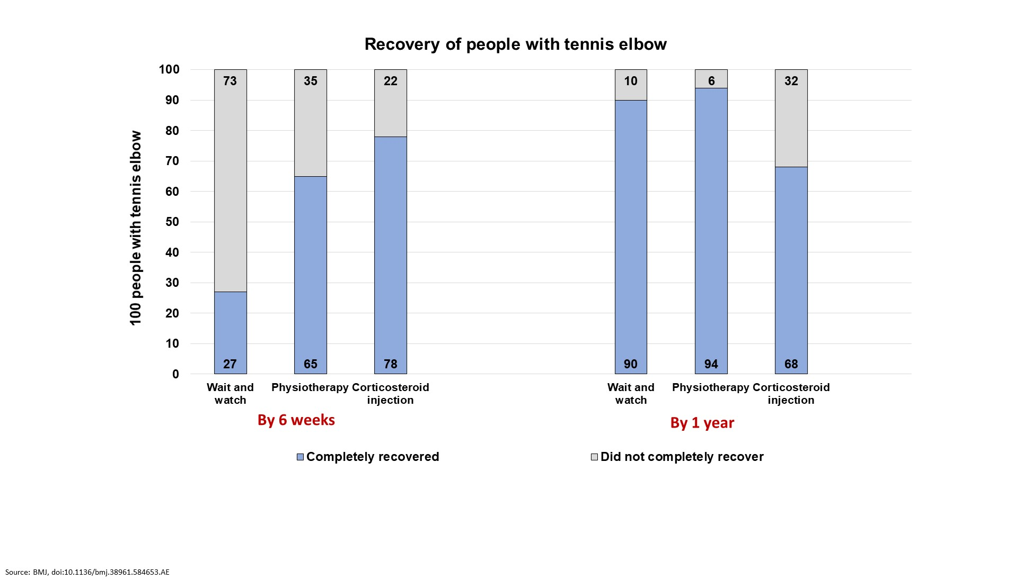

2.3. Pictograph
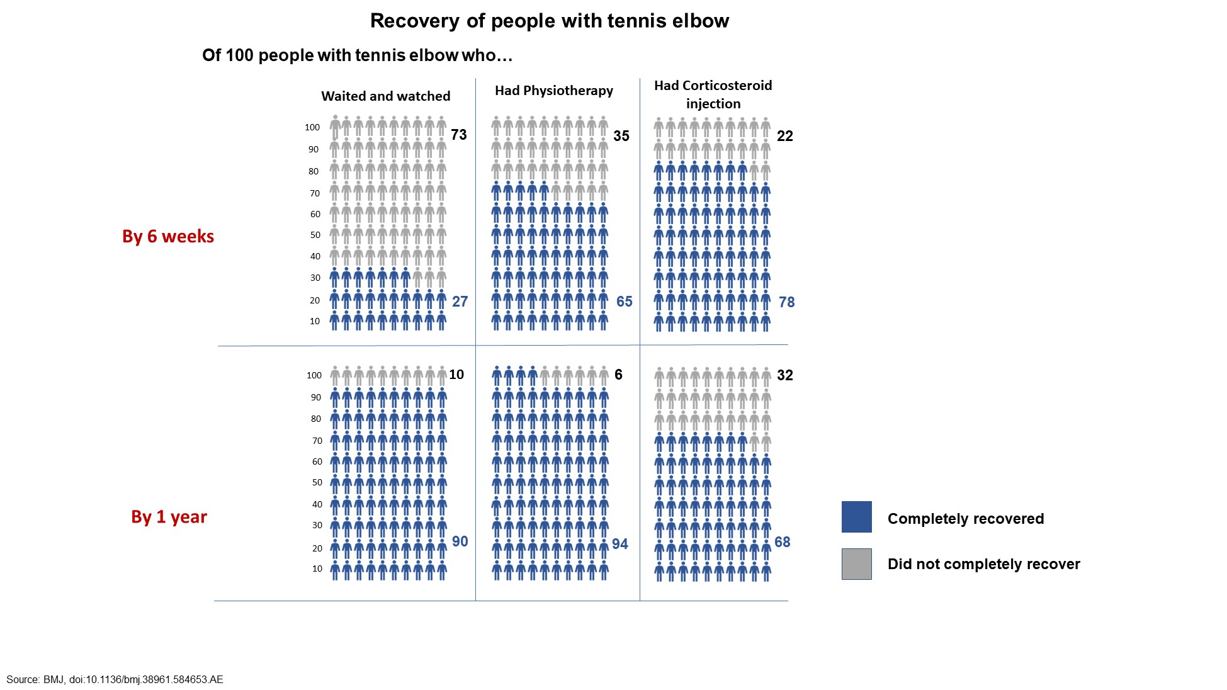
2.4. Line graph
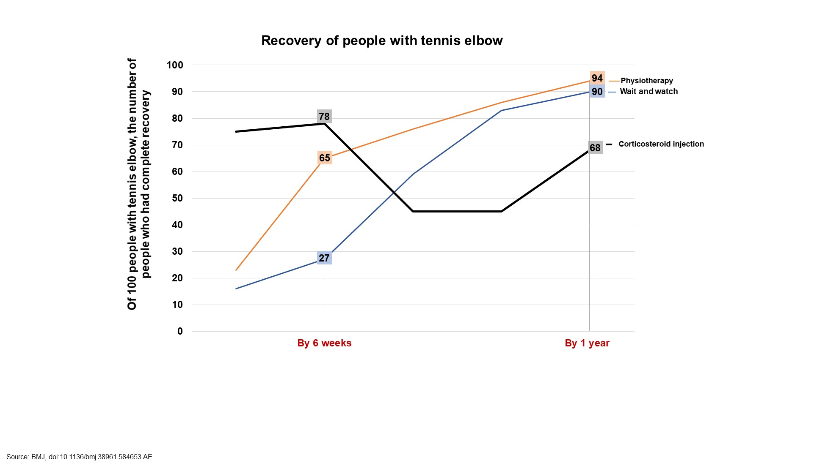

Ancker, J. S., et al. (2006). "Design features of graphs in health risk communication: a systematic review." J Am Med Inform Assoc 13(6): 608-618.
This review describes recent experimental and focus group research on graphics as a method of communication about quantitative health risks. Some of the studies discussed in this review assessed effect of graphs on quantitative reasoning, others assessed effects on behavior or behavioral intentions, and still others assessed viewers' likes and dislikes. Graphical features that improve the accuracy of quantitative reasoning appear to differ from the features most likely to alter behavior or intentions. For example, graphs that make part-to-whole relationships available visually may help people attend to the relationship between the numerator (the number of people affected by a hazard) and the denominator (the entire population at risk), whereas graphs that show only the numerator appear to inflate the perceived risk and may induce risk-averse behavior. Viewers often preferred design features such as visual simplicity and familiarity that were not associated with accurate quantitative judgments. Communicators should not assume that all graphics are more intuitive than text; many of the studies found that patients' interpretations of the graphics were dependent upon expertise or instruction. Potentially useful directions for continuing research include interactions with educational level and numeracy and successful ways to communicate uncertainty about risk.

Armstrong, K., et al. (2002). "Effect of framing as gain versus loss on understanding and hypothetical treatment choices: survival and mortality curves." Med Decis Making 22(1): 76-83.
BACKGROUND: Presentation of information using survival or mortality (i.e., incidence) curves offers a potentially powerful method of communication because such curves provide information about risk over time in a relatively simple graphic format. However, the effect of framing as survival versus mortality on understanding and treatment choice is not known. METHODS: In this study, 451 individuals awaiting jury duty at the Philadelphia City Courthouse were randomized to receive 1 of 3 questionnaires: (1) survival curves, (2) mortality curves, or (3) both survival and mortality curves. Each questionnaire included a brief description of a hypothetical treatment decision, survival curve graphs and/or mortality curve graphs presenting the outcome of the treatment, and questions measuring understanding of the information contained in the graphs and preference for undergoing treatment. After completing a brief practice exercise, participants were asked to answer questions assessing their ability to interpret single points on a curve and the difference between curves, and then to decide whether they would choose to undergo preventive surgery for 3 different scenarios in which the benefit of surgery varied. RESULTS: Participants who received only survival curves or who received both survival and mortality curves were significantly more accurate in answering questions about the information than participants who received only mortality curves (P < 0.05). For 2 of the 3 treatment presentations, participants who received only mortality curves were significantly less likely to prefer preventive surgery than participants who received survival curves only or both survival and mortality curves (P < 0.05). The effect of framing on understanding was greatest among participants with less than a college education and among non-Caucasian participants. CONCLUSION: Framing graphic risk information as chance of death over time results in lower levels of understanding and less interest in preventive surgery than framing as chance of survival over time.

Bisset, L., et al. (2006). "Mobilisation with movement and exercise, corticosteroid injection, or wait and see for tennis elbow: randomised trial." BMJ 333(7575): 939.
OBJECTIVE: To investigate the efficacy of physiotherapy compared with a wait and see approach or corticosteroid injections over 52 weeks in tennis elbow. DESIGN: Single blind randomised controlled trial. SETTING: Community setting, Brisbane, Australia. PARTICIPANTS: 198 participants aged 18 to 65 years with a clinical diagnosis of tennis elbow of a minimum six weeks' duration, who had not received any other active treatment by a health practitioner in the previous six months. INTERVENTIONS: Eight sessions of physiotherapy; corticosteroid injections; or wait and see. MAIN OUTCOME MEASURES: Global improvement, grip force, and assessor's rating of severity measured at baseline, six weeks, and 52 weeks. RESULTS: Corticosteroid injection showed significantly better effects at six weeks but with high recurrence rates thereafter (47/65 of successes subsequently regressed) and significantly poorer outcomes in the long term compared with physiotherapy. Physiotherapy was superior to wait and see in the short term; no difference was seen at 52 weeks, when most participants in both groups reported a successful outcome. Participants who had physiotherapy sought less additional treatment, such as non-steroidal anti-inflammatory drugs, than did participants who had wait and see or injections. CONCLUSION: Physiotherapy combining elbow manipulation and exercise has a superior benefit to wait and see in the first six weeks and to corticosteroid injections after six weeks, providing a reasonable alternative to injections in the mid to long term. The significant short term benefits of corticosteroid injection are paradoxically reversed after six weeks, with high recurrence rates, implying that this treatment should be used with caution in the management of tennis elbow.

Brick, C., et al. (2020). "Risk communication in tables versus text: a registered report randomized trial on 'fact boxes'." R Soc Open Sci 7(3): 190876.
OBJECTIVES: identifying effective summary formats is fundamental to multiple fields including science communication, systematic reviews, evidence-based policy and medical decision-making. This study tested whether table or text-only formats lead to better comprehension of the potential harms and benefits of different options, here in a medical context. DESIGN: pre-registered, longitudinal experiment: between-subjects factorial 2 (message format) x 2 topic (therapeutic or preventative intervention) on comprehension and later recall (CONSORT-SPI 2018). SETTING: longitudinal online survey experiment. PARTICIPANTS: 2305 census-matched UK residents recruited through the survey panel firm YouGov. PRIMARY OUTCOME MEASURE: comprehension of harms and benefits and knowledge recall after six weeks. RESULTS: fact boxes-simple tabular messages-led to more comprehension (d = 0.39) and slightly more knowledge recall after six weeks (d = 0.12) compared to the same information in text. These patterns of results were consistent between the two medical topics and across all levels of objective numeracy and education. Fact boxes were rated as more engaging than text, and there were no differences between formats in treatment decisions, feeling informed or trust. CONCLUSIONS: the brief table format of the fact box improved the comprehension of harms and benefits relative to the text-only control. Effective communication supports informed consent and decision-making and brings ethical and practical advantages. Fact boxes and other summary formats may be effective in a wide range of communication contexts.

Brown, S. M., et al. (2011). "Health literacy, numeracy, and interpretation of graphical breast cancer risk estimates." Patient Educ Couns 83(1): 92-98.
OBJECTIVE: Health literacy and numeracy are necessary to understand health information and to make informed medical decisions. This study explored the relationships among health literacy, numeracy, and ability to accurately interpret graphical representations of breast cancer risk. METHODS: Participants (N=120) were recruited from the Facing Our Risk of Cancer Empowered (FORCE) membership. Health literacy and numeracy were assessed. Participants interpreted graphs depicting breast cancer risk, made hypothetical treatment decisions, and rated preference of graphs. RESULTS: Most participants were Caucasian (98%) and had completed at least one year of college (93%). Fifty-two percent had breast cancer, 86% had a family history of breast cancer, and 57% had a deleterious BRCA gene mutation. Mean health literacy score was 65/66; mean numeracy score was 4/6; and mean graphicacy score was 9/12. Education and numeracy were significantly associated with accurate graph interpretation (r=0.42, p<0.001 and r=0.65, p<0.001, respectively). However, after adjusting for numeracy in multivariate linear regression, education added little to the prediction of graphicacy (r(2)=0.41 versus 0.42, respectively). CONCLUSION: In our highly health-literate population, numeracy was predictive of graphicacy. PRACTICE IMPLICATIONS: Effective risk communication strategies should consider the impact of numeracy on graphicacy and patient understanding.

Carling, C. L., et al. (2009). "The effect of alternative graphical displays used to present the benefits of antibiotics for sore throat on decisions about whether to seek treatment: a randomized trial." PLoS Med 6(8): e1000140.
BACKGROUND: We conducted an Internet-based randomized trial comparing four graphical displays of the benefits of antibiotics for people with sore throat who must decide whether to go to the doctor to seek treatment. Our objective was to determine which display resulted in choices most consistent with participants' values. METHODS AND FINDINGS: This was the first of a series of televised trials undertaken in cooperation with the Norwegian Broadcasting Company. We recruited adult volunteers in Norway through a nationally televised weekly health program. Participants went to our Web site and rated the relative importance of the consequences of treatment using visual analogue scales (VAS). They viewed the graphical display (or no information) to which they were randomized and were asked to decide whether to go to the doctor for an antibiotic prescription. We compared four presentations: face icons (happy/sad) or a bar graph showing the proportion of people with symptoms on day three with and without treatment, a bar graph of the average duration of symptoms, and a bar graph of proportion with symptoms on both days three and seven. Before completing the study, all participants were shown all the displays and detailed patient information about the treatment of sore throat and were asked to decide again. We calculated a relative importance score (RIS) by subtracting the VAS scores for the undesirable consequences of antibiotics from the VAS score for the benefit of symptom relief. We used logistic regression to determine the association between participants' RIS and their choice. 1,760 participants completed the study. There were statistically significant differences in the likelihood of choosing to go to the doctor in relation to different values (RIS). Of the four presentations, the bar graph of duration of symptoms resulted in decisions that were most consistent with the more fully informed second decision. Most participants also preferred this presentation (38%) and found it easiest to understand (37%). Participants shown the other three presentations were more likely to decide to go to the doctor based on their first decision than everyone based on the second decision. Participants preferred the graph using faces the least (14.4%). CONCLUSIONS: For decisions about going to the doctor to get antibiotics for sore throat, treatment effects presented by a bar graph showing the duration of symptoms helped people make decisions more consistent with their values than treatment effects presented as graphical displays of proportions of people with sore throat following treatment. CLINICAL TRIALS REGISTRATION: ISRCTN58507086.

Charles, C., et al. (1997). "Shared decision-making in the medical encounter: what does it mean? (or it takes at least two to tango)." Soc Sci Med 44(5): 681-692.
Shared decision-making is increasingly advocated as an ideal model of treatment decision-making in the medical encounter. To date, the concept has been rather poorly and loosely defined. This paper attempts to provide greater conceptual clarity about shared treatment decision-making, identify some key characteristics of this model, and discuss measurement issues. The particular decision-making context that we focus on is potentially life threatening illnesses, where there are important decisions to be made at key points in the disease process, and several treatment options exist with different possible outcomes and substantial uncertainty. We suggest as key characteristics of shared decision-making (1) that at least two participants-physician and patient be involved; (2) that both parties share information; (3) that both parties take steps to build a consensus about the preferred treatment; and (4) that an agreement is reached on the treatment to implement. Some challenges to measuring shared decision-making are discussed as well as potential benefits of a shared decision-making model for both physicians and patients.

Fagerlin, A., et al. (2007). "Measuring numeracy without a math test: development of the Subjective Numeracy Scale." Med Decis Making 27(5): 672-680.
BACKGROUND: Basic numeracy skills are necessary before patients can understand the risks of medical treatments. Previous research has used objective measures, similar to mathematics tests, to evaluate numeracy. OBJECTIVES: To design a subjective measure (i.e., self-assessment) of quantitative ability that distinguishes low- and high-numerate individuals yet is less aversive, quicker to administer, and more usable for telephone and Internet surveys than existing numeracy measures. RESEARCH DESIGN: Paper-and-pencil questionnaires. SUBJECTS: The general public (N = 703) surveyed at 2 hospitals. MEASURES: Forty-nine subjective numeracy questions were compared to measures of objective numeracy. RESULTS: An 8-item measure, the Subjective Numeracy Scale (SNS), was developed through several rounds of testing. Four items measure people's beliefs about their skill in performing various mathematical operations, and 4 measure people's preferences regarding the presentation of numerical information. The SNS was significantly correlated with Lipkus and others' objective numeracy scale (correlations: 0.63-0.68) yet was completed in less time (24 s/item v. 31 s/item, P < 0.05) and was perceived as less stressful (1.62 v. 2.69, P < 0.01) and less frustrating (1.92 v. 2.88, P < 0.01). Fifty percent of participants who completed the SNS volunteered to participate in another study, whereas only 8% of those who completed the Lipkus and others scale similarly volunteered (odds ratio = 11.00, 95% confidence interval = 2.14-56.65). CONCLUSIONS: The SNS correlates well with mathematical test measures of objective numeracy but can be administered in less time and with less burden. In addition, it is much more likely to leave participants willing to participate in additional research and shows much lower rates of missing or incomplete data.

Feldman-Stewart, D., et al. (2007). "Further insight into the perception of quantitative information: judgments of gist in treatment decisions." Med Decis Making 27(1): 34-43.
PURPOSE: To compare relative accuracy and relative response times (RTs) as well as impact of foreground and background colors in a treatment decision context of judging larger/smaller when the following elements are added to the graphics studied previously: 1) a number (the displayed percentage), 2) a referent scale, and 3) a number and a referent scale. METHOD: An experiment compared pie charts, vertical bars, horizontal bars, digits, systematic ovals, and random ovals. On each trial, participants saw 2 percentages (in 1 format) and were asked to choose the larger chance of survival or the smaller chance of side effects. Outcomes were errors and RT. Formats were either black and white or blue and yellow; background color was either white or blue. Participants were 216 volunteers from the community older than 50 years. RESULTS: Formats with a number produced the same relative errors and relative RT as the formats with a number and scale. Formats with only a scale, however, shifted relative performance: Errors increased with more difficult formats (pie charts and random ovals by 3%-4% v. approximately 1% with other formats), but RT decreased with easier formats (vertical bars, horizontal bars, and systematic ovals decreased 100-200 ms v. an increase of 0-300 ms with other formats). Vertical bars with scales were the fastest and most accurately processed. Neither foreground nor background color had any impact on either outcome. CONCLUSIONS: For supporting older people's judgments of relative extent, risk information is best presented using vertical bars with a scale; the format systematic ovals with a scale are among the next most easily processed.

Fortin, J. M., et al. (2001). "Identifying patient preferences for communicating risk estimates: a descriptive pilot study." BMC Med Inform Decis Mak 1: 2.
BACKGROUND: Patients increasingly seek more active involvement in health care decisions, but little is known about how to communicate complex risk information to patients. The objective of this study was to elicit patient preferences for the presentation and framing of complex risk information. METHOD: To accomplish this, eight focus group discussions and 15 one-on-one interviews were conducted, where women were presented with risk data in a variety of different graphical formats, metrics, and time horizons. Risk data were based on a hypothetical woman's risk for coronary heart disease, hip fracture, and breast cancer, with and without hormone replacement therapy. Participants' preferences were assessed using likert scales, ranking, and abstractions of focus group discussions. RESULTS: Forty peri- and postmenopausal women were recruited through hospital fliers (n = 25) and a community health fair (n = 15). Mean age was 51 years, 50% were non-Caucasian, and all had completed high school. Bar graphs were preferred by 83% of participants over line graphs, thermometer graphs, 100 representative faces, and survival curves. Lifetime risk estimates were preferred over 10 or 20-year horizons, and absolute risks were preferred over relative risks and number needed to treat. CONCLUSION: Although there are many different formats for presenting and framing risk information, simple bar charts depicting absolute lifetime risk were rated and ranked highest overall for patient preferences for format.

Galesic, M. and R. Garcia-Retamero (2011). "Graph literacy: a cross-cultural comparison." Med Decis Making 31(3): 444-457.
BACKGROUND: Visual displays are often used to communicate important medical information to patients. However, even the simplest graphs are not understood by everyone. OBJECTIVE: To develop and test a scale to measure health-related graph literacy and investigate the level of graph literacy in the United States and Germany. DESIGN: Experimental and questionnaire studies. Setting. Computerized studies in the laboratory and on probabilistic national samples in the United States and Germany. Participants. Nationally representative samples of people 25 to 69 years of age in Germany (n = 495) and the United States (n = 492). Laboratory pretest on 60 younger and 60 older people. Measurements. Psychometric properties of the scale (i.e., reliability, validity, discriminability) and level of graph literacy in the two countries. RESULTS: The new graph literacy scale predicted which patients can benefit from visual aids and had promising measurement properties. Participants in both countries completed approximately 9 of 13 items correctly (in Germany, x = 9.4, s = 2.6; in the United States, x = 9.3, s = 2.9). Approximately one third of the population in both countries had both low graph literacy and low numeracy skills. Limitations. The authors focused on basic graph literacy only. They used a computerized scale; comparability with paper-and-pencil versions should be checked. CONCLUSIONS: The new graph literacy scale seems to be a suitable tool for assessing whether patients understand common graphical formats and shows that not everyone profits from standard visual displays. Research is needed on communication formats that can overcome the barriers of both low numeracy and graph literacy.

Hamstra, D. A., et al. (2015). "The impact of numeracy on verbatim knowledge of the longitudinal risk for prostate cancer recurrence following radiation therapy." Med Decis Making 35(1): 27-36.
OBJECTIVE: . Given the long natural history of prostate cancer, we assessed differing graphical formats for imparting knowledge about the longitudinal risks of prostate cancer recurrence with or without 'hormone' or 'androgen deprivation' therapy. METHODS: . Male volunteers without a history of prostate cancer were randomized to 1 of 8 risk communication instruments that depicted the likelihood of prostate cancer returning or spreading over 1, 2, and 3 years. The tools differed in format (line, pie, bar, or pictograph) and whether the graph also included no numbers, 1 number (indicating the number of affected individuals), or 2 numbers (indicting both the number affected and the number unaffected). The main outcome variables evaluated were graphical preference and knowledge. RESULTS: . A total of 420 men were recruited; respondents were least familiar and experienced with pictographs (P < 0.0001), and only 10% preferred this particular format. Overall accuracy ranged from 79% to 92%, and when assessed across all graphical subtypes, the addition of numerical information did not improve verbatim knowledge (P = 0.1). Self-reported numeracy was a strong predictor of accuracy of responses (odds ratio [OR] = 2.6, P = 0.008), and the impact of high numeracy varied across graphical type, having a greater impact on line (OR = 5.1; 95% confidence interval [CI] = 1.6-16; P = 0.04) and pie charts (OR = 7.1; 95% CI = 2.6-19; P =0.01), without an impact on pictographs (OR = 0.4; 95% CI = 0.1-1.7; P = 0.17) or bar charts (OR = 0.5; 95% CI = 0.1-1.8; P = 0.24). CONCLUSION: . For longitudinal presentation of risk, baseline numeracy was strongly prognostic for outcome. However, the addition of numbers to risk graphs improved only the delivery of verbatim knowledge for subjects with lower numeracy. Although subjects reported the least familiarity with pictographs, they were one of the most effective means of transferring information regardless of numeracy.

Kasper, J., et al. (2017). "A new graphical format to communicate treatment effects to patients-A web-based randomized controlled trial." Health Expect 20(4): 797-804.
OBJECTIVE: Patients making treatment decisions require understandable evidence-based information. However, evidence on graphical presentation of benefits and side-effects of medical treatments is not conclusive. The study evaluated a new space-saving format, CLARIFIG (clarifying risk figures), aiming to facilitate accuracy of comprehension. METHODS: CLARIFIG displays groups of patients with and without treatment benefits as coloured sectors of a proportional bar graph representing in total 100 patients. Supplementary icons indicate the corresponding group's actual condition. The study used an application showing effects of immunotherapy intended to slow disease progression in multiple sclerosis (MS). In a four-arm web-based randomized controlled trial, CLARIFIG was compared to the reference standard, multifigure pictographs (MFP), regarding comprehension (primary outcome) and processing time. Both formats were presented as static and animated versions. People with MS were recruited through the website of the German MS society. RESULTS: Six hundred and eighty-two patients were randomized and analysed for the primary end point. There were no differences in comprehension rates (MFPstatic =46%, CLARIFIGstatic =44%; P=.59; MFPanimated =23%, CLARIFIGanimated =30%; P=.134). Processing time for CLARIFIG was shorter only in the animated version (MFPstatic =162 seconds, CLARIFIGstatic =155 seconds; P=.653; MFPanimated =286 seconds, CLARIFIGanimated =189 seconds; P</=.001). However, both animated versions caused more wrong answers and longer processing time than static presentation (MFPstatic vs animated : P</=.001/.001, CLARIFIGstatic vs animated : P=.027/.017). CONCLUSION: Comprehension of the new format is comparable to MFP. CLARIFIG has the potential to simplify presentation in more complex contexts such as comparison of several treatment options in patient decision aids, but further studies are needed.

Lipkus, I. M. and J. G. Hollands (1999). "The visual communication of risk." J Natl Cancer Inst Monogr(25): 149-163.
This paper 1) provides reasons why graphics should be effective aids to communicate risk; 2) reviews the use of visuals, especially graphical displays, to communicate risk; 3) discusses issues to consider when designing graphs to communicate risk; and 4) provides suggestions for future research. Key articles and materials were obtained from MEDLINE(R) and PsychInfo(R) databases, from reference article citations, and from discussion with experts in risk communication. Research has been devoted primarily to communicating risk magnitudes. Among the various graphical displays, the risk ladder appears to be a promising tool for communicating absolute and relative risks. Preliminary evidence suggests that people understand risk information presented in histograms and pie charts. Areas that need further attention include 1) applying theoretical models to the visual communication of risk, 2) testing which graphical displays can be applied best to different risk communication tasks (e.g., which graphs best convey absolute or relative risks), 3) communicating risk uncertainty, and 4) testing whether the lay public's perceptions and understanding of risk varies by graphical format and whether the addition of graphical displays improves comprehension substantially beyond numerical or narrative translations of risk and, if so, by how much. There is a need to ascertain the extent to which graphics and other visuals enhance the public's understanding of disease risk to facilitate decision-making and behavioral change processes. Nine suggestions are provided to help achieve these ends.

McDowell, M., et al. (2019). "Effect of Tabular and Icon Fact Box Formats on Comprehension of Benefits and Harms of Prostate Cancer Screening: A Randomized Trial." Med Decis Making 39(1): 41-56.
BACKGROUND: Fact boxes employ evidence-based guidelines on risk communication to present benefits and harms of health interventions in a balanced and transparent format. However, little is known about their short- and long-term efficacy and whether designing fact boxes to present multiple outcomes with icon arrays would increase their efficacy. METHOD: In study 1, 120 men (30-75 y) completed a lab study. Participants were randomly assigned to 1 of 3 fact box formats on prostate cancer screening: a tabular fact box with numbers, a fact box with numbers and icon array, and a fact box with numbers, separate icon arrays, and text to describe each benefit and harm. Comprehension of information (while materials were present) and short-term knowledge recall were assessed. Study 2 recruited an online sample of 244 German men (40-75 y). Participants were randomly assigned to 1 of the 3 fact box formats or widely distributed health information, and knowledge was assessed at baseline, shortly after presentation, and at 6-mo follow-up, along with comprehension while materials were present. RESULTS: In both studies, comprehension and knowledge-recall scores were similar when comparing tabular and icon fact boxes. In the 6-mo follow-up, this positive effect on knowledge recall disappeared. Fact boxes increased knowledge relative to baseline but did not affect decision intentions or perceptions of having complete information to make decisions. CONCLUSIONS: This study shows that fact boxes with and without icon arrays are equally effective at improving comprehension and knowledge recall over the short-term and are simple formats that can improve on current health information. Specifically, if fact boxes are used at the time or immediately before a decision is made, they promote informed decisions about prostate cancer screening.

Paladino, J., et al. (2019). "Communication Strategies for Sharing Prognostic Information With Patients: Beyond Survival Statistics." JAMA.

Petrova, D., et al. (2015). "Understanding the Harms and Benefits of Cancer Screening: A Model of Factors That Shape Informed Decision Making." Med Decis Making 35(7): 847-858.
OBJECTIVE: Decisions about cancer screenings often involve the consideration of complex and counterintuitive evidence. We investigated psychological factors that promote the comprehension of benefits and harms associated with common cancer screenings and their influence on shared decision making. METHODS: In experiment 1, 256 men received information about PSA-based prostate cancer screening. In experiment 2, 355 women received information about mammography-based breast cancer screening. In both studies, information about potential screening outcomes was provided in 1 of 3 formats: text, a fact box, or a visual aid (e.g., mortality with and without screening and rate of overdiagnosis). We modeled the interplay of comprehension, perceived risks and benefits, intention to participate in screening, and desire for shared decision making. RESULTS: Generally, visual aids were the most effective format, increasing comprehension by up to 18%. Improved comprehension was associated with 1) superior decision making (e.g., fewer intentions to participate in screening when it offered no benefit) and 2) more desire to share in decision making. However, comprehension of the evidence had a limited effect on experienced emotions, risk perceptions, and decision making among those participants who felt that the consequences of cancer were extremely severe. CONCLUSIONS: Even when information is counterintuitive and requires the integration of complex harms and benefits, user-friendly risk communications can facilitate comprehension, improve high-stakes decisions, and promote shared decision making. However, previous beliefs about the effectiveness of screening or strong fears about specific cancers may interfere with comprehension and informed decision making.

Rovers, M. M. and G. A. Zielhuis (2004). "Otitis media meta-analysis." Pediatrics 114(2): 508-509; author reply 508-509.

Scherer, L. D., et al. (2016). "Development of the Medical Maximizer-Minimizer Scale." Health Psychol 35(11): 1276-1287.
OBJECTIVE: Medical over- and underutilization are central problems that stand in the way of delivering optimal health care. As a result, one important question is how people decide to take action, versus not, when it comes to their health. The present article proposes and validates a new measure that captures the extent to which individuals are "medical maximizers" who are predisposed to seek health care even for minor problems, versus "medical minimizers" who prefer to avoid medical intervention unless it is necessary. METHOD: Studies 1-3 recruited participants using Amazon's Mechanical Turk. Study 1 conducted exploratory factor analysis (EFA) to identify items relevant to the proposed construct. In Study 2 confirmatory factor analysis (CFA) was conducted on the identified items, as well as tests of internal, discriminant, and convergent validity. Study 3 examined test-retest reliability of the scale. Study 4 validated the scale in a non-Internet sample. RESULTS: EFA identified 10 items consistent with the proposed construct, and subsequent CFA showed that the 10 items were best understood with a bifactor model that assessed a single underlying construct consistent with medical maximizing-minimizing, with 3 of the 10 items cross-loading on another independent factor. The scale was distinct from hypochondriasis, distrust in medicine, health care access, and health status, and predicted self-reported health care utilization and a variety of treatment preferences. CONCLUSIONS: Individuals have general preferences to maximize versus minimize their use of health care, and these preferences are predictive of health care utilization and treatment preferences across a range of health care contexts. (PsycINFO Database Record

Trevena, L. J., et al. (2013). "Presenting quantitative information about decision outcomes: a risk communication primer for patient decision aid developers." BMC Med Inform Decis Mak 13 Suppl 2: S7.
BACKGROUND: Making evidence-based decisions often requires comparison of two or more options. Research-based evidence may exist which quantifies how likely the outcomes are for each option. Understanding these numeric estimates improves patients' risk perception and leads to better informed decision making. This paper summarises current "best practices" in communication of evidence-based numeric outcomes for developers of patient decision aids (PtDAs) and other health communication tools. METHOD: An expert consensus group of fourteen researchers from North America, Europe, and Australasia identified eleven main issues in risk communication. Two experts for each issue wrote a "state of the art" summary of best evidence, drawing on the PtDA, health, psychological, and broader scientific literature. In addition, commonly used terms were defined and a set of guiding principles and key messages derived from the results. RESULTS: The eleven key components of risk communication were: 1) Presenting the chance an event will occur; 2) Presenting changes in numeric outcomes; 3) Outcome estimates for test and screening decisions; 4) Numeric estimates in context and with evaluative labels; 5) Conveying uncertainty; 6) Visual formats; 7) Tailoring estimates; 8) Formats for understanding outcomes over time; 9) Narrative methods for conveying the chance of an event; 10) Important skills for understanding numerical estimates; and 11) Interactive web-based formats. Guiding principles from the evidence summaries advise that risk communication formats should reflect the task required of the user, should always define a relevant reference class (i.e., denominator) over time, should aim to use a consistent format throughout documents, should avoid "1 in x" formats and variable denominators, consider the magnitude of numbers used and the possibility of format bias, and should take into account the numeracy and graph literacy of the audience. CONCLUSION: A substantial and rapidly expanding evidence base exists for risk communication. Developers of tools to facilitate evidence-based decision making should apply these principles to improve the quality of risk communication in practice.

Venekamp, R. P., et al. (2015). "Antibiotics for acute otitis media in children." Cochrane Database Syst Rev(6): CD000219.
BACKGROUND: Acute otitis media (AOM) is one of the most common diseases in early infancy and childhood. Antibiotic use for AOM varies from 56% in the Netherlands to 95% in the USA, Canada and Australia. This is an update of a Cochrane review first published in The Cochrane Library in Issue 1, 1997 and previously updated in 1999, 2005, 2009 and 2013. OBJECTIVES: To assess the effects of antibiotics for children with AOM. SEARCH METHODS: We searched CENTRAL (2015, Issue 3), MEDLINE (1966 to April week 3, 2015), OLDMEDLINE (1958 to 1965), EMBASE (January 1990 to April 2015), Current Contents (1966 to April 2015), CINAHL (2008 to April 2015) and LILACS (2008 to April 2015). SELECTION CRITERIA: Randomised controlled trials (RCTs) comparing 1) antimicrobial drugs with placebo and 2) immediate antibiotic treatment with expectant observation (including delayed antibiotic prescribing) in children with AOM. DATA COLLECTION AND ANALYSIS: Two review authors independently assessed trial quality and extracted data. MAIN RESULTS: For the review of antibiotics against placebo, 13 RCTs (3401 children and 3938 AOM episodes) from high-income countries were eligible and had generally low risk of bias. The combined results of the trials revealed that by 24 hours from the start of treatment, 60% of the children had recovered whether or not they had placebo or antibiotics. Pain was not reduced by antibiotics at 24 hours (risk ratio (RR) 0.89, 95% confidence interval (CI) 0.78 to 1.01) but almost a third fewer had residual pain at two to three days (RR 0.70, 95% CI 0.57 to 0.86; number needed to treat for an additional beneficial outcome (NNTB) 20). A quarter fewer had pain at four to seven days (RR 0.76, 95% CI 0.63 to 0.91; NNTB 16) and two-thirds fewer had pain at 10 to 12 days (RR 0.33, 95% CI 0.17 to 0.66; NNTB 7) compared with placebo. Antibiotics did reduce the number of children with abnormal tympanometry findings at two to four weeks (RR 0.82, 95% CI 0.74 to 0.90; NNTB 11), at six to eight weeks (RR 0.88, 95% CI 0.78 to 1.00; NNTB 16) and the number of children with tympanic membrane perforations (RR 0.37, 95% CI 0.18 to 0.76; NNTB 33) and halved contralateral otitis episodes (RR 0.49, 95% CI 0.25 to 0.95; NNTB 11) compared with placebo. However, antibiotics neither reduced the number of children with abnormal tympanometry findings at three months (RR 0.97, 95% CI 0.76 to 1.24) nor the number of children with late AOM recurrences (RR 0.93, 95% CI 0.78 to 1.10) when compared with placebo. Severe complications were rare and did not differ between children treated with antibiotics and those treated with placebo. Adverse events (such as vomiting, diarrhoea or rash) occurred more often in children taking antibiotics (RR 1.38, 95% CI 1.19 to 1.59; number needed to treat for an additional harmful outcome (NNTH) 14). Funnel plots do not suggest publication bias. Individual patient data meta-analysis of a subset of included trials found antibiotics to be most beneficial in children aged less than two years with bilateral AOM, or with both AOM and otorrhoea.For the review of immediate antibiotics against expectant observation, five trials (1149 children) from high-income countries were eligible and had low to moderate risk of bias. Four trials (1007 children) reported outcome data that could be used for this review. From these trials, data from 959 children could be extracted for the meta-analysis of pain at three to seven days. No difference in pain was detectable at three to seven days (RR 0.75, 95% CI 0.50 to 1.12). One trial (247 children) reported data on pain at 11 to 14 days. Immediate antibiotics were not associated with a reduction in the number of children with pain (RR 0.91, 95% CI 0.75 to 1.10) compared with expectant observation. Additionally, no differences in the number of children with abnormal tympanometry findings at four weeks, tympanic membrane perforations and AOM recurrence were observed between groups. No serious complications occurred in either the antibiotic or the expectant observation group. Immediate antibiotics were associated with a substantial increased risk of vomiting, diarrhoea or rash compared with expectant observation (RR 1.71, 95% CI 1.24 to 2.36; NNTH 9).Results from an individual patient data meta-analysis including data from six high-quality trials (1643 children) that were also included as individual trials in our review showed that antibiotics seem to be most beneficial in children younger than two years of age with bilateral AOM (NNTB 4) and in children with both AOM and otorrhoea (NNTB 3). AUTHORS' CONCLUSIONS: This review reveals that antibiotics have no early effect on pain, a slight effect on pain in the days following and only a modest effect on the number of children with tympanic perforations, contralateral otitis episodes and abnormal tympanometry findings at two to four weeks and at six to eight weeks compared with placebo in children with AOM. In high-income countries, most cases of AOM spontaneously remit without complications. The benefits of antibiotics must be weighed against the possible harms: for every 14 children treated with antibiotics one child experienced an adverse event (such as vomiting, diarrhoea or rash) that would not have occurred if antibiotics were withheld. Therefore clinical management should emphasise advice about adequate analgesia and the limited role for antibiotics. Antibiotics are most useful in children under two years of age with bilateral AOM, or with both AOM and otorrhoea. For most other children with mild disease in high-income countries, an expectant observational approach seems justified.

Weiss, B. D., et al. (2005). "Quick assessment of literacy in primary care: the newest vital sign." Ann Fam Med 3(6): 514-522.
PURPOSE: Current health literacy screening instruments for health care settings are either too long for routine use or available only in English. Our objective was to develop a quick and accurate screening test for limited literacy available in English and Spanish. METHODS: We administered candidate items for the new instrument and also the Test of Functional Health Literacy in Adults (TOFHLA) to English-speaking and Spanish-speaking primary care patients. We measured internal consistency with Cronbach's alpha and assessed criterion validity by measuring correlations with TOFHLA scores. Using TOFLHA scores <75 to define limited literacy, we plotted receiver-operating characteristics (ROC) curves and calculated likelihood ratios for cutoff scores on the new instrument. RESULTS: The final instrument, the Newest Vital Sign (NVS), is a nutrition label that is accompanied by 6 questions and requires 3 minutes for administration. It is reliable (Cronbach alpha >0.76 in English and 0.69 in Spanish) and correlates with the TOFHLA. Area under the ROC curve is 0.88 for English and 0.72 for Spanish versions. Patients with more than 4 correct responses are unlikely to have low literacy, whereas fewer than 4 correct answers indicate the possibility of limited literacy. CONCLUSION: NVS is suitable for use as a quick screening test for limited literacy in primary health care settings.

Woloshin, S. and L. M. Schwartz (2011). "Communicating data about the benefits and harms of treatment: a randomized trial." Ann Intern Med 155(2): 87-96.
BACKGROUND: Despite limited evidence, it is often asserted that natural frequencies (for example, 2 in 1000) are the best way to communicate absolute risks. OBJECTIVE: To compare comprehension of treatment benefit and harm when absolute risks are presented as natural frequencies, percents, or both. DESIGN: Parallel-group randomized trial with central allocation and masking of investigators to group assignment, conducted through an Internet survey in September 2009. (ClinicalTrials.gov registration number: NCT00950014) SETTING: National sample of U.S. adults randomly selected from a professional survey firm's research panel of about 30,000 households. PARTICIPANTS: 2944 adults aged 18 years or older (all with complete follow-up). INTERVENTION: Tables presenting absolute risks in 1 of 5 numeric formats: natural frequency (x in 1000), variable frequency (x in 100, x in 1000, or x in 10,000, as needed to keep the numerator >1), percent, percent plus natural frequency, or percent plus variable frequency. MEASUREMENTS: Comprehension as assessed by 18 questions (primary outcome) and judgment of treatment benefit and harm. RESULTS: The average number of comprehension questions answered correctly was lowest in the variable frequency group and highest in the percent group (13.1 vs. 13.8; difference, 0.7 [95% CI, 0.3 to 1.1]). The proportion of participants who "passed" the comprehension test (>/=13 correct answers) was lowest in the natural and variable frequency groups and highest in the percent group (68% vs. 73%; difference, 5 percentage points [CI, 0 to 10 percentage points]). The largest format effect was seen for the 2 questions about absolute differences: the proportion correct in the natural frequency versus percent groups was 43% versus 72% (P < 0.001) and 73% versus 87% (P < 0.001). LIMITATION: Even when data were presented in the percent format, one third of participants failed the comprehension test. CONCLUSION: Natural frequencies are not the best format for communicating the absolute benefits and harms of treatment. The more succinct percent format resulted in better comprehension: Comprehension was slightly better overall and notably better for absolute differences. PRIMARY FUNDING SOURCE: Attorney General Consumer and Prescriber Education grant program, the Robert Wood Johnson Pioneer Program, and the National Cancer Institute.

Zikmund-Fisher, B. J., et al. (2007). "Mortality versus survival graphs: improving temporal consistency in perceptions of treatment effectiveness." Patient Educ Couns 66(1): 100-107.
OBJECTIVE: Previous research has demonstrated that people perceive treatments as less effective when survival graphs show fewer years of data versus more data. We tested whether using mortality graphs would reduce this temporal inconsistency bias. METHODS: A demographically diverse sample of 1461 Internet users read about a hypothetical disease and then were randomized to view either survival or mortality graphs that showed either 5 years of data or 15 years of treatment outcomes data. Participants identified the most effective treatment, provided ratings comparing the effectiveness of two treatments, and answered comprehension questions. RESULTS: Treatment effectiveness ratings varied significantly between respondents seeing the 5 year and 15 year survival graphs even though the relative risk reduction was the same in both cases. This variation was significantly reduced in the mortality graph conditions. Responses on comprehension measures were mixed: viewers of mortality graphs were less able to identify which treatment was more effective but better able to correctly report individual data points. CONCLUSIONS: Perceptions of treatment effectiveness appear more temporally consistent with mortality graphs than with survival graphs. PRACTICE IMPLICATIONS: All line-based risk graphics (whether framed in survival or mortality terms) should highlight duration information to facilitate improved comprehension of treatment effectiveness.

Zikmund-Fisher, B. J., et al. (2008). "Improving understanding of adjuvant therapy options by using simpler risk graphics." Cancer 113(12): 3382-3390.
BACKGROUND: To help oncologists and breast cancer patients make informed decisions about adjuvant therapies, online tools such as Adjuvant! provide tailored estimates of mortality and recurrence risks. However, the graphical format used to display these results (a set of 4 horizontal stacked bars) may be suboptimal. The authors tested whether using simpler formats would improve comprehension of the relevant risk statistics. METHODS: A total of 1,619 women, aged 40-74 years, completed an Internet-administered survey vignette about adjuvant therapy decisions for a patient with an estrogen receptor-positive tumor. Participants were randomized to view 1 of 4 risk graphics, a base version that mirrored the Adjuvant! format, an alternate graph that showed only 2 options (those that included hormonal therapy), a graph that used a pictograph format, or a graph that included both changes. Outcome measures included comprehension of key statistics, time required to complete the task, and graph-perception ratings. RESULTS: The simplifying format changes significantly improved comprehension, especially when both changes were implemented together. Compared with participants who viewed the base 4-option bar graph, respondents who, instead, viewed a 2-option pictograph version were more accurate when they reported the incremental risk reduction achievable from adding chemotherapy to hormonal therapy (77% vs 51%; P< .001), answered that question more quickly (median time, 28 seconds vs 42 seconds; P< .001), and liked the graph more (mean, 7.67 vs 6.88; P< .001). CONCLUSIONS: Although most patients will only view risk calculators such as Adjuvant! in consultation with their clinicians, simplifying design graphics could significantly improve patients' comprehension of statistics essential for informed decision making about adjuvant therapies.

Zikmund-Fisher, B. J., et al. (2010). "A demonstration of ''less can be more'' in risk graphics." Med Decis Making 30(6): 661-671.
BACKGROUND: Online tools such as Adjuvant! provide tailored estimates of the possible outcomes of adjuvant therapy options available to breast cancer patients. The graphical format typically displays 4 outcomes simultaneously: survival, mortality due to cancer, other-cause mortality, and incremental survival due to adjuvant treatment. OBJECTIVE: To test whether simpler formats that present only baseline and incremental survival would improve comprehension of the relevant risk statistics and/or affect treatment intentions. DESIGN: . Randomized experimental manipulation of risk graphics shown included in Internet-administered survey vignettes about adjuvant therapy decisions for breast cancer patients with ER + tumors. PARTICIPANTS: Demographically diverse, stratified random samples of women ages 40 to 74 y recruited from an Internet research panel. INTERVENTION: Participants were randomized to view either pictographs (icon arrays) that displayed all 4 possible outcomes or pictographs that showed only survival outcomes. MEASUREMENTS: Comprehension of key statistics, task completion times, graph evaluation ratings, and perceived interest in adjuvant chemotherapy. RESULTS: In the primary study (N = 832), participants who viewed survival-only pictographs had better accuracy when reporting the total chance of survival with both chemotherapy and hormonal therapy (63% v. 50%, P < 0.001), higher graph evaluation ratings (x = 7.98 v. 7.67, P = 0.04), and less interest in adding chemotherapy to hormonal therapy (43% v. 50%, P = 0.04; adjusted odds ratio [OR] = 0.68, P = 0.008). A replication study (N = 714) confirmed that participants who viewed survival-only graphs had higher graph evaluation ratings (x = 8.06 v. 7.72, P = 0.04) and reduced interest in chemotherapy (OR=0.67,P=0.03). LIMITATIONS: Studies used general public samples; actual patients may process risk information differently. CONCLUSIONS: Taking a ''less is more'' approach by omitting redundant mortality outcome statistics can be an effective method of risk communication and may be preferable when using visual formats such as pictographs.

Zikmund-Fisher, B. J., et al. (2007). "Validation of the Subjective Numeracy Scale: effects of low numeracy on comprehension of risk communications and utility elicitations." Med Decis Making 27(5): 663-671.
BACKGROUND: In a companion article, the authors describe the Subjective Numeracy Scale (SNS), a self-assessment of numerical aptitude and preferences for numbers that correlates strongly with objective numeracy. OBJECTIVE: The objective of this article is to validate the Subjective Numeracy Scale using measures of subjects' capacity to recall and comprehend complex risk statistics and to complete utility elicitations. RESEARCH DESIGN: The study is composed of 3 general public surveys: 2 administered via the Web and 1 by paper and pencil. Subjects. Studies 1 and 3 surveyed 862 and 1234 people, respectively, recruited via a nationwide commercial Internet survey panel. Study 2 involved 245 people who completed paper-and-pencil surveys in a Veterans Administration hospital. MEASURES: The authors tested whether one's score on the SNS predicted the likelihood of correct recall and interpretation of risk information (studies 1 and 2A) or the likelihood of effectively completing a time tradeoff or person-tradeoff utility elicitation (studies 2B and 3). In Studies 1 and 2, the authors also tested whether an objective test of quantitative ability would predict performance. RESULTS: In all studies, survey participants with higher SNS scores performed significantly better than other respondents. The predictive ability of the SNS approached that observed for objective numeracy. CONCLUSIONS: The SNS effectively predicts both risk comprehension and completion of utility elicitations without requiring survey participants to complete time-consuming and stress-inducing mathematics tests. The authors encourage the use of the SNS in a variety of health services research contexts.

Zikmund-Fisher, B. J., et al. (2014). "Blocks, ovals, or people? Icon type affects risk perceptions and recall of pictographs." Med Decis Making 34(4): 443-453.
BACKGROUND: Research has demonstrated that icon arrays (also called "pictographs") are an effective method of communicating risk statistics and appear particularly useful to less numerate and less graphically literate people. Yet research is very limited regarding whether icon type affects how people interpret and remember these graphs. METHODS: 1502 people age 35-75 from a demographically diverse online panel completed a cardiovascular risk calculator based on Framingham data using their actual age, weight, and other health data. Participants received their risk estimate in an icon array graphic that used 1 of 6 types of icons: rectangular blocks, filled ovals, smile/frown faces, an outline of a person's head and shoulders, male/female "restroom" person icons (gender matched), or actual head-and-shoulder photographs of people of varied races (gender matched). In each icon array, blue icons represented cardiovascular events and gray icons represented those who would not experience an event. We measured perceived risk magnitude, approximate recall, and opinions about the icon arrays, as well as subjective numeracy and an abbreviated measure of graphical literacy. RESULTS: Risk recall was significantly higher with more anthropomorphic icons (restroom icons, head outlines, and photos) than with other icon types, and participants rated restroom icons as most preferred. However, while restroom icons resulted in the highest correlations between perceived and actual risk among more numerate/graphically literate participants, they performed no better than other icon types among less numerate/graphically literate participants. CONCLUSIONS: Icon type influences both risk perceptions and risk recall, with restroom icons in particular resulting in improved outcomes. However, optimal icon types may depend on numeracy and/or graphical literacy skills.

Zipkin, D. A., et al. (2014). "Evidence-based risk communication: a systematic review." Ann Intern Med 161(4): 270-280.
BACKGROUND: Effective communication of risks and benefits to patients is critical for shared decision making. PURPOSE: To review the comparative effectiveness of methods of communicating probabilistic information to patients that maximize their cognitive and behavioral outcomes. DATA SOURCES: PubMed (1966 to March 2014) and CINAHL, EMBASE, and the Cochrane Central Register of Controlled Trials (1966 to December 2011) using several keywords and structured terms. STUDY SELECTION: Prospective or cross-sectional studies that recruited patients or healthy volunteers and compared any method of communicating probabilistic information with another method. DATA EXTRACTION: Two independent reviewers extracted study characteristics and assessed risk of bias. DATA SYNTHESIS: Eighty-four articles, representing 91 unique studies, evaluated various methods of numerical and visual risk display across several risk scenarios and with diverse outcome measures. Studies showed that visual aids (icon arrays and bar graphs) improved patients' understanding and satisfaction. Presentations including absolute risk reductions were better than those including relative risk reductions for maximizing accuracy and seemed less likely than presentations with relative risk reductions to influence decisions to accept therapy. The presentation of numbers needed to treat reduced understanding. Comparative effects of presentations of frequencies (such as 1 in 5) versus event rates (percentages, such as 20%) were inconclusive. LIMITATION: Most studies were small and highly variable in terms of setting, context, and methods of administering interventions. CONCLUSION: Visual aids and absolute risk formats can improve patients' understanding of probabilistic information, whereas numbers needed to treat can lessen their understanding. Due to study heterogeneity, the superiority of any single method for conveying probabilistic information is not established, but there are several good options to help clinicians communicate with patients. PRIMARY FUNDING SOURCE: None.

