Person Responsible Information and Consent Form

Full Project Title:

Deep Brain Stimulation for severe generalised epilepsy of Lennox-Gastaut Phenotype

*Electrical Stimulation of Thalamus for Epilepsy of Lennox-Gastaut phenotype – “ESTEL”*

**Principal Researcher:**

Dr John Archer

**Associate Researchers:**

Dr Wes Thevathasan, Mr Kristian Bulluss, Dr Linda Dalic

1. Introduction

The person you are responsible for is invited to take part in this research project because they have a type of epilepsy that is often difficult to treat, known as Lennox-Gastaut Syndrome. The research project is testing a new treatment for Lennox-Gastaut Syndrome, called Deep Brain Stimulation (DBS) of the thalamus.

This Person Responsible Information Sheet/Consent Form tells you about the research project. It explains the tests and treatments involved. Knowing what is involved will help you decide if you want the person you are responsible for to take part in the research.

Please read this information carefully. Ask questions about anything that you don’t understand or want to know more about. Before deciding whether or not they should take part, you might want to talk about it with a relative, friend or the local doctor of the person you are responsible for.

Participation in this research is voluntary. If you don’t wish for the person you are responsible for to take part, they don’t have to. They will receive the best possible care whether or not they take part.

If you decide you want them to take part in the research project, you will be asked to sign the consent section. By signing it you are telling us that you:

• Understand what you have read

• Consent for the person you are responsible for to take part in the research project

• Consent for the person you are responsible for to have the tests and treatments that are described

• Consent for the person you are responsible for the use of their personal and health information as described.

You will be given a copy of this Person Responsible Information and Consent Form to keep.

**2 What is the purpose of this research?**

About 5% (1 in 200) Australians have epilepsy. Most will become seizure free with medications or brain surgery, but around 25% (1 in 4) continue to have seizures despite the current best medical treatment. Deep brain stimulation (DBS) has recently been approved for treatment of epilepsy in Australia offering a new treatment option for people with epilepsy. This study tests whether DBS is effective for a particular type of epilepsy known as Lennox-Gastaut Syndrome.

In DBS, electrical impulses are delivered to a structure deep in the brain known as the thalamus. Stimulation is delivered by a pair of electrodes (approximately 1mm in diameter, 15mm long) placed in the brain, that are attached to wires that come out of the skull, travel down the neck and connect to a ‘pacemaker’ box sitting on the chest wall (below the collar bone). All components are under the skin, with no external wires. Implantation of the stimulator box and wires is done under general anaesthetic by a neurosurgeon. Stimulation is of low intensity, not felt by the patient.

Lennox-Gastaut Syndrome (LGS) is a severe epilepsy syndrome that usually begins in young children, causing frequent seizures. Unfortunately seizures usually continue throughout adult life. This study aims to demonstrate that DBS to the thalamus results in reduced seizures in people with LGS.

Deep Brain Stimulation of the thalamus is approved in Australia to treat focal epilepsy. However DBS it is not approved to treat LGS. Therefore, it is an experimental treatment for LGS.This means that it must be tested to see if it is an effective treatment for LGS.

To measure the response to stimulation we will be asking you to continue to record an accurate seizure diary for the person you are responsible for throughout the study. There are a number of brain scans done pre- and post-operatively to make sure placement is accurate. We will also be measuring their EEG (brain waves), on a couple of occasions before and after surgery to see whether DBS suppresses epileptic discharges. We will be testing mental abilities before and after surgery to make sure brain stimulation is safe.

This research has been initiated by the study doctor, Dr John Archer, is funded by NHMRC and is being conducted through the University of Melbourne and Austin Health.

The results of this research will be used by the study doctor, Dr Linda Dalic, to obtain a Doctor of Philosophy (PhD).

**3 What does participation in this research involve?**

Participation in this study involves undergoing 10 study visits and 3 telephone calls.

One of the visits is a hospital admission for a neurosurgical procedure to implant the DBS.

Prior to this operation, baseline assessments (~3 months prior to the operation) will be performed. After the operation, the participant will be assessed with a combination of visits and phone calls according to the assessment schedule. The total duration of the study for each participant in 12 months. For a schedule of the study visits see table 1.

Study assessments:

*Seizure diary* – participants are to keep daily seizure diaries. These diary cards will enable the researchers to see how seizure frequency changes over the course of the study. This should take a few minutes each day to note down if any seizures have occurred.

*24hr EEG* – Electroencephalography (recording of brain waves) is performed to assess how much epileptic activity is present. This requires a visit to the hospital to have the EEG leads attached to the participant’s head. There are about 20 leads that are glued to the scalp and then attached to a portable recording machine (small box) that sits in a little bag that is worn around the body. Once the electrodes are attached and all recording correctly, the participant is allowed to go home. They will wear the EEG for approximately 24 hours and then come back into the hospital where the electrodes are removed with a specific solvent (a liquid that dissolves the glue). Once the electrodes are removed, the participant may return home. The scientist who will do the connection will provide specific instructions about the EEG such as not showering with it. The participant will sleep with the system on.

*Neuropsychology* – assessments of cognition (thinking) and mood. These are mostly written tests (like quizzes). This testing session should take approximately 30-60 minutes.

*PHQ-9* – a questionnaire to assess presence and level of depression. This questionnaire has 9 questions and takes about 5 minutes to complete.

*QOLIE-31* – Quality of Life questionnaire. This questionnaire has 31 questions that ask about one’s overall wellbeing. It takes approximately 15 minutes to complete.

*GASE/GADS* – *Global Assessment of Severity in Epilepsy/Global Assessment of Disability in Seizures ­*– one question each that asks one to rate severity and disability of epilepsy and takes approximately 2 minutes to complete.

*Pre op MRI* – MRI performed prior to surgery to enable the surgeon clear view of the thalamic target and surrounding blood vessels. This is performed so the surgical team can view the brain structures (neuroanatomy) and plan the path of the electrode (trajectory) so that there is minimal chance of complications from the surgical procedure and that the electrode is placed in the exact position to maximise the benefit. It is expected that this session would take 60 minutes. As part of this research we would like to perform some additional imaging to see whether advanced studies better identify the optimal stimulation target. In particular we will perform a functional MRI sequence and a diffusion sequence, to test the strength of connections between the thalamus and the cortex. These additional sequences add approximately half an hour to the clinically indicated imaging protocol which brings the entire scanning time to about 2.0 hours. This time includes breaks and the scans can be divided and done over two sessions on different days.

*Pre op CT* – CT scan performed the day of surgery, once anaesthetised, to ensure the surgeon can precisely determine the location of the stimulation target (the thalamus) in relation to the skull.

*Head* Frame – Part of the participant’s head will be shaved this will include the front of their head and behind the ear to the neck. On the day of surgery, and for the duration of the operation, a metal head frame is attached, to ensure electrodes are placed in the pre-planned positions. This looks like a large helmet made up of metal strips, that is temporarily attached to the head via four metal pins. The skin is anaesthetised with local anaesthetic to minimise pain from the placement of the metal pins. The head frame attachment will be placed under general anaesthetic. The head frame is removed at the end of surgery. There will be puncture sites in the skin from the attachment pins which will heal up within several days.

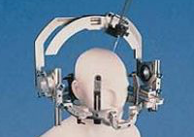Fig 1:

Head frame (figure sourced from Integra which is the company that makes the head frames.)

*Implantation* – the operation where the leads and pulse generator are inserted. This operation is performed under general anaesthesia. During the operation head x-rays (approximately 8 [4 on each side of the brain]) and some short periods of continuous x-ray screening (approximately 10 seconds total [5 seconds on each side of the brain]) will be performed to help ensure the electrodes are placed where they need to be. It is difficult to estimate an exact time for how long the surgery will take. Approximately 5 hours is average. Analgaesics (painkillers) will be available to the participant in the post-operative period to ensure they are comfortable. It is expected that they will be in hospital for 2-3 days after the surgery.

The procedure involves drilling two small holes (less than 10mm in diameter) through the skull bone and inserting two electrodes (metallic leads) into the brain until the tips reach the thalamus. These electrodes then connect to a wire that runs under the skin, down the neck and connects to a battery and generator (like a pacemaker) that is implanted into the chest, just below the collarbone.

Fig 2: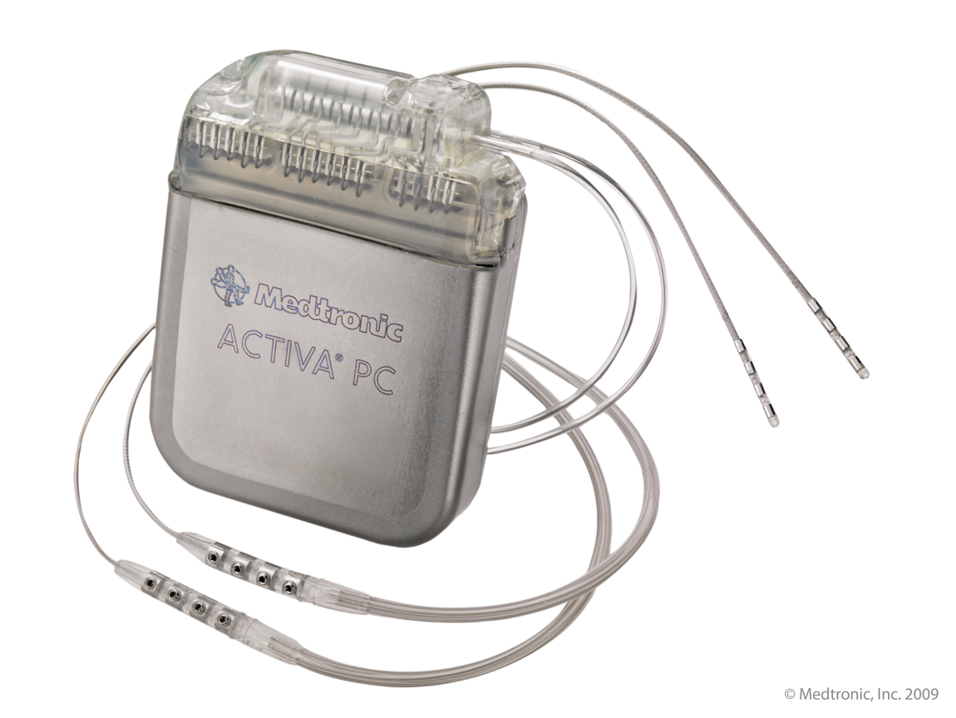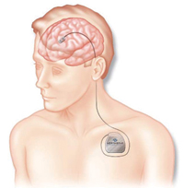

Left: diagram of electrodes and box placement

Above: the generator “pacemaker” box. Dimensions are 65x49x15 mm and it weighs 67 g.

*Post op CT* – CT scan performed the day after surgery to visualise the location of the electrodes, and to confirm that they have been placed as planned.

Not all participants who agree to take part in the study will be able to proceed to implantation. Once you have signed this consent and the person you are responsible for has had their MRI scans they will be analysed to see that it is actually possible to insert the electrodes safely (without puncturing any large veins on the way in). This analysis is referred to as “pre-planning” of the surgery. If the pre-planning all looks appropriate and safe, an appointment will be made for the participant to see the Neurosurgeon (Mr Kristian Bulluss). He and his team will go through the procedure with you and the participant and he will also discuss all of the risks in detail. You will have opportunity to ask questions directly to him and his team. If pre-planning cannot show a clear and safe route for the electrodes to pass though, you will be informed and the person you are responsible for will not be offered a deep brain stimulator and their participation in this study will cease. All neurosurgery carries risks and all effort is taken during pre-planning to minimise the chance of a problem such as bleeding occurring during the operation.

Randomisation - 20 participants will be recruited into this study. There are two groups in this study with 10 participants in each. After successful implantation, participants will be randomised to either active (stimulator on) or control (stimulator off) for 12 weeks (blinded phase). After this point the control group will also be switched on and all participants become active.

As stimulations are seldom felt by the participant neither you, nor the doctors taking care of the participant in this blinded phase will know if the stimulator is active or not. There will be separate medical staff available who will be able to break the blind should it become necessary for their safety.

There are no additional costs associated with participating in this research project, nor will you or the participant be paid. All medication, tests and medical and surgical care required as part of the research project will be provided free of charge by Austin Health. You may be reimbursed for any reasonable travel, parking, meals and other expenses associated with the research project visit. Please speak to the research team and they will assist you with arrangements.

It is desirable that the participant’s local doctor be advised of your decision for them to participate in this research project. If they have a local doctor, we strongly recommend that you inform them of their participation in this research project.

**4 Does the person I am responsible for have to take part in this research project?**

Participation in any research project is voluntary. If you do not wish for the person you are responsible for to take part, they do not have to. If you decide for them to take part and later change your mind, you are free to withdraw them from the project at any stage.

If you do decide to take part, you will be given this Person Responsible Information and Consent Form to sign and you will be given a copy to keep.

Your decision whether or not they take part, or take part and then withdraw, will not affect their routine treatment, their relationship with those treating them or their relationship with Austin Health.

**5 What are the alternatives to participation?**

The person you are responsible for does not have to take part in this research project to receive treatment at this hospital. Other options are available; these include ongoing adjustment of medical (tablet) treatment. The study doctor will discuss these options with you and the person you are responsible for before you decide whether or not they take part in this research project. You can also discuss the options with their local doctor.

**6 What are the possible benefits of taking part?**

We cannot guarantee or promise that the person you are responsible for will receive any benefits from this research; however, possible benefits may include reduction in their seizure frequency and adding to the knowledge of these treatments in conditions such as LGS.

**7 What are the possible risks and disadvantages of taking part?**

Medical treatments often cause side effects. Participants may have none, some or all of the effects listed below, and they may be mild, moderate or severe. If the participant has any of these side effects, or are worried about them, talk with the study doctor. The study doctor will also be looking out for side effects.

There may be side effects that the researchers do not expect or do not know about and that may be serious. Tell the study doctor immediately about any new or unusual symptoms that you notice or that the participant reports to you.

Many side effects go away shortly after treatment commences. However, sometimes side effects can be serious, long lasting or permanent. If a severe side effect or reaction occurs, the study doctor may need to stop the treatment. The study doctor will discuss the best way of managing any side effects with you and the participant.

**Operation related**:

Infection

With the introduction of any foreign body there is a risk of infection. Based on our experience with DBS for Parkinson’s Disease we estimate the infection risk is 5% (1 in 20). If this happens the stimulator box and or leads will probably need to be removed.

Haemorrhage

To reach the targeted structure in the brain, electrodes need to pass through the brain substance. We use pre-operative imaging to select the safest path. Nevertheless there is risk of piercing small blood vessels causing bleeding. In this type of procedure, there is a 1% (1 in 100) risk of haemorrhage. Half of these (0.5% - 1 in 200) are noticeable by the patient, for example resulting in headache, seizures, weakness or numbness of a limb, that can either resolve over days to weeks or be permanent

Death

In neurosurgical procedures of this type, there is a 0.01% (1 in 1000) risk of death.

**Anaesthesia:**

Although anaesthesia is generally very safe there are some risks. The most common problems associated with anaesthesia are feeling unwell or vomiting, bruising at the site of injections, sore throat or hoarse voice. Most patients do not have these problems. If these problems do happen, they usually get better very quickly. Damage to teeth may occur, but this is rare. The risk of brain damage or death due to anaesthesia is very rare.

The risk of problems from anaesthesia increases for patients who are having more major surgery, those with medical problems and those that require difficult anaesthetic procedures. If you have any concerns about these issues, you should discuss them with the study team.

**Brain Imaging:**

MRI

MRI stands for magnetic resonance imaging. A MRI scanner is a machine that uses electromagnetic radiation (radio waves) in a strong magnetic field to take clear pictures of the inside of the body. Electromagnetic radiation is not the same as ionising radiation used, for example, in X-rays. The pictures taken by the machine are called MRI scans. These scans are an important part of the pre-operative work-up.

We will ask the participant to lie on a table inside the MRI scanner. The scanner will record information about their brain. It is very important that they keep very still during the scanning. When they lie on the table, we will make sure they are in a comfortable position so that they can keep still. The scanner is very noisy and we will provide some earphones to reduce the noise. Some people may experience symptoms of claustrophobia from lying in a confined space. If the participant does experience discomfort at any time during the scan, they will be able to alert staff by pressing on a call button provided.

There are no proven long-term risks related to MRI scans as used in this research project. MRI is considered to be safe when performed at a centre with appropriate procedures. However, the magnetic attraction for some metal objects can pose a safety risk, so it is important that metal objects are not taken into the scanner room.

We will thoroughly examine the participant to make sure there is no reason for them not to have the scan. We must be told if they have metal implanted in their body, such as a pacemaker or metal pins.

CT-scan

‘CT’ stands for computer aided tomography. CT-scans are performed immediately prior to surgery to precisely define the location of deep brain structures relative to the skull, to allow accurate placement of stimulating electrodes. This is an x-ray based imaging technique, and hence involves exposure to ionising radiation. The level of x-ray exposure is explained in more detail below.

**Stimulation related**:

Cognition (thinking)

In LGS patients studied so far, there do not appear to be adverse cognitive effects from DBS, and indeed there are some reports of improved ‘alertness’. We are including a number of neuropsychologic tests, to document any positive or negative cognitive changes with stimulation. Stimulation can be switched off if cognitive changes are considered unacceptable.

Pain and tingling

Around 10% (1 in 10) of participants experience some pain in the area of the stimulator box in the chest wall, although none of the cases required the box to be removed. There are also isolated reports of tingling in the limbs when the stimulator was first turned on which did not persist.

**Ionising radiation:**

This research project involves exposure to a very small amount of radiation. As part of everyday living, everyone is exposed to naturally occurring background radiation and receives a dose of about 2 millisieverts (mSv) each year. The effective dose from this research project is about 1mSv. The dose from this research project is comparable to that received from many diagnostic medical x-ray and nuclear medicine procedures. At this dose level, no harmful effects of radiation have been demonstrated, as any effect is too small to measure. This risk is believed to be low.

**8 What will happen to the person I am responsible for’s test samples?**

No additional samples (blood, tissue or urine) will be taken apart from what will be required for routine clinical care. Samples will be processed as per standard Austin Health pathology procedures. Results will be stored in the participant’s medical record.

**9 What if new information arises during this research project?**

Sometimes during the course of a research project, new information becomes available about the treatment that is being studied. If this happens, the study doctor will tell you and the participant about it and discuss with you whether you want them to continue in the research project. If you decide to withdraw the participant, the study doctor will make arrangements for their regular health care to continue. If you decide for the participant to continue in the research project you will be asked to sign an updated consent form.

Also, on receiving new information, the study doctor might consider it to be in the participant’s best interests to withdraw from the research project. If this happens, he/ she will explain the reasons and arrange for regular health care to continue.

**10 Can they have other treatments during this research project?**

Whilst the person you are responsible for is participating in this research project, they may not be able to take some or all of the medications or treatments they have been taking for their condition or for other reasons. It is important to tell the study doctor and the study staff about any treatments or medications they may be taking, including over-the-counter medications, vitamins or herbal remedies, acupuncture or other alternative treatments. You should also tell the study doctor about any changes to these during their participation in the research project. The study doctor should also explain which treatments, or medications, need to be stopped for the time they are involved in the research project.

**11 What if I withdraw the person I am responsible for from this research project?**

If you decide to withdraw the participant from the project, please notify a member of the research team before you withdraw them. This notice will allow that person or the research supervisor to discuss any health risks or special requirements linked to withdrawing.

If you decide to withdraw the participant from the study after the device has been implanted, the components can be removed or left in situ, depending on preference. If requested, the stimulator box and electrodes can be left in situ but switched off. It is not necessary to remove either the stimulator box or electrodes, as these can be left in situ long-term with no known adverse effects. If removal of the stimulator box and/or electrodes is requested, this is a relatively simple procedure, which can be done as a day-only patient, but would typically require a brief general anaesthetic.

**12 Could this research project be stopped unexpectedly?**

This research project may be stopped unexpectedly for a variety of reasons. These may include reasons such as:

• Unacceptable side effects

• The device being shown not to be effective

• The device being shown to work and does not need further testing

A safety and oversight committee will be used in this study. This is a committee comprising of neurologists and neurosurgeons that will look over all the data and medical records of all participants approximately every 6 months. Their job is to ensure the study is being run according to protocols and all participants are safe and being treated appropriately. The members of this committee are separate to the investigators of this study and are external to the Austin Hospital. Their reports will form the basis of the annual reporting to the Human Research Ethics Committee who has oversight of this project.

**13 What happens when the research project ends?**

At the end of this project participants will be followed in the Neuromodulation Clinic run at Austin Health. This is a weekly clinic is being established where patients with DBS will be booked in for regular review under the supervision of a consultant neurologist. The review period will be determined by clinical need but will typically occur every 3-6 months.

Stimulator battery life is approximately 3-5 years. Around this time, the stimulator becomes no longer able to deliver the programmed voltage, and eventually ceases working. Projected life of the battery can be measured via the ‘programming wand’, which is held over the subcutaneously located stimulator box. When no longer functioning, the stimulator box and wires can be left in situ or removed. If subjects wish to have ongoing stimulation, the old box can be removed and a replacement box connected to the original stimulating electrodes. This is a minor surgical procedure, usually performed as day surgery. At this stage we are not able to offer a guarantee of replacement devices. However, if this study shows benefit, this may form the basis of an application to Medicare for public funding of DBS for LGS.

**14 What will happen to information about the person I am responsible for?**

By signing the consent form you consent to the study doctor and relevant research staff collecting and using personal information about the participant for the research project. Any information obtained in connection with this research project that can identify them will remain confidential. They will be assigned a participant number and their data will be stored under locked conditions in this coded form. Participant information will only be used for the purpose of this research project and it will only be disclosed with your permission, except as required by law.

Information about the participant may be obtained from their health records held at this and other health services for the purpose of this research. By signing the consent form you agree to the study team accessing those health records if they are relevant to participation in this research project.

Information about their participation in this research project will be recorded in their health records.

In accordance with relevant Australian and/or Victorian privacy and other relevant laws, you have the right to request access to the participant’s information collected and stored by the research team. You also have the right to request that any information with which you disagree be corrected. Please contact the study team member named at the end of this document if you would like to access this information.

Any information obtained for the purpose of this research project that can identify participants will be treated as confidential and securely stored. It will be disclosed only with your permission, or as required by law.

**15 Complaints and compensation**

If the person you are responsible for suffers any injuries or complications as a result of this research project, you should contact the study team as soon as possible and they will be assisted with arranging appropriate medical treatment. If they are eligible for Medicare, they can receive any medical treatment required to treat the injury or complication, free of charge, as a public patient in any Australian public hospital.

**16 Who has reviewed the research project?**

All research in Australia involving humans is reviewed by an independent group of people called a Human Research Ethics Committee (HREC). The ethical aspects of this research project have been approved by the HREC of Austin Health.

This project will be carried out according to the *National Statement on Ethical Conduct in Human Research (2007)*. This statement has been developed to protect the interests of people who agree to participate in human research studies.

**17 Further information and who to contact**

The person you may need to contact will depend on the nature of your query.

If you want any further information concerning this project or if the participant has any medical problems which may be related to their involvement in the project (for example, any side effects), please contact:

The principal study doctor, Dr John Archer, on

(03) 9035 7071 or (03) 9496 5529

or any of the following people:

Mr Kristian Bulluss Dr Linda Dalic

Neurosurgeon Neurologist

Via the Austin Hospital switchboard (03) 9496 5000

Annie Roten

Study Coordinator

(03) 9035 7245

After hours please call the Austin Switchboard and ask for the Epilepsy Registrar to be paged.

**For complaints**:

If you have any complaints about any aspect of the project, the way it is being conducted or any questions about being responsible for a research participant in general, then you may contact:

Name: Complaints Officer

Telephone: (03) 9496 4090 or (03) 9496 3248

Email: ethics@austin.org.au

Table 1: Schedule of visits



**Consent Form**

Full Project Title:

Deep Brain Stimulation for severe generalised epilepsy of Lennox-Gastaut Phenotype

* I have read the Person Responsible Information Sheet or someone has read it to me in a language that I understand.
* I understand the purposes, procedures and risks of the research described in the project.
* I give permission for the person I am responsible for’s doctors, other health professionals, hospitals or laboratories outside this hospital to release information to Austin Healthconcerning their disease and treatment for the purposes of this project. I understand that such information will remain confidential.
* I have had an opportunity to ask questions and I am satisfied with the answers I have received.
* I freely agree for the person I am responsible for to participate in this research project as described and understand that I am free to withdraw them at any time during the study without affecting their future health care.
* I understand that I will be given a signed copy of this document to keep.

Name of Participant (printed).………………………………………………………………………………….

Name of Person Responsible (printed).………………………………………………………………….

Relationship of Person Responsible (printed) ……………………………………………………….

Signature of Person Responsible Date

Name of witness to person responsible’s signature (printed) ………………………………

Signature Date

**Declaration by Study Doctor/Senior Researcher†**

I have given a verbal explanation of the research project, its procedures and risks and I believe that the participant has understood that explanation.

Researcher’s name (printed) ………………………………………………………………………..…………

Signature Date

† A senior member of the research team must provide the explanation of, and information concerning, the research project.

Note: All parties signing the consent section must date their own signature.