Department of Psychological Medicine
Faculty of Medical and Health Sciences
The University of Auckland
Private Bag 92019
Auckland 1142, New Zealand

STUDY PROTOCOL

Project Title: | The efficacy of a brief mindset intervention on side effect reporting and experience of the COVID-19 vaccination
Public Title: | Reducing side effect reporting and improving the experience of the COVID-19 vaccination: a mindset intervention
ANZCTR number:
Universal Trial Number:
Principal Investigators: | Professor Keith Petrie  Department of Psychological Medicine  Faculty of Medical and Health Sciences  University of Auckland  kj.petrie@auckland.ac.nz  Professor Alia Crum  Psychology Department  Stanford University  crum@stanford.edu
Student Researcher: | Zara Morrison  Masters Student in Health Psychology  Department of Psychological Medicine  Faculty of Medical and Health Sciences  University of Auckland  zmor057@aucklanduni.ac.nz
Co-Investigators: | Helen Petousis-Harris  Mark Thomas  Kari Leibowitz  Rachael Yielder

The outbreak of COVID-19 was declared a Public Health Emergency of International Concern in January 2020 by the World Health Organisation. More than a year on, highly effective vaccinations for COVID-19 are being made available in New Zealand and worldwide. However, vaccinations can cause unpleasant side effects, which can create concern and vaccine hesitancy for some, that may reduce the likelihood of getting vaccinated in the future (Smith et al., 2020). This study investigates a new method for reducing side effects by changing the meaning of side effects to signs that the medication is working.

Vaccination side effects

The vast majority of reactions after a vaccination are normal and indicate the start of the process of gaining immunity. Mild reactions show that the vaccination is working by stimulating the immune system and forming antibodies against the infection. Local reactions occur through redness, swelling or pain around the injection site, whereas systemic reactions can include fatigue, fever, headache and aching limbs.
The informed consent process requires individuals to be informed of the possible side effects when receiving a vaccination. However, research has shown that expectations of symptoms can increase the awareness and reporting of adverse side effects (Petrie & Rief, 2019). This phenomenon is called the nocebo effect. Studies investigating the nocebo effect have found that negative expectations generated by warnings of side effects, or even general awareness of adverse reactions to a treatment, can heighten the chance of them being experienced. Myers et al. (1987), for instance, found that when a consent form listed gastrointestinal disturbance as a possible side effect of a drug, patients were six times more likely to report gastrointestinal symptoms than patients whose consent form did not list it as a possible side effect.
There is evidence to suggest that the way in which medical information is framed and delivered can impact on patients’ side effect reporting. Findings from Webster, Weinman and Rubin (2018) showed that when side effect risk information being presented as “uncommon, 90% of people will not be affected”, in comparison to “common, 1 in 10 people will be affected”, the likelihood of attributing nocebo-induced side effects to the tablet was significantly reduced. Similarly, O’Connor, Pennie and Dales (1996) investigated whether positive versus negative framing of expectations and side effects would alter experiences of the influenza vaccination. In this study, patients received benefit and risk information that was positively framed - as the percentage who remain free of influenza and have no vaccine side effects, or negatively - as the percentage who acquire influenza and have vaccine side effects. In comparison to common practice of using negative frames to describe possible side effects, the positive frame group in this study had more realistic expectations of possible side effects, fewer systemic symptoms, and less work absenteeism after their vaccination.

‘Symptoms as positive signals’ intervention

A new approach that provides information on possible side effects whilst simultaneously reducing negative expectations involves framing side effects as positive signals that the vaccine is working. The process has been referred to as altering ones mindset - referring to the lens or frame of mind which orients an individual to a particular set of associations and expectations, thus guiding attentional and motivational processes (Crum, Salovey & Achor, 2013).
Evidence has suggested that framing symptoms as positive signals in the body can reduce the reporting and concern about side effects. Howe et al. (2019) demonstrated this in a study with oral immunotherapy patients. In this study, patients were either informed that their symptoms were either unfortunate side effects of the treatment or positive reactions that signal the desensitization is working. In the latter condition, patients experienced fewer symptoms as doses increased, were less likely to skip doses, felt less anxious, and were less likely to contact staff about their symptoms. There has been recent discussion about how positive expectancy can be used to impact side effects from the COVID-19 vaccination as most common side effects of the COVID-19 vaccines are signs that the vaccine is working and the body is building immunity (Barsky et al., 2021).
The current study investigates whether framing COVID-19 vaccination symptoms as positive signals to the COVID-19 vaccination can positively impact the reporting and experience of side effects and adherence to returning for the second dose of the vaccine. Participants in the study will be randomised to either symptoms as positive signals group or to a standard care control group. The positive signals group will watch a short video intervention immediately following their vaccination that explains bodily reactions to vaccinations. Common side effects (e.g., fevers, headaches, muscle soreness, and fatigue) will be framed as positive signals that the vaccination is working effectively in the body. All of the information shared in this condition will be true and accurate, and patients will still be given information on how to manage side effects (e.g., rest and drink plenty of fluids), as well as information about the rare, unlikely, and more serious side effects of the COVID-19 vaccines or when to contact a medical professional. And while the video intervention will emphasize that side effects are a sign that the vaccine is working and the body is building immunity, it will also mention that a lack of side effects does not mean that the vaccine isn’t working, so as to reassure patients who do not experience side effects.
The primary outcomes of side effects will be measured by participants prior to leaving the vaccination centre, 3 days after the vaccination, and lastly, 3 days after the second dose of the vaccination. This will include the number of symptoms attributed to the vaccination at these time points, as well as concern about side effects. Differences in attendance at the second vaccine dose will also assessed between the two groups. Secondary outcomes include differences between groups in intention to vaccinate in the future and specific mindset beliefs about the effectiveness of vaccinations. We will also assess whether the effect of the intervention is modified by vaccination sensitivities and attitudes.

Aims and Hypothesis
- To determine whether a symptoms as positive signals intervention can reduce the reporting and concern about side effects attributed to the COVID-19 vaccination immediately after the injection, 3 days post-vaccination, and again 3 days after the second vaccine dose approximately 3 weeks later.
- To determine whether a symptoms as positive signals intervention increases one’s likelihood to get the second dose of the COVID-19 vaccination and to recommend the COVID-19 vaccination to others, as well other vaccinations i.e. influenza.
- To determine whether the perceived sensitivity and attitudes of participants towards vaccinations modifies the effect of the symptoms as positive signals intervention.

We hypothesize that those who receive the symptoms as positive signals intervention will report fewer side effects to the COVID-19 vaccination at each measurement point and that the side effects they do report will be experienced as less worrying and bothersome than those who did not receive the intervention. We also predict that the symptoms as positive signals group will attend the second COVID-19 vaccination at a higher rate and report higher intention to vaccinate for COVID-19 in the future if required.

METHOD
Study design
Randomised controlled trial

Study Population
Participants

Recruitment
Individuals will be approached by a researcher in one of the Auckland vaccination pop-up centres during the 30-minute wait period after receiving their first dose of the COVID-19 vaccination. Potential participants will be asked if they would like to take part in a study looking at evaluating the effect of receiving different types of information about the COVID-19 vaccination.

Inclusion criteria
To participate, individuals must:
- Have a current and active email address
- Have just received the COVID-19 vaccination
- Be English speaking
- Be over the age of 18

Randomisation
Eligible participants will be randomised into a symptoms as positive signals intervention group or a control group. This will be done automatically through Qualtrics on the tablet used to conduct the study.

Sample size calculation
The sample size for this study was determined using the software program G*Power3. Based on Howe et al. (2019) we expect a small effect size (d = 0.25). With 80% power and 0.05 alpha level, a total of 506 will be required. In order to allow for participant drop-out at follow-up, the aim is to recruit a total of 660 participants for this study - of which 330 will be randomly allocated to each condition.

Procedure

Individuals will be recruited during the 30-minute wait time post-vaccination in vaccination pop-up clinics in Auckland. Participants will be provided with the Participant information sheet and asked to sign the consent form if they are willing to participate.

Participants will then be given an electronic tablet and asked to complete a short questionnaire about their attitudes towards vaccinations and demographic details before being randomised to either the symptoms as positive signals or control group. Following the questionnaire the symptom as positive signals group will be shown a short (5 minute) interventional video that explains how the body responds to vaccinations and how these side effects are often signs that the vaccination is working The control group (“treatment as usual”) will just complete demographic and the attitudes questionnaire. Both groups will complete the first side effects questionnaire prior to leaving the centre and evaluation of the information they received about the vaccination.

Two days after the vaccination all participants will receive a reminder that the study questionnaire evaluating any side effects will be sent the next day. The intervention group will also receive a link to the research video should they wish to watch it again. Three days after the vaccination both groups will be emailed a link to fill out a follow-up vaccination side effects questionnaire. To maximise response rate participants all questionnaires returned will be entered into a draw to win a $500 shopping voucher prize.

After receiving the second dose of the COVID-19 vaccination, a second follow-up email will be sent including a link to fill out a post-vaccination side effects questionnaire and questions assessing intent to vaccinate in future. To maximise response rate participants all questionnaires returned will again be entered into a draw to win a $500 shopping voucher prize.

Figure 1. study flow diagram

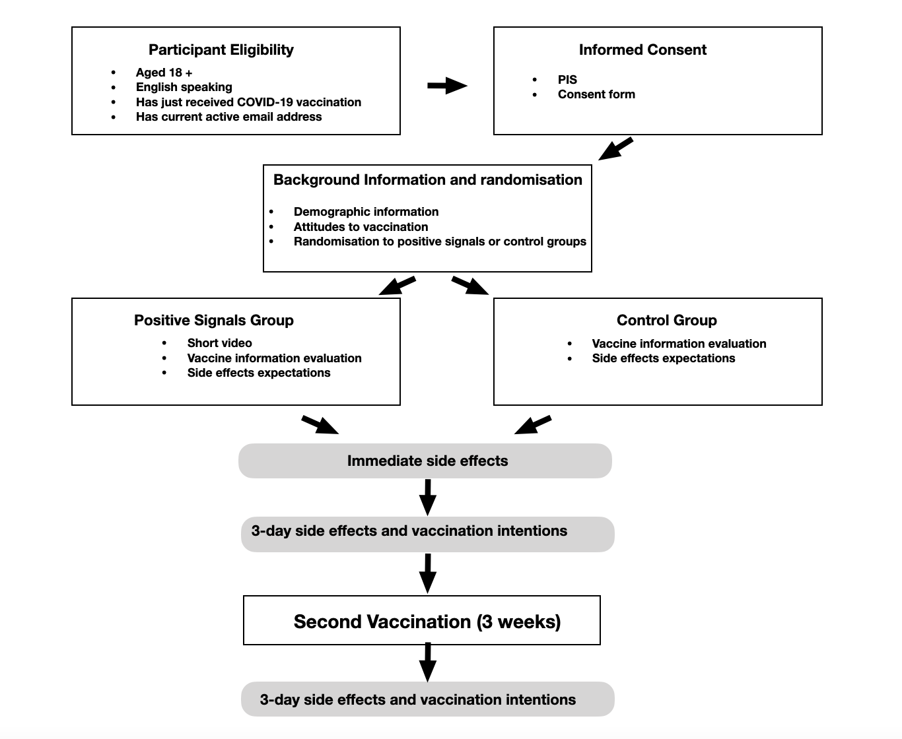

MEASURES
Post-vaccination

Demographic information
Standard information regarding gender, age, ethnicity will be collected.

Perceived sensitivity and attitudes to vaccinations.
The brief 4-item Perceived Sensitivity to Vaccination Scale (Horne et al., 2013) and brief Vaccination Attitudes Examination Scale (VAX) (Martin & Petrie, 2017) will be presented in order to assess participant’s perceived sensitivity to and attitudes towards vaccinations.

Past vaccination behaviour.
Participants will be asked how many flu (influenza) vaccinations they have received over the past five years.

COVID-19 mindset evaluation.
Five questions assessing the individuals’ mindset, beliefs, and feelings surrounding the COVID-19 vaccination will be asked.

Side effect reporting.
A list of 15 side effects taken from the Side Effect Attribution Scale (Mackrill et al., 2020) will be presented to participants at the end of the wait period following their first vaccination. These (mostly local) side effects are based on CDC data as those most frequently reported immediately following the vaccination (Gee et al., 2021). Participants will be asked if they have experienced the symptom and whether or not they think the symptom is a side effect of the vaccination. Two additional questions assessing how ‘bothersome’ and ‘worrying’ the experience of their side effects have been will also be asked.

Information evaluation.
Both groups will be asked to rate the information received about the vaccine and side effects in terms of how easy it was to understand, how informative, whether it was enough information and how reassuring the information was (Crichton & Petrie, 2015).

Three day follow-up after first and second vaccination dose

Side effect reporting and experience.
The 3-day follow-up side effects questionnaire will list 27 symptoms (the 14 symptoms as asked in the first questionnaire along with an additional 13 systemic symptoms). The 2 additional questions assessing how ‘bothersome’ and ‘worrying’ the experience of their side effects have been will be asked again. The same response formats will be used.
Participants will also if they have sought out additional information about side effects.

COVID-19 mindset evaluation.
The same five questions assessing the individuals’ mindset, beliefs, and feelings surrounding the COVID-19 vaccination will be asked again.

Intention to vaccinate in the future.
Participants will be asked about their intention to recommend the vaccine to family and friends, their intentions to be vaccinated against COVID-19 and other illnesses in the future.

Data Analysis and Statistical Considerations

Statistical analysis will be carried out using the Statistical Package for Social Sciences (SPSS) Version 27. Initially, data will be screened for errors, outliers, skewness, and normality where required. In the case of non-normative distribution of variables, non-parametric testing will be used. An alpha level of .05 will be used across all analyses. Repeated-measures between-within Analysis of Variance (ANOVA) will be conducted when assessing differences between study groups primary outcomes - from post-vaccine to 3-day follow up to second dose follow-up in side effect reporting and attribution to vaccination.

Ethical considerations

Ethical approval will be obtained from the Health and Disability Ethics committee prior to study commencement. Written informed consent will be collected from participants prior to participating in the study. We consider that the study poses no ethical risk to participants. The intervention is information based only. Participants will be able to withdrawal from the study at any time.

Budget

The costs of this study in terms of video creation, research assistants, and data gathering devices will be covered by the postgraduate fund, University of Auckland and Stanford University.

Timeline

May 2021 - Apply for ethical approval
June 2021 – Assemble study materials and personnel
July-August 2021 - Recruitment process
September 2021 – Data Analysis
October - December 2021 - Write-up for publication

References

Barsky, A., Bingel, U., Colloca, L., Petrie, K J., Rief, W., Schedlowski, M., Wiech, K., & (2021). Fear of side effects and COVID vaccine hesitancy. JAMA Health Forum. Published online April 16, 2021. doi: 10.1001/jamahealthforum.2021.0804
Crichton, F., & Petrie, K. J. (2015). Health complaints and wind turbines: The efficacy of explaining the nocebo response to reduce symptom reporting. Environmental Research, 140, 449-455.
Crum, A. J., & Langer, E. J. (2007). Mind-set matters: Exercise and the placebo effect. Psychological Science, 18(2), 165-171.
Crum, A. J., Salovey, P., & Achor, S. (2013). Rethinking stress: The role of mindsets in determining the stress response. Journal of Personality and Social Psychology, 104(4), 716.
Gee, J., Marquez, P., Su, J., et al. (2021). First Month of COVID-19 Vaccine Safety Monitoring — United States, December 14, 2020–January 13, 2021. MMWR Morb Mortal Wkly Rep 2021;70:283–288. DOI: http://dx.doi.org/10.15585/mmwr.mm7008e3external icon.
Horne, R., Faasse, K., Cooper, V., Diefenbach, M. A., Leventhal, H., Leventhal, E., & Petrie, K. J. (2013). The perceived sensitivity to medicines (PSM) scale: an evaluation of validity and reliability. British Journal of Health Psychology, 18, 18-30. doi: 10.1111/j.2044-8287.2012.02071.x
Howe, L. C., Leibowitz, K. A., Perry, M. A., Bitler, J. M., Block, W., Kaptchuk, T. J., ... & Crum, A. J. (2019). Changing patient mindsets about non–life-threatening symptoms during oral immunotherapy: a randomized clinical trial. The Journal of Allergy and Clinical Immunology: In Practice, 7(5), 1550-1559.
Kumar, R., & Burns, E. A. (2008). Age-related decline in immunity: implications for vaccine responsiveness. Expert Review of Vaccines, 7(4), 467-479.
Lord, J. M. (2013). The effect of aging of the immune system on vaccination responses. Human Vaccines & Immunotherapeutics, 9(6), 1364-1367.
MacKrill, K., Webster, R., Rubin, G. J., Witthöft, M., Silvester, C., Emad, Y., & Petrie, K. J. (2021). When symptoms become side effects: Development of the side effect attribution scale (SEAS). Journal of Psychosomatic Research, 141, 110340.
Martin, L. R., & Petrie, K. J. (2017). Understanding the dimensions of anti-vaccination attitudes: The vaccination attitudes examination (VAX) scale. Annals of Behavioral Medicine, 51(5), 652-660.
Myers, M. G., Cairns, J. A., & Singer, J. (1987). The consent form as a possible cause of side effects. Clinical Pharmacology & Therapeutics, 42(3), 250-253.
O'Connor, A. M., Pennie, R. A., & Dales, R. E. (1996). Framing effects on expectations, decisions, and side effects experienced: the case of influenza immunization. Journal of clinical epidemiology, 49(11)
Petrie, K. J., Moss‐Morris, R., Grey, C., & Shaw, M. (2004). The relationship of negative affect and perceived sensitivity to symptom reporting following vaccination. British journal of health psychology, 9(1), 101-111.
Smith, L. E., Amlôt, R., Weinman, J., Yiend, J., & Rubin, G. J. (2020). Why do parents not re-vaccinate their child for influenza? A prospective cohort study. Vaccine, 38(27), 4230-4235.
Webster, R. K., Weinman, J., & Rubin, G. J. (2018). Positively framed risk information in patient information leaflets reduces side effect reporting: a double-blind randomized controlled trial. Annals of Behavioral Medicine, 52(11), 920-929.

