Appendix I: RCH ONLINE Participant Information AND CONSENT FORM

Quality of Kids’ Lives Study – Finding the best way to measure kids’ health

Thank you for taking an interest in the Quality of Kids’ Lives Study.

This project aims to find out the best way to measure the health of children. The results of this work may help us to better measure wellbeing in children in order to give better tests, treatments and services to children in future.

Taking part in this research will involve completing two surveys. A 15-30 minute online survey now and a 5 minute survey in 2-8 weeks.

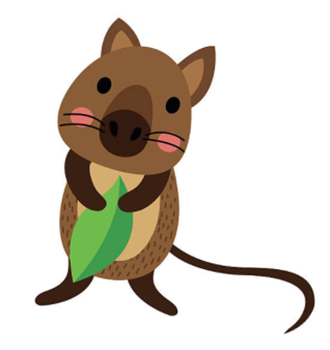

Screening Questions
Before you get started, we have a few questions to check if you can take part.

- Are you the parent or carer of a child who is currently aged between 2 and 18 years old?

If no to 1, then to Exclusion.
If yes to 1, then to PICF.

Exclusion:
Thank you for your time and willingness to participate in this research. Based on your responses to the previous questions, your response to the survey is not required.

PICF:
Thank you. You are able to take part in the survey. Please read the information about the study below. This will help you decide if you would like to take part.
- What is the research project about?
The purpose of this research is to help understand the health of children. This project will compare measures of health currently used in children. If you have a child aged 2-4 years, this project will also involve testing a new measure of health for children of this age group.

- Who is running the research project?
The project is being led by a team of researchers based in the University of Melbourne and Murdoch Children’s Research Institute (MCRI), in collaboration with doctors at The Royal Children’s Hospital (RCH).

- Why am I being asked to take part?
We are asking you to take part in the project because you are the caregiver of a child aged 2 to 18 years.

- What do I need to do in this project?
We are inviting you to complete a 15-30 minute online survey during which you will be asked to answer questions about your child’s health as well as a few short questions about you and your family. We will also ask your child (if aged 7 years or older) to answer some questions about their health during the online survey. You can decide if your child is able to complete these questions.

In addition to the above, we will also ask you (and your child if aged 7 years or older) to complete a short 5 minute survey again two to eight weeks’ after you complete the first survey. This second survey a shorter part of the original questions.
Once you have completed the second online survey, there will be no other involvement in the project. We will not be able to change your responses once you have completed the survey.

- Do I have to take part?
It is up to you to decide whether or not to take part. If you do not want to take part it will not affect you in any way, and you do not have to give a reason. If you agree to take part but then decide that you do not want to finish the survey you are free to withdraw at any time. You should be aware that data collected up to the time you withdraw will form part of the research project results. If you do not want your data to be included, you must tell the researchers when you withdraw from the research project.

- What are the possible risks, discomforts and/or inconveniences?
The time taken to complete both surveys may inconvenience you and your family. As a token of our appreciation for your time, you will receive an online $15 gift pay gift voucher after completing the second follow-up survey.
- What will be done to make sure my information is confidential?
Any information collected in the study will be treated as confidential, stored securely and can only be accessed by the research team and The Royal Children’s Hospital Human Research Ethics Committee. All information collected will be entered electronically and stored securely on the MCRI hosted REDCap database. All information will be stored securely in the MCRI and kept for at least 5 years. Publications and reports resulting from this study will be presented so that you and your child cannot be identified. The RCH, MCRI and University of Melbourne are research partners. This means that these organisations will always share research information with each other.

- Who is funding the project?
Part of this project is funded by the Australian Medical Research Future Fund (MRFF) and part is funded by the EuroQol Research Foundation.

- Will we be informed of the results when the research project is finished?
At the end of the project we will provide a summary of the project results on our study website: <insert link to website>.

- How do I take part in the survey?
Do you agree to participate in this research? Clicking Yes will take you to the survey.

Yes No
If you would like more information about the project, please contact:
Name: Renee Jones, Research Assistant, Murdoch Children’s Research Institute
Email: <insert study email>
You can contact the Director of Research Ethics & Governance at The Royal Children’s Hospital Melbourne if you:
- have any concerns or complaints about the project
- are worried about your rights as a research participant
- would like to speak to someone independent of the project.
The Director can be contacted by telephone on (03) 9345 5044. The reference numbers for this project are 71963 and 71872.

Getting help if you are concerned about your child’s health:
If you are concerned about your child’s health, please seek help. Your child’s GP (or any GP) is often a good place to start. You may also wish to discuss these concerns with your child’s paediatrician or other health professionals who look after your child. In a crisis, please contact Emergency services on 000.

If click Yes: link to the survey introduction and questions.
If click No: You have indicated that you would not like to participate in the survey. Thank you for your time.

