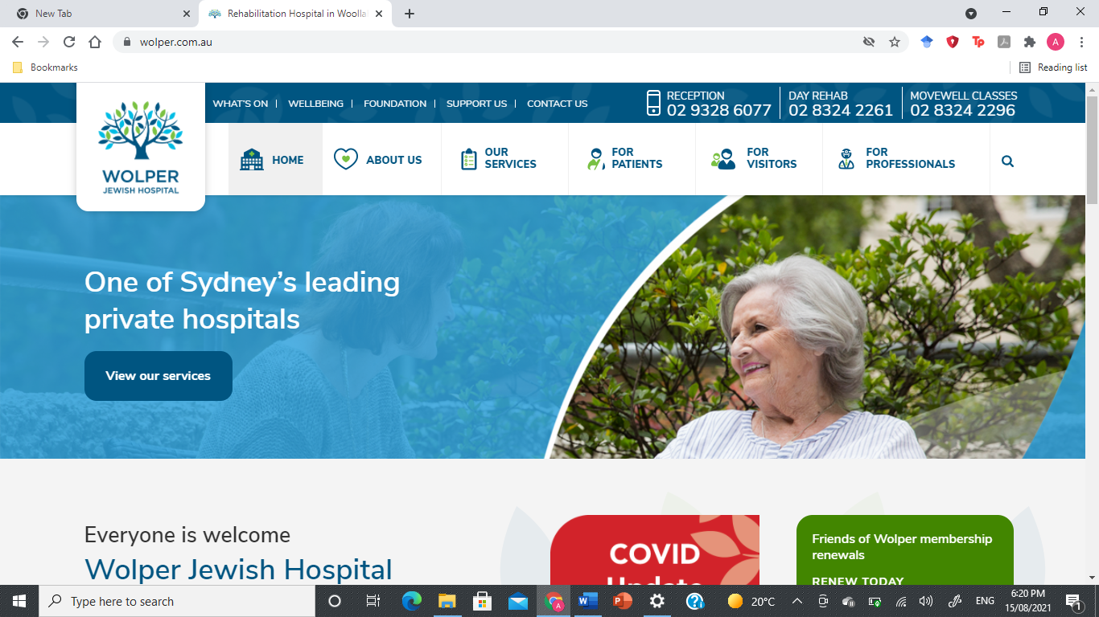Follow-up Research Questionnaire

Instructions:

* Fill in your name, date of birth and current date above
* Circle the answer that best represents your personal experience during your in hospital stay

1. Did you find your walking aid easy to access?

(a) Always

(b) Most of the time

(c) Sometimes

(d) Rarely

(e) Never

2. Approximately how often did you call a member of staff to pick up your

walking aid or retrieve it?

(a) More than 5 times per day

(b) 3-4 times per day

(c) Twice a day

(d) Once a day

(e) Less than once a day

3. Approximately how often did you retrieve your walking aid from the

ground?

(a) More than 5 times per day

(b) 3-4 times per day

(c) Twice a day

(d) Once a day

(e) Less than once a day

4. How often did you use your walking aid in your room?

(a) Always

(b) Most of the time

(c) Sometimes

(d) Rarely

(e) Never

5. Overall, how accessible was your walking aid during your inpatient stay?

(a) It was never accessible when I needed it.

(b) I usually had to take several steps to get to it and that made me

nervous/anxious

(c) I usually had to take several steps to get to it but that was not a problem

for me

(d) I could usually retrieve it with one or two steps

(e) It was always within easy reach.

6. Overall, how accessible was your walking aid at night or in the dark?

(a) Easy – it was usually by my side and I didn’t need room lights to find it

(b) It was usually within a few steps and I could access it without needing

the room lights

(c) It was usually within a few steps and I could access it but felt more

comfortable with the room lights

(d) It was usually several steps away such that I needed the room lights to

access it

(e) I never used it at night or in the dark.



7. How important is it to you that your walking aid is secure and accessible

during your hospital admission?

(a) Extremely important

(b) Quite important

(c) Important

(d) Somewhat unimportant

(e) Completely unimportant

8. Did you sustain any injuries whilst using this walking aid?

(a) Yes

(b) No

If Yes, please briefly describe: __________________________________________

___________________________________________________________________

9. When the walking aids were magnetically attached to mount, how did

you feel about them?

(a) I completely disliked them and did not want to use them at all.

(b) Annoying and I wanted to place them like I would place a normal walking

aid

(c) Slightly cumbersome, but I tolerated it

(d) I liked that they were always there when I needed them

(e) I would not use anything else. I wish I had a magnetic walking aid a long

time ago.

(f) Other – please describe: ________________________________________

________________________________________________________________

10. Given the option, would you choose to use a magnetic walking aid rather

than a standard walking aid at home?

(a) Yes

(b) No

Please explain your answer: ___________________________________________

___________________________________________________________________

11. Did you find the magnetic walking aids secure when attached to

magnetic surface?

(a) Yes

(b) No

12. Once at home, would you feel more comfortable leaving your house to go for a walk or to go shopping, either by yourself or with family/friends if you had a magnetic walking aid?

(a) Yes

(b) No

13. How likely are you to recommend this product to a friend?

(a) Very likely

(b) Somewhat likely

(c) Neither likely or unlikely

(d) Somewhat unlikely

(e) Very unlikely

Non research questions:

14. Please describe any improvements you feel could be made to the

magnetic walking aid system: _____________________________________________

_____________________________________________________________________

_____________________________________________________________________