Title
The role of middle meningeal artery (MMA) embolisation as primary and adjunct treatment for chronic subdural haematoma (cSDH)
Project Team Roles and Responsibilities
- Dr Alexander Lam –Co-investigator
  - Position: Neurosurgery Registrar SET 2
  - Responsibilities: ethics application, project design, recruitment, performing surgical procedures, data analysis, publication
- Dr Peter Mews – Principal investigator
  - Position: Neurosurgeon
  - Responsibilities: project design, performing and supervising surgical procedures, performing MMA embolisation, publication
- Dr Shivendra Lalloo – Co-investigator
  - Position: Interventional neuroradiologist
  - Responsibilities: performing MMA embolisation, project design, publication
Resources
- Medtronic (to be confirmed): providing Onyx liquid embolic agents required for MMA embolisation
- ACT health (to be confirmed): Angio suite and theatre staff
Background
Literature review
Chronic subdural haematoma (cSDH) is one of the most common neurosurgical conditions and its frequency continues to rise as a result of the aging population and the increasing use of anticoagulation and antiplatelet medications. While there are no established guidelines for its management, symptomatic cSDHs are usually treated with surgical evacuation including twist drill craniostomy, burr hole craniostomy and mini-craniotomy. The reported recurrence rates following surgical evacuation in the literature vary widely from 2% to 37%, with most estimates ranging between 20% and 30%[1, 2].
Recent studies have suggested middle meningeal artery (MMA) embolisation to be a potential alternative treatment for cSDH. Numerous case reports and series have demonstrated MMA embolisation as a safe treatment for primary cSDHs or as an adjunct treatment to surgery for recurrent cSDHs[3-12]. Ban et al. 2018 reported the largest prospective study to date consisting of 72 consecutive patients with cSDH, with 27 patients underwent MMA embolisation as primary treatment and the other 45 patients underwent MMA embolisation as an adjunct treatment prior to surgical evacuation. No recurrence was observed amongst the 27 patients who underwent MMA embolisation as sole therapy, while one (2.2%) of the 45 patients in the MMA embolisation and surgery group developed recurrence at 4 months and required redo surgical evacuation. The recurrence rates were significantly lower than the 27.5% observed in the historic control group of 469 patients. Furthermore, Kim et al. 2017 conducted a retrospective study comparing MMA embolisation with redo burr hole evacuation, in 43 patients with recurrent cSDH following an initial burr hole drainage[13]. The recurrence rate in the 20 patients who underwent MMA embolisation was 3.8%, significantly lower than the 33.3% observed in the 23 patients who underwent redo burr hole drainage.
To the best of our knowledge, there are no randomised controlled trials in the literature to compare surgical evacuation of cSDH with MMA embolisation, both as primary treatment and adjunct treatment to surgical evacuation.
We aim to conduct the first RCT evaluating the efficacy of MMA embolisation as primary treatment with expectant treatment in stable cSDH patients who do not require urgent surgical evacuation on admission. In unstable patients who require urgent surgical evacuation on admission, we aim to evaluate the efficacy of post-operative MMA embolisation when compared to surgical evacuation alone. The primary outcome will be recurrent or residual cSDHs that require surgical evacuation. Secondary outcomes will include procedure-related complications, radiological resolution of cSDH, modified Rankin Scale and hospital length of stay. Patients will be followed up at 6 weeks, 3 months and 6 months with a repeat CT scan.
Relevant references

1. Weigel, R., P. Schmiedek, and J.K. Krauss, Outcome of contemporary surgery for chronic subdural haematoma: evidence based review. J Neurol Neurosurg Psychiatry, 2003. 74(7): p. 937-43.

2. Almenawer, S.A., et al., Chronic subdural hematoma management: a systematic review and meta-analysis of 34,829 patients. Ann Surg, 2014. 259(3): p. 449-57.

3. Chihara, H., et al., Recurrence of a Refractory Chronic Subdural Hematoma after Middle Meningeal Artery Embolization That Required Craniotomy. NMC Case Rep J, 2014. 1(1): p. 1-5.

4. Hashimoto, T., et al., Usefulness of embolization of the middle meningeal artery for refractory chronic subdural hematomas. Surg Neurol Int, 2013. 4: p. 104.

5. Hirai, S., et al., Embolization of the Middle Meningeal Artery for Refractory Chronic Subdural Haematoma. Usefulness for Patients under Anticoagulant Therapy. Interv Neuroradiol, 2004. 10 Suppl 2: p. 101-4.

6. Ishihara, H., et al., Experience in endovascular treatment of recurrent chronic subdural hematoma. Interv Neuroradiol, 2007. 13 Suppl 1: p. 141-4.

7. Link, T.W., et al., Middle Meningeal Artery Embolization for Chronic Subdural Hematoma: A Series of 60 Cases. Neurosurgery, 2019. 85(6): p. 801-807.

8. Mandai, S., M. Sakurai, and Y. Matsumoto, Middle meningeal artery embolization for refractory chronic subdural hematoma. Case report. J Neurosurg, 2000. 93(4): p. 686-8.

9. Matsumoto, H., et al., Which surgical procedure is effective for refractory chronic subdural hematoma? Analysis of our surgical procedures and literature review. J Clin Neurosci, 2018. 49: p. 40-47.

10. Mino, M., et al., Efficacy of middle meningeal artery embolization in the treatment of refractory chronic subdural hematoma. Surg Neurol Int, 2010. 1: p. 78.

11. Takahashi, K., et al., [Middle meningeal artery embolization for refractory chronic subdural hematoma: 3 case reports]. No Shinkei Geka, 2002. 30(5): p. 535-9.

12. Tempaku, A., et al., Usefulness of interventional embolization of the middle meningeal artery for recurrent chronic subdural hematoma: Five cases and a review of the literature. Interv Neuroradiol, 2015. 21(3): p. 366-71.
13. Kim, E., Embolization Therapy for Refractory Hemorrhage in Patients with Chronic Subdural Hematomas. World Neurosurg, 2017. 101: p. 520-527.

Hypotheses
- H₀: MMA embolisation does not reduce the rate of surgical evacuation in chronic subdural haematoma patients who do not require urgent surgical evacuation on admission

- H₀: In comparison to surgical evacuation alone, the recurrence rate of cSDH remains unchanged following post-operative MMA embolisation in unstable patients who require urgent surgical evacuation on admission

- H₁: MMA embolisation decreases the rate of surgical evacuation in chronic subdural haematoma patients who do not require urgent surgical evacuation on admission

- H₁: In comparison to surgical evacuation alone, the recurrence rate of cSDH is decreased following post-operative MMA embolisation in unstable patients who require urgent surgical evacuation on admission

Aims
- To determine whether MMA embolisation in stable cSDH patients is associated with a lower rate of surgical evacuation when compared to expectant treatment

- To determine whether MMA embolisation following surgical evacuation is associated with a lower recurrence rate in unstable cSDH patients when compared to surgical evacuation alone

Project Design
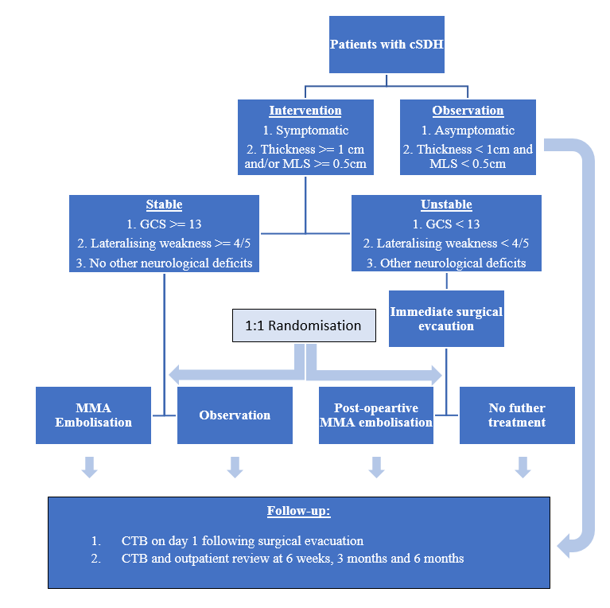
- Randomised controlled trial
  - Stable patients will be randomly allocated to MMA embolisation or observation
  - Unstable patients will receive emergency surgical evacuation and subsequently randomised to receive post-opeartive MMA embolisation or no further treatment
- Randomisation method
  - 150 envelopes with 75 containing an embolisation label and the other 75 containing a non-embolisation label will be randomly shuffled and subsequently assigned a number from 1 to 150.
  - The envelopes will then be allocated to participants in numerical order, thereby envelope 1 will be assigned to the first participant and so on.
Location
- The Canberra Hospital
Participants
- All patients with symptomatic chronic subdural haematoma
- Inclusion criteria
  - Aged 18 years or above
Primary outcome
- Symptomatic recurrent/residual subdural haematoma that requires surgical evacuation
Secondary outcomes
- Radiological resolution of cSDH
  - At 6 weeks, 3 months and 6 months
- Modified Rankin Scale
  - On admission, on discharge, at 6 weeks, 3months and 6 months
- Hospital length of stay
- Procedure-related complications
  - For surgery: infection, wound dehiscence, neurological deficits, seizures DVT/PE, MI and death
  - For embolisation: infection, pseudoaneurysm, retroperitoneal haematoma, allergic reaction to contrast, DVT/PE, MI, death, stroke, intracerebral haemorrhage
Duration
- Data collection: 18 months (June 2020 – Dec 2021)

Statistical analysis
- Stable patients: the anticipated recurrence rate will be 3% in the MMA embolisation group and the anticipated rate of failed conservative management will be 30% in the observation group. The required sample size in each group is estimated to be 36 patients for alpha = 0.05 and power = 90%.
- Unstable patients: the anticipated recurrence rate will be 3% in the surgery with post-operative MMA embolisation group and 30% in the control group with surgical evacuation alone. The required sample size in each group is estimated to be 36 patients for alpha = 0.05 and power = 90%.
- Independent T-test will be used to compare the means between different groups.

