**FEASIBILITY OF INSTITUTING GRADUATED HIGH INTENSITY TRAINING FOR PARKINSON DISEASE- FIGHT PD**

**Study one; feasibility, tolerability and safety of non-contact boxing exercise as an intervention for Parkinson disease.**

**The first in a series of studies.**

**Study protocol**

Version 1.

October 2020.

**Principle investigators:**

**David Blacker, MB BS, FRACP**

Neurologist and stroke physician, Sir Charles Gairdner Hospital, Nedlands WA

Clinical Professor of Neurology, University of Western Australia

Medical Director, Perron Institute for neurological and translational science

**Jesse Dixon, BSc**

Senior research physiotherapist, Perron Institute

**Travis Cruickshank, BSc, Phd and Mitchell Turner, MSc**

Exercise physiologist, Edith Cowan University

**In collaboration with;**

**Rai Fazio**

Boxing and fitness instructor

**Supported by;**

The Perron Institute for neurological and translational science

8 Verdun St, Nedlands WA 6009

**TABLE of CONTENTS**

1. **Synopsis 3**
2. **Study objectives 4**
3. **Background 5**
4. **Study design 11**
5. **Selection of subjects 11**
6. **Study intervention 12**
7. **Study schedule 13**
8. **Participant questionnaire and scales**
9. **Outcome measures 14**
10. **Management of adverse experiences 15**
11. **Statistical considerations 16**
12. **Data collection 17**
13. **Trial registration. 17**
14. **References. 18**

**1. SYNOPSIS**

*Title:* **Feasibility of Instituting Graduated High intensity Training for Parkinson Disease (FIGHT-PD).**

Study one; feasibility, tolerability and safety of non-contact boxing exercise as an intervention for Parkinson Disease.

*Study objectives:*

The primary objectives are to;

1. To determine the feasibility and logistics of conducting a non-contact boxing exercise program for PD patients.
2. To determine the tolerability of the program.
3. To determine the safety of the program.

The secondary objective is to study the details of heart continual heart rate response during the workouts.

*Design setting and outcomes;* Phase 1 study, analogous to a pharmaceutical “dose escalation“ and safety study, incorporating measures of logistical feasibility. To be co-ordinated from the Perron Institute and conducted there and at The Exercise Research Institute, Edith Cowan University (Joondalup Campus).

The primary outcomes for each objective are;

1. To measure the recruitment and retention of subjects, and describe the logistical issues and details of the program.
2. To measure the rate of perceived exertion (RPE) using the Borg scale (6-20) and rate of perceived mental exertion (RPME), of a series of non-contact boxing workouts. Each workout includes a warm up regimen and boxing rounds of different intensity, duration and complexity; the components of the workouts will be analysed. Standardised scales measuring fatigue and sleep and a questionnaire to measure tolerability will be used to evaluate each workout.
3. Safety will be measured by subjects completing a body chart discomfort scale after each workout, and by completing scales of fatigue and well being. Adverse events will be monitored and recorded.

The secondary outcomes include;

1. Quantification of heart rate response during each workout, expressed as total time, and time as a percentage component of the total workout, spent at each centile of predicted maximum heart rate, 50-100%.
2. Patterns of heart rate change, including recovery, and tasks required to produce high intensity exercise (define as > 80% maximum heart rate) will be analysed.

*Intervention and duration:* A supervised exercise program of non-contact boxing utilizing a boxing machine, with instruction by a professional boxing coach and neurological physiotherapist, and oversight by exercise physiologists and a neurologist.

The program includes a detailed warm up to sequentially prepare the upper body, trunk, then legs with movements, stretching and balance exercises, and then a series of aerobic exercises. This is followed by rounds of boxing using standardised sequences of punches and body movements utilising the machine.

The 15 week program will include three, five weeks blocks. The first block will focus on development of boxing technique, the second on escalating workouts of increasing intensity, and the third will add additional cognitive challenges to the physical workout. Three workouts per week will be performed, ranging from 45-60 minutes duration. Each five week block will include a week with non-workout sessions allocated for assessments and review. Subjects will wear portable heart rate (Polar) monitors that will quantify heart rate during each workout. Subjects will rate their perceived level of physical and mental exertion using the Borg scale at multiple points during the workout. Subjects will complete a questionnaire in a logbook at the end of each workout, assessing the tolerability of each workout and documenting the development of any musculoskeletal pain or change in PD symptoms.

*Sample size and population:* Twenty subjects with early stage Parkinson’s disease, defined by Hoehn and Yahr scale 1 and 2. Subjects to be recruited from the Perron Institute movement disorders clinic, private neurology practices and Parkinson’s support groups and a data base of subjects who expressed interest in the program after media publicity.

**2. STUDY OBJECTIVES:**

The aim of the study is to determine the feasibility, tolerability and safety of a non-contact boxing exercise program for PD patients. This will assist with the logistics of planning future studies and determine an optimum level of training, balancing cardiovascular load measured by heart rate, and tolerability, measured by perceived level of exertion, along with close observation for the development of musculoskeletal side effects. The primary objectives are;

1. To determine the feasibility and logistics of conducting a non-contact boxing exercise program for PD patients.
2. To determine the tolerability of the program.
3. To determine the safety of the program.

The secondary objective is to study the details of heart rate response during the workouts.

Feedback from subjects will be used to further refine the program for future studies.

**3. BACKGROUND:**

There is growing evidence that exercise and physical activity are important components of any treatment program for Parkinson’s disease1.  There is great interest that exercise programs may potentially be a disease modifier for PD.  A variety of exercise based programs seem promising including aerobic treadmill training, walking, aquatherapy, Tai chi, yoga and resistance strength training2. A phase two study3 of treadmill based exercise in early stage PD patients not on medications made some important findings. It showed that high intensity treadmill exercise defined by a target heart rate 80-85% of maximum, for 30 minutes, three times per week was feasible. Compared with moderate intensity (60-65% maximum heart rate) and a control group, the subjects undertaking high intensity exercise did not show progression measured by the Unified Parkinson’s disease rating scale, suggesting that this level of exercise could modify progression of the disease. Another study4 utilizing stationary bicycling , examined the effect levels of exercise above a comfortable, voluntary level, known as forced exercise, also demonstrated benefit. The same authors have explored this concept in several small studies, including an fMRI study5 which showed that forced exercise could produce similar effects on cortical and subcortical motor areas activation as L-dopa medication. These data suggest that the “dose “ of exercise is important, and heart rate monitoring and intensity are important factors.

There has been great interest in non-contact boxing training for PD, which has seen a substantial uptake by several thousands of Parkinson’s patients across the globe.  A recent review2 of the evidence for boxing as a therapy for PD could however only identify two quality studies with 37 participants.  This review concluded that there was limited evidence for the efficacy of boxing for PD and that there were many deficiencies in the available data.  Our team at the Perron Institute has undertaken to develop a program of scientific studies to examine the safety, tolerability, and efficacy of boxing for PD.

This has arisen because of a unique collaboration between a previous national boxing champion who has more than 30 years of boxing and exercise coaching experience, with a Neurologist who has Parkinson’s disease himself6. A specialist neuro physiotherapist and exercise physiologist with experience in trials of exercise for neurological conditions have assisted with the design of the study. A training program developed by the boxer for general fitness has been adapted for Parkinson’s disease patients after the Neurologist and neuro physiotherapist undertook the training themselves, concentrating on the components that were likely to be particularly beneficial.

Particular focus on balance and improvement of arm swing have been noted, and components that could put PD patients at risk, such as maneuvers that may cause symptoms of postural hypotension that could lead to falls, were modified.  The overall duration and intensity of the program was modified to match the predicted capacity of a PD population.  A key component of the program is a commercial training device, the FightMaster (see figure one) which comprises of eleven padded punching targets on a resistant stand.  The targets are fully adjustable and numbered.  The participant trains by performing a sequence of punches including jabs, hooks and upper cuts directed at the numbered pads.  Interposed with the punching are stretching, squatting and weaving maneuvers which are incorporated into a number of different sequences.  Each sequence takes approximately 60-90 seconds. The aerobic and cardiovascular load depends on the intensity of effort.

Typically a sequence involves a sequence of different jabs, hooks and upper cuts from each hand mixed with other movements. Varying the sequences and having the participant call out the numbers as they are being punched requires a degree of mental focus and concentration that can add a layer of cognitive demand, providing a component of dual tasking. Additionally, the ability to speak during exercise or not, is a measurable point on the Borg scale of rate of perceived exertion . A full session includes one on one sparring at the end with the coach, but this can be skipped if there is excess fatigue, and is logistically difficult to include in a group setting.

The boxing session on the machine is preceded by a warm-up phase with a series of upper and limbs rotational exercises to loosen joints and muscles from head to toe and provide some general aerobic warm-up.  Many of these exercise are quite similar to those used in other PD specific exercise programs such as PD Warrior7 and the LVST Big program8.  Boxing style movements are a feature of the warm up, which particularly focus on balance and gait stability.

The program provides an efficient, challenging, high intensity aerobic workout, combined with specific movements that could potentially be helpful for the specific movement problems in PD such as reduced arm swing, bradykinesia and poor balance.

Whilst FightMaster based training has been used widely in gymnasiums and the training of healthy people and there are anecdotal reports of it’s use in PD patients, there is no published data on the specific use of this program in PD patients. Optimal training levels, tolerability and adverse events in PD subjects are unknown, and will be the purpose of this initial study. Four workouts of increasing intensity will be used, with each workout being repeated three times, with the third repetition including an extra intense burst of boxing. This will provide eight different workouts to analyse. This protocol is analogous to a dose escalation study, used in early phase studies of pharmacological agents. Continuous heart rate monitoring will be used to objectively record aerobic effort (see figure two) and the Borg scale of rate of perceived exertion will also be used to assess the intensity of the exercise. The workout that results in subjects reaching the important target of >80% maximum heart rate will be identified. Subjects will complete a questionnaire at the end of each session, regarding the tolerability of each level, and the development of any excessive musculoskeletal pain issues, or other unexpected side effects will be closely monitored. The results of this study will be used to refine the program, and provide valuable information for future studies using the program to study a broad range of research questions regarding the use of specific exercise in PD.

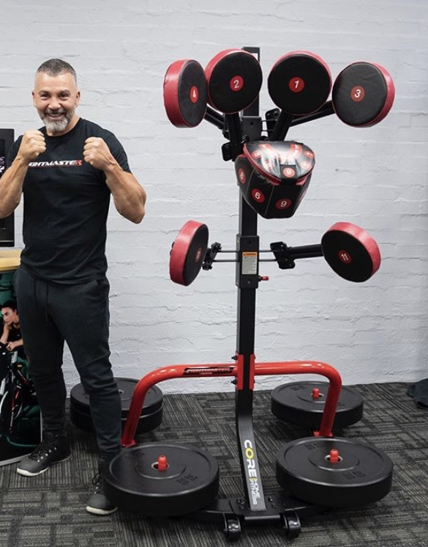

**Figure one.**

Rai Fazio and the FightMaster training machine.

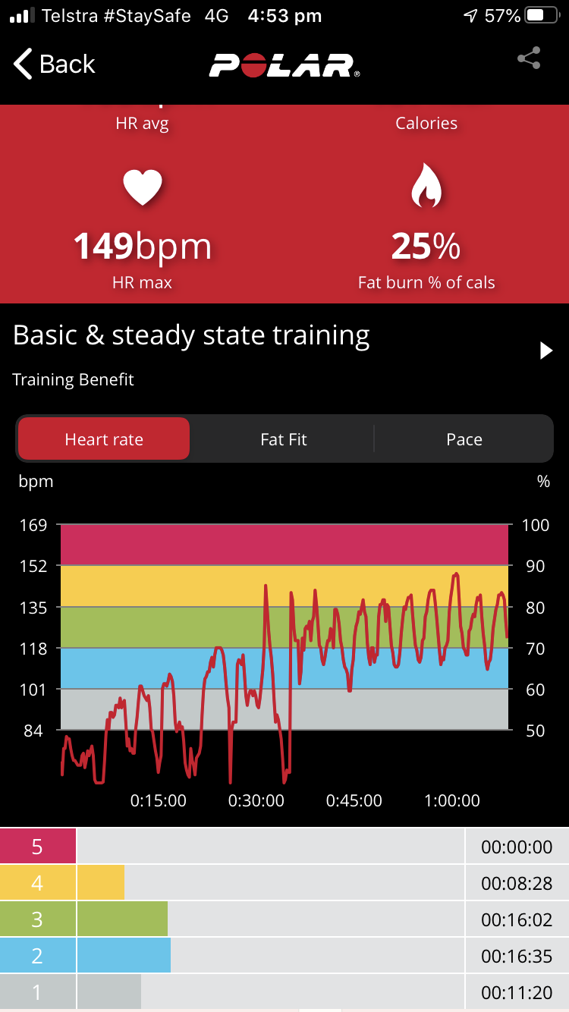

**Figure two.**

Polar monitor readout of heart rate from a typical session, with graphical readout and actual time spent in each centile of maximum heart rate.

**4. STUDY DESIGN**

This is a phase I, dose escalation study of increasingly intense levels of a non-contact boxing exercise programme for patients with early stage Parkinson disease. The three primary objectives will explore the feasibility, tolerability and safety of the program. The study is observational, and by necessity “open label”, utilizing subject self reported, but previously validated scales of perceived exertion (the Borg scale) and pain, as well as ongoing subject reported experience of each level. The secondary objectives are to analyse the details of continual heart rate monitoring using a chest strap (Polar 10) linked by Bluetooth to a smart phone app (Polar Beat). This will record the heart rate during each session, producing a record of heart rate expressed as absolute values and centiles of percentage of maximum heart rate, calculated from the Karnoven equation (Maximum heart rate = 220-age). Continuous observation by the boxing trainer and physiotherapist will be used to monitor adverse effects.

**5. SELECTION of SUBJECTS**

**5.1 Population and sample size**

Participants will be recruited from the Perron Institute Movement Disorders Clinic ,neurologists private rooms, Parkinson’s support groups and a list of subjects who indicated interest in the study after local media publicity on World Brain Day, July 22nd 2020. Initially 20 participants will be recruited, in line with the sample size of a previous study of Pilates in PD undertaken at this institute9, and similar to other preliminary studies of exercise in PD3. Potential participants will be provided with information regarding the study and referred to a private cardiology laboratory to undergo a resting 12 lead ECG and exercise stress test. If no significant abnormalities are detected they will be eligible to participate.

**5.2 Inclusion criteria**

1. Established diagnosis of Parkinson Disease made by a neurologist using the UK Brain Bank criteria.

2. Willingness to participate in an exercise program.

3. Hoehn and Yahr scale 1 and 2.

4. No significant abnormality on cardiac stress testing.

**5.3 Exclusion criteria**

1. Cognitive impairment prohibiting ability to follow complex commands.
2. Poorly controlled cardiovascular or respiratory disease that impact on exercise.
3. Uncontrolled hypertension > 160/90
4. Use of negative chronotropic medications (such as beta-blockers) that impact on heart rate response to exercise.
5. Musculoskeletal deformities of hands, wrists or spine that would be exacerbated by, or cause pain when boxing.

**6. STUDY PROCEDURES;**

1.       Screening physical examination to be undertaken by a doctor.  The study doctor will undertake a general physical examination focused on checking for issues that would place your health at undue risk by participation.  The study doctor will also answer questions about the programme and obtain informed consent.

2.     The boxing trainer and the neuro physiotherapist will meet with you to examine you as well and also to explain the exercise programme.

3.    Baseline assessments of any areas of muscle or joint pain, and PD symptoms, including fatigue, depression and sleep.

4. Baseline questionnaire about recent, and current level of exercise.

5. Subjects will be given a Polar heart rate monitor to use for the study, and provided with instructions on its use. They will also be instructed on the use of the Borg scale of Rate of Perceived Exertion.

6. The programme of exercise will be implemented over 15 weeks with escalating intensity. The warm up comprises of a series of movements to sequentially prepare the upper body, trunk and legs with sets of flexion and extension and rotational movements around each joint. Photographs and detailed explanations of each component of the three workouts can be viewed using the following Google drive links;

[****](https://drive.google.com/file/d/1Kfxucm73gCXSmiAGMUzfseSkrOC2g75A/view?usp=drive_web)

[****](https://drive.google.com/file/d/1ScK44EwNKf0QXPf0mfRcpVFS704f1v37/view?usp=drive_web)

[****](https://drive.google.com/file/d/1Kt698ErAlcWToPAiV4dUBL_XEVEaALb0/view?usp=drive_web)

Exercise physiology students will quiz participants on their perceived rate of physical exertion Borg RPE (6-20) and perceived rate of mental exertion (RPME) , 1-10, at numerous time points during the workouts.

The first five week block will commence with sessions focus on the development of boxing technique, with a low intensity (Borg RPE <13). The second five week block will steadily increase exercise intensity, starting at <13 and building towards >15. The duration of each level gradually increases, and the intensity also increases by changing the rate of punching and the addition of short bursts of rapid punching and finally the addition of an end sequence where subjects are encouraged to push towards maximum exertion. In the third five week block, additional cognitive tasks will be added, such as learning sequences “on the fly”, and switching laterality; ie from an orthodox (right handed) stance to “Southpaw”, (left handed). Adding sequences with several consecutive punches from the same hand, interrupting a bi-manual pattern, seems to also provide an effective, inhibitory cognitive challenge. Subjects will be continuously observed by the trainer and physiotherapist and instructed to modify technique to avoid injury, and asked to cease if visible signs of distress become apparent. Participants will be questioned about any emerging pain issues, side effects or new medical issues prior to the commencement of each session. Midway through the program, an interim medical examination will be undertaken checking for emerging injuries. Feedback and any necessary revision of technique will occur continuously, but a separate session will be devoted to this in the middle of the program..

7. Subjects will be given a logbook, and make entries at the end of each session. This will consist of questionnaires and scales .

8. Heart rate data will be downloaded after each session.

9. The final session will be used to collate all paperwork, answer questions, take feedback and suggestions and invite participants into future studies

Boxing Intervention

|  |  |  |  |
| --- | --- | --- | --- |
|  | Session 1 | Session 2 | Session 3 |
| Block 1 (Boxing Development) | | | |
| Week 1 | HR: <70%  RPE: ≤13  RPME: <7 | HR: <70%  RPE: ≤13  RPME: <7 | HR: <70%  RPE: ≤13  RPME: <7 |
| Week 2 | HR: <70%  RPE: ≤13  RPME: <7 | HR: <70%  RPE: ≤13  RPME: <7 | HR: <70%  RPE: ≤13  RPME: <7 |
| Week 3 | HR: <70%  RPE: ≤13  RPME: <7 | HR: <70%  RPE: ≤13  RPME: <7 | HR: <70%  RPE: ≤13  RPME: <7 |
| Week 4 | HR: <70%  RPE: ≤13  RPME: <7 | HR: <70%  RPE: ≤13  RPME: <7 | HR: <70%  RPE: ≤13  RPME: <7 |
| Week 5  Active rest week | HR: <70%  RPE: ≤13  RPME: <4 | HR: <70%  RPE: ≤13  RPME: <4 | HR: <70%  RPE: ≤13  RPME: <4 |
| Block 2 (Boxing HIIT) | | | |
| Week 1 | HR: >80% (6 rounds)  RPE: ≥15 (6 rounds)  RPME: <6 | HR: >80% (6 rounds)  RPE: ≥15 (6 rounds)  RPME: <6 | HR: >80% (7 rounds)  RPE: ≥15 (7 rounds)  RPME: <6 |
| Week 2 | HR: >80% (7 rounds)  RPE: ≥15 (7 rounds)  RPME: <4 | HR: >80% (7rounds)  RPE: ≥15 (7rounds)  RPME: <4 | HR: >80% (8 rounds)  RPE: ≥15 (8 rounds)  RPME: <4 |
| Week 3 | HR: >80% (8 rounds)  RPE: ≥15 (8 rounds)  RPME: <4 | HR: >80% (8 rounds)  RPE: ≥15 (8 rounds)  RPME: <4 | HR: >80% (9 rounds)  RPE: ≥15 (9 rounds)  RPME: <4 |
| Week 4 | HR: >80% (10 rounds)  RPE: ≥15 (10 rounds)  RPME: <4 | HR: >80% (10 rounds)  RPE: ≥15 (10 rounds)  RPME: <4 | HR: >80% (11 rounds)  RPE: ≥15 (11 rounds)  RPME: <4 |
| Week 5  Active rest week | HR: <70%  RPE: ≤13  RPME: <4 | HR: <70%  RPE: ≤13  RPME: <4 | HR: <70%  RPE: ≤13  RPME: <4 |
| Block 3 (Boxing Mind) | | | |
| Week 1 | HR: <70%  RPE: ≤13  RPME: ≥7 | HR: <70%  RPE: ≤13  RPME: ≥7 | HR: <70%  RPE: ≤13  RPME: ≥7 |
| Week 2 | HR: 70-80%  RPE: 13-15  RPME: ≥7 | HR: 70-80%  RPE: 13-15  RPME: ≥7 | HR: 70-80%  RPE: 13-15  RPME: ≥7 |
| Week 3 | HR: >80% (6 rounds)  RPE: ≥15 (6 rounds)  RPME: ≥7 | HR: >80% (6 rounds)  RPE: ≥15 (6 rounds)  RPME: ≥7 | HR: >80% (7 rounds)  RPE: ≥15 (7 rounds)  RPME: ≥7 |
| Week 4 | HR: >80% (7 rounds)  RPE: ≥15 (7 rounds)  RPME: ≥7 | HR: >80% (7rounds)  RPE: ≥15 (7rounds)  RPME: ≥7 | HR: >80% (8 rounds)  RPE: ≥15 (8 rounds)  RPME: ≥7 |
| Week 5  Active rest week | HR: <70%  RPE: ≤13  RPME: <4 | HR: <70%  RPE: ≤13  RPME: <4 | HR: <70%  RPE: ≤13  RPME: <4 |

**8. PARTICIPANT QUESTIONNAIRE and SCALES**

Baseline scales;

1. FIGHT-PD measures; A combination of validated scales ; Depression Anxiety Stress (DASS), Sleep Health Index, Sleep Satisfaction Tool, Multidimensional Fatigue Symptom Inventory (MFSI),and Parkinson Disease Questionnaire (PD-Q39)
2. Questionnaire on recent and current exercise levels; International Physical Activity Questionnaire- Short Form. Exercise diary to continue throughout to track exercise done in addition to the programme.
3. Self-Efficacy for Exercise (SEE) scale
4. Body chart discomfort scale

Before each workout;

1. Fatigue severity scale
2. SATED scale
3. Body Chart Discomfort scale

During each session assistants will question the subjects to administer the Borg scale of rate of perceived exertion (6-20) ,and rate of perceived mental exertion (RPME) at various points during the workout.

Questionnaire after each workout;

How did you tolerate this level of exercise? (options below)

* 1. I found it very easy and could tolerate much more
  2. I found it easy and could tolerate more
  3. I found it just about right, but could tolerate some more
  4. I found it to be the right amount, but could try some more
  5. This level is optimal and I would be reluctant to try more
  6. I found this level too uncomfortable and would not like to try more

Scales at the end of each 5 week block

SEE scale

Scales at the end of the program

Repeat FIGHT-PD measures

Questionnaire of participant satisfaction, barriers, enablers and suggestions.

1. **OUTCOME MEASURES**

The primary outcomes for each objective are;

1. Feasibility outcomes. The recruitment and retention of subjects will be recorded, and the logistical issues and details of the program described.

The following data will be recorded;

The number of candidates approached, the number of candidates formally screened, then included, then consented. The number and reason for exclusion. The number of subjects completing the full program, part of the program and drop outs (and reason).

The time taken for completion of program and collection of data.

Questionnaire of participant satisfaction, barriers, enablers and suggestions, to be completed at the end of the study.

1. Tolerability outcomes.

2.1 The rate of perceived exertion using the Borg scale will be measured at several points during the warm up and boxing sequences.

2.2 The rate of perceived mental exertion will be measured at several points during the warm up and boxing sequences.

2.3 A six point questionnaire assessing the tolerability of each work out will be completed after each work out.

1. Safety outcomes will be measured by subjects completing a body chart discomfort scale after each workout, and by completing scales of fatigue and well being. Adverse events will be monitored and recorded.

The secondary outcomes include;

1. Quantification of heart rate response during each workout, expressed as total time, and time as a percentage component of the total workout, spent at each centile of predicted maximum heart rate, 50-100%.
2. Patterns of heart rate change, including recovery, and tasks required to produce high intensity exercise (define as > 80% maximum heart rate) will be analysed.

**10. MANAGEMENT OF ADVERSE EXPERIENCES**

Subjects will be closely observed for any potential discomfort or adverse effects during each session, and asked about issues that may have developed in between sessions, prior to commencing a new session. An experienced person (boxing trainer, physiotherapist or doctor) will be present at each session, and will intervene if problems arise. Subjects will receive the best medical care available during and after the study, if that is required. In the unlikely event that they experience any research related harm as a result of participating in this study, you will be provided with medical treatment at no cost to them. Research related harm means both physical or mental injury cased by the study procedures. Subjects have the right to pursue legal action for any research related harm as a result of their participation.

It is anticipated that there may be some risks associated with participating in the study including;

1. Cardiovascular complications. Subjects will have been screened with a 12 lead ECG and exercise stress test, which should minimise risk; nonetheless high intensity exercise poses a cardiac risk. Cardiac stress tests are estimated to have a 1 in 10 000 risk of death, 2 in 10 000 risk of hospitalization 4 in 10 000 risk of heart attack.

Complications of exercise such as breathlessness, chest pain, dizziness or faintness.  The trainer and physiotherapist are highly experienced professionals who will supervise your involvement and advise you to cease activity or reduce it if there appear to be any obvious signs of distress or impending complications. If necessary, the institutional protocols for managing a medical emergency will be activated.

2. Musculoskeletal pain and injuries associated with the boxing movement such as sprains and aches. Management and appropriate modification of technique will be made on a case by case basis.

3.  Many PD patients are at risk of falling. If a fall occurs during an exercise session it will be reported as an adverse event (AE) or serious adverse event (SAE). The subject will be immediately assessed by the trainer and physiotherapist and the study doctor notified, and appropriate treatment or referral will be undertaken.

.

All AEs will be recorded and documented in the subjects study record

All SAEs will be reported to the HREC within 24 hours.

**11. STATISTICAL CONSIDERATIONS**

The outcome measures and observations are all descriptive and will be presented in tabular form.

Heart rate data from each session for each subject will be collated and presented in tabular form, expressed as time spent in each centile of maximum heart rate between 50-100%.

A key data point will be to identify the workout that consistently produce heart rate >80% of maximum.

**12. DATA COLLECTION**

Each subject will have a physical study file which will be kept in a locked secure location within the Perron Institute accessible to the Principal Investigators. The file will include the signed informed consent, medical screening data and physician notes. Logs of each stage of exercise, the completed questionnaires and scales will also be recorded. Subjects will have the option to completer either hard copy or electronic study logs.

Study materials will be archived within a secure storage area at the Perron Institute for 15 years.

**13. TRIAL REGISTRATION**

The study has been registered with the Australian and New Zealand Clinical Trials Registry; request number is: 380492

**14. REFERENCES**

1. Weintraub D, Morgan JC. Both the Body and Brain Benefit from Exercise: Potential Win-Win for Parkinson’s Disease Patients. *Movement Disorders.* 2011;26:607.
2. Morris ME, Ellis TD, Jazaayeri D, Heng H, Thomson A, Balasundaram AP, Slade SC. Boxing for Parkinson’s Disease: Has Implementation Accelerated Beyond Current Evidence? *Fontiers Neurol* 2019;10:1222.
3. Schenkman M, Moore C, Kohrt W, et al. Effect of High-Intensity Treadmill Exercise on Motor Symptoms in Patients With De Novo Parkinson Disease.*JAMA Neurology* 2018;75(2):219-226.
4. Ridgel AL, Vitek JL, Alberts JL. Forced, Not Voluntary Exercise Improves Motor Function in Parkinson’s Disease Patients. *Neurorehabilitation and Neural Repair* 2009;23: 600-608.
5. Alberts J, Phillips M, Lowe M et al. Cortical and motor responses to acute forced exercise in Parkinson’s disease. *Parkinsonism Relat Disord.* 2016;24:56-62.
6. A neurologist with Parkinson’s disease. Blacker D, *Pract Neurol* 2020. vol.20(5) 423-424.
7. McConaghy M. The New Parkinson’s Treatment. Exercise in medicine. PD Warrior. Publisher Simon and Schuster,March 2019..
8. Fox C, Ebersbach G, Ramig L, Sapir S. LVST LOUD and LVST BIG: Behavioral Treatment Programs for Speech and Body Movement in Parkinson Disease. *Parkinsons’s Disease* 2012 article 391146.
9. Johnson L, Putrino D, James I, Rodrigues J, Stell R, Thickbroom G, Mastaglia F. The effects of a supervised training program on balance in Parkinson’s disease. *Advances in Parkinson’s Disease* 2013; 2 : 58-61

**APPENDIX:**

**Scales**

Short international physical activity questionnaire

FIGHT-PD measures; including Depression Anxiety Stress (DASS), Sleep Health Index, Sleep Satisfaction Tool, Multidimensional Fatigue Symptom Inventory (MFSI),and Parkinson Disease Questionnaire (PD-Q39)

Borg scale of rate of perceived exertion (RPM)

Scale of rate of perceived mental exertion (RPME)

Fatigue severity scale

SATED

SEE scale

Body Chart Discomfort scale

Questionnaire of participant satisfaction, barriers, enablers and suggestions