RESEARCH STUDY PROTOCOL

Evaluating the impact on in-hospital orthopaedic waitlists after the introduction of community-based advanced physiotherapy assessments for patients with chronic musculoskeletal conditions

Investigators:
Doctor Susan Jacups
Doctor Arvind Puri
Associate Professor Edward Strivens
Professor Christopher Doran
Professor Sarah Larkins
Doctor Carol Flavell

Activity Summary
Activity 1: Participating Cairns General Practitioners (GPs) can refer patients with chronic musculoskeletal conditions for an assessment with a Cairns Hospital funded advanced physiotherapist. The assessment will be conducted at a Cairns Hospital Community Health Centre (Smithfield, Cairns North or Edmonton). The physiotherapists (physios) will work with other Cairns Hospital allied health professionals to tailor a multi-disciplinary (MDT) health plan for patients who are not suitable for orthopaedic surgery. This allied health MDT plan will be provided to the GP. Guided by the recommendations in the allied health plan, GPs will discuss with their patients how to complete the allied health plan by accessing existing allied primary health care services (PHC). There is no cost to the patient for this assessment and we are hoping the appointment wait time will only be a few weeks.

Background Activity 1:
Across Australia and internationally, the surgical specialty area of orthopaedics reports long waitlists and wait times ¹⁻⁵. In Cairns, the regional referral hospital (Modified Monash Model 3) reports orthopaedic waitlists are double that of other specialty areas, such as ENT and general surgical, and outpatient wait-time for orthopaedics is on average 326 days, with some patients waiting almost two years (unpublished QH data). Factors contributing to long-waitlists are multiple, but are in part due to an aging population, rising obesity rates, advancements in hip and knee replacement success ^{6,7}; and the complex nature of bone healing and musculoskeletal presentations. Furthermore, in regional Cairns (local area ~2000m², pop ~153,000, ~1700 km north of Brisbane)⁶ there are widespread health workforce shortages and problems attracting specialist medical practitioners, these factors also impact on waiting list problems.

To reduce excessive hospital waitlists, advanced physiotherapists (physios) are employed within outpatient orthopaedics departments. Physios have been employed in this capacity across the UK, Canada and Australia ^{1-5,8,9}, and have been shown to be as effective as junior orthopaedic surgeons for initial assessment and management of new patients presenting to outpatient orthopaedic departments. Furthermore, evidence suggests that physios reduce direct hospital costs ^{4,10}. In PHC settings, physios provide an alternative to doctors in the assessment of musculoskeletal disorders, reducing the need for patients to be reviewed by a GP or medical specialist ^{2,11-13}. In Sweden, a PHC triage system is employed, which directs patients with musculoskeletal disorders directly to physiotherapists. Since introduction, this approach has significantly reduced GP visits and subsequent referrals to medical specialists ¹¹.

One pilot program delivered in Doncaster UK, aimed to reduce orthopaedics outpatient department referrals¹⁴ by providing GPs direct referral access to community-based physiotherapists. In that study, a physiotherapy service was established in six general practices as an alternative to a tertiary hospital-based physiotherapy service, and over the first year reported a utilisation rate of 31 per 1000 patients in the participating practices. A drop in hospital outpatient referral rates to the orthopaedics department of 8% was also noted. The study concluded that physiotherapy based in GP practices can substitute for hospital-based physiotherapy, and reduce referrals to the orthopaedic outpatient department¹⁴.

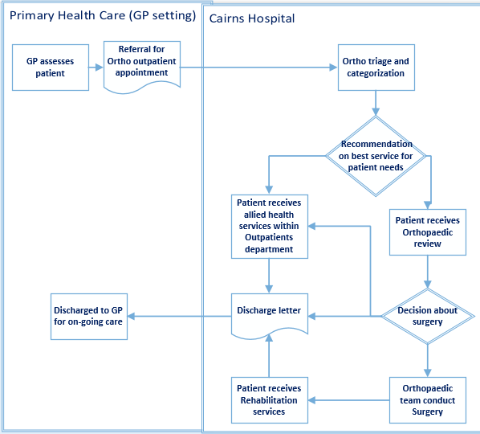
Currently, only one Queensland Health¹⁵ unpublished report of a trial offering advanced physio services for orthopaedic outpatients assessments within a PHC exists. Both this and a Doncaster¹⁴ based trial had an explicit aim to reduce hospital waitlists; however, each trial offered hospital-based allied health services, placed within the PHC setting. These studies did not utilise existing PHC services.

Current service delivery model of care for Cairns based orthopaedic outpatients
Presently, the Cairns Hospital receives 250-275 orthopaedic outpatient referrals per month (unpublished- Queensland health data- 2019). Two thirds of these referrals are considered unsuitable for surgery and are advised to pursue allied health services (MDT: physio, dietician, pharmacy and psychology). Historically, the provision of outpatient allied health services within Cairns Hospital arose to reduce orthopaedic waitlists and to offer a service to local Cairns patients who could not afford PHC allied health services. However, this service is offered to all local patients, many of whom have the means to access existing (fee-for-service) allied health services within the community. Consequently, demand for these services within the hospital now exceeds capacity, leading to longer wait times and a huge patient burden on the hospital. Input from a MDT team has been demonstrated to improve patient outcomes over and above that of a physio service alone ¹⁶. Typically, the MDT team provide 8-10 sessions with each patient, spending up to 1.5 hours per session (Figure 1).

Site/s you will be conducting your Research at:
Activity 1: Advanced physiotherapy assessments will be offered from the three QH operated community centres in Cairns (Smithfield, Cairns North and Edmonton).
Research Questions:

Activity 1: Main research question
- What is the impact of introducing a specialized physiotherapist (with MDT review) in community health settings on access to care, treatment success and costs for people with chronic musculoskeletal conditions?
Sub-questions:
- Does access to advanced physio assessments lead to a reduction in referrals to orthopaedic outpatients?
- Does access to advanced physio assessments lead to a reduction in orthopaedic outpatient waitlists?

Methods:
Hypothesis: There is a reduction in referrals to orthopaedic outpatients after the introduction of physio assessments in PHC compared standard treatment (historical referrals and waitlist data comparisons)
Purpose: To increase access to services for regional patients by increasing allied health use in PHC, and reduce orthopedic outpatient waitlists (times)
Aims
Activity 1 will address: Improving access to health assessments and reducing orthopaedic waitlists for patients with chronic musculoskeletal conditions through deploying QH physiotherapists to community health centre settings to undertake assessments
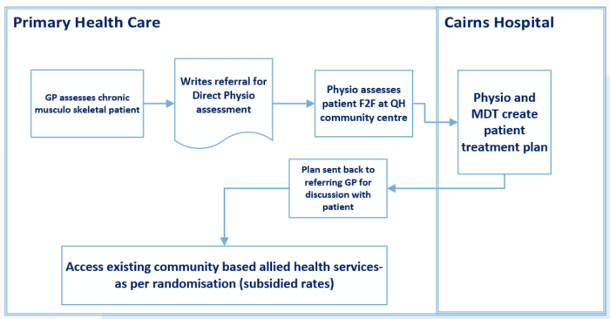
(Figure 2).
Elements of Intervention: Intervention 1 1. i) Project funded advanced physiotherapists to work in QH community setting. Direct referral to advanced physio by GPs. Physios assess people with chronic musculoskeletal conditions (no cost to patient). Physios work with MDT (Cairns Hospital outpatients) to create individual AH treatment plans. ii) These care plans will be sent to each patient’s GP (no cost to patient). Assessments incur wait period to 2-3 weeks (compared with current orthopaedics waitlist ~260 days) iii) Education and training of GPs /AH staff and others about access to care via the new pathway.

Study Design:

Activity One adopts a non- randomised control (comparing with historical data) trial design of implementing a complex intervention

Study Settings: Advanced physiotherapy assessments will be offered from the three community centres in Cairns (Smithfield, Cairns North and Edmonton)
Study Period: 3-5 years total, 18-24 months intervention, depending on funding stream. This will enable adequate community consultation, recruitment of staff, GP practices and patients, analysis of findings and dissemination of outcomes.

Sample size and power calculation
Activity 1: Previous studies have indicated that ~65% of current orthopaedic referrals would be more appropriate for physio assessment and treatments (intervention) ^{1,8}, and that similar interventions have reduced overall orthopaedic referrals by a total of 21% ¹¹. We apply the same utilising parameters of ¹¹ using t-tests and z distribution multivariate modelling, a sample size of 150 participants (allowing for censoring) with 80% power to detect statistical significance at 5% alpha level, will be required.
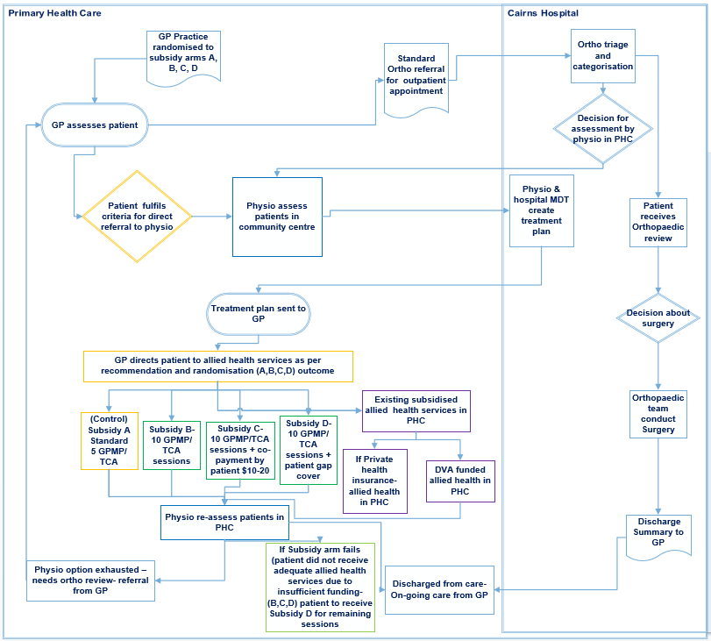
Figure 3: Activities 1& 2 process flow

Informed Consent: Practices, individual GPs and patients will be required to make an informed decision for consent, so they will have full disclosure available prior to the consent.

Consenting participants from Intervention 1 will be approached for one-on-one structured telephone interviews to elicit views on self-management, knowledge of pain mechanisms, access to services, relative importance of exercise, medications, choice of treatment provider and barriers and facilitators to effective good treatment ¹⁷. In addition, interviews will be conducted with a range of clinicians including GPs, orthopaedic surgeons, physiotherapists, dietitians, aimed at elucidating additional information on barriers and facilitators to treatment and views on current treatments.

Blinding: No blinding will be undertaken in this study.
Study Subjects:
Activity 1&2: The study Project manager will approach General practices within the Cairns Hospital area to participate in the study. A convenience sample of 16- 20 participating General Practices (with varying numbers of GPs employed) will be recruited, with 4-5 practices in each arm of the trial, refer to conceptual framework below. Each GP practice owner/ partner will consent to involvement in the study and cluster randomisation at practice level.

Study population: Consenting adults (ages 18-75) with a chronic musculoskeletal condition, who have been directly referred to the advanced physio assessment program. Currently Cairns Hospital receives 250-275 referrals per month from the Cairns area. Eligibility Criteria Participants must be: direct GP referral to physio assessment via Cairns Hospital for a chronic orthopaedic or musculoskeletal condition, live and attend a GP (consented to be included in study) within the geographical catchment (Cairns area), patients must be adults aged ≥18 years and less than 75 years. Exclusion Criteria: patients with acute orthopaedic conditions, such as fractures, patients older than 75 years, residents of Residential Aged Care Facility (RACF), patients with congenital musculoskeletal conditions or permanent physical disabilities (paraplegia, cerebral palsy, spina bifida), patients with extremely complex orthopaedic conditions, such as previous MVA with multiple fractures, patients who are immuno-compromised, or currently receiving oncology specialist treatment, patients with intellectual disability &/or extensive psychiatric histories, impacting their ability to consent or comply with physiotherapy assessment and treatment.

Data Analysis:
Activity 1: Statistical methods
The primary analysis will be based on the intention to treat principle. Activity 1: Intervention one evaluation will include numeric (means or median) comparisons of orthopaedic outpatient waitlists, allied health (outpatient) health care utilisation, wait times and FTA rates 12 months before, during and up to 6 months after the intervention. Patients enrolled in the intervention will provide basic demographic information at time of consent, GP patient records will not be reviewed or accessed. For intervention one, data analyses will include student’s t-tests and generalised linear models, adjusted for demography where applicable. All statistical tests will be two-sided and performed using a 5% significance level with no adjustment for multiplicity. Data analysis will be performed using STATA version 14 and Excel.
Costing analyses
Costs will be calculated as the sum of health care costs minus the cost of the FTA costs, as obtained from QH casemix (internal) data. The costing analyses will report costs post MDT treatment plan completion by patient, for each Tier 2 coding, within the participant sample. Pre-trial costings: base cost, current practice: AH service assessment and service offered through outpatients department 100% funded through QH; will be undertaken from generic hospital records, based on set costs included in QH activity based funding model- health care purchasing framework ¹⁸. We will compare base costs with the costs of Intervention one (staffing and service delivery costs).
References:

