Clinical Research Proposal - “Acupuncture and Adult Post-Tonsillectomy Analgesia”

Dr David Ho, MBBS, FANZCA, Visiting Anaesthetist, Northside Anaesthesia
Dr Hannah Burns, MBBS, FRACS, Visiting ENT Surgeon, Northside ENT
Dr David McCrystal, MBBS, FRACS, Visiting ENT Surgeon, Northside ENT
Dr Paul Canty, MBBS, FRACS, Visiting ENT Surgeon, Northside ENT
Dr Richard Barr, MBBS, FRACS, Visiting ENT Surgeon, Northside ENT

Correspondence:

Dr David Ho
Northside Anaesthesia
Level 3 Mary Aitkenhead Building,
St Vincent’s Private Northside Hospital,
627 Rode Rd,
Chermside 4032.
Phone: 07 3359 7011
Fax: 07 3359 7022
Mobile: 0402 898781
Email: david@hohoho.net.au

Introduction

Tonsillectomy is one of the most commonly performed surgical procedures and is usually accompanied by significant morbidity, such as postoperative bleeding, pain, nausea, vomiting, poor oral intake and dehydration. In Australia, pain relief post-tonsillectomy is commonly managed with Paracetamol, Non-steroidal anti-inflammatory drugs (NSAID), and narcotics such as oral Oxycodone. Although such regimens are usually highly effective, the use of opioid medications can precipitate or exacerbate nausea, vomiting, respiratory suppression, and — as seen in some well-publicized cases — result in death.

Recent evidences indicate that acupuncture may have a role in reducing post-operative pain and vomiting for tonsillectomy in adults and in children aged 1-5. This would then reduce their opioid requirement and, in turn, reduce undesirable drug side effects.

In a study of 143 adult patients, Sertel et al showed that acupuncture significantly reduced odynophagia after tonsillectomy; however, this study employed only post-procedure inpatient acupuncture that was timed with NSAID administration (1). It suggests that acupuncture may serve as an alternative pain treatment to NSAID following tonsillectomy.

In a similarly designed study of 60 children, Gilbet et al showed that, in the study group, there was less pain, less analgesic drug consumption, and higher patient/parent satisfaction with analgesic treatment scores (2). No adverse effects were recorded. They concluded that acupuncture, in addition to conventional analgesic treatment, is an effective treatment for post-tonsillectomy pain. They also noted that acupuncture is safe and well received by children and their parents.

Both these studies suggest that acupuncture may have a significant role in reducing post-operative tonsillectomy pain. However, performance of acupuncture in children who are awake is unlikely to gain wide acceptance.

In an alternatively designed study of intra-operative acupuncture and post-tonsillectomy pain in 59 children, Tsao et al found there were no significant differences in opioid dose administered or total post-anesthesia care unit time between the control and treatment groups (3). Home surveys (of patients, not of parents) revealed significant improvements in pain control in the acupuncture treatment group postoperatively (P = 0.0065 and 0.051, respectively), and oral intake improved significantly earlier in the acupuncture treatment group (P = 0.01). However, the clinical trends were suggestive of improvements in the treatment group and the authors suggest the study was insufficiently powered to detect a statistical difference.

Similarly, in a retrospective study of 57 children with post-operative tonsillectomy pain, Occhi found that intra-operative acupuncture significantly decreased pain for up to 72 hours after treatment (4). In separate study of 60 children, Lin et al found that intra-operative acupuncture reduced pain and agitation after myringotomy (5). These studies suggest that intra-operative acupuncture may have significant benefits for up to 72 hours following treatment.

Finally, in a recent meta-analysis, Cho et al noted that the pain score reported by patients during the first 48 postoperative hours and the postoperative analgesic requirement were significantly lower in the acupuncture group versus the control group (6). Additionally, the incidence of postoperative nausea and vomiting was significantly lower in the acupuncture group than in the control group. No major adverse effects of perioperative acupuncture were reported in the enrolled studies. They conclude that perioperative acupuncture may provide pain relief without side effects in patients undergoing tonsillectomy. However, there were high levels of heterogeneity in several of the measured parameters, and the authors suggested that additional well-designed trials are required to further support the results of this meta-analysis.

These studies suggest that the use of intra-operative acupuncture to supplement general anaesthesia may be able to reduce the narcotic requirement for patients undergoing tonsillectomy and hence improve their post-operative outcomes by reducing post-operative pain, reducing vomiting, and increasing oral intake at an earlier stage. Furthermore, this can readily be performed on the anaesthetised patients, which will minimise the placebo effect. We propose this clinical trial to determine the effects of intra-operative acupuncture on analgesic requirements and vomiting in patients undergoing tonsillectomy.

Method

Subject to the ethics committee approval, we propose to enrol two hundred and sixty (260) adult patients, ASA grade 1 or 2, undergoing adenotonsillectomy in a double-blinded randomised controlled clinical trial.

Inclusion criteria:
- Age : 16-80
- ASA grade : 1-2
- Healthy otherwise
- No significant medical disease

Exclusion criteria:
- Any significant allergy
- Known bleeding tendency
- Known or likely airway difficulty
- Patients who had received acupuncture, analgesics and sedatives within 36 hours prior to surgery.

All patients will receive a written informed consent prior to surgery. All patients will be interviewed and consented by the anaesthetist before or on the day of surgery. They will all be given a chance to ask questions, and any further queries will be addressed prior to the procedure.

The patients will be randomised in blocks of 50 and assigned by a computer-generated programme to either the control or the acupuncture group. To minimise allocation bias, this randomisation programme will be held by an independent collaborator. On the day of surgery, the anaesthetist would contact the independent collaborator with the names of the patients. The independent collaborator would then assign the patients to the respective groups and inform the anaesthetist just prior to the procedure as to which group the patients had been assigned. All the designated assessors –recovery nurses, ward nurses and follow-up research nurses – will all be blinded as to which group each patient is assigned.

After consent is checked on arrival to the operating suite, an intravenous cannula will then be inserted in the anaesthetic induction bay and then, after cleaning with alcoholic wipes, ten (10) auricular acupuncture needle pads will be inserted onto the patient’s earlobes. On each earlobes, the five (5) needles are inserted according to the well-established pattern of Battlefield acupuncture (see Appendix 1). In the Intervention group, Serin acupuncture pads with needle size 0.15mm x 0.6mm will be used. These needle pads contain very small needles and are designed to be left comfortably in situ for many days. In the Control group, identical Serin acupuncture pads with the needles already removed will be used as placebo pads. These pads for the control group would be prepared prior to the insertion by the acupuncturist. They would look indistinguishable from the pads with the needles. In our study, these acupuncture pads in both groups will be removed by patient at home after 5 days postoperatively.

Once the auricular acupuncture procedure is completed, the patient will be brought into operating room. General anaesthesia will be induced with intravenous Midazolam 2mg, Fentanyl 100 microgram and Propofol 2mg/kg. Other intravenous drugs will be given including Oxycodone 0.1mg/kg, Paracetamol 1g, Granisetron 1mg, and Dexamethasone 4mg. All medications will be cross-checked by the anaesthetist and the operating room nurse on the day to ensure correct dosage. A flexible laryngeal mask (LMA) will then be inserted to maintain the airway for the duration of surgery and recovery. Anaesthesia will be maintained with oxygen 100% and end-tidal Desflurane of 6-8% with spontaneous ventilation. An intravenous fluid bolus of 1000ml will be given intra-operatively and followed by 60ml/hr in the ward. The adeno-tonsillectomy procedure will then be performed by electrocautery. At end of surgery, the patient will be transferred onto a ward bed and taken to recovery with the LMA in situ. The LMA will be removed when the patient is awake and able to maintain his/her own airway in recovery.

In the acupuncture group an identical procedure to that described above will be followed, with the addition of the insertion of ten (10) body acupuncture needles after LMA insertion and prior to surgical stimulation. All acupunctures will be performed by Dr Ho, who is also a qualified acupuncturist with the Australian College of Medical Acupuncturist (AMAC). Stainless steel acupuncture needles, 15 mm in length and 0.18 mm in diameter (Serin Co, Shizuoka, Japan), will be used for the acupuncture. The positions for the needles inserted, according to Chinese Medicine standards, are: LI4x2, LI20/Bitongx2, CV(REN)22, GV(DU)20, LI1, PC6, ST44, SP6 (see Appendix 2). These particular acupuncture points are selected for their local analgesic property in the pharyngeal region, or for their general analgesic/anti-inflammatory property, or for their anti-emetic property. No electrical stimulation will be applied to the acupuncture needles. The surgical intervention will then commence immediately following acupuncture needle insertion. The needles will be left in situ for the duration of surgery, and immediately removed at the completion of surgery prior to the patient waking up.

In recovery and the ward, the patient will be assessed for pain by using the 0-10 Numerical Pain Scale (NPS) by the recovery nurses at the following intervals: on awakening and at 10, 20, 30, and 60 minutes. In this scale, the patient is asked to rate their pain level with a number between 0 and 10, with no pain = 0 and worst pain imaginable = 10. If patient shows evidences of significant pain, with a pain score of > 7 on the NPS scale, he/she will be treated with an Oxycodone bolus of 2mg every 5 minute in recovery until pain settles. The patient will also be assessed for nausea and vomiting, and will be treated with Droperidol 0.5mg if required. All doses of Oxycodone bolus will be recorded as well as the time at which they are given.

On the ward postoperatively, all patients will be given Paracetamol 1g orally every 6-hourly. For additional rescue analgesia, Oxycodone 10mg will be given 4-hourly as required if the pain score is > 7, at the discretion of the ward nurse. All patients are encouraged to eat and drink as tolerated. All observations, including pulse oximetry and pain score, are recorded at 2-hourly intervals as well as the time and dose of Oxycodone given during their post-operative stay by the ward nurse. Patients are given another dose of Dexamethasone 4mg intravenously or orally on the first postoperative morning. Patients are discharged on the first postoperative morning if they are able to tolerate an oral intake. If the patient is still in significant pain, or not tolerating oral intake, then he/she remains in hospital until these issues are overcome.

All patients will be interviewed on day 1, 3 and 7 after discharge from hospital by telephone, and an assessment of pain and oral intake will be assessed and recorded by a research nurse, who is blinded to the randomisation of the patients.

Null hypothesis

Our null hypothesis is that there is no difference between the control group and the acupuncture group. The patients will be blinded in both groups, as they will not be advised to which group they have been assigned and acupuncture will only be performed after patients are fully anaesthetised. Staff in recovery and on the ward will be also blinded, as they will not be told to which group the patient belongs and acupuncture needles are removed prior to patients leaving the operating room. By necessity, the anaesthetist and surgeon will not be blinded, as they will be in the operating room during insertion of the acupuncture needles. However, we felt that our study structure will be rigorous enough to minimise the potential for bias.

Power analysis

During our ascertainment period in the first nine months of 2015, we observed that by using supplemental acupuncture intra-operatively, there appears to be about one-third reduction in the amount of intra-operative Oxycodone required for patient comfort in recovery, as well as a similar reduction in total amount of Oxycodone required on the ward during their post-operative stay. Based on these observations, we estimate that between 100 to 150 patients are required in each group to achieve a level of statistical significance of p < 0.05 at power of 90% . We note that an earlier study with similar design to ours used an initial 35% difference to arrive at a sample size of 30 for each group but was subsequently found to be underpowered (11). A recent editorial examined the results of that study and their power recalculation was made post-hoc, showing an estimate sample size of 260 patients [ES: 0.35; estimated sample size: 260 (130+130), σ=0.05, β=0.2, 1:1 group allocation ratio, compared means between two independent groups; post hoc recalculated power: 0.16] (12). Our own power analysis resulted similarly in a sample size of 258 patients. We estimate that it would take approximately 24 months to complete the trial.

Sample size – Means

Compare the mean of a continuous measurement in two samples:
The sample sizes are calculated in two different ways: first using the T statistic (with a non-centrality parameter), then using the Z statistic. The Z statistic approximates the T statistic, but provides sample sizes that are slightly too small. (We provide the Z statistic calculation to allow comparison with other calculators which use the Z approximation.)

Calculation:
α (two-tailed) = | 0.05 | Threshold probability for rejecting the null hypothesis. Type I error rate.
β = | 0.2 | Probability of failing to reject the null hypothesis under the alternative hypothesis. Type II error rate.
q1 = | 0.5 | Proportion of subjects that are in Group 1 (exposed)
q0 = | 0.500 | Proportion of subjects that are in Group 0 (unexposed); 1-q1
E = | 0.35 | Effect size (If μ1 = mean in Group 1 and μ0 = mean in Group 0, then E = μ1 - μ0.)
S = | 1 | Standard deviation of the outcome in the population
The standard normal deviate for α = Zα = 1.95996
The standard normal deviate for β = Zβ = 0.84162
Standardized Effect Size = (E/S) = 0.350

1. Calculation using the T statistic and non-centrality parameter:
N1: 129
N0: 129
Total: 258

2. Normal approximation using the Z statistic instead of the T statistic:
A = (1/q1 + 1/q0) = 4.00000
B = (Zα+Zβ)2 = 7.84887
Total group size = N = AB/(E/S)2 = 288.296
N1: 129
N0: 128
Total: 257

This formula uses the Z statistic to approximate the T statistic. As a result it slightly underestimates the sample size. We provide this approximation to allow comparison to other calculators that use the Z statistic.
Reference: Hulley SB, Cummings SR, Browner WS, Grady D, Newman TB. Designing clinical research : an epidemiologic approach. 4th ed. Philadelphia, PA: Lippincott Williams & Wilkins; 2013. Appendix 6A, page 73.
Chow S-C, Shao J, Wang H. Sample size calculations in clinical research. 2nd ed. Boca Raton: Chapman & Hall/CRC; 2008. Section 3.2.1, page 58.

Potential benefits

We feel that acupuncture has the potential to improve outcomes in patients undergoing adeno-tonsillectomy as it can lower the overall narcotic requirement and, in turn, lead to better post-operative pain relief. More importantly, we believe it may lessen the risk of serious complications including respiratory depression, post-operative apnoea, and oxygen desaturations. Evidence to date suggest that acupuncture also helps to minimise nausea and vomiting following tonsillectomy, which enables patients to better tolerate an oral intake and reduce the need for extended hospital stays.

Potential complications

As both groups receive the same identical general anaesthesia and surgery, the only additional potential complications will be from the acupuncture needling itself, which includes minor bleeding and nerve injury. The incidences of these complications are unknown but estimated to be extremely low, at 1:10,000 for minor bleeding and <1:100,000 for nerve injury. These injuries are self-limiting and not likely to require any active treatment. In a review of worldwide literature, White finds that the rate of serious adverse events is estimated to be 0.05 per 10,000 patients undergoing acupuncture treatment. He concludes that acupuncture incurs a ‘very low’ risk in term of medical interventions and that acupuncture is deemed as ‘a very safe intervention in the hands of a competent practitioner’ (8).

A recent article in the Medical Journal of Australia suggests that a possible infection and abscess in the neck was related to an acupuncture needle (7). However, as the authors pointed out, the acupuncture treatment in this case was unconventional, as the needle was left in-situ in the patient’s neck for more than 24 hours. In this study, all body needles will be removed at end of surgery, which is usually of less than 1 hour in duration and thus minimise the chance of infection. For auricular acupuncture, the acupuncture pads in the Control group contain no needle and so should have no risk of infection. In the Intervention group, the acupuncture pads contain a very small needle which is designed to be left in-situ for many days. We sought to minimise the risk by ensure decontamination with alcoholic wipes before insertion in all patients and reminding them to self-remove their acupuncture pads after 5 days, on the day of surgery as well as during phone follow-ups.

References

1) Sertel S, Herrmann S, Greten HJ, Haxsen V, El-Bitar S, Simon CH, Baumann I, Plinkert PK. Additional use of acupuncture to NSAID effectively reduces post-tonsillectomy pain. Eur Arch Otorhinolaryngol 2009; 266:919–925.

2) Tsao GJ , Messner AH , Seybold J , Sayyid ZN , Cheng AG , Golianu B . Intraoperative acupuncture for post-tonsillectomy pain: a randomized,
double-blind, placebo-controlled trial. Laryngoscope 2015; Aug 125(8):1972-8.

3) Gilbey P, Bretler S, Avraham Y, Sharabi-Nov A, Ibrgimov S, Luder A. Acupuncture for posttonsillectomy pain in children: a randomized, controlled study. Pediatric Anesthesia 2015; 25: 603–609.

4) Ochi JW. Acupuncture instead of codeine for tonsillectomy pain in children. International Journal of Pediatric Otorhinolaryngology 2013; 77:2058–2062.

5) Lin YC, Tassone R, Jahng S, Rahbar R, Holzman RS, Zurakowski D, Sethna N. Acupuncture management of pain and emergence agitation in children after bilateral myringotomy and tympanostomy tube insertion. Pediatric Anesthesia 2009; 19: 1096–1101.

6) Cho HK , Park IJ , Jeong YM , Lee YJ , Hwang SH. Can perioperative acupuncture reduce the pain and vomiting experienced after tonsillectomy? A meta-analysis. Laryngoscope 2015; Oct 20: 2055-2023.

7) Dlaska CE, Temple S, Schuetz MA. Disseminated methicillin-sensitive Staphylococcus aureus infection resulting from a paracervical abscess after acupuncture. Med J Aust 2015; 203 (10): 408-409.

8) White A. A cumulative review of the range and incidence of significant adverse events associated with acupuncture. Acupuncture Med 2004;22(3):122-133.

Appendix 1. Auricular Acupuncture Points

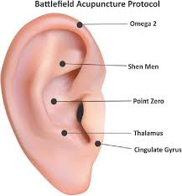

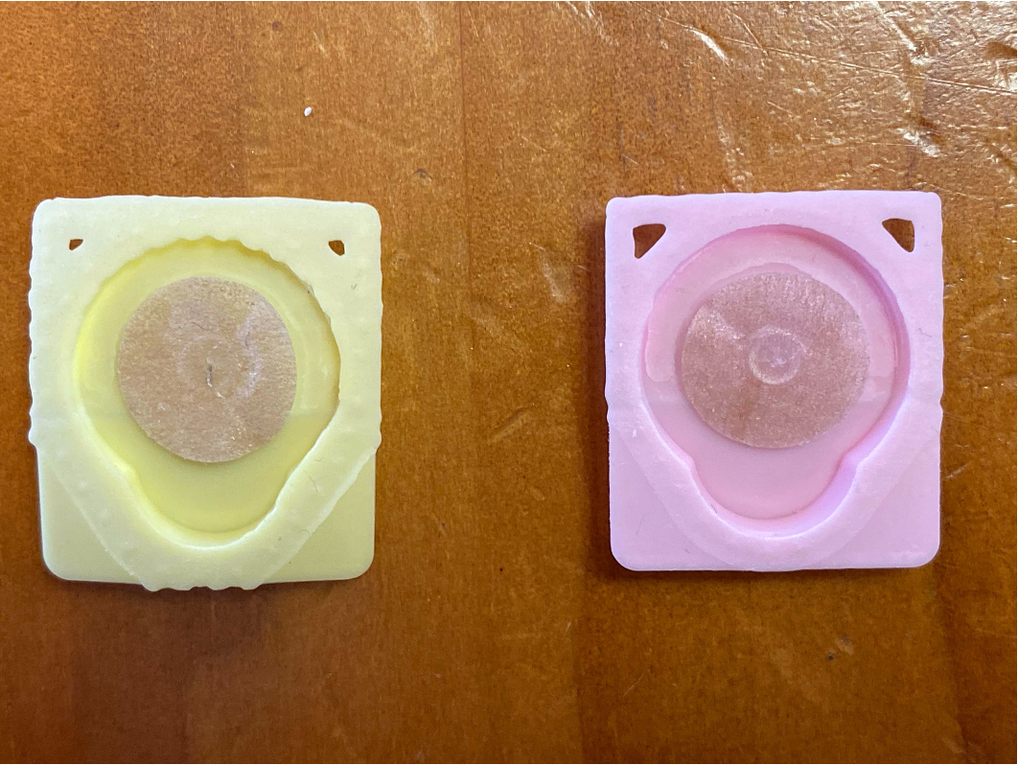
Without needle
With needle
Appendix 2. Body Acupuncture Points

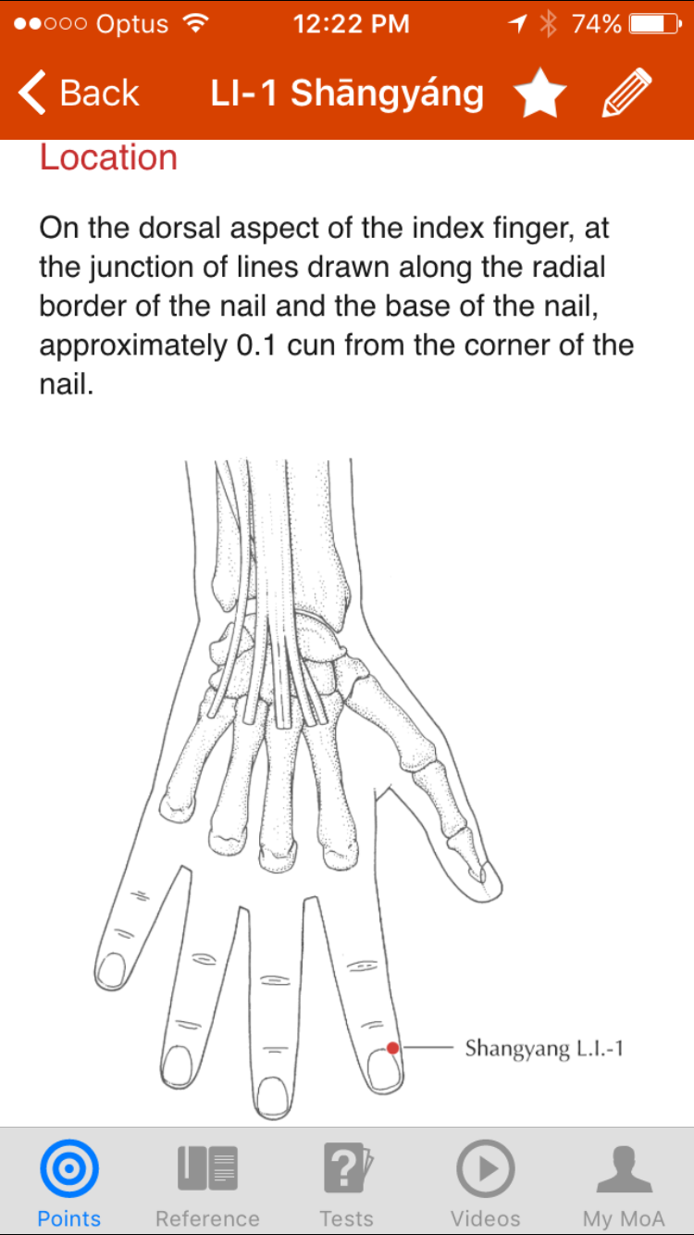
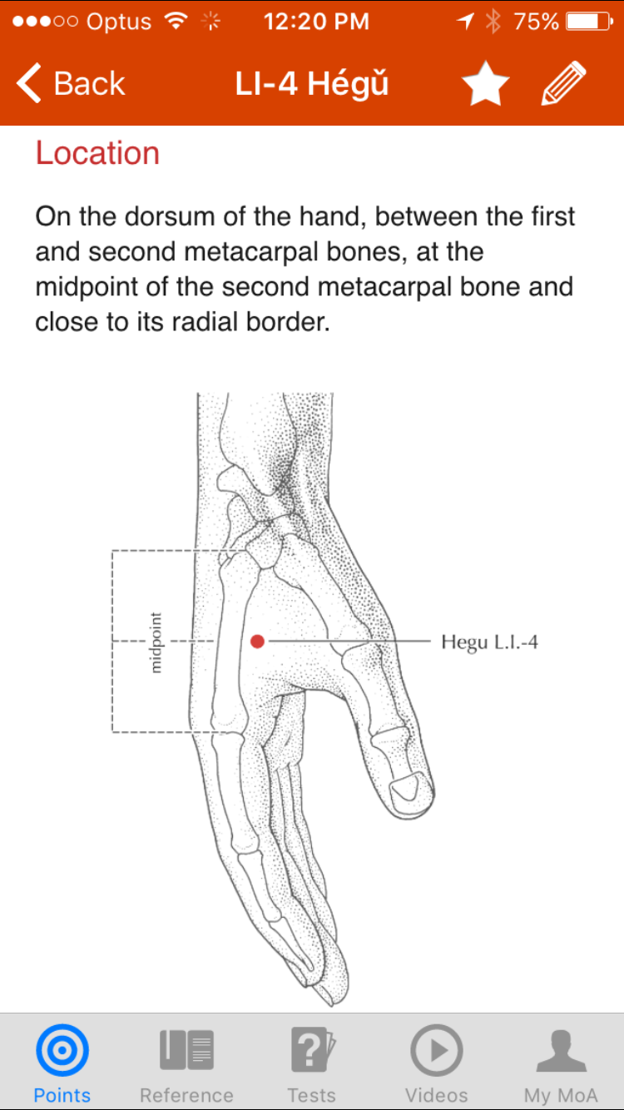

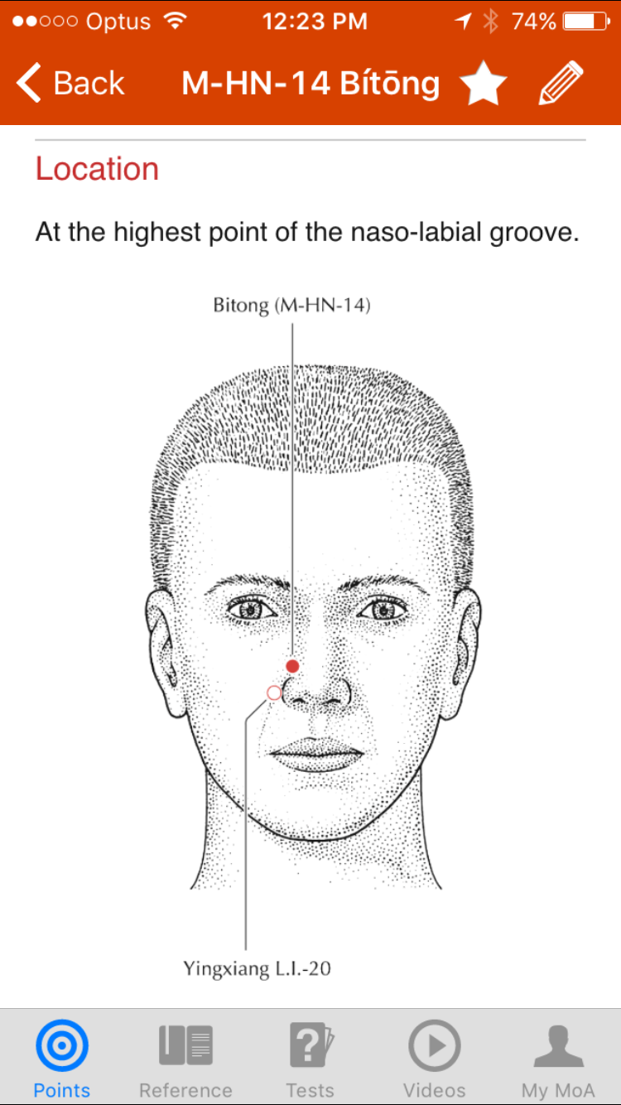
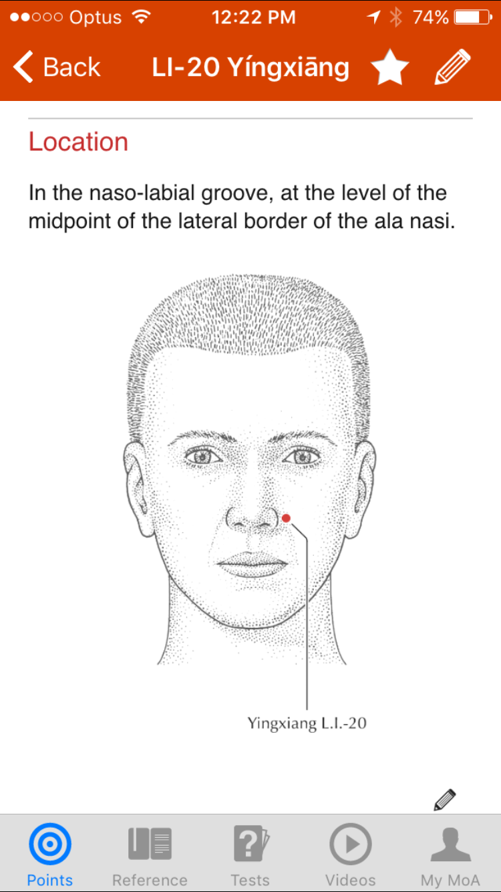

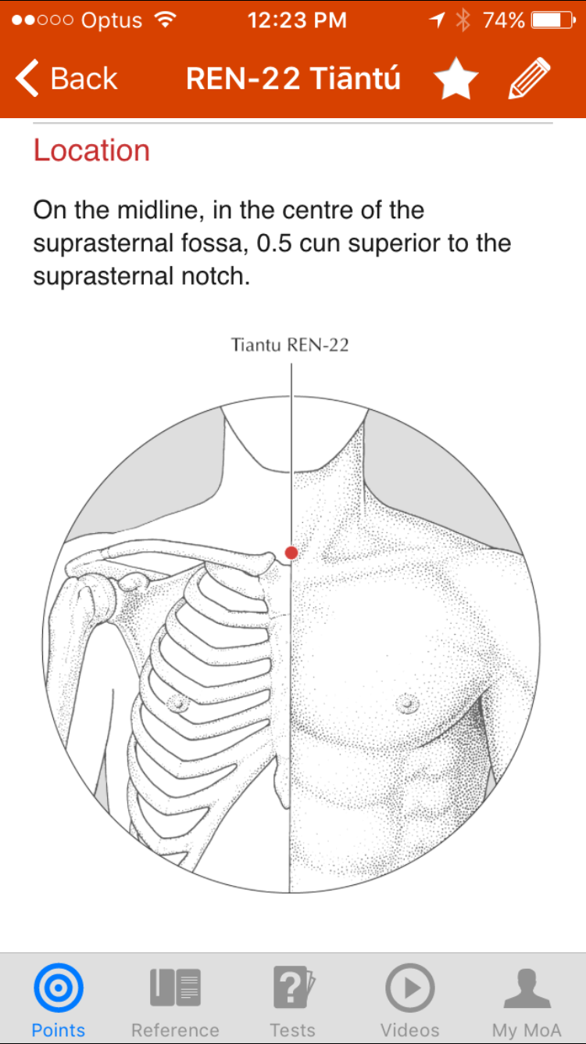
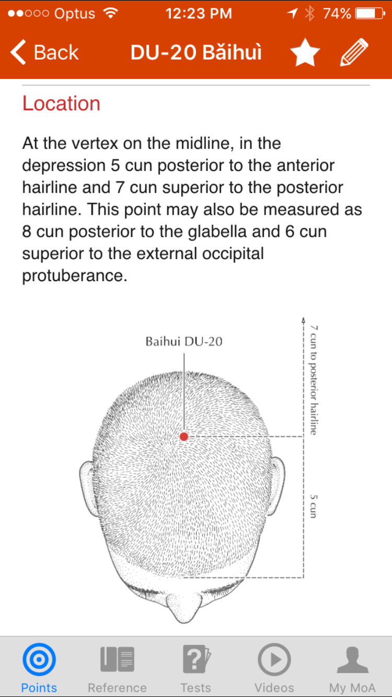

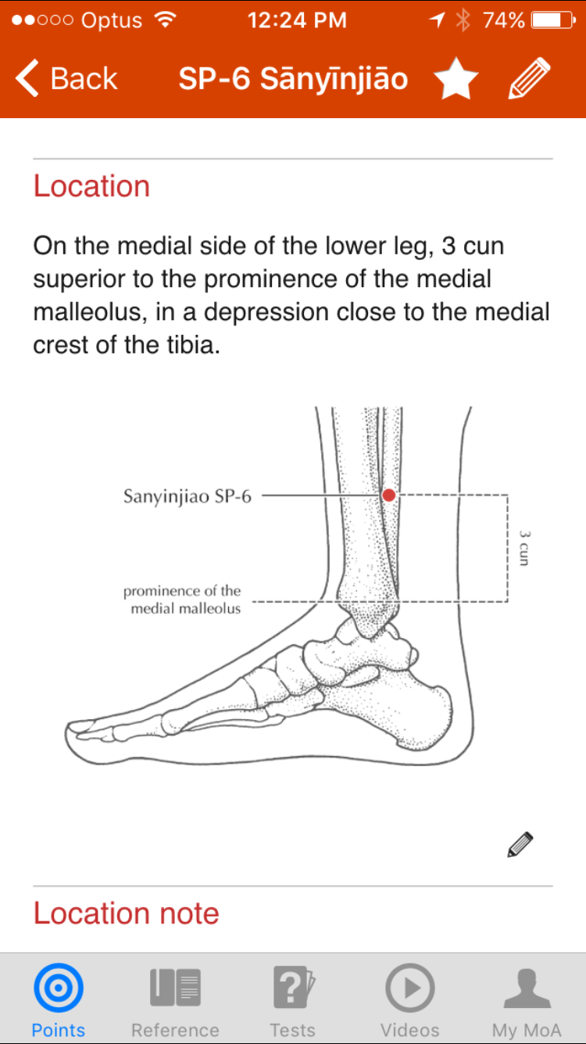
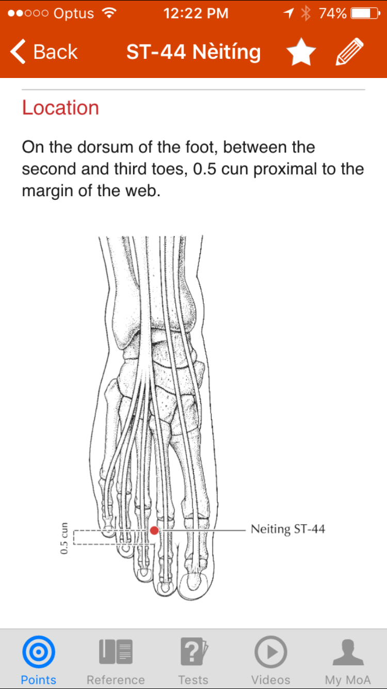

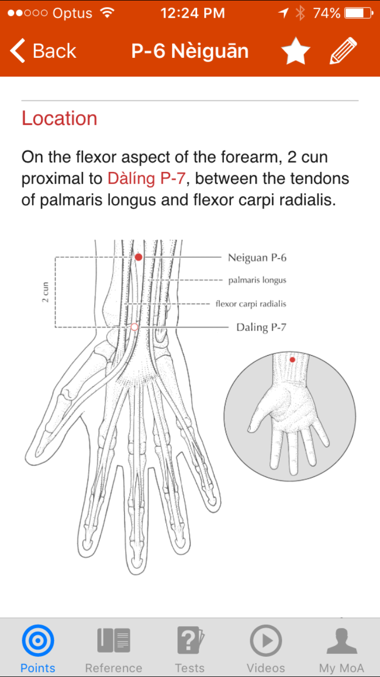

Appendix 3 - Information Sheet and Consent Form for Patients

You will be having a surgical operation to remove your tonsils and adenoids under general anaesthesia. On the day of surgery, you would be admitted to the hospital by a nurse on the surgical ward. You may be contacted by your anaesthetist by telephone before the day of surgery to discuss your procedure. Otherwise, your anaesthetist will see you before the operation to discuss the plan for general anaesthesia and pain management following surgery.

When you is brought to the operating room, an intravenous cannula will be inserted into your hand or arm, and this will generally remain in place until the following day. The acupuncturist will clean your earlobes with antiseptic wipes and then insert acupuncture pads onto your earlobes. They may have very small needles on them. These should cause minimal discomfort to you and should be left in place for 5 days. If you feel pain or discomfort at any time, you can remove them. Otherwise, you should remove them after 5 days.

Once the acupuncture needles are placed on your earlobes, general anaesthesia will be induced with a mixture of intravenous drugs and you will be kept anaesthetised for the duration of procedure. The surgery will then proceed, and usually will take about 30-60 minutes. When the surgery is finished, you will be transferred to the recovery room and allowed to wake slowly from the anaesthetic. When you are awake, and comfortable with your pain relief, you will be transferred back to the surgical ward.

This operation is well known to be associated with significant pain and possible vomiting after the surgery. Our standard pain management after tonsillectomy surgery is regular oral Panadol, with Endone tablets for breakthrough pain between doses of Panadol. Endone is a narcotic-based drug that has very effective pain relieving properties, but can impair breathing if large doses are given. Our aim is not to take away all pain, but to reduce pain enough to enable you to eat and drink while minimising the risk of respiratory depression. Most patients tolerate this pain relief regimen very well, experience manageable levels of discomfort, and should be able to go home after breakfast the next day.

Recent scientific evidence suggests that the use of acupuncture may help to improve pain control and dietary intake in patients after tonsillectomy. We would like to enrol you in a trial to help establish whether acupuncture does indeed significantly improve such outcomes after tonsil surgery. If you agree to enrol in this study, you will be randomly assigned to one of two groups – a control group, or a treatment group. If you are in the control group, you will receive the same standard regimen that we have been using at this hospital as outlined above. If you are in the treatment group, you will receive the standard regimen as above but with the addition of acupuncture treatment. This will be in the form of acupuncture pads on your ears and acupuncture needles on your body. On arrival to the operating room, the anaesthetist will put an intravenous needle into your hand in preparation for the procedure. He will then put very small acupuncture needle pads onto your ear. These contains very tiny needles that should not cause you any pain. These will stay in place for 5 days and you can remove them at home by yourself unless they have already fallen out by themselves. When you are under general anaesthesia, the anaesthetist will also put body acupuncture needles on your face, hands and feet. This body acupuncture will only be performed after you are under general anaesthesia, and you will not be aware whether you have had acupuncture or not. You will not feel any pain from the needle insertion. All these body needles will be removed before you wake up. The nurses in recovery and on the surgical ward will use a pain scale to assess your pain level in both control and treatment groups; this will be used to compare the two groups to see if there is any difference. Our pain management after surgery is identical in both groups, and you will otherwise be given the same treatment (as outlined above), regardless of which trial group you are assigned to.

Benefits:

By participating in this study, you will help us to determine whether acupuncture will benefit other patients having the same procedure in future.

If you are in the control group, you can be expected to have the same outcome following your surgery as has always been the case. If you are in the treatment (ie. acupuncture) group, then you may or may not experience additional benefits as a result of the acupuncture.

Risks:

If you are in the control group, then there is no additional risk. If you are in the treatment group, there may be risks related to the acupuncture procedure. These risks are very small, and as described in the scientific literature, include minor bleeding (<1:100,000), nerve injury (<1:1,000,000), and infection of the acupuncture site (<1:500,000). Minor bleeding from acupuncture can generally be stopped with gentle pressure. The risk of infection is minimised by using sterile acupuncture needles, by removing body needles as soon as the surgery is finished and by removing ear acupuncture pads after a maximum of only 5 days.

Consent form

I, , (name)

of , (address)

hereby consent to my participation in the study “ Acupuncture and Post-operative Tonsillectomy Analgesia”.

I have read the information provided about this study, and understand the potential risks and benefits. I have had the opportunity to ask questions regarding the details and the conduct of the study.

Signed

Date / /

