Children’s Health Queensland

Parent / Guardian Information Sheet

Project Title Preschool HABIT-ILE: A randomised controlled trial to determine efficacy of intensive rehabilitation compared to usual care to improve motor skills of children, aged 2 to 5 years, with bilateral cerebral palsy.

HREC Number HREC/19/QCHQ/59444
Investigators Assoc. Prof. Leanne Sakzewski, Prof Roslyn Boyd, Dr Sarah Reedman, Professor Yannick Bleyenheuft, Ms Kate McLeod, Ms Megan Thorley, Dr David Rowell, Dr Mark Chatfield.
Research Staff There will be other experienced occupational therapists and physiotherapists who will be trained to provide the intervention. University therapy students will also be involved and supervised by senior therapists.
Version Number: 3.0 Version Date: 9 June 2020

Thank you for taking the time to read this Parent/Guardian Information Statement and Consent Form. We would like to ask your child to participate in a research project that is explained below.

It is ok to say no

What is an Information Statement?

These pages tell you about the research project. It explains to you clearly and openly all the steps and procedures of the project. The information is to help you decide whether or not you would like your child to take part in the research. Please read this Information Statement carefully.

Before you decide if you want your child to take part or not, you can ask us any questions you have about the project. You may want to talk about the project with your family, friends or health care worker.

Important things to know

- It is your choice whether or not your child can take part in the research. You do not have to agree if you do not want to.

- If you decide you do not want your child to take part, it will not affect the treatment and care your child receives through Children’s Health Queensland

If you would like your child to take part in the research project, please sign the consent form provided by the Researcher. By signing the consent form you are telling us that you:

- understand what you have read
- had a chance to ask questions and received satisfactory answers
- consent to your child taking part in the project

We will give you a copy of this information and consent form to keep.

Body of Information Sheet:

What is the research project about?

This project is for young children with cerebral palsy (CP) aged between 2 and 5 years who have difficulties with movement on both sides of their body (bilateral CP). We are trying to see if a particular intensive therapy called Hand Arm Bimanual Intensive Training Including Lower Extremity Training (HABIT-ILE) can help to improve hand and gross motor skills.

Intensive therapies such as HABIT-ILE have mainly been used for children with CP who have difficulties moving one side of their body and all the studies have been for older school aged children. There has only been one small study of HABIT-ILE with children and teenagers with bilateral CP and results were promising. There are no other intensive movement training therapies for children with bilateral CP that have been studied in a randomized clinical trial.

This is a randomised controlled trial. That means that your child will have a 50% chance of receiving HABIT-ILE OR continue with their routine regular therapy program. If your child is randomised to the group that will continue to receive their regular routine therapy, they will still come for assessments. We don’t know if Preschool HABIT-ILE will be any better than routine regular therapy. By having one group who receives Preschool HABIT-ILE and one group who continues with routine regular therapy, this will help us to understand whether Preschool HABIT-ILE leads to greater outcomes.

- Who is funding the research project?

Ramaciotti Foundation Health Investment Grant (2019HIG/043)

University of Queensland, Faculty of Medicine

- What is involved?

Why is my child being asked to take part in the first pilot phase of the study?
We are asking your child to take part because he/she:
- Is 2 – 5 years, 5 months of age
- Has a diagnosis of CP and experiences difficulties with movement of both legs and one or both arms
- Is classified using the Gross Motor Function Classification System II, III or IV
- Is able to grasp light objects and lift their most impaired arm 15 cm above a table surface
- Is able to understand instructions and complete all the tests
- Does not have epilepsy uncontrolled by medication
- Has not had any orthopaedic surgery in the six months prior to the study period
- Does not have difficulties with vision that interfere with treatment and tests

What does my child need to do in this research project?

The project consists of three parts: 1. The therapy. Measurement of physical activity. 3. Test re-test reliability of the Both Hands Assessment

If you agree to be in the study, there are a number of steps:

- We will contact you with a 10-15 minute telephone call to talk about the project and ask you some questions to help us see whether your child meets the above inclusion criteria of the study.
- If we are not sure if your child meets these criteria we will organize an appointment to see you and your child to see whether he/she would benefit from Preschool HABIT-ILE.
- Then your child will be randomly assigned to a group as by the flip of a coin, completely by chance, to either Preschool HABIT-ILE or a control group who will receive therapy as usual over the study period. There is a 50% chance of getting in each group. It is totally random, like flipping a coin, so it is FAIR for everyone. It is not possible to know which group you will be in until after the first assessment.
- Preschool HABIT-ILE runs over 2 weeks. Your child will come to a group every day from Monday to Friday for 4 hours in the morning. There will be about 4 -6 children in the group. There will be at a minimum of one therapist/therapy student working with each child. If your child needs more help because of balance difficulties, one therapist will work with your child and one will be a “spotter”. There will be four supervising therapists including two senior occupational therapists and two senior physiotherapists who have extensive experience in working with children with CP and have been trained as supervisors for Preschool HABIT-ILE. They will be supervising and mentoring volunteer therapists/therapy students who will work directly with your child. They will undergo standardised HABIT-ILE training before the camp. All therapists are registered health practitioners. We will have therapy students helping with the camp and they will be closely supervised by our senior occupational therapist and physiotherapist. Therapy students have a valid ‘Blue Card’ working with children check. Each day will involve:
- Group welcome and song
- Practice of daily life goals that are important to you and your child,
- Playing with toys and games to encourage use of both hands
- Practice of gross motor skills through play
- Snack and lunch
We will video record each day so we can review the content of the program. Videoing of the daily sessions is compulsory to allow us to be consistent with the content across a number of different groups. You will be able to stay and participate in the program. We ask all parents to join us each day during the camp so you can see what your child is working on and talk with your child’s therapists about things you can work on at home with your child. If your child is distracted by having you there, you will be able to watch the therapy session from a viewing room with a one-way mirror.

- We will provide you with a small number of activities to practice at home. While we will be providing 40 hours of direct therapy, it is likely that the children will need more time to practice their skills in order to reach their goals. Your therapist will demonstrate each of the home practice activities. You might want to video these on your mobile phone to help you remember what to do. Your therapist will write the activities down. We will ask you to complete a home practice diary each day over 12 days (10 days camp, 2 days weekend). This involves recording how much time you spent, on what activities and provides you with an opportunity to write any comments you think are relevant. Your therapist will also check in with you each day to talk about how the home practice is going.

- One to four weeks before the therapy, your child will complete a number of tests and we will get you to do some questionnaires. There will be another appointment one to three weeks after Pre-school HABIT-ILE to complete the assessments again. We will do a final assessment six months following Preschool HABIT-ILE to determine whether any improvements from the intervention and kept in the longer term. The tests your child will do will be:

- Peabody Developmental Motor Scales: evaluates gross and fine motor skills for young children.
- Gross Motor Function Measure (GMFM): This measures how your child does different motor skills like sitting, walking, and running. The test takes about 30 minutes to do.
- Both Hands Assessment (BoHA): This measures how your child uses two hands together during a play session. The session is video-taped and is later scored by an occupational therapist who has been trained to use it.

We will ask you to do one questionnaire at the first assessment only and five questionnaires at each appointment and one questionnaire at the first and last timepoint only:
- Study Baseline Questionnaire: This questionnaire will be completed at the first assessment time only. We will ask questions about your child and family. We will also ask about medications your child might be using, any food allergies or intolerances and any other information we need to know for your child to attend Pre-school HABIT-ILE. We will also request your permission to access your child’s previous medical history and assessments. Specifically, we are interested in whether your child has had an MRI scan of their brain, or if they have had any previous medical interventions.
- Canadian Occupational Performance Measure (COPM): asks you to identify areas of difficulty in everyday activities and rate how you feel your child does an activity and how satisfied you are with how they do it. This helps to identify goals to work on in therapy and see if their goals are met as a result of the therapy. This takes about 15-20 minutes.
- Pediatric Evaluation of Inventory Computer Adapted Test (PEDI-CAT): You can do this questionnaire electronically on a laptop or tablet. There are four areas: The questionnaire gets you to rate how your child does a range of daily activities, mobility, cognitive/social abilities and how much assistance you provide your child to do everyday activities. This will take you up to 25 minutes to complete.
- Child Health Utility (CHU-9D): is a short questionnaire to measure health-related quality of life in children. The CHU-9D will be completed by you.
- ACTIVLIM-CP: is a questionnaire asking a range of questions about how your child performs daily activities that require use of the arms or legs or both. This questionnaire will be completed by you.
- Quality of Life (ITQOL): is a questionnaire measuring quality of life and is specifically developed for infants and toddlers. The ITQOL will be completed by you.
- Health Resource Usage Questionnaire (HRU): is a questionnaire to give us an idea about the type of healthcare and equipment your child uses. This is an important part of our assessment that will be used to determine the “cost benefit” of Pre-school HABIT-ILE. This questionnaire will only be completed twice, once before Preschool HABIT-ILE and then at 6 months after.
- Behavior rating Inventory of Executive Function – Preschool Version (BRIEF-P) This is a questionnaire to measure executive function (eg, memory; emotional control; planning and organising) in preschool aged children. The BRIEF-P will be completed by you.

Part 2. Measuring Movement with Devices

We want to improve our ability to measure improvements in your child’s gross motor skills, use of both hands together, and their physical activity. To do this, we need to use small devices with sensors inside. These sensors are the same as what are inside commercial smartwatches.

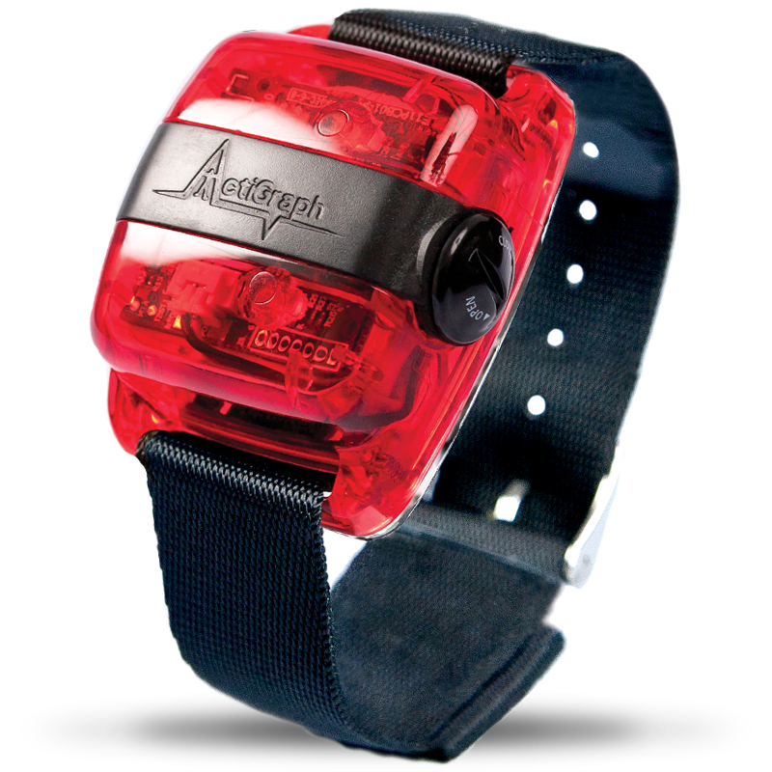
Just like a smartwatch, the devices do not emit anything harmful, sit on top of the skin, and do not cause any pain. Sometimes they can be uncomfortable if too tight, but we will do everything we can to fit them properly so your child does not experience any discomfort. We sanitise the devices between users.
- ActiGraph GT3X-wBT: a watch-sized device with red plastic housing, secured on an elastic belt or watchband. The ActiGraph contains a motion sensor inside which records information about how the device is moving in space. We will ask your child to wear:
  - 1 ActiGraph on each wrist
  - 1 ActiGraph only on the less affected ankle
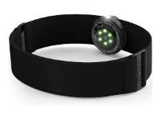
- Polar OH1 Optical heart rate sensor: a coin-sized device with green flashing lights that point towards the skin. It is secured on an elastic band. Blood flowing under the skin scatters light in a predictable way, so the sensor can use the information from the green flashing lights to estimate your child’s heart rate. This tells us how hard they are exercising. We will ask your child to wear:
  - 1 Polar OH1 on one upper arm

We will ask your child to wear the devices
- During all assessments
- During the camp

We will show your child how safe and comfortable the devices are, and allow them to try wearing them. If, after this, they still do not want to wear the devices, we will not put the devices on your child.

Part 3. Test re-test reliability of the Both Hands Assessment.

This reliability study will help us to see whether the Both Hands Assessment is stable over time. This is important for us to understand and will help us interpret how meaningful changes are on this assessment in response to preschool HABIT-ILE. To do this, we need to do the assessment twice, close together. The first time, will happen when your child has their baseline assessment. If you are interested in being a part of this study, we will arrange a time that is suitable to you to visit you and your child at home within 2 weeks of the baseline assessment. Alternatively, if you have another visit scheduled at the Queensland Children’s Hospital within two weeks of the first assessment, we can arrange a time to coincide with your visit. Our occupational therapist will do the second Both Hands Assessment with your child at home/or at the Queensland Children’s Hospital. This will be videotaped and scored later by an occupational therapist who is certified. This assessment will take between 20 and 30 minutes.

Your child can still be involved in Part 1 (The Therapy) even if you do not want them to participate in the Part 2. Measuring Movement with Devices or Part 3. Test re-test reliability of the Both Hands Assessment. We will ask you which parts of the study you agree to participate in.

- What if I wish to withdraw from the research project?

My decision whether or not my child participates will not prejudice their future relations with Children’s Health Queensland. If I decide for my child to participate, I am free to withdraw my consent and to discontinue participation at any time. The decision to withdraw from the study will not affect their routine medical treatment or their relationship with the person treating them.

- What are the possible benefits for my child and other people in the future?

If your child is randomized to receive Preschool HABIT-ILE it may help improve his/her hand and gross motor skills. Irrespective of the group your child is allocated to, he/she will continue to receive their usual therapy care. If we show Preschool HABIT-ILE is helpful, then occupational therapists and physiotherapists working with other children with bilateral CP to improve their hand and gross motor skills can use it.

- Alternative Treatment

At the moment, there are no other intensive group therapies for young children with bilateral CP aimed to improve hand and gross motor skills that have been tested in a randomized trial and shown to work.

- What are the possible risks, side-effects, discomforts and/or inconveniences?

The assessments will happen at the Centre for Children’s Health Research (QLD) or at the Queensland Children’s Hospital, however these appointments will be planned to minimize any inconvenience to you. The only inconvenience to you and your child is the time that the assessment and training will take – The assessments will take approximately 1 hour each. Doing the pre-school HABIT-ILE program might be tiring, so it is important your child has plenty of rest time in the afternoons. If you feel throughout the program that it is too much time for your child, we will be able to schedule rest breaks throughout. The camps run for 4 hours/day, so if your child is younger they might find it a bit tiring.

- What will be done to make sure my child’s information is confidential?

Confidentiality
- All results of assessments/questionnaires will be stored without your child’s name on them.
- A number is used to identify the assessments. This number is linked to your child’s name but the linking file will be kept confidential and only made available to the researchers.
- We will use electronic forms and all information will be kept on a database at the Queensland Cerebral Palsy and Rehabilitation Research Centre, South Brisbane Queensland. Any paper forms that we use to record the assessments and questionnaires will be stored in a secure filing cabinet and only the researchers will have access to this information. The paper forms containing assessment or questionnaire results will be kept at the Queensland Cerebral Palsy and Rehabilitation Research Centre in Brisbane in a locked filing cabinet. Under current Queensland law, no information will be destroyed.
- Videos of the therapy sessions and assessments will be kept at the Queensland Cerebral Palsy and Rehabilitation Centre on a secure University of Queensland server.
- If we give talks or write about the results of this project, we will not use any names or identifying details.

- Compensation

This trial is covered by standard clinical trials insurance. That means you may be entitled to make a claim if you believe your child suffers an injury as a result of their participation in the study. You may request a copy of the terms of this insurance.

- Who should I contact for more information?

If you would like more information about the project or if you need to speak to a member of the research team in an emergency please contact:

Name: | Associate Professor Leanne Sakzewski
Contact telephone: | 07 30697345
Email: | l.sakzewski1@uq.edu.au

The Children’s Health Queensland Hospital and Health Service Human Research Ethics Committee (HREC) has approved this study. If you have any concerns and/or complaints about the project, the way it is being conducted or your child’s rights as a research participant, and would like to speak to someone independent of the project, please contact the HREC Coordinator on:
3069 7002 or email CHQETHICS@health.qld.gov.au

