Strain sUrveillance during Chemotherapy for improving Cardiovascular OUtcomes
(SUCCOUR-MRI Study)

PROTOCOL
(Version: 11, November 2019)

IMPRESS INVESTIGATORS

Chief Investigator
Professor Tom Marwick MBBS, PhD, MPH

Study Site-Investigators
A/Prof Andre La Gerche, Dr John Atherton, Dr Sudhir Wahi, Dr. Mitra Shirazi, Dr. Liza Thomas, Dr Constantine Tam, Dr Willis Lam, Dr Ben Fitzgerald, Dr Leighton Kearney, A/Prof Piyush Srivastava, Dr James Otton, Prof Kazuaki Negishi, Dr Peter Dias, Prof Joseph Selvanayagam

FUNDING
Software and logistics support is being provided by GE Medical Systems. Investigator initiated study with site self-funding. The study is further supported by the National Health and Medical Research Council (NHMRC).

CLINICAL TRIAL REGISTRATION
The SUCCOUR Study is registered with the publically accessible Australian New Zealand Clinical Trials Registry (ANZCTR) and an Australian New Zealand Clinical Trials Registry Number (ANZCTRN) is ACTRN12614000341628.

Co-ordinating centre
Baker Heart and Diabetes Institute
Melbourne, VIC 3004
+61 03 8532 1550 +61 03 8532 1160
tom.marwick@baker.edu.au

STUDY SITES –
Royal Brisbane Hospital, Brisbane (Dr John Atherton)
Princess Alexandra Hospital, Brisbane (Dr Subhir Wahi)
Baker Heart and Diabetes Institute, Melbourne (Dr Andre La Gerche)
Royal Adelaide Hospital, Adelaide (Dr. Mitra Shirazi)
Westmead Hospital, Sydney (Dr. Liza Thomas)
Peter MacCallum Cancer Centre (Dr Constantine Tam)
Cairns and Hinterland Hospital and Health Service, Queensland (Dr Willis Lam)
HeartCare Partners Brisbane, Milton (Dr Ben Fitzgerald)
HeartCare Victoria, Heidelberg, Bundoora, Doncaster East (Dr Leighton Kearney)
HeartCare Victoria, Mulgrave and Berwick (A/Prof Piyush Srivastava)
HeartCare Victoria, Ringwood (A/Prof Piyush Srivastava)
HeartCare Western Australia, Murdoch (Dr Peter Dias)
Liverpool Hospital, Liverpool (Dr James Otton)
Nepean Hospital, Kingswood (Prof Kazuaki Negishi)
Flinders Medical Centre, Adelaide (Prof Joseph Selvanayagam)

FUNDING
Supported by a Project grant from the National Health and Medical Research Council of Australia (NHMRC).

CLINICAL TRIAL REGISTRATION
The SUCCOUR Study will been registered with the publically accessible Australian New Zealand Clinical Trials Registry (ANZCTR) and an Australian New Zealand Clinical Trials Registry Number (ANZCTRN) is ACTRN12614000341628 (Date Registered: 31/March/2014).

ethics and good clinical practice statement

The SUCCOUR Study has been designed and will be performed according to the principles of the International Conference on Harmonisation (ICH) and the guidelines of Good Clinical Practice (GCP) enunciated within the Declaration of Helsinki. Specifically, this study will follow the National Statement on Ethical Conduct in Research Involving Humans written by the National Health and Medical Research Council (NHMRC) and the Note for Guidance on Good Clinical Practice (CPMP/ICH/135/95) produced by the Therapeutic Goods Administration (TGA), both of which are the Australian ethical standards against which all research involving humans, including clinical trials, are reviewed.

The study will not commence without written approval from appropriate Human Research Ethics Committees (HRECs) that comply with the NHMRC National Statement. Primary ethics approval will be sought and obtained from each participating site. All participants will provide written informed consent prior to study commencement. The Protocol and Participant Information and Consent Form will be reviewed and approved by a properly constituted HREC before study start as acknowledged by a signed and dated Ethics Approval Certificate.

Table of Contents

1. background 6

2. STUDY Rationale 9

3. study hypotheses & study endpoints 7
3.1 Hypothesis 9
3.2 Primary End-Point 9
3.3 Secondary End-Points 9

4. METHODOLOGY 9
4.1 Study Design 9
4.2 Study Centers 10
4.3 Study Timelines and Follow-up 11
4.4 Participants 11
4.5 Screening and Recruitment Procedures...……………………………………………11
4.6 Baseline Profiling 12
4.7 Randomisation 12
4.8 Heart Failure Intervention 13
4.9 Visits 13

5. LV FUNCTION 13
5.1 Echocardiograms 13
5.2 CMR (MRI) 14

6. DATA 14
6.1 Data Collection and Management 14

7. SAFETY 14
7.1 Clinical Safety 14

8. STATISTICS 15
8.1 Study Power 15
8.2 Statistical Analyses 15

9. APPENDIces (Tables/Figures) 17

1. background
As cancer therapies and survival have improved, millions of patients treated with cardiotoxic therapy are now cancer survivors (1). For early stage breast cancer, a patient is more likely to die from heart disease than cancer (2). The reported incidence of LV dysfunction varies from 5-15% and HF varies from 0-5%, but reports from the SEER-Medicare database in the USA show a cancer cohort treated from 2002-7 to have a 3 year incidence of heart failure or LV dysfunction of 18-42%, depending on the treatment group (3).

1.1 Magnitude of the problem. Cardiotoxic drugs are widely used in the treatment of haematologic malignancy, sarcoma and breast cancer (4). The cardiac risks of anthracyclines are dose-related (4,5), but LV dysfunction has been documented with doses under the usual threshold of 450mg/m² doxorubicin (or equivalent) (6). Despite efforts to avoid these drugs, for example replacing them with docetaxel-based protocols in breast cancer (7), they are effective and remain widely used. In addition, a number of non-anthracycline therapies used in cancer treatment are cardiotoxic – principally monoclonal antibodies and tyrosine kinase inhibitors. For example, trastuzumab (Herceptin), a very effective therapy used in conjunction with anthracyclines in the particularly aggressive cancers over-expressing the growth factor receptor gene HER2 (8,9), increases the cardiotoxicity risk from anthracyclines. Left ventricular (LV) dysfunction is noted in 19-32% of patients in studies administering trastuzumab after anthracycline-based chemotherapy (10-12) and alone (3). Cardiotoxicity is likely to become an increasing problem as many small molecules and kinase inhibitors have adverse effects on the heart similar to trastuzumab (4), and with the increasing age and comorbidity status of the treated population.

1.2 Definition of cardiotoxicity. Clinical presentations with HF offer unequivocal diagnosis of cytotoxic-induced cardiomyopathy, but are an undesirable diagnostic criterion, as this type of HF has been reported to have a poor prognosis, with a 2 year mortality of up to 60% (13). As late-stage HF has such an adverse prognosis, attention has been directed towards recognition of Stage B HF (SBHF; patients with structural disease but without signs and symptoms of HF) (14). SBHF benefits from treatment with beta-blockers and ACE inhibitors. While SBHF is readily defined after myocardial infarction, its recognition in patients with diffuse disease is more challenging, and LV function markers may be of value (15).
Figure 1. CMR measurement of LVEF. Accurate quantitation is facilitated by high contrast and spatial resolution.
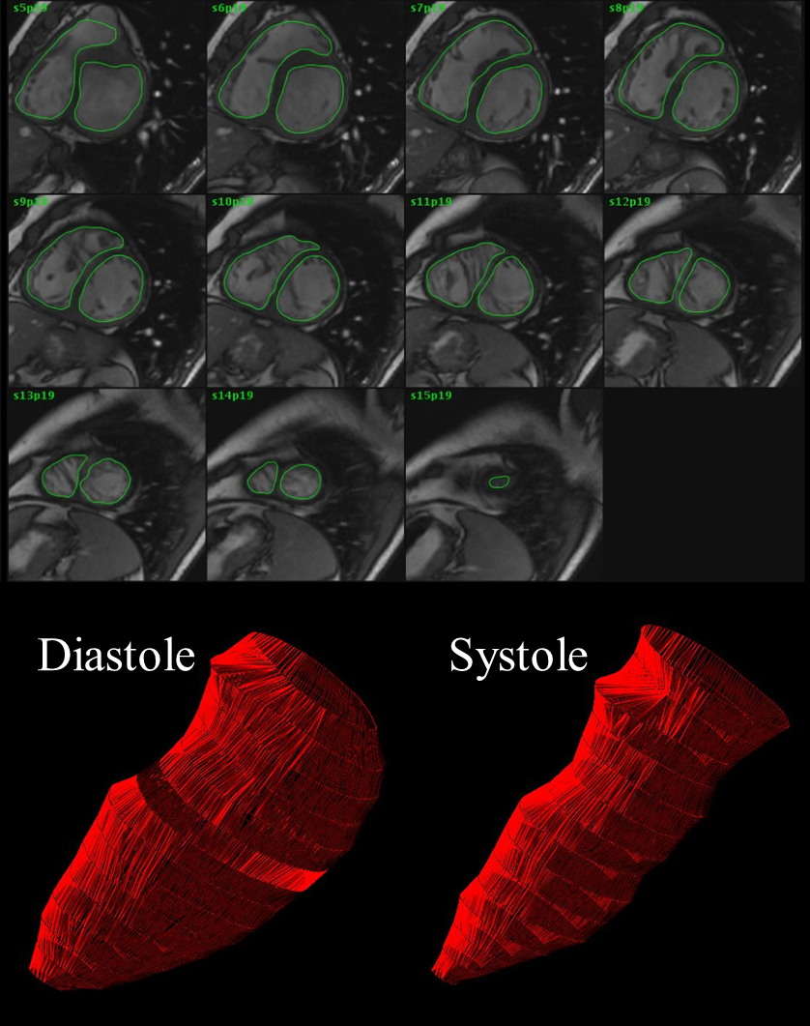

Left ventricular ejection fraction (LVEF), commonly assessed by echocardiography, is an important predictor of outcome, and is widely used to monitor LV systolic function after chemotherapy. New guidelines propose that symptomatic LVEF reductions >5% or asymptomatic reductions of >10% to <53% constitute cardiotoxicity (16). However, echo measurement of LVEF presents a number of challenges related to image quality, assumption of LV geometry and expertise (17). The coefficient of variation (CV) for repeated echo recording is reported to be 12% (18), so this method fails to detect subtle alterations in LV function. Three-dimensional echo (3DE) has greater reproducibility and accuracy (19). However CMR is now the gold standard for the assessment of LV size and ejection fraction (20), and possesses two fundamental advantages over echo. First, image acquisition is not limited by availability of a suitable acoustic window, nor is image quality degraded by factors that may affect the propagation of ultrasound waves through tissue. Second, the entire LV can be easily imaged with contiguous short axis cine imaging slices enabling calculation of LV size and ejection through the “summation of discs” method (Figure 1). As a result the CV for repeated CMR measurement of LVEF is approximately 4% (21), or about one third that described for echocardiography. However, the cost and availability of CMR have left this as a reference method. LVEF by all methodologies is dependent on haemodynamic conditions, and this parameter is not as sensitive to minor changes as measurements of myocardial deformation.

Two-dimensional strain (2DS) is an automated and quantitative technique for the measurement of global long-axis function from gray-scale images (22). The application of relatively simple steps permit the acquisition of reproducible measurements, even by non-experts (23). Normal ranges have been well defined (24,25). Our preliminary work has shown that strain (GLS) is a superior predictor of outcome to EF (26,27). Strain is more sensitive than typical indices such as LVEF to small changes in systolic function, and CI-A has applied it in a variety of situations to identify subclinical ventricular dysfunction, as well as document changes in response to treatment (28-32). Recent work by CI-A and -B (33-36) and other groups (37) has shown that changes in tissue deformation, assessed by myocardial strain, identify LV dysfunction earlier than conventional echocardiographic measures in patients treated with chemotherapy. Thus, 2DS may help the clinician recognize the chemotherapy patient who has evidence of myocardial abnormalities, as demonstrated by abnormal deformation, and this result should be treated as Stage B HF.

A variety of cardiospecific biomarkers, including troponin, C-reactive protein and natriuretic peptide (e.g. NT-proBNP) have also been used to identify cardiotoxicity, and – especially cardiac troponin elevation - may have higher prognostic value than imaging modalities (38). However, what we need is not so much a predictor of risk, but a marker of risk that is amenable to intervention. Cardinale et al (39) have shown that patients with troponin elevation in response to trastuzumab are unlikely to recover cardiac function after the initiation of HF therapy. While biomarkers are more convenient than imaging and a good marker of risk, they may not provide the optimal screening strategy to facilitate decision-making. Nonetheless, falls in NT-proBNP are an interesting endpoint as LV distension is rarely a feature of early disease and hence would reflect the anti-inflammatory effects relevant to both ACE inhibition and carvedilol.

1.3 Potential strategies to reduce cardiotoxicity. Of potential strategies to address cardiotoxicity, late treatment.is not an option, so the choice is between prevention and early treatment.

The three possible prevention approaches all pose problems. First, avoidance of the causative agents has been contemplated, but these are very effective agents for the treatment of cancer. Second, using an inhibitor of the specific effect of anthracyclines might be cardio-protective (40), but dexrazoxane has never entered routine use – in part because of concerns about potential loss of tumor cytotoxic effect. The third possibility would be to use cardioprotective strategies that may be effective – observational studies have proposed angiotensin converting enzyme inhibitors (ACEi) or receptor blockers, statin therapy or beta-blockers (41) to be protective. Several small clinical trials have provided positive results (42-45). The fundamental problem with all three prophylactic approaches is that all patients need to be considered for the intervention, despite the fact that at least 80% will never develop cardiotoxicity. This is particularly a concern when the use of vasoactive medications has been considered on a prophylactic basis, as the risk of side-effects (especially dizziness and hypotension) has been documented in 20% of cancer survivors (45).

The alternative strategy is based upon early detection of myocardial disease, with either biomarkers or imaging, followed by treatment of subclinical dysfunction (Figure 2). The attraction of this approach is that there is potential benefit for any such patient, and those without dysfunction are not burdened by treatment. The disadvantage is that screening has to be sufficiently accurate to identify most or all at risk patients, and that some patients have progressed to sufficient damage as to prevent a full response. Nonetheless, this approach has been effective with ACE inhibitors (46), and beta blockers (BB) may be effective (see below). Ongoing surveillance is important, as the response rate progressively decreases with increasing delay between the time from the end of chemotherapy to the start of HF. Cessation of chemotherapy is generally not necessary.

However, these observational data are insufficient to justify a change of practice to the use of strain for surveillance – first because the data are non-randomized and second because there is no evidence that the identification and treatment of subclinical dysfunction will change the outcome of these patients. The purpose of this application is to perform a randomized study which will define the value of strain in guiding patient management with cardioprotective therapy.

1.4 Preliminary data. The current reference standard for the assessment of cardiotoxicity is EF (16). In a study of the best echocardiographic method for sequential quantification of EF in patients undergoing cancer chemotherapy with stable strain over up to 5 time points (19, 77 citations), the test-retest variation of 2DE was at the level of change required for diagnosis of cardiotoxicity. Although 3DE and CMR are less variable, EF probably is not the best marker of early toxicity.

CIA was one of the initial investigators to show the value of changes in strain as a predictor of subsequent reductions of EF (which define cardiotoxicity), initially with tissue-velocity based strain (33). One of the initial studies using 2D speckle strain for this purpose was published by CIB (35, 51 citations), and CI-A’s subsequent study of 81 consecutive women with speckle strain (34, 43 citations), the strongest predictor of reduced EF (i.e. cardiotoxicity) was ΔGLS (AUC 0.82), with an optimal cut-point of 11% reduction (95% CI 8-14% reduction), seen in 21 patients. A similar report was made independently by CI-B (47, 10 citations), who also reported changes in diastolic function (48, 17 citations). A subsequent meta-analysis documented the evidence base for using strain to identify cardiotoxicity (37, 67 citations), and helped to inform guidelines.

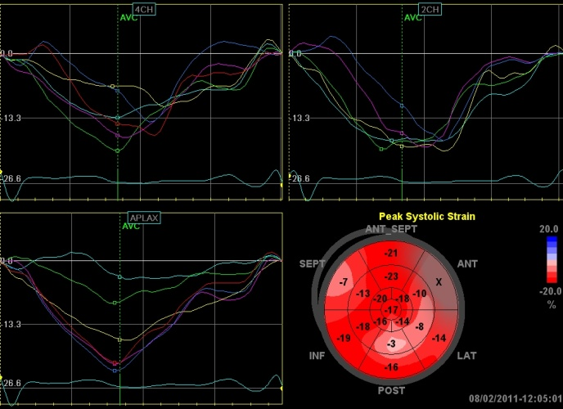 | 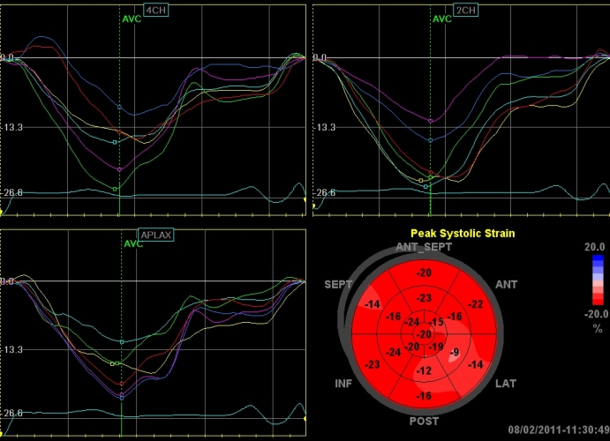
Figure 2. Detection and treatment of subclinical dysfunction. In this patient with initially normal EF and strain, GLS was reduced to -15.3% at 3 months (left). After initiation of beta blockade and without change in blood pressure, 6 month GLS (right) was -18.3%.

The CIs have also worked on potential cardioprotective strategies. In a study of 628 newly-diagnosed female breast cancer patients treated with anthracycline (49), continuous statin treatment was found to have a protective effect on new-onset HF (HR=0.3 (95% CI 0.1-0.9, p=0.03). In a recently published paper (50), beta-blocker agents (BB) were protective against HF in 920 patients without established structural heart disease who were receiving cardiotoxic therapy (HR=0.2, 95% CI 0.1-0.5, p=0.003). A systematic review and meta-analysis (41, 51 citations) combined the existing evidence base for the treatment of cardiotoxicity and its prevention. This information has informed the authors’ subsequent work on cardioprotective strategies. In an observational study of 140 patients (48±14yo, 109 women), the strategy of restricting therapy to patients with reduced strain (51, 17 citations), 42 (30%) demonstrated decreased strain with chemotherapy. Those who were treated with beta blockers showed significant EF increase after 6 months (from 52.6±5.6 to 57.4±6.0%, p<0.001) but non-BB patients showed no change (p=0.001 between groups). Cardiotoxicity developed in none of BB treated and 20% of untreated patients.
A pilot to the proposed study (n=50) has shown cardiotoxicity (Figure 3), 29 have reached 3-month follow-up, and 19 reached 6 month follow-up. Of these, 3 (10%) have developed evidence of cardiotoxicity on EF grounds and 10 (33%) have developed abnormal GLS. The pilot study has shown that the planned study is highly feasible and the objectives are achievable.
Figure 3. Pilot data showing EF and GLS response.
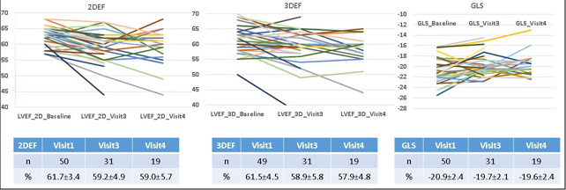

Finally, the investigators have developed a Markov model (52) to compare the strategies of treating all “at risk” patients versus an imaging–based strategy of identifying and treating patients with LV dysfunction defined by strain and EF. This model, informed by the literature, shows the current “usual care” approach based on EF to be the least effective, with a GLS-guided approach being the most effective. We seek to confirm this from prospectively-gathered data.

2. STUDY Rationale
This randomized study will define the value of cardioprotective therapy in patients with subclinical LV dysfunction.

3. study hypotheses & study endpoints

3.1 Hypothesis
The Strain sUrveillance during Chemotherapy for improving Cardiovascular OUtcomes (SUCCOUR-MRI) Study will test the following hypothesis (see Section 3.3):
The use of adjunctive therapy (cardioprotection) will limit:
- The development of impaired ejection fraction (EF) at 12 months by MRI (primary outcome)
- Interruptions to planned chemotherapy

3.2 Primary End-Point
Consistent with the study hypothesis, the primary study end-point is change in CMR ejection fraction from baseline to one year, as determined by a blinded core laboratory (Baker Institute, Prof Andrew Taylor) and analyzed on an intention-to-treat basis according to randomisation to treatment or no treatment in patients with subclinical LV dysfunction.

3.3 Secondary End-Points
Secondary endpoints (from baseline to 12 months) will be:
- Development of cardiotoxicity – i.e. a categorical analysis of reduced LVEF concordant with the recent guidelines (reduction of LVEF of more than 5% to less than 50% with symptoms of heart failure, or an asymptomatic reduction of LVEF of more than 10% to less than 50%).
- Comparison of the rate of completion of the planned chemotherapy among groups.
- Comparison of the rate of heart failure among groups.

4. METHODOLOGY

4.1 Study Design
The study hypotheses will be examined via a multi-center randomized controlled trial (PROBE design). Baseline imaging will be performed in patients at risk of cardiotoxicity. Those developing reduced strain (in the absence of EF diagnosis of cardiotoxicity) will be randomized to cardioprotective therapy with beta blockers and ACE inhibitors, or no treatment.

This study will be based on the CONSORT guidelines for the practice and reporting of randomised trials. Figure 4 shows the overall design of the SUCCOUR-MRI Study.

Incident heart failure will be assessed by data linkage and/or chart review at 3 years.

Figure 4: Study Design

Baseline | N = 1100 [patients undergoing chemotherapy at increased risk of cardiotoxicity (see text 4.4)]  Echo, MRI
3-9M | Echo 3M, 6M, 9M
Group allocation by echo at 3-9M | Group A (n=154)  ↓ GLS only at any time | Group B (n=198)  ↓ EF or ΔEF threshold at any time | Group C (n=748)  GLS + EF  preserved
Management | Randomise to one of the below:  - ACEi + BB  - No initial Rx  Group A moves to Group B if ↓ EF or ΔEF threshold | Discontinuation visit with MRI  Physician guided care | No treatment  Group C moves to Group A if ↓ in GLS  Group C moves to Group B if ↓ EF or ΔEF threshold
12M | Echo, MRI |  | Echo only
36M | Any new HF via data linkage or chart review

Group A: Reduction in strain only. Randomised to ACEi + BB or no treatment. 3D echo at months 3,6,9,12. MRI at 12 months. Review of data or data linkage will occur at 36 months.

Group B: Any reduction in EF <50% or change in EF > threshold at any time during 12 months regardless of group allocation a discontinuation visit is to be performed with an MRI. Physician-guided care is followed. Review of data or data linkage will occur at 36 months.

Group C: Strain and EF are preserved. 3D echo at months 3,6,9,12. No MRI at 12 months. Review of data or data linkage will occur at 36 months.

4.2 Study Centers
In this multi-center study, participants will be recruited from Australia. The coordinating site will be the Baker Institute, with responsibility for data management and core imaging laboratory for primary endpoint determination. Randomisation and data entry will be completed by each site through REDCap.

We will recruit 1100 patients at 14 sites over 4 years. In order to complete study enrolment, each site is expected to recruit ~80 patients.

4.3 Study Timelines and Follow-up
Participant recruitment utilising this current protocol is planned to commence in mid-2018 and conclude in late 2021 (42 months in total). All outcome data will be censored 36 months following the recruitment of the last patients

4.4 Participants
This study will be conducted in patients undergoing chemotherapy at increased risk of cardiotoxicity (see below). Individuals can participate in the study if they fulfil inclusion criteria i or ii, and iii-iv and fulfil none of the exclusion criteria as described below.

Inclusion Criteria:
- Patients undergoing chemotherapy at increased risk of cardiotoxicity;
At least 1 planned cycle of anthracycline after consent (prior to commencement OR already commenced and up to an including 3rd dose) WITH one of the following (not necessarily concurrently)
- Trastuzu-mab (Herceptin) in breast-cancer with the HER2 mutation OR
- Tyrosine kinase inhibitors (e.g. sunitinib) OR
- Cumulative anthracycline doses >450mg/m2 OR
- Chest radiotherapy (left sided) OR
- Treatment for previous cancer (solid or haematological) that involved treatment with anthracycline (any dose) or chest radiotherapy OR
- Increased risk of HF (age >65y, type 2 diabetes mellitus, hypertension, previous cardiac injury e.g. myocardial infarction)
- OR patients who have completed anthracycline treatment but will continue to be treated with other cardiotoxic treatments such as Trastuzu-mab (Herceptin), Tyrosine kinase inhibitors or left chest radiotherapy during the course of surveillance
- Live within a geographically accessible area for follow-up
- Are able and willing to provide written informed consent to participate in the study (this includes the ability to communicate fluently with the investigator and that the patient is mentally competent)

Exclusion Criteria:
- Unable to provide written informed consent to participate in this study
- Participating in another clinical research trial where randomized treatment would be unacceptable
- Ejection fraction at baseline echo <50%
- Valvular stenosis or regurgitation of >moderate severity
- History of previous heart failure (baseline NYHA >2)
- Systolic BP <110mmHg
- Pulse <60/minute if not on BB
- Inability to acquire interpretable images (identified from baseline echo)
- Contraindications/Intolerance to beta blockers or ACE inhibitors
- Contraindications to MRI
- Oncologic (or other) life expectancy <12 months or any other medical condition (including pregnancy) that results in the belief (deemed by the Chief Investigators) that it is not appropriate for the patient to participate in this trial
- Taking concurrently ACEi/angiotensin-receptor blocker/entresto AND BB

4.5 Screening and Recruitment Procedures
Based on profiling patients undergoing chemotherapy for those at increased risk of cardiotoxicity, we seek 1100 patients who will be subject to the following screening and recruitment process:

STEP 1: Identification of potentially eligible participants
At each referral site, a range of recruitment strategies targeting potentially eligible subjects will be applied. These reflect the different institutional settings and will include:

- Detailing of oncology teams
- Posters and information brochures for patients and relatives being treated for cancer at the health care facilities attached to each centre
- A “Consent to Contact” will be given to potentially eligible individuals who meet the inclusion/exclusion criteria by referring doctor (only applicable to participants being referred to Baker Institute for investigations from other referral sites)

STEP 2: Initial risk profiling of at risk individuals (Eligibility Visit)
After informed consent is obtained, baseline echo imaging will be used to identify whether image quality is suitable for enrolment. Suitable patients will proceed to imaging.

Baseline echo and baseline MRI can be obtained up to two weeks apart if no change in chemotherapy treatment occurs during this period. If chemotherapy treatment is changed during the two weeks, the baseline echo must be repeated and performed within a week of the baseline MRI.

4.6 Baseline Profiling
The following baseline data will be collected by participant self-report and verified by personal interviews with the individual if required:

- Demographic profile: age, sex, marital status, social support, income, education, ethnicity and language;
- Chemotherapy and radiotherapy treatment
- Treatment(s): existing prescribed medications (if any) and type of non-pharmacologic treatments (if any). The following should be archived on the CRF;
MRI-compatible permanent pacemaker
Diuretics
Anticoagulants
Antiarrhythmic drugs
ACE inhibitors (cannot concurrently be on BB)
BB (cannot concurrently be on ACEi)
Statins
Antidiabetics or other drugs known to cause provoke fluid retention (e.g. NSAIDs)
- Clinical profile: this includes a physical assessment to measure height, weight, waist and hip circumference, blood pressure, vital signs and past/concurrent cardiac and non-cardiac disease states including history of cardiovascular risk factors (DM, Hx smoking, total cholesterol), known CAD, valvular heart disease, NYHA class.
- Functional/general and mental health status: Health-related quality of life (EQ-5D-5L) complete questionnaire
- Neoplastic history – type of cancer
- Pathology renal function, glucose level, routine troponin assay
- ECG - arrhythmia assessment, conduction abnormalities

4.7 Randomisation
Consenting individuals will be tracked with imaging. If there is a reduction of global longitudinal strain by >12% in any of the follow-up echocardiograms (3,6,9 months), as compared to baseline, the patient will be randomized to initiation and titration of heart failure therapy or no treatment (see below). Those that develop impairment of strain (Group A) will be centrally randomised using a computerized protocol at a ratio of 1:1 ACEi and beta blockers vs no treatment. Randomisation for the participating centres will be applied through RedCAP.

Because patients are being randomized to therapy that is not specifically registered for this purpose, this study is being performed under a CTN registered with the TGA.

Patients with a significant drop in EF as per conventional imaging will be referred for heart failure therapy irrespective of global longitudinal strain.

4.8 HF Intervention
Patients in Group A (reduced strain but no/subthreshold change of EF) will be randomized to two possible strategies of follow up: study treatment or no treatment (Figure 4).

Study treatment: This intervention is based upon the use of ACEi with beta blockade, based on evidence that HF patients derive most benefit from combined therapy. In a study of incremental effectiveness in HF, yearly mortality with diuretics was reduced from 12% to 10% with ACEi, but to 7% with ACEi and BB (54). By protocol, these patients will be initially treated with Ramipril at a dose of 1.25 or 2.5mg (according to baseline systemic arterial pressure), once or twice a day, and gradually up-titrated to 10mg/day, or to the maximal-tolerated dose. In patients receiving at least 2.5mg/day of Ramipril, Metoprolol will be started at an initial dose of 50 (25mg twice a day) and progressively up-titrated to the maximal dose of 100mg/day. Dose-equivalents of other agents may be used if for some reason, these two agents are not feasible

Titration schedule
Weeks since starting therapy | 0 | 2 | 4 | 6 | 8 | 10
Ramipril (mg/d) | 2.5 | 5.0 | 5.0 | 5.0 | 5.0 | 10.0
Metoprolol (mg/d) | 0 | 0 | 50 | 75 | 100 | 100

Patients will be seen every 2 weeks during the up titration phase. At each of these visits, symptom status (fatigue, dizziness), BP and HR will be obtained. If patients complain of side-effects or the HR is <50/minute, the dose should be reduced to that prior to the last increment.

4.9 Visits
Patients will be seen every 3 months, unless in Group A during titration. Study procedures to be completed at each visit is detailed in Table 1. At medication titration follow-up, the baseline clinical history and physical exam will be repeated, attending to drug accountability concurrent medications, and adverse event assessment – especially relating to symptom status (fatigue, dizziness). Additional therapy can be given at the discretion of the clinicians involved. Concomitant medications and interventions are allowable for standard of care treatment, but use should be archived on the case report form.

If patients complain of side-effects or the HR is <50/minute, the beta blocker dose should be reduced to that prior to the last increment.

Discontinuation criteria – Group B;
- Symptoms consistent with myocardial dysfunction (dyspnea, reduced exercise capacity), side-effects of therapy (fatigue), progression of myocardial dysfunction (EF<50%, dyspnea, reduced exercise capacity).
- Asthma
- Conventional imaging: If there is a symptomatic drop of more than 5% of ejection fraction, or a 10% asymptomatic drop of ejection fraction to EF <50%, the patient will be referred for physician-guided care of cardiotoxicity.

5. LV FUNCTION
5.1 Echocardiogram
A key feature of this study is on-site strain (GLS) measurement to further delineate risk of cardiotoxicity. It is important that this occurs at the site, as that is how the test will be used in practice. A standardised training and accreditation program will be coordinated through GE Medical Systems to ensure that each lab undertaking “point-of-care” CIMT measurement will obtain accurate images.

Patients will undergo an echocardiogram at baseline (defined by start of anthracycline with other risk factors, anthracycline up to and including 3rd cycle, or anthracycline and Herceptin). Testing will be repeated every 3 months (3,6,9,12 month), using standard measurements as follows:

- M-mode assessment of LV mass
- 2D echo assessment of LV volumes and EF, with contrast used if necessary. If contrast is used at baseline, it should be used at all other visits. Contrast use should ONLY be performed after acquisition of all other measures especially LV strain
- 3D echocardiography assessment of LVEF will be performed by acquiring a full- volume dataset using a matrix array transducer. Using offline analysis software (the same software should be used for each visit), this dataset will be manipulated to derive conventional 4-chamber, 2 chamber and short axis views. After selection of annular and apical reference points, a 3-dimensional endocardial shell will be constructed using semi-automated contour tracing. The resultant end-diastolic and end-systolic volumes will be used to calculate 3D- LVEF (EchoPAC 3DLVQ). Cardiac magnetic resonance (CMR) is the most reliable means of measuring EF, but is not suitable for all patients (those with implantable ferrous devices are excluded), nor is it universally available. Hence the use of 3DE will ensure that an appropriate endpoint will be available for all patients. CMR will be performed using a steady-state free precession (SSFP) protocol to measure EF. All baseline and final 3D images will be subsequently sent to the core laboratory at the Baker Institute for independent blinded measurement. In addition, a random 10% of strain images will be quantified at the core lab for verification of on-site measurements.
- Transmitral flow will be measured using pulsed-wave Doppler at the leaflet tips, aligned with the direction of LV filling. Mitral E and A waves, and medial and lateral mitral annular velocities (e’) will be measured. The class of diastolic dysfunction was determined using the E/e’, LA size and age-predicted normal range for E wave deceleration time as follows: class I – delayed relaxation; class II – pseudonormal filling (normal deceleration time for age in the presence of LA enlargement); and class III – restrictive filling (short deceleration time).
- Left atrial volume will be calculated from the apical 4- and 2-chamber views using the Simpson’s rule method.
- In addition to standard echocardiography, the three apical views will be acquired at increased frame-rate (50-70frames/second). Cine-loops of 5 cardiac cycles will be saved digitally and analyzed offline, to allow Doppler-independent strain and strain rate to be assessed using offline semi-automated speckle tracking techniques (Echopac, GE Medical Systems). Timing of the aortic valve opening and closure will be obtained using single-gated pulsed wave Doppler traces. The three apical views will be used to obtain an average global peak systolic longitudinal strain and peak systolic longitudinal strain rate, with systole manually defined by aortic valve closure. After initial tracing of the endocardial border and software processing, the operator will confirm adequate tissue tracking. Segments unable to be adequately tracked will be excluded.

The calculation of mean strain will be derived from model of the entire LV. All measures will be made in a blinded fashion by a single observer

5.2 CMR (MRI)
Cardiac magnetic resonance (CMR) will be performed using an SSFP protocol to measure EF. These data will be used purely to characterize response, and patients will not be allocated to treatment groups based on this finding. After CMR, Group A patients will be randomized to intervention or no treatment. Patients with reduced EF will be treated as usual and those with preserved EF will be observed (Figure 4). Follow-up will be performed on all patients, with CMR-EF in Groups A and B. On participant request, oral or sublingual Alprazolam 0.5 – 1mg will be provided as an anxiolytic.

6. DATA

6.1 Data Collection and Management
Data will be collected at each visit. This will include:
- Baseline profiling data
- Titration data
- Follow-up visit data
- Echocardiogram parameters
- CMR parameters
- Safety data
- Discontinuation data.

7. SAFETY

7.1 Clinical Safety
Safety evaluations will be performed by recording adverse events (AEs), serious adverse events (SAEs), and by monitoring laboratory parameters, physical examinations, ECGs and vital signs. The following cardiac events will be considered:

1) Sudden death;
2) Cardiac death;
3) Overt HF requiring hospitalization, including acute pulmonary oedema;
4) Serious arrhythmias requiring treatment; and
5) Conduction disturbances requiring a permanent pacemaker implantation.

Routine monitoring of adverse events will be provided by a Data & Safety Monitoring Board (3 review physicians + independent statistician). Interim analyses of feasibility on the ITT population (to monitor recruitment and site performance) and safety will be performed at 6-monthly intervals in patients who receive at least one dose of the study combination. An independent interim analysis of efficacy will be performed when 50% of the expected number of events has been observed. Type 1 error will be controlled using the O’Brien Fleming method with a Lan-DeMets alpha-spending function. The two-sided alpha will be 0.006 at the interim analysis and 0.044 at the final analysis.

Study data capture, analyses and archiving will be coordinated via the Baker Institute using well established resources. Investigators and/or research nurses will enter the information required by the protocol into REDCap. Non-obvious errors or omissions will be recorded on data query forms which will be returned to the investigational site for resolution. Study monitors will verify randomly selected study data against source documents via a systematic auditing program.

8. Statistics

8.1 Study Power
An early (3-6 month) reduction in strain is expected in 32%, with reduction of EF in 18%, so there is a reduction in strain only in 14%. To obtain 154 patients to show reduced strain alone (Figure 4), we will recruit 1100 patients at 5 sites over 4 years.

Cardiotoxicity (reduced 12 month EF) will be anticipated in;
- 2% in those with preserved strain and EF (Group C) at 3-6 months,
- 20% with reduced 3-6 month strain with preserved EF (Group A),
- 35% in untreated and 12% in treated patients with reduced EF (i.e. risk reduction of 60%) (31).

Based on a similar risk reduction in patients with reduced 3-6 month strain, 70 completed patients per group would give >90% power to identify a difference with a 5% probability of type 1 error, allowing for the greatest possibility of clustering due to differences in care at different sites (ICC 0.05). At lower ICC values (0.02), the study power would be 95%.

8.2 Statistical Analyses
The study has a primary endpoint (based on CMR-derived EF) and two secondary endpoints – completion of chemotherapy (first) and HF (second). In order to preserve alpha, we plan to test these endpoints sequentially such that if the null hypothesis of the primary endpoint is rejected, we will proceed to the first secondary endpoint, and if this null hypothesis is rejected, we will proceed to the second secondary endpoint.

Efficacy. The main analysis concerns the randomized subjects in Group A. The primary efficacy analysis will be undertaken when a minimum of one year of follow-up is completed on all subjects under continuing observation. Kaplan-Meier methods will be used to illustrate HF-free survival proportions and estimate median survival for each arm. The primary analysis will compare the survival in the two arms using a log-rank test. Cox proportional hazard models will be used to estimate the hazard ratio and its 95% confidence interval, and to make adjustment for factors that (by mischance of randomization) are not balanced between the treatment arms. Possible confounders include type and dose of cardiotoxin, individual co-morbidities associated with HF (such as vascular disease) and collectively summarized by the Charlson co-morbidity score, medication history, possible contraindications to treatment, and prescribed medications. There will be prespecified subgroup analyses, based on the main underlying aetiologies. Analysis will be based on intention to treat (ITT), and missing data will be addressed by multiple imputation.

Efficacy analyses in Group B will be performed by t-tests and by multivariable linear regression. Outcomes in Group C will be used to inform the Markov model.

Per-protocol analyses. Supportive per-protocol analyses will be undertaken with adherence to medication assessed using the medication possession ratio (MPR) based on dispensing records obtained with patient consent from the trial pharmacies.
Figure 5. Health states in the prevention of cardiotoxicity.
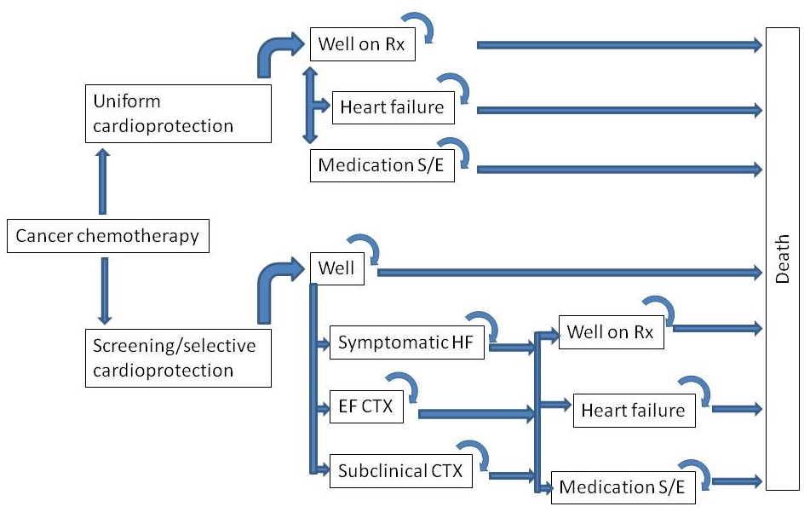

Cost-effectiveness analysis. A Markov model (Figure 5) has been constructed to study the cost-effectiveness of imaging-guided and uniform cardioprotection (52). This will be informed by the risks of LV dysfunction and HF, costs of testing and therapy, and health status from the quality of life questionnaires. CIA has completed multiple similar models since his Quantitative Methods training.

A Clinical Safety and Efficacy Committee (CSEC) led by an experienced clinician will review the safety findings at the end of each year and the efficacy findings after 2 years. All endpoints will be blindly adjudicated (including determination of probable causality). The CSEC will use the Haybittle-Peto stopping rule at a p=0.001 level of significance (which is unlikely).

Table 1. Study procedures
Study Procedures | Screening/ Baseline | Month 3 | Month 6 | Month 9 | Month 12 | Month 36 | Early Discontinuation Visit
Informed Consent | X
Medical History ª | X
Physical Exam | X |  |  |  |  |  | X
12 Lead ECG (with arrhythmia assessment, conduction abnormalities)^{b} | X |  |  |  |  |  | X
Echocardiogram | X | X | X | X | X
CMR | X |  |  |  | X* |  | X
Questionnaire (EQ-5D-5L) | X | X | X | X | X
Vital Signs (BP, HR, RR) | X | X | X | X | X
Usual care labs | X | X | X | X | X
Concomitant Medications | X | X | X | X | X
AE/SAE Assessment | X | X | X | X | X | X
Heart Failure Assessment (NYHA-HF)-see attachment 1 | X | X | X | X | X | X
Chemotherapy Regimen & Review ^{c} | X | X | X | X | X
Review for dispensing/continuing cardioprotective drug ^{d} |  | X | X | X | X
Medication Compliance (pill counts) |  | X | X | X | X

a- History of cardiovascular risk factors, known CAD, valvular heart disease; BMI, side of breast cancer, Hx DM, Hx smoking, total cholesterol
b- 12 lead ECG
c- Time from chemotherapy completion to HF symptoms; Interruptions in planned chemotherapy; completion or discontinuation of chemotherapy
d- Patients who have strain evidence of cardiotoxicity are randomized to cardio-protective therapy
X* - MRI to be completed at month 12 for Group A only

