Research design

Recruitment for Study Population
To test our hypothesis, up to 600 healthy adult Caucasian males will be recruited from the general population using advertisements in national and local newspapers. We note that we are specifying a single racial group to reduce haplotype diversity [34].
Individuals will be eligible for this trial if they are:
- Caucasian male
- Aged between original 45-65, subsequent 20-80 years
- Have no history of treatment for cancer in the previous 5 years, excluding non-melanoma skin cancers.
- Are not taking any dietary supplement.
- Able to attend local study centre for evaluation
We will require that individuals complete a validated food frequency questionnaire [46], and provide limited family baseline demographic and medical history. A blood sample will be requested in order to measure SNPs in 6 genes, as identified above. Individuals will continue being recruited until we have the minimum number per genotype group.
In order to estimate the required sample size for this study, a simple parametric t-test approach is assumed. Although more sophisticated statistical methods will be applied to the data, this simple assumption provides a reasonable platform for the calculation of power. Performing a paired sample t-test (samples taken before and after Se supplementation) for each SNP genotype, for each of the six genes requires 18 hypothesis tests. Power calculations are based on use of the Bonferroni adjustment to account for multiple testing, under the assumption of test independence. Although the tests are likely to be dependent, treating them as independent will result in a conservative estimate of sample size requirements, making it likely that power is underestimated here. Based on the data of Gill et al. [47], a sample standard deviation of 10 is assumed for the power calculations. For a two-sided paired sample t-test using an alpha level of 0.05/18=0.00278 (Bonferroni correction), 23 samples are required to detect a change in response of 10 (25%) with a power of greater than 90%. Assuming a 15% drop-out rate, this level of power can be achieved with 27 patients per SNP genotype. SNP genotype frequencies in the preliminary data indicate that the rarest genotype (homozygous LL in GPX1) occurs in approximately 0.047 of the population. To achieve an expected sample size of 27 for this genotype requires a patient population of 27/0.047=574, which is slightly less than the proposed sample size of 600. Thus, based on the available data, a sample of 600 patients is expected to provide at least 90% power to detect a 25% change in response in any of the 18 SNP genotypes under investigation, with less than a 5% chance of any false positives across any of the 18 tests.

Initial Cohort Assessment
Initially following recruitment and prior to Se intervention, one 10 ml blood sample will be collected and immediately either frozen or processed immediately for DNA extraction and SNP analysis. Either TaqMan^{R} or restriction fragment length polymorphism (RFLP) methods will used to estimate frequencies of known polymorphisms in genes for the 6 key selenoproteins identified in table 1 [16, 31, 35, 37, 38, 40, 41, 43, 45].

Second cohort assessment
Once we are certain we have the required numbers in each genotype group, we will again invite the subjects into the Nutrition Unit. We will request a set of 4x10 ml blood samples, as well as providing Se tablets for intervention (see below). One blood sample will be immediately frozen for safe keeping. A second will be immediately processed for estimation of DNA strand breaks (COMET assay) and subsequent enzyme assays, while the third will be processed to provide a serum sample, which will be stored for Se and cytokines analysis. The fourth sample will be collected for RNA and protein expression profiling.

The primary assays that will be performed on all this second group of samples are described below:

Serum Se will be measured for all samples using hydride generation atomic absorption spectrometry (Instrumentation Laboratories, Model 951 dual channel AAS equipped with a single slot burner head) using protocols of Hershey & Oostdyk [48] as described in Karunasinghe et al. [8]. These assays will be done at Alpha Scientific, a branch of Gribbles Veterinary Pathology, Hamilton, New Zealand.

Antioxidant enzyme activity will be measured as GPX and TR activities in hemolysates stored at -80ºC. GPX activity will be assayed using the protocol of Wendel [49] modified to suit a 96 well plate format. TR activity will be assayed using the protocol of Smith and Levander [50].
COMET assay (Standard): The single cell gel electrophoresis (or COMET) assay provides a measure of either single or double strand DNA breaks (or other damage) at the level of the single cell [25].

COMET assay (H₂0₂ challenge): A variant of the COMET assay exposes WBC ex vivo to DNA breaking agents such as hydrogen peroxide (H₂O₂), as a measure of the way in which a dietary regime has enhanced the innate ability of the cells to repair DNA damage [51].

Pro-inflammatory cytokines: Plasma samples will be stored frozen at -80ºC and assayed as a group at baseline and after supplementation. The plasma levels of the pro-inflammatory cytokines IL-6, IL-1β and TNF-α will be measured on a Luminex 100 using Linco multiplex bead technology [31]

Selenium Intervention Study
At their second visit, all individuals will receive 6 months of supplementation with 200μg/day Se as selenised yeast, and blood samples will be collected immediately before and after this dietary intervention. This time is based on a pharmacokinetic model of supplementation with selenomethionine metabolism that shows a long whole body turnover time, reflecting both the re-utilization of Se, and the slow turnover time of muscle tissue which is presumed to be one of the largest body pools for selenomethionine. Selenised yeast provides Se mostly in the form of selenomethionine [52]. This was the form of Se used in the demonstration of human cancer protection by Clark et al. [53, 54], and our own preliminary studies described above. We have organised a supply of standardised Se yeast for this study (Alltech). Pills will be dispensed to each subject after their initial visit, and again at 3 months. We will ensure quality control of samples so that selenomethionine content is standardised. We will also analyse batches to ensure they are not deteriorating with time.

Secondary analyses:
Subgroups will be identified on the basis of genotype and initial biomarker data, for further analyses as below. We will consider the following, on groups of 20 individuals of each of the identified genotype (60 total per sample group). We will attempt to make these groups as homogeneous as possible for other genes:

Se-P variants: We will consider implication of SNPs in this gene for carrying Se into the serum, using an ELIZA method of analysis.
Lipid peroxidation: We will measure serum levels of the F2 isoprostane, 8-isoprostane (8-isoprostaglandin F_{2a}), following Winterbourne and co-workers [55]. Isoprostanes are stable oxidation products of arachidonic acid that are formed specifically as a result of lipid peroxidation, and are considered a highly reliable marker of lipid peroxidation. We will use the Eliza Kit provided by Cayman Chemicals, Ann Arbor.

Selenoprotein expression profiling: The combination of gene and protein expression profiling will be a powerful tool for the identification of the mechanism(s) of action of selenoproteins in cancer prevention. This approach has been used successfully in other studies, for example to identify the pattern of gene and protein expression in peripheral blood cells of rheumatoid arthritis patients [56, 57]. The novel pathways associated with selenoprotein activity will be the target for further SNP analysis on blood WBC DNA in future studies.
RNA will be pooled from 20 subjects carrying the GPX1 CC variant, 20 with the CT variant and 20 with the TT variant, before and after Se supplementation. It will be hybridised for transcript profiling using Agilent full genome oligonucleotide arrays, to identify genes and/or signalling pathways where Se and selenoprotein metabolism is altered in a manner that correlates with phenotypic measures of cancer risk. Pooled extracted proteins (from the same blood samples used to prepare RNA) will be used for two-dimensional protein gels. Differentially expressed proteins on these gels will be trypsin-digested, and the resulting proteolytic fragments identified using MALDI-TOF and other MS methodologies [57].

Table 2: Proposed samples, analyses and time scheduling
Subjects |  | Assessment  or sample | Analysis | Visit 1 | Visit 2 | Visit 3
All | Selected
 |  | Current health
 |  | Medical history
 |  | Lifestyle questionnaire
 |  | Dietary questionnaire
 |  | Blood
 |  | WBC-DNA | SNPs (table 1)
 |  |  | COMET assay (Std)
 |  |  | COMET assay (H₂0₂ challenge)
 |  | Serum | Se
 |  |  | GPX activity
 |  |  | TR activity
 |  |  | Cytokines
 |  |  | Isoprostanes
 |  |  | SeP
 |  | WBC-RNA | Selenoprotein gene expression profiling
 |  | WBC-protein | Selenoprotein expression profiling

Data Analysis
All analyses will be based on intention-to-treat, and will be performed to address the main aims of the study. In each case this involves investigating the effect of SNP genotypes on the dependent variable of interest, while taking the effects of diet, serum Se levels and other clinical variables into account. Analysis of covariance (ANCOVA) will be used for each of the analyses, with dependent variables including measures of DNA damage from the COMET assay (baseline level, and change in response from baseline to six months), antioxidant enzyme activity and pro-inflammatory cytokines. Initial analyses will take a parametric approach, with non-normality of residuals then leading to the use of distribution-free methods (e.g., bootstrapping) if required. In addition to analysing the various dependent variables separately, the data will also be combined for use in a multivariate analysis (multivariate multiple regression containing both continuous and categorical variables) in order to take likely correlations between the dependent variables into account. This will provide additional power for studying the effect of SNP genotype on the various outcome measures.

Trial Organisation
Nutrigenomics New Zealand will provide complete project management services including study management, recruitment, data management, quality monitoring, biological assays, documentation, and statistical analyses.

Timeline
Jul – Dec 2006 | Convene study management committee, finalise study design and data collection materials, recruit staff and obtain ethical permit.
Jan 2007 | Commence recruitment for clinical trial
Jan – Apr 2009 | Data collection and follow-up
July 2008 - Jun 2009 | Data analysis and project report

Significance
We would anticipate that this study approach will lead us better understand the design features in scaling up populations or individuals to the personalised advice that is essential to reduce cancer risk in high risk groups. The concept of a “genome health” clinic has been recently discussed by Fenech [1]. He proposes that data such as obtained as a result of our pilot study can be integrated into an overall health strategy, utilising information from “genome health diagnostics” including biomarkers of chromosomal damage such as the COMET assay. Applying this concept to Se would involve interrogating serum Se and key SNPs, and comparing this with information in a “Genome Health Nutrigenomics” database, containing data on the genome stability response to dietary treatment in relationship to genetic background.
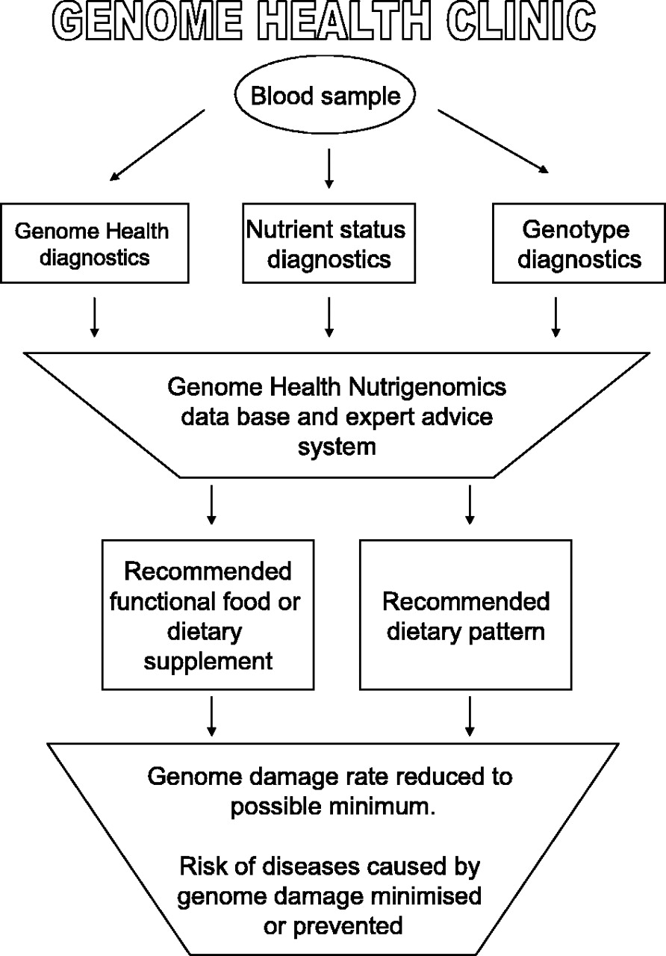
Fig. 2. Genome health concept,
as outlined by Fenech, 2005[1]
The Ministry of Health and New Zealand Cancer Control Trust have issued the following statements about cancer control in New Zealand [58, 59]: “Cancer is a major public health issue in New Zealand, as in other economically developed countries. It ranks second as a cause of death (after cardiovascular disease), accounting for more than a quarter of all deaths in the late 1990s”. Cancer control is an organised approach to reducing the burden of cancer in our community through prevention, screening and early detection, treatment, support and rehabilitation, and palliative care. Cancer control has therefore been given a high priority by the Government. The aim of reducing the incidence and impact of cancer is one of the 13 population health objectives of the New Zealand Health Strategy, which was launched in December 2000. It is also the key aim of the New Zealand Cancer Control Strategy. The Minister of Health has agreed to the establishment of a Cancer Control Council. The Council's key objective will be to lead the sector to successfully implement New Zealand's Cancer Control Strategy, of which the key purposes are to:
  - reduce the incidence and impact of cancer
  - reduce inequalities with respect to cancer.”
The first goal of this strategy is to reduce the incidence of cancer through primary prevention”.
Epidemiologic studies have shown a consistent trend for populations with low Se levels to have a higher mortality from cancer [8,10]. The selection of New Zealand as the centre for this present study, and the selection of Se as the first nutrient for which we will explore methodology for nutrigenomics, is justified by the exceptionally low Se levels in the soils and in the population of New Zealand. While the Se intake in the New Zealand population has increased by about 50% since the large-scale importation of wheat from Australia [58], the blood Se levels in an Auckland cohort are still low by international standards.

6. Dissemination of results
We anticipate that the major vehicle for dissemination of results would be in international refereed journals and at International Conferences on Selenium and/or Nutrigenomics. In addition, however, there are public health messages to be gained from this study. Media releases may well be appropriate.

