


VOLUNTEER INFORMATION SHEET
The impact of age on the acute effects of whey protein intake on blood glucose, plasma insulin concentrations and underlying gut mechanisms

YOUR PARTICIPATION IS VOLUNTARY
You have been asked to take part in a study conducted by Dr Stijn Soenen, Dr Caroline Giezenaar, Professor Ian Chapman, Professor Michael Horowitz, Professor Karen Jones and Mrs Avneet Oberoi. This is a research project and you do not have to be involved. Also, you may withdraw from the study at any time after you have commenced.

WHO IS ELIGIBLE TO PARTICIPATE?
There are 4 groups to be included: men or women
- 18-50 years with type 2 diabetes (on Diet and Metformin & HbA1c 6-8.5)
- 18-50 years without type 2 diabetes
- ≥ 65 years with type 2 diabetes
- ≥ 65 years without type 2 diabetes

WHAT IS THE PURPOSE OF THE TRIAL?
Factors that control food intake, gut function and release of hormones are complex and our understanding of them is far from complete. Given the age-related changes to gastrointestinal mechanisms underlying appetite and glycaemia, as well as body composition, strength and function, morbidity, and quality of life, there is a need for detailed studies on the acute and longer-term effects of whey protein and glucose in older and young people with type 2 diabetes. The development of effective, evidence-based, treatments based on the results of the proposed study will be the major outcome. These treatments can then be delivered to older people in a variety of settings to provide the maximum benefit for health and quality of life.
We are conducting this trial to determine the impact of age on the acute effects of whey protein intake and glucose alone or in combination on blood glucose, plasma insulin concentrations, appetite and food intake and underlying gut mechanisms in younger and older type 2 diabetes patients.

WHAT YOU WOULD HAVE TO DO?
There will be an initial phone screening for about 10 mins to find out if you are eligible to take part, where you would be asked general questions about your medical history, medication, diet and exercise. If eligible, you will be required to attend the Adelaide Health and Medical Sciences Building, the University of Adelaide (AHMS, see page 4 for location) for a screening visit, to determine if you are further eligible to participate (30 min visit). Your height, body weight will be measured. A urine sample will be taken to determine whether you have proteinuria (excessive protein concentrations in urine, indicative of illness).
We will take a small blood sample to measure your blood glucose and HbA1c and Hb levels. HbA1c is used as a marker of blood glucose control, and HbA1c levels above the normal range may indicate a risk of type 2 diabetes. If you are not diabetic and your levels are high it may exclude you from participating. If you are a subject with known diabetes
and if your HbA1c is outside the eligible range of 6-8.5 % or urine protein test is positive, you will not be eligible to take part; as appropriate you will be referred to your GP for follow-up, and a letter outlining the results of the test will be sent to them. At the end of the screening visit, you will be provided with a light breakfast.

You should not participate in the study if you smoke, consume alcohol excessively, have any allergy to foods, epilepsy, or gallbladder, pancreatic, cardiovascular or respiratory diseases, have any gastrointestinal disorders, have had previous gastrointestinal surgery, or are taking any prescribed medications that may affect appetite, energy expenditure or gastrointestinal function.

STUDY DAYS
If you are eligible, we will assess your gastrointestinal function in response to protein and glucose by means of taking small amount of blood samples after you have drinks containing these nutrients. You will need to attend 4 appointments, each separated by 5-7 days. Each study day starting between 8-8.30am, will take approximately 4-5 hours at the laboratory. On each of the study mornings, you will receive a different drink, varying in the protein and glucose they contain, followed by a buffet style meal.

You should refrain from blood donation for a period of 12 weeks following the trial in line with the Australian Red Cross guidelines.

Study procedures at each of the 4 appointments
- For each visit you will be asked to come to the ‘Discipline of Medicine’ by 8.30am in a fasted state (no food or drinks after 7 pm the previous day, only water allowed).
- A cannula will be placed in your arm for blood sampling.
- We will ask you to consume a drink (250 ml within 2 mins or less).
- Throughout the day, you will be seated and asked to tell us how you are feeling (i.e. hungry, full, nauseous, drowsy etc.) on standardised questionnaires at an interval of 30 mins
- We will take 7 blood samples (about 15mL per sample) at approximately 30 minute intervals throughout the day. In total, we will take about 90mL or about half of a cup of blood at each visit. From the blood we will determine gut hormone and glucose concentrations.
- We will assess the rate of emptying of the test drinks from the stomach 5 times during the study by having you breath out into a small bag.
- After the study, the IV tube will be removed from your arm and we will provide you with a buffet lunch meal. You will be allowed to eat as much as you wish within 30 mins.

Restrictions
For subjects with diabetes taking metformin
You will be asked to withhold metformin on a day before each study day and on each study day until after you have completed the study procedures including your meal.

For all subjects
- The night before each study day you will be asked to eat a similar meal and refrain from any food or drink after 7 pm (only water allowed).You will have to come in fasted, but you are allowed to consume 1 glass of water before you attend the laboratory.
- Kindly discuss any medication you are taking with the investigators at your screening phone call and/or visit. If you are using vitamins and/or supplements which might affect gastrointestinal or energy metabolism you may be asked to stop taking it for at least 14 days prior to the first test day. If you use any daily medication, like medication for high blood pressure, we will ask you to hold it on the study day until after the study for that day has finished.
- You will need to refrain from alcohol and unaccustomed exercise for 24 hours before the visit. We would request that you not exercise for 12 hours before each study visit.
- You should refrain from blood donation for a period of 12 weeks following the trial in line with the Australian Red Cross guidelines.

WHAT PROBLEMS MIGHT OCCUR DURING OR AFTER THE TRIAL
You may experience slight bruising as a result of insertion of the tube into your arm. You should contact us if the bruising persists, or concerns you. The total amount of blood taken will be about 400mL which is lower than a standard Red Cross blood donation.

RESEARCH RELATED INJURY
A trained medical person or nurse will be in attendance at the Discipline of Medicine throughout the study. If something were to occur treatment will be provided in the public hospital system. If you become injured during this study, and your injury is a direct result of the study procedures, the Royal Adelaide Hospital will provide reasonable medical treatment. Your participation in the study does not affect any other right to compensation you may have under common law.

IS THERE ANYTHING TO GAIN FROM PARTICIPATING?
This study is not directly assessing a treatment for a disease. You will therefore, not directly benefit from participating. However, we will be able to offer you information about the result of the screening visit. At the end of the entire study, we will provide you with the summary of the results, if needed. We estimate that each test day will require your presence at the research unit for approximately 4 hours. You will be offered $18 per hour for your time spent in the laboratory, including the screening visit.

CONFIDENTIALITY
Your participation in this study is strictly confidential and will not be disclosed to other medical or research staff unless you agree or as required by law. Once you have been enrolled in our study you will be given a study participant code, and only study investigators will have access to your name and personal details. If information that we gather from this study is published, it will be done so in a manner that does not allow you to be personally identified.

NAMES AND CONTACT NUMBERS OF INVESTIGATORS
Should you have any questions or concerns before, during or after the study, please feel free to contact Avneet Oberoi on 8313 5076 or avneet.oberoi@adelaide.edu.au or Dr Stijn Soenen stijn.soenen@adelaide.edu.au or Prof Ian Chapman ian.chapman@adelaide.edu.au

INDEPENDENT CONTACT
If you wish to talk to someone not directly involved with the study about your rights as a volunteer, or about the conduct of the study, you may also contact Mr Ian Tindall at the Central Adelaide Local Health Network Human Research Ethics Committee on 7117 2215 during office hours.

The study has been approved by the Research Ethics Committee of the Royal Adelaide Hospital and will be conducted according to the NHMRC National Statement on Ethical Conduct in Human Research.

OUR LOCATION
AHMS building
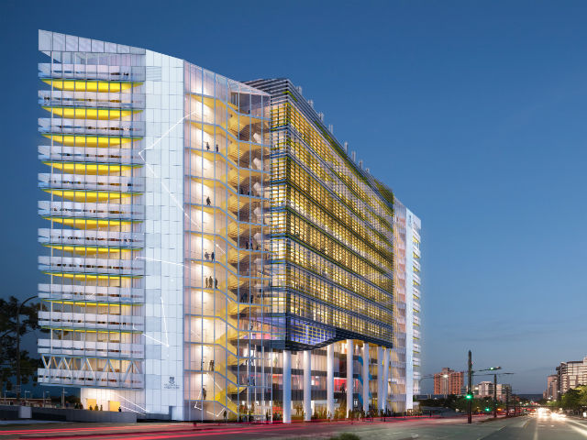

Directions map
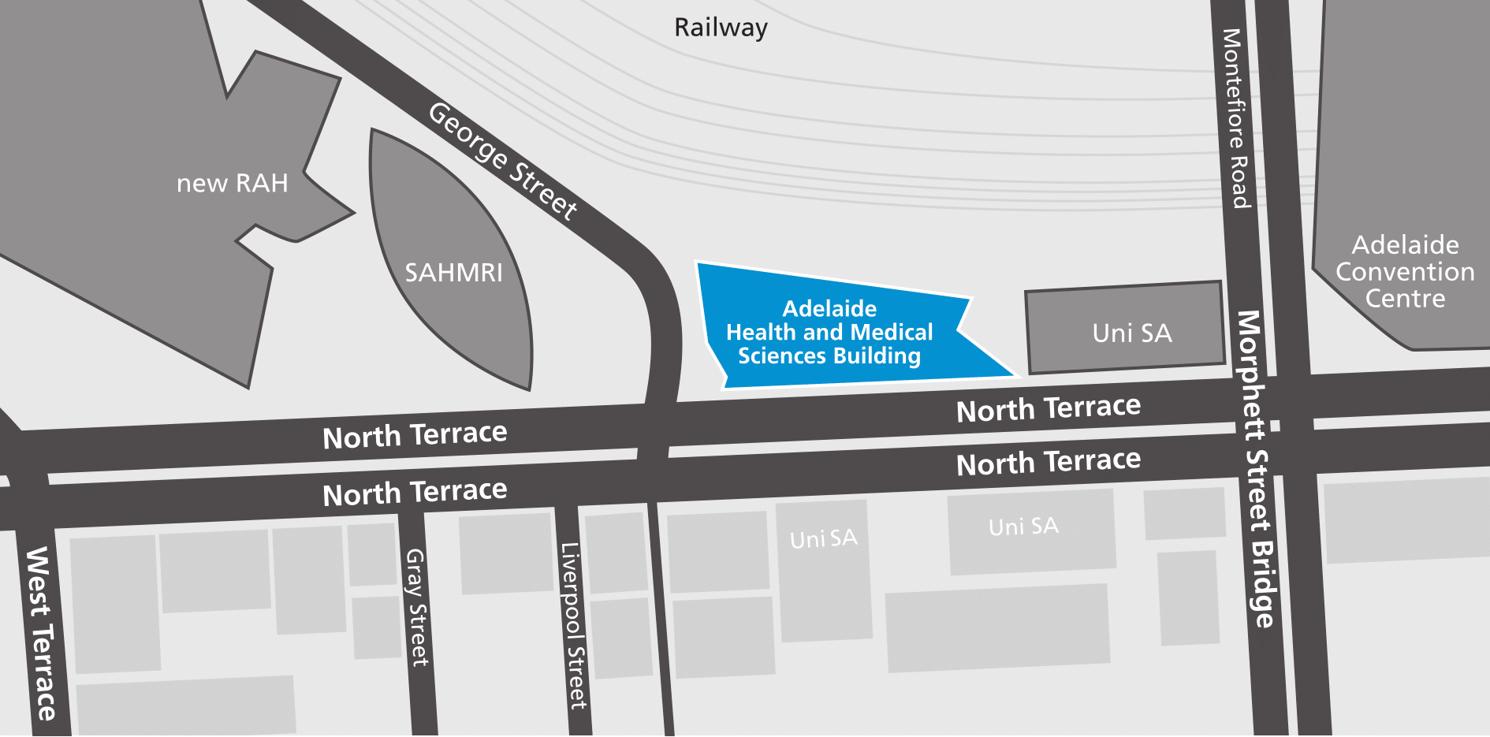

Enter the building from North Terrace. Find the lifts at the western end of the building and go up to level 4. When you exit the lifts turn right and head towards the North Terrace side of the building to find the Clinical Research Facility reception area. Use the phone on the wall to the left as you enter reception to call Caroline Giezenaar on 36098 (internal phone number). She will come down to reception to collect you and show you to your clinic room.

