Study Protocol

# TITLE:

# Patient risks associated with the use of blue and green ambient light in modern interventional suites – an anaesthetic perspective

**Short Title**: Influence of ambient lighting conditions on anaesthetic risk

## Investigators

André van Zundert, Benjamin Keir, Maria Moon, Anita Pelecanos, Kerstin Wyssusek

## Introduction

Improvements in high-precision intraoperative imaging1-2 have resulted in a surge of minimally invasive, real-time-image-ged interventions (surgery/gastro/cardiac/ radiology), benefiting both patient and proceduralist. These procedures occur under blue and green ambient lighting to optimise contrast–enhancement, allowing clinicians to reliably distinguish between healthy and sick tissue during endoscopic or radiological interventions.3-6

Changes to the clinical environment in terms of ambient light spectrum may negatively affect the visual performance of other staff (anaesthetists/scrub nurses) in terms of their ability to accurately prepare/verify medical processes and assess their surroundings.7-11

These considerations could result in:

* serious patient hazards such as misadministration of drugs either through incorrect drug selection or wrong dosage (see Figure 1);
* difficulties in patient monitoring (i.e. assessment of skin colour, cyanosis, sweating) which are identifiers for major blood loss, inadequate ventilation and inadequate anaesthesia; and
* increased clinical response time (i.e. accuracy and speed of task performance are paramount in high level patient care).

Of note is The National Standard for user-applied labelling of Injectable Medicines, Fluids and Lines and the Anaesthetic Labelling Standard ISO 26825:2008, which are designed to function under normal white ambient light.12-15

This research may have a direct impact on the safety afforded in interventional suites employing this technology and further help guide the facilities when developing specifications for future operating theatre redevelopments or building new capacity.

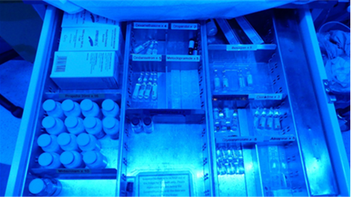 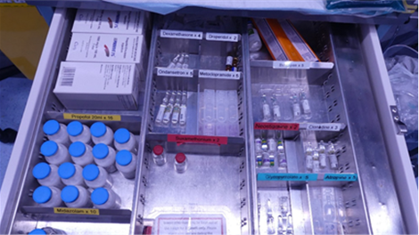

Figure 1. Tray with anaesthetic drugs in blue ambient light (left) and normal white light (right)

## Aims

As hospitals move towards modern interventional suites, this study aims to identify potential safety risks related to ambient light-related performance deficiencies. Specifically, the aims are to measure the influence of spectral selection in the operating theatre and interventional suite environments and to interpret safety risks for patients in relation to the performance of anaesthetic staff in blue and green ambient light conditions.

### Primary Objective

To administer two tests that will demonstrate task performance deviation (in accuracy and time) under different spectral conditions (white, green and blue).

### Secondary Objective

To identify features in the international standard drug labels that allow accurate identification, irrespective of the colour of ambient light.

## Hypothesis

Blue and green spectral conditions will negatively affect the ability of anaesthetic staff to correctly detect colour hues using the Farnsworth test and diminish performance in a drug labelling matching task, in staff who performed adequately in white light conditions. This may indicate the potential hazards of incorrect drug identification, impaired patient monitoring performance and delayed clinical response in clinical practice.

## Study Design

A randomized crossover trial comparing task performance in blue and green spectral conditions in volunteer anaesthetic staff with accurate performance in white light spectral conditions at the Royal Brisbane and Women’s Hospital, Queensland, Australia.

## Randomisation

Participants will be randomized to either one of two lighting placement sequences: blue then green light or green then blue light. A blinded member of staff, not associated with the study will be asked to place numbered cards (1 or 2) corresponding to the order of blue and green ambient lighting conditions into sequentially numbered, opaque sealed envelopes. The sequence of placement will be based on a computer-generated random numbers program. Each participant will be randomized to an intervention group ordering by allocation of an envelope following the successful completion of the Ishihara Test and Farnsworth D-15 hue and drug labelling tests in white light conditions.

## Population

The study population will consist of volunteer staff anaesthetists (senior/junior), medical students, residents and nurses. Recruitment will be performed by research nurses.

***Inclusion criteria:***

* Volunteers aged >18 years
* Anaesthetists, anaesthetic health practitioners and nurses who participate in any of prescription, preparation, administration, and checking of medications.
* Written informed consent by the volunteer.

***Exclusion criteria:***

* A failure of the Ishihara Test.
* A failure of the Farnsworth D-15 hue test and/or drug labelling test in white light conditions.

## Setting

The Centre for Excellence and Innovation In Anaesthesia (CEIA), Department Level 4 Ned Hanlon Building, Royal Brisbane and Women’s Hospital.

## Intervention

Volunteer participants that have met the inclusion criterion of passing the Ishihara test, and Farnsworth D-15 hue and drug labelling tests in white light conditions will progress to Stage Two and complete the Farnsworth D-15 hue and drug labelling tests using a random order of items 1) ambient green light; 2) ambient blue light.

The ‘Farnsworth-Test’, 15 cups with different hues will be given to participants to be put in order of hue from the starter cup with a standard colour. Complete passing to mild failure (13-15 correctly) is deemed acceptable. Anything that results in >2 mismatched cups is considered a failure of the test. Accuracy and time to complete the test is recorded (Table 1).

The Drug-Labelling-Test’, 15 names of commonly-used drugs in anaesthesia (on international standardized colour labels) will be provided on an A4 form (left side), which needs to be matched by participants using identical drug labels on the form’s right side (Table 2). Accuracy and time to complete the test is recorded. The number of inaccurate selections of drug label will be recorded out of 15.

## Control

Scores obtained under standard white light (all successes) will be compared with scores obtained under coloured light scores to assess variations in performance.

The human visual system is sensitive to different wavelengths of light; as such it will be necessary to control the illumination of each coloured ambient condition (i.e. white, blue, green). The visual standard sensitivity function for photopic vision will be used to ensure the same perceived brightness for each light source will be used when carrying out experiments.

## Consent

Participants will be identified when they volunteer and present to the clinical research nurses in the Department of Anaesthesia and their eligibility will be confirmed. Verbal information and an information and consent form will be given to eligible participants. Written informed consent will be obtained prior to testing.

## Data Collection

The following demographic data and study parameters will be recorded for analysis at the time of the interventions:

* Age, gender, glasses wearing status
* Experience: senior / junior anaesthetist; anaesthetic assistant; research nurse; medical student
* Times taken to complete each combination of Farnsworth Test and Drug-labelling test
* Accuracy of each Farnsworth Test / Drug-labelling test
* Subjective data as to how participant actioned each Farnsworth Test/Drug-labelling test

It is anticipated that the data collection will take approximately 45 minutes for each participant.

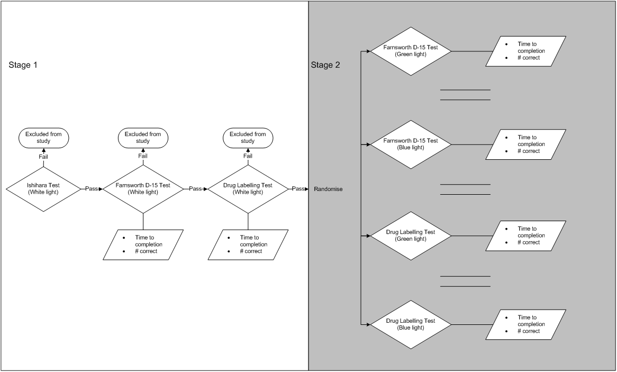

Figure 2. Study Pathway

## Feasibility

The Royal Brisbane and Women’s Hospital is a tertiary referral centre with 24 operating theatres and interventional suites where blue and green ambient light is routinely used during clinical procedures, and anaesthetic staff are familiar with these conditions. Employing 2.5 FTE research nurses, the Department of Anaesthesia and Perioperative Medicine (RBWH) is part of the Burns, Trauma and Critical Care Research Centre and has the experience and infrastructure to support this study. The research nurses will recruit the volunteers and obtain informed consent. The investigators will liaise with the research nurses to arrange logistically convenient times to perform the interventions, after informed consent is obtained. The equipment is available on loan from the Department of Ophthalmology and Biomedical Technology Services. All aspects of the study are feasible.

## Clinical Significance

Clinicians anecdotally describe situations, which involve difficulty reading medication labels in blue and green ambient light. The results of this research have the potential to modify clinical practice and contribute to patient safety by facilitating accurate medication administration. This study will foreseeably prompt further research into the use and benefit of ambient blue and green light and its impact on safe anaesthetic practice.

## Statistical Analysis

The sample size and methods for this study have been devised in consultation with a statistician from QIMR Berghofer Medical Research Institute. The primary outcome is success, defined as a score of 13 or more on the Farnsworth D-15 hue test. The acceptable success rate is defined as 0.99 (acceptable failure rate = 0.01), since it would be severely detrimental to patients if anaesthetic staff were unable to distinguish between colours in theatre lighting conditions. Using a binomial test, to have 95% confidence that the success rate was greater than 0.99, we would need to observe 299 successes out of 299 anaesthetic staff recruited. Thus 300 participants involved in Stage 2 will be required to allow for balanced numbers for each randomized sequence. Summary statistics and 95% confidence intervals will be reported.

## Ethical Considerations

**Consent**

All participants will be required to sign a Participant Information and Consent Form prior to participating in the study.  
 **Confidentiality/anonymity of participant data**

Each participant will be given a study ID number. The participants’ IDs and the study ID numbers will remain in a confidential file locked in the Anaesthetic Department’s research office, in a restricted access area. Each participant will be de-identified on the study CRF and only the study ID number will be displayed. It is necessary to collect identifiable or re-identified data to confirm and verify data accuracy when checking CRFs against original data. The data collected is kept confidentially and stored in a password protected database.

**Data storage and security**

All unidentified paper records will be kept in a locked filing cabinet in the Investigator’s locked office which is in a restricted access area. All computer records will be kept on a password protected Queensland Health computer. Access to data sheets and databases will be restricted to the study investigators and research nurses. Study data will not be released to other individuals or agencies. Access to study data will be managed by the Principle Investigator. All identifying information will be removed for statistical analysis. Data will be retained for fifteen years in accordance with the Australian Code for the Responsible Conduct of Research, and then the contents of the drive will be deleted and paper records will be confidentially destroyed in accordance with Queensland Health Clinical Records Retention and Destruction Policy.

## Publication

Results will be published in a peer-review journal and presented at local, national and international conferences relevant to anaesthetic care.

**Table 1. Results Farnsworth D-15 hue test**

|  |  |  |  |
| --- | --- | --- | --- |
| Study ID: |  |  |  |
| Date: |  |  |  |
| Age (years): |  |  |  |
| Gender: male/female |  |  |  |
| Wearing glasses: yes/no |  |  |  |
| Experience:  Senior anaesthetist  Junior anaesthetist  Anaesthetic assistant  Medical student  Research nurse |  |  |  |
| Ishihara Test: POS/NEG |  |  |  |
|  |  |  |  |
|  |  |  |  |
| **Farnsworth D-15** | **White Light** | **Blue Light** | **Green Light** |
| Time to complete |  |  |  |
| No mismatched cups |  |  |  |

**Table 2. Drug Labelling Test Data Record Sheet** **LIGHT**: 0 WHITE - 0 BLUE - 0 GREEN

Date: Study ID:

|  |  |  |  |  |  |
| --- | --- | --- | --- | --- | --- |
| **FIXED LABEL** | **MATCHED LABEL** | **Colour** | **Text** | **Shape** | **Pure Guess** |
|  |  |  |  |  |  |
|  |  |  |  |  |  |
|  |  |  |  |  |  |
|  |  |  |  |  |  |
|  |  |  |  |  |  |
|  |  |  |  |  |  |
|  |  |  |  |  |  |
|  |  |  |  |  |  |
|  |  |  |  |  |  |
|  |  |  |  |  |  |
|  |  |  |  |  |  |
|  |  |  |  |  |  |
|  |  |  |  |  |  |
|  |  |  |  |  |  |
|  |  |  |  |  |  |
|  |  |  |  |  |  |

This form will be completed for each type of light spectrum (white-blue-green)

Basis for decision

(select one or more as appropriate)

**Time to complete test (matching labels):**

**References**

1. The Nobel Prize of Physics 2014. New light to illuminate the world – the blue light-emitting diode LED. https://www.nobelprize.org/nobel_prizes/physics/laureates/2014/press.html (accessed 30/03/2017).
2. Tuenge J. Technical guidance document: LED surgical task lighting. US Department of Energy. Building technology program. https://buildingdata.energy.gov/cbrd/resource/1081 (accessed 18/11/2016).
3. Knulst AJ, Stassen LPS, Grimbergen CA, Dankelman J. Choosing surgical lighting in the LED era. Surg Innov 2009;16:317-23.
4. Shen H, Zhu L, Zheng Z. Optimal illumination for contrast enhancement based on color entropy analysis. J Biomed Opt. 2015;20:015005.
5. Pollard BJ, Chawla AS, Delong DM, Hashimoto N, Samei E. Object detectability at increased ambient lighting conditions. Med Phys 2008;35:2204-13.
6. Wang H, Cuijpers RH, Luo MR, Heynderickx I, Zheng Z. Optimal illumination for local contrast enhancement based on the human visual system. J Biomed Opt 2015;20: 015005
7. Pollard BJ, Chawla AS, Delong DM, Hashimoto N, Samei E. Object detectability at increased ambient lighting conditions. Med Phys 2008;35:2204-13.
8. Hicks RW, Becker SC, Krenzischeck D, Beyea SC. Medication errors in the PACU: a secondary analysis of MEDMARX finding. J Perianesth Nurs 2004;19:18-28.
9. Simmons D, Graves K, Flynn EA. Threading needles in the dark: The effect of the physical work environment on nursing practice. Crit Care Nurs Q. 2009;32:70-74.
10. Dain SJ, Hood JW, Montano S, Arali C. A method for evaluating the acceptability of light sources for clinical visual evaluation of cyanosis. Color Res Appl 1998;23:4-17.
11. Graves K, Symes L, Cesario S, Malecha A. Is there light? Well it depends – a grounded theory study of nurses, lighting and medication administration. Nurs Forum 2014;50: 241-51.
12. Kothari D, Agrawal J. Colour-coded syringe labels: a modification to enhance patient safety. Br J Anaesth 2013;110:1056-1058.
13. Woodcock T. Chairman Safety Committee, Association of Anaesthetists of Great Britain and Ireland. Syringe labelling in critical care areas – Review 2014; <https://www.aagbi.org/sites/default/files/SYRINGE%20LABELLING%202014.pdf> [accessed 10.10.2018].
14. Standard Specification for Used Applied Drug Labels in Anesthesiology. Compass. <https://compass.astm.org/EDIT/html_annot.cgi?D4774+11(2017)> –[accessed 10.10.2018]
15. Christie W, Hill MR. Standardized colour coding for syringe drug labels: a national survey. Anaesthesia 2002; 57: 793–8.