Skin swab instructions

IMPORTANT: if you have Buruli/Bairnsdale ulcer DO NOT

Swab the ulcer and AVOID that side of your body completely

(e.g. if ulcer is on your left ankle please entirely OMIT all ankle, calf, elbow and wrist swabs on the LEFT side!)

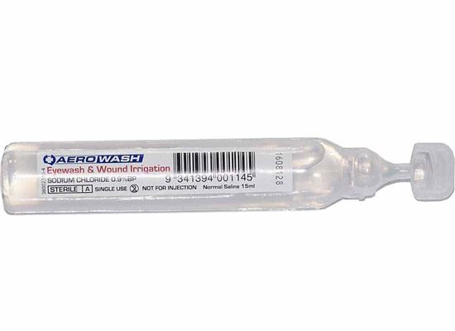

Twist to open



4 Swabs are supplied

1 Tube of sterile saline is provided

**STEP 1:** Twist the top off the tube of saline to open.

**STEP 2:** Twist and pull the flat bottom off the swab container. Don’t touch the tip of the swab with your hands and don’t put it down on any surface.

**STEP 3:** Squeeze 2 drops of saline from the tube on the tip of the swab. Use the tube of saline for all 4 swabs.

**STEP 4:** Hold the swab 2-3cm from the tip to prevent breaking (see image).

**STEP 5:** Rub FIRMLY on specified area of skin (see next pages)

**STEP 6:** Return swab to container, repeat Step 2-5 for all swabs and place all 4 swabs in envelope with questionnaire and consent form

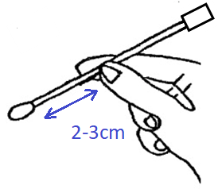

**STEP 5:** Rub each swab FIRMLY on specified area of skin

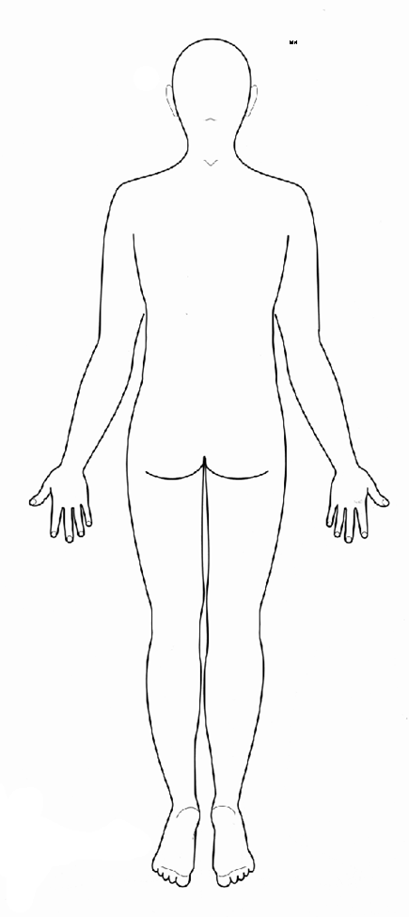

Back view

Swab #1

Rub firmly on BACKS of both elbows

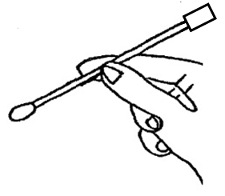

Swab #2

Rub firmly on BACKS of both wrists and lower forearms



Swab #3

Rub firmly on

backs of both

calves



PTO 🡪

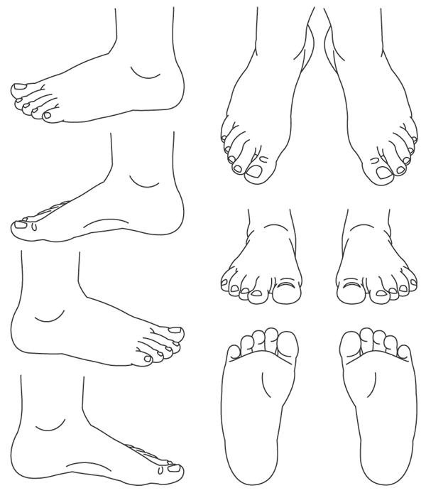

**STEP 5:** Rub each swab FIRMLY on specified area of skin

Swab #4

Rub firmly on inside and outside of both ankles



**STEP 6:** Return swab to container and place all 4 swabs in envelope with COMPLETED QUESTIONNAIRE and SIGNED CONSENT FORM. Seal envelope and return to us!

