**Cognitive Processing Following Cerebrovascular Events**

***Research Protocol***

*Version 4 Dated 9th July2016*

Cerebrovascular anomalies are conditions characterized by malformed or damaged blood vessels that often result in cerebrovascular events such as strokes, hemorrhages, and blood clots. Stroke in particular is a leading cause of disability and the second leading cause of death worldwide (Lozano et al., 2010; Murray et al., 2010) with 30-40% of patients also being diagnosed as clinically depressed. For a stroke to be clinically diagnosed, motor and language deficits to an individual must be present for more than 24 hours, whereas cerebrovascular events where the deficits are not functionally apparent beyond a 24 hour period are termed Transient Ischemic Attacks (TIA’s; The National Stroke Foundation, 2014). Strokes are more frequent among people who are over 65 years of age (Australian Institute of Health and Welfare, 2013). There are two major types of stroke - ischaemic and haemorrhagic stroke. Ischaemic strokes are caused by occlusion or blockage of an artery that supplies blood to the brain, whereas haemorrhagic strokes are a result of a rupture to an artery (Bamford, et al., 1991; Ropper & Browh, 2005). Ischemic strokes also result in an interruption to the blood supply to the surrounding the lesion site (Betteridge, 2000; Liberato & Krakauer, 2007)A devastating consequence of this, is substantial functional loss associated with the affected region and the associated neural networks, manifested by marked shifts in an individual’s ability to perform everyday activities (Cerella & Hale, 1994; Jenkins, Myerson & Joerding, 2000). These deficits are often exaggerated by the age of the individual.

Normal aging is usually associated with reduced motor performance, restricted mobility and cognitive activities and more limited quality of life. These deficits are further complicated in stroke patients. More specifically, cognitive abilities that are reliant on sensory processing speed and attention shifting ability and are affected by age are also likely to be affected further by stroke (Gerritsen et al., 2003; Leskela et al. 1999). In fact aspects of all three major functional domains are commonly affected following an ischaemic stroke, i.e., motor, sensory and cognitive domains and to further limit recovery. Furthermore, as a result of these impairments, emotional confidence is undoubtedly affected due to the cognitive realization of mortality vulnerability and associated complications or inability associated with communication and language and independent living. **Thus, the proposed study aims to examine the effects of first cerebrovascular events such as stroke and TIA on timing of information processing and application of attention to salient stimuli. This data will be compared to that of healthy, aged matched controls as part of a study conducted at La Trobe University (HREC# S15-19).**

Much research has been devoted to exploring cognitive, motor, and sensory impairments following a stroke. However, the vast majority of studies have failed to consider how these changes differ from the normal variability in unnoticed and undiagnosed aging, or in unnoticed TIA’s. Furthermore, few studies have examined how such findings can be incorporated into the design of better rehabilitation outcomes for stroke patients. . There is also only limited, research available on the potentially permanent cognitive changes associated with TIA’s. Rather, most research on TIA has tended to focus on risk prevention of a future TIAs or stroke (e.g., Davis & Donnan, 2012; Gupta, Farrell, & Mittal, 2014; Poisson & Claiborne, 2011). In a recent study conducted by van Rooij et al. (2014), Patients with TIA aged 45 to 65 years without prior stroke or dementia underwent comprehensive neuropsychological testing three months after their first TIA. Results indicated that more than one third of TIA patients demonstrated impairments of cognitive domains that correlate with the vascular cognitive impairment profile (van Rooij, et al., 2014). More specifically, TIA patients performed worse on all cognitive domains with the exception of episodic memory (van Rooij et al. 2014). **Thus, the proposed study also aims to explore cognitive performance after TIA’s and compare this cognitive performance after strokes.**

Another neglected area of research has been the widespread comorbidity between visual difficulties, and stroke (Ciuffreda et al., 2007; Khan, Leung, & Jay, 2008; Rowe, et al., 2013) and the consequent effects on visually driven attention. In particular, binocularity is often impaired following stroke and the total or partial paresis of the movements of the eye on the same side of brain. This is a vital concern, as accurate foveal fixation is necessary to optimally direct attention by shifting focus and attention to what falls into the ‘spotlight’ of ones’ gaze (Friedenberg, 2012). Such a change in ability to rapidly shift binocular gaze would be expected to play a significant role in speed of attentional and information processing. For example, in a study conducted by Rowe et al. (2013), 915 stroke patients were examined to assess their visual deficits post stroke. The results indicated that 54% of patients (n = 498) were diagnosed with ocular motility abnormalities (Rowe et al., 2013). It has become increasingly evident that research examining the cognitive impact of stroke needs to be expanded to examine or control for factors such as monocular eye movements associated with visual deficits. Furthermore, research needs to include inferences on how their results can inform rehabilitation programs for stroke patients who are usually aged > 60 years in order to make a positive contribution to the quality of life to these patients post-stroke. Given the importance of vision in guiding human behaviour, it is not surprising that impairments in vision after stroke are likely to transfer to deficits in other cognitive domains, such as processing speed and working memory. Despite this, little is understood of the neurobiological nature of such fundamental cognitive impairments. **Therefore, the proposed study also aims to examine visual difficulties after cerebrovascular events and correlate these with the cognitive performance i.e., attention shifting and processing speed.**

Overall, our ultimate goal is to contribute to the knowledge regarding post-stroke/TIA deficits so that any deficits can be rapidly identified and incorporated into an individually tailored rehabilitation regime. We aim to contribute to the knowledge in the field of rehabilitation after cerebrovascular events in order to optimize the development of better rehabilitation regimes and to ensure optimal quality of life (QoL) for the entire older community who suffer from impaired vascular integrity

**Participants**

It is hoped to recruit 100 stroke/TIA patients from Footscray Hospital (outpatients) and Sunshine Hospital (inpatients) Stroke units One-hundred healthy age matched controls will also be tested as part of a research project conducted within La Trobe University (Ethics approval number S15-19). Testing of healthy controls may also be conducted at Footscray hospital if an individual responds to a flyer advertised within the hospital. Healthy controls will be tested using the same battery of tests.

**Recruitment Process:** Participants may respond to flyers or written invitations to participate in the study (See appendix B).

Inclusion Criteria:

1. First stroke/TIA
2. Stroke/TIA occurred within the past 3 months
3. No history of neurological disorder. Given that cognitive abilities and attention shifting may be influenced by neurological disorders, these groups of patients will not be eligible to participate in the current study in order to avoid influence of extraneous variables.
4. Understands written and spoken English. Given that the study will be spoken and written in English, participants must be able to relay their answers in written or spoken English. Furthermore, given that patients will need to provide written consent, understanding written and spoken English is vital.

Exclusion Criteria

1. Those who are unable to understand English language.
2. Those whose Raven's Coloured Progressive Matrices score is indicative of an Intellectual Disability.
3. Stroke patients who exhibit severe cognitive compromise, are highly dependent on medical care, and/or are unable to provide written informed consent.
4. Those who have a mental illness or previous psychiatric history.
5. Those who report severe or extremely severe levels of depressive symptoms on the DASS21.
6. Those who have a comorbid degenerative illness such as dementia (this will be identified based on review of their medical file or during the initial screening with the participant).

***Consent Process***:

Participants will be recruited and required to provide written consent to participate in the proposed study. Participants' capacity to participate will be made through subjective judgment by the student researcher, based on their ability to:

1) Understand the nature and purpose of the study

2) Understand the risks and benefits of the study

3) Understand their rights to participate and withdraw

4) Make reasonable judgments and decisions independently

Potential participants will all have at least a 24 hour delay between screening info visit and testing, to ensure that sufficient time to consider the project and discuss with family/friends/doctors is given. This will remove any

perceived pressure to agree to participate in a clinic situation.

For aphasic patients, information provision and the consent process will take place only in the presence of the patient’s next of kin/family member or carer. Both the patient and significant other will be briefed on the study. Like other potential participants, they will be given at least 24 hours to think about it and to ask any questions before signing the form (which could take place on a different day). This will provide an opportunity for the patient and the significant other to discuss the study together, and for the significant other to check in with the patient regarding his/her understanding of the study. Minimal eye or head movement responses (e.g. Yes/No) will be requested to ascertain the patient’s understanding of the nature of the study. In addition, informed consent will be obtained from both the patient as well as significant other. This therefore ensures that both individuals have reached a mutual understanding; that the patient understands and agree to participate, and that the significant other agrees to the patient’s decision to participate after discussion with the patient. The testing session will not, in any way, take place on the day of information provision and consent process.

We will only be recruiting patients with expressive aphasia. Patients with receptive aphasia are unlikely to be able to consent to the study. Also, patients who participate will not be required to complete any task that they do not understand.

**Materials**

|  |  |  |
| --- | --- | --- |
| **1a) Demographic Information Form** | Participants will be asked to complete a demographic information form, with additional brief lifestyle questions such as, “*Do you use hand held devices, i.e., SmartPhones, and if so, how often?"* This form should take no longer than 1 minute to complete (See Appendix A). Asking for information regarding the use of hand held devices is a procedure of potential efficacy of these devices as rehabilitation aids. | |
| **1b) Visual Screening and Handedness**  http://www.colour-blindness.com/CBTests/ishihara/Plate3.gif | Participants will be asked to look at and label some shapes and colors. This will indicate whether they have any basic visual abnormalities. Furthermore, participants will be asked to report whether they are left or right handed. | |
| **2) Depression Anxiety Stress Scale 21 (DASS)** | Current negative emotional states will be measured by the21-item Depression Anxiety and Stress Scale (DASS-21; Lovibond & Lovibond, 1995). It consists of 3 subscales; Depression, Anxiety and Stress. The DASS-21 will be used to identify significantly depressed or anxious individuals. An estimate of 5 min is estimated for the duration of this task. | |
| **3) Purdue Pegboard Test**  http://e-current.com/images/products/detail/060201.jpg | This will be administered to all participants to ascertain their relative rate of motor processing in any 30s exposure. Specifically, participants will be asked to place as much “pegs” in a wooden board in an allocated amount of time (30s). Participants will first complete the task with their dominant and non-dominant hand individually, then both hands together, with a time limit of 30s for each trial. Total time is therefore 1.5 minutes. | |
| **4) Inspection Time Task:** | This task is a measure of attention and cognition. It measures the exposure duration required for a human subject to reliably identify a stimulus. This task will be computer guided. Specifically, participants will be shown a “rainbow-like” image for a very short period of time that is facing 1 of 4 directions (left, right, up or down). They will be asked to identify what direction the image was facing. The duration that the image is on the screen for will become less and less over time. This task is estimated to take a maximum of 5 minutes. | |
| **5) Cognitive Change Detection Test** | Cognitive shifts in attention will be assessed using the Change Detection test.This custom designed computer test will determine threshold exposure time (i) needed for perceived change in an array of visual stimuli, and (ii) time needed to ascertain the nature of change as a measure of visual processing***.*** Participants will be requested to identify (i) whether there is a change in the 4 images and (ii) nature of the change presented to them before and after a 250ms gap. The threshold duration of the exposure required for correct identification of the 2 tasks will be established using a Parametric Estimate of Stimulus Threshold (PEST) procedure. An estimate of 5 min will be required for completion of this task. | |
| **6) Symbol Search and Coding (Subtests from WAIS-IV):** http://i57.tinypic.com/29vjfnk.png | Participants will also be asked to complete the Symbol Search and Coding tasks, which examine how fast one can process information and discriminate between similar stimuli. More specifically, the symbol search will examine how fast participants can process information and discriminate between similar on a cognitive level, and make verbal and written response whereas the Coding task will assess this capacity when limited on a motor level, given that participants must copy images onto a paper. These tasks will be administered by the assessor and a total of 4 minutes is estimated for this task. | |
| **7) 0-back Task:** | During this computer guided task, participants will be shown a rapidly presented series of visual images for 2.5 mins, and asked to indicate if the previous image (i.e., n=0 or "Zero-Back") is the same. This task enables the assessment of sustained attention (i.e., staying on task). | |
| **8) Receptive and Expressive Language Tests:** | | |
| ***Rapid Automatic Naming (RAN) task:*** | | Participants will then be given the RAN task, where participants must verbally name images as quickly as possible and such images will include a cat, a dog, or a pen. This task is expected to take no longer than 2 minutes. This task gives a measure of rate of visual information processing. |
| **9) Auditory Gap Detection Task**:  http://www.ihr.mrc.ac.uk/sites/ncs/Images/gapdetection.png | | Threshold time needed to discriminate between 2 separate sounds will be investigated using the auditory gap detection task. This task will take approximately 1 minute. |
| **10) Forwards and Backwards Digit Span (Auditory and Visual):** | | These tasks will be used to assess auditory and visual short-term memory and the backwards manipulations will assess visual and auditory working memory (i.e., the ability to hold and manipulate auditory and visual information). This task is estimated to take 5 minutes. |
| **11) Speed and accuracy of visual fixation (Eye Movements)**. | | Speed and accuracy to engagement and disengagement of visual fixation will be measured using the eye gaze-eye movement tracker that records the point and duration of gaze and the motion of an eye relative to the head. This software based camera records the movement and direction of both eyes together or each eye independently while the participant engages in a visual task requiring sequential eye movements, such as when reading a short piece of text. The eye movement tracker will be temporarily provided by La Trobe University, School of Psychological Science. This device does not add additional time to the total testing time, as it is used during the Rapid Automatic Naming task. |
| **12) Electrophysiology: Visually Evoked Potentials (VEP’s)**  Satellite?blobcol=urldata&blobheader=image%2Fjpeg&blobkey=id&blobtable=MungoBlobs&blobwhere=1294152128775&ssbinary=true&eHA_media_type= | | VEP’srefer to electrical potentials, initiated by brief visual stimuli, which are recorded from the scalp overlying visual cortex. VEP waveforms are extracted from the electro-encephalogram (EEG) by signal averaging.  VEPs are used primarily to measure the functional integrity of the visual pathways from retina via the optic nerves to the visual cortex of the brain. Any abnormality that affects the visual pathways or visual cortex in the brain can affect the VEP.  Patients will be asked whether they wish to participate in the electrophysiological aspect of this study. VEPS take less than 30mins total recording time (8 blocks of 30 sec giving 40,000 trials). This includes time for preparation and setting up. The device used for this will be temporarily borrowed from La Trobe University under the consent of the School of Psychology and Public Health. |
| Ocular Coherence Tomography (OCT): | | This technique is a non-invasive technique taking no longer than 2 mins.  OCT Heidelberg Spectra enables assessment of retinal structure and electrophysiological assessment of the topography and integrity of retinal and optic nerve function using the multifocal Visual Evoked Potentials (mfVEPs) and behavioural tests. |
| Analysis of Blood (Patient sample only) | | It is proposed that blood samples from 15 stroke and 15 TIA patients (that are taken as part of routine in-hospital assessment) are analysed as part of the study. Analysis of blood from stroke/TIA patients will enable evaluation of proteins, neurotransmitters, and lipids etc which in turn have strong potential to provide blood-based biomarkers that may have implications for the diagnoses of stroke origin and subtype, prediction of outcomes. This may aid in post-stroke assessments in general.  Researchers from the current study will not be collecting extra blood samples so there is no risk of harm, discomfort or inconvenience to the participants. Additionally, analysing blood samples will not add extra time to testing session with participants. |
| Total testing time is estimated to take a total of 50 minutes. | | |

Given that the previously mentioned tasks will take up to 50 minutes to complete, it is proposed that the testing can be divided into 2 testing sessions, specifically with electrophysiological testing taking place at a later date, if participants consent to this.

If participants do not wish to come back there is no disadvantage. Furthermore we only aim to electrophysiologically record a total of 50 CVA patients (i.e., 25 stroke, and 25 TIA) to allow us to dissociate vascular cognitive changes from motor and age effects *per se*.

**Hypotheses**

1. It is hypothesised that there will be no significant difference in stroke patients performance in their cognitive change detection, visual and auditory attention, non-verbal reasoning ability, and speed and accuracy of visual fixation, compared to TIA patients.
2. It is hypothesised that cerebrovascular event patients will havemore severe deficits in their cognitive change detection, visual and auditory attention, non-verbal reasoning ability, and speed and accuracy of visual fixation, compared to healthy controls.
3. Impairments in eye movements of the eye on the side of the lesion will be evident in cerebrovascular event patients as opposed to healthy older adults, and this will be associated with less rapid shifts in attention, longer fixation duration and longer times to disengagement leading to slower information processing. For example, if a patient cannot optimally direct their binocular eye gaze, they will have further complications optimally directing their attention, compared to those with no eye gaze impairments.

**Statistical Analysis**

A Multivariate Analysis of Variance (MANOVA) will be used to examine whether there is a difference between healthy older adults and cerebrovascular event patients in cognitive change detection, visual and auditory attention, non-verbal reasoning ability, and speed and accuracy of visual fixation.

Furthermore, an ANOVA will be used to investigate whether speed and accuracy of visual fixation (i.e., eye-movements) on the side of the lesion are more impaired in cerebrovascular event patients compared to healthy older adults. Additionally, if this is the case, further covariance analysis will be conducted to determine whether impaired speed and accuracy of visual fixation is a mediator of impaired attention and processing speed (where attention and processing speed is gathered using the above measures).

*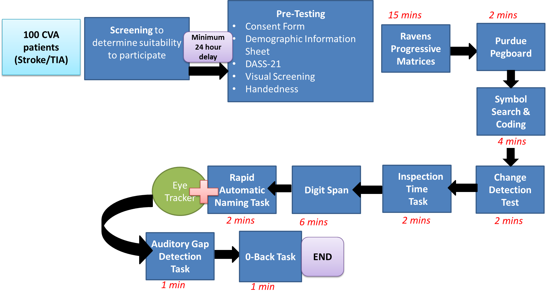***Procedure**

*Figure 1*. Flowchart of the experimental procedure for the first one hour session (session 1).

**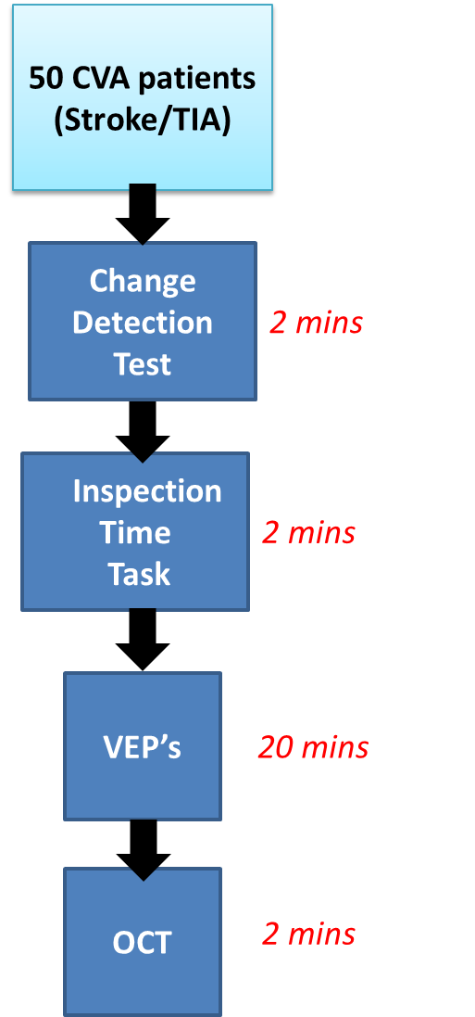**

*Figure 2*. Flowchart of the experimental procedure for session 2.

**Study Design**

The proposed study is a between-subjects experimental design.

**Risk Management**

The proposed psychophysical tests will take up to 50 minutes. If a participant feels tired or uncomfortable during a testing session, they are encouraged to let us know in order for the researcher to provide them with a break and/or a drink. It is possible that a patient may also feel distressed or upset when completing the mood questionnaire, or other tasks. In this case, they are free to inform the researcher if they prefer not to participate in any of the tasks, as they are not required to complete all the tasks involved. In the event that a patient reports severe or extremely severe levels of depressive and/or anxiety symptoms, we will have a duty of care to inform their clinician, or refer you to their General Practitioner or a Primary Health Practitioner to ensure that they receive appropriate treatment.

**Data and Security Handling**

To ensure confidentiality, participants will be assigned with a code that will replace their name on all questionnaires and computerised tasks ensuring all data is non-identifiable. This code, together with their electronic data, will be stored securely in password-protected files. Hardcopy data of patient responses will be stored in a locked cabinet in the office of the research investigator, located at La Trobe University. Data access will be limited to members of the research team.

Information collected as part of this study may be used in future research, to look at further longitudinal changes of recovery in a larger stroke sample and to investigate predictive factors of recovery of attention and processing speed.

In any publication, information will be provided in such a way that participants cannot be identified. The results will only be analysed and presented as group data in the student researcher’s theses, journals, or in national conferences. The results of the study will also be available to participants on request, but only in the form of group data.

In accordance with Victorian privacy law, participants have the right to access the information collected by the researchers about them. They also have the right to request that any information, with which they disagree, be corrected. Participants will be advised to contact one of the researchers if they would like to access their information.

References

Bamford, J., Sandercock, P., Dennis, M., Warlow, C., & Burn, J. (1991). Classification and natural history of clinically identifiable subtypes of cerebral infraction. *The Lancet, 337*(8756), 1521 – 1526. doi: 10.1016/0140-6736(91)93206-o

Betteridge, D. J. (2000). What is oxidative stress? *Metabolism, 49*(2), 3 – 8.

Cerella J., & Hale, S. (1994) The rise and fall in information-processing rates over the life span. *Acta Psychologica 86*: 109–197.

Ciuffreda, K. J. Kapoor, N. Rutner, D. Suchoff, I. B. Han, M. E. & Craig, S. (2007). Occurrence of oculomotor dysfunctions in acquired brain injury: a retrospective analysis.*Optometry, 78*(4), 155–161.

Crotty, M., & George S. (2009). Retraining visual processing skills to improve driving ability after stroke. *Arch Phys Med Rehabil*, *90*, 2096-102.

Davis, S. M. M. D., & Donnan, G. A. M. D. (2012). Secondary Prevention after Ischemic Stroke or Transient Ischemic Attack. *The New England Journal of Medicine, 366*(20), 1914-1922.

Formby, C., Phillips, D. E., & Thomas, R. G. (1987). Hearing loss among stroke patients. *Ear and Hearing, 8*(6), 326 - 332.

Friedenberg, J. (2012). *Visual Attention and Consciousness.* Taylor and Francis.

Gupta, V. H., Farrell, A. M., Mittal, & M. K. (2014). Transient ischemic attacks: predictability of future ischemic stroke or transient ischemic attack events, *Journal of Therapeutics and Clinical Risk Management,* *10,* 27-35.

Karp, E., Belmont, I., & Birch, H. (1969). Unilateral hearing loss in hemiplegic patients. *Journal of Nervous and Mental Disease, 148,* 83-86.

Hoops, H., & McLaughlin, R. (1969). Reliability of conventional audiometry in the aphasic. *Journal of Auditory Research, 3,* 240-246.

Jenkins, L., Myerson, J., Joerding, J.A., & Hale, S. (2000) Converging evidence that visuospatial cognition is more age-sensitive than verbal cognition. *Psychology and Aging, 15*, 157–175.

Klavora, P., Gaskovski, P., Forsyth, R. (1995). Test-retest reliability of three Dynavision tasks. *Perceptual and Motor Skills, 80,* 607 – 610.

Leskela, M., Hietanen, M., Kalska, H., Ylikoski, R., Pohjasvaara, T., Mantyla, R., et al.(1999). Executive functions and speed ofmental processing in elderly patients with

frontal or nonfrontal ischemic stroke. *European Journal of Neurology, 6,* 653–661.

Liberato, B., & Krakauer, J. W. (2007). Ischemic stroke: Mechanisms, evaluation and treatment. In A. S. (Ed.), *Neurology and Clinical Neuroscience* (pp. 551 – 586). Philadelphia: Elsevier.

Lozano, R., Naghavi, M., Foreman K, et al. (2012). Global and regional mortality from 235 causes of death for 20 age groups in 1990 and 2010: a systematic analysis for the Global Burden of Disease Study 2010. *Lancet*, *380*, 2095-2128.

Lovibond, S.H., & Lovibind, P. F. (1995). *Manual for the depression anxiety stress scale*

*(2nd ed.)*. Sydney : Psychology Foundation of Australia.

Gerritsen, M. J.J, Berg, I. J., Deelman, B. G., Visser- Keizer, A. C. & Meyboom-de Jong, B. (2003). Speed of Information Processing After Unilateral Stroke, *Journal of Clinical and Experimental Neuropsychology, 25,* 1, 1-13

Miller, M. (1960). Audiologic evaluation of aphasic patients. *Journal of Speech and Hearing Disorders, 25,* 333-339.

Moscicki, E.K., Elkins, E.F., Baum, H.M., & McNamara, P.M. (1985). Hearing loss in the elderly: an epidemiologic study of the Framingham Heart Study Cohort. *Ear Hear 6*, 184-90.

Murray, C.J., Vos, T., Lozano, R., Naghavi, M., et al (2012). Disability-adjusted life years (DALYs) for 291 diseases and injuries in 21 regions, 1990—2010: a systematic analysis for the Global Burden of Disease Study 2010. *Lancet*, *380*, 2197-2223.

Poisson, S., & Johnston, S. C. (2011). Prevention of Stroke Following Transient Ischemic Attack. *Current Atherosclerosis Reports, 13*(4), 330-337. doi: 10.1007/s11883-011-0181-4

Ropper, A. H., & Browh, R. H. (2005). *Adam’s and Victor’s principles of neurology.* New York: McGraw-Hill Medical Pub Division.

Rowe, F. J., Wright, D., Brand D. et al. (2013). Profile of gaze dysfunction following cerebrovascular event. *ISRN Ophthalmology,* 1-8, doi:10.1155/2013/264604

Snowdon, J. (2001). Late-life depression: what can be done? *Aust Prescrib, 24*, 65–67.

The Psychological Corporation (1997). Wechsler adult intelligence scale – Third edition: Technical Manual. San Antonio, TX.

van Rooij, F. G., Schaapsmeerders, P., Maaijwee, N. A.M., Duijnhoven, D. A.H. J., de Leeuw, F. E., Kessels, R. P.C., & van Dijk, E. J. (2014). Persistent cognitive impairment after transient ischemic attack. *American Heart Association, Inc,45*(8), 2270-2274.

Appendix A

Demographic Information Statement

*Version 1 Dated 17 November 2015*

**Demographic Information Statement**

**Name: \_\_\_\_\_\_\_\_\_\_\_\_\_\_\_\_\_\_\_\_\_\_\_\_\_\_\_\_\_\_\_\_\_\_\_\_\_\_\_\_\_\_\_\_\_\_\_\_\_\_\_\_\_\_\_\_\_\_\_\_\_\_\_**

**Age: \_\_\_\_\_\_\_\_\_\_ (years) Gender:**  **Male**  **Female**

**Highest Level of Education: (Please tick one)**

Secondary School 

Diploma 

Bachelor 

Post-Graduate  
 Masters   
 Doctorate/PhD 

**Number of years of education (from Year 1 high school onwards):\_\_\_\_\_\_\_\_\_**

**Current Lifestyle:**

Working 

Volunteering 

Retired 

Homemaker 

Others  Please state: \_\_\_\_\_\_\_\_\_\_\_\_\_\_\_\_\_\_\_\_\_\_\_\_

**Do you use hand held devices (e.g., Smart Phones and hand-held devices)?**

Yes No   
(If so) How Often?   
 Daily   
 1-3 times a week   
 4- 6 times a week   
 Monthly 

Appendix B

**Participant Invitation Flyer**

*Version 3 Dated 4 March 2016*

