A Prospective Randomized Trial Comparing the Bard Inlay Optima Stent with the Cook Universal Soft Ureteral Stent Using The Validated Ureteric Stent Symptom Questionnaire

STUDY INVESTIGATOR(S) or PROJECT TEAM MEMBERS
Name | Phone | Email | Institution | Project Role
Dr Alexander Ngoo | 0434622645 | AlexanderGa-Onn.Ngoo@health.qld.gov.au | Townsville  Hospital | Principal Investigator
Dr Michael Kwok | 0416 823 878 | mkwokmail@gmaill.com | Redcliffe Hospital | Principal Investigator
Dr Devang Desai | 0408 154 889 | ddesai@towoombaurology.com.au | Toowoomba Hospital | Supervisor
Dr Philippe Wolanski | 0439741974 | philipe.wolanski@health.qld.gov.au | Townsville  Hospital | Supervisor

This protocol was written to ensure this proposed study is in accordance with the obligations and expectations of the following organizations and professional bodies:
- The Australian Medical Association Code of Conduct for Medical Practitioners
- Australian Health Practitioner Regulation Agency
- National Statement on Ethical Conduct in Human Research (2007)
- The Townsville Hospital

Centres Involved in Study:
- Townsville Hospital
- Toowoomba Hospital
- Redcliffe Hospital

- Introduction
Ureteral stents are routinely used as a minimally invasive technique for temporarily draining the upper urinary tract to preserve renal function and treat pain caused by ureteral obstruction. Unfortunately, side effects of these devices are well reported, with up to 80% of patients report a reduced quality of life from the symptoms¹ which include frequency (60%), urgency (60%), dysuria (40%)², pain (80%)³ and hematuria (54%)⁴. The gold standard for assessment of Stent Related Symptoms (SRS) is the Ureteral Stent Symptoms Questionnaire (USSQ), a validated multi language questionnaire which encompasses the full spectrum of SRS and quantifies all morbidity associated⁵.

There remains no clear consensus on which stent brand most effectively reduces SRS. Indeed, the absence of strong evidence for any particular brand or design has meant that the choice of which type of stent to insert is primarily informed by clinician preference, experience and research and marketing produced by stent producers. Both stents are however TGA approved and considered the standard of care. This study therefore aims, through a randomized double blinded controlled trial to determine whether the Bard Inlay Optima and Cook Universa Soft are different in regards to post-operative SRS as measured by the USSQ. By determining which stent design has a superior SRS profile, clinicians and hospitals will be able to make more evidence based decisions regarding which stent to provide for their patients.

- Background
SRS are likely multifactorial in origin⁶ and thus from a design perspective, prevention of SRS, has focused on a variety of factors including (though not limited to) stent rigidity, surface roughness and biocompatibility, coatings and ease of deployment. For example, the Bard Inlay Optima Stent launched in the USA in 2012 argues in its white papers that its smoother stent surface acts to reduce ureteral reactions such as ulceration, epithelial hyperplasia, inflammation and edema and softens from 29% up to 49% at body temperature to promote greater patient comfort⁷. Despite this, there remains a paucity of compelling evidence to suggest that stent materials or design significantly reduce SRS⁶ Moreover there is little literature in this area in general, with a systematic review in 2017 by Betschart et al. finding there were only 6 studies since 1991 which investigated the impact different brands of stent had on SRS⁶.

Indeed, only two studies have shown significant reduction in SRS related to stent design and materials. A randomized, unblinded trial on 44 patients in 2005 comparing the 6F Bard Inlay, Cook Universa Soft, Microvasive Contour, Applied Medical Vertex to the 6Fr Surgitek Classic found that while no stent design demonstrated significant differences in pain, general symptom scores or narcotic use, the Inlay stent did demonstrate a significant lower urinary symptom score on day 3. A more recent randomized double blind study on 90 patients in 2015 on the Cook Endo-soft, Enhanced Durometer loop versus the Polaris stents found that the Polaris had a lower International Prostate Symptoms Score (IPSS), storage symptoms and Visual Analogue Pain scale (VAPs)⁸. Nevertheless, the reliability of the findings of both studies is difficult to determine. Both were underpowered, the former was not blinded and the latter did not use the USSQ as it was nominally investigating bladder irritation symptoms.

In contrast, other studies have showed no significant differences in SRS relating to stent model. A randomized single blind (researcher) study on 116 patients in 2005 by Joshi et al. found no significant differences in USSQ scored SRS between the Percuflex and Contour. These sentiments were also expressed by a more recent study by Davenport et al. 2011 on 129 patients, which found no significant differences between the InLay stent (Bard Medical, Covington, GA, USA) or the Polaris ureteral stent (Boston Scientific) despite the Polaris having a softer composition of distal stent material⁹.

The studies however are limited in their clinical applicability as their time since publications means that new stent designs exist and previous ones investigated are not necessarily the same as those used in clinical practice. Indeed, the most recent study which used the USSQ was Davenport et al.’s 2011 study which collected data between 2002 and 2006. To contrast, the Bard Inlay Optima Stent and the Cook Universa Soft were both launched in the USA in 2012.

Clearly, there is a paucity of contemporary trial data on the impact stent design has on SRS. We thus aim in this study to compare the Cook Universa Soft 5 French and Bard Inlay Optima 4.7 French Stent Multi-Length Double J Stents via a randomized double-blinded trial in regards to the validated USSQ score. These stents represent the two most commonly used ureteric stents used in Queensland.

- Aims of Project
The aims of this study are to:
- Compare the impact of the Cook Universa Soft and Bard Inlay Optima Stent on SRS as defined by the USSQ score, IPSS and need for early stent removal
- Compare the degree to which overall USSQ score and or subscores correlate with bladder irritation symptoms as defined by the IPSS

- Objectives
Primary Objective
To compare and report the impact the Cook Universa Soft and Bard Inlay Optima Stent have upon SRS at 1 and 3 weeks after insertion. The USSQ score and its relevant subscores +/- the need for early stent removal will be used to measure this.

Secondary Objective
To compare and report the impact the Cook Universa Soft and Bard Inlay Optima Stent have upon bladder irritation symptoms as defined by the IPSS

- Hypothesis
There will no significant difference in SRS as defined by the USSQ score between the Cook Universa Soft and Bard Inlay Optima stent. This will also be true of bladder irritation symptoms as defined by the IPSS.

- Project Design
Methodology – Randomized Double-Blinded Clinical Trial

Setting and Target Participants: All consenting patients receiving stent insertion for upper urinary tract calculi, large stones before lithotripsy or after ureteroscopy or Pelvo-Ureterojunction Obstruction at the Townsville, Redcliffe and Towoomba Hospital between the 1st of August 2017 to the 1st of August 2019.

Inclusion criteria
- Patients undergoing unilateral retrograde ureteral stent placement
- Age – over 18 years

Exclusion criteria
- Untreated urinary tract infections
- Undergoing additional transurethral procedures or bilateral calculi
- All patients with obstructive uropathy secondary to malignancy
- Anatomical deformities of the urinary tract such as Duplex or Complete Duplex Ureters
- Pelvic radiation therapy
- Current bladder cancer
- Long term indwelling ureteric stents
- Indwelling catheter (IDC) or Suprapubic Catheter (SPC) dependent
- Performing clean intermittent self-catheterisation
- Ureteric stent present in last 31 days or if the patient has been previously recruited for the study
- Post-operative sepsis
- Patients who do not speak English – USSQ version used has been only validated in English
- Patient’s with cognitive impairments or intellectual disabilities preventing them from comprehending or answering the USSQ
- Pregnant women
- Patients with history of:
- Chronic pain
- Bladder or prostate surgeries including:
  - Radical Prostatectomy
  - Partial cystectomy
  - Diveritculectomy
  - Ureter reimplant
  - Other significant Bladder Surgeries
- Neurogenic bladder
- Chronic alpha-blocker medication, opioid analgesia or anticholinergics
- Spinal cord injury

Participants and Consent
Participants will be recruited from the patients on the urological surgical list at approved study centres who meet criteria stated above. Patient consent will be sought pre-operatively and each patient will be provided with a PICF and have the study fully explained to them. Participants will make this decision free of any coercion or pressure and their decision will not affect their healthcare management.

Sample size: The study will require a minimum of 128 patients; 64 per stent group detect a difference of 15%, 30% and 25% in the mean index scores for the urinary symptom, pain and general health domains of the USSQ respectively with 80% power. This is the patient size for the questionnaire recommended by the original USSQ validation study⁵.

Potential for Risk Burdens and Benefits
As described further below patients will have two main burdens for partaking in this study. First, they will be requested approximately 60 minutes of their time required to perform the questionnaires at week 1 and 3 post stent insertion. Secondly, they will face the risk of a breach of privacy if their questionnaire data was inadvertently reidentified. However, as described further below in the section on Data Management and Protection, all steps will be taken to reduce this privacy breach risk.

- Project Procedures
Data Collection
Following patient consenting for the procedure, patient’s will have the stent they are randomized to inserted (see below for information on the randomization process). All those associated with the study will follow the Stent Study Recruitment Flowchart (Appendix 4) in order to determine patient suitability, appropriately recruit patients and determine patient suitability for the study. Intra-operatively, Bard Inlay Optima 4.7 French or Cook Universa Soft 5 French multi-length double J stents will be inserted.

Post operatively, patients will be provided with appropriate medications for stent pain if desired.

Patients will be then receive a phone call from the Principal Investigator (PI) at 1 and 3 weeks after insertion and surveyed as per the USSQ (Appendix 2) and IPSS (Appendix 3). We would note that throughout this the PI conducting the survey will be blinded to which stent was inserted in the patient (see randomization process below). If patient’s report as per the USSQ that they have been using analgesia, (P8, pg 6. of USSQ, Appendix 3), the PI will ask patient’s the further question outside of the USSQ if the analgesia used was an opioid analgesic.

All data will be recorded in a relevant data collection tool (Appendix 1) in which data pertaining to the date of procedure, , post operative opiod use for SRS, patient characteristics, USSQ score, IPSS +/- early stent removal will be recorded. Early stent removal will be defined as having the stent removed prior to 3 weeks.

Randomization
Patients will first be divided up into 32 groups of 4 (16 groups of 4 per stent; 64 patients per stent). Following this, 1 set of 32 unique numbers will be generated using the “Research Randomizer” (Version 4.0) software¹⁰. Numbers to be assigned will range from 1 to 32 with each number in the set to remain unique. An assigned individual independent from the study to be steward of randomization will generate this list of numbers upon initiation of the study. From that list of numbers all odd numbers will be converted into “As” and all even numbers converted into “Bs”.

The randomization steward will then have this list of 16As and 16Bs assigned in the order they were generated to each group into a designated table document. For example, if the order generated was A,A,B,A, etc. the resultant table would read “Group 1 – A, Group 2 – A, Group 3 – B, etc., Group 4 - A”. The randomization steward will then decide at the beginning of the study A or B represents Bard or Cook stent groups. All this will be documented at the beginning of the “Stent Study Book” in the space provided (See Appendix 5).

These pre-assigned stent groups will be documented at the start of the book in order to ensure that theatre staff will collect the correct stent for the procedure if patients consent for the study. It will be made clear from the outset of the study to all theatre staff who collect the stents for the procedure that all investigators associated with the data collection and questionnaire process above will not be privy to this knowledge. (See Appendix 5).

Re-matching patient serial numbers and the relevant data collected during the data collection process to which type of stent they had inserted will only be revealed to any investigators associated with data collection upon completion of the data collection process described above. In doing so, both patient and investigators will be blinded.

Data Management and Protection
Patients will be de-identified following initial patient listing. Each patient’s medical record number will be coded with a unique serial number. This serial number will be entered in the data collection sheet as ID. The list with medical record numbers linking with the unique serial numbers will be electronically stored with access restricted only to the Principal Investigator (PI). However, since this will be potentially identifiable data, it will be password protected for confidentiality and stored on the PI’s desk top. Access will be restricted to the PI. No other data potentially identifies the patient. The data will be stored for a period in compliance with NHRMC (15 years) requirements and subsequently destroyed. All information will be only stored on Queensland Health computer systems with all its relevant cybersecurity.

Data Monitoring
Data will be monitored by an independent committee organized by an assigned associate investigator (Doctor Rajan Narula, Consultant Urologist, Director of Urology at the Townsville Hospital). Regular meetings will be conducted to ensure that the study is following its protocol. The study will be ceased if at any point new information or studies are published suggesting that either stent being analysed has a superior SRS profile compared to the other.

Data Analysis
Data will first be collected onto a secure excel spreadsheet. This will then be imported into statistical software for analysis.

Tests of normality will be done to ascertain parametric and non-parametric methods for statistical analysis for continuous variables. Where appropriate, data will be presented as mean, median and interquartile range. All categorical data will be presented as percentages.

Correlation and regression tests will be done to determine association between continuous variables. Chi square test will be used to determine association between categorical variables.

SPSS version 23 will be used for analysing the data. A p value of p<0.05 will be considered statistically significant for the study.

- Project Outcomes
By determining whether the Bard Inlay Optima or Cook Universa Sof Stents are significantly better than one another in reducing SRS as defined by the USSQ, the primary outcome of this study will be to guide clinicians and hospitals in selecting stents which pose less post-operative morbidity.

- Duration of Project

August 2017 to August 2018 – Study initiation and data collection

August 2018 - September 2018– Data collation and analysis.

September 2018 - November 2018 – Review of data, and preparation for publication.

December 2018 to January 2019 – Publication in peer reviewed journal.

- Dissemination of Results
Conference presentation
Publication

Privacy and confidentiality of results
No demographic data that potentially identifies study subjects will be presented in the results.

References
1. Joshi HB, Stainthorpe A, MacDonagh RP, Keeley FX, Jr., Timoney AG, Barry MJ. Indwelling ureteral stents: evaluation of symptoms, quality of life and utility. J Urol. 2003;169(3):1065-9; discussion 9.
2. Joshi HB, Okeke A, Newns N, Keeley FX, Jr., Timoney AG. Characterization of urinary symptoms in patients with ureteral stents. Urology. 2002;59(4):511-6.
3. Joshi HB, Stainthorpe A, Keeley FX, Jr., MacDonagh R, Timoney AG. Indwelling ureteral stents: evaluation of quality of life to aid outcome analysis. J Endourol. 2001;15(2):151-4.
4. Leibovici D, Cooper A, Lindner A, Ostrowsky R, Kleinmann J, Velikanov S, et al. Ureteral stents: morbidity and impact on quality of life. Isr Med Assoc J. 2005;7(8):491-4.
5. Joshi HB, Newns N, Stainthorpe A, MacDonagh RP, Keeley FX, Jr., Timoney AG. Ureteral stent symptom questionnaire: development and validation of a multidimensional quality of life measure. J Urol. 2003;169(3):1060-4.
6. Betschart P, Zumstein V, Piller A, Schmid HP, Abt D. Prevention and treatment of symptoms associated with indwelling ureteral stents: A systematic review. Int J Urol. 2017;24(4):250-9.
7. Bard Medical. Inlay Optima Ureteral Stent AU-BMD-047/0615 Rev 1. In: Bard Medical, editor. AU-BMD-047/0615 Rev 1 ed: Bard Medical,; 2017.
8. Lee JN, Kim BS. Comparison of efficacy and bladder irritation symptoms among three different ureteral stents: A double-blind, prospective, randomized controlled trial. Scandinavian Journal of Urology. 2014;49(3):237-41.
9. Davenport K, Kumar V, Collins J, Melotti R, Timoney AG, Keeley FX. New Ureteral Stent Design Does Not Improve Patient Quality of Life: A Randomized, Controlled Trial. The Journal of Urology. 2011;185(1):175-8.
10. Urbaniak G. C. P, S. . Research Randomizer (Version 4.0) [Computer software] 2015 [cited 2017 2 June]. Available from: https://www.randomizer.org/.

Appendix 1: Data Collection Tool

Study ID Number | Patient Characteristics |  | Operation and Post-Op |  | Week 1 |  |  |  |  |  |  |  | Week 3 |  |  |  |  |  |  |  | Date of Early Removal if Relevant | Additional Comments
 | DOB | Sex | Date | Use of opiod analgesia in post operative period to manage SRS | USSQ |  |  |  |  |  |  | IPSS | USSQ |  |  |  |  |  |  | IPSS
 |  |  |  |  | Urinary Score | Pain Score | General Health Score | Work Performance Score | Sexual Matters Score | Additional Problems Score | Total Score |  | Urinary Score | Pain Score | General Health Score | Work Performance Score | Sexual Matters Score | Additional Problems Score | Total Score

Appendix 2 - USSQ

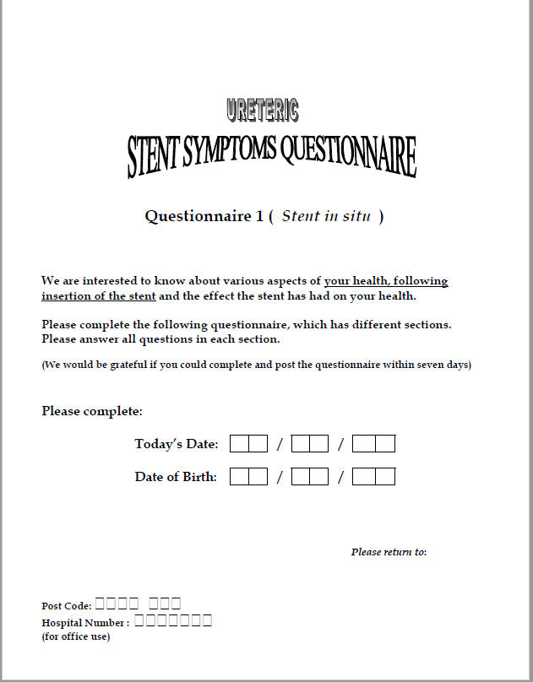

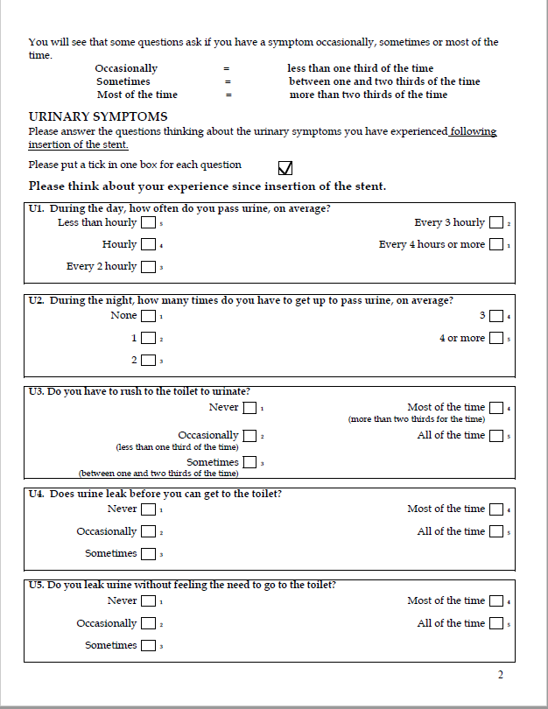

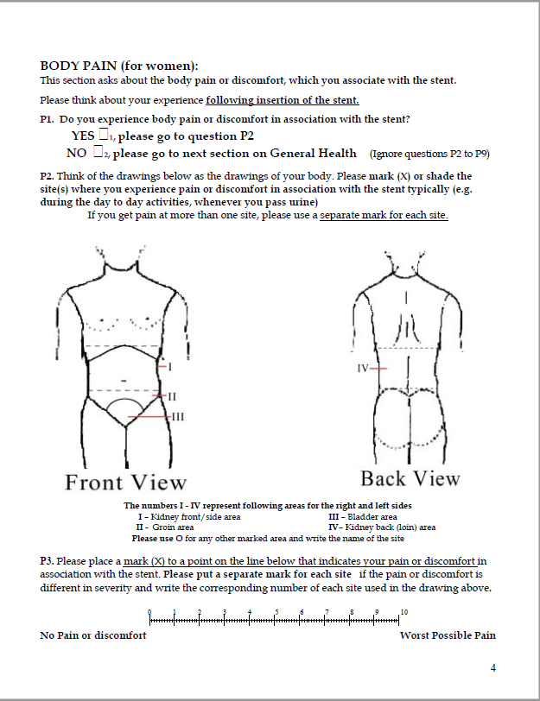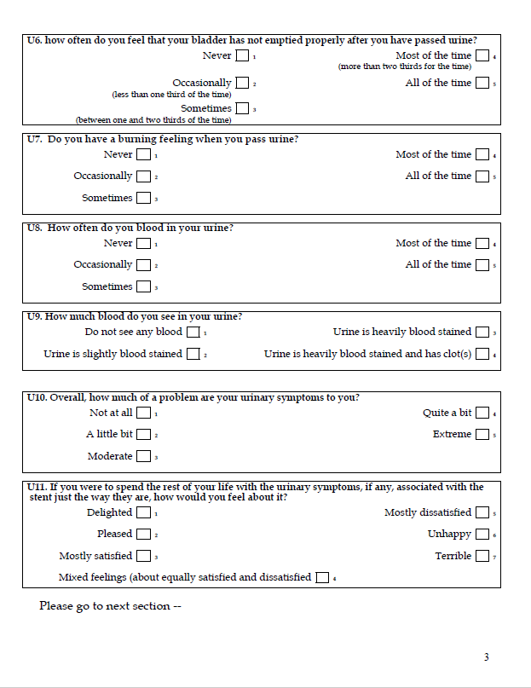

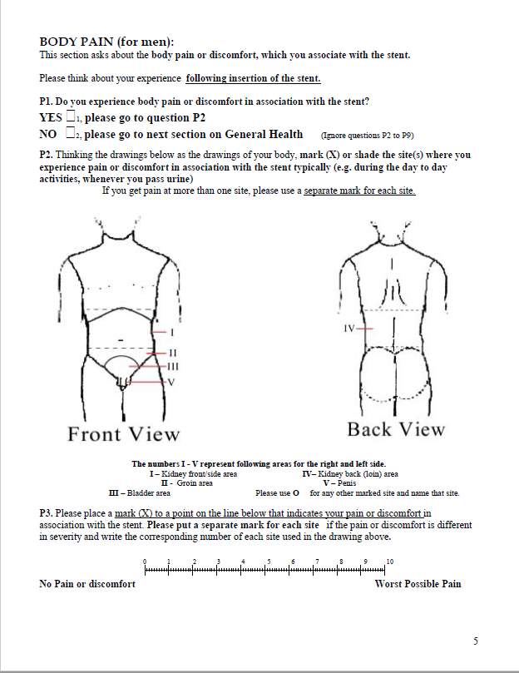

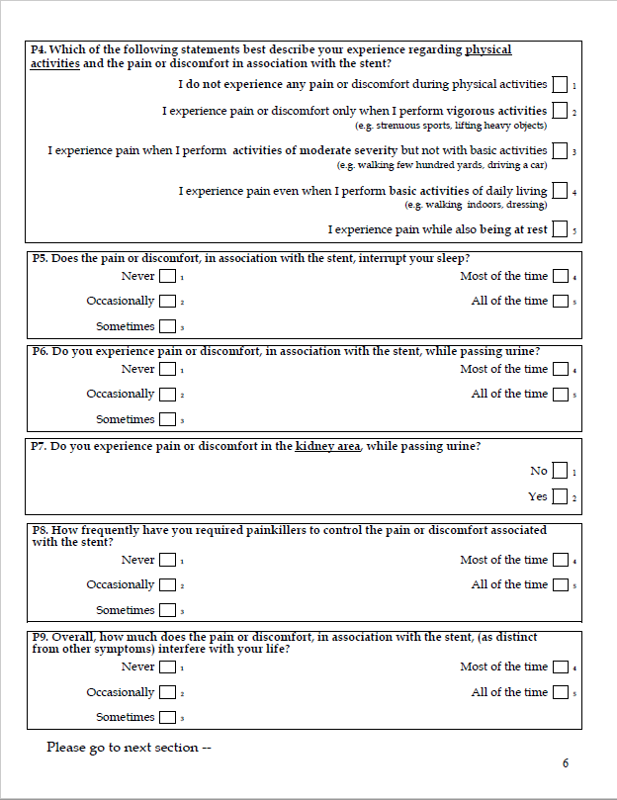

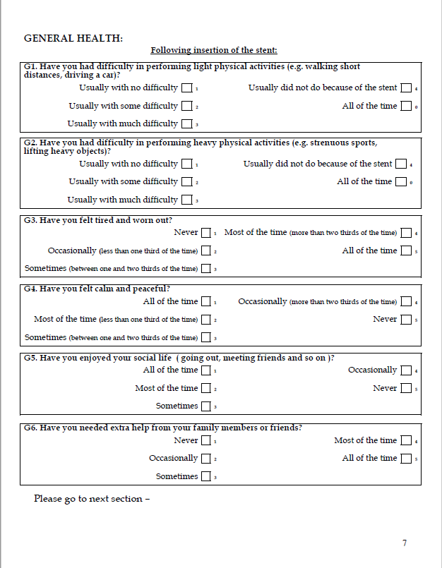

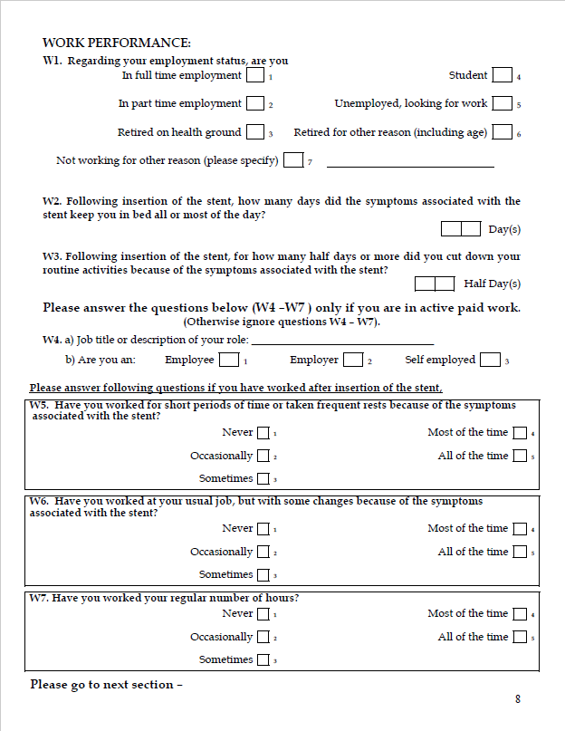

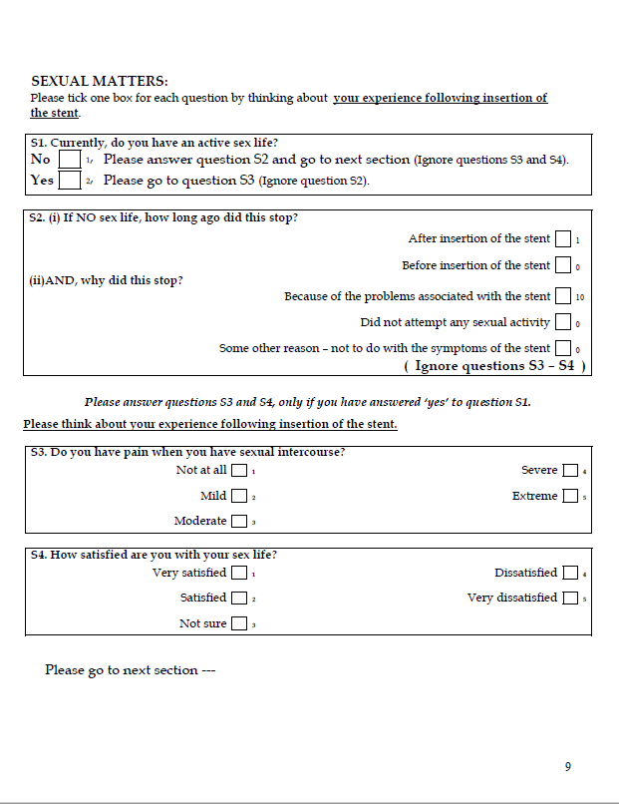

Appendix 3 - IPSS
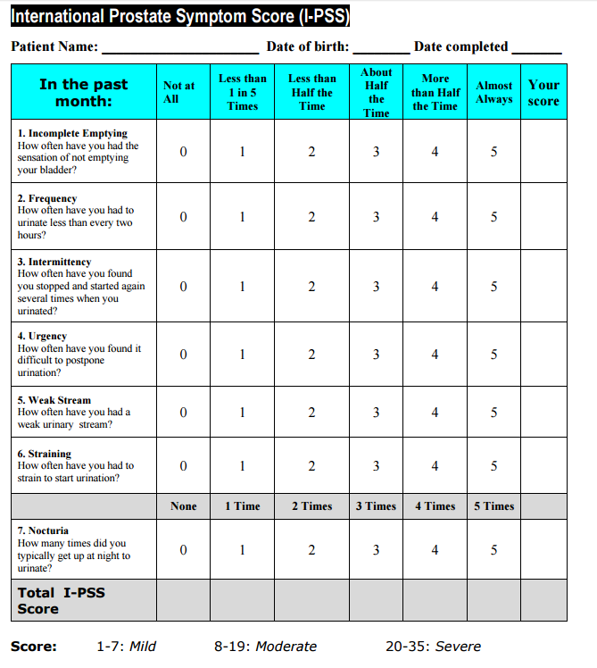

Appendix 4 – Stent Study Recruitment Flowchart
Not appropriate for stent study

START HERE:
Is the patient:
- 18 years or older
- Clinically indicated for a unilateral retrograde ureteral stent

Do any of these apply to the patient:
Patient
- Is unable to speak English
- Has cognitive impairments or intellectual disabilities
- Is currently pregnant
- Has an untreated urinary tract infection
- Has an obstructive uropathy secondary to malignancy
- Has a long term indwelling catheter or suprapubic catheter
Past Medical History includes:
- Ureteric stent inserted in last 31 days
- Chronic pelvic pain syndrome
- Interstitial Cystitis
- Neurogenic bladder
- Spinal Cord Injury
- Pelvic Irradiation
- Current Bladder Cancer
- Pelvic radiation therapy
- Anatomical deformities of the urinary tract such as Duplex or Complete Duplex Ureters
Past Surgical History includes:
- Insertion of long term indwelling ureteric stent
- Radical prostatectomy
- Partial cystectomy
- Diverticulectomy
- Ureter Reimplant
- Other significant bladder surgeries
Medications include:
- Regular opioid analgesia use including:
- Endone (Oxycodone)
- Targin (Oxycodone/Naloxone)
- Panadeine Forte (Codeine)
- Regular anticholinergic medications including:
- Oxybutynin
- Solifenacin
- Regular alpha blocker medication including:
- Tamsulosin
- Prazosin

If Yes to all
No to EITHER
If NONE apply
Patient Appropriate for Stent Study

Go to Page 2

If Patient Appropriate for Stent Study
(See Page 1 to determine if patient appropriate)
Consent Checklist
- Patient aware that consent to study is NOT the same as consent to procedure
- Patient consented for study
- Two consent forms signed (in Stent Study Pack)
- One copy given to patient
- One copy (study copy) filed ______
- Patient copy of consent form filed in Stent Study Pack and pack given to patient

Assigning Patients to Stent Group
Consult “Bard vs Cook Stent Study Book” to determine which stent group (Bard or Cook) patient is to be assigned to
- Place copy of patient sticker in “Stent Study – Group Assignment” Book in relevant location indicated in book. Fill in checklist and state date of study consent as indicated
- At top of page will say which group patient belongs to (eg. Group 10)
- Turn to front of book to determine what stent that particular Group relates to (eg. Group 10 – A)
Obtain Stent Study Pack from _______
Proceed to Consent Patient

Check Stent Study Pack Obtained Contains
- Two Patient Information and Consent Forms (one for patient, one copy for study)
- One copy of Universal Stent Symptoms Questionnaire

Appendix 5 – First 5 pages of Stent Study Book (Proof of Concept, actual book will extend to 32 Groups of 4)

Bard vs Cook Stent Study Book

Stent Assignment
Group Number | Stent Assignment
Group 1 | A
Group 2 | B
Group 3 | A
Group 4
Group 5
Group 6
Group 7
Group 8
Group 9
Group 10
Group 11
Group 12
Group 13
Group 14
Group 15
Group 16
Group 17
Group 18
Group 19
Group 20
Group 21
Group 22
Group 23
Group 24
Group 25
Group 26
Group 27
Group 28
Group 29
Group 30
Group 31
Group 32
A Represents _Bard______________
B Represents ___Cook_____________
Note that following clinicians associated with study must NOT be made aware at any point the nature of the stents inserted:
- Dr Alexander Ngoo
- Dr Philipe Wolanski
Group 1 – Page 2 indicates which stent this represents
Patient Sticker | Checklist
Date of Stent Insertion: | - Patient appropriate for study as per Page 1 of Stent Study Recruitment Pathway  - Patient consented for study  - Two consent forms signed (in Stent Study Pack)  - One copy given to patient  - One copy filed in ______
Date of Stent Insertion: | - Patient appropriate for study as per Page 1 of Stent Study Recruitment Pathway  - Patient consented for study  - Two consent forms signed (in Stent Study Pack)  - One copy given to patient  - One copy filed in ______
Date of Stent Insertion: | - Patient appropriate for study as per Page 1 of Stent Study Recruitment Pathway  - Patient consented for study  - Two consent forms signed (in Stent Study Pack)  - One copy given to patient  - One copy filed in ______
Date of Stent Insertion: | - Patient appropriate for study as per Page 1 of Stent Study Recruitment Pathway  - Patient consented for study  - Two consent forms signed (in Stent Study Pack)  - One copy given to patient  - One copy filed in ______

Group 2 - Page 2 indicates which stent this represents
Patient Sticker | Checklist
Date of Stent Insertion: | - Patient appropriate for study as per Page 1 of Stent Study Recruitment Pathway  - Patient consented for study  - Two consent forms signed (in Stent Study Pack)  - One copy given to patient  - One copy filed in ______
Date of Stent Insertion: | - Patient appropriate for study as per Page 1 of Stent Study Recruitment Pathway  - Patient consented for study  - Two consent forms signed (in Stent Study Pack)  - One copy given to patient  - One copy filed in ______
Date of Stent Insertion: | - Patient appropriate for study as per Page 1 of Stent Study Recruitment Pathway  - Patient consented for study  - Two consent forms signed (in Stent Study Pack)  - One copy given to patient  - One copy filed in ______
Date of Stent Insertion: | - Patient appropriate for study as per Page 1 of Stent Study Recruitment Pathway  - Patient consented for study  - Two consent forms signed (in Stent Study Pack)  - One copy given to patient  - One copy filed in ______

Group 3 - Page 2 indicates which stent this represents
Patient Sticker | Checklist
Date of Stent Insertion: | - Patient appropriate for study as per Page 1 of Stent Study Recruitment Pathway  - Patient consented for study  - Two consent forms signed (in Stent Study Pack)  - One copy given to patient  - One copy filed in ______
Date of Stent Insertion: | - Patient appropriate for study as per Page 1 of Stent Study Recruitment Pathway  - Patient consented for study  - Two consent forms signed (in Stent Study Pack)  - One copy given to patient  - One copy filed in ______
Date of Stent Insertion: | - Patient appropriate for study as per Page 1 of Stent Study Recruitment Pathway  - Patient consented for study  - Two consent forms signed (in Stent Study Pack)  - One copy given to patient  - One copy filed in ______
Date of Stent Insertion: | - Patient appropriate for study as per Page 1 of Stent Study Recruitment Pathway  - Patient consented for study  - Two consent forms signed (in Stent Study Pack)  - One copy given to patient  - One copy filed in ______

