**PARENT INFORMATION SHEET AND CONSENT FORM**

**Study Title:** Early pharmacological treatment with supportive care versus supportive care alone in preterm infants with a patent ductus arteriosus

**Principal Investigator**: Dr Koert de Waal

You are invited to take part in this research study because your baby was born before 29 weeks of pregnancy and therefore may be at risk of developing a patent ductus arteriosus (PDA). If your baby develops a PDA, this study will explore if current standard treatment (supportive care with medication) is any better than supportive care alone.

Before you decide whether or not you wish to take part, it is important for you to understand why the research is being done and what it will involve. You can discuss it with a relative, friend or anyone else. Please read this carefully and feel free to ask questions. If you agree for your baby to join the study, you will be asked to sign the Consent Form. By signing it, you show that you understand this information and consent to join the study. You will be given a copy of this document and Consent Form to keep as a record. Participation in this research is voluntary. If you don’t wish to take part, you don’t have to. Your baby will receive the best possible care whether you take part or not.

A patent ductus arteriosus (PDA) is a common finding in preterm infants. The ductus arteriosus is a blood vessel that joins two of the major arteries (the aorta and the pulmonary artery) that are connected to the heart in the unborn fetus. In a fetus this allows most of the blood from the heart to bypass the lungs that are filled with fluid. Once the baby is born and the lungs fill with air, the PDA normally closes within a few days. In some babies, however, the ductus arteriosus remains open (patent) which can lead to problems of fluid overload in the heart and lungs. (see picture)

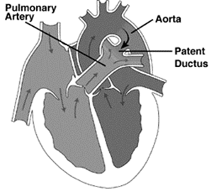

**What is the purpose of the study?**

Our current standard treatment includes medications that narrow all blood vessels and thus can help constrict and/or close a PDA. The most commonly used medications are indomethacin and ibuprofen. We have learned from previous studies that giving medications to all babies with a PDA does not improve important clinical outcomes such as the need for extra oxygen, lung damage or bowel infection, even though many of the PDA’s closed. We also know that medications can have significant side effects in preterm infants, so we are researching if they are really needed.

A new trial is necessary because there is uncertainty as to whether supportive care alone (that is non medication based management such as changes in breathing support and control of fluid balance) may be just as effective as supportive care with medications.

**What does the study involve?**

When a PDA of a certain size is diagnosed before 72 hours of life, your baby will be randomized (like tossing a coin) to treatment with medication, or a placebo (a substance that looks like medication but contains no active ingredients). In both cases your baby will also receive supportive treatment for a PDA. If the PDA remains open after 2 courses of study drug, no further PDA treatment medications are allowed in this study. In this case we would continue to provide supportive care and await PDA closure naturally which can take up to several weeks, depending on the gestation of your baby and possible other complications. Currently this approach is the standard care if treatment fails to close a PDA in preterm infants.

Ultrasound scans will be used to screen your baby after birth, and to monitor the PDA and its treatment. One additional ultrasound scan is requested before your baby is transferred or discharged from the neonatal intensive care unit. We use ultrasound in the routine clinical care of preterm babies and it is common for preterm babies to have at least one ultrasound of the heart in the first few days of life.

**Why have I been invited to allow my baby to be included in this study?**

This study is suitable for your baby because he or she was born at less than 29 weeks gestation. Preterm babies are more likely to develop a patent ductus arteriosus.

**Are there any risks or benefits to my baby taking part in this study?**

It is hoped that the information collected from this study will improve our understanding of the PDA and that we will be able to offer the best treatment for preterm infants with a PDA. However, this information will only be available after the trial is completed. There are no specific risks or benefits to your baby, as all other treatments and monitoring will be according to standard guidelines. Both approaches to PDA management used in this study are reasonable and used by doctors treating preterm babies.

**Is the Information Collected Confidential?**

Nurses and doctors involved in your care will know if your baby is taking part in this study. Any information about your baby in this study will remain confidential and will not be disclosed without your permission, except as required by law. All information collected will be accessed, used and stored in accordance with the Commonwealth Privacy Laws and the NSW Health Records and Information Privacy Act 2002. The data may be published in research papers in scientific journals to further the understanding of doctors and scientists involved in the care of babies around the world. The data from the images obtained in this might also be used in other research studies. Your baby will not be identifiable in any presentations or publications of this data.

**What if I don’t want my baby to join, or if I want to withdraw later?**

Participation in this study is entirely your choice. Only those people who give their informed consent will be included in the project. If your baby does not take part, it will not affect your baby’s treatment or your relationship with the staff, now or in the future. If you do decide to participate, you may withdraw from the project at any time without giving a reason. You may also choose to withdraw any data collected in relation to your child. Before you decide to take part, a member of the study team can answer your questions. Please ask anything you want. Sign the Consent Form only if you are satisfied with the answers.

**What are the alternatives to participating in this study?**

If you decide that you do not want your child to participate in this study, your child will still receive the standard treatment available for a PDA. Standard treatment includes ultrasounds of the heart and treatment with medications including indomethacin or ibuprofen.

**What if I Have a Complaint About the Study?**

This project has been approved by the Hunter New England Human Research Ethics Committee of Hunter New England Health, Reference No: 15/12/16/3.03

Should you have concerns about your rights as a participant in this research, or you have a complaint about the manner in which the research is conducted, it may be given to the researcher, or, if an independent person is preferred, to Dr Nicole Gerrand, “Manager Research Ethic and Governance”, Hunter New England Human Research Ethics Committee, Hunter New England Health, Locked Bag 1, New Lambton NSW 2305, telephone (02) 49214950, email [Nicole.Gerrand@hnehealth.nsw.gov.au](mailto:Nicole.Gerrand@hnehealth.nsw.gov.au)

**What do you need to do to participate?**

Please read this information statement and be sure you understand its content before you consent to participate. If there is anything you do not understand, or you have questions, please contact the investigators. You may keep this information sheet for future reference. If you would like to participate please read and sign the attached consent form. Thank you for considering this invitation, on behalf of the research team,

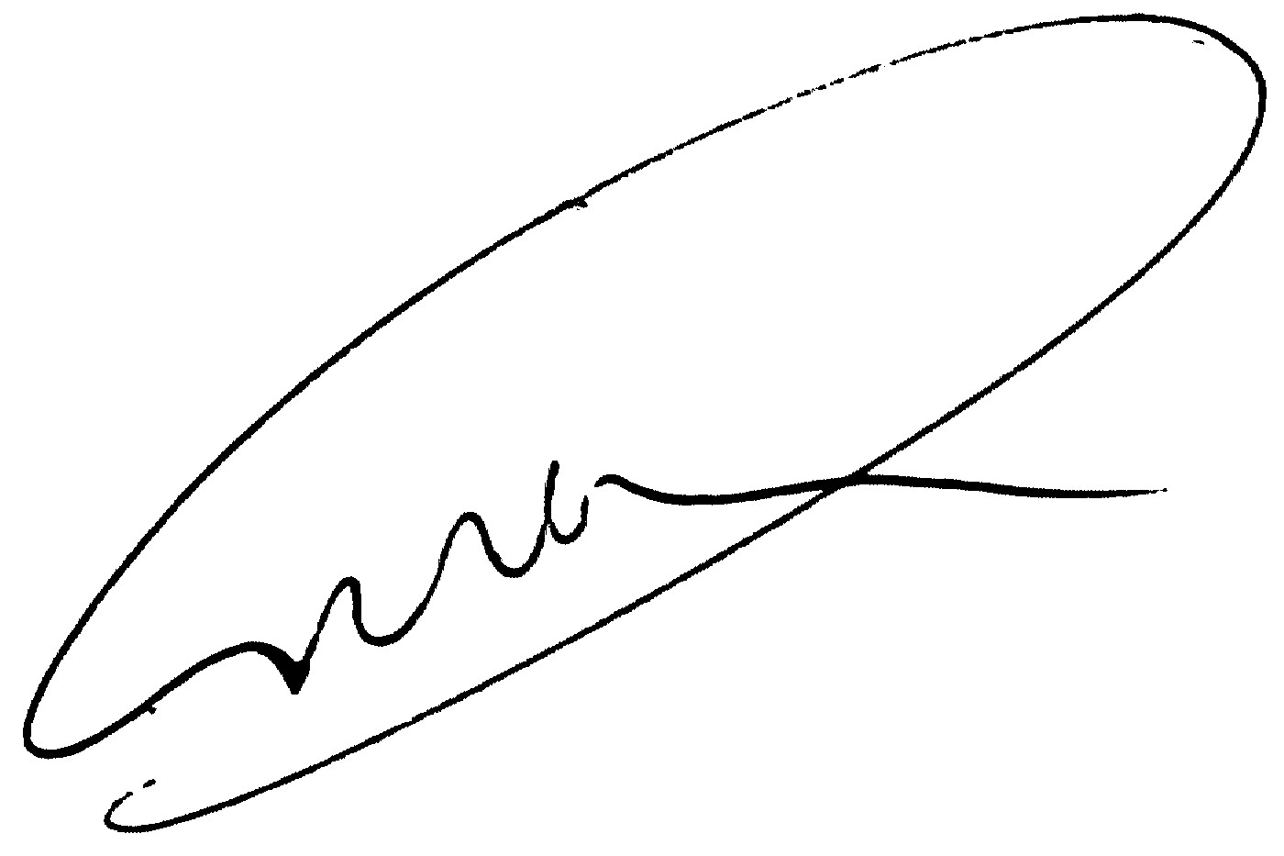

Dr Koert de Waal, Staff specialist Neonatology

**Early pharmacological treatment with supportive care versus supportive care alone in preterm infants with a patent ductus arteriosus**

**PARENT CONSENT FORM**

I, ....................................................................................................................... [name]

of...........................................................…………………………………… have read and understood the Information for Participants on the above named research study and have discussed the study with

..............................................................................................

I understand that I am agreeing to participate my child in a research study.

Baby’s Name:……………………………………………………….

I have been made aware of the procedures involved in the study, including any known or expected inconvenience, risk, discomfort or side effect, and of their implications as far as they are currently known by the researchers. I acknowledge this has been explained to me to my satisfaction.

Before signing this consent form, I have been given the opportunity of asking any questions relating to any possible physical and mental harm my child might suffer as a result of his/her participation and I have received satisfactory answers.

I understand that the research project will be carried out according to the principles in the National Health & Medical Research Council Statement on Ethical Conduct in Research Involving Humans.

I freely choose to participate my child in this study and understand that I can withdraw my child from the study at any time without prejudice to my relationship with the treating hospital

I also understand that the research study is strictly confidential.

I agree that research data gathered from the results of the study may be published, provided that my child cannot be identified.

I understand that if I have any questions relating to participating in this research, I may contact Dr de Waal on telephone 49214362.

I acknowledge receipt of a copy of this Consent Form and the Participant Information Sheet.

Signature of parent/guardian:……………………………….…………………………….…. Date:____/____/____

Name of person obtaining consent:………………………………………………..…………

Signature of person obtaining consent:……………………………………………….…….. Date:____/____/____

Name of witness/ interpreter:…………………………………………………………………

Signature of witness/interpreter:……………….……………………………………………. Date:____/____/____