12-WEEK PERSONALISED PHYSICAL ACTIVITY PROMOTION PAIR-BASED PROGRAM

FOR AUTISTIC ADULTS

INTERVENTION'S MANUAL

**Welcome to the Program!**

We’re excited to have you join us for this 12-week program designed to support you in becoming more physically active. Throughout this journey, you’ll have the opportunity to learn more about physical activity, explore new activities, set and track your personal goals using advanced technological gear, work closely with your chosen supporter, and get live online support from our team.

This manual will guide you step by step, offering helpful tips, resources, and tools to make your experience enjoyable and rewarding. Remember, you’re not alone—our team is here to support you every step of the way.

Let’s get started on this exciting journey together!

*Curtin University Research Team*

*Curtin University Human Research Ethics Committee (HREC) has approved this study (HREC number HRE2024-XXXX)”*

**CONTENTS**

|  |  |
| --- | --- |
|  | Pages |
| Program Overview | 4 |
| Weekly Step-by-Step Checklists | 5 |
| * Week 0: Getting Started | 5 |
| * Week 1: Educational Workshop | 6 |
| * Week 2: Weekly Physical Activity | 7 |
| * Week 3: Performance Review Week | 8 |
| * Week 4: Weekly Physical Activity | 9 |
| * Week 5: Performance Review Week | 10 |
| * Week 6: Weekly Physical Activity | 11 |
| * Week 7: Performance Review Week | 12 |
| * Week 8: Weekly Physical Activity | 13 |
| * Week 9: Performance Review Week | 14 |
| * Week 10: Weekly Physical Activity | 15 |
| * Week 11: Performance Review Week | 16 |
| * Week 12: Weekly Physical Activity | 17 |
| * Week 13: Performance Review Week | 18 |
| Fitbit Usage Manual | 19 |
| Fitbit App Usage Manual | 22 |
| SENS Usage Manual | 27 |
| SENS Motion App Usage Manual | 29 |
| General Device Usage Agreement | 30 |
| List of Easy-to-Do Physical Activities | 32 |
| Physical Activities' Benefits | 36 |
| Sedentary Activities' Consequences | 38 |
| Puclic Physical Activities' Space Ettiquette | 40 |
| Problem Solving Worksheets | 43 |
| Action Planning Worksheets | 51 |
| Activity Logbook | 59 |

**PROGRAM OVERVIEW**

This program is designed to help you build healthy physical activity (PA) habits through structured activities, planning, and support from your partner and our research team. You’ll have workshops, action planning sessions, and opportunities to track and improve your PA using advanced technology. By the end of the program, you’ll have the tools and confidence to maintain an active lifestyle.

1. Key tasks:

* Online Workshop: You and your partner will attend an online workshop (in week 1) to learn about PA, problem-solving skills, gym etiquette, planning fortnightly PA, and your personalised support system.
* Action Plans: You and your partner will co-plan your fortnightly PA schedules (at the start of weeks 1, 3, 5, 7, 9, 11) using the provided templates and send them back to us to receive personalised reminders
* PA Engagement: You and your partner will co-participate in your chosen PA according to your scheduled plans across 12 weeks.
* PA Tracking: You’ll monitor your weekly PA using a provided Fitbit and an activity log book. During week 0 (pre-intervention), week 7 (mid-intervention), and week 13 (post-intervention), you’ll also be provided with a SENS device to collect data on your activity level subjectively.
* Checking-in meeting: You and your partner will attend fortnightly online (Weeks 1, 3, 5, 9, 11) and in-person meetings (Weeks 7 and 13) with the researchers to review your activity level and get support to identify any challenges to improve or maintain your ongoing performance.
* Support: Our team will regularly send reminders, encouragement, and support via a Whatsapp group chat to support you and your partner during the program.

1. Key Program Materials:

* Intervention Manual: This manual provides step-by-step instructions and materials to guide you through the program.
* Partner’s Guide: This guide explains how your partner can assist you in the program.
* Problem-Solving Worksheet: Use this to help you identify and solve challenges related to PA.
* Action Planning Worksheet: You and your partner will use this to set fortnightly PA schedules and send them back to us to receive personalised reminders.
* PA Logbook: Use this to record your weekly physical activities and sedentary behaviour as instructed.
* Fitbit & SENS Devices: You will wear these devices to track your weekly PA and sedentary behaviour.
* Motivational Posters: Printable posters to motivate you to stay active.
* Educational Posters: Printable posters will provide information on gym etiquette, PA benefits, and consequences for sedentary behaviour.

*\* Please note: All written and printable materials will be provided freely to you in this manual, and some will be sent via the WhatsApp group chat. You can keep them after the program. However, the researchers will hand the devices to you in person, and they must be returned to the University as instructed.*

**WEEKLY STEP-BY-STEP CHECKLISTS**

In this section, you will find the step-by-step task checklists and relevant materials (where applicable) you must complete each week, from week 0 (pre-intervention week) to week 13 (post-intervention week). All tasks are presented in time order. Whenever you complete a task, please note Y (yes) in the status column for that task. This will help you easily monitor and complete the program and allow your partner and the research team to follow your progress.

WEEK 0: GETTING STARTED

|  |  |  |
| --- | --- | --- |
| WEEK 0 CHECKLIST | | |
| Tasks | Materials | Status (Y/N) |
| Meet the research team at Curtin University | Not avaiable (n.a) |  |
| Understand the program | n.a |  |
| Understand the roles and responsibilities of each party (autistic adults, partner, and research team) in the program | n.a |  |
| Understand how to use the Intervention Manual | Intervention Manual |  |
| Understand how to use Fitbit | Fitbit Usage Manual (p. 19) |  |
| Install and understand how to use Fitbit application | Fitbit App Usage Manual(p. 22) |  |
| Understand how to use SENS device | SENS Usage Manual (p. 27) |  |
| Install the SENS Motion app to transfer data | SENS Motion app Usage Manual (p. 29) |  |
| Collect the SENS device with a prepaid envelop | General Devices Usage Agreement (p. 30) |  |
| Completing the International Physical Activity Questionaire (IPAQ_ | n.a |  |
| Completing the Behavioral Regulation in Exercise Questionnaire-2 (BREQ-3) | n.a |  |
| Schedule week 1's workshop | n.a |  |
| Participate in the WhatsApp's group chat with the research team | WhatsApp group chat |  |
| Wearing SENS continuously for seven days | SENS Usage Manual (p. 27) |  |
| Open the Motion app five minutes to transfer data from SENS daily | SENS Motion app Usage Manual (p. 29) |  |
| Return SENS to the researcher using the prepaid envelop | General Devices Usage Agreement (p. 30) |  |

WEEK 1

|  |  |  |
| --- | --- | --- |
| WEEK 1 CHECKLIST | | |
| Tasks | Materials | Status |
| Meet the research team online as scheduled | n.a |  |
| Understand the definition of PA and easy-to-do PA | List of easy-to-do physical activity (p. 32 ) |  |
| Understand the benefits of PA | List of Physical activity benefits (p. 36 ) |  |
| Understand the defintion and consequences of sedentary activities | List of Sedentary activities' consequences (p. 38) |  |
| Identify and solve problems when participate in PA | Problem solving worksheet (p. 43) |  |
| Understand the public physical activity space's ettiquette | Public physical activity space's etiquette pamphlet for autistic adults (p. 40) |  |
| Understand the online support system | WhatsApp group chat |  |
| Communication standard and conflict management | n.a |  |
| Understand how to co-plan and schedule PA for the next 2 weeks (week 1 and 2) | Action planning worksheet (p. 51) |  |
| Send your Action planning worksheet to the research team via WhatsApp | WhatsApp group chat |  |
| Understand how to monitor your weekly PA and sedentary behaviour using the Fitbit and activity logbook | Activity logbook (p. 59)  Fitbit App Usage Manual (p. 22) |  |
| Schedule week 3 performance review meeting. | n.a |  |
| Check daily communication from the research team via the WhatsApp group chat | WhatsApp group chat |  |
| Wear the Fitbit daily | Fitbit Usage Manual (p. 19) |  |
| Co-participate PA with partners as scheduled | Action planning worksheet (p. 51) |  |
| Check Fitbit app and fill in Activity logbook at the end of week 1 | Activity logbook (p. 59)  Fitbit App Usage Manual(p. 22) |  |

WEEK 2

|  |  |  |
| --- | --- | --- |
| WEEK 2 CHECKLIST | | |
| Tasks | Materials | Status |
| Check daily communication from the research team via the WhatsApp group chat | WhatsApp group chat |  |
| Wear the Fitbit daily | Fitbit Usage Manual (p. 19) |  |
| Co-participate PA with partners as scheduled | Action planning worksheet (p. 51) |  |
| Check Fitbit app and fill in Activity logbook at the end of week 2. | Activity logbook (p. 59)  Fitbit App Usage Manual(p. 22) |  |

WEEK 3

|  |  |  |
| --- | --- | --- |
| WEEK 3 CHECKLIST | | |
| Tasks | Materials | Status |
| Meet the research team online as scheduled | n.a |  |
| Review week 1 and 2 physical activity levels | Activity logbook (p. 59) |  |
| Identify and solve problems from week 1 and 2 | Problem solving worksheet (p. 43) |  |
| Co-schedule PA for week 3 and 4 | Action planning worksheet (p. 51) |  |
| Send your Action planning worksheet to the research team via WhatsApp | WhatsApp group chat |  |
| Schedule week 5 performance review meeting. | n.a |  |
| Check daily communication from the research team via the WhatsApp group chat | WhatsApp group chat |  |
| Wear the Fitbit daily | Fitbit Usage Manual (p. 19) |  |
| Co-participate PA with partners as scheduled | Action planning worksheet (p.51 ) |  |
| Checking Fitbit app and fill in Activity logbook at the end of week 3 | Activity logbook (p. 59)  Fitbit App Usage Manual(p.22 ) |  |

WEEK 4

|  |  |  |
| --- | --- | --- |
| WEEK 4 CHECKLIST | | |
| Tasks | Materials | Status |
| Check daily communication from the research team via the WhatsApp group chat | WhatsApp group chat |  |
| Wear the Fitbit daily | Fitbit Usage Manual (p. 19) |  |
| Co-participate PA with partners as scheduled | Action planning worksheet (p. 51) |  |
| Checking Fitbit app and fill in Activity logbook at the end of week 4 | Activity logbook (p. 59)  Fitbit App Usage Manual(p. 22) |  |

WEEK 5

|  |  |  |
| --- | --- | --- |
| WEEK 5 CHECKLIST | | |
| Tasks | Materials | Status |
| Meet the research team online as scheduled | n.a |  |
| Review week 3 and 4 physical activity levels | Activity logbook (p. 59) |  |
| Identify and solve problems from week 3 and 4 | Problem solving worksheet (p. 43) |  |
| Co-schedule PA for week 5 and 6 | Action planning worksheet (p. 51) |  |
| Send your Action planning worksheet to the research team via WhatsApp | WhatsApp group chat |  |
| Schedule week 7 performance review meeting (in person). | n.a |  |
| Check daily communication from the research team via the WhatsApp group chat | WhatsApp group chat |  |
| Wear the Fitbit daily | Fitbit Usage Manual (p. 19) |  |
| Co-participate PA with partners as scheduled | Action planning worksheet (p.51 ) |  |
| Checking Fitbit app and fill in Activity logbook at the end of week 5 | Activity logbook (p. 59)  Fitbit App Usage Manual(p.22 ) |  |

WEEK 6

|  |  |  |
| --- | --- | --- |
| WEEK 6 CHECKLIST | | |
| Tasks | Materials | Status |
| Check daily communication from the research team via the WhatsApp group chat | WhatsApp group chat |  |
| Wear the Fitbit daily | Fitbit Usage Manual (p. 19) |  |
| Co-participate PA with partners as scheduled | Action planning worksheet (p. 51) |  |
| Checking Fitbit app and fill in Activity logbook at the end of week 6 | Activity logbook (p. 59)  Fitbit App Usage Manual(p. 22) |  |

WEEK 7

|  |  |  |
| --- | --- | --- |
| WEEK 7 CHECKLIST | | |
| Tasks | Materials | Status |
| Meet the research team in person as scheduled | n.a |  |
| Review week 5 and 6 physical activity levels | Activity logbook (p. 59) |  |
| Identify and solve problems from week 5 and 6 | Problem solving worksheet (p. 43) |  |
| Co-schedule PA for week 7 and 8 | Action planning worksheet (p. 51) |  |
| Send your Action planning worksheet to the research team via WhatsApp | WhatsApp group chat |  |
| Schedule week 9 performance review meeting. | n.a |  |
| Completing the International Physical Activity Questionaire (IPAQ) | n.a |  |
| Completing the Behavioral Regulation in Exercise Questionnaire-2 (BREQ-3) | n.a |  |
| Collect the SENS device with a prepaid envelop | General Device Usage Agreement (p. 30) |  |
| Check daily communication from the research team via the WhatsApp group chat | WhatsApp group chat |  |
| Wear the Fitbit daily | Fitbit Usage Manual (p. 19) |  |
| Wearing SENS continuously for seven days | SENS Usage Manual (p. 27) |  |
| Open the Motion app five minutes to transfer data from SENS daily | SENS Motion app Usage Manual (p. 29) |  |
| Co-participate PA with partners as scheduled | Action planning worksheet (p. 51) |  |
| Checking Fitbit app and fill in Activity logbook at the end of week 7 | Activity logbook (p. 59)  Fitbit App Usage Manual(p. 22) |  |
| Return SENS to the researcher using the prepaid envelop | General Device Usage Agreement (p. 30) |  |

WEEK 8

|  |  |  |
| --- | --- | --- |
| WEEK 8 CHECKLIST | | |
| Tasks | Materials | Status |
| Check daily communication from the research team via the WhatsApp group chat | WhatsApp group chat |  |
| Wear the Fitbit daily | Fitbit Usage Manual (p. 19) |  |
| Co-participate PA with partners as scheduled | Action planning worksheet (p. 51) |  |
| Checking Fitbit app and fill in Activity logbook at the end of week 8 | Activity logbook (p. 59)  Fitbit App Usage Manual(p. 22) |  |

WEEK 9

|  |  |  |
| --- | --- | --- |
| WEEK 9 CHECKLIST | | |
| Tasks | Materials | Status |
| Meet the research team online as scheduled | n.a |  |
| Review week 7 and 8 physical activity levels | Activity logbook (p. 59) |  |
| Identify and solve problems from week 7 and 8 | Problem solving worksheet (p. 43) |  |
| Co-schedule PA for week 9 and 10 | Action planning worksheet (p. 51) |  |
| Send your Action planning worksheet to the research team via WhatsApp | WhatsApp group chat |  |
| Schedule week 11 performance review meeting. | n.a |  |
| Check daily communication from the research team via the WhatsApp group chat | WhatsApp group chat |  |
| Wear the Fitbit daily | Fitbit Usage Manual (p. 19) |  |
| Co-participate PA with partners as scheduled | Action planning worksheet (p.51 ) |  |
| Checking Fitbit app and fill in Activity logbook at the end of week 9 | Activity logbook (p. 59)  Fitbit App Usage Manual(p.22 ) |  |

WEEK 10

|  |  |  |
| --- | --- | --- |
| WEEK 10 CHECKLIST | | |
| Tasks | Materials | Status |
| Check daily communication from the research team via the WhatsApp group chat | WhatsApp group chat |  |
| Wear the Fitbit daily | Fitbit Usage Manual (p. 19) |  |
| Co-participate PA with partners as scheduled | Action planning worksheet (p. 51) |  |
| Checking Fitbit app and fill in Activity logbook at the end of week 10 | Activity logbook (p. 59)  Fitbit App Usage Manual(p. 22) |  |

WEEK 11

|  |  |  |
| --- | --- | --- |
| WEEK 11 CHECKLIST | | |
| Tasks | Materials | Status |
| Meet the research team online as scheduled | n.a |  |
| Review week 9 and 10 physical activity levels | Activity logbook (p. 59) |  |
| Identify and solve problems from week 9 and 10 | Problem solving worksheet (p. 43) |  |
| Co-schedule PA for week 11 and 12 | Action planning worksheet (p. 51) |  |
| Send your Action planning worksheet to the research team via WhatsApp | WhatsApp group chat |  |
| Schedule week 13 performance review meeting (in person). | n.a |  |
| Check daily communication from the research team via the WhatsApp group chat | WhatsApp group chat |  |
| Wear the Fitbit daily | Fitbit Usage Manual (p. 19) |  |
| Co-participate PA with partners as scheduled | Action planning worksheet (p.51 ) |  |
| Checking Fitbit app and fill in Activity logbook at the end of week 11 | Activity logbook (p. 59)  Fitbit App Usage Manual(p.22 ) |  |

WEEK 12

|  |  |  |
| --- | --- | --- |
| WEEK 12 CHECKLIST | | |
| Tasks | Materials | Status |
| Check daily communication from the research team via the WhatsApp group chat | WhatsApp group chat |  |
| Wear the Fitbit daily | Fitbit Usage Manual (p. 19) |  |
| Co-participate PA with partners as scheduled | Action planning worksheet (p. 51) |  |
| Checking Fitbit app and fill in Activity logbook at the end of week 12 | Activity logbook (p. 59)  Fitbit App Usage Manual(p. 22) |  |

WEEK 13

|  |  |  |
| --- | --- | --- |
| WEEK 13 CHECKLIST | | |
| Tasks | Materials | Status |
| Meet the research team in person as scheduled | n.a |  |
| Review week 11 and 12 physical activity levels | Activity logbook (p. 59) |  |
| Identify and solve problems from week 11 and 12 | Problem solving worksheet (p. 43) |  |
| Complete the International Physical Activity Questionaire (IPAQ) | n.a |  |
| Complete the Behavioral Regulation in Exercise Questionnaire-2 (BREQ-3) | n.a |  |
| Complete feasibility and acceptability survey | n.a |  |
| Recieve Program Completion Certificate | n.a |  |
| Return the Fitbit device | n.a |  |
| Collect the SENS device with a prepaid envelop | General Device Usage Agreement (p. 30) |  |
| Wearing SENS continuously for seven days | SENS Usage Manual (p.27 ) |  |
| Open the Motion app five minutes to transfer data from SENS daily | SENS Motion app Usage Manual (p. 29) |  |
| Return SENS to the researcher using the prepaid envelop | General Device Usage Agreement (p. 30) |  |
| Recieve $50 giftcard after returning the SENS device | n.a |  |

FITBIT USAGE MANUAL

As part of this research study, you will wear a Fitbit device on your non-dominant wrist for 12 weeks to self-monitor your physical activity. Below is an easy guide on how to use, care for, and charge your Fitbit. Please follow these steps to help ensure we collect accurate data throughout the study.

**1. What you will get?**

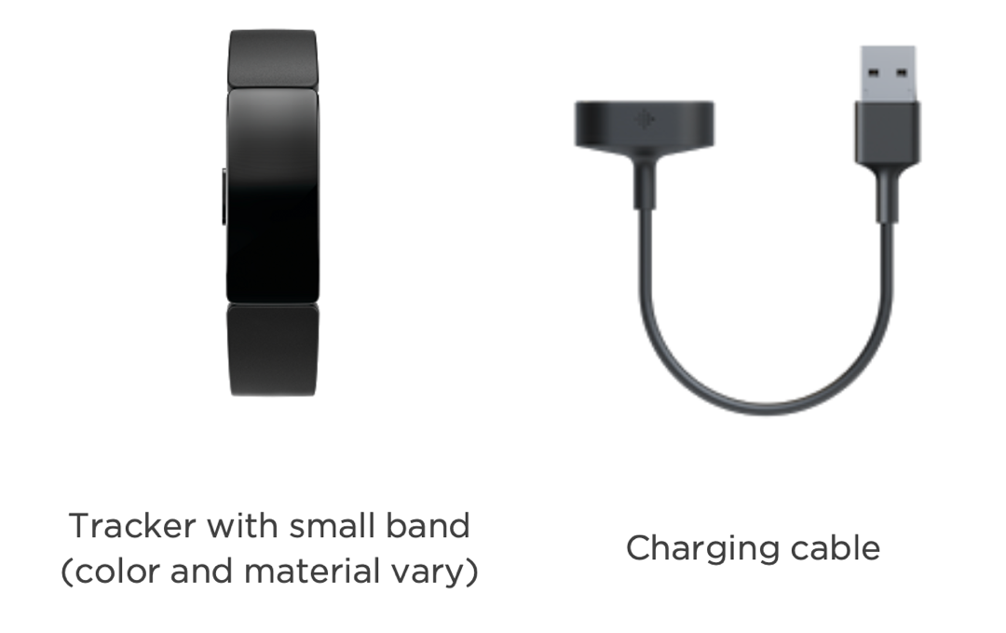

1 x Fitbit Inspire 3 and 1 x charging cable

**2. Wearing Your Fitbit:**

**- Which wrist?**

* Always wear the Fitbit on your non-dominant wrist (if you're right-handed, wear it on your left wrist; if you're left-handed, wear it on your right wrist).

**- How to wear it?**

* Secure the Fitbit snugly but comfortably around your wrist. It should not be too tight or too loose. You should be able to fit a finger underneath the band, but it shouldn’t slide up and down your arm. Wear your tracker on top of your wrist, a finger's width above your wrist bone and ensure the back of the device is in contact with your skin, as illustrated below.

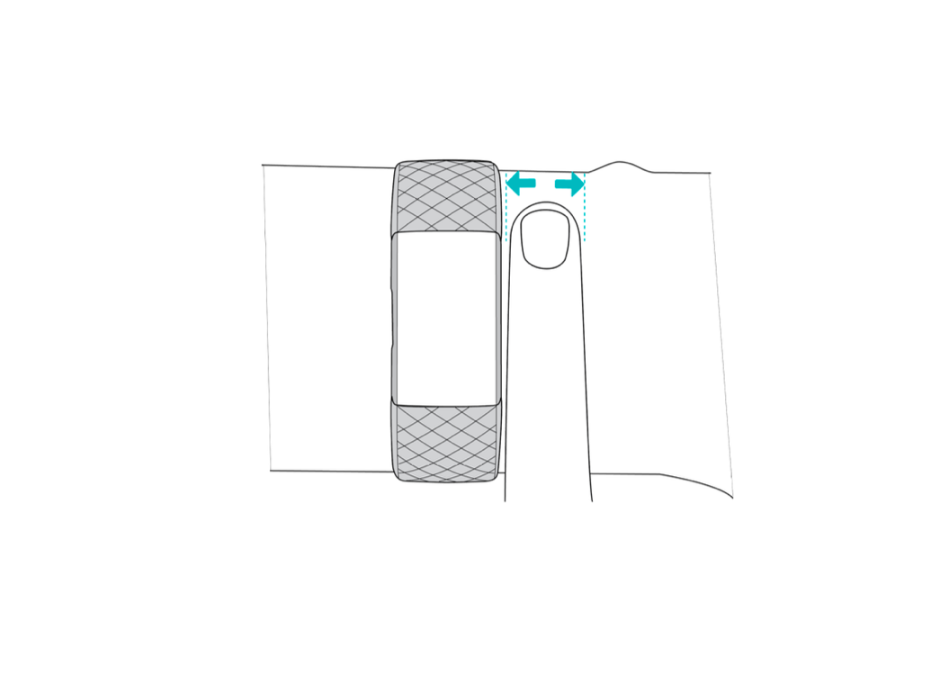

**- How long should I wear it?**

* Wear the Fitbit at all times **across the 12 weeks of the program**, including during physical activities. You should only take it off when you need to charge it or shower.

**- Wear and Care Tips:**

* Clean your band and wrist regularly with a soap-free cleanser.
* If your tracker gets wet, remove it and dry it completely after your activity.
* Take your tracker off when you shower to let your skin breathe.

**- What do I do when I find wearing Fitbit uncomfortable?**

* Adjust the Fit
* Loosen the band slightly to allow for better air circulation and comfort. You should be able to fit one finger under the band without it moving around too much.
* Tighten the band if it’s too loose and sliding, as this can irritate friction.
* Take Short Breaks
* If the discomfort persists, remove the Fitbit for a short break (10-15 minutes) to let your skin breathe. Place it somewhere safe, and remember to put it back on after the break.
* Clean the Band
* Sometimes, sweat, dirt, or skin oils can build up and irritate. Wipe the Fitbit and your wrist with a soft cloth and clean the band regularly to prevent this.
* Switch Wrist Temporarily
* If you’re feeling discomfort on your usual wrist, you can temporarily wear the Fitbit on your other wrist. Just switch back to the non-dominant wrist when it's comfortable again for consistent data collection.
* Check for Allergies or Skin Sensitivity
* If the skin under the band becomes red or itchy, you might have skin sensitivity or be allergic to the materials in the band. In that case, you may need to try a different band material (e.g., fabric or silicone) or contact the research team for guidance.
* If the discomfort continues after trying these steps, please get in touch with the research team for assistance or recommendations. Your comfort is important!

3. Charging Your Fitbit

- **When to charge?**

* Charge your Fitbit **only when it alerts you that the battery is low**. This helps ensure you maximise the use of the battery without overcharging. Your Fitbit will notify you when it needs to be charged (usually when the battery is below 20%).

- **How to charge?**

* Plug the charging cable into the USB port on your computer, a UL-certified USB wall charger, or another low-energy charging device.
* Hold the other end of the charging cable near the port on the back of the tracker until it attaches magnetically. Ensure the pins on the charging cable align with the port on the back of your tracker.

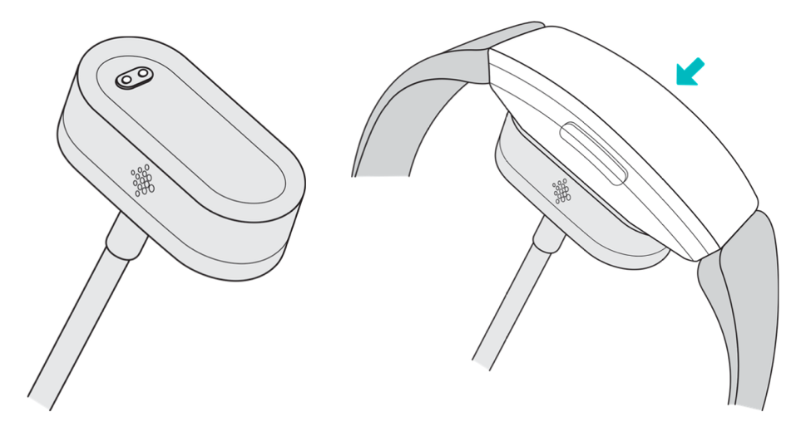

* Charging fully takes about 1-2 hours. While the tracker charges, you can press the buttons to check the battery level. A fully-charged tracker shows a solid battery icon with a smile. A fully charged tracker has a battery life of 5 days. Battery life and charge cycles vary with use and other factors; actual results will vary.

FITBIT APP USAGE MANUAL

You must set up your Fitbit using the Fitbit App for iPhones, iPads, or Android phones to track the data. Please see the instructions below.

1. Download the Fitbit App

* Download the Fitbit app:
* Apple App Store for iPhones
* Google Play Store for Android phones
* Install the app and open it.
* Tap "Sign in with Google" and follow the on-screen instructions to set up your device.

2. Use the Fitbit App to track your activity

* What do I need to track?
* **Active Zone Minutes** are a way to track how much time you spend doing exercises that get your heart rate up. When your heart beats faster during exercises like walking, biking, or running, you earn Active Zone Minutes. The more intense the activity, the more minutes you earn. The goal is to reach at least 150 Active Zone Minutes each week, which is recommended for good health by the World Health Organisation. You will need to fill in the total Active Zone Minutes weekly using the Activity Logbook provided (p. )
* **Stationary hours** track how long you've been sitting or not moving much during the day. It helps you be aware of how many hours you stay inactive. You will need to fill in the total Stationary hours weekly in the Activity Logbook provided (p. )
* How do I check?
* **Active Zone Minutes:**

+ **Open the Fitbit App** on yourphone.

+ On the main screen, you'll see your daily stats. Look for the "Active Zone Min" tile and click it.

+ It will show your Active Zone Min daily, weekly, monthly or yearly.

+ Click the "Week" title to check your weekly Active Zone Min total (red arrow).

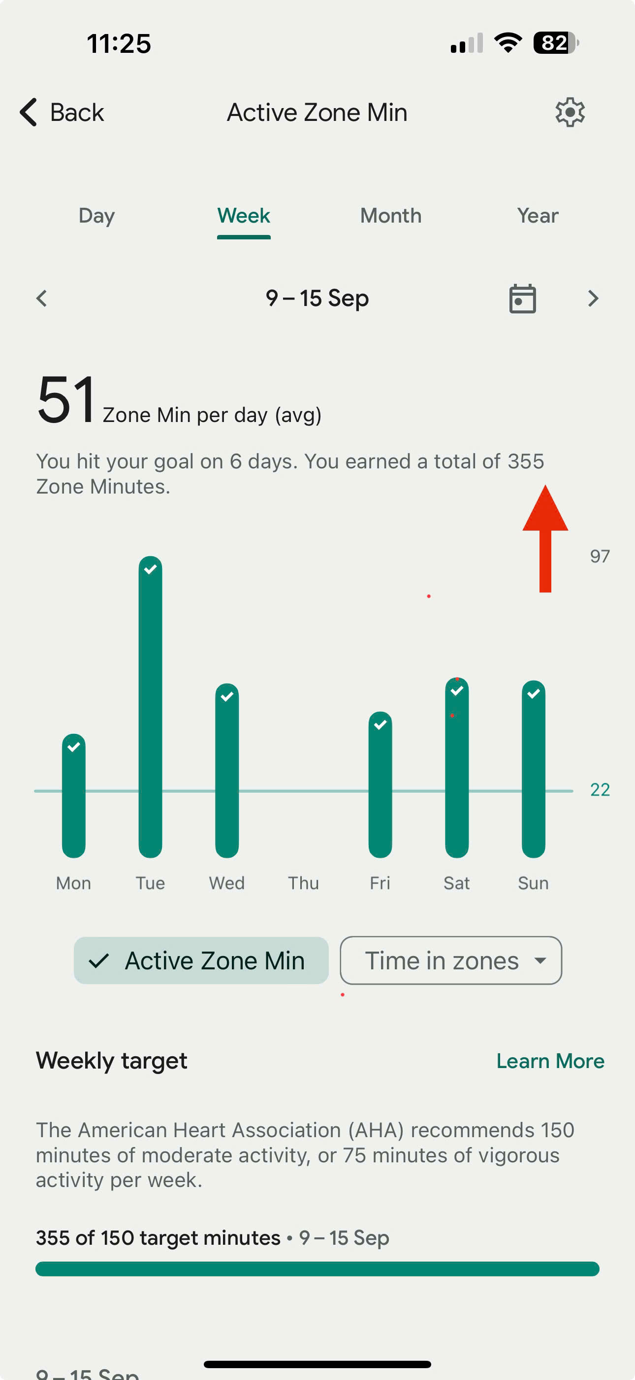

+ It will also show your daily Active Zone Min for each day within that week.

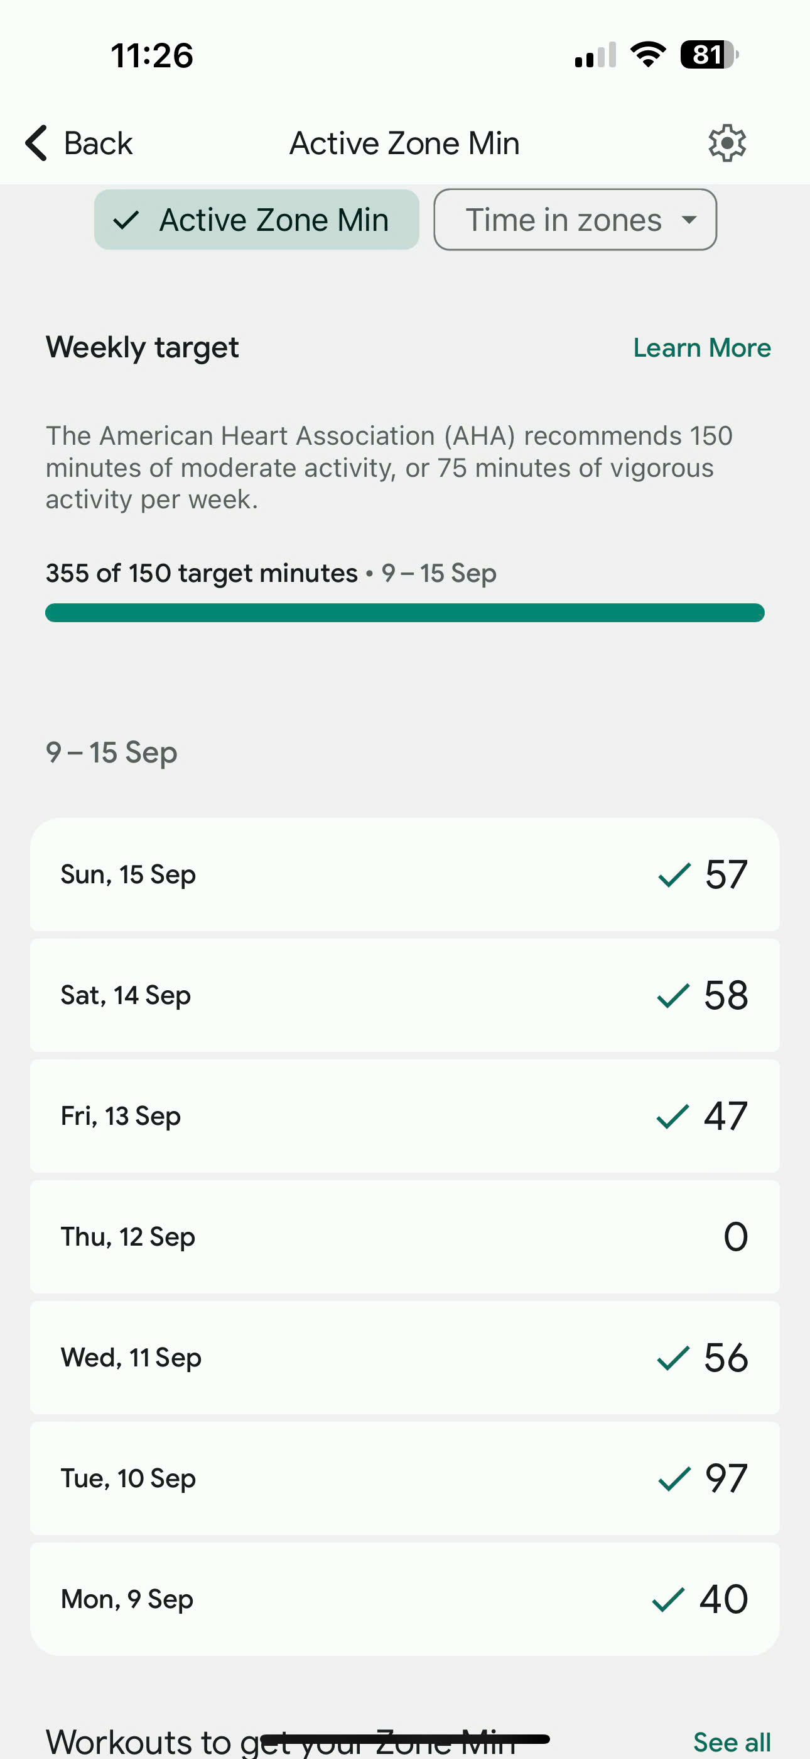

+ Use this data of Active Zone Min to fill out the Activity Logbook weekly.

* **Stationary hours:**

**+ Open the Fitbit App** on yourphone.

+ On the main screen, you'll see your daily stats. Look for the "Hourly activity" tile and click it.

+ Click on the day you want to track. You’ll see a breakdown of each hour of that day, showing how many hours you’ve been stationary for the day (red arrow).

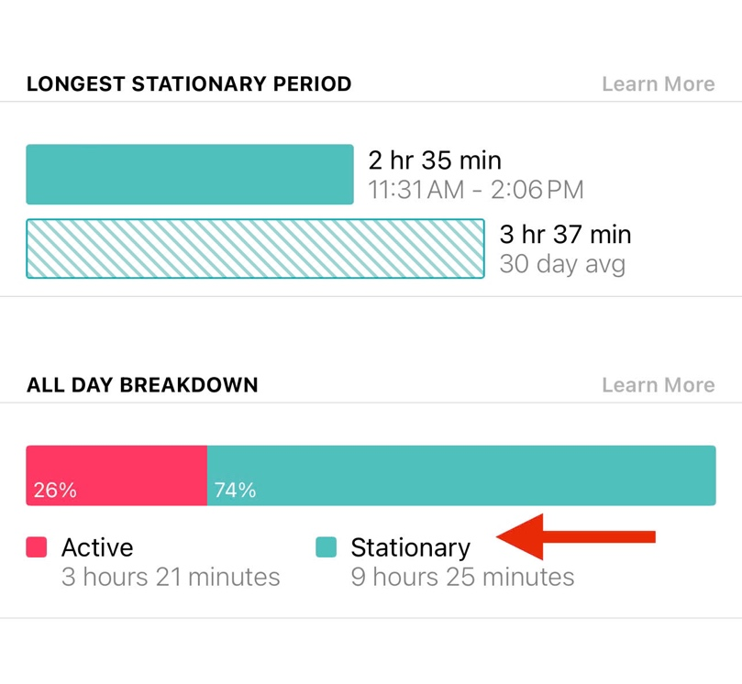

+ Please use this data of Stationary Hours to fill in the weekly Activity Logbook provided (p. )

SENS USAGE MANUAL

As a part of this research, you will wear a sensor or SENS device to help us objectively track your activity levels during week 0 (pre-intervention), week 7 (mid-intervention), and week 13 (post-intervention). You must wear the device continuously seven days a week without taking it off. This is a very small sensor. It has been tested to ensure comfortability and that it can be worn as requested.

**1. What you will get?**

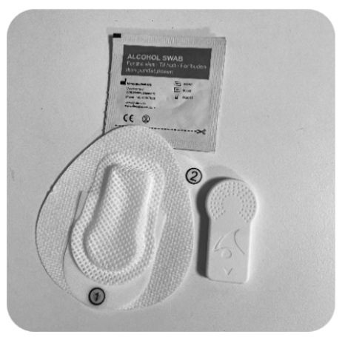

1 x SENS sensor and 2 x sensor patch.

2. Assesmbly your SENS sensor

* **Where to attach it?**
* The sensor should be attached to your non-dominant thigh or upper arm, depending on where you feel most comfortable.
* **How long should I wear it?**
* You must wear the sensor continuously (without taking it off) for seven days during week 0, week 7, and week 13, as instructed. The waterproof sensor can run up to 20 weeks, so you don't have to remove it for charging or showering.
* **How do I attach it?**
* Use the provided patch to attach it. Please access step-by-step instructions on attaching the sensor by scanning the QR code below.

* **Wear and care tips:**
* You should clean the skin where the sensor should be placed before attaching the sensor to reduce any risk of discomfort.
* You should not detach the sensor during the seven days to ensure continuous data collection.
* Since it is a very small sensor, you should not be aware that you are wearing it after a while.
* However, if you feel uncomfortable, you can detach the sensor and immediately re-attach it to the other part of your thigh or upper arms using the extra patches provided.
* If the discomfort continues after trying these steps, please contact the research team for assistance or recommendations. Your comfort is important!
* You must open the SENS Motion app to transfer data to the underlying system daily. Please see details in the SENS Motion app manual on the next page.
* **Returning the device:**
* After wearing it for seven days, please return it to the research team using the provided pre-paid envelope.

SENS MOTION APP USAGE MANUAL

You must use the SENS Motion app to transfer the data to our system. Please follow the instructions below.

1. Download the SENS Motion app.

* Download the SENS Motion app:
* Apple App Store for iPhones
* Google Play Store for Android phones
* Bluetooth must be turned on on your phone, and location services may need to be accepted the first time the app is opened.
* Step-by-step instructions can be accessed by scanning the QR code below:



2. Open the SENS Motion app to transfer data automatically.

* The data transfer from your sensor is automatic as long as the app is visible on the device.
* Open the app, leave it on the screen for at least 5 minutes daily and stay close to your phone during that 5 minutes.

GENERAL DEVICE AGREEMENT

This General Devices Usage Agreement ("Agreement") is entered into between the participant ("Participant") and the research team at Curtin University ("Research Team") in relation to the use of the following devices provided for research purposes:

- Fitbit Inspire 3

- Sens Sensor

By signing this Agreement, the Participant agrees to comply with the terms and conditions set forth below.

1. Ownership of Devices

The Participant acknowledges that all devices provided by the Research Team at Curtin University, including but not limited to the Fitbit Inspire 3 and the Sens Sensor (collectively referred to as "Devices"), remain the property of Curtin University at all times. The Participant is granted temporary use of the Devices solely for the purpose of participating in the research project.

2. Use of Devices

The Participant agrees to:

- Use the Devices solely for the purposes outlined by the research project.

- Follow all instructions provided by the Research Team regarding the proper care and usage of the Devices.

- Refrain from tampering, altering, or modifying the Devices in any way.

3. Care and Maintenance

The Participant is responsible for taking reasonable care of the Devices during the period of use. Any damage, loss, or malfunction should be immediately reported to the Research Team.

4. Return of Devices

At the completion of the research project or upon the Research Team’s request, the Participant agrees to return all Devices in good working condition (reasonable wear and tear excepted). The Devices should be returned as per the instructions provided by the Research Team, which may include returning them in person or via mail.

5. Breach of Agreement

In the event that the Participant fails to return the Devices as instructed or damages the Devices beyond normal wear and tear, the Participant agrees to:

- Pay the full replacement value of the Devices as determined by the Research Team.

- The current replacement value for the provided Devices is as follows:

- Fitbit Inspire 3: [insert current value]

- Sens Sensor: [insert current value]

6. Loss or Theft

If the Devices are lost or stolen during the Participant's possession, the Participant is required to notify the Research Team immediately. The Participant may be held liable for the full replacement cost of the Devices, unless otherwise determined by the Research Team.

7. Limitation of Liability

The Research Team and Curtin University are not responsible for any injuries or damages arising from the Participant's use or misuse of the Devices. The Participant uses the Devices at their own risk.

8. Confidentiality and Data Usage

The Participant agrees to comply with all Research Team guidelines concerning confidentiality and data usage related to the Devices. Any data collected by the Devices remains the property of Curtin University and may only be used in accordance with the research project’s guidelines.

9. Termination of Agreement

The Research Team reserves the right to terminate this Agreement at any time and may require the immediate return of the Devices if the Participant fails to comply with the terms of this Agreement.

10. Acknowledgment

By signing this Agreement, the Participant acknowledges and agrees to all the terms and conditions listed above. Failure to comply with this Agreement may result in the Participant being held financially responsible for the Devices provided.

---

Participant Information:

- Name: ______________________________________

- Address: ____________________________________

- Phone: ______________________________________

- Email: _______________________________________

Participant Signature: ______________________________

Date: ___________________________________________

Research Team Representative: _________________________

Date: ___________________________________________

LIST OF EASY-TO-DO PHYSICAL ACTIVITY

What Are Physical Activities?

**Physical activities** are any movements that make your body use energy. This means doing things that get you moving and can help you stay healthy. Understanding the different levels of physical activity can help you choose exercises that suit your comfort and fitness level. Here are the three main levels:

**1.** **Light Physical Activity**

These activities are gentle and easy to perform. They help with basic movement and flexibility.

* **Examples:**
  + **Leisurely Walking:** Strolling around your home or neighbourhood.
  + **Stretching:** Simple movements to loosen muscles.
  + **Easy Housework:** Tasks like dusting or folding laundry.
  + **Gentle Yoga:** Basic poses and breathing exercises.

**2. Moderate Physical Activity**

These activities increase your heart rate and breathing but still allow you to hold a conversation.

* **Examples:**
  + **Brisk Walking:** Walking at a faster pace.
  + **Dancing:** Moving to music at a moderate speed.
  + **Swimming Leisurely:** Casual swimming or water aerobics.
  + **Cycling on Flat Terrain:** Riding a bike on level ground.
  + **Gardening:** Activities like raking leaves or planting.

**3. Vigorous Physical Activity**

These activities significantly raise your heart rate and breathing. Talking may be more difficult during these exercises.

* **Examples:**
  + **Running or Jogging:** Moving at a fast pace.
  + **Fast Cycling or Uphill Cycling:** More intense biking.
  + **Competitive Sports:** Basketball, soccer, or tennis.
  + **Aerobic Dancing:** High-energy dance routines.
  + **Swimming Laps:** Swimming continuously without breaks.

**Recommended Guidelines for Physical Activity**

Health experts suggest the following guidelines for adults to maintain good health:

* **Aim for at least 150 minutes of moderate-intensity activity each week.**
  + This could be **30 minutes a day, 5 days a week**.
* **Or 75 minutes of vigorous-intensity activity each week.**
  + This could be **15 minutes a day, 5 days a week**.
* **Include muscle-strengthening activities on 2 or more days a week.**
  + Exercises like lifting weights, resistance band workouts, or body-weight exercises (e.g., push-ups, squats).

**Tips to Get Started:**

* **Start Slowly:** Begin with light activities and gradually increase intensity as you feel comfortable.
* **Set Achievable Goals:** Small milestones can help you stay motivated.
* **Choose Enjoyable Activities:** Pick exercises you find fun to make it easier to stick with them.
* **Make It Social (If You Like):** Join a group or ask a friend to participate with you.
* **Listen to Your Body:** Pay attention to how you feel during and after activities. It's okay to rest when needed.
* **Stay Safe:**
  + Wear comfortable clothing and appropriate footwear.
  + Stay hydrated by drinking water before, during, and after activity.
  + Warm up before starting and cool down afterward with gentle stretches.

**Remember:** Any physical activity is better than none. Even short bursts of movement throughout the day can add up and contribute to your overall health. Always consider consulting a healthcare provider before starting a new exercise routine, especially if you have any health concerns.

Easy-To-Do Physical Activities

Below are some recommended easy-to-do physical activities and their scientifically validated benefits. Please choose activities that you are interested in and perform them with your partner. You can also be creative and choose activities that are not listed. Happy moving!

1. Walking



Walking is a low-impact exercise that improves cardiovascular health and reduces stress. Research indicates that regular physical activity like walking can enhance mood and decrease anxiety in autistic individuals.

2. Yoga



Yoga combines physical postures with mindfulness and deep breathing. Studies have shown that yoga can improve self-regulation, reduce anxiety, and enhance body awareness in autistic adults.

3. Swimming

Swimming provides a full-body workout and sensory input from the water's pressure, which can be calming. Aquatic activities have been found to improve motor skills and social behaviours in autistic individuals.

4. Cycling

Cycling enhances cardiovascular fitness and motor coordination. Physical activities like cycling can improve mood and reduce stereotypic behaviours in autistic adults.

5. Stretching Exercises

Stretching helps maintain flexibility and reduces muscle tension. Incorporating stretching routines can lead to decreased anxiety and improved overall well-being for autistic people.

6. Dancing

Dancing combines movement with rhythm, promoting coordination and social interaction. Dance therapy has been associated with improved communication skills and improved behavioural problems in autistic individuals.

7. Tai Chi

Tai Chi involves slow, deliberate movements and deep breathing. It has been shown to reduce stress, enhance balance, and improve emotional regulation in autistic adults.

8. Gardening

Gardening is a physical activity that also provides sensory stimulation and a sense of accomplishment. Horticultural activities can reduce stress and improve social functioning in autistic individuals.

9. Resistance Band Exercises

Resistance training with bands can improve muscle strength and coordination. Strength exercises enhance motor skills in autistic adults.

10. Light Jogging

Light jogging boosts cardiovascular health and releases endorphins, which elevate mood. Aerobic exercises like jogging have been linked to reduced anxiety and improved social skills.

11. Household Chores

Engaging in household chores provides physical activity and helps develop daily living skills. Such activities can increase independence and functional abilities in autistic adults.

12. Water Aerobics

Water aerobics offers low-impact resistance training. Aquatic exercises have been shown to enhance motor function and provide sensory benefits for autistic people.

13. Hiking

Hiking combines exercise with nature exposure, which can reduce stress and anxiety. Nature-based activities are known to improve mood and promote relaxation.

14. Pilates

Pilates focuses on core strength, flexibility, and controlled movements. Mind-body exercises like Pilates can improve body awareness and motor coordination in autistic individuals.

15. Balance Exercises

Practising balance enhances stability and proprioception. Balance training can improve motor skills and reduce the risk of falls for autistic adults.

16. Jump Rope

Jumping rope enhances cardiovascular fitness and coordination. Aerobic activities like this can decrease behavioural issues and improve attention spans.

17. Weightlifting

Weightlifting builds muscle strength and can boost confidence. Strength training is beneficial for improving motor skills.

PHYSICAL ACTIVITY BENEFITS

I. Health Benefits:

1. Stronger Heart and Lungs

- Exercise helps your heart and lungs work better, making you healthier.

2. Healthy Weight

- Being active helps you lose weight or keep a healthy weight.

3. Strong Muscles and Bones

- Physical activity makes your muscles and bones stronger, reducing the chance of injuries.

4. Better Sleep

- Exercise can help you fall asleep faster and sleep more soundly.

5. More Energy

- Regular activity can make you feel more energetic during the day.

6. Lower Risk of Diseases

- Being active reduces the risk of diseases like type 2 diabetes, some cancers, and heart problems.

7. Improved Balance and Coordination

- Physical activity improves your balance, helping to prevent falls.

8. Healthy Joints

- Exercise keeps your joints flexible and can reduce joint pain.

9. Boosted Immune System

- Regular activity strengthens your immune system to fight off illnesses.

10. Better Digestion

- Exercise helps your digestive system work better, reducing issues like constipation.

II. Social Benefits:

1. Meet New People

- Joining sports or exercise groups helps you meet and connect with others.

2. Make Friends

- Being active with others can lead to new friendships.

3. Feel Part of a Community

- Participating in group activities gives you a sense of belonging.

4. Teamwork Skills

- Group activities teach cooperation and working well with others.

5. Fun and Enjoyment

- Physical activities can be enjoyable and add fun to your life when shared with others.

6. Approval and Recognition from Others

- Achieving goals or excelling in activities can lead to praise and recognition from others, boosting your confidence.

III. Emotional Benefits:

1. Feel Happier

- Exercise releases "feel-good" chemicals in your brain that improve your mood.

2. Reduce Stress and Anxiety

- Physical activity helps lower stress levels and promotes relaxation.

3. Boost Self-Esteem

- Achieving fitness goals can make you feel better about yourself and increase confidence.

4. Better Thinking and Memory

- Exercise can help you think more clearly and improve your memory.

5. Improve Mental Health

- Being active can reduce feelings of depression and enhance overall mental well-being.

6. Increase Resilience

- Regular activity can help you cope better with challenges and setbacks.

*\*Remember: Any amount of physical activity can improve your health, social life, and emotional well-being. Choose activities you enjoy to make staying active fun and rewarding!*

SEDENTARY ACTIVITIES' CONSEQUENCES

What Are Sedentary Activities?

- Sedentary activities are tasks where you sit or lie down and use very little energy. These activities involve little physical movement. For examples:

* Watching TV or Movies
* Using a Computer or Tablet
* Playing Video Games
* Reading Books or Magazines
* Sitting at Work or School for Long Periods
* Riding in a Car, Bus, or Train for Extended Times
* Scrolling on a Smartphone

Consequences of Sedentary Activities

I. Health Consequences:

1. Weight Gain

- Sitting too much can lead to weight gain and make it harder to keep a healthy weight.

2. Weak Muscles and Bones

- Not moving enough can make your muscles and bones weaker, increasing the risk of injuries.

3. Heart Problems

- Being inactive raises the risk of heart disease and high blood pressure.

4. Higher Blood Sugar

- Sitting for long periods can increase blood sugar levels, raising the risk of type 2 diabetes.

5. Poor Blood Circulation

- Staying still can slow down blood flow, leading to swelling or blood clots.

6. Stiff Joints and Muscles

- Lack of movement can cause stiffness and pain in your joints and muscles.

7. Back and Neck Pain

- Sitting with poor posture can lead to discomfort or pain in your back and neck.

8. Weaker Immune System

- Inactivity can weaken your immune system, making fighting illnesses harder.

9. Higher Risk of Certain Cancers

- Being sedentary is linked to a greater risk of some cancers, like colon and breast cancer.

10. Shorter Lifespan

- Too much sitting can increase the risk of early death from various health problems.

II. Social Consequences:

1. Less Social Interaction

- Spending a lot of time sitting alone can reduce time spent with friends and family.

2. Feelings of Isolation

- Inactivity may lead to loneliness because of less social activity engagement.

3. Missed Opportunities

- Being sedentary limits participation in group events, sports, or community gatherings.

4. Reduced Social Skills

- Less face-to-face interaction can affect your ability to communicate well with others.

5. Strained Relationships

- Spending too much time on solitary activities might cause distance in relationships.

6. Lack of Teamwork Experience

- Not joining group activities can mean missing out on learning how to work well with others.

III. Emotional Consequences:

1. Increased Stress and Anxiety

- Lack of physical activity can lead to higher stress levels and feelings of anxiety.

2. Risk of Depression

- Sitting too much is linked to a greater chance of feeling depressed or unhappy.

3. Low Self-Esteem

- Inactivity can cause feelings of low confidence and poor self-image.

4. Less Happiness

- Not moving enough may reduce the release of "feel-good" chemicals in your brain.

5. Difficulty Concentrating

- Being sedentary can make it harder to focus and remember things.

6. Sleep Problems

- Inactivity can make it more difficult to fall asleep or have restful sleep, affecting how you feel.

7. Reduced Motivation

- Spending too much time inactive can lead to a lack of drive to do things or set goals.

*Remember: Reducing the time you spend on sedentary activities and adding more movement to your day can greatly improve your health, social life, and emotional well-being. Simple changes like standing up more often, taking short walks around the house, or choosing active hobbies can make a big difference!

PUBLIC PHYSICAL ACTIVITIES SPACE'S ETIQUETTE FOR AUTISTIC INDIVIDUALS

**Welcome!** This guide is designed to help you navigate public physical activity spaces like gyms, parks, and sports centers comfortably and confidently. It includes tips on etiquette, how to find support, and solutions for potential social challenges. Remember, support is available to you through researchers via WhatsApp and your exercise partner.

**Getting Started**

1. **Plan Ahead**
   * **Visit During Quieter Times:** If you prefer less crowded spaces, consider going during off-peak hours.
   * **Virtual Tour:** Look up pictures or videos of the facility online to familiarize yourself with the environment.
   * **Make a Checklist:** Write down what you need to bring (e.g., water bottle, towel, workout clothes).
2. **Know That Support Is Available**
   * **Online Support:** You can reach out to researchers via WhatsApp if you have questions or need assistance.
   * **Exercise Partner:** Your partner is there to support you during activities. Don't hesitate to ask for help.

**General Guidelines**

1. **Respect Others**
   * **Personal Space:** Keep a comfortable distance from others (about an arm's length).
   * **Waiting Your Turn:** If equipment is in use, stand back and wait until it's free.
   * **Quiet Communication:** If you need to speak to someone, use a calm and clear voice.
2. **Follow Facility Rules**
   * **Read Signs Carefully:** Look for posted rules or symbols that indicate what to do.
   * **Ask for Clarification:** If you're unsure about a rule, ask your partner or a staff member.
3. **Share Equipment**
   * **Time Awareness:** Use a timer or watch to keep track of how long you've been using equipment.
   * **Offer to Share:** During rest periods, you can let others use the equipment if they are waiting.
4. **Clean Up After Yourself**
   * **Wipe Down Equipment:** Use the provided wipes or spray to clean equipment after use.
   * **Organize Equipment:** Put weights and other items back where they belong.

**Using Equipment Safely**

1. **Learn How to Use Equipment**
   * **Ask for Demonstrations:** Staff or your partner can show you how to use machines.
   * **Follow Step-by-Step Instructions:** Some equipment has pictures or guides; follow them carefully.
2. **Be Mindful of Noise and Sensory Sensitivities**
   * **Use Earphones:** If loud noises bother you, consider listening to calming music.
   * **Bring Sensory Aids:** Items like sunglasses or fidget tools can help you stay comfortable.
3. **Avoid Overstimulation**
   * **Take Breaks:** Find a quiet spot if you need a moment to relax.
   * **Deep Breathing:** Practice breathing exercises to stay calm.

**Interacting with Others**

1. **Communication Tips**
   * **Prepare Simple Phrases:** Have some ready-to-use phrases like "May I use this next?" or "Excuse me, please."
   * **Non-Verbal Cues:** It's okay to use gestures or pointing if that feels more comfortable.
2. **Handling Social Situations**
   * **Group Activities:** If participating in a class, you can stay near the back if you prefer.
   * **Partner Support:** Your partner can help facilitate interactions if needed.
3. **Dealing with Conflicts**
   * **Stay Calm:** If someone says something upsetting, take a deep breath before responding.
   * **Seek Assistance:** Find your partner or a staff member to help resolve the issue.

**Finding Support**

1. **Researchers via WhatsApp**
   * **How to Reach Out:**
     + **Send a Message:** You can text us via the WhatsApp group chat if you have questions or need reassurance. We will get back to you as soon as possible.
2. **Exercise Partner**
   * **Role of Your Partner:**
     + **Guidance:** They can help you navigate the facility and routines.
     + **Advocacy:** They can communicate with staff on your behalf if needed.
     + **Companionship:** Having someone familiar can make the experience more enjoyable.
3. **Staff Members**
   * **Identifying Staff:**
     + **Uniforms or Badges:** Look for employees wearing uniforms or name tags.
     + **Front Desk:** Staff are often available at the entrance or reception area.
   * **Asking for Help:**
     + **Be Specific:** Clearly state what you need help with, like "Can you show me how to use this machine?"
     + **Use Written Notes:** Consider writing down your question if speaking is difficult.

**Managing Potential Social Challenges**

1. **Sensory Overload**
   * **Identify Quiet Areas:** Know where you can go if you need a break.
   * **Use Sensory Tools:** Items like noise-cancelling headphones can reduce overwhelming sounds.
2. **Understanding Social Cues**
   * **Practice Common Scenarios:** Role-play situations with your partner beforehand.
   * **Observation:** Watch how others interact to get a sense of expected behaviours.
3. **Expressing Your Needs**
   * **Be Direct:** It's okay to tell others if you need space or assistance.
   * **Use "I" Statements:** For example, "I prefer to work out alone, but thank you."
4. **Dealing with Uncomfortable Situations**
   * **Have an Exit Plan:** Know that you can leave a situation if it becomes too much.
   * **Relaxation Techniques:** Practice techniques like counting to ten or visualization to stay calm.

**Facility Etiquette**

1. **Dress Comfortably**
   * **Wear Preferred Clothing:** Choose clothes that feel good to you and are appropriate for exercise.
   * **Layers:** Bring extra layers in case the temperature changes.
2. **Personal Hygiene**
   * **Bring Personal Items:** Pack things like deodorant, a towel, or hand sanitizer.
   * **Hand Washing:** Wash your hands before and after your workout.
3. **Using Locker Rooms**
   * **Privacy Options:** If the locker room is overwhelming, ask if private changing areas are available.
   * **Organize Your Space:** Keep your belongings in a bag or locker to avoid misplacing items.
4. **Food and Drinks**
   * **Stay Hydrated:** Bring a water bottle to keep yourself hydrated.
   * **Snacks:** If allowed, bring a light snack in case you need energy.

**Accessibility and Inclusion**

1. **Adaptive Equipment**
   * **Ask About Options:** Facilities may have equipment suited to different needs.
   * **Request Modifications:** Don't hesitate to ask staff if equipment can be adjusted for you.
2. **Inclusive Classes**
   * **Specialized Programs:** Some places offer classes tailored for different abilities.
   * **Trial Sessions:** Attend a class with your partner to see if it's a good fit.

**Enjoy Your Time!**

* **Set Personal Goals:** Focus on what you want to achieve, no matter how small.
* **Celebrate Successes:** Acknowledge your efforts and progress.
* **Have Fun:** Choose activities you enjoy to make exercising a positive experience.

**Remember:**

* **It's Okay to Ask for Help:** Whether it's your partner, the researchers, or staff, support is available.
* **Everyone Is Learning:** It's normal to feel unsure; others have been there too.
* **You Are Welcome Here:** Public physical activity spaces are for everyone, including you.

We hope this guide helps you feel more comfortable and confident in public physical activity spaces. Stay active, be yourself, and enjoy the benefits of exercise!

**PROBLEM SOLVING WORKSHEETS**

This worksheet is designed to help you identify problems related to physical activity and prepare solutions.

**Instructions:**

1. Identify the Problem: Write down the specific issue you are facing.
2. Describe Your Feelings: Note how the problem makes you feel.
3. List Possible Solutions: Brainstorm several ways to solve the problem from your own views.
4. Evaluate Solutions: For each solution, list the pros and cons.
5. Choose a Solution: Select the best option for you.
6. Create an Action Plan: Outline the steps you will take.
7. Reflect on the Outcome: After trying the solution, record what happened.

**How to Use the Worksheet Effectively:**

* Be Specific: Clearly define the problem. For example, "I feel anxious when the gym is crowded" instead of "I don't like the gym."
* List Multiple Solutions: Aim for at least three possible solutions to give yourself options.
* Weigh Pros and Cons Honestly: Consider how each solution will help or hinder you.
* Actionable Steps: Break down the chosen solution into small, manageable steps.
* Reflect on Results: After trying the solution, note what worked and what didn't to adjust if necessary.
* Seek Support: Share your worksheet with your exercise partner or researcher for additional input.
* Keep It Accessible: Store your worksheets in a place where you can easily refer to them.

**Final Reminders:**

* Personalize It: Modify the worksheet to suit your preferences (e.g., using colours or symbols).
* Be Patient: If the first solution doesn't work perfectly, it's okay. Problem-solving is a process.
* Celebrate Successes: Acknowledge even small victories to stay motivated.
* Remember: This worksheet is a tool to empower you to overcome challenges related to physical activity. By systematically addressing problems, you can enhance your experience and achieve your fitness goals.

**Examples:**

|  |  |  |  |  |  |  |  |
| --- | --- | --- | --- | --- | --- | --- | --- |
| **Problem** | **Feelings** | **Potential Solutions** | **Pros** | **Cons** | **Chosen Solution** | **Action Plan** | **Outcome** |
| 1. I feel overwhelmed by loud noises at the gym. | Anxious, stressed | 1. Wear noise-cancelling headphones.  2. Go during quieter hours.  3. Exercise at home instead of the gym. | 1. Reduces noise levels  2. Fewer people around  3. Comfortable environment | 1. May not hear important announcements  2. Schedule may not allow  3. Limited equipment | Wear noise-canceling headphones | Bring headphones next gym visit | Felt calmer; enjoyed workout more |
| 2. I don't know how to approach people to ask for help with equipment. | Nervous, unsure | 1. Prepare a script of what to say  2. Ask my exercise partner to assist  3. Attend a beginner's tour with staffs | 1. Reduces anxiety about speaking  2. Immediate help available  3. Professional instruction | 1. Might still feel nervous  2. Dependence on partner    3. Class schedules may not align | Prepare a script | Write and practice the script before going | Successfully asked for help |

|  |  |  |  |  |
| --- | --- | --- | --- | --- |
|  |  |  |  |  |

|  |  |  |  |  |  |  |  |
| --- | --- | --- | --- | --- | --- | --- | --- |
| **Problem** | **Feelings** | **Potential Solutions** | **Pros** | **Cons** | **Chosen Solution** | **Action Plan** | **Outcome** |
| Week 1 |  |  |  |  |  |  |  |
| Week 2 |  |  |  |  |  |  |  |

|  |  |  |  |  |  |  |  |
| --- | --- | --- | --- | --- | --- | --- | --- |
| **Problem** | **Feelings** | **Potential Solutions** | **Pros** | **Cons** | **Chosen Solution** | **Action Plan** | **Outcome** |
| Week 3 |  |  |  |  |  |  |  |
| Week 4 |  |  |  |  |  |  |  |
| **Problem** | **Feelings** | **Potential Solutions** | **Pros** | **Cons** | **Chosen Solution** | **Action Plan** | **Outcome** |
| Week 5 |  |  |  |  |  |  |  |
| Week 6 |  |  |  |  |  |  |  |
| **Problem** | **Feelings** | **Potential Solutions** | **Pros** | **Cons** | **Chosen Solution** | **Action Plan** | **Outcome** |
| Week 7 |  |  |  |  |  |  |  |
| Week 8 |  |  |  |  |  |  |  |
| **Problem** | **Feelings** | **Potential Solutions** | **Pros** | **Cons** | **Chosen Solution** | **Action Plan** | **Outcome** |
| Week 9 |  |  |  |  |  |  |  |
| Week 10 |  |  |  |  |  |  |  |
| **Problem** | **Feelings** | **Potential Solutions** | **Pros** | **Cons** | **Chosen Solution** | **Action Plan** | **Outcome** |
| Week 11 |  |  |  |  |  |  |  |
| Week 12 |  |  |  |  |  |  |  |

ACTION PLANNING WORKSHEETS

This action planning worksheet will help you schedule your physical activities over the next 12 weeks. It provides a structured format to plan activities, set goals, and reflect on progress.

**Instructions:**

1. Set a fortnightly schedule with your partner: At the beginning of weeks 0, 3, 5, 7, 9, and 11, meet with your partner to set up your physical activity schedule. The worksheets provide seven rows for seven days within each program week. However, you can set your plan as much as you want.
2. Detailed action plan: Fill in the details for each day, including the activity, estimated time and duration, location, completion status, and additional comments (any notes you would like to share).
3. Send your plan to the researchers: Take a photo/screenshot of your schedule to get personalised reminders from the research team.

**Examples:**

|  |  |  |  |  |  |  |
| --- | --- | --- | --- | --- | --- | --- |
| **Program Week** | **Day** | **Activity Type** | **Estimated Star Time - End Time - Duration** | **Location** | **Completion (Yes/No)** | **Comments** |
| **1** | Monday 10/01/25 | Walking | 08:00 - 08:30 - 30 mins | King Park | Yes | Actual walking duration was 1 hour. |
| Wednesday | Walking | 17:00 - 17:30 - 30 mins | Local neighbourhood | Yes | Walking with my dog as well |
| Friday | Running and weight lifting | 08:00 - 09:00 - 60 mins | Local gym | Yes | Running with treadmil was great |
| Saturday | Gardening | 08:00 - 09:00 60 mins | Home garden | Yes | I did this alone but my partner helped to remind and motivate me. |
|  |  |  |  |  |  |
|  |  |  |  |  |  |
|  |  |  |  |  |  |

**Action Planning Worksheet**

|  |  |  |  |  |  |  |
| --- | --- | --- | --- | --- | --- | --- |
| **Program Week** | **Day** | **Activity Type** | **Estimated Star Time - End Time - Duration** | **Location** | **Completion (Yes/No)** | **Comments** |
| **Week 1** |  |  |  |  |  |  |
|  |  |  |  |  |  |
|  |  |  |  |  |  |
|  |  |  |  |  |  |
|  |  |  |  |  |  |
|  |  |  |  |  |  |
|  |  |  |  |  |  |
| **Week 2** | **Day** | **Activity Type** | **Estimated Star Time - End Time - Duration** | **Location** | **Completion (Yes/No)** | **Comments** |
|  |  |  |  |  |  |
|  |  |  |  |  |  |
|  |  |  |  |  |  |
|  |  |  |  |  |  |
|  |  |  |  |  |  |
|  |  |  |  |  |  |
|  |  |  |  |  |  |
| **Week 3** | **Day** | **Activity Type** | **Estimated Star Time - End Time - Duration** | **Location** | **Completion (Yes/No)** | **Comments** |
|  |  |  |  |  |  |
|  |  |  |  |  |  |
|  |  |  |  |  |  |
|  |  |  |  |  |  |
|  |  |  |  |  |  |
|  |  |  |  |  |  |
|  |  |  |  |  |  |
| **Week 4** | **Day** | **Activity Type** | **Estimated Star Time - End Time - Duration** | **Location** | **Completion (Yes/No)** | **Comments** |
|  |  |  |  |  |  |
|  |  |  |  |  |  |
|  |  |  |  |  |  |
|  |  |  |  |  |  |
|  |  |  |  |  |  |
|  |  |  |  |  |  |
|  |  |  |  |  |  |
| **Week 5** | **Day** | **Activity Type** | **Estimated Star Time - End Time - Duration** | **Location** | **Completion (Yes/No)** | **Comments** |
|  |  |  |  |  |  |
|  |  |  |  |  |  |
|  |  |  |  |  |  |
|  |  |  |  |  |  |
|  |  |  |  |  |  |
|  |  |  |  |  |  |
|  |  |  |  |  |  |
| **Week 6** | **Day** | **Activity Type** | **Estimated Star Time - End Time - Duration** | **Location** | **Completion (Yes/No)** | **Comments** |
|  |  |  |  |  |  |
|  |  |  |  |  |  |
|  |  |  |  |  |  |
|  |  |  |  |  |  |
|  |  |  |  |  |  |
|  |  |  |  |  |  |
|  |  |  |  |  |  |
| **Week 7** | **Day** | **Activity Type** | **Estimated Star Time - End Time - Duration** | **Location** | **Completion (Yes/No)** | **Comments** |
|  |  |  |  |  |  |
|  |  |  |  |  |  |
|  |  |  |  |  |  |
|  |  |  |  |  |  |
|  |  |  |  |  |  |
|  |  |  |  |  |  |
|  |  |  |  |  |  |
| **Week 8** | **Day** | **Activity Type** | **Estimated Star Time - End Time - Duration** | **Location** | **Completion (Yes/No)** | **Comments** |
|  |  |  |  |  |  |
|  |  |  |  |  |  |
|  |  |  |  |  |  |
|  |  |  |  |  |  |
|  |  |  |  |  |  |
|  |  |  |  |  |  |
|  |  |  |  |  |  |
| **Week 9** | **Day** | **Activity Type** | **Estimated Star Time - End Time - Duration** | **Location** | **Completion (Yes/No)** | **Comments** |
|  |  |  |  |  |  |
|  |  |  |  |  |  |
|  |  |  |  |  |  |
|  |  |  |  |  |  |
|  |  |  |  |  |  |
|  |  |  |  |  |  |
|  |  |  |  |  |  |
| **Week 10** | **Day** | **Activity Type** | **Estimated Star Time - End Time - Duration** | **Location** | **Completion (Yes/No)** | **Comments** |
|  |  |  |  |  |  |
|  |  |  |  |  |  |
|  |  |  |  |  |  |
|  |  |  |  |  |  |
|  |  |  |  |  |  |
|  |  |  |  |  |  |
|  |  |  |  |  |  |
| **Week 11** | **Day** | **Activity Type** | **Estimated Star Time - End Time - Duration** | **Location** | **Completion (Yes/No)** | **Comments** |
|  |  |  |  |  |  |
|  |  |  |  |  |  |
|  |  |  |  |  |  |
|  |  |  |  |  |  |
|  |  |  |  |  |  |
|  |  |  |  |  |  |
|  |  |  |  |  |  |
| **Week 12** | **Day** | **Activity Type** | **Estimated Star Time - End Time - Duration** | **Location** | **Completion (Yes/No)** | **Comments** |
|  |  |  |  |  |  |
|  |  |  |  |  |  |
|  |  |  |  |  |  |
|  |  |  |  |  |  |
|  |  |  |  |  |  |
|  |  |  |  |  |  |
|  |  |  |  |  |  |

ACTIVITY LOGBOOK

This activity logbook will help you monitor your weekly physical and sedentary activities.

Instructions:

* Please complete this activity logbook at the end of each program week.
* You must use the Fitbit App data on Active Zone Min and Stationary Hours to complete this activity logbook. Please check the Fitbit App Usage Manual (p. ) on how to get those data from the app. You should provide daily Active Zone Min, weekly total daily Active Zone Min, and daily Stationary Hours. All of these data will be avaiable on your Fitbit App if you wear Fitbit properly.
* In each fortnightly performance review meeting, please report your previous fortnightly Activity Logbook to the research team.
* Improve your total Active Zone Min and reduce the total Stationary Hours each week.

Examples:

|  |  |  |  |  |
| --- | --- | --- | --- | --- |
| Program Week | Date | Active Zone Min | Stationary Hours | Notes |
| Week 1 | 10.01.25 | 57 | 6 hours 47 minutes |  |
| 11.01.25 | 58 | 11 hours 1 minute |  |
| 12.01.25 | 47 | 4 hours 50 minute |  |
| 13.01.25 | 0 | 9 hours 1 minute |  |
| 14.01.25 | 56 | 11 hours 3 minute |  |
| 15.01.25 | 97 | 12 hours 54 minute |  |
| 16.01.25 | 40 | 9 hours 51 minute |  |
| Weekly Total |  | 365 |  | I achieved the target this week. Yay! |

Activity Logbook

|  |  |  |  |  |
| --- | --- | --- | --- | --- |
| Program Week | Date | Active Zone Min | Stationary Hours | Notes |
| Week 1 |  |  |  |  |
|  |  |  |  |
|  |  |  |  |
|  |  |  |  |
|  |  |  |  |
|  |  |  |  |
|  |  |  |  |
| Weekly Total |  |  |  |  |
| Program Week | Date | Active Zone Min | Stationary Hours | Notes |
| Week 2 |  |  |  |  |
|  |  |  |  |
|  |  |  |  |
|  |  |  |  |
|  |  |  |  |
|  |  |  |  |
|  |  |  |  |
| Weekly Total |  |  |  |  |
| Program Week | Date | Active Zone Min | Stationary Hours | Notes |
| Week 3 |  |  |  |  |
|  |  |  |  |
|  |  |  |  |
|  |  |  |  |
|  |  |  |  |
|  |  |  |  |
|  |  |  |  |
| Weekly Total |  |  |  |  |
| Program Week | Date | Active Zone Min | Stationary Hours | Notes |
| Week 4 |  |  |  |  |
|  |  |  |  |
|  |  |  |  |
|  |  |  |  |
|  |  |  |  |
|  |  |  |  |
|  |  |  |  |
| Weekly Total |  |  |  |  |
| Program Week | Date | Active Zone Min | Stationary Hours | Notes |
| Week 5 |  |  |  |  |
|  |  |  |  |
|  |  |  |  |
|  |  |  |  |
|  |  |  |  |
|  |  |  |  |
|  |  |  |  |
| Weekly Total |  |  |  |  |
| Program Week | Date | Active Zone Min | Stationary Hours | Notes |
| Week 6 |  |  |  |  |
|  |  |  |  |
|  |  |  |  |
|  |  |  |  |
|  |  |  |  |
|  |  |  |  |
|  |  |  |  |
| Weekly Total |  |  |  |  |
| Program Week | Date | Active Zone Min | Stationary Hours | Notes |
| Week 7 |  |  |  |  |
|  |  |  |  |
|  |  |  |  |
|  |  |  |  |
|  |  |  |  |
|  |  |  |  |
|  |  |  |  |
| Weekly Total |  |  |  |  |
| Program Week | Date | Active Zone Min | Stationary Hours | Notes |
| Week 8 |  |  |  |  |
|  |  |  |  |
|  |  |  |  |
|  |  |  |  |
|  |  |  |  |
|  |  |  |  |
|  |  |  |  |
| Weekly Total |  |  |  |  |
| Program Week | Date | Active Zone Min | Stationary Hours | Notes |
| Week 9 |  |  |  |  |
|  |  |  |  |
|  |  |  |  |
|  |  |  |  |
|  |  |  |  |
|  |  |  |  |
|  |  |  |  |
| Weekly Total |  |  |  |  |
| Program Week | Date | Active Zone Min | Stationary Hours | Notes |
| Week 10 |  |  |  |  |
|  |  |  |  |
|  |  |  |  |
|  |  |  |  |
|  |  |  |  |
|  |  |  |  |
|  |  |  |  |
| Weekly Total |  |  |  |  |
| Program Week | Date | Active Zone Min | Stationary Hours | Notes |
| Week 11 |  |  |  |  |
|  |  |  |  |
|  |  |  |  |
|  |  |  |  |
|  |  |  |  |
|  |  |  |  |
|  |  |  |  |
| Weekly Total |  |  |  |  |
| Program Week | Date | Active Zone Min | Stationary Hours | Notes |
| Week 12 |  |  |  |  |
|  |  |  |  |
|  |  |  |  |
|  |  |  |  |
|  |  |  |  |
|  |  |  |  |
|  |  |  |  |
| Weekly Total |  |  |  |  |