**Project Title: Increasing the ease and quality mental health triaging using Online Mental Health Assessment (OMHA)**

**Protocol number:** 4.0, 19 December 2019

**Funding:**

Innovation Scholarship 2018

​Partnerships, Innovation & Research Unit​

Hunter New England Local Health District

Email: judith.swan @ hnehealth.nsw.gov.au

**Team leader Contact details for Correspondence:**

Dr Irosh Fernando, Chief Investigator

Staff Specialist Psychiatrist

Conjoint Senior Lecturer, University of Newcastle

Newcastle Mental Health Service

James Fletcher Hospital

Newcastle NSW 2300

Australia

Email: [irosh.fernando@hnehealth.nsw.gov.au](mailto:irosh.fernando@hnehealth.nsw.gov.au)

Phone: 0423281664

HNE staff ID: 60001822

**Associate Investigators**

1. Associate Professor Lisa Lampe, Discipline of Psychiatry, School of Medicine and Public Health, University of Newcastle
2. Dr Cyriac Matthew, Clinical director and staff specialist psychiatrist, Newcastle Mental Health Service, Hunter New England Local Area Health District
3. Dr Christopher Oldmeadow, Director Clinical Research Design and Statistics, Hunter Medical Research Institute
4. Kim Edmunds, Health Research Economist, Hunter Medical Research Institute
5. Philip Collard, Manager, Applications Development and Integration, Hunter New England Local Area Health District
6. Katarzyna Zalewska, Research Assistant, Hunter New England Mental Health
7. Dominique Rich, Research Assistant, Hunter New England Mental Health
8. Kate Simpson, Clinical Coordinator, Mental Health Line (MHL) and Northern Mental Health Emergency Care-Rural Access Program (NMHEC-RAP)
9. Dr Agatha Conrad, Research Manager / Clinical Psychologist, Research, Evaluation, Analysis & Dissemination (MH-READ), Centre for Brain and Mental Health Research (CBMHR), Hunter New England Mental Health

**Other contributing members**

1. Fionna Murphy, Service Manager, Newcastle Mental Health Service, Hunter New England Local Area Health District
2. Jessica Johnston, Clinical Coordinator, Newcastle Mental Health Service, Hunter New England Local Area Health District
3. Steven Collard, Software developer, Applications Development and Integration, Hunter New England Local Area Health District
4. Pamela Davis, Team Manager, Clinical Coordinator, Mental Health Line (MHL)
5. Peter Kemp, Service Manager, Mental Health Line (MHL)
6. Dr John Towney, School of Medicine and Public Health, Faculty of Health and Medicine, University of Newcastle
7. Bron Rose, District Manager Aboriginal Mental Health Service and Workforce, Hunter New England Local Area Health District
8. Elizabeth Newton, Senior Consumer Advisor, Consumer Unit, Hunter New England Local Area Health District
9. Prue Selwood, Member of Family and Carer Advisory Committee, Family Carer Coordinator, Hunter New England Local Area Health District
10. Sheree Flanagan, Family worker/social worker, Lake Macquarie Mental Health Service, Hunter New England Local Area Health District
11. Tania Ewin, Senior Support Coordinator, Carers NSW
12. Anthony Tuite, Consumer Peer Worker, Newcastle Mental Health Service, Hunter New England Local Area Health District.

**Background**

**In acute presentations, decisions need to be made about more definitive mental health assessment and treatment efficiently. We refer to this as “mental health triage”.** The need is evident: there were more than 88,000 mental health related occasions of service in NSW emergency departments in 2014-2015. Approximately 13,000-14,000 triages occur annually (1,000-1,200 per month on average) within the Mental Health Line of Hunter New England Local Area Health District where the proposed study will be conducted. Safe and appropriate treatment and referral decisions require specific types of information to be collected from client and informants. These triages include direct referrals from clients via phone, referral from carers, and fax referrals from GPs and other professionals (e.g. psychologists, social workers and occupational therapists). The current triaging practice involves conducting a clinical interview of the client by a triage clinician over the phone and completing the triage documentation including an action plan, which will be used by other clinicians in a subsequent detailed assessment and management. For example, psychiatrists often use the triage documentation when they conduct a detailed assessment for GP referrals requesting an opinion and a management plan from a psychiatrist.

**There is an increasing need for an efficient and reliable system for mental health triaging**. It is often difficult to meet the demand created by the large volume of acute presentations because of the limited availability of acute services As a result of the large demand on triaging, clients and carers who contact the service for self-referral may spend a prolonged period of time waiting on the phone, which may take up to two hours. While the Mental Health Line receives about 2,500 phone calls per month, about 40% of these calls are abandoned. This is a concerning situation since the Key Performance Indicator for calls abandonments needs to be less than 5% according to the NSW Health.

**Mental health triaging in remote and rural setting can be challenging due to lack of staffing including senior clinicians and specialists.** In many rural and regional health settings, such as those which characterise much of the Hunter New England Health District, staff with specialised training are not always available. As a result, achieving reliable mental health triaging in these settings can be challenging.

**As a solution, we have developed an internet-based triage application**. The proposed application will guide triage staff to efficiently collect pertinent information, including important cultural considerations, and present it in the most optimal form to enable mental health clinicians to advise on appropriate management. It has been showed that usage of mobile health apps could improve the patient experience with regard to accessing health information or making physician-patient communication more efficient (Chuntao Lu, 2018).

This project is to be piloted in a setting where highly trained and experienced mental health clinicians are providing phone triage services. The investigators are confident that in this setting, the proposed innovation has the potential to achieve a substantial saving of clinician time, and an increase in client satisfaction. The pilot study offers the opportunity to test the feasibility, acceptability and performance of the application. The results from the pilot study will also inform the feasibility of expanding this work to areas of emergency department assessments and its scalability across other LHDs.

An increase in the quality and comprehensiveness of information is likely to result in the provision of specialist psychiatric opinions that are better informed and therefore safer and better tailored to the individual.

**The proposed assessment approach has the potential to replace the existing model of care for mental health triaging and assessment**. It can significantly increase the quality of mental health assessment by collecting comprehensive, relevant information from multiple sources. As such, it will integrate fully within existing psychiatric services, being relevant to service provision in both inpatient and outpatient settings, for acute and ongoing care. The greatest potential benefit is likely to be realised in rural and remote settings, where access to specialist mental health assessment is very limited, and mental health clinicians have variable access to training and professional development. In this context, the application also has a professional development potential by prompting the collection of information essential to a safe and effective assessment. Significant time efficiencies are expected from a structured assessment and by having clients and/or carers provide much of the information themselves directly into the application. These time efficiencies will benefit clients through shorter wait times and the service by enabling greater throughput. The proposed approach can also be extended to other areas including tele-psychiatry and ED assessments. The clients using this technology will not receive less care than the current standard.

**Aims**

1. To reduce clinician's time required for triaging psychiatric referrals and the associated system cost
2. To increase the overall quality of triage documentation.
3. Improve mental health care by reducing waiting time for a psychiatric triage

**Primary hypothesis**

1. Whilst collecting information of at least the same quality as currently the proposed system will reduce clinician's time required for triaging psychiatric referrals, by at least 30%.

**Secondary hypotheses**

1. The proposed system will increase the quality of clinical documentation.
2. The proposed system will be acceptable in its use to clients, carers and clinicians.

**Study Design**

This study will be conducted as a pilot randomised control trial (RCT) in which eligible consenting clients that are randomised to the intervention arm will undergo mental health triaging using OMHA and those randomised the control arm will undergo the existing triaging process. The study will also involve the following components: a) an audit of triage clinical documentation in order to assess and compare its quality and comprehensives between the two groups; b) an assessment of consumer and clinician satisfaction with the proposed approach and its acceptability. While the Mental Health Line receives direct referral from clients via phone calls as well as referrals from GPs and third parties, we will only include the referrals from GPs and other professionals in this study because of the feasibility to randomise the participants. GP who sent the referral will be informed about this if their patient signed the consent form. The overview of the study is described in Figure-1.

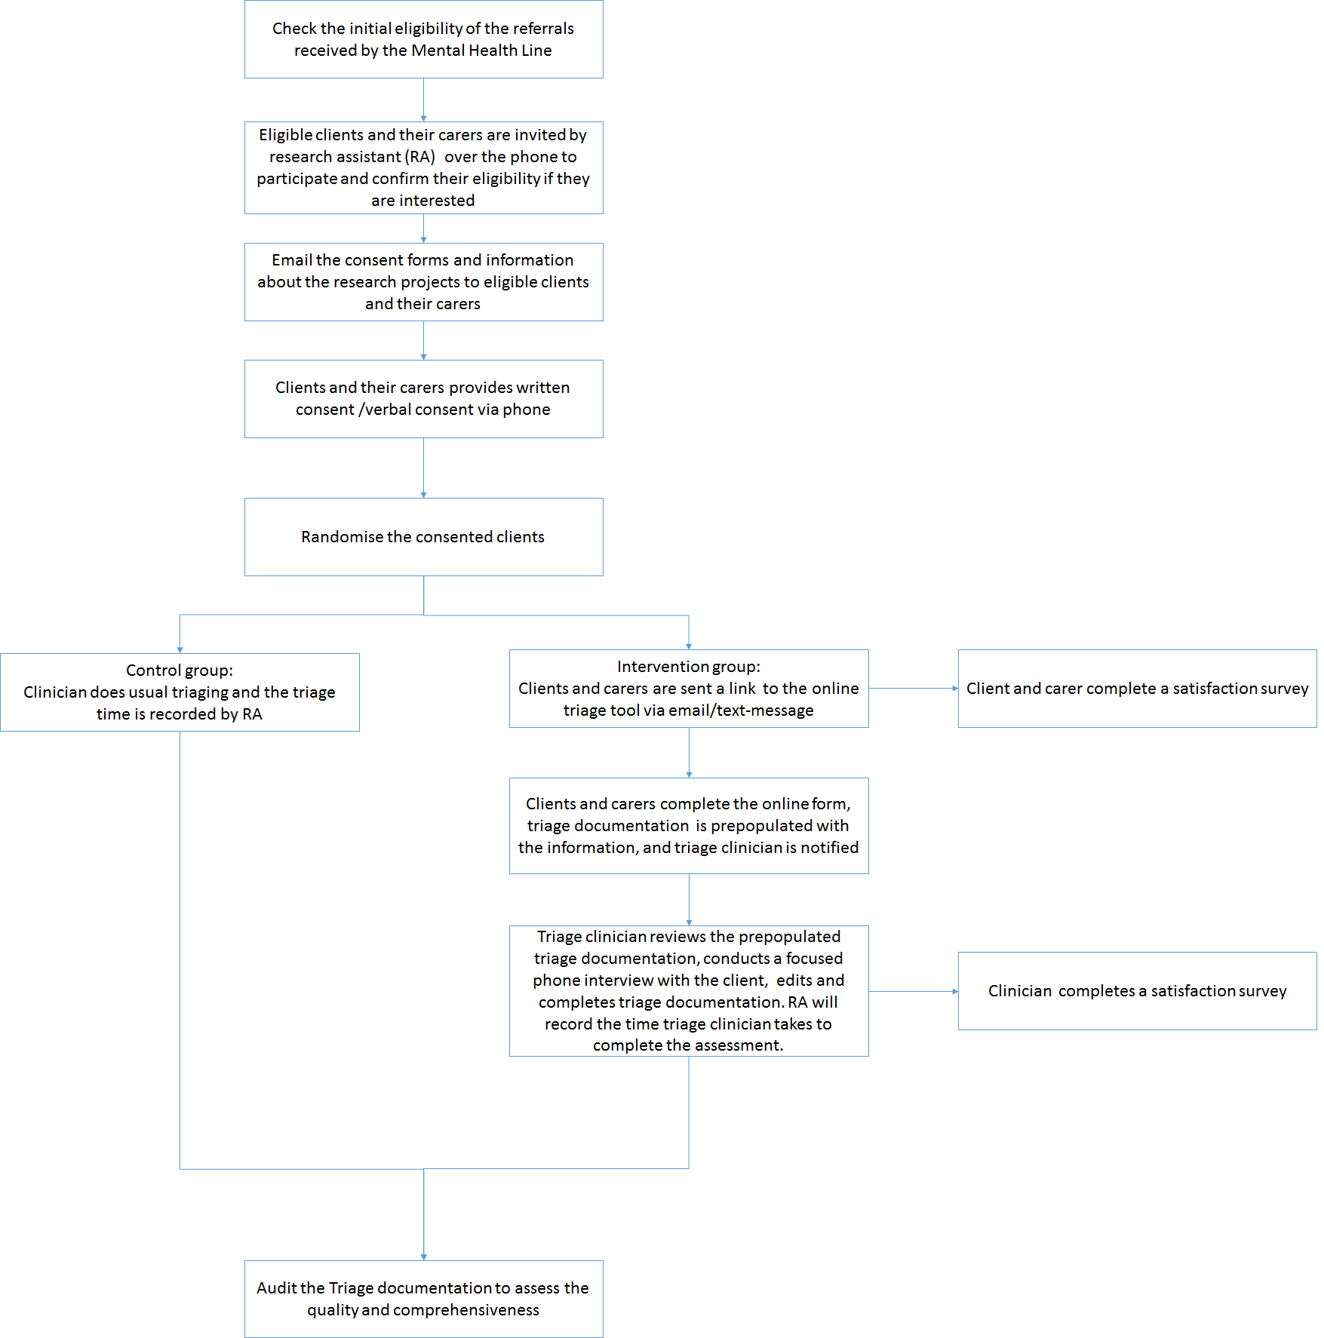

Figure 1. Overview of study design

***Recruitment of clients and carers:*** Potential clients will be identified through psychiatry referrals from GPs by the triaging team at the Mental Health Line. Clients who are deemed eligible will be contacted by research assistant/ admin person/ clinician (Telephone script – attachment 1), who checks their eligibility and potential involvement of a carer in the triaging . Consent will be sought from the potential clients or their carers to participate in their triaging and study. Once the eligibility and carer involvement is confirmed, clients and their carers will be sent Participant Information Sheet (attachment 6) and the consent forms (attachment 5) via email and/or text message (attachment 2 & 3), and advised to provide written consent via a website (if the client is randomised into the intervention group) or verbally prior to the triaging (if the client is randomised to the control group). These documents will clearly outline the voluntary nature of the research and the participant’s ability to exit the study at any stage during data collection without explanation or penalty, and the procedure for complaints. If the participants do not respond within 12 hours (standard response of the Mental Health Line is 48h), research assistant/ admin person/ clinician will contact them via phone and attempt to obtain either verbal or written consent. Non-contactable participants will be deemed ineligible and receive care as usual.

OMHA will provide the option for participants to withdraw the consent and leave the study. In that case, the system will notify research assistant/clinicians at Mental Health Line and the client will be assessed in the usual way over the phone and his/her data will be removed from the study.

***Client and carer eligibility:***

Inclusion criteria:

* People over 18 years old
* English speaking
* Basic computer literacy required for using the OMHA
* Access to a computer/smartphone, internet and email
* Referred to the Mental health line via fax by their GP or other professionals

Exclusion criteria:

* Minors under 18 years of age.
* People who are unable to give consent due to intellectual disability, medical status or age.
* People who require an interpreter.
* People needing urgent psychiatric assessment as stated in the referral letter
* People who are in acute psychological distress (i.e. in a state of intolerable psychological pain or distress )
* People who are acutely psychotic or manic
* People who are acutely drugged or intoxicated
* Re-connect clients (flag in the CHIME system)
* People at increased risk of violence or suicide

***Recruitment of triage clinicians and training to use the online triaging tool:*** All the triage clinicians working at Mental Health Line will be invited to participate and deemed eligible to participate in the study. Information about the online triaging tool (attachment 4) and consent form (attachment 5) will be emailed to them and advised to return the sign consent form to the research assistant. In terms of training, a presentation which will include a demonstration of the use of the online triaging tool and training material will be provided along with training materials to the consenting triage clinicians.

***Participant requirements:*** Consented participants including clients, carers and triage clinicians will be expected to complete the triage either over the phone or using the Online Mental Health Assessment (OMHA). Each triage is anticipated to take 60-90 mins to complete. Also, participants are also invited to complete a satisfaction survey in relation to the use of the OMHA.

**Methodology**

*Randomised controlled trial (hypothesis-1):* Eligible consented participants for psychiatry triaging will be randomly allocated to either control or experimental groups. Their GP will be informed about this study (by fax) and about the consent of their patient (attachment 14) In the experimental group, clients and carers will be sent a link to the OMHA via email by a research assistant/admin person at the Mental Health Line. Once the client and carers complete the triaging using OMHA, it will prepopulate collected data into the triage documentation template (attachment 10 &11) and notify the relevant triage clinician. Then the clinician will review the documentation and conduct a shorter interview with the client over the phone and complete the triage documentation by doing the necessary editing and amendments. The research assistant will record the time the triage clinician takes to complete triaging from the time he/she opens the prepopulated triage documents to the completion of documentation.

If the client from the intervention group becomes distressed during the completion of the on-line assessment or changes his/her mind, or needs to talk to a triage clinician, the OMHA will have the option to do so at any time and the research assistant and the Mental Health Line will be notified. In that case, the client will be directly contacted by the triage clinician and deemed ineligible for the study. Additionally, clients will be given information that they can also speak to their GP or contact a local emergency department (attachment 2, 3 & 6)

The clients in the control group will undergo the usual triage interview which may take between 60-90min to complete. The research assistant will record the time the triage clinician takes to complete triaging from the time he/she makes the phone call to the client and carer to the completion of triage documentation.

*Audit (hypothesis-2):* 50 triage documents will be selected at random from each of the experimental and control groups and scored against a standard checklist of clinical information which have been prepared by an expert panel (attachment 9). The total score reflects how well the document meets the clinical standard. The assessors who will be the clinicians in the research team, will be blinded to which group the documents have come from.

*Satisfaction survey (hypothesis-3):* Clients, carers and clinicians are invited to complete a self-administered satisfaction survey (attachment 7 & 8) about the proposed triaging system (i.e.OMHA).

**Outcome measures**

1. Time duration for psychiatry triaging as recorded by research assistant
2. Score for triage documentation quality
3. Acceptability score
4. Proportion of eligible referrals
5. Recruitment rate
6. Rate of successful completion of triage information using the OMHA
7. Cross-over rate (i.e. proportion of clients who required transfer from using OMHA to usual triaging)

**Sample size:**  A sample of 160 clients randomised 1:1 (i.e, 80 per arm) will give the study 80% power to detect a moderate effect size of 0.5 standard deviations (SD) at 5% significance. This calculation has been inflated by 20% to account for potentially non-Normally distributed triage times. Historically, the duration of triage process ranges from approximately 30 to 90 minutes, with a mean of 60 minutes; this corresponds to a SD of approximately 15 minutes. The study is powered to detect a difference of approximately 8 minutes. There are approximately 50 referrals received each day; assuming 80% of these are eligible, and 80% of clients consent; a sample of this size is achievable within a period of 1-2 weeks.

For the audit, a sample of 100 triage documents will give the study 80% power to detect a moderate effect size of 0.65SD difference between groups at the 5% significance level.

***Statistical analysis***: Student's t-test (or rank-sum test if appropriate) will be performed to compare the mean triage time between the two groups. A linear regression model will be used to explore potential association between the triage time and clinician characteristics including clinical discipline, years of experience which will be collected during the consent process).

For the audit, a similar analysis will be performed to compare the mean scores for documentation quality between the two groups.

For the acceptability score, chi-square tests for independence will be conducted to examine the relationship between acceptability questionnaire responses and intervention group. Survey items using a 5-point Likert-scale will be categorized as either disagree (score of 1-3) or agree (score of 4 or 5) to assess potential associations between sample characteristics and agreement status for each questionnaire item.

***Health Economic analysis:*** The economic analysis will be conducted from a healthcare perspective. A within trial cost-effectiveness analysis will be based on the mean difference over the 6 month trial period between usual care (phone triaging) and the intervention (OMHA) in the primary outcome variable: per cent reduction in clinician time required for triaging psychiatric referrals. This measure will be used for both control and intervention participants who meet the study’s inclusion criteria. Results will be expressed as an incremental cost effectiveness ratio (ICER) or the incremental cost per percent change in time for triaging.

A cost model will capture the resources required to deliver the intervention and comprise those that reflect (i) the intervention (ii) and resources allocated by providers that are associated with the intervention.

Sensitivity analysis will be conducted to explore the robustness of the results to the uncertainty around the parameters. The economic results will be considered in the context of decision making criteria that include strength of evidence and the capacity of the intervention around stakeholder acceptability, feasibility and sustainability

***Study sites:*** Mental Health Line, James Fletcher Hospital, Newcastle NSW 2300

***Duration of the study:*** 6 months

***Data collection:*** All data will be collected by using OMHA and recorded phone calls in accordance with the NSW Health Policy Directive document number PD2010_057, the National Statement on Ethical Conduct in Human Research (2007), and the Australian Code for the Responsible Conduct for Research (2007 - updated May 2017). Data will be securely stored in password-protected servers within HNE-LHD IT department.

The website would be hosted on the HNE Internet ColdFusion webserver which is in the DMZ (De-Miltiarised Zone) which is a hardened firewall zone between the www and HNE network. The system runs full https: encryption. It is considered very high security.

Ethics and dissemination:

**Research Ethics approval:**

Ethics approval will be sought from the Hunter New England Human Research Ethics Committee (HNEHREC).

**Confidentiality:**

All data will be treated confidentially in accordance with the NSW Health Policy Directive document number PD2010_057, the National Statement on Ethical Conduct in Human Research (2007), and the Australian Code for the Responsible Conduct for Research (2007 - updated May 2017). Confidentiality and privacy will be protected though restricted access to research data. Confidentiality and privacy in the clinical setting will follow the standard clinical practice protocol.

**Declaration of conflict of interest:**

The research team have no conflicts of interest to disclose.

**Risk and burdens associated with the current study:**

Online data collection forms have been designed with inputs from clinicians, client and carer representatives, and Aboriginal health workers to ensure the following: 1) Information and instructions to clients and carers are worded in an appropriate and understandable language; 2) contents are culturally appropriate to Aboriginal clients; 3) data collection process is user-friendly and efficient; 4) minimise or avoid any potential distress while filling the online data collection forms.

If participants experience distress during the online data collection process, they are given the option to terminate the process and contact their triage clinician directly through the system.

If a participant indicates that he/she is suicidal in the online assessment form, this information will be highlighted and presented to the triage clinician immediately. As stated previously, the client will also be given the option to terminate the online assessment and talk to the triage clinician directly if it is urgent.

To assure that each patient will be contacted by the mental health clinician without delays all of the patients’ details will be kept in the database created for the purpose of this project. Once patients will be found ineligible, opt-out or do not respond within 12 hours since referral been received by the MHL, this information will be immediately submitted to the MHL. Patients’ referrals will be added to the MHL request line and MHL’s clinicians will have further 36 hours to contact the patient (48 hours is a standard MHL response).

To minimize risks associated with the potential breach of privacy and confidentiality of participant information, the data will be securely stored in password-protected servers within HNE-LHD Applications Development and Integration Department. The website where data are collected will be hosted on the HNE Internet ColdFusion webserver which is in the DMZ (De-Miltiarised Zone) which is a hardened firewall zone between the www and HNE network. The system runs full https: encryption. It is considered very high security.

**Access to data:**

All data will be treated in accordance with the NSW Health Policy Directive document number PD2010_057, the National Statement on Ethical Conduct in Human Research (2007), and the Australian Code for the Responsible Conduct for Research (2007 - updated May 2017). Interview recordings, clinical triaging s and notes will be stored as electronic files in a password protected drive accessible only to the research team approved by the ethics committee, except if required by law. All personal identifiers will be removed and replaced with a code. The key for this code will be stored as an encrypted file accessible only to the research team approved by the ethics committee to enable the retrieval of notes if participants decide to withdraw during the data collection period. All of the collected data will be accessed only by the authorised team members. All hard copy data collected will be kept in the researcher’s office at the Newcastle Mental Health Service, James Fletcher Hospital. The PISCF and any advertising material will be kept in the researcher’s office at the Newcastle Mental Health Service, James Fletcher Hospital. All data will be retained by the research team for at least five years beyond the final publication after which it will be deleted or placed in confidential waste bins.

**Dissemination of results:**

This research will be reported / disseminated in the following ways:

* presentation of findings to HNELHD MHS executives
* presentation of findings at national and / or international professional conferences
* presentation of findings to local health professionals through hospital journal clubs or in-services
* articles published in scholarly peer-reviewed journals

Only de-identified personal information will appear in publications or presentations produced from the study. Participants who are invited to interview will be asked in the PISCF to indicate if they wish to receive any electronic copies of publications or final results from the study once they are completed. Any organisations or communities involved in this project will be acknowledged during presentation of the results.

**References**

Chuntao Lu, Y. H. (2018). The Use of Mobile Health Applications to Improve Patient Experience: Cross-Sectional Study in Chinese Public Hospitals. JMIR Mhealth Uhealth.