**FIRST – NT Study**

Fibroblast Activation protein imaging research SPECT/CT (FIRST-NT):

Assessing the safety and tolerability of 99mTc-3BP-4961 SPECT/CT

**Information Sheet**

**“This is for you to keep”**

*Acronyms:*

*FAPI= Fibroblast activated protein inhibitor*

*FDG=Fluorodeoxyglucose*

*PET=Positron Emission Tomography*

*SPECT=Single photon emission computed tomography*

*CT=Computed tomography*

**Introduction**

It is important for you to read this booklet so that you can understand what this research study is all about. A member of the research team will talk to you about the study and answer any questions you may have.

Once you understand what the research is and if you agree to take part in it, you will be asked to

sign a consent form. Signing the consent form means that you understand what the research is about and you agree to take part in it. You will be given a copy of this information booklet and the consent form to keep for yourself.

**Participating in this study is voluntary. You can choose to withdraw from the study at any time without providing a reason. Your decision will not affect your ability to receive treatment.**

**What is study about?**

We're investigating a new tracer known as 99mTc-3BP-4961. This tracer has not yet been approved for use by the therapeutics goods administration and is therefore experimental. The safety and tolerability of 99mTc-3BP-4961 in humans is unknown, and the purpose of this investigation is to determine whether it is safe and whether there are any adverse effects. We plan to use 99mTc-3BP-4961 to run an additional SPECT/CT scan to complete the standard of care FDG PET/CT scan you already received.

**Why is this study important?**

This study is important because FDG PET/CT scans need a long fasting time (sometimes up to 12 hours), which can be challenging for people with diabetes. If they can't fast long enough, it can affect the scan quality and results.

The new tracer 99mTc-3BP-4961 targets a protein called fibroblast activation protein (FAP) on tissue surfaces. A significant advantage is that fasting before this scan isn't necessary, making it more comfortable, especially for people with diabetes. Our main goal is to find cancer more accurately, helping us determine the best ways to check and treat it. We aim to provide better and more precise information for your treatment, simplify the entire process, reduce the time you spend in the hospital for tests and explore if this new scan could be in the future a good alternative to other scans that require fasting.

While this study might not benefit you directly, it will help the researchers understand how effective this kind of scan may be for patients in the future.

**Who can take part in the FIRST-NT Study?**

We are looking for 10 adult participants who have been referred by their doctors to undergo investigations for a new or relapsed cancer. There are some rules (eligibility criteria) we need to follow to find the right participants.

**What will I have to do if I take part of this study?**

If you want to take part in this study, you will receive an additional SPECT/CT scan with the new tracer 99mTc-3BP-4961 Nuclear medicine physicians, with access to your health information, will look at the pictures from this study. They want to see if the new tracer might be good in the future as an alternative for finding cancer instead of ones we are currently using.

i

**What will I have to do if I take part of this study?**

**Consent:** You will be asked to agree to be part of the study. If needed, interpreters or Aboriginal Health Practitioners will help share all the necessary details so you can make an informed decision.

**Health check:** You will have a check-up to keep an eye on your health, including checking your weight, temperature, breathing, heart rate and oxygen levels. Questions about your health will also be asked.

**Medical record:**We'll look at your notes and electronic records to understand more about your health.

**Tests/samples:**

If you participate in the study, we will collect blood and urine samples.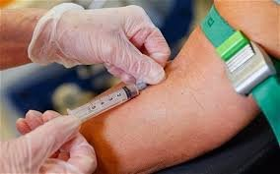

**Scans procedure:**

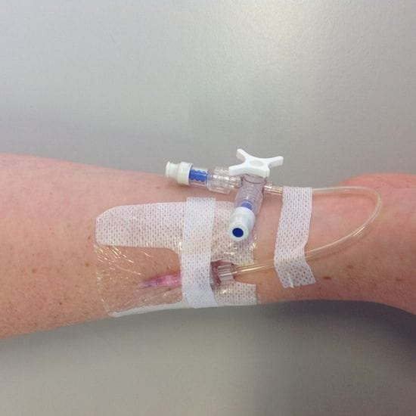First, our skilled research team will gently place a small tube, called an IV cannula, in your arm. This is where we inject the tracer for the new scan and the research team is experienced in handling challenging cannulation.

After that, you'll go through the scanning machine. The SPECT scan is a safe procedure that has been used for more than 30 years.

You will have a maximum of three different image acquisitions (scans):

1. 20 to 30 minutes after the injection
2. 60 to 90 minutes after injection
3. 120 to 180 minutes after the injection

We schedule these scans at different times to determine the optimal time for identifying any potential issues using the tracer. Importantly, you'll only receive one injection during this process. The tracer stays in your body for a short time and leaves naturally through urine. By the time you're ready to leave, most of the radiation will have already left your body through this natural process and the breakdown of the tracer particles.

The entire process, from entering the department to leaving, will take between 3 to 4 hours. We will provide you with food and drinks as needed and make you comfortable between the scans.

**Adverse Events:**

Since this is a first in human study, we'll keep an eye out for any issues from the time of the injection until after the scan and our staff will be checking on you often.

**Follow up visits:**

If you accept to take part in the study, after the scan is finished we will talk to you, make sure you are feeling ok and do another health check.

Some days after the scan, we will visit you in the ward again or, if you are no longer in the hospital, we will call you on the phone to ask you a few more questions about how you are feeling after the scan. Then we will call you again on the phone, again to make sure you are feeling ok after the scan. This will happen no longer than 4 weeks after the scan is done. After this, the study will be finished.

**Do I have to be involved in this study?**

No, you are free to decide if you want to be part of this study

* If you choose not to take part, you will still receive the best available treatment and care.
* If you decide to join the study then change your mind you can withdraw out at any time and you will still receive the best available treatment and care.

**What if I withdraw the participant from this study?**

**Participation in a clinical trial is voluntary. If you don’t wish to take part, you don’t have to. If you decide to take part and later change your mind, you are free to withdraw from the project at any stage. If you decide to withdraw from the project, please notify a member of the research team before you withdraw. If you do withdraw your consent during the study, the research team will stop collecting personal information from you. Your decision whether or not to take part, or to take part and then withdraw will not affect your routine treatment, your relationship with those treating you or your relationship with Royal Darwin Hospital.**

**What will happen to the information collected?**

**By signing this consent form, you agree to let the study doctor and research team collect and use your personal information for this research project. We will keep your information confidential and secure to protect your privacy.** Any data obtained from this study will be kept confidential and only accessible by the study researchers. **We will not share your information without your permission, unless required by law.**

**Any information that could identify you will be kept by Royal Darwin Hospital for up to 15 years, then securely destroyed. We are committed to ensuring your privacy and safety throughout the study.**

In this clinical trial, your data will be securely managed to protect your privacy and ensure research integrity. Information collected through medical records, questionnaires, and other tools will be stored securely, with physical records kept in locked cabinets and electronic data stored on encrypted servers on a system called REDCAP. Access to digital information will be restricted to authorized personnel with multi-factor authentication, and all data will be encrypted both during transmission and while stored. We will remove or code personal identifiers to maintain confidentiality, and data access will be monitored and logged. Regular encrypted backups will be made to safeguard against data loss. By participating, you consent to these data protection practices.

Anonymized results from this study will potentially be shared at international or domestic conferences and expected to be published in medical journals. **No identifiable information will be made public, and all the data will be stored safely as per the directives of Ethics Committee.**

**Ethics Committee Clearance:**

This study has been approved by the Human Research Ethics Committee of the NT Department of Health and Menzies School of Health Research. We will provide regular reports to update them on how the study is going.

If you have any concerns or complaints regarding the ethical conduct of the study, you are invited to contact Ethics Administration, Human Research Ethics Committee of the NT Department of Health and Menzies School of Health Research on 8946 8600 or email [ethics@menzies.edu.au](mailto:ethics@menzies.edu.au).

**Concerns and Complaints:**

The conduct of this study at **name of site** has been authorized by Northern Territory Health. Any person with concerns or feedback (complaints or compliments) about the conduct of this study may contact the NT Health Research Governance Officer on [08 8922 7764](mailto:08%208922%207764) or email [nthealth.rgo@nt.gov.au](mailto:nthealth.rgo@nt.gov.au).

**Contact details:**

Please contact the study doctor as soon as possible if you suffer any side effect, allergic reaction, injury or complication as result from the scans so that appropriate medical treatment can be organized promptly.

**Dr Joshua Morigi**

**FIRST-NT Principal Investigator**

08 8922 8545 (Mon to Fri 8am to 4pm)

[Joshua.morigi@nt.gov.au](mailto:Joshua.morigi@nt.gov.au)

Clinical Director of Molecular Imaging at the Department of Medical Imaging

Royal Darwin Hospital

Tiwi NT 0810

**Thank you for taking the time to consider this study.**

# PARTICIPANT CONSENT FORM

#### Consent form for additional scan to be signed

**“This means you can say NO”**

|  |  |
| --- | --- |
| **Participant Name** | |
| **DOB** | **HRN** |

I have read and understood the information provided about the **FIRST - NT** study and the use of this information to assess the clinical use and accuracy of 99mTc-3BP-4961 SPECT/CT scans (“new scan”).

I have been able to ask any questions about the study and am happy with the answers I have received.

I give consent for myself to participate in the **FIRST-NT** study by undergoing an additional new scan.

I understand that involvement in this study might involve additional blood tests to be performed and that inclusion in the study involves the use of a limited amount of radiation which is additional to what would otherwise be used.

I understand that I, may withdraw consent to participate in the study at any time, and that no reason is required to do s o. Withdrawal from the study will not have an impact on your standard of care.

I understand that no personal details (name, address or date of birth) will be disclosed in any published material, reports, promotions or journals.

#### Please circle appropriate response and sign below

I have read and understood the information regarding the study and consent for myself to participate in the study.

Name of Participant: _________________________________________________

Signature of Participant: Date (dd/mmm/year):

Name of Interpreter (if interpreter used): _________________________________________________

Signature of Interpreter (if interpreter used): Date (dd/mmm/year):

**Declaration by Study Doctor/Senior Researcher**

**I have given a verbal explanation of the implications of withdrawal from the research project and I believe that the participant has understood that explanation.**

Name of Study Doctor: _________________________________________________

Signature: Date (dd/mmm/year)

**Pictorial explanation:**

1. **Consent:** signing the consent form is up to you, after talking with the researchers and deciding if you want to be part of the study.



1. **Health check: We will check your health by asking questions, collecting blood and urine specimens. We will also check your medical records.**

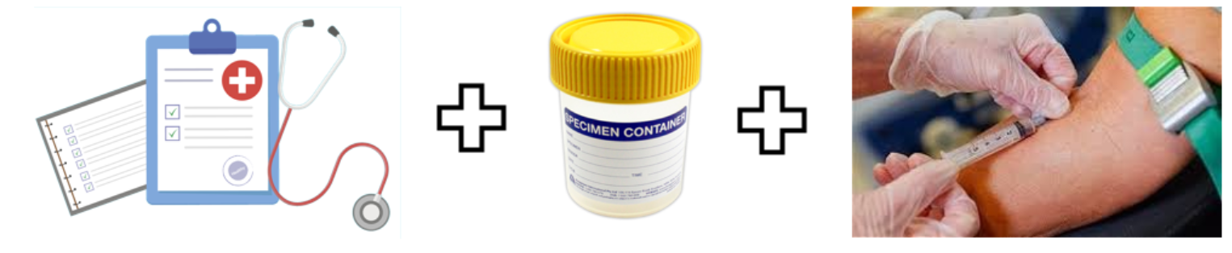

1. The scan: We will put a cannula in your arm and then we will do **three** scans at about 30, 60 and 120 minutes. Each scan will take about 20 minutes.

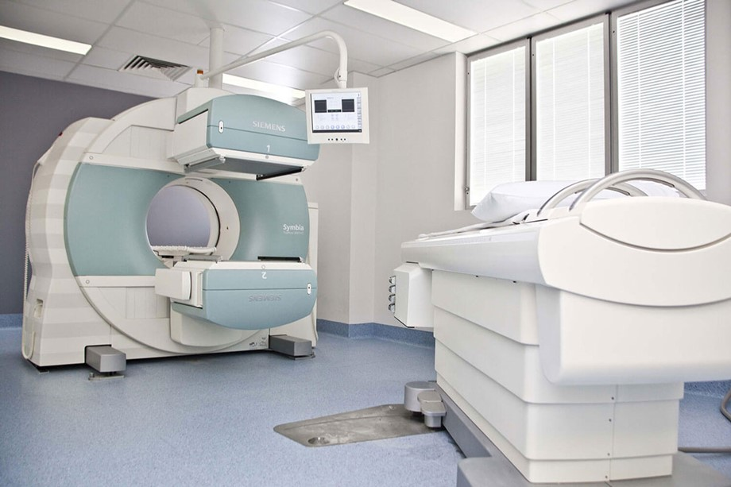

1. **Follow up: A few days after the scans, we will ask you a few more questions about the scans and how you are feeling. We can do this in person or over the phone.**

