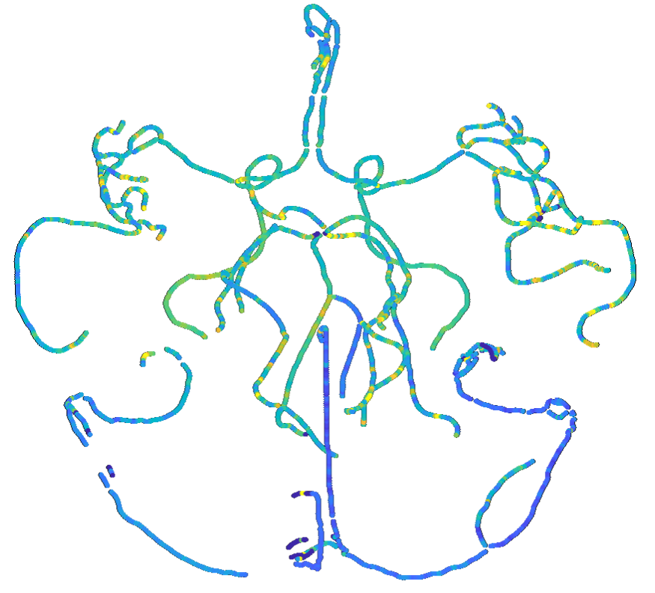

Study Protocol for the

**Hemodynamic Encephalopathy Risk Study (The HER Study)**

Using advanced MRI biomarkers to stratify cerebrovascular sex differences associated with brain damage and dementia.

Version 1.3 24/06/2024

**Introduction and Study Reasoning**

**Background:** Our understanding of human physiology is largely driven by data from males of European ethnicities, leading to widespread sex and ethnicity differences in quality of treatment and clinical outcomes. Females for instance, have a higher risk of severe dementia and vascular diseases [1], but the reason is unknown. Neurodegeneration is strongly linked with abnormal pulsatility patterns [2-5] which supports a vascular damage hypothesis [6] termed pulse wave encephalopathy (PWE), but research to date has not identified strong, and often conflicting evidence for sex differences [1, 7, 8]. In our recent study of brain perfusion [15], we discovered - via a novel pulsatility transmission risk index (PT) - sex-specific patterns of brain perfusion (not previously reported in the literature) that influence mechanisms of homeostasis and adaptation. This suggests profound discrepancies in women's physiology. This has been shown in a small cohort (n=20) which we are expanding here. The implications identify that females may have higher risks of cerebrovascular diseases if treated in the same manner as males due to these physiological differences.

Vascular risk factors are not just limited to chronic neurodegenerative disease; understanding vascular physiology, specifically cerebrovascular reactivity (CVR) can inform on the ability of the vessels to adapt to acute ischemic events (during stroke) [9]. It has been reported that Māori have a higher mortality to stroke, which has been attributed to inequitable treatment and lifestyle risk factors [10-11], however, these risk factors do not represent Māori physiology - how the vessels react. If Māori also have reduced CVR (as measured in this preliminary healthy, low-risk factor cohort), identification can motivate the change of treatment guidelines to preserve the mana of individuals at greater risk. If Māori have increased CVR, this further highlights the impact of poorer access to interventions/increases in mortality [10].

**The goal of this study:** Analyse if there are concrete vascular risk factor differences between sex, and ethnicity in a young cohort. To achieve this, we will perform cerebral and heart, flow-based scans at rest, and vessel activated states by asking participants to inhale a gas blend (hypercapnic stimulus). We will also be testing blood components known to alter cerebral blood flow.

**Significance:** By directly studying under-represented groups (females and Māori), we may uncover findings that promote investigation to understand physiological differences between the groups and the development of more comprehensive biomarkers and guidelines to better characterise health, at-risk, and disease, in cerebrovascular conditions related to blood perfusion impairments, improving in health delivery. CVR and intracranial pulsatility based vascular risk factors have also never been measured in the Māori population which will contribute to our understanding of ethnicity, and sex-based differences in these measures, contributing to equitable research and upholding Te Tiriti o Waitangi in line with the New Zealand Health Research Strategy.

**Participant Pool and Criteria**

**Study Timeline:** Start: 20th July 2024, End: 1st Dec 2024

**Participants:** A maximum of 20 participants will be recruited, 10 male, and 10 female who are from an otherwise healthy young population aged 25-35 years old. The cohort will be split 1:1 Pakeha and Māori. Due to the small sample being studied, we will minimise ethnicity differences in vascular hemodynamics [12] by only recruiting those of European descent at this time since the number of participants is low. This number of subjects selected will provide sufficient data on which to project cohort sizes needed for a larger study.

**Participant Eligibility:**

Inclusion criteria:

1. Between the age of 25 and 35 within the calendar year.
2. Nominal blood pressure (<130 systolic and <90 diastolic blood pressure)
3. Has not smoked within 6 months.
4. Is not diabetic.
5. Is not and has no history of alcoholism.

Exclusion criteria:

1. Contraindications for MRI (large metal implants that may cause resistive heating (orthodontics are MRI safe, and acceptable), claustrophobia.
2. Contraindications in donating blood (uncomfortable with needles).
3. History or current psychiatric disorders.
4. Any major structural brain abnormalities (e.g., due to surgery or previous traumatic brain injury).
5. Any major heart abnormalities (e.g., myocarditis, hypertrophic cardiomyopathy, low ejection fraction, brady/tachycardia, known arrhythmias).
6. Does not meet health and safety requirements for MRI site access (e.g., Covid Vaccination status).

**Participant Experience Summary:**

Each participant will have a similar experience for this study shown in the following figure. Details of the steps are provided in chronological order of the experience flow chart. The participant experience was designed using a kaupapa Māori approach for Māori participants and supports a culturally appropriate process of recruitment.

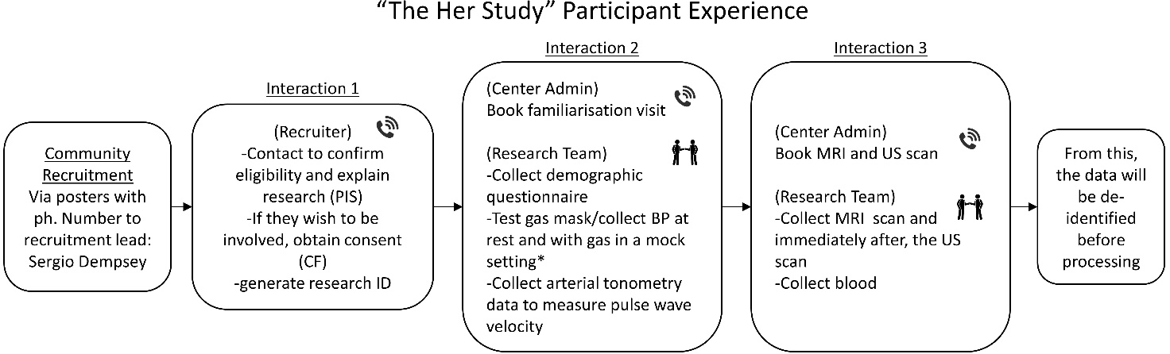

Pakeha will be imaged at the Centre for Advanced MRI (CAMRI) in Auckland, NZ <https://www.camri.co.nz/>

Māori will be imaged at Matai Medical Research Institute in Gisborne, NZ <https://www.matai.org.nz/>

**Interaction 1 – Recruitment and Consent:** The participant pool will be recruited from posters advertised around the city (Auckland and Gisborne) and campuses (University of Auckland and Matai Medical Research Institute). Upon expressed interest to the recruiter, the recruiter will explain the research either over the phone, by email, or in person. Should the potential participant wish to join the study, a meeting with a researcher and the potential participant will be booked to complete the informed consent process over the phone or video call. The recruiter will then pass on the participants contact information to imaging centre administration to schedule Interactions 2 and 3.

**Interaction 2 – Visit 1: Demographics, BP measurement, and Mock Scan:**

The participant will be booked for a one-hour visit to the scanning centre. 24 hours before the visit, the participant will be asked to abstain from alcohol, exercise, and be encouraged to have good sleep. Participants will be asked to not eat 2 hours before the visit to minimise the effects of digestion in the measurements. Provided the participant has followed the pre scan preparation:

During the visit:

* A member of the research team will first complete the demographic questionnaire form with the participant.

At this stage, and prior to measurement, the option to have a female or male chaperone   
will be offered to the participant during the time the researcher is collecting measurements.

* The participant will then be asked to test several gas masks for an ideal fit and to lie down. A finger heart rate monitor will be attached, the mask will be placed on the participant, and headphones will be provided playing MRI scanner sounds. This will simulate the MRI experience to prepare the participant before the scan. This will last for 10 minutes. Five minutes into rest, 3 brachial blood pressure cuff measurements will be taken for consistent measurement followed by arterial tonometry (a pencil based pressure reader) to measure pulse wave velocity (PWV) by reading the blood signal at the neck and femoral artery. A measure of distance between both measurements will also be collected using a tape measure.
* The participant will then practice breathing a 5% CO2 mixture for 10 minutes to make sure they are comfortable with the sensation, which may provoke anxiety. 5% CO2 is completely safe for the human body and little to no sensation is expected. It can comfortably be inhaled and has been used in MRI scanners before at higher percentages for 15 minutes at a time in a young and older cohort [13]. Their blood pressure will be taken thrice again at 5 minutes with CO2, followed again by the arterial tonometry.

*Differences between CAMRI and Matai centres: At CAMRI, a realistic mock scanner will be used to simulate the MRI and prepare participants for a real scan. At Mātai, participants will be in a private room for resting blood pressure measurements with required members of the research team present.

**Interaction 3 – Visit 2: MRI, Ultrasound (US), and Blood Sample:**

The participant will be booked by imaging centre admin for a two-hour visit. Availability for this visit will be confirmed during the scheduling of visit 1.

24 hours before the visit, the participant will be asked to abstain from alcohol, exercise, and be encouraged to have good sleep. Participants will be asked to not eat 2 hours before the scan to minimise the effects of digestion. Provided the participant has followed the pre scan preparation:

* The participant and researcher will move into the MRI scanner module and similar equipment to the mock scan will be placed on the participant.
* The participant will then be imaged using the MR protocol detailed in the next section. The scan is non-invasive and does not involve any harmful substances or needles. Mid way through, the CO2 gas blend will be opened to image changes in vascular flow. We are aware of the time commitment and comfort of participants, and as such have developed the entire MRI scanning protocol to be approximately 30 minutes.
* After the MRI scan, the participant will be immediately transported with the research team to the ultrasound scan room where they will receive a cardiac echo ultrasound scan which will take approximately 30 minutes.
* Finally, the research team will accompany the participant to the blood clinic, where blood samples will be collected.

*Differences between CAMRI and Matai: At CAMRI, the blood clinic is also within the hospital. At Matai, the MRI and ultrasound will happen in the same building with an onsite sonographer. The blood testing will be done at Gisborne regional hospital; a member of the research team will drive the participant to and from the blood clinic.

**MRI Protocol: Scan Time 30 minutes**

|  |  |  |  |
| --- | --- | --- | --- |
| **Type** | **Sequence** | **Analysis Plan/Use** | **Visual Example** |
| Structural | T1w | Measure total intracranial volume, grey matter, white matter, cerebrospinal |  |
| Angiogram (Time of Flight) | Localise the brain vessels to plan the 4D flow |  |
| 4D Flow | 3D phase contrast (0.75mm isotropic)  Velocity encoding=80cm/s | Measure cardiac gated cerebral blood flow in the brain  (focused on circle of Willis) |  |
| Functional | fMRI + Coreg and B0,B1 fields | During initial CO2 inhalation, measure the initial response to CO2 bolus as a form of tissue reactivity |  |

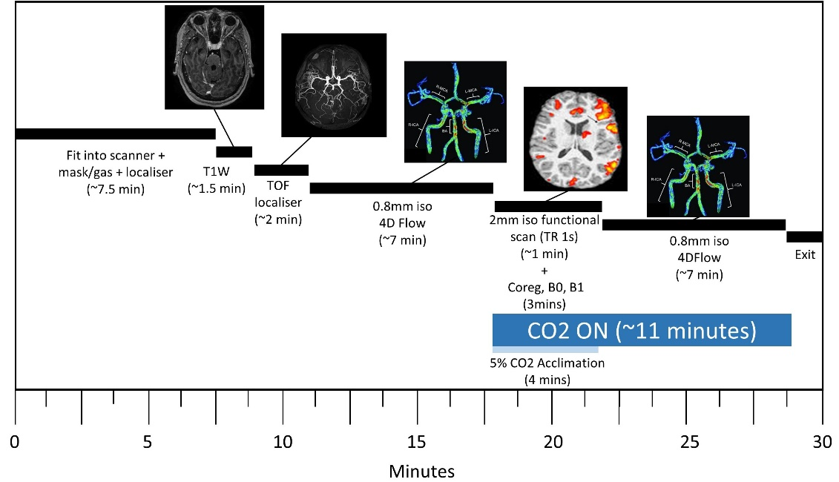

Figure 3. Breakdown of time in the scanner module.

**Ultrasound Protocol: Scan Time 30 minutes**

Immediately following the MRI, an echocardiogram will be performed. This will be undertaken by an experienced echocardiographer using a cardiac ultrasound system. The echocardiogram will be undertaken in the MRI recovery area next to the MRI.

At this stage, and prior to measurement, the option to have a female or male chaperone   
will be offered to the participant during the time the researcher is collecting measurements.

Two-dimensional (2D), pulsed-Doppler, and colour tissue Doppler imaging will be performed from standard parasternal and apical transducer positions. All indices will be measured according to the recommendation of the American Society of Echocardiography [14]:

1. Standard 2D left ventricular measurements (apical 4 and 2 chamber volumes) and left atrial size will be recorded. Left ventricular ejection fraction will be quantified using Simpson’s biplane method, left atrial volume will be obtained from Simpson’s biplane volume assessment or area length volume assessment in the apical views. 3D left ventricular volumes will be assessed.
2. Left ventricular diastolic parameters will include the combined mitral inflow and annular tissue Doppler velocities (with sample volume placed at the mitral annulus and the average value of the medial and lateral velocities will be used to derive the E/e’).
3. Left ventricular global longitudinal strain (GLS) will be measured using speckle tracking echocardiography (STE) in the three standard apical views and the average value recorded. If regional tracking is suboptimal in more than two myocardial segments in a single view, the calculation of GLS will be recorded as unobtainable.
4. RV systolic function will be assessed by tricuspid annular plane systolic excursion [TAPSE]. TAPSE is easily obtainable and has been shown to be an accurate reflection of RV global systolic function.

Two 3D+t volumetric scans of one breath-hold each will be acquired to reconstruct 3D cardiac geometry and function within one cardiac cycle. Using echo analysis software, 3D measurements of left ventricular geometry and function such as: left ventricular mass, left ventricular end-diastolic volume, left ventricular end-systolic volume, left ventricular ejection fraction, as well as 3D myocardial strain, will be derived from the 3D volumetric data. Finally, the raw imaging data will be converted to DICOM images, which will then be analysed using a model-based image processing software tool to construct a 3D computer model of the left ventricle for biomechanical analysis.

Two 3D-doppler images will be taken in the left ventricle and aorta to allow for assessment of quantification of pressure via a non-invasive means. A Pulse Cor R6.5 Cardiovascular monitor will be used to measure aortic pressure and arterial stiffness. This is a standard automated blood pressure cuff and the measurements are no different to having a standard blood pressure measurement performed.

The 3D left ventricle imaging will be repeated with CO2 for reactivity measurements after free end tidal CO2 has normalised on the gas monitor.

**Blood Collection:**

The participant and accompanying researcher will travel by foot or cab to the designated blood collection sites. The private third-party company will draw, store, process, and destroy the blood tissue (unless return is requested, an option by the companies named below).

Blood will be collected by two companies’ dependant on region:

Auckland New Zealand:

**Company:** LabPLUS <https://www.medlabcentral.co.nz/about-us/about-medlab-central/>

**Location:** Building 31, Auckland City Hospital, Gate 4 off Grafton Rd, Grafton, Auckland 1023

Gisborne, New Zealand:

**Company:** MedLab Central <https://www.medlabcentral.co.nz/about-us/about-medlab-central/>

**Location:** Gisborne Hospital, 421 Ormond Road, Gisborne, NZ 4010

**Tests:**

Oestradiol (Estrogen) from plasma

Progesterone from plasma.

Haematocrit (red blood cell count, platelet count) from whole blood sample.

Testosterone (Totla) from plasma

**The participant will then be offered a Koha as a thank you, completing their participation experience**

**Participant Incidentals and Takeaways:**

We will organise and pay for a taxi for those who do not have personal transport. Those who come in personal transport (driven by themselves, friends or family), will be eligible for a petrol reimbursement of $25 for each visit. A voucher ($100) will be offered to participants upon completion of the MRI and US scans and blood donation.

**At any point, the participant will be allowed to withdraw if they feel anxious.**

**The petrol reimbursement will still be provided for either visit 1 or 2.**

Participants may request an electronic generalised explanation of their brain and heart from this study. This report will provide detailed and explained parameters of the brain vessels for research purposes. An image will be generated which contains a montage of the brain vessels and a videographic of their blood flow. They will be made aware all information is not for clinical purposes, rather for their own information. Furthermore, participants will be invited to a public study findings seminar before the results are published. They can request access any time to their raw brain scans as this is their right. At any time, participants may request their data be removed from the study, at which point the participants raw scan data, and any subsequent derivative data will be removed. Any data that has already been shared/published will not be removed.

**Personal Findings, Incidental Findings and Communication Policy**

Participants may receive a report explaining their brain volumetric changes if requested. Throughout the study, if an incidental finding is discovered during the study analysis the researcher will:

* Inform the participants nominated healthcare provider/GP of the potential incidental finding.
* Notify the Mātai radiologist or relevant clinician of the incidental finding for their review.

If an incidental finding is confirmed:

* The radiologist or relevant clinician will complete the incidental findings form and inform the participants nominated healthcare provider/GP.
* The radiology senior administrator will ensure the referral for clinical assistance is sent to the GP and up-date the incidental findings database.
* The nominated healthcare provider/GP will inform the participants and recommend a suitable health professional for clinical follow-up.

Before any publication of data, all manuscripts will be passed to the Mātai Medical Research Institute for the Māori Advisory committee to screen and make suggestions on wording for any issues that reflect on our Māori participants.

**Protocol Related Risks:**

There are no known side effects or risks associated with MRI scanning. It is painless, and involves no radiation exposure, needles, or injections. However, MRI is unsafe for people who have magnetic metal implants in their body (e.g., pacemaker, hearing aid, screws/plates from an operation, etc.). At the MRI centre, the participant will be asked to fill out a safety checklist which will confirm eligibility. Those who do not like tight spaces (claustrophobia) can find lying in the narrow tunnel of the MRI scanner difficult. Therefore, we do not recommend that claustrophobic participants join the study. Very rarely people can find the scanner makes them feel warm or can feel a tickling or twitching sensation. These are harmless. However, if the participant is uncomfortable for any reason whilst in the scanner, they can let the MRI operator know via the communication system or the emergency buzzer. It is always the participants right to request that scanning be discontinued and that they be removed from the scanner.

During blood donation needles may make people feel faint, but the volume of blood collected (~6mL) poses no challenge for the circulatory system to accommodate.

**Contact Details:**

Dr Gonzalo Maso Talou (P.I.)

Auckland Bioengineering Institute

The University of Auckland

Private Bag 92019, Auckland 1142

Email: g.masotalou@auckland.ac.nz

Ph.: 210-846-8901

Sergio Dempsey

Auckland Bioengineering Institute

The University of Auckland

Private Bag 92019, Auckland 1142

Email: sdem348@aucklanduni.ac.nz

Ph.: 027-335-5731

Kelly Burrowes

Auckland Bioengineering Institute

The University of Auckland

Private Bag 92019, Auckland 1142

Email: k.burrowes@auckland.ac.nz

Ph.: 9923-2748

James Fisher

Auckland Bioengineering Institute

The University of Auckland

Private Bag 92019, Auckland 1142

Email: jp.fisher@auckland.ac.nz

Ph.: 93737599 Ext. 86320

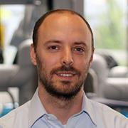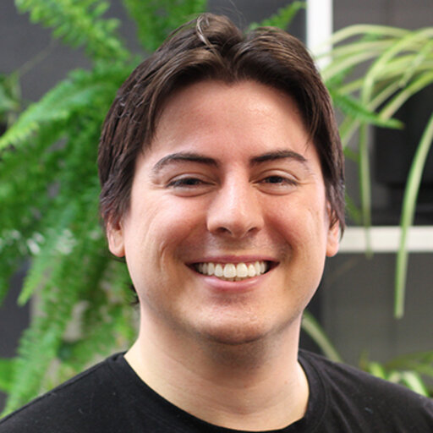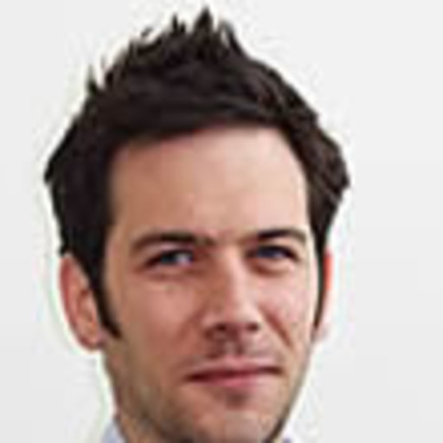

**References**

[1] W. K. Lefferts, J. P. DeBlois, J. A. Augustine, A. P. Keller, and K. S. Heffernan, “Age, sex, and the vascular contributors to cerebral pulsatility and pulsatile damping,” *J. Appl. Physiol.*, vol. 129, no. 5, pp. 1092–1101, Nov. 2020, doi: 10.1152/japplphysiol.00500.2020.

[2] C. Björnfot *et al.*, “Cerebral arterial stiffness is linked to white matter hyperintensities and perivascular spaces in older adults – A 4D flow MRI study,” *J. Cereb. Blood Flow Metab.*, p. 0271678X241230741, Feb. 2024, doi: 10.1177/0271678X241230741.

[3] S. Purkayastha *et al.*, “Impaired Cerebrovascular Hemodynamics are Associated with Cerebral White Matter Damage,” *J. Cereb. Blood Flow Metab.*, vol. 34, no. 2, pp. 228–234, Feb. 2014, doi: 10.1038/jcbfm.2013.180.

[4] A. Wåhlin, K. Ambarki, R. Birgander, J. Malm, and A. Eklund, “Intracranial pulsatility is associated with regional brain volume in elderly individuals,” *Neurobiol. Aging*, vol. 35, no. 2, pp. 365–372, Feb. 2014, doi: 10.1016/j.neurobiolaging.2013.08.026.

[5] J. Birnefeld, A. Wåhlin, A. Eklund, and J. Malm, “Cerebral arterial pulsatility is associated with features of small vessel disease in patients with acute stroke and TIA: a 4D flow MRI study,” *J. Neurol.*, vol. 267, no. 3, pp. 721–730, Mar. 2020, doi: 10.1007/s00415-019-09620-6.

[6] M. D. Sweeney *et al.*, “Vascular dysfunction—The disregarded partner of Alzheimer’s disease,” *Alzheimers Dement.*, vol. 15, no. 1, pp. 158–167, Jan. 2019, doi: 10.1016/j.jalz.2018.07.222.

[7] G. S. Roberts *et al.*, “Normative Cerebral Hemodynamics in Middle-aged and Older Adults Using 4D Flow MRI: Initial Analysis of Vascular Aging,” *Radiology*, vol. 307, no. 3, p. e222685, May 2023, doi: 10.1148/radiol.222685.

[8] M. R. Alwatban *et al.*, “Effects of age and sex on middle cerebral artery blood velocity and flow pulsatility index across the adult lifespan,” *J. Appl. Physiol.*, vol. 130, no. 6, pp. 1675–1683, Jun. 2021, doi: 10.1152/japplphysiol.00926.2020.

[9] E. Sleight, M. S. Stringer, I. Marshall, J. M. Wardlaw, and M. J. Thrippleton, “Cerebrovascular Reactivity Measurement Using Magnetic Resonance Imaging: A Systematic Review,” *Front. Physiol.*, vol. 12, p. 643468, Feb. 2021, doi: 10.3389/fphys.2021.643468.

[10] S. G. Thompson *et al.*, “The impact of ethnicity on stroke care access and patient outcomes: a New Zealand nationwide observational study,” *Lancet Reg. Health - West. Pac.*, vol. 20, p. 100358, Mar. 2022, doi: 10.1016/j.lanwpc.2021.100358.

[11] A. Ranta, B. Jones, and M. Harwood, “Stroke among Māori in Aotearoa New Zealand and solutions to address persistent inequities,” *Front. Stroke*, vol. 2, p. 1248351, Aug. 2023, doi: 10.3389/fstro.2023.1248351.

[12] Y. Lu *et al.*, “Global distributions of age- and sex-related arterial stiffness: systematic review and meta-analysis of 167 studies with 509,743 participants,” *eBioMedicine*, vol. 92, p. 104619, Jun. 2023, doi: 10.1016/j.ebiom.2023.104619.

[13] K. B. Miller *et al.*, “Age-Related Reductions in Cerebrovascular Reactivity Using 4D Flow MRI,” *Front. Aging Neurosci.*, vol. 11, p. 281, Oct. 2019, doi: 10.3389/fnagi.2019.00281.

[14] R. M. Lang *et al.*, “Recommendations for Cardiac Chamber Quantification by Echocardiography in Adults: An Update from the American Society of Echocardiography and the European Association of Cardiovascular Imaging,” *J. Am. Soc. Echocardiogr.*, vol. 28, no. 1, pp. 1-39.e14, Jan. 2015, doi: 10.1016/j.echo.2014.10.003.

[15] S. Dempsey et al., "Measuring global cerebrovascular pulsatility transmission using 4D flow MRI." Scientific Reports 14, no. 1 (2024): 12604.