A Randomised Controlled Trial Assessing the Efficacy of Intra-operative Rigenera Autologous Micrograft Therapy (AMT) in FUT Hair Transplant Patients
Dr Adam Ellerby (MBChB, BSc, FRACGP), Dr Russell Knudsen (MBBS(Hons), FACCSM (Med), FISHRS, Diplomate ABHRS), Dr Sarah Macdonald (MBBS, Mast. Philosophy, FRACGP)
The Knudsen Clinic, Level 2, 45a Bay Street, Double Bay, Sydney 2028.
Phone: +61 2 9327 0300 | Email: [ajellerby@gmail.com]

Sponsorship: There is no formal sponsorship of this research protocol. Each Rigenera AMT procedure kit is being provided without charge by Austramedex Pty Ltd (92 Abbott Rd, Hallam VIC 3803).
Table of Contents
Introduction: 1
Objective: 2
Study Design: 2
Participants: 2
Interventions: 2
Primary Outcome Measures: 3
Secondary Outcome Measures: 3
Methodology: 3
Pre-operative: 3
Intra-operative Procedure: 4
“The Rigenera protocol”: 4
“Placebo protocol”: 4
Post-operative Follow-up: 4
Safety: 5
Data Collection / Analysis: 5
Ethical Considerations: 6
Time line: 7
Conclusion: 7
References: 7

Introduction:
Alopecia, a widespread condition worldwide, primarily arises due to genetic predisposition, hormonal imbalances, immune system dysfunction, malnutrition, environmental influences, psychological stressors, ageing, and various other factors. The most common form is Androgenic Alopecia (AGA) caused by DHT-dependant thinning of the upper scalp hairs with age. AGA is a common concern affecting millions worldwide, with significant impacts on self-esteem and quality of life.
In recent years, stem cell-based therapies have emerged as promising interventions for hair regeneration. Among these, Rigenera® Autologous Micrografts technology (AMT) has garnered attention for its potential in stimulating hair growth. Studies suggest that the micrografts obtained through Rigenera technology contain a rich source of stem cells and growth factors, which promote hair growth and improve hair follicle function .
Rigenera AMT is created using a procedure of processing harvested tissue from the patient. This is disaggregated in solution using a specially designed kit. The end product is a concentrated solution of stem cells which are injected into the patient’s scalp. This study will follow manufacturer’s guidance on preparation of the solution. The injection pattern will follow the manufacturer’s recommendation as seen in other studies to date.
Studies have shown positive effects on angiogenesis, reduction in inflammation, suppression of apoptosis and increased production of extracellular matrix.
The clinical benefits shown include:
- stimulation of hair growth⁶
- increased hair thickness
- improved patient satisfaction
In the literature to date there have been no reported adverse outcomes from using Rigenera AMT and it has no predicted risks.
This study aims to build on past and recent studies on the safety and efficacy of Rigenera stem cell treatment for hair regeneration. We specifically aim to add to the current understanding around concurrent use of Rigenera AMT alongside FUT hair restoration surgery, which is an area lacking from the current evidence base.

Objective:
This study seeks to evaluate the effectiveness of intra-operative Rigenera therapy compared to a placebo in improving hair survival, increasing hair density and thickness, and improving patient satisfaction in patients undergoing Follicular Unit Transplantation (FUT) for hair restoration.

Hypothesis:
It proposed that using Rigenera AMT in conjunction with FUT surgery will improve post-operative outcomes including hair survival, density and thickness and that patient satisfaction will be greater.

Null Hypothesis:
The effect of Rigenera AMT alongside FUT surgery will be nil.

Study Design:
This is a double-blinded, Randomised Controlled Trial (RCT) - patients and study observers will be blinded to the treatment.

Participants:

Inclusion criteria:
Forty patients aged over 25 undergoing FUT hair transplant for androgenetic alopecia.
- Patients selected based on their need for frontal region transplant
- Frontal recipient area must have advanced AGA
- Medications - Every patient should be stabilised on hair loss medications (ie slow progression or cessation of hair loss for >6 months using standard medical therapies)

Exclusion criteria:
- Non-androgenic cause for alopecia - autoimmune, scaring, thyroid, iron and Vit D
- Hair transplant surgery within past 18 months
- Other regenerative treatments within past 12 months - regenera, PRP, PRF
- Intercurrent systemic illness or scalp disease
- interstate or out of area patients due to in-person follow up requirements

Withdrawal:
- Patients can withdraw from the study at any time by written request to the Knudsen Clinic.

Interventions:

Each patient will have one side treated with Rigenera and the other side with saline injection.

1. **Experimental side (Rigenera):**
- Intra-operative Rigenera therapy during FUT procedure.
- Recipient area injection - mesotherapy needle - inject in grid pattern - 0.2ml per 1cm^2 using 30g needle at 4mm depth

2. **Control side (Placebo):**
- Standard FUT procedure without intra-operative Rigenera therapy - injection with normal saline

Primary Outcome Measures:
- Graft survival 3, 6 and 12 months post-transplant
- Hair follicle density at 3, 6 and 12 months post-transplant.
- Hair follicle thickness at 3, 6 and 12 months post-transplant

Secondary Outcome Measures:
1. Patient-reported satisfaction scores

Methodology:

Pre-operative:

- Informed consent
- A detailed patient information sheet will be provided to each potential participant
- Participants will be given the opportunity to ask further questions if required
- A standardised proforma will be completed by each patient

- Baseline assessments:
- Marking recipient area
  - Recipient area designed based on individual transplant needs / location - as per standard surgical procedure
  - Within recipient area a study area is selected by practitioner - to be central to the recipient area and away from the midline
  - Central point of this study area is marked with a single permanent marker dot
  - Triangulated distances from glabella and lateral canthus noted for future relocation of the same spot
- Global scalp photos taken using Canfield Hair Metrix device
  - Frontal, fronto-temporal (bilateral), top views
  - Distances recorded to relocate at follow up visits (within global photo software of canview) - see above description for measuring
- Measures:
  - Using Canfield device
  - Hair Thickness, Density, FUs, hair numbers at selected study area
  - Patient satisfaction surveys taken at commencement
  - Data entered into shared spreadsheet
- Randomization of recipient sides into Rigenera and Placebo group
  - side recorded in separate spreadsheet
  - spreadsheet to have restricted access to procedural practitioner only
  - (observer will not have access to which side has been allocated to which group)

Intra-operative Procedure:

Side 1:

“The Rigenera protocol”:
(i) collection of donor tissue from FUT strip - fat, off-cuts and transected HFs all to be included
(ii) disaggregation of tissue by Rigeneracons through the addition of 1 ml of sterile saline solution
(iii) collection of autologous micro‐grafts obtained after the disaggregation and
(iv) injection of these micro‐grafts
- 1ml syringe, injected into recipient area, 0.2ml / cm^2 in a grid pattern
- Depth 4mm using 30g needle
All the Rigenera AMT solution will be injected during the above procedure.
All remaining tissue used to create Rigenera AMT solution will be discarded in the same fashion as all other FUT off-cut tissue. No tissue is stored or recorded.

Side 2:

“Placebo protocol”:
- Standard FUT with injection of saline at the end of FUT procedure (as above)

Implantation:
- A predetermined number of grafts implanted into the study area depending on individual patient needs
- Number of implants is documented in patient’s study file
- Implantation in both study areas, for all patients, will be performed by a single implanter to minimise variability in technique which may otherwise confound results
- Remaining recipient area to be implanted by normal transplant method

Post-operative Follow-up:
- Regular follow-up at 2 weeks, 3 months, 6 months, and 12 months.
- Evaluation of primary outcome measures.
- The study area is re-measured each visit (as per “baseline assessments” section)
- Canfield device used to measure and record the specified data
- Evaluation of secondary outcome measures.
- patients will complete a satisfaction score from 1-10 for each side of the scalp

Safety:
Dr Russell Knudsen will be the primary physician involved in each surgical case. Patient safety and all medical decision-making, on the operative day, and for all subsequent follow up, will be performed by Dr Knudsen. Any surgical complication will be assessed and managed by Dr Knudsen.

Data Collection / Analysis:
- Patient files collated on Canfield Hair Metrix software
- Data collected on excel spreadsheet, printed and de-identified
- Descriptive statistics for baseline characteristics (age, Norwood scale)
- Comparison of primary and secondary outcomes using appropriate statistical tests
- Multivariate analysis to adjust for potential confounding factors.

Statistcal Test of Power:
We employed a linear mixed model, utilising data (attached as data.xlsx) from another study (link to source of data is included within the sheet). We fit a linear mixed model on that data (attached as lme.pdf) to obtain estimates of random effect and residual variance. We then assumed a random effect variance of 80 and a residual variance of 64. The effect size for the interaction between our variable of interest and time was set at 10/52, assuming an anticipated increase of 10 hair follicles per cm^2 over a 52-week period (note that a smaller effect size means that the difference or relationship between variables is smaller or more subtle, which in turn requires a larger sample size to detect with sufficient statistical power).
With a significance level (alpha) of 0.05 and a target power of 0.8, our analysis conducted using the simr package in R indicated a required sample size of 19 (see image below). Considering potential attrition and differences from the initial sample, we chose a final sample size of 40.
This calculated sample size ensures that our study is sufficiently powered to detect meaningful changes in hair follicle density over time, while also considering variability and potential participant dropouts.
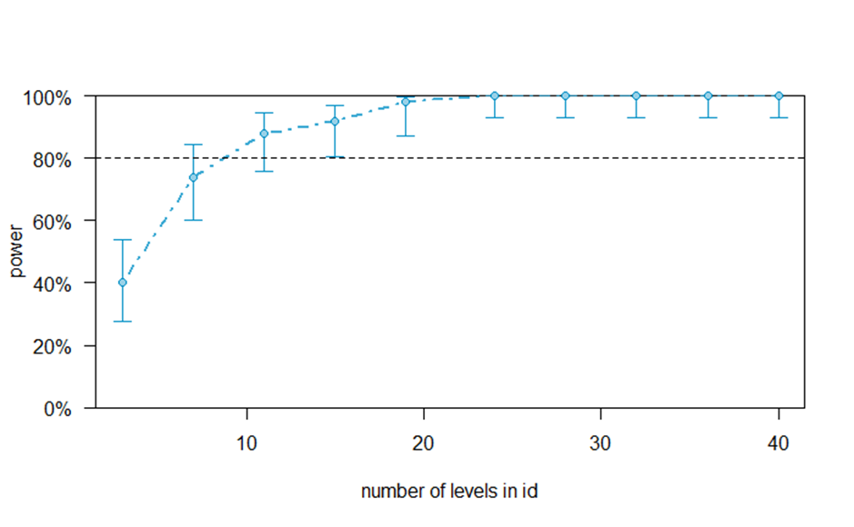

Ethical Considerations:
Informed consent from all participant using
- A detailed patient information sheet will be provided to each potential participant
- Participants will be given the opportunity to ask further questions if required
- A standardised proforma will be completed by each patient
Anonymisation of data
- Patients will not be identifiable to anyone outside of the study
- Randomisation of data will prevent the observing investigator from knowing which data set belongs to the treatment group until after unblinding.
- Any accidental, early unblinding will be documented in the data set and may be excluded from the results
Data protection
- Patient files to remain onsite / electronically at the Knudsen Clinic
- Protected access to data will only be given to study authors and observers
Financing
- This study has no direct financing.
- Clinical costs are paid by the patient for the standard surgical procedure.
- Additional financial, staff and supply costs are covered by The Knudsen Clinic.
Insurance:
- All staff involved in the surgical procedure adequate medical indemnity for their roles.
- The Knudsen has necessary public liability insurance for all staff and patients on site.
There will be strict adherence to any and all ethical guidelines and approval from the Institutional Review Board (IRB) throughout this study.

Time line:
This study aims to start recruiting patients as soon as ethical approval is granted. It is likely the collection of data will take 12-18 months before all endpoints are satisfied. At this time data processing can be finalised.

Conclusion:
This randomised controlled trial aims to provide valuable insights into the potential benefits of intra-operative Rigenera therapy in FUT hair transplant procedures. The outcomes will contribute to the evidence-based practices in the field of hair restoration surgery.

References:

Egger A, Tomic-Canic M, Tosti A. Advances in Stem Cell-Based Therapy for Hair Loss. CellR4 Repair Replace Regen Reprogram. 2020;8:e2894. Epub 2020 Sep 2. PMID: 32968692; PMCID: PMC7508456.
AlSogair, S. (2019). Stem cell therapy and hair loss: Present evidence and future perspectives. Journal of Dermatology and Dermatologic Surgery, 23(2), 61.
Bertozzi, N., Simonacci, F., Grieco, M. P., & Grignaffini, E. (2019). Autologous Micrografts From Scalp Tissue: Trichoscopic and Longitudinal Scan Evaluation in 92 Patients With Male and Female Androgenetic Alopecia. Dermatologic Surgery, 45(5), 730–737. [DOI: 10.1097/DSS.0000000000001844]
Gentile, P., Scioli, M. G., Bielli, A., Orlandi, A., & Cervelli, V. (2017). Stem Cells from Human Hair Follicles: First Mechanical Isolation for Immediate Autologous Clinical Use in Androgenetic Alopecia and Hair Loss. Stem Cell Investigation, 4, 58. [DOI: 10.21037/sci.2017.06.12]
Owczarczyk-Saczonek A, Krajewska-Włodarczyk M, Kruszewska A, Banasiak Ł, Placek W, Maksymowicz W, Wojtkiewicz J. Therapeutic Potential of Stem Cells in Follicle Regeneration. Stem Cells International 2018; 2018: 1049641. [PubMed: 30154860]
Gentile, P., Scioli, M. G., Bielli, A., De Angelis, B., De Sio, C., De Fazio, D., Ceccarelli, G., Trivisonno, A., Orlandi, A., Cervelli, V., et al. (2019). Platelet-Rich Plasma and Micrografts Enriched with Autologous Human Follicle Mesenchymal Stem Cells Improve Hair Re-Growth in Androgenetic Alopecia. Bio-molecular Pathway Analysis and Clinical Evaluation. Biomedicines, 7(2), 27.
Fukuoka, H., & Suga, H. (2019). Hair Regeneration Treatment Using Adipose-Derived Stem Cell Conditioned Medium: Follow-up With Trichograms. Plast Reconstr Surg Glob Open, 7(12 Suppl), 42–43.
Li, Z. J., Choi, H. I., Choi, D. K., Sohn, K. C., Im, M., Seo, Y. J., ... & Lee, Y. H. (2017). Autologous adipose-derived stem cell therapy for atrophic acne scars: A pilot study. Journal of Cosmetic and Laser Therapy, 19(1), 22-27
Buonocore, D., Nobile, V., Michelotti, A., & Marzatico, F. (2013). Clinical efficacy of a cosmetic treatment by Crescina((R)) human follicle stem cell on healthy males with androgenetic alo- pecia. Dermatologic Therapy (Heidelb), 3(1), 53–62.
Zhang, M., Ye, Y., Zhao, P., Bai, L., & Li, X. (2020). Preliminary studies of hair follicle regeneration by injections of epidermal stem cells and dermal papilla cells into nude mice. Cell and Tissue Banking, 21(2), 321–327.
Khatu, Swapna S., et al. "Platelet-rich plasma in androgenic alopecia: Myth or an effective tool." Journal of Cutaneous and Aesthetic Surgery 7.2 (2014): 107-110.
Tak, Y. J., Lee, S. Y., Cho, A. R., & Kim, Y. S. (2020). A randomized, double-blind, vehicle-controlled clinical study of hair regeneration using adipose-derived stem cell constituent extract in androgenetic alopecia. STEM CELLS Translational Medicine, 9(8), 839–849.
Rinaldi, Federica, et al. "A novel device for the processing of lipoaspirate: Preliminary results about fat grafting and cell isolation." BioMed Research International 2019 (2019).
Lv, M., Zhang, S., Jiang, B., Cao, S., Dong, Y., Cao, L., & Guo, S. (2021). Adipose-derived stem cells regulate metabolic homeostasis and delay ageing by promoting mitophagy. The FASEB Journal, 35(7), e21709.

