# Research title: Intermittent Phototherapy vs Continuous Phototherapy In Treating Neonatal Jaundice – A Randomized Controlled Trial

**Principal investigator: Dr Ong Jia Cheng (MMC 81023)**

**Introduction**

Jaundice is yellowish discolouration of skin and mucus membrane due to deposition of bilirubin in the soft tissue. Bilirubin is normally cleared from body by hepatic conjugation with glucuronic acid and elimination in bile in the form of bilirubin glucuronides. Neonatal jaundice can be transient and physiological due to rapid turnover of red cells and delay in conjugation. There are pathologic conditions that cause severe jaundice such as Rhesus isoimmunization, hemolytic disorder, extravasated blood and genetic disorder such as Gilbert syndrome. Phototherapy is the mainstay of treatment of neonatal jaundice. Phototherapy involves rapid photochemical reaction at skin level in nanoseconds and followed by slow migration of unbound bilirubin from the blood into the skin and undergoes photodegradation over a period of one to three hours.

# Problem statement & Study rationale

# Traditionally, we practice continuous phototherapy in treating neonatal jaundice. By understanding the mechanism of phototherapy, intermittent phototherapy should be able to reduce duration of hospitalization, hospital cost and manpower. There are various studies doing intermittent phototherapy but most are not applicable for daycare phototherapy. Our study design mimics daycare phototherapy. If results are promising, we can use the data for future daycare phototherapy where patients can be discharged with no overnight stay in hospital.

# Research Question(s)

# Can intermittent phototherapy reduce the bilirubin level effectively compared to continuous phototherapy?

# Objective

**General:** to determine the effectiveness of intermittent phototherapy in low risk neonatal jaundice babies compared with continuous phototherapy

# Specific:

# To analyze rate of decline of bilirubin per hour between 2 groups

# To analyze the mean of serum bilirubin at 24h of study between 2 groups (post phototherapy)

# To compare the rate of treatment failure among 2 groups

# Literature review

# Few studies had been done on intermittent phototherapy vs continuous phototherapy in treating neonatal jaundice. However, there was no similar study done in Malaysia. Based on Malaysia Paediatric Protocol, we stratify neonatal jaundice into three groups which are low risk, moderate risk and high risk. The risk factors include prematurity, Rhesus isoimmunization, ABO incompatibility, G6PD deficiency and sepsis. Low risk includes babies who are born 38 weeks above and well with no risk factor mentioned above. Moderate risk includes babies who are born between 35 weeks to 37 weeks 6 days and well and born above 38 weeks with risk factors. High risk includes babies who are born between 35 weeks to 37 weeks 6 days with risk factors.

# Sachdeva (2015) conducted a study titled “Intermittent versus continuous phototherapy for the treatment of neonatal non-hemolytic moderate hyperbilirubinemia in infants more than 34 weeks of gestational age: a randomized controlled trial”. Healthy late preterm (>34 weeks) and term neonates with neonatal hyperbilirubinemia under phototherapy for 8 h and total serum bilirubin (TSB) < 18 mg/dL were randomized either into intermittent (IPT) or continuous (CPT) group. Infants in IPT group received 12 h on and 12 h off cycles of phototherapy. In both arms, phototherapy was continued until TSB < 13 mg/dL. Primary outcome was rate of fall of bilirubin. Seventy-five infants (IPT n = 36 vs. CPT n = 39) were enrolled in the study. The rate of fall of bilirubin was significantly higher with “IPT” phototherapy (p = 0.002). In term and late preterm infants with non-hemolytic moderate hyperbilirubinemia, intermittent phototherapy with 12 h on and 12 h off cycles is as efficacious as continuous phototherapy. Since this study showed similar efficacy between intermittent and continuous phototherapy, thus we choose 10 hours as it mimics daycare phototherapy. If 10 hours intermittent phototherapy prove to be effective, we can practice daycare phototherapy in low-risk babies. 12 hours is too long for daycare phototherapy. From this study, it has proven that 12 hours intermittent phototherapy is as effective as continuous thus justifying the safety of using intermittent phototherapy. In our study we also checked bilirubin level after phototherapy discontinue to ensure bilirubin did not raise to dangerous level.

# This study was done with infants more than 34 weeks and they have applied 12 hours on and 12 hours off intermittent phototherapy. However, the length of intermittent phototherapy is too long to apply for daycare phototherapy and the sample is premature infants at 34 weeks. Modification to 10 hours of intermittent phototherapy in my study is to suit the settings of daycare phototherapy. My target population is only for term infants more than 38 weeks. Nevertheless, the result of this study by Sachdeva et al showed that there is same efficacy in both groups and the safety of intermittent phototherapy is ensured.

# Zhou et al (2019) conducted another study titled “Analysis of therapeutic effect of intermittent and continuous phototherapy on neonatal hemolytic jaundice”. A retrospective analysis of 307 patients with neonatal hemolytic jaundice admitted to Qilu Hospital of Shandong University (Qingdao) from January 2010 to December 2017 was undertaken. A total of 165 cases of children with continuous blue light irradiation and 142 cases of intermittent blue light irradiation were analyzed. The serum bilirubin levels, phototherapy time and frequency, treatment efficiency and adverse reaction rates were compared between the groups. Children in the phototherapy group were treated with continuous 12–18 h of blue light irradiation with a stop of 8–12 h in between. Children in the intermittent phototherapy group were treated with intermittent blue light: 3–5 h of blue light of irradiation and a stop of 2–4 h in between. The course of treatment for each group was 72 h. The overall effective rate of the continuous phototherapy group was higher than that of the intermittent phototherapy group (P>0.050). The adverse reaction rates after treatment in the continuous phototherapy group was significantly higher than the intermittent phototherapy group (P<0.050). The treatment effect of the intermittent blue light irradiation on neonatal ABO hemolytic jaundice is consistent with the continuous blue light irradiation treatment.

# The sample population is neonates with hemolytic jaundice which is not our interest group. We target low risk babies that need conventional phototherapy and applied intermittent phototherapy to them. The duration of phototherapy is given in range instead of exact duration.

# Taheritafti (2019) conducted study on neonatal jaundice titled “Comparison of Intermittent and Continuous Phototherapy to Treat Non-hemolytic Moderate Hyperbilirubinemia in Term Infants: A Randomized, Controlled Trial.” The current double blinded RCT was conducted on 60 icteric term neonates from November 2016 to June 2017. A total of 60 icteric term neonates were randomly divided into two groups. In the continuous group, the phototherapy device was turned on for 24 hours and in the intermittent phototherapy group, the phototherapy device was turned on for 18 hours (off for eight hours). The length of hospital stay was 2.3±0.60 and 2.46±0.93 days in the continuous and intermittent groups, respectively (P=0.516). The duration of phototherapy was 45.26±16.39 and 46±11.82 hours in the continuous and intermittent groups, respectively, and they had no significant differences (P=0.843). The rate of serum bilirubin cessation in the two groups was similar after 36 hours. Although the melatonin level was higher in the intermittent group than in the continuous group, the difference was not statistically significant (P=0.455). Intermittent phototherapy was as effective as continuous phototherapy to treat icteric full-term neonates.

# In this study, the intermittent phototherapy is 18 hours on with 8 hours off. Results showed that both group has no significant difference in duration of treatment and length of hospital stay. However, 18 hours is not suitable for daycare phototherapy.

# Mallanagouda (2020) conducted study titled “Continuous vs Intermittent Phototherapy in the Management of Non-Haemolytic Neonatal Hyperbilirubinemia – A Randomised Non - Inferiority Study”. Total 190 neonates who were > 34 weeks and birth weight ≥ 2000 gm were included. They were randomised into group A (continuous phototherapy) and group B (intermittent phototherapy). Group A received phototherapy for three hours and 45 minutes off and group B received phototherapy for three hours and then three hours off. TSB levels estimation were done in both groups and compared after each 12 hours, 24 hours, and 48 hours of commencing phototherapy. The mean TSB at presentation was 15.64 ± 2.19 mg/dl for continuous and 15.03 ± 1.07 mg/dl for intermittent group. Mean TSB at 12, 24, 48 hours were 13.26 ± 2.4 mg/dl, 10.8 ± 1.72 mg/dl, 10.16 ± 0.95 mg/dl respectively for continuous and 12.6 ± 1.65 mg/dl, 10.04 ± 1.8 mg/dl, 9.1 ± 0.66 mg/dl respectively for intermittent group (p < 0.05). The mean rate of fall in serum bilirubin was 0.22 ± 0.12 mg/dl/hr for group A and 0.21 ± 0.08 mg/dl/hr for group B (p =0.45). There was not much difference in mean duration of hospitalisation in both groups (p = 0.547). Intermittent phototherapy is a non-inferior option to continuous phototherapy, in the management of non-haemolytic hyperbilirubinemia with additional advantages of less interrupted mother infant bonding and decreased irradiance.

# This study showed intermittent phototherapy is as efficient as continuous phototherapy. It proves that neonates with jaundice do not require continuous phototherapy. However, the duration of intermittent phototherapy is not applicable for daycare phototherapy.

# According to American Academy of Paediatrics, infants who exceeded phototherapy threshold during birth hospitalization, received phototherapy before 48 hours of life, positive Direct Coombs test, suspected hemolytic disease should have bilirubin measured 6 to 12 hours after phototherapy discontinuation.

# In conclusion, we are looking for study that mimics daycare phototherapy. However, studies above show that the duration of intermittent therapy did not suit daycare phototherapy or the target population is not the same. The information that we can extract from the studies are the safety of intermittent phototherapy. All 4 studies showed that the efficacy is same as continuous phototherapy and no concerning regarding safety issue. We are designing a study using intermittent phototherapy that mimics daycare phototherapy. The data produced can be used for daycare phototherapy in treating patients in neonatal ward.

# Conceptual framework

Low risk babies admitted for neonatal jaundice

Comparing effectiveness between 2 groups

1. Rate of decline of bilirubin per hour
2. Mean of serum bilirubin 24 hour post phototherapy between 2 groups
3. Rate of treatment failure between 2 group

Intermittent phototherapy (intervention)

Continuous phototherapy (control)

# Research design

Randomized controlled trial

Subjects will be selected after they fulfil inclusion criteria and pass exclusion criteria. All the risk factors listed in Malaysia Paediatric Protocol such as gestational age, Rhesus status, mother’s blood group, G6PD status and ruling out sepsis must be determined before recruitment. Only babies fulfil low risk group based on Malaysia Paediatric Protocol will be considered for this trial. If this information is not complete, they will not be recruited. Consent will be taken from parents and decision to be in which group either in control group or intervention group will be based on block randomization. Timing of recruitment will be in office hour or parents are around. All participants are inpatients. Both participants and mothers are not separated unless mothers choose to leave them in ward for treatment or we do not have enough bed for mother to room in with participants.

We will use block randomization in this study by using randomizer.org. There will 37 sets of numbers. Each set contained 2 numbers which is 1 and 2. 1 is for control group and 2 is for intervention group. There will be equal number in control and intervention group. Only the participant will be blind. There is no matching. Researcher cannot be blind, however, measurement of serum bilirubin is an objective assessment.

Control group – Serum bilirubin (pre-treatment) will be taken at 0 hour and phototherapy will be started till 24 hour and serum bilirubin (post-treatment) will be taken. Results will be ready within one hour and have to be interpreted. Treatment such as discontinue phototherapy, continue conventional phototherapy or escalate to intensive phototherapy will be decided based on bilirubin level following standard treatment.

Intervention group – Serum bilirubin (pre-treatment) will be taken at 0 hour and phototherapy will be started till 10 hour and phototherapy will be discontinued. Another one bilirubin test using venous blood gas need to be done at 16 hours to ensure no rebound jaundice. This bilirubin is repeated at 6 hours after phototherapy discontinuation according to American Academy of Paediatrics. Results will be need to be interpreted immediately. If the level of bilirubin from blood gas reaches phototherapy level either require conventional or intensive phototherapy, then this study will be discontinued and subjects will be given standard treatment based on the bilirubin. If they do not require phototherapy, at 24 hours of study, serum bilirubin (post-treatment) will be taken to decide whether phototherapy is to be restarted. Results will be ready within one hour and have to be interpreted. Treatment such as discontinue phototherapy, continue conventional phototherapy or escalate to intensive phototherapy will be decided based on bilirubin level following standard treatment.

All subjects recruited into the study is inpatient. The duration of this study in both groups is 24 hours.

All subjects will be using the same phototherapy machine - The Niscomed Bistos LED Phototherapy System.

Bilirubin sample will be sent to Chemical Laboratory HUSM and be ran as standard sample.

# Study area

Hospital USM Neonatal Ward

# Study population

# Babies admitted to neonatal Wad for phototherapy

# Subject criteria

Inclusion criteria :

1. All babies admitted to Wad Nilam 2 and Wad 1 Timur Belakang for phototherapy
2. Bilirubin level must be below 50 µmol/L from the phototherapy level based on hours of life
3. Age must be more than 24 hours of life but less than 2 weeks of life
4. Gestational age more than 38 weeks
5. Birth weight more than 2.5kg
6. Low risk babies

Exclusion criteria :

1. Severe jaundice requiring intensive phototherapy
2. Had risk factors such as ABO incompatibility, G6PD deficiency, clinical sepsis, Rhesus isoimmunization and clinical sepsis
3. Syndromic babies

Withdrawal criteria :

1. Babies develop second medical problem such as sepsis, dehydration
2. Serum bilirubin level requires intensive phototherapy

# Sample size estimation

# Sample size calculation is based on objective no.2.

# For objective 1, sample size is calculated based on study done by Patil et al (3) with the largest standard deviation of 2.04 with expected difference of 1.5. The sample size based on Ariffin sample size calculator (9) is total 68 with 34 in each group including 10% dropout rate.

# 

For objective no. 2, there is no effect size measured in published paper. G*Power was used to calculate the sample size as we use mixed factorial ANOVA. Effect size of 0.3 (median effect size) is based on expert opinion.

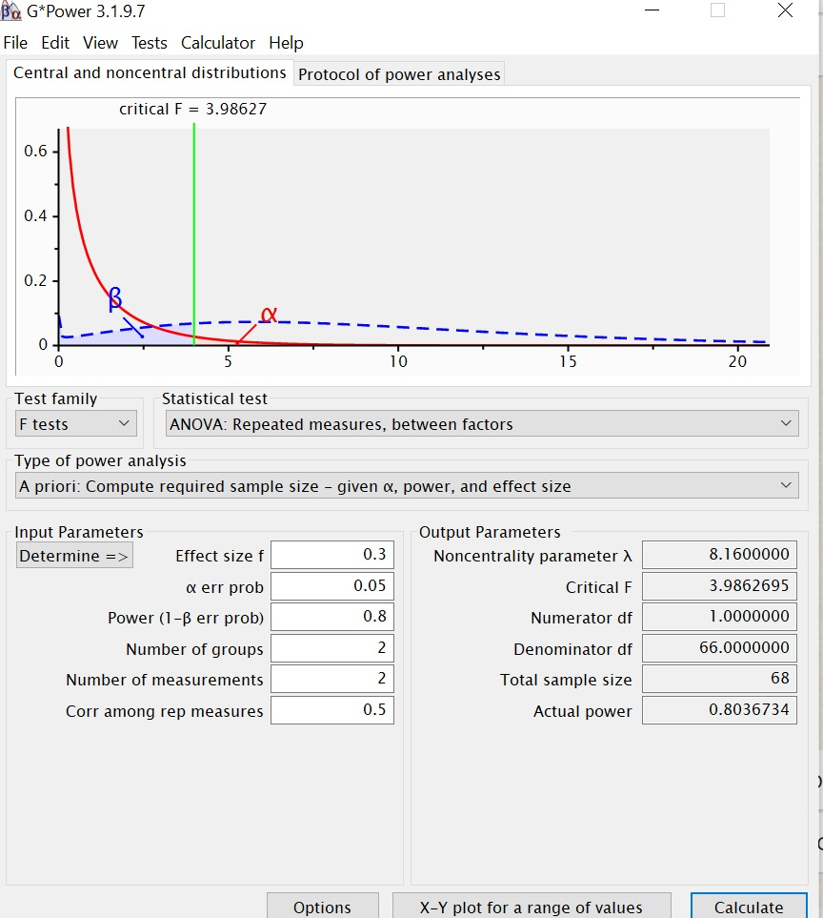

For objective no.3, sample size is not estimated because no literature reported significant difference between two intervention groups in the failure rate. In the present study researcher would expect no difference between two intervention groups on failure rate which indicate that intermittent phototherapy is competent as continuous phototherapy.

In statistics, sample size is estimated to ensure the study has sufficient power to detect the significant difference between comparison groups. Hence, sample size estimation is not done for this objective.

In summary the total sample size needed for this study is 74 based on objective 2 (37 for intervention and 37 for control).

# Research tool

1. Phototherapy machine - The Niscomed Bistos LED Phototherapy System
2. Serum bilirubin – Chemical laboratory Hospital USM

# Operational definition

1. Intermittent phototherapy – phototherapy will be commenced for 10 hours and then off for 16 hours
2. Continuous phototherapy – phototherapy will be commenced for 24 hours
3. Age – 24 hours of life till 2 weeks of life
4. Bilirubin level : must be below 50 µmol/L from the phototherapy level based on hours of life
5. Treatment failure : Require another cycle of phototherapy after 24 hours

# Data collection method

There were 2 groups – control and intervention group. In control group, blood taking need to be done at 0 hour and 24 hour of study to measure serum bilirubin level as part of standard care. In intervention group, blood taking need to be done at 0 hour, 16 hour and 24 hour of study to measure the serum bilirubin level. There is only one extra blood taking at 16 hour compared to standard treatment. Blood taken will be sent to Chemical Laboratory HUSM for processing and result will be traced from Laboratory Information System website.

# Study flowchart

|  |  |  |  |
| --- | --- | --- | --- |
| Control group | 0 hour serum bilirubin |  | 24 hour serum bilirubin |
|  | Phototherapy 24 hours | | |
| Intervention group | 0 hour serum bilirubin | 16 hour serum bilirubin | 24 hour serum bilirubin |
|  | Phototherapy 10 hours | |  |

# Data analysis

## Data will be entered and analysed using SPSS version *27*.

## Descriptive statistics will be used to summarise the socio-demographic characteristics of subjects which are age on admission, gestational age and gender.

## Statistical analysis for each subjective

## 1. To analyze rate of decline of bilirubin per hour between 2 groups – independent T test

## 2. To analyze the mean of serum bilirubin at 24h of study (post phototherapy) between 2 groups – mixed factorial ANOVA

## 3. To compare the rate of treatment failure between 2 groups – chi-square test

# Expected result(s)

|  |  |  |
| --- | --- | --- |
| **Dummy table for sociodemographic** | N | % |
| Age on admission (day) |  |  |
| Gestational age (weeks) |  |  |
| Gender |  |  |

**Result**

|  |  |  |  |
| --- | --- | --- | --- |
| Group | Serum bilirubin (Mean) | | |
|  | 0 hour | 16 hour | 24 hour |
| Control |  |  |  |
| Intervention |  |  |  |

|  |  |
| --- | --- |
| Group | Rate of fall of serum bilirubin per hour (Mean) |
| Control |  |
| Intervention |  |

|  |  |  |  |
| --- | --- | --- | --- |
| Treatment failure | | | |
| Group | N (%) | | |
|  | Intensive phototherapy | Conventional phototherapy | No need phototherapy |
| Control |  |  |  |
| Intervention |  |  |  |

**Objective 1**

|  |  |  |
| --- | --- | --- |
| Independent T test | | |
|  | Mean rate of fall of serum bilirubin | Standard deviation |
| Control |  |  |
| Intervention |  |  |

**Objective 2**

|  |  |  |  |  |
| --- | --- | --- | --- | --- |
| Mixed factorial ANOVA | | | | |
| Variable | Group | Mean | Test effect | P value |
|  |  | Post phototherapy bilirubin |  |  |
| Bilirubin | Intermittent phototherapy |  |  |  |
|  | Continuous phototherapy |  |  |  |

**Objective 3**

|  |  |  |  |  |
| --- | --- | --- | --- | --- |
| Variable | (N) | | Chi square | p value |
|  | Control | Intervention |  |  |
| No need phototherapy |  |  |  |  |
| Require  phototherapy |  |  |  |  |

# Gantt chart & milestone

|  |  |  |  |  |  |
| --- | --- | --- | --- | --- | --- |
| **Project activities** | **October 2023 – December 2023** | **Jan 2024 –**  **December 2024** | **Jan 2025 – March 2025** | **April 2025 - June 2025** | **July 2025** |
| Proposal presentation and ethics application |  |  |  |  |  |
| Data collection |  |  |  |  |  |
| Data analysis and interpretation |  |  |  |  |  |
| Report writing |  |  |  |  |  |
| Thesis submission |  |  |  |  |  |

# Budget proposal [If applicable]:

Not applicable

# Ethical consideration(s) [if applicable]:

**1. Subject vulnerability**

Subjects are neonates thus they are in the vulnerable group where they have no capability to give consent. Consent will be taken from parents. Standard treatment will be given if parents refused to participate in the study.

For subject safety, all subjects selected are from low risk group and serum bilirubin is less than 308umol/L on admission. Vital sign, BIND score and bilirubin was taken at 16 hours to ensure intervention group did not have rebound severe jaundice.

Another one ethical consideration is that there is one extra blood taking in the intervention group. This is inevitable as we need to monitor the bilirubin after phototherapy was off to ensure no rebound jaundice among the intervention groups as part of subject safety.

# 2. Declaration of absence of conflict of interest

The researchers are part of the managing team for the babies. Babies will receive the optimal therapy regardless of their parents decision whether to join the study or not. No payment or benefits that will be received by research team in this study.

1. **Data Protection**

**All participants’ data will be kept anonymous and only be reviewed by research team only. Data will be kept in laptop protected by password.**

# Privacy and confidentiality

All forms are anonymous and will be entered into SPSS software. Only research team members can access the data. Data will be presented as grouped data and will not identify the responders individually. Data will be kept for record only for team members to access.

# Community sensitivities and benefits

Benefit of this study can be applied if proven effectiveness of intermittent phototherapy. We can apply the concept to carry out daycare phototherapy.

# Honorarium and incentives

No honorarium and incentives will be given to parents

# Other ethical review board approval [if applicable]

Not applicable

# References

1. Sachdeva, M., Murki, S., Oleti, T. P., & Kandraju, H. (2015). Intermittent versus continuous phototherapy for the treatment of neonatal non-hemolytic moderate hyperbilirubinemia in infants more than 34 weeks of gestational age: a randomized controlled trial. European Journal of Pediatrics, 174(2), 177–181. <https://doi.org/10.1007/s00431-014-2373-8>
2. Taheritafti, R. (2020). Comparison of Intermittent and Continuous Photother-apy to Treat Non-hemolytic Moderate Hyperbilirubine-mia in Term Infants: A Randomized, Controlled Trial. Biomedical Journal of Scientific & Technical Research, 24(2). <https://doi.org/10.26717/BJSTR.2020.24.004017>
3. Patil, M. M., S, G. G., Bijapure, H. R., Sajjan, A. K., Kalyanshettar, S. S., & Patil, S. v. (2020). Continuous vs Intermittent Phototherapy in the Management of Non-Haemolytic Neonatal Hyperbilirubinemia - A Randomised Non - Inferiority Study. Journal of Nepal Paediatric Society, 40(3), 185–189. <https://doi.org/10.3126/jnps.v40i3.29535>
4. McDonagh AF (1983) Mechanism of action of phototherapy. In: Levine RL, Maisels MJ (eds) Hyperbilirubinaemia in the newborn. Report of the eighty-fifth Ross Conference on Pediatric Research. Ross Laboratory, Columbus, pp 47–53
5. Eggert, L. D., Pollary, R. A., Folland, D. S., & Jung, A. L. (1985). Home phototherapy treatment of neonatal jaundice. *Pediatrics*, *76*(4), 579–584
6. Maisels, M. J., & McDonagh, A. F. (2008). Phototherapy for Neonatal Jaundice. New England Journal of Medicine, 358(9), 920–928. <https://doi.org/10.1056/NEJMct0708376>
7. Arnold, C., Tyson, J. E., Pedroza, C., Carlo, W. A., Stevenson, D. K., Wong, R., Dempsey, A., Khan, A., Fonseca, R., Wyckoff, M., Moreira, A., & Lasky, R. (2020). Cycled Phototherapy Dose-Finding Study for Extremely Low-Birth-Weight Infants. JAMA Pediatrics, 174(7), 649. <https://doi.org/10.1001/jamapediatrics.2020.0559>
8. Zhou, S., Wu, X., Ma, A., Zhang, M., & Liu, Y. (2019). Analysis of therapeutic effect of intermittent and continuous phototherapy on neonatal hemolytic jaundice. Experimental and Therapeutic Medicine. <https://doi.org/10.3892/etm.2019.7432>
9. Arifin, W. N. (2024). Sample size calculator (web). Retrieved from <http://wnarifin.github.io>