# Participant Information and Consent Form

|  |  |
| --- | --- |
| Short **Name of Project** | Niagara Massage Pad Therapeutic Study |
| Full Name of Project | The effect of Niagara® Cycloid® action on legs with chronic oedema/lymphoedema following treatment for cancer |
| Principal Investigator | Professor Neil Piller |
| Project Sponsor | Niagara® CT Health Care |
| Site Name | Flinders University |

### What am I being invited to do?

We, Lymphoedema Clinical Research Unit, invite you to take part in a project that is testing the impact of daily 30 minutes cycloid vibration therapy (CVT) delivered by a massage pad (Niagara® Cycloid®) over 3 weeks on leg lymphoedema (developed following cancer treatment). You have been invited to take part because you have been diagnosed with chronic oedema/lymphoedema arising from the treatment of cancer.

Around 30 will take part in this project. They will be from areas in South Australia.

Please read this information and feel free to ask any questions. You can take some time to make up your mind and decide if this project is right for you. You can also talk to someone you trust, like a family member, friend, or your local doctor.

### What is the purpose of this project?

In this project we will use CVT, a form of massage, therapeutically using a three-dimensional, low frequency vibration generated by a special electromechanical oscillator in a massage pad (Niagara® Cycloid®). The energy wave is created using a specialised 3-dimensional vibration motor and suspension systems. When a device that produces cycloid vibration is applied externally to the skin, it non-invasively penetrates deeply into the human body.

Human studies have shown that this vibration can increase venous and arterial blood flow and the movement of interstitial fluid in participants with lymphoedema (swelling caused by abnormal accumulation of lymph fluid). This increased local area blood flow may assist in the reduction of lymphoedema, musculoskeletal pain and improve joint mobility. In turn, improving quality of life and general wellbeing.

Fluid retention or oedema (collection of fluid in the spaces between cells of the body) occurs when fluid isn’t removed from the tissues. Lymphoedema can occur following cancer treatment when the lymphatic system is damaged through node removal as occurs with cancer surgery or damage as occurs with radiotherapy. This can have substantial negative effects on quality of life, impaired limb function, pain and skin changes.

There are limited studies with scientific rigour available on the effect of CVT on leg lymphoedema. This study aims to investigate the response of leg blood flow, extracellular fluid/limb volume and skin moisture level and integrity changes to CVT applied to the lower back, thigh and calf muscle of people with leg lymphoedema developed following cancer treatment. The treatment will be self-delivered at home, 30 minutes a day, over 3 weeks.

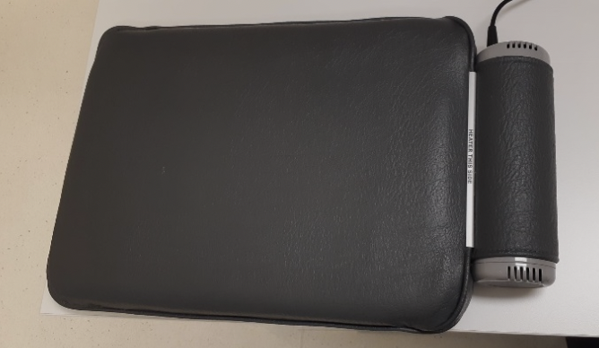

The Niagara® Cycloid massage pad is a portable device that delivers cycloid vibration externally to the skin. It is a TGA-approved medical device, class IIa (ARTG 151788) for therapeutic massage.

The device has been tested and approved for the treatment of lymphoedema (accumulation of protein rich fluid in the interstitium). All Niagara® products are listed on the Australian Register of Therapeutic Goods (ARTG) and manufactured to the highest standards.

More detailed information can be found on: https://www.niagara.com.au/products/portable-equipment/



### Do I have to take part and can I change my mind?

**Taking part is up to you**

You get to decide whether you take part in this project. You can say yes or no.

Your decision won’t affect your relationship with your doctor or your regular lymphoedema therapist or clinic that you frequent. If you don’t take part, your doctor will discuss other options with you.

**You can change your mind at any time**

If you do take part, you can stop at any time. If you want to stop, please tell someone in our project team. You do not have to tell us the reason.

Once you stop taking part, we will not collect any more information about you. We will keep the information we have already collected to make sure the results of the project can be measured properly.

**The project might stop for other reasons**

We might need to stop the project while you are taking part. If this happens, we will explain the reasons to you.

We may also ask you to stop taking part in the project if it is no longer in your best interest. If this happens, we will discuss this with you.



### What do I have to do if I take part?

If you take part in this project, you will be in it for 17 weeks.

This table below outlines what you need to do in this project. For more information, please ask a member of our project team.

If you choose to participate, you will be assessed for your suitability for the trial at a screening appointment at the Lymphoedema Clinical Research Unit (LCRU) at the Flinders Centre for Innovation in Cancer (FCIC) building, Bedford Park. If suitable, you will enter the trial and will be randomly entered to treatment (Niagara® Cycloid massage pad) or control (your normal lymphoedema care routine) group. After your 4-week follow-up period, you will be crossed over into the other group from which you were firstly assigned (i.e. control group will cross over to the treatment group).

|  |  |
| --- | --- |
| **What part of the project?** | **What do I have to do?** |
| Consenting to take part in this project | If you are happy to take part in this project, you will be asked to sign a consent form.  This will occur at the start of your **screening appointment** at our clinic.  It will take approximately take 2 hours. |
| When you start the project | If you qualify at the screening appointment, you will be notified and come in for a **baseline appointment**.  You will have baseline measurements and be instructed on the home use of the massage pad.  It will approximately take 3 hours. |
| When you start treatment | After your baseline appointment, you will take home the massage pad and use it daily for 30 minutes, (10 minutes each in three locations; lower back, upper leg and lower leg) using the set minimum frequency).  You will be asked to rest supine for 15 mins prior to starting each treatment, most suitably on a bed.  You will perform 5 cycles of deep breathing before and after the massage pad use. |
| During the project | After screening and baseline appointments, you will have the following measurement visits for each group (treatment and control):  • **Day 1 or Day 2** (phone call; allow 30 minutes)  • **Day 4** (in clinic)  • **1 week** (in clinic)  • **2 weeks** (in clinic)  • **3 weeks** (in clinic)  • **2 weeks Follow-up** (in clinic)  • **4 weeks Follow-up** (in clinic)  It will approximately take 2-3 hours at each clinic appointment. |
| At the end of the project | You will be able to keep the Niagara® Cycloid massage pad and continue self-treatments at home, if you wish. |

The clinic measurements taken are as follows; they are non-invasive, carry no risks and are measurements normally conducted in our clinic:

• Perometry: this measures the circumference and volume of the legs. It involves sitting in a chair and resting the leg in a horizontal position whilst the leg is scanned by a square frame, which takes measurements at every 3 millimetres. Procedure takes less than 2 minutes.

• Bioimpedence: this measures how much fluid is in the leg tissue. It involves standing on an electronic machine (like scales) and holding two handles in the hands for less than 2 minutes.

• Blood flow: using standard laser doppler equipment used in all vascular clinics, measuring arterial, venous and skin blood flow.

• Moisture meter: this measures the moisture content in the skin using a portable device that tests the bioelectric impedance of the skin. It passes a painless and safe electrical current through the skin measuring how long the current takes to travel from one sensor to the other. Your skin’s moisture level is determined by this time.

• Indurometer: measure the skin integrity using a portable device that measures how hard the tissue is (tissue’s resistance to compression). It is a painless measure of induration of the skin and upper subcutis noninvasively.

You will also be asked to complete a Symptom Scale (10-point Likert) questionnaire rating 10 symptoms commonly associated with limb swelling such as tightness, heaviness, cramps, skin dryness burning feelings etc using a 10 point Likert scale. (1 = no problem or issue to 10 = worst imaginable problem or issue). As well as a Quality of Life questionnaire (LYMQL);

This is a validated instrument to measure the impact of leg lymphoedema on a patient’s quality of life.

You will be asked to give unstructured, open-ended feedback at the Day1 or Day 2 phone call and at the end of using the massage pad for 3 weeks.

Schedule of assessments taken:

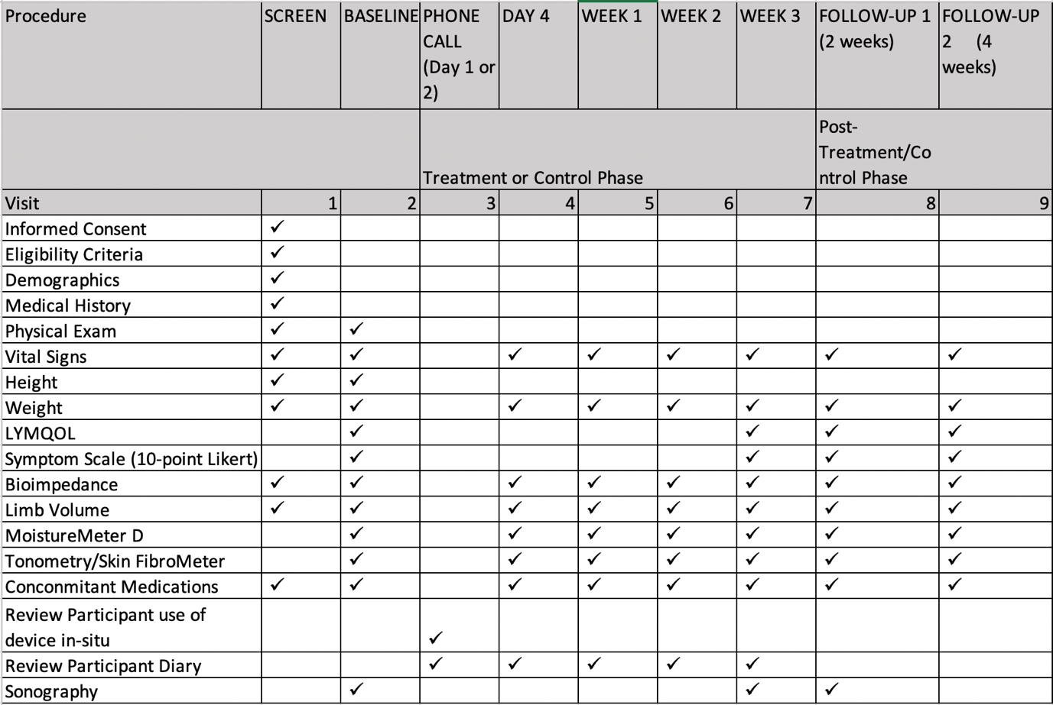

*crossover to other group*

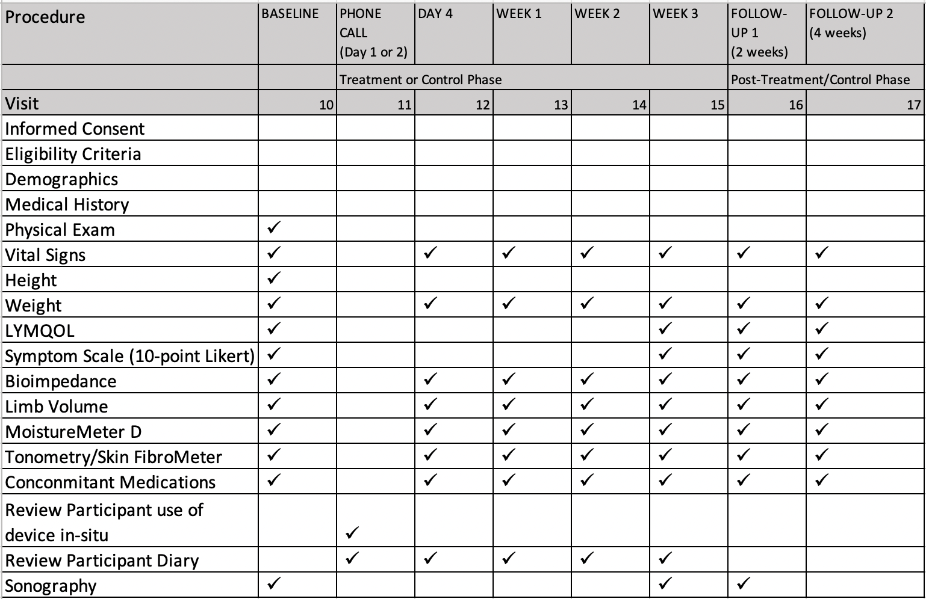

Payment for your time and expenses

You will need to spend time taking part in this project. To recognise your time, we will offer you the Niagara® Cycloid massage pad at the end of the trial.

We will reimburse you for some of your out-of-pocket expenses while you are taking part in this project. We will reimburse you for parking and a light meal voucher for each clinic appointment (total value of $160). A pre-paid parking ticket (Care Park at FMC) and a $10 gift voucher for a light meal or drink at a local café (FMC Volliecare - volunteer service cafes), will be provided at each clinic appointment.

### What are the benefits of taking part?

You may or may not directly benefit from taking part in this project. It is possible but unknown whether CVT will improve your leg lymphoedema symptoms.

We cannot guarantee you will receive any benefits from this research. However, possible benefits from treatment may include a reduced circumference/extracellular fluid in the treatment leg. You may experience reduced feelings of limb heaviness and a general state of reduced muscle tension, often seen following a massage.

By taking part, you will help the researchers understand more about the effects of CVT on leg lymphoedema and be a part of a study with scientific rigour in this area. This knowledge may help people in the future.

### What are the risks and discomforts of taking part?

There are no risks to you from taking part in this project.

There are no anticipated risks or disadvantages with taking part in this research. As you are required to lie down on a bed for up to 30 minutes per day over three weeks, any conditions that prevent doing this comfortably will prevent you from taking part in this study. You will not be able to take part if you are pregnant, have a cardiac pacemaker or large metal plates in your body due to these conditions being exclusion criteria to having measurement on our bioimpedance equipment. Damage to the skin, like from wounds/infections, can impair our ability to obtain accurate measures from clinic equipment, and are therefore also exclusions for taking part.

There is a risk the quality of life questionnaire (LYMQL) may cause distress. Counselling will be provided if required; support service contact details will be provided ( e.g. Lifeline Australia ph: 131114; Beyond Blue ph: 1300224636).

You should talk to a doctor urgently if you start to feel unwell during this project.

### If I take part, what will happen to my information?

**Collecting your information**

We will collect information for the project directly from you.

**Keeping your information safe**

To keep your information safe, we will:

follow all relevant privacy requirements

keep it securely locked at FCIC, Flinders University and on a password-protected electronic database

take steps to prevent anyone from accessing information that identifies you unless they need to, for example, to check it in an audit

give it a code and keep it separate from anything that could easily identify you, like your name or contact information.

You can ask us to tell you what information we have collected about you as part of this project. If your information is not correct, you can also ask us to change it.

We will keep your information for 5 years. After this, we will destroy it.

**Sharing your information with others**

Data may be published or presented at scientific meetings, but you will never be identified.

### Who is running and paying for this project?

This project is being run by Flinders University.

This project is being funded by Niagara® CT Health Care.



### Who has approved this project?

The Southern Adelaide Clinical HREC has approved this project. This committee makes sure that this project meets Australian ethical standards for research that involves people.

**Complaints about how this project is being run**

If you have any complaints about how this project is being run, please contact:

Name: Southern Adelaide Local Health Network

Role: Manager, Research Governance and Ethics

Telephone: 8204 6453

Email: Health.SALHNOfficeforResearch@sa.gov.au



### What happens if something goes wrong?

In an emergency, you should call 000 or go to the emergency department at your nearest hospital. If your injury is not urgent, you should contact us. We can help you organise medical care.

The sponsor of this project has agreed to follow the compensation process set out in the Medical Technology Association of Australia’s ‘Guidelines for Compensation for Injury Resulting from Participation in a Company-Sponsored Clinical Trial’.

Under these Guidelines, you should be compensated for significant injuries you get from taking part in this project. The sponsor will decide whether to pay compensation to you and how much you will get. You may also be able to take action through the courts.

### Where can I find more information?

Thank you for taking the time to read this information about our project. You can contact a member of the project team at any time to ask questions.

Name: Professor Neil Piller

Role: Director, Lymphoedema Clinical Research Unit

Telephone: 08 8204 4711

Email: neil.piller@flinders.edu.au

Name: Marielle Esplin

Role: Clinical Research Officer, Lymphoedema Clinical Research Unit

Telephone: 08 8204 4903

Mobile: 0438 357 622

Email: LCRU@flinders.edu.au

# Signature Page

|  |  |
| --- | --- |
| Short **Name of Project** | Niagara Therapeutic Study |
| Full Name of Project | The effect of Niagara® Cycloid® action on legs with chronic oedema/lymphoedema following treatment for cancer |
| Principal Investigator | Professor Neil Piller |
| Project sponsor | Niagara® CT Health Care |
| Site Name | Flinders University |

|  |
| --- |
| **Consent to take part in this project** |
| By signing this consent form, I acknowledge that:  I freely agree to take part in this project  I understand that I can stop taking part in the project at any time  I have read, or have had read to me, the information provided about this project and understand what is involved  I have had the opportunity to consider the information, ask questions and am satisfied with the answers I received |

Yes or No I would like to receive a copy of my results. (please tick relevant box)

**Person taking part in the project**

Signature: ______________________________________________ Date: ______________

Name: _________________________________________________

**Person conducting the informed consent discussion**

I have explained the research project, its procedures and risks to the participant and I believe they have understood that explanation.

Signature: ______________________________________________ Date: ______________

Name: __________________________________

**Witness**

Signature: ______________________________________________ Date: ______________

Name: __________________________________

Each person must sign and personally date this consent form