Items to be fixed before Steps 11/12 deployment on 22 May 2024
- Update video link for step 11 to https://vimeo.com/944289120
- Update data item definitions doc – Admin to provide doc, please replace current document that appears at this link:
https://www.anzctr.org.au/docs/ANZCTR%20Data%20field%20explanation.pdf
- Check issue with opening basic results document links in Step 12 – looks to be mapped to a local/UAT drive (D: drive?) - occurring on public and user views, for studies with pre-existing documents that have been mapped
383560 and 378016
Basic results summary downloads not working, get one of these error pages when clicking on the basic results attachment link:
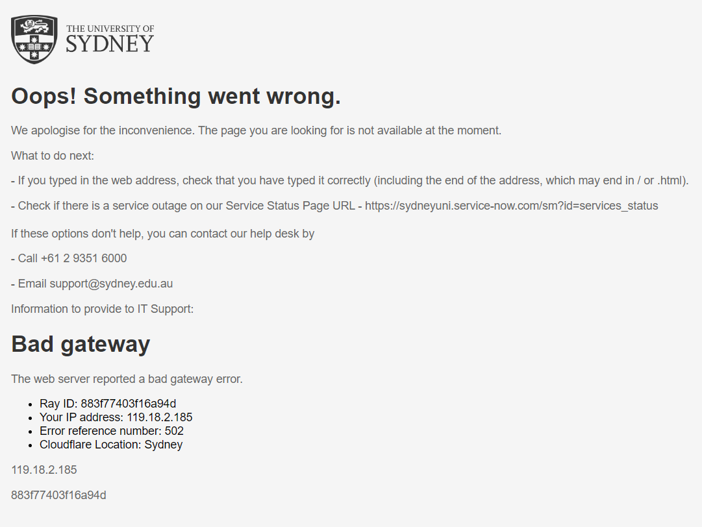
However, the migration aspect seems to have worked ok, see uat:
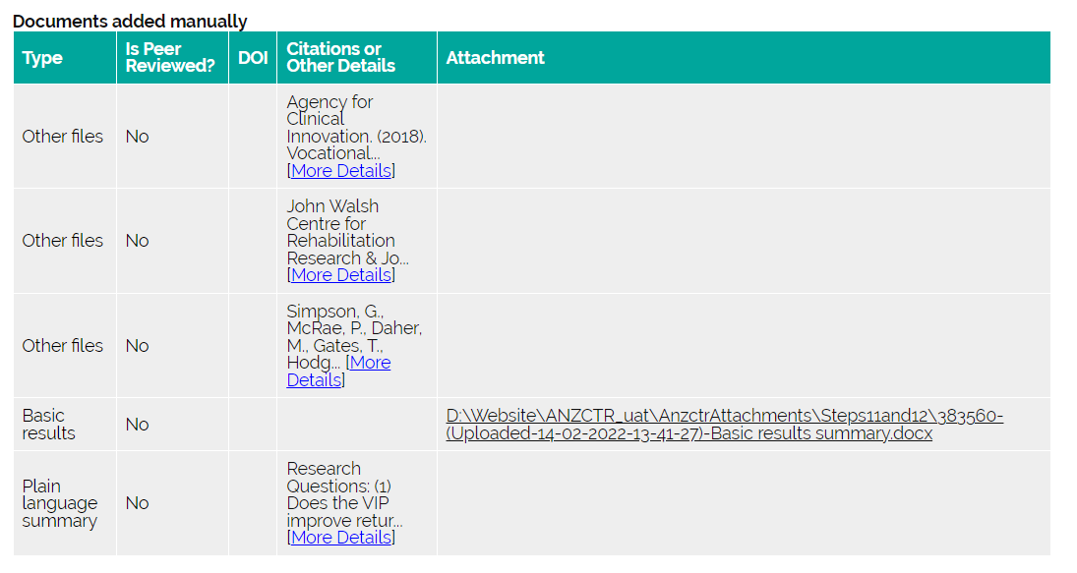
Compared to live:
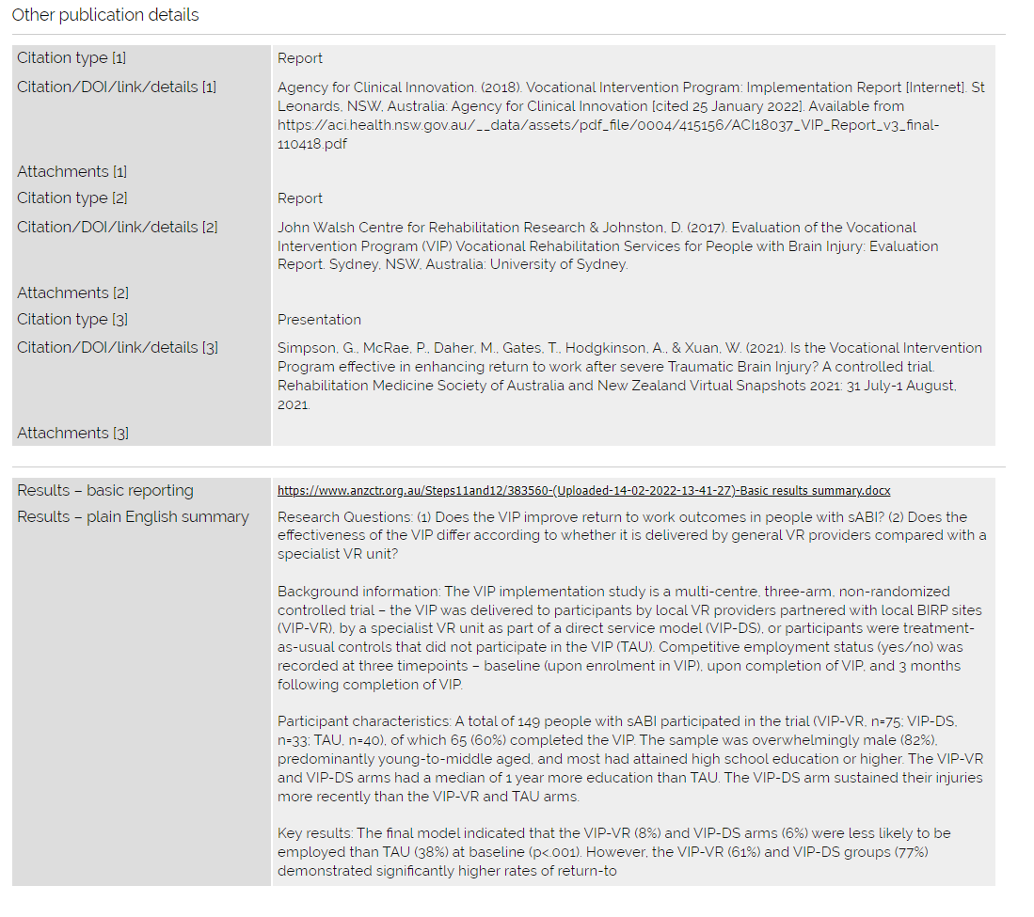

- Query email missing Step 11/12 queries when sent to user – preview email on admin side shows all queries, but then actual email received by user is missing random Step 11 or Step 12 queries. Note this was a different behaviour across different request IDs, i.e., sometimes Step 12 queries were missing and other times Step 11 queries were missing. Examples above (308241 – missing queries for both, 364913- missing queries for Step 12).
308241
Have updated step 11 and 12 for this record:
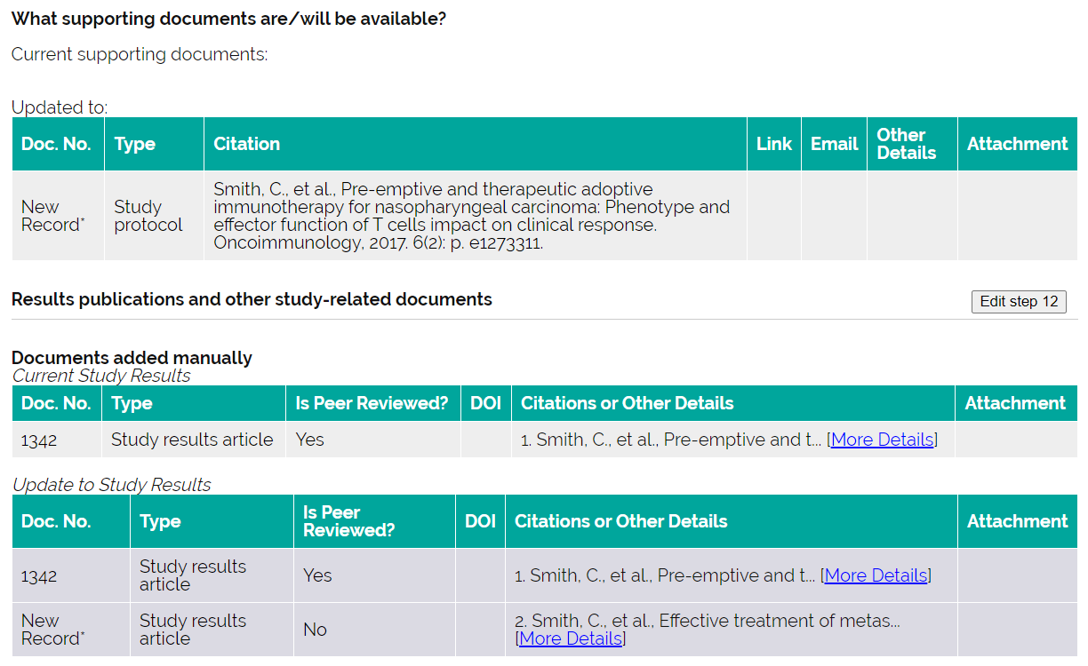
Query email being sent: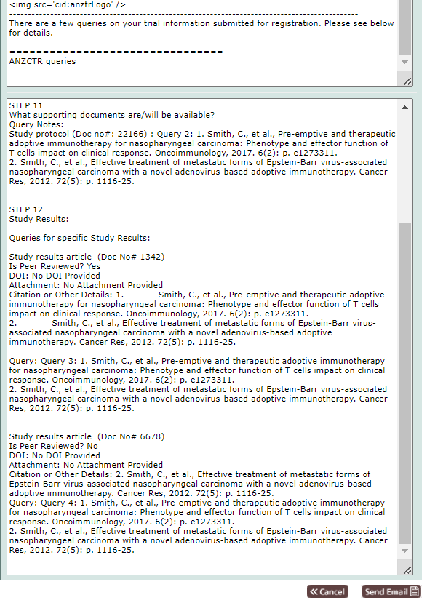

In the email that was sent to the registrant, this query email is missing both step 11 and 12 queries?
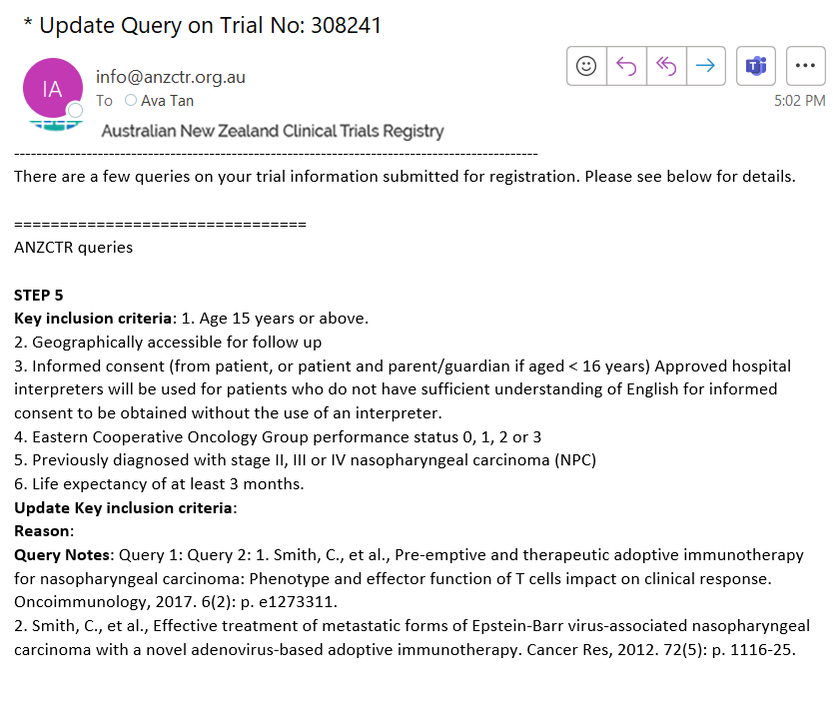
Query email sent to registrant is missing step 12 queries: 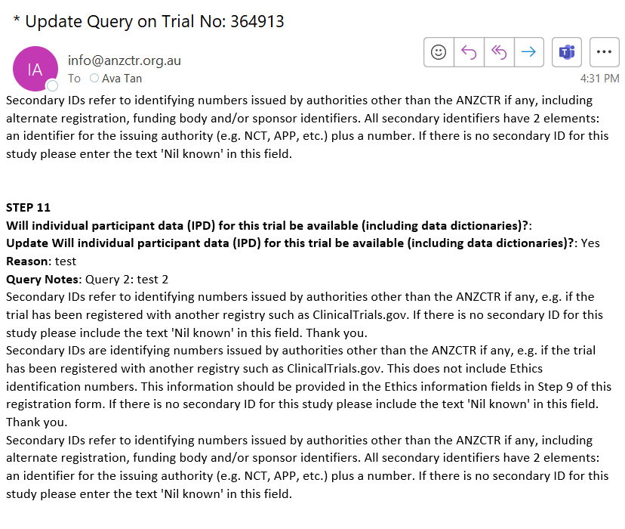 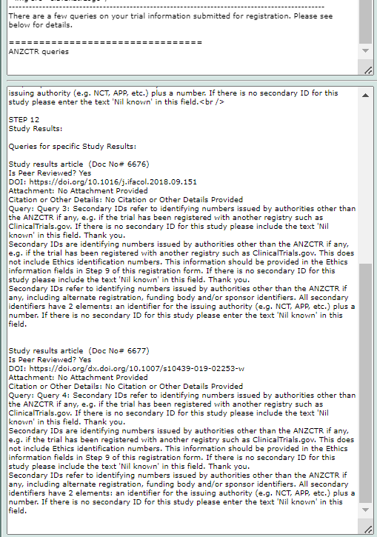
82711
Admin side looks fine – have forced queries so I can update the other sections of the form BUT the email seems to include ‘empty’ Step 12 query
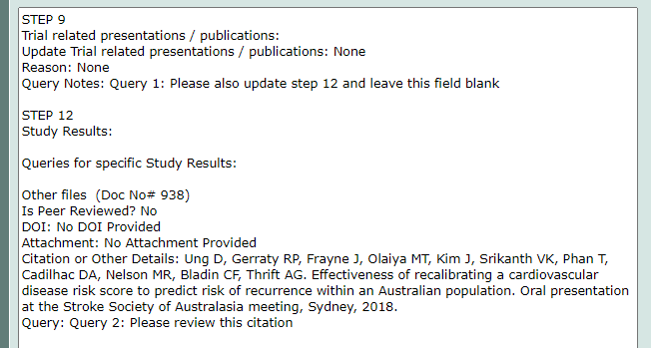
Especially when I didn’t add a query for the step 12 table
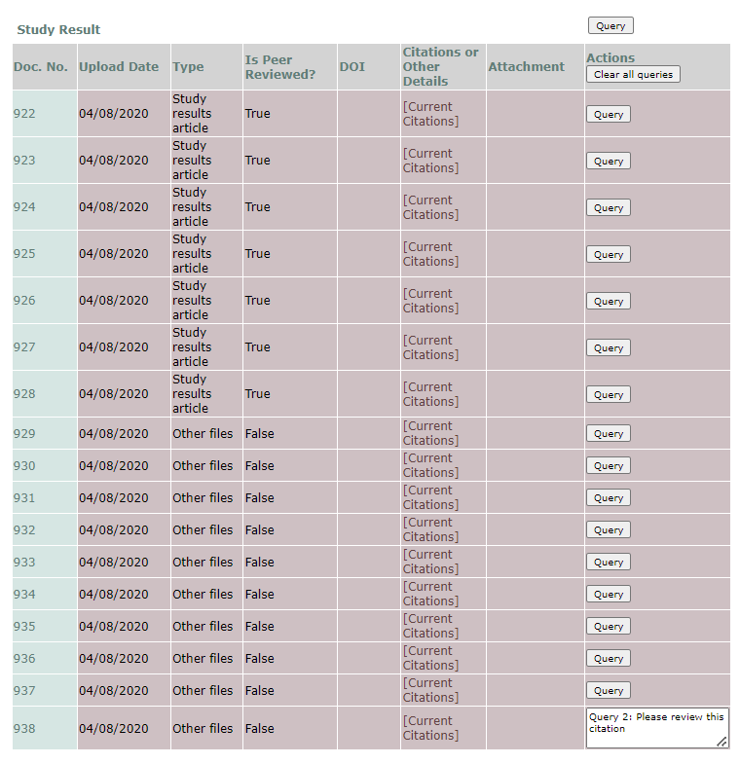
AND the actual email only displays the first query:
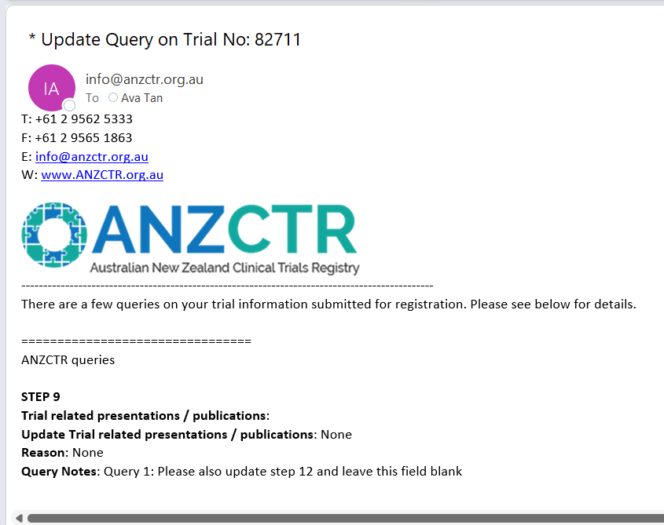
- Removal of red warning notice on step 11 page:
https://uat.anzctr.org.au/Trial/Result/ResultsReporting_Update.aspx?id=369653
