Effects of Immersive Virtual Reality Therapy on Intravenous Patient Controlled Sedation During Orthopedic Surgery Under Regional Anesthesia
Authors:
- Mark Huang, MD, Department of Anesthesia and Acute Pain Medicine, St. Vincent’s Hospital Melbourne.
  - This author is the primary author, did all data collection and analysis, and wrote the first draft of the paper
- Peter Y Chan, BSc, MBBS, FCICM. Department of Intensive Care Medicine, Eastern Health, Melbourne
  - This author is the final author, supervisor of project, responsible for experimental design and data analysis, and re-wrote the manuscript
- Simon Scharf, MBBS, FANZCA. Department of Anesthesia and Acute Pain Medicine, St. Vincent’s Hospital Melbourne.
  - This author is the supervising anesthesiologist, responsible for manuscript editing and finishing, and protocol design.
Corresponding Author:
Dr. Peter Chan BSc MBBS FCICM
Department of Intensive Care Medicine
Box Hill Hospital
8 Arnold Street
Box Hill VIC
Australia 3128

Phone: +61 3 83968227
Email: peter.chan@easternhealth.org.au
Financial Disclosures: Funded by St. Vincent’s Hospital Research Endowment Fund
Conflicts of Interest: None
Word Count: Abstract: 222 Manuscript: 3774
Abbreviated Title: Virtual Reality and Patient Controlled Sedation in Regional Anesthesia

Key Points
Question: Does Immersive Virtual Reality reduce the self administered propofol sedation requirements of patients receiving joint replacement under regional anesthesia?
Findings: There was no reduction in self administered propofol sedation in individuals receiving Immersive Virtual Reality compared to individuals receiving conventional care when receiving joint replacement.
Meaning: It is unlikely that IVR therapy will demonstrate any significant reduction in sedation requirements without a larger, higher powered trial in specific patient subpopulations and personalized software, and the effect, if it exists, is likely to be very small.

Effects of Immersive Virtual Reality Therapy on Intravenous Patient Controlled Sedation During Orthopedic Surgery Under Regional Anesthesia

Mark Huang, Simon Scharf, and Peter Chan

Department of Anesthesia and Acute Pain Medicine

St Vincent’s Hospital

Melbourne, Australia

Abstract

Objective: To assess the effect of providing Immersive Virtual Reality (IVR) Therapy on the self-administered sedation requirements of patients undergoing joint replacement surgery under regional anesthesia in a single center.
Design, setting, and participants: Single center, randomized control trial at St Vincent’s Hospital in Melbourne, Australia. Fifty patients undergoing elective knee and hip replacement surgery were randomized to IVR and patient controlled propofol sedation or patient controlled propofol sedation alone.
Main Outcome Measure: Mean propofol usage per hour.
Results: 25 patients received IVR in conjunction with propofol patient controlled sedation (PCS), and 25 patients received PCS alone. All patients received adjunct analgesia from the treating Anesthesiologist. Mean propofol use/hour over the entire procedure in the control group was 53.46 ± 9.71 mg/hour compared with 52.33 ± 9.91 mg/hour in the IVR group (p = 0.94, mean difference 1.12, 95 CI -26.7-29.03). There were no differences in patterns of propofol use over the course of each procedure. Postoperative satisfaction scores were equivalent in both groups. The VR intervention was well tolerated by all patients, with no report of major side effects. Post-hoc analysis showed an association of propofol usage with position of patient, pre-procedure emotion score, and fentanyl use.
Conclusions: In patients receiving joint replacement surgery under regional anesthesia with PCS, IVR was well tolerated but did not decrease the overall sedation requirement.

Key words: Virtual reality, VR, distraction, sedation, joint replacement surgery

Introduction

Immersive virtual reality (IVR) is a form of distraction therapy, used as early as 2003 as an analgesia and sedation sparing agent (1) and has shown potential in the management of wound care, physical therapy, or anxiety-provoking procedures (2-5) A typical IVR setup utilizes a head-mounted display (HMD) projecting an interactive, computer-generated environment with accompanying auditory stimuli, enhanced by head-tracking technology.

A pilot study of IVR using the Oculus Rift Virtual Reality Goggles (Oculus Inc, California, USA) as an adjunct during joint surgery under regional anesthesia showed promise as a sedation sparing agent (6). This study demonstrated a statistically significant reduction in sedation requirements, with average propofol use of 155mg/hour and 260mg average total use in non-IVR patients, and average 63 mg/hr and 102mg average total use in IVR patients (6). These findings were limited by small numbers of participants. Further, the absence of blinding allowed selection bias and created the potential for anesthesiologists to unwittingly administer less propofol to the IVR group. Nonetheless, the study demonstrated the potential for a sedation sparing effect and provided the basis for a larger, well designed, adequately powered study.

There have been several other studies that demonstrate a sedation or analgesic sparing effect of IVR (7-11). Further efforts have also been made to commercialize IVR, with little high quality evidence of effectiveness (12). These projects suffer from the same limitations (6), namely small numbers and a heterogeneous population, poor blinding, and little bias control (13).

Patient controlled sedation (PCS) has been reported as early as 2013 to confer benefits during regional anesthesia (14), specifically allowing patients to control their own depth of sedation to ensure comfort without increasing complications. Ekin et al. reported the successful use of PCS during joint replacement surgery using 400 mcg/kg bolus and a 5 minute lockout, demonstrating a mean usage of 133 mg of propofol over the duration of a procedure in thirty patients. (14). A recent review demonstrated the safety and efficacy of PCS, with a reduced the risk of rescue interventions for sedation-related adverse events (15)
The current study aimed to address the limitations of recent studies, and better assess the potential sedation-sparing effect of IVR by combining it with PCS. Providing patients with control over sedation would theoretically minimize bias created by Anesthesiologist initiated sedation. It was hypothesized that IVR would reduce patient sedative requirement, lower patient anxiety and maintain equivalent or greater patient satisfaction.

Method

This study was a prospective, randomized controlled trial conducted at St Vincent’s Hospital Melbourne, Australia, and was approved by the St Vincent’s Hospital Research and Ethics Committee (HREC Approval LRR 142/15). Written and informed consent was obtained from all participants. This manuscript adheres to the Equator guidelines of the Consolidated Standards of Reporting Trials (16). The clinical trial was registered prior to patient enrolment,

All patients undergoing elective knee or hip joint replacement surgery under regional anesthesia were eligible for enrolment. Inclusion criteria were English-speaking patients 18 years of age with and over no significant cardiovascular or respiratory disease. Exclusion criteria were patients receiving general anesthesia, cognitive impairment preventing the use of subjective outcome surveys, visual or hearing impairment and non-English speaking patients. Enrolled patients were randomized to the IVR or control group by computer generated randomization, with the process blocked every 5 patients.

After insertion of an intravenous cannula and attachment of a crystalloid infusion, regional anesthesia for all patients was performed by the Anesthesiologist. Patients were positioned in the upright position for spinal blocks and in the supine position for femoral and popliteal blocks. After local anaesthetic with 1% lidocaine at the L3-L4 interspace, between 2.8 and 3.4 ml of 0.5% Bupivacaine was injected into the subarachnoid space. For knee replacements, a popliteal nerve block was administered using 20ml of 0.2% ropivicaine and a femoral nerve catheters were inserted, with the patient receiving 20ml of 0.375% ropivicaine. Sensory and motor block was determined by pinprick and by attempting to elicit spontaneous movement of lower limbs.

At the discretion of the Anesthesiologist, some patients also received either midazolam or fentanyl in this pre-operative period, either to tolerate the anesthetic procedure or to manage pre-operative anxiety. All patients received 5 minutely blood pressure, and continuous heart rate and oxygen saturation monitoring via a Philips MX800 Monitor (Koninklijke Philips, Netherlands) throughout before and during the procedure.

The IVR group received IVR using one of two available HMD setups including noise-cancelling headphones. The control group received no distraction and did not wear any HMD or headphones. Both groups were able to control their intra-operative sedation using propofol via a patient-controlled sedation (PCS) button with an Alaris pump and PCA module (BD, Franklin Lakes, New Jersey, USA), with instruction to use it whenever they felt too aware or anxious. Each press of the PCS supplied a propofol bolus of 400mcg/kg Ideal Body Weight with a 5 minute lockout period. To prevent unwanted hypotension documented in previous studies (14) and on the advice from Anesthesiologists reviewing the study protocol, an upper limit of 30mg per bolus was put in place as an additional safeguard. Anesthesiologists were advised that PCS should be the primary form of sedation, but were not limited in giving additional sedation or analgesia if required in their clinical judgement. PCS and IVR if allocated were initiated in the operating room following spinal anesthetic, transfer to operating table and patient positioning, but before the beginning of the surgery. PCS and IVR were ceased once the procedure was complete.

The primary outcome was the mean intra-operative propofol use, with the amount used and procedure duration recorded from the PCS machine after surgery. Secondary outcome measures included usage of propofol over time, the amount of adjuvant midazolam or fentanyl used before and during the case, the overall unmet propofol demand, and postoperative patient satisfaction scores.

Patient experience was assessed using a modified Quality of Recovery Survey (QoR-40) (17). The QoR-40 includes questions regarding patient comfort, emotional state, symptoms and pain rated on a 1-5 scale, where 1 means “never” and 5 means “all the time”. A modified version of the QoR-40 was used (Appendix 1), and was employed before and after surgery. In addition, subjects were asked if they were satisfied with their experience, and if they would be willing to undergo future invasive surgeries using IVR.

IVR simulation used
The IVR environment was provided by either a Samsung Gear VR HMD (Samsung, Korea) or the Oculus Rift Development Kit 2 (Oculus Inc, California USA) HMDs. Both HMDs feature a large field of view and high quality display; the Gear VR with a 96 degree field of view and 1280 x 1440 pixel resolution per eye; and the DK2 with a 100 degree field of view and 960 x 1080 pixel resolution per eye. In addition, both HMDs block the user’s view of their immediate environment.

The Gear VR setup was powered by a Samsung Galaxy S6 phone (Samsung, Korea), running the freely available IVR software EdenRiver v1.0 by Unello Design (Unello Design, Texas, USA). This software allowed subjects to float along a procedurally generated three-dimensional river. The DK2 setup was powered by an MSI GS60-2QE gaming laptop (MSI Inc, Taiwan) running a custom-designed version of the software “Iceland” by Gert-Jan Werburg at VergeVR Inc (VergeVR, Netherlands) (18). This software was modelled after the University of Washington software Snow World (19), and allowed subjects to travel through a landscapes of an Arctic tundra. Both software were chosen as they provided a continuous “ride” experience, taking the user through the virtual environment without any need for directing travel. Both setups included noise-cancelling headphones playing background sound from the IVR simulation and classical music from the Hush Collection Volume 13 by the Tasmanian Symphony Orchestra (Hush Foundation, Victoria, Australia) provided with permission by Dr. Catherine Crock, pediatrician at the Royal Children’s Hospital, Melbourne.

Statistical Analysis
Data were analyzed by intention to treat. Baseline variables including demographic and case data between treatment groups were compared despite randomization, given the relatively small sample size. Propofol use was compared using a one-way ANOVA comparing means. Fisher’s Exact test and the Mann Whitney U test were used for the comparison of categorical and continuous non-parametric variables respectively. Continuous data are presented as means with standard error or medians with interquartile range. Independent association between the measured variables and propofol use was assessed using the Mann Whitney U-test for categorical variables (including pre-procedure QoR-40 scores), and Pearson’s correlation coefficient for continuous variables. QoR-40 score changes from pre- to post-procedure were compared using the Mann Whitney U test.

Post-hoc negative binomial regression was employed to assess for potential confounders, however, relatively small sample size permitted adjustment for only one covariate in the final model. Each covariate was evaluated individually for its confounding effect on the relationship between treatment group and propofol use, with the largest confounder selected for the final model.

For all comparisons, a two-sided p-value of <0.05 was used for statistical significance. Statistical analysis was performed using SPSS v20 (IBM, Armonk, NY)

Sample Size
The pilot study previously trialling the use of the Oculus Rift as a non-pharmacological adjunct to sedation in during elective joint replacement surgery estimated that to achieve a power of 80% with a difference in means of 91 mg/hour, a sample size of 22 in each group would be required. To allow for a potential 10% attrition rate, 25 patients per group were recruited.

Results
A total of 134 patients were approached for this study between February and June 2016, of which 64 patients were enrolled to participate (Figure 1). Of these, 12 patients were later excluded as they required a general anesthetic for unforeseen reasons, including difficulty performing spinal anesthesia, inadequate effect from spinal anesthesia and failure to cease anticoagulant medication thus contraindicating spinal anesthesia. A further two patients were excluded after being deemed inappropriate for PCS by the treating Anesthesiologist for other reasons. The remaining 50 patients were randomized to the control or IVR group, with 25 patients in each group. Of the 25 patients randomized to IVR, 16 (65%) utilized the HMD to the end of the procedure. Four patients (16%) used it for more than 80 minutes, 4 (16%) used it for between 15-45 minutes, and one patient (4%) did not tolerate it at all. Reasons included discomfort, finding the VR software boring, and disliking the chosen software. The one patient who did not tolerate the IVR at all complained of worsening nausea that was present prior to the procedure. No other adverse outcomes were reported.

Baseline demographics and case characteristics of both groups are listed in Table 1. The median age in the IVR group was younger by 5 years (p = 0.03). Gender, height, weight and BMI did not differ significantly across the two groups. The cases included 20 total knee joint replacements, 23 total hip joint replacements, five anterior total hip joint replacements, one hip hemiarthroplasty and one patellofemoral replacement. Case distribution, patient positioning and case duration was similar between the two groups.

A summary of propofol use can be seen in Table 2. Mean propofol use/hour over the entire procedure in the control group was 53.5 ± 9.7 mg/hour compared with 52.3 ± 9.9 mg/hour in the IVR group (mean difference 1.1, 95 CI -26.7-29.0 p = 0.94). The total average use in the control and IVR groups was 107.8 ± 22.7 mg and 108.0 ± 22.8 mg respectively (p = .995, mean difference -0.2, CI -62.1-61.7). There was no significant difference in mean propofol use between the control and intervention arms at any time point. This is illustrated in Figure 2. The number of presses for propofol that were requested during the lockout period of the PCS was also recorded and was identical in both cases (p = 0.66) The median number of unmet requests over the course of the entire case was 0 in both control and intervention arms (p = 0.61, IQR 0-4).

When excluding patients who removed the goggles early, mean propofol use was in the IVR group was 40.5 ± 11.4 mg/hour compared to 53.5 ± 9.7 mg/hour in the control group (mean difference 13.0, 95 CI -17.7 – 43.7, p = 0.40). The total average use in the control and IVR groups was 107.8 ± 22.7 mg and 92.4 ± 31.0 mg respectively (p = 0.67, mean difference 15.4, CI -61.1-91.9).

Midazolam and fentanyl administration during the procedures are listed in Table 3. The mean fentanyl use in the IVR group and the control group over the course of the entire procedure was 23.2 ± 6.5 mcg and 41 ± 7.2 mcg respectively (p = 0.07). The mean midazolam use in the IVR group and the control group over the procedure was 1.9 ± 0.3 mg and 2.4 ± 0.3 mg respectively (p = 0.13).

To determine potential confounders of the relationship between IVR and propofol use, univariate analysis was undertaken for independent association with propofol use, as listed in Table 4. Greater propofol use was associated with increase in weight and BMI (p = 0.06, p = 0.04 respectively) and higher pre-procedure Emotion-B (negative emotion) score (p = 0.02). Higher intra-operative fentanyl dose (p = 0.07), and procedures in the lateral position (p = 0.06) were also included given they approached significance and there was a mechanistic probability in their ability to confound. Each covariate was adjusted for individually in a negative binomial regression model with IVR, which identified intra-operative fentanyl use as having the largest impact. Following adjustment for these confounders, a negative binomial regression model demonstrated a non-significant result of the VR group using 26% less propofol compared with the control group (CI -74% – 111%). The final model adjusted for fentanyl use alone, and again found no significant difference in propofol use between the two treatment groups, though with subjects in the VR group using 22% less propofol (CI -72% – 113%).

The median change in subjective scores from the QoR-40 is listed in the supplemental material. There was no significant difference in changes of comfort score, emotion score, symptom score, emotion-B score (negative emotion) or pain score from before to after surgery. There was a non-significant trend towards a decrease in confusion score in the control group, with 3 patients reporting a decrease, while all patients in the IVR group reported no change (p = 0.07). The median overall QoR-40 score change was -7 in both groups.

Additional questions regarding patient satisfaction found that all patients in both treatment groups were satisfied with their experience. All but one patient using IVR distraction would use it again. The one patient who would not use IVR again found use of the HMD to be “claustrophobic” but still reported satisfaction with trying the experience. The majority of comments from patients were positive, including “It helped take my mind off the surgery”, “It was very relaxing”, “I felt like I was in a beautiful place” and “I really enjoyed that”. Other comments indicated patients wanted more choice in IVR experience, “It was fantastic, though a bit boring” and “It was a little repetitive, I wanted to try more”.

No major adverse outcomes were reported that were directly attributable to the IVR. There was one episode of nausea that was pre-existing before institution of IVR that necessitated removal of the goggles. There were no documented episodes of hypotension, bradycardia, or injection site pain associated with the administration of PCS.

Discussion

The current study aimed to address the limitations of recent IVR studies, by attempting to eliminate the anesthesiologist as a source of potential bias by combining IVR with PCS. There was no significant difference in patient-controlled propofol use during joint replacement surgery under regional anesthesia when using IVR compared with no distraction. IVR did not affect the pattern of propofol use, with no significant difference observed in propofol use during the first, second, and third hours of the procedures. There was no difference in the administration of anxiolytic or analgesic agents between the two groups. QoR-40 scores found no difference in patient satisfaction between treatment groups.

In our previous study, where Anesthesiologists controlled the amount of sedation given, the mean propofol use was 155 ± 45 mg/hr in the routine care group. This compares to 53.5 mg ± 9.7 mg/hr in this study, where the sedation was patient controlled. Ekin et al (14) equally reported lower doses of self administered propofol in their study compared to our pilot study. As a whole, this suggests that the lower sedation doses in the IVR group seen in the pilot study was not the result of IVR, but a lower overall sedation requirement than what was administered as a routine by the anesthesiologist. As propofol was delivered as a weight based dose, the number of demands per patient was also examined, and there was no difference in demands between the two groups. In both cases, the median unmet demand was zero, suggesting that the sedation administered was adequate to maintain patient comfort.

Post-hoc analysis of propofol usage demonstrated a number of other factors influencing propofol requirements independent of IVR use. Weight/BMI, an increased preoperative fentanyl requirement, pre-procedure anxiety, and procedures in the lateral position all had p values approaching significance. While increased requirements with larger patients was expected and accounted for using a weight-based bolus dose, the other factors were unanticipated. The increased sedation required in patients with a pre-procedure anxiety score and higher fentanyl requirements most likely represent the same subset of stressed and uncomfortable patients requiring more pharmacological intervention. Future studies may benefit from targeting these patients specifically.

There was a trend approaching significance towards more total midazolam and fentanyl use in the IVR group, with the bulk being given pre-procedure. While these results could be due to chance, there is the possibility that this was the result of the non-blinded nature of this study, where the anesthesiologist could still control some element of the patient’s sedation and instinctively gave more midazolam and fentanyl to the IVR group. This could then potentially explain the apparent reduction in propofol usage when correcting for fentanyl use using negative binomial regression. The effect of this pre-medication on the sedation requirement of the patient is itself unknown – the mean pre-procedure midazolam and fentanyl doses were between 1 and 2 mg and 20 - 30 mcg respectively, and these effects may have largely worn off over the course of a procedure generally over 2 hours in length. Equally, the intraoperative dose of fentanyl in either group rarely exceeded 10 mcg and its overall influence is unclear.

In this study, 9 of the 25 patients randomized to the IVR arm removed the goggles early and suggests that not every patient remains engaged with the IVR for the entire duration of the procedure. The inclusion of these patients in the analysis may have reduced the ability to discern a treatment effect. As such, the mean propofol dose was calculated amongst only the patients who used IVR for the entirety of the procedure. The mean propofol use per hour and mean total propofol use in this cohort, while less than that when all patients were included, was still nonsignificant.

Given an effective treatment failure of 36%, the addition of more engaging content may be needed in order to demonstrate a potential effect. While the chosen software was generally well-received, some patients become bored and sought more engaging options. A limitation of both Iceland and Eden River was that they could become repetitive, with a number of patients commenting that increasing the selection of content would have improved their experience. At the time of this study, the selection of IVR software was limited, as many options were often still in early development, or were games requiring a gamepad or significant head movements, neither of which are appropriate during a surgical procedure. A number of IVR studies have utilised the Snow World software by the University of Washington (19), which allows some interaction with the virtual environment in the form of throwing of virtual snowballs at passing objects. This may allow greater engagement with the virtual environment, with greater engagement postulated to have a greater analgesic effect (20). Providing personalized or more engaging software, however, would pose challenges, given every patient may have different preferences in what they find engaging, and would add to the complexity of administering IVR in a busy surgical environment.

By chance, patients in the IVR group were younger than those in the control group. Given older patients may require lower doses of propofol (21) it is possible that the skew towards in a younger age group in the IVR group is responsible for some of the absence of a treatment effect.

It should also be noted that almost half of the patients approached for this study declined, and preferred to have analgesia and sedation managed by the Anesthesiologist without IVR. These patients tended to cite anxiety over the upcoming procedure as a reason for declining to participate. It is unknown how these more anxious patients might have responded to IVR compared to the cohort that agreed to the trial, or how their inclusion might have affected postoperative satisfaction scores.

The Quality of Recovery was also the same between the two groups, with both reflecting an improvement in subjective symptoms. This suggests that in addition to having no role in reducing the pharmacological demands of patients, IVR did not result in any subjective benefit to patients.

Conclusion

This study demonstrates that it is feasible to implement IVR without much difficulty in a busy operating theatre. Given the lack of significant treatment effect, it may not be worth the effort in doing so. As with the trial of any new intervention with a small sample size, care must be made not to overinterpret preliminary findings, and to be wary of potential sources of bias. This study reflects this, and does not support the hypothesis that IVR confers a sedation sparing effect on patients receiving joint replacement surgery under regional anesthesia. There appear to be many factors that have greater influence on sedation requirements over any effect of IVR, including the use of adjunctive pharmacological agents, the type of surgery, and pre-existing patient anxiety.

An IVR treatment benefit may potentially exist by selecting patients with higher sedation requirements, namely younger patients with higher pre-procedure anxiety. Testing this hypothesis, however, would also most likely require more personalized and engaging content in order to keep the IVR engaged for the duration of the procedure. A much larger study targeting this smaller subset of individuals, while also controlling for confounders such as patient positioning and the use of adjunctive pharmacological agents, would also likely be necessary to show any benefit of IVR. This benefit, should it exist, would likely be much smaller than that demonstrated with Anesthesiologist administered sedation (6).

Conflicts of interest
This study was supported financially from the St Vincent’s Research Endowment Fund. Oculus VR did not contribute in any way to the design, collection of results, and data analysis.

Acknowledgements
Many thanks to Vijaya Sundararajan and Sara Vogrin who performed the statistical analysis, Gert van-Werburg of VergeVR (vergevr.com) who allowed use and created a specifically modified version of his Iceland software for use in this trial, and Cathy Crock for allowing the use of her musical compilation.

References

- Hoffman HG Patterson DR, Carrougher GJ, Sharar SR. Effectiveness of Virtual Reality-Based Pain Control with Multiple Treatments. Clin J Pain. 2001. 17(3): p. 229-35.
- van Twillert B, Bremer M, Faber AW. Computer-Generated Virtual Reality to Control Pain and Anxiety in Pediatric and Adult Burn Patients During Wound Dressing Changes. J Burn Care Res. 2007. 28(5): p. 694-702.
- Furman E, Jasinevicius TR, Bissada NF, Victoroff KZ, Skillicorn R, Buchner M. Virtual Reality Distraction for Pain Control During Periodontal Scaling and Root Planing Procedures. The Journal of the American Dental Association, 2009. 140(12): p. 1508-16.
- Maani CV, Hoffman HG, Morrow M, Maiers A, Gaylord K, McGhee LL, DeSocio PA. Virtual Reality Pain Control During Burn Wound Debridement of Combat-Related Burn Injuries Using Robot-Like Arm Mounted VR goggles. J Trauma. 2011. 71(1 Suppl): p. S125-30.
- Gershon J, Zimand E, Pickering M, Rothbaum BO, Hodges L. A Pilot and Feasibility Study of Virtual Reality as a Distraction For Children With Cancer. J Am Acad Child Adolesc Psychiatry. 2004. 43(10): p. 1243-9.
- Chan P, Scharf S. Virtual Reality as an Adjunctive Non-Pharmacological Sedative During Orthopedic Surgery under Regional Anesthesia: A Pilot and Feasibility Study. Anesth Analg. 2017 Oct;125(4):1200-1202.
- Tanja-Dijkstra K, Pahl S, White MP, Auvray M, Stone RJ, Andrade J, May J1, Mills I, Moles DR. The Soothing Sea: A Virtual Coastal Walk Can Reduce Experienced and Recollected Pain. Environ Behav. 2018 Jul;50(6):599-625.
- Pourmand A, Davis S, Marchak A, Whiteside T, Sikka N. Virtual Reality as a Clinical Tool for Pain Management. Curr Pain Headache Rep. 2018 Jun 15;22(8):53.
- Piskorz J, Czub M. Effectiveness of a Virtual Reality Intervention to Minimize Pediatric Stress and Pain Intensity During Venipuncture. J Spec Pediatr Nurs. 2018 Jan;23(1).
- McSherry T, Atterbury M, Gartner S, Helmold E, Searles DM, Schulman C. Randomized, Crossover Study of Immersive Virtual Reality to Decrease Opioid Use During Painful Wound Care Procedures in Adults. J Burn Care Res. 2018 Feb 20;39(2):278-285.
- Pandya PG, Kim TE, Howard SK, Stary E, Leng JC, Hunter OO, Mariano ER. Virtual Reality Distraction Decreases Routine Intravenous Sedation and Procedure-Related Pain During Preoperative Adductor Canal Catheter Insertion: A Retrospective Study. Korean J Anesthesiol. 2017 Aug;70(4):439-445.
- AppliedVr. Available at: http://www.appliedvr.io Accessed July 20, 2018
- Indovina P, Barone D, Gallo L, Chirico A, De Pietro G, Antonio G. Virtual Reality as a Distraction Intervention to Relieve Pain and Distress During Medical Procedures: A Comprehensive Literature Review. Clin J Pain. 2018 Feb 26. [Epub ahead of print]
- Ekin A, Donmez F, Taspinar V, Dikmen B. Patient-Controlled Sedation in Orthopedic Surgery Under Regional Anesthesia: A New Approach in Procedural Sedation. Braz J Anesthesiol. 2013 Sep-Oct;63(5):410-4.
- Kreienbühl L, Elia N, Pfeil-Beun E, Walder B, Tramèr MR. Patient-Controlled Versus Clinician-Controlled Sedation With Propofol: Systematic Review and Meta-analysis With Trial Sequential Analyses. Anesth Analg. 2018 May 9.. [Epub ahead of print]
- Schulz KF, Altman D, Moher D and the CONSORT Group. CONSORT 2010 Statement: Updated Guidelines for Reporting Parallel Group Randomised Trials. BMC Medicine. 2010 8:18.
- Myles PS. Measuring Quality of Recovery in Perioperative Clinical Trials. Curr Opin Anaesthesiol. 2018 Aug;31(4):396-401.
- Werburg, G.-j. VergeVR Inc. [cited 2016 June 1s]; Available from: http://www.vergevr.com/.
- Hoffman HG, Chambers GT, Meyer WJ 3rd, Arceneaux LL, Russell WJ, Seibel EJ, Richards TL, Sharar SR, Patterson DR. Virtual reality as an Adjunctive Non-Pharmacologic Analgesic for Acute Burn Pain During Medical Procedures. Ann Behav Med. 2011 Apr;41(2):183-91.
- Das DA, Grimmer KA, Sparnon AL, McRae SE, Thomas BH. The Efficacy of Playing a Virtual Reality Game in Modulating Pain for Children with Acute Burn Injuries: A Randomized Controlled Trial. BMC Pediatr. 2005;5:1.
- Patanwala AE, Christich AC, Jasiak KD, Edwards CJ, Phan H, Snyder EM. Age-Related Differences in Propofol Dosing for Procedural Sedation in the Emergency Department. J Emerg Med. 2013 Apr;44(4):823-8.

Figure 1: Patient recruitment, allocation and analysis

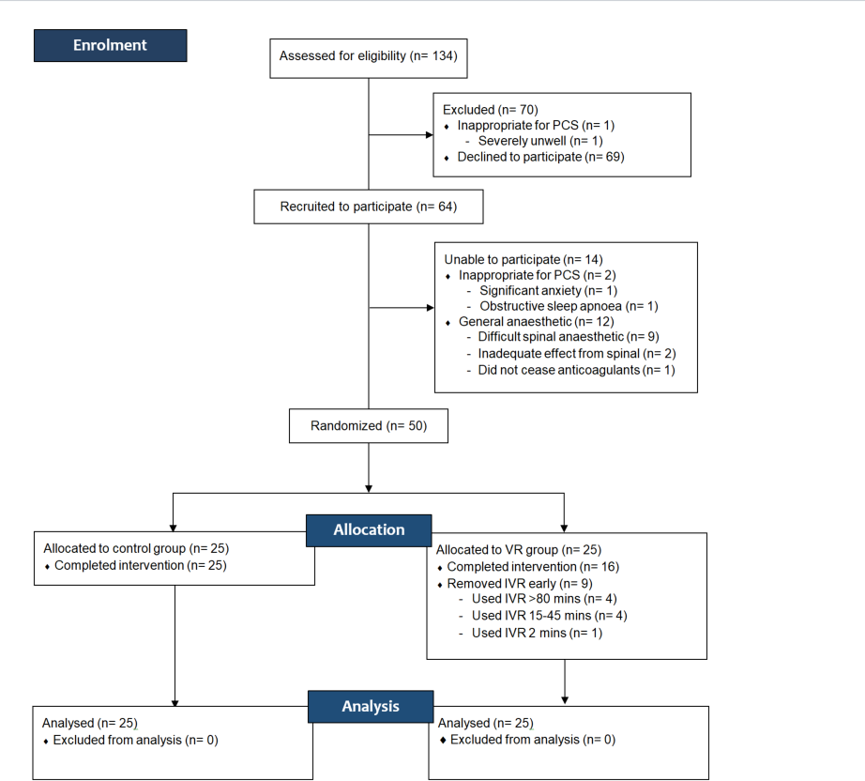

Figure 2: Mean Propofol use and distribution over time
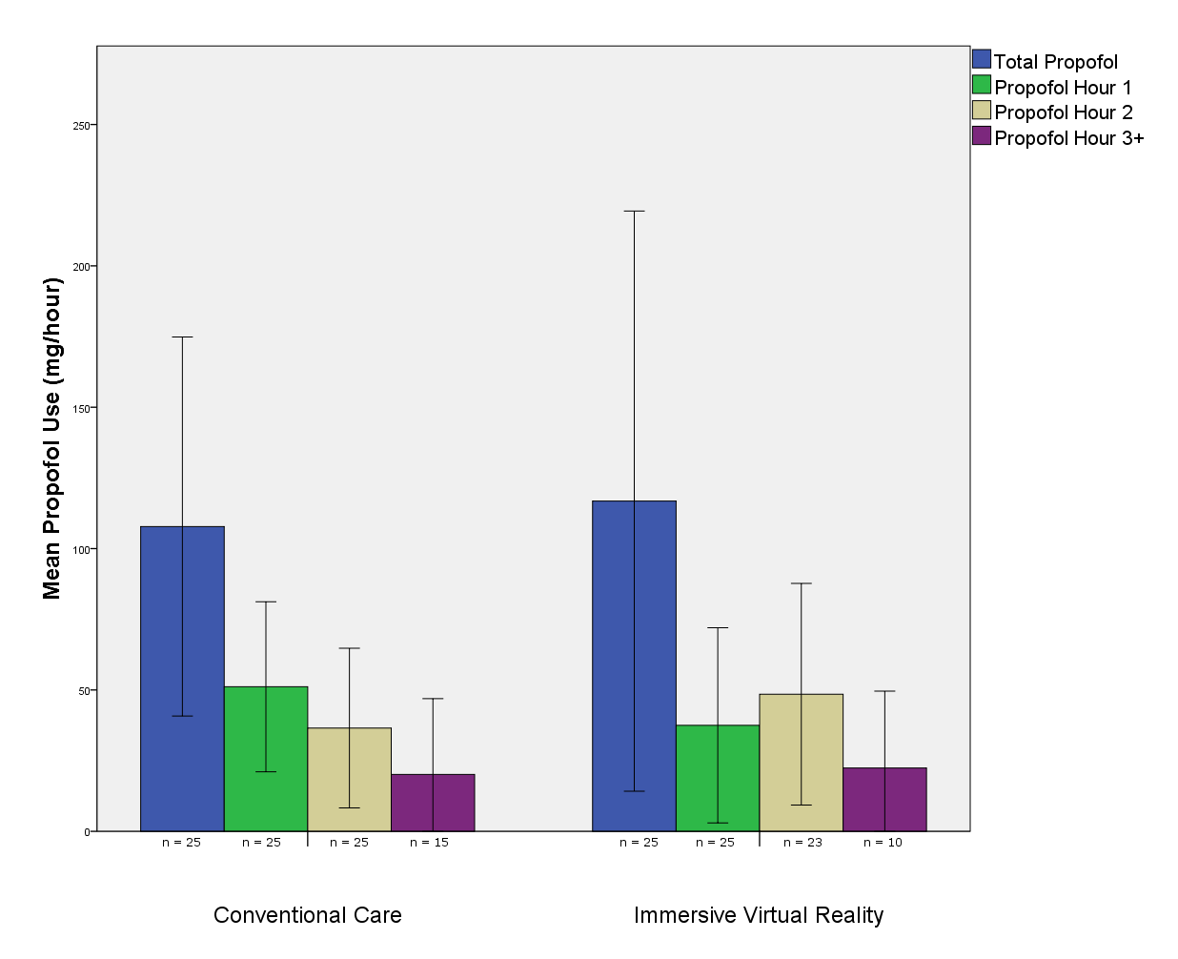
Table 1: Summary of demographic data from control and IVR groups

 | Control | IVR
Gender | n (percent) | n (percent)
Female | 12 (48) | 13 (52)
Male | 13 (52) | 12 (48)
Median Age (y) | 70 | 65
Height (cm) | 164.0 | 163.5
Weight (kg) | 80.5 | 86.0
BMI | 29.97 | 33.03
Median case duration (min) | 130 | 120
Procedure | n (percent) | n (percent)
TKR | 9 (36) | 11 (44)
THR | 14 (56) | 9 (36)
Anterior THR | 1 (4) | 4 (16)
Hip hemiarthroplasty | 0 (0) | 1 (4)
PFJ | 1 (4) | 0 (4)
Position | n (percent) | n (percent)
Lateral | 14 (56) | 10 (40)
Supine | 11 (44) | 15 (60)

Table 2: Summary of self-administered sedation use from control and IVR groups
 | Control | IVR | p
Propofol Dose | Mean ± SE dose mg | Mean ± SE dose mg
Dose/hour (mg/hr) | 53.5 ± 9.7 | 52.3 ± 9.9 | 0.72
Hour 1 (mg) | 60.2 ± 10.9 | 53.7 ± 10.6 | 0.67
Hour 2 (mg) | 35.5 ± 8.6 | 45.7 ± 11.8 | 0.48
Hour 3+ (mg) | 20.1 ± 12.5 | 22.4 ± 12.0 | 0.90
Total (mg) | 107.8 ± 20.7 | 108.0 ± 22.8 | 0.99
Met Propofol Requests | Median met requests (IQR) | Median met requests (IQR)
Hour 1 | 2 (1-4.5) | 2 (0-4) | 0.41
Hour 2 | 1 (1-2.5) | 0 (0-3) | 0.84
Hour 3+ | 0 (0-1) | 0 (0-3) | 0.81
Total | 3 (1-8) | 4 (0-6) | 0.66
Unmet Propofol Requests | Median unmet requests (IQR) | Median unmet requests (IQR)
Hour 1 | 0 (0-1) | 0 (0-2) | 0.52
Hour 2 | 0 (0-0) | 0 (0-0) | 0.77
Hour 3+ | 0 (0-0.75) | 0 (0-0) | 0.70
Total | 0 (0-4) | 0 (0-4) | 0.61

Table 3: Summary of midazolam and propofol use before and during procedure

 | Control | IVR | p
Midazolam | Mean dose mg (95% CI) | Mean dose mg (95% CI)
Pre-procedure | 1.8 (1.5 - 2.1) | 2.4 (2.1 – 2.6) | 0.13
During procedure | 0.1 (0 – 0.2) | 0.1 (0 – 0.2) | 0.85
Total | 1.9 (1.6 – 2.2) | 2.4 (2.1 0 -2.7) | 0.16
Fentanyl | Mean dose mcg (95% CI) | Mean dose mcg (95% CI)
Pre-procedure | 22 (16.2 – 28.4) | 32 (25 – 39) | 0.31
During procedure | 1 (0-2) | 9 (4.5 – 13.5) | 0.09
Total | 23.2 (16.8 – 29.7) | 41 (0-62.5) | 0.07

Table 4: Variables independently associated with total propofol use

 | Association | p
Weight* | 0.267 | 0.06
BMI* | 0.295 | 0.04
Intra-operative fentanyl* | 0.261 | 0.07
Pre-procedure Emotion-B score* | 0.330 | 0.02
Lateral position** | -1.878 | 0.06

*Pearson’s correlation test
**Mann Whitney U test

Supplemental Table 1: Median change in QoR-40 scores from before and after procedure

 | Control (IQR) | VR (IQR) | p
Comfort Score Change | 0(0-1) | 0 (0-2) | 0.25
Emotion Score Change | 1 (0-2.5) | 0 (-.5-2) | 0.15
Symptom Score Change | 0 (-1-0) | 0 (-1-0) | 0.80
Emotion (B) Score Change | -2 (-3-0) | -2 (-3.5-0) | 0.61
Confusion Score Change | 0 (0-0) | 0 (0-0) | 0.08
Pain Score Change | -6 (-9-(-)4) | -5 (-8.5-(-)3) | 0.60
Overall Score Change | -7 (-10-(-)4) | -7 (-10.5-(-)1) | 0.82

