**Managing diabetes in a ‘flash’: A mixed-methods study exploring a novel glucose monitoring system among adolescents with poorly controlled type 1 diabetes**

**INFORMATION SHEET FOR TEENS**



Thank you for showing an interest in this project. Please read this information sheet carefully before deciding whether or not to consent to participate. If you decide to participate we thank you. If you decide not to take part there will be no disadvantage to you or your child of any kind and we thank you for considering our request.

# Background

Many young people have difficulty checking their blood glucose levels as frequently as is recommended. This can lead to unhealthy diabetes control and increased risk for hypoglycaemia, and other health complications in the future. We would like to better understand if flash continuous glucose monitoring technology safely helps young people manage their diabetes and how young people can be better supported to use this new technology.

**Participation**

This is a 9-month study. If you decide to participate you have a 50/50 chance of being allocated to one of two groups. One group will be given a FreeStyle Libre flash continuous glucose monitor (FGM) system to use for 9 months. The other group will monitor their glucose levels for 6 months using their usual glucose meter and then will be given FGM supplies for 3 months.

The FGM monitoring system uses a handheld reader to scan a glucose sensor that is placed under the skin in the back of your arm, which will display the current glucose level in the tissue under your skin and your glucose information for the past 8 hours. The FGM sensor lasts for 14 days and then needs to be replaced. You may feel slight discomfort from applying the sensor, but it should not last long.

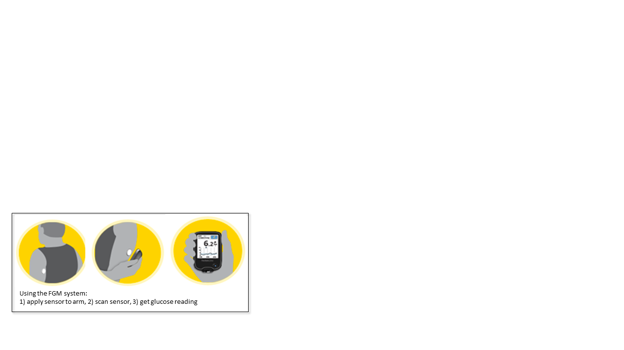

You may have used a similar continuous glucose monitor before, especially if you use a pump for your diabetes. The FGM sensor does not require finger stick blood test to help make it more accurate and there are no alarms to tell you if your glucose levels are too low or too high. You will be asked to keep a record of adverse events such as severely low blood glucose (where you require assistance to treat it), diabetic ketoacidosis (high blood glucose with ketones), and visits to the emergency department.

There will be four visits that will take place in the diabetes clinic and will last approximately 1 hour. During each visit, you will have your HbA1c checked and we will ask you and your parent or guardian to complete questionnaires about your diabetes and your glucose monitoring habits. We will also download the information that is stored on the FGM reader and your personal glucose meter. You will receive a small token of appreciation at the end of each visit.

If you decide to participate in the study, you will also be invited to take part in two separate interviews (approximately 30 minutes to 1 hour each) where you can share your experience using the FGM. These interviews will be recorded so that we can review them later and look into what helps you to use the FGM and what prevents you from using the FGM. You will receive a small token of appreciation after each interview.

Your participation is entirely voluntary (your choice). You do not have to take part in this study, and if you choose not to take part this will not affect any future care or treatment. If you do agree to take part in the study, you are free to withdraw from the study at any time, without having to give a reason, and this will in no way affect your future health care.

# Confidentiality and results

No material that could personally identify you will be used in any reports on this study. All data obtained for the study will be securely stored in the Department of Women’s and Children’s Health, University of Otago, in such a way that only the study investigators will be able to gain access to it.

Thank you for considering helping this study.

Kind regards,

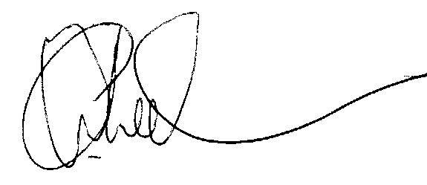

Dr Ben Wheeler

Please feel free to contact the researchers if you have any questions about this study.

Principal Investigator Co-investigator

Dr Ben Wheeler Sara Boucher

This study has been approved by the University of Otago Human Ethics Committee. If you have any concerns about the ethical conduct of the research you may contact the Committee through the Human Ethics Committee Administrator (ph 03 479 8256). Any issues you raise will be treated in confidence and investigated and you will be informed of the outcome.

**Managing diabetes in a ‘flash’: A mixed-methods study exploring a novel glucose monitoring system among adolescents with poorly controlled type 1 diabetes**

**ASSENT/CONSENT FORM FOR TEENS**



All my questions have been answered in a way that I understand, and I know that I can ask for more information at any point (as well as who to contact if I do have questions).

I also know that:

1. Taking part in this project is my decision, which means I do not have to take part if I do not want to, and nothing will happen to me;
2. I can stop taking part in the project at any time and it won’t affect me in any way;
3. Personal information about me which can identify me as an individual person will be destroyed when the researchers are finished with this project but the raw data on which the results of the project depend will be safely stored for 10 years after I turn 16 years old (i.e., aged 26 years);
4. I am aware that I will be given a small token of appreciation for taking part in this study;
5. The results of the project may be published and will be available in the University of Otago Library (Dunedin, New Zealand) but every attempt will be made to preserve my anonymity (keep my identity secret).

I agree to take part in this project. YES / NO

I agree to my primary diabetes care health professional YES / NO and General Practitioner being informed of my participation in this study.

I agree to be contacted about related diabetes studies in the future. YES / NO

|  |  |
| --- | --- |
| ............................................................... | ............................................................ |
| Signature of participant | Date of birth |
|  |  |
| ............................................................... | ........................................................... |
| Name of participant | Date |
|  |  |
| ........................................................ | ............................................................. |
| Signature of parent/guardian | Date |

Thank you for your help.