RESEARCH PROTOCOL: The Effects of Micro-Osteoperforations on Orthodontic Root Resorption and Tooth Movement- A Pilot Study

Method:
Phase 1: The effect of micro-osteoperforations on orthodontic root resorption- Duration 4 weeks (28 Days)

VISIT 1
1) Orthodontic brackets bonded to the upper first permanent molar and first premolar teeth.

2) 150g buccally directed force, applied bilaterally to the first premolars to achieve buccal tipping. 4 weeks of force application
- Using a 0.017” x 0.025” TMA (Ormco, CA) spring as seen in the figure below (Springs will be provided from the department).
- Force magnitude measured to the nearest gram with a strain gauge (Dentaurum, Germany).
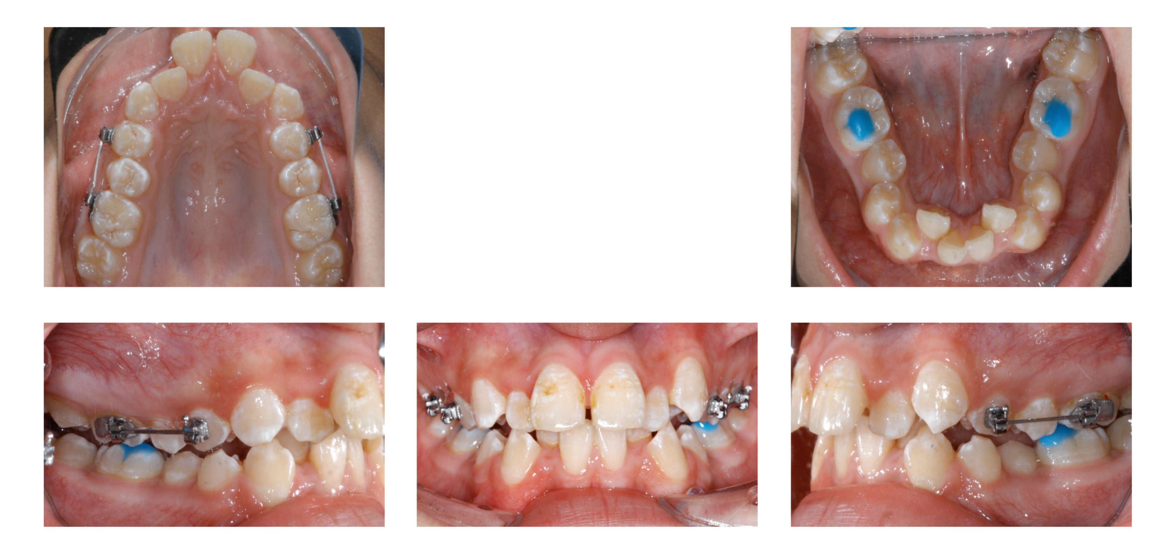

3) Split-mouth procedure: micro-osteoperforations performed on one randomly selected side of the mouth
Side A & Side B - randomly assigned per patient) at the commencement of the 4 week period.
i. Side “A” [no micro-osteoperforations]
ii. Side “B” [micro-osteoperforations]
- Micro-osteoperforations performed with disposable appliance designed for this purpose by Propel Orthodontics
- Three perforations in a vertical alignment will be placed on both the mesial and distal aspects of the upper first premolar

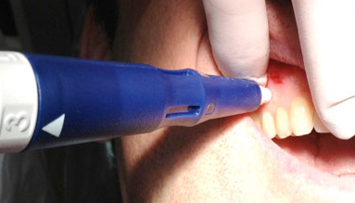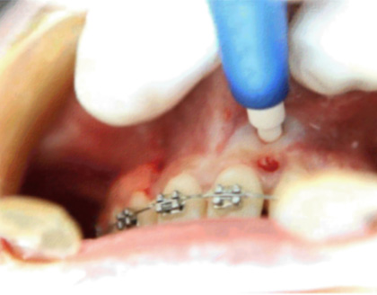

VISIT 2
4) Bilateral extraction of first premolars at 4 weeks (28 days).
- Random assignment of identification number to experimental and control teeth for Micro-CT scanning as same researcher to do extraction and scanning
5) Analysis of teeth at Sydney Dental Hospital using a Micro-CT scanner.
Statistical analysis:
- Amount of root resorption with Force (Control) vs Force + micro-osteoperforations.
6) Patients will also be asked to record an assessment of the level of discomfort on the experimental and control side using a Visual Analogue Scale in a take home questionnaire. The subjects will complete the questionnaire the following time points: 24 hours, 2 days, 3 days and 7 days.

Phase 2: Effect of micro-osteoperforations on tooth movement- Duration 36 Weeks (24 weeks of alignment and levelling + 8 weeks of canine retraction)

The allocated sides of the mouth for each subject (control, micro-osteopeforations) will be kept from part one.

1) Full orthodontic braces upper and lower arches
- Levelling and aligning the teeth for 24 weeks
  - Reviewed every 8 weeks (3 visits)
2) After 24 weeks: micro-osteoperforations performed on only one side of the mouth- same as Phase 1
a. Split-mouth procedure (Side A & Side B - randomly assigned per patient) during the same 4 week period.
i. Side “A” [no micro-osteoperforations]
ii. Side “B” [micro-osteoperforations]
- Micro-osteoperforations performed with disposable appliance designed for this purpose by Propel Orthodontics
- Three perforations in a vertical alignment on alveolar bone associated with distal aspect of the upper first premolar

3) Canines retracted bilaterally into the upper 1st premolar extraction spaces using Nickel Titanium springs. 8 weeks retraction period.
4) Review every 2 weeks for 8 weeks (4 visits)
- Clinical measurements and impressions (taken every 14 and 28 days respectively).
- Clinical measurements taken using standardised Digital Callipers.
  - Inter-bracket distance (between Canine and 2nd Premolar brackets) measured and recorded, every 14 days
- Analysis of measurements and Impressions – every 28 days.
5) Intra-patient Rate and Amount of retraction compared (micro-osteoperforation vs control).

4 weeks after the commencement of the 8-week canine retraction period
- Clinical photographs and alginate impressions

After completion of the canine retraction period – 8 weeks
- Clinical photographs and alginate impressions

Statistical analysis:
Compare:
1) Rate of tooth movement (micro-osteoperforation vs control).
2) Amount of retraction (micro-osteoperforation vs control).

